**How to become a professional football player**

Your dream is to become a professional football player? Well, you have found the right

article.

A lot of people want to become professional football players, but only very few can do it.

So why is it so hard? At first, you should think about how realistic your goal is. Oliver Lederer

(Admira Coach) says that on average only 1% of academy players will make it into a

professional team.

What could be the reasons that you want to be a professional footballer?

* You realize that you have what it takes to become one of the best
* For the love of football
* Money
* Fame and glory
* Make it to the top

Only very few players, for example Kylian Mbappe (19) and Neymar Jr. (26), have managed to become one of the best at a very young age. Both are currently playing at the same club.

**Neymar Jr.:**

During his childhood, Neymar used to be a well-known player of street football. His father was a professional footballer and trained him too. At the age of 11, Neymar joined FC Santos. 6 years later he got his first professional contract. He joined FC Barcelona in 2013 and in 2017 PSG payed 222 Million to buy him.

**Kylian Mbappe:**

His father played football and then continued his career as a coach. Of course, Mbappe was a talented football player in his childhood. At first, his father coached him and then sent him to the prestigious academy "Clairefontaine", which "produced" famous football players. He signed a contract with AS Monaco when he was 15. Today he is a world champion too.

Ein Bild, das Gras, draußen, Feld, Fußball enthält.

David Alaba, an Austrian professional footballer, currently plays for the German club Bayern Munich and the Austrian national team. Alaba was born in Vienna and he began his career with SV Aspern, before joining the youth side of FK Austria Wien at the age of 10. He was a very talented player and that is why he was contracted by FC Bayern Munich when he was 16.

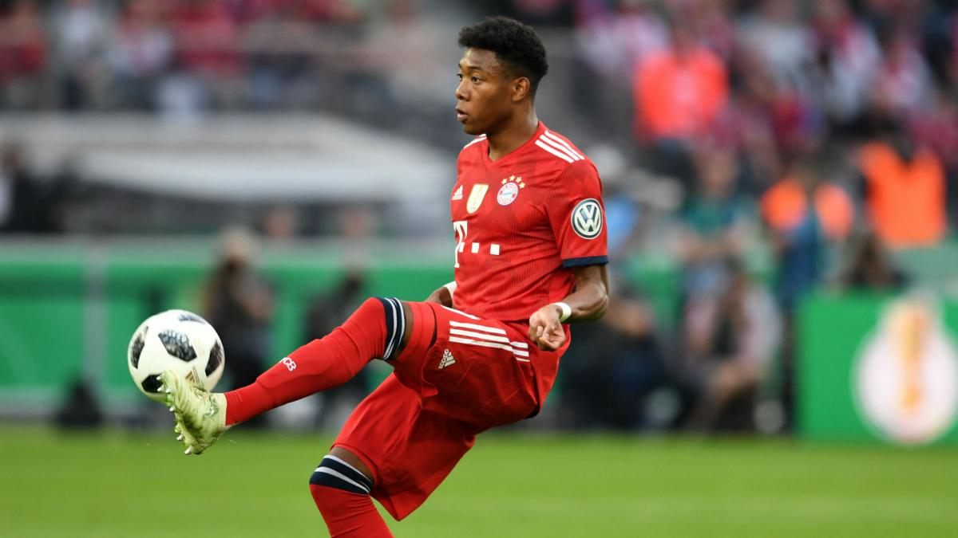

The first step to becoming a professional footballer is the training. You have to give more than 100% in every training and match. It is important that you have very good stamina, because football is an exhausting sport.

What can you do to get better?

* Focus on the weaknesses
* Work on yourself after training and in your free time

You should look for an agent who can help you with organizing special trainings with different professional teams. That will help you to gather experience and you will get the chance to talk to coaches. They could give you tips and an overall view of your skills.

**What you have to expect when you successfully achieved your dream of being a professional footballer**

**Lifestyle:** You have to change your lifestyle completely, eating a healthy diet and being fit are two of the requirements.

**Free time:** Being known in the public is not always as easy as it seems, because people will criticize you for every mistake. You have to be aware of the things you present to the public.

**Social pressure:** In the last match you were not able to show your best, the fans and the media blame you for losing. That is one thing that could happen, so you have to learn how to deal with it.

Ein Bild, das Gras, Person, Fußball, Spieler enthält.

All in all, you have to work hard to achieve your dream, but one of the most important things is to be patient and lucky to be seen by the right people.

There are a lot of professional football players that have revealed how they become a professional.

The most important things:

* Go on if you fail
* 14-16 is the most important age
* Work always on yourself, especially on your weaknesses
* No one is perfect 🡪 do not get down after a bad game
* FUN is very important, too
* Never lose the focus on football
* You need the right people, at the right moment around you
* Do not care about haters

There are just a few points summarized. If you want to see the whole video, you can click on the link below.

<https://www.youtube.com/watch?v=kH9pXdsaa3g&feature=youtu.be>

**Football Academy:** A football academy is a sports school and performance center where football players are trained and educated. Students attend a secondary higher school and take their school leaving exam at 18-19.