# AUTONOMOUS CARS

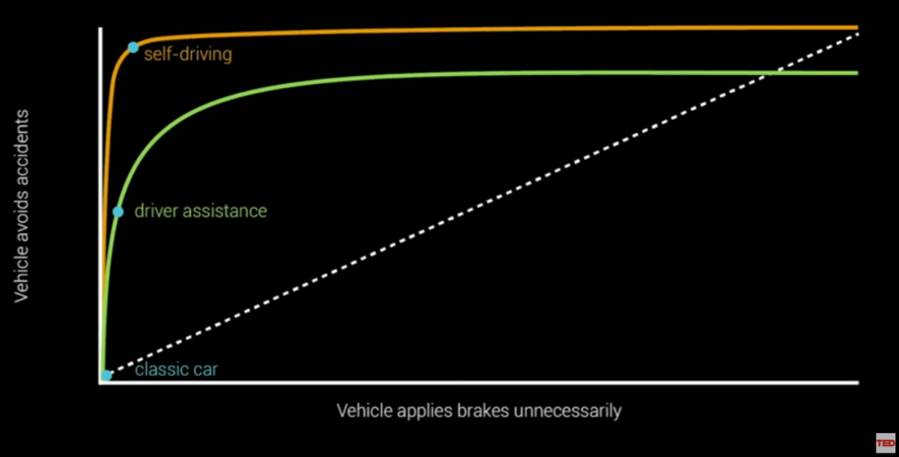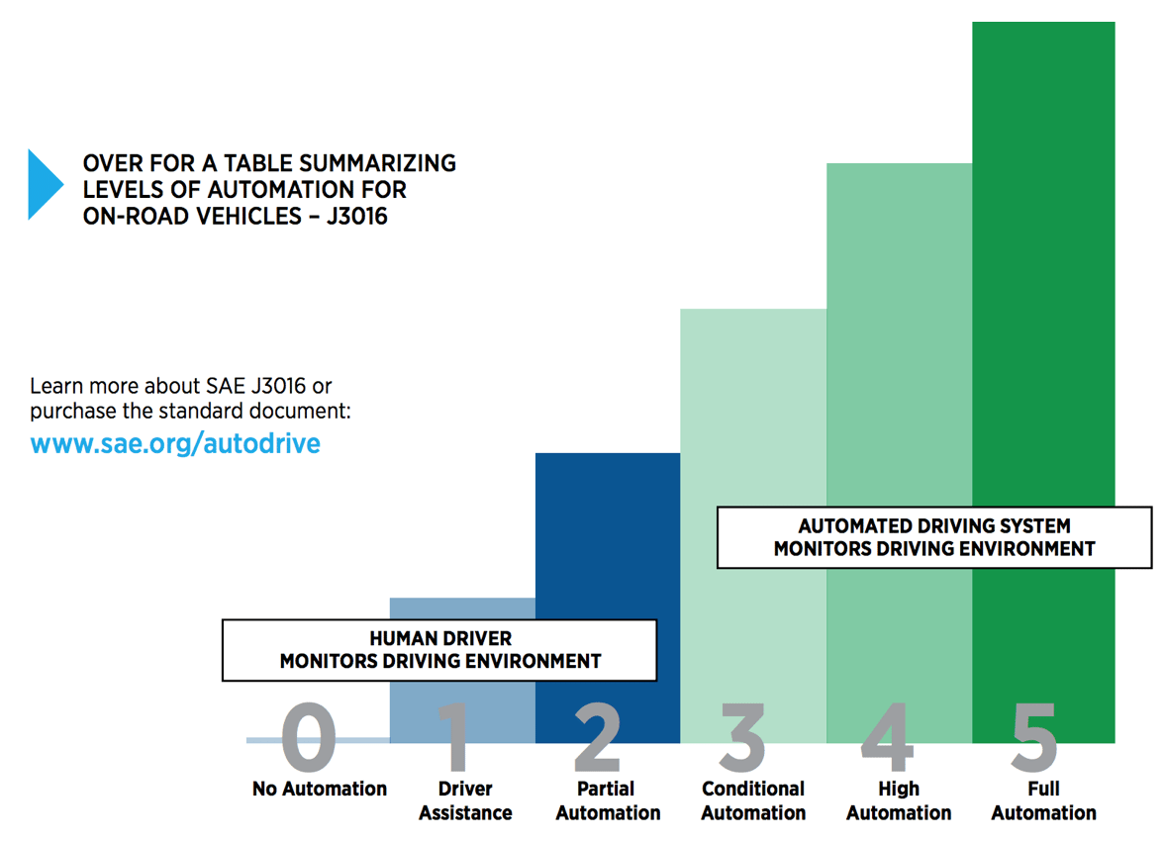A driverless car is not just a car without a driver, there is a highly complex software supporting the driver of the car. The computer has to calculate every possible scenario. 600.000 people are dying yearly in car accidents, the goal of self-driving cars is that there are no car accidents anymore or at least no deadly ones.

Chris Urmson, who is an engineer, known for his work as a pioneer of self-driving auto technology said, that accidents always going to happen, but with self-driving cars, there is an explicit reduction of accidents and casualties.

Source: https://www.youtube.com/watch?v=tiwVMrTLUWg

This graphic shows the different steps of assistance /automation of the car. At the moment we are between step 3 and 4, which means the cars today can drive nearly alone and they give the driver a lot of assistance. As recent events of UBER, where a self-driving UBER-Taxi killed a person on the street has shown, that the automotive manufacturers are not yet ready for the step into the full automation, as far too many risks prevail. For now, a lot of cars can drive alone but the driver always has to hold the steering wheel that the driver can turn it in an emergency or can pull the brake. But the aim of the big car brands is that from 2020 onwards, there will be completely self-driving cars without pedals and steering 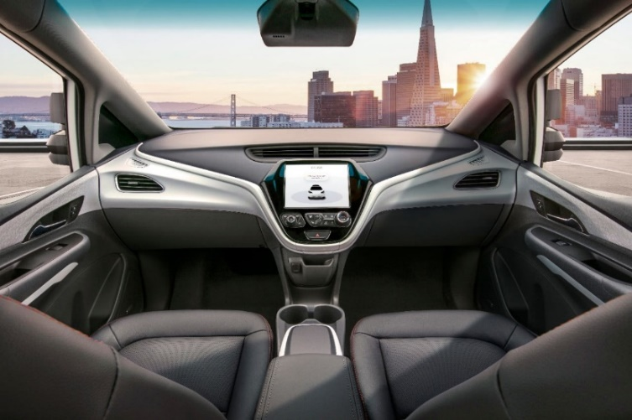wheels. Of course, it is important for companies to make more profit. So, in a nutshell, the self-driving cars are hopefully going to save a lot of lives in the public transport, because a computer is made to never fail. Also, no one can go over the speed limit if the car controls everything. But there are also negative things on the “only self-driving cars concept”. There are going to be a lot of job losses because taxi drivers, school bus drivers, truck drivers, and driving schools are no longer needed. But are we, the customers ready to give our lives in the hand of computers?

Sources: TED, The Guardian, Techmergence