**Report**

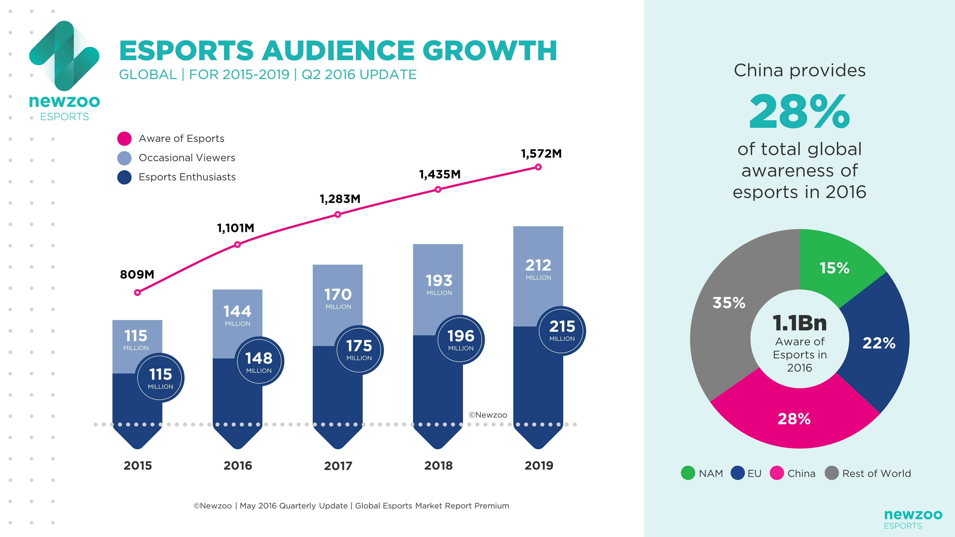

**E-sports: audience growth vs marketing growth**

**Introduction**

The aim of the report is to show the development of e-sports in the last few years and to provide an outlook for the future development. It will also analyse the advantage investors in e-sports have. E-sports has had an audience growth of 20 million people from 2017 to 2018. Some business magazines in late 2018 call E-Sport the fastest growing investment sector.

**Why is e-sports growing so fast?**

To start with, the reason why e-sports is growing so fast lies in the role of the new, digital media. With growing popularity of streaming networks like Twitch or Youtube, there was a new opportunity for gamers to broadcast their competitive events. Because at the beginning of professional gaming, no TV channel would broadcast them. As a result of the digitization, nearly every kid that has access to a computer plays computer games, like billions of other people. With introducing more players into the professional scene of their favorite game, there is a strong possibility, they will start watching tournaments.

**E-Sports as investment for a company**

As mentioned in the Global E-Sports Market Report, investors may count with about 200 million viewers every year, which means that companies could present their products to 0,025% of the world population. If only 0,001% of the 0,025% buy a product, they will still have sold their product to about 200.000 customers, who they will have gained from investing in e-sports for a only one entire year. As another result of investing in e-sports the awareness level of a brand increases. Many people underrate the marketing influence of electronics sports. Football clubs like the FC Bayern München noticed that very early and founded their own e-sports team. Keep in mind that football is the most influential sport in the world, which realizes the most money in comparison to all other sports. The business strategy of FC Bayern München should show many investors and companies how powerful the business of electronic sports is and how much potentials it has.

**Future developments**

In conclusion it may safely be predicted that the audience growth is going to increase further. The number of big companies sponsoring and investing in e-sports is also going to rise. Obviously, this means that e-sports will be more lucrative for athletes, the media and companies.