The Amazon Empire

# Introduction

On the fifth of July 1994 Jeff Bezos started a book selling website called Amazon. Fast forward 24 Years, and Amazon is the largest online retailer, with a huge selection and 97000 Employees and an Annual Revenue of 61.09 Billion US-Dollars. Amazon has over 200 million products on their website listed. Jeff Bezos is now in 2018 the richest man alive with approximately 150 Billion US-Dollars in Amazon Stock-shares.

# The Beginning

Jeff Bezos was 30 years old and working on Wall Street as he saw the Internet revolution take place. He quickly made the decision to quit his Job and create an Internet company which sells stuff, but he didn’t know what to sell. He created a “top 20” list of things that he could sell online. He eventually set on selling books, because they´re cheap and in worldwide demand.

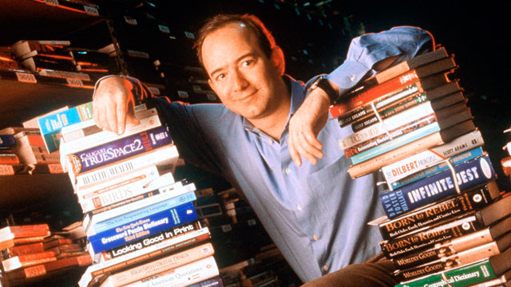

# Jeff Bezos´ Funding

The first investment was not from a big company, but from his parents. They invested more than 300000 US-Dollars. But they weren’t interested in t

he Company. The first question Jeff Bezos´ Dad asked him was, “What is the Internet?”. “They believed in me, not the Company.”, said Jeff Bezos. After 3 years in 1997, Amazon goes public with an IPO (initial public offering) of 18 US-Dollar per share.

# Jeff Bezos´ Advice for starting a Business

Jeff Bezos always said to never give up, because it took Amazon three times to get third party seller business to work. Also, your company should have a long-term view, so that it won´t get irrelevant after a few years.

# Amazon Controversies

Like all online retailers, customers cannot try the goods before purchase. If you buy a product you can only rely on the experience of other customers. There is no guarantee of delivery on every product worldwide. Like in all online shops, shipping costs apply, which can be even more expensive than the product costs.

Amazons expansion is also very controversial. Amazon states to create more jobs by investing in warehouses all around the globe, but how are the working conditions? Looking back at the 2018 Axel Springer Awards ceremony, angry Amazons employees were protesting outside of the building. And that’s not the first time, that workers for amazon, strike. For example, in Germany (where strikes are possible), a multi-day strike for an increase of wage, resulted in delivery delays.

“Amazon destroys more jobs, than it creates.”, states Forbes, a reputable online magazine.

Most jobs in Amazon Warehouses consist of packaging, delivery and sortation in part time and part benefit, says Amazons Insider.

Price pressure keeps getting bigger, as people like to spend less money on things. That’s why it’s like a cat and mouse game between sellers to sell things even cheaper. And when things cheaper, Amazon is under pressure to make higher profits, so they decrease the wages, or they fire more people. In the end, it’s an endless dilemma. Big sellers provide more service per unit of human labor, which results in unfair working conditions (slave labor and social injustice).

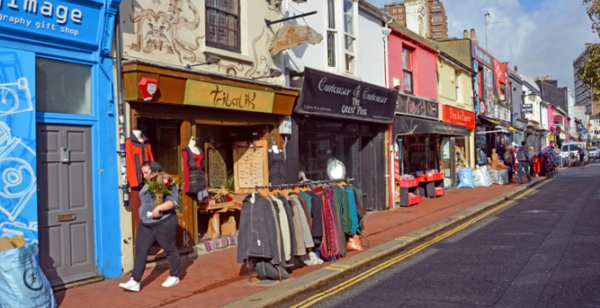

Small Shops in Brighton

For towns and cities, the “death” of small businesses occurs. Retailers must close, because more people buy their things on Amazon, because its cheaper. Streets without storefront windows will be everywhere.

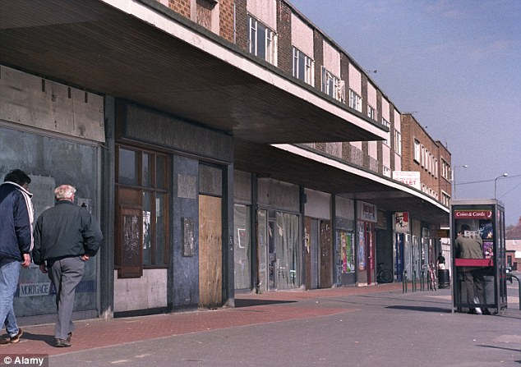

Closed Stores in NYC due to Amazon

And that will result in massive unemployment, lack of individual advice and knowledge, loss of creativity and formation of a monopoly.

Unfortunately, it is an unfair situation that professions in health care service or education, dealing with the future of people, are not getting paid equivalent.

Amazon is part of the Globalization, which is an economic wave that is sweeping over the world, with influence in political decisions, for example regarding tax payments.

# Summary

In summary, Amazon is the largest growing Company in 2018 as the Stock price doubled in one year since 2017. And now with the title of the Richest man in the World, he invests his income in his own Space Agency and Cancer Research, his actions are still very controversial.

Resources:

<https://www.marketwatch.com/story/its-not-just-amazon-and-whole-foods-heres-jeff-bezos-enormous-empire-in-one-chart-2017-06-21>

<https://www.referralcandy.com/blog/jeff-bezos-quotes/>

<https://www.fundable.com/learn/startup-stories/amazon>

<https://www.forbes.com/sites/timworstall/2017/01/12/of-course-amazon-destroys-more-jobs-than-it-creates-thats-the-whole-darn-point/>