## Ideas for career – corrected version

Do you know what you want to do after finishing school? If your answer is “Yes”, then you can stop reading now. Everyone else is invited to read this article, you may get some idea about shaping your future. There are a couple of options:

First, you can get a job, of course. As a graduate from any technical college, various doors are open for you, so getting hired somewhere shouldn’t be a major problem. Safe options are to begin as a software developer or network engineer. If you have nerves of steel and are a good communicator, you could apply for a position as an IT support analyst, a job where you have to give support to your customers (and repair their systems, too). Those who have focused on media technology as their major, are recommended to go into web design.[1]

Wanted: STEM graduates

Whatever you are choosing, you will probably not have a hard time getting hired. From services to manufacturing, all businesses are competing over graduates from Science, Technology, Engineering and Maths subjects. There are many manufacturers in Austria, from automotive to space technology, from mechanical engineering to the production of high tech materials and these industries urgently need STEM graduates like you. Furthermore, with industry 4.0, demand is expected to increase still. [3] The following graph shows that there are many jobs available that to graduates from Technical High Schools such as ours: [4]

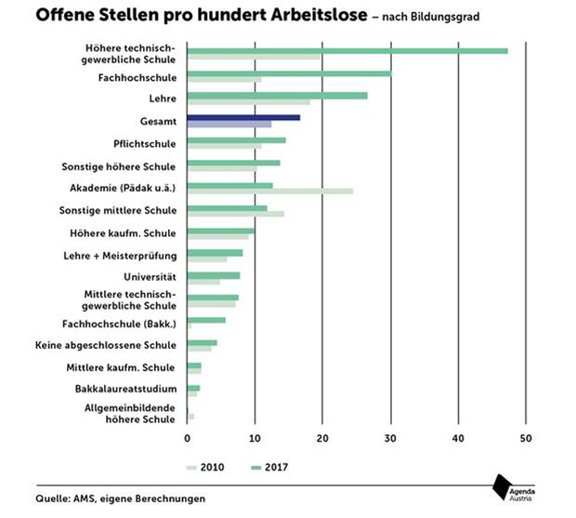

Second, you could go to university and study computer science or related courses. This will take some time, but at Universities of Applied Science (FH – such as our partner college at Höchstädtplatz) you may be accredited two semesters for having taken the five years of technical education at this school. [2] For this reason, you may expect to finish your studies earlier and graduate after two years instead of three (Bsc). The Master’s programwill take another two to three years.

Third, you may want to start your own company, provided that you have the business idea, the guts and the money to do that. What exactly you want to produce will be up to you and your skills.

Sources:

<https://targetjobs.co.uk/career-sectors/it-and-technology/advice/286189-ten-typical-jobs-graduates-can-do-in-it> [[1](https://targetjobs.co.uk/career-sectors/it-and-technology/advice/286189-ten-typical-jobs-graduates-can-do-in-it%5B1)]

[https://www.technikum-wien.at/htl-ingenieur-bachelor/[2](https://www.technikum-wien.at/htl-ingenieur-bachelor/%5B2)]

<https://derstandard.at/2000084047144/Fachkraeftemangel-Industrie-fordert-dringend-Ausbau-der-HTL-Angebote> [3]

<https://www.google.com/search?q=HTL+Arbeitslosigkeit&hl=de&source=lnms&tbm=isch&sa=X&ved=0ahUKEwjK-KiX0M7eAhWMA8AKHcAIDvUQ_AUIDygC&biw=1920&bih=1094#imgrc=3wb2GFLc3HOmsM>[4]