What to do for lunch?

By Markus Mondl

„What are you going doing for lunch today?“, is something every TGM student has asked his or her classmates before.

In the vicinity of the school building there are many different restaurants and shops where one can have lunch. However, in the last 2 years that I attended the TGM, I have observed that the students have 3 main places they go to.

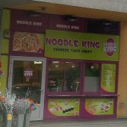

Of these three, the most visited and closest to the school is Noodle King. Although the time to get there is rather short, the waiting time in the queue is fairly long. The food is always freshly made and tastes excellent. The staff are very friendly and polite. In addition, they are very flexible regarding changes in the menu.

**Food:** 5/5

**Service:** 5/5

**Waiting time:** 2/5

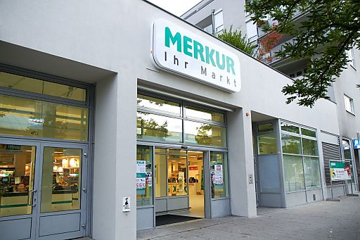

The second most popular option amongst students is the grocery store Merkur. Merkur is, just like Noodle King, very close to the TGM and has a very wide range of products one can buy. However, Merkur also sells freshly baked buns and has the option to have those filled with different toppings. Not only are the staff very helpful when requiring help with finding products in the store, but they are also very polite when speaking to customers. Recently Merkur added a new payment method, the self-checkout, which has reduced waiting times at the checkouts.

**Food:** 5/5

**Service:**  5/5

**Waiting time:** 4/5

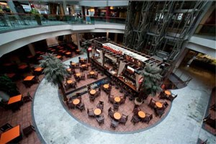

Lastly let´s have a look at the food court in the Mall. Unlike the other shops, the Mall is two underground stops away from school. Nonetheless, is there still enough time to eat and enjoy ones meal at a pleasing speed. In the food court there are many different shops students can pick from. Because of that, the waiting time in each of the restaurants is rather short. Furthermore, the food that is served is excellent and the staff are very friendly and polite.

**Food:** 5/5

**Service:** 5/5

**Waiting time:** 5/5

To sum it up, in regular breaks, Noodle King and Merkur are definitely the most popular option. However, if students have a longer break the majority will go to the Mall and enjoy their meal there.

Source:

<https://www.google.at/search?q=food+court+millennium+city&rlz=1C5CHFA_enAT763AT763&source=lnms&tbm=isch&sa=X&ved=0ahUKEwipzoanrJffAhUSDOwKHQ9-DgUQ_AUIDigB&biw=1440&bih=790#imgrc=_e0Ce2C3vwYhJM>:

<https://www.google.at/search?q=noodle+king+j%C3%A4gerstra%C3%9Fe&rlz=1C5CHFA_enAT763AT763&source=lnms&tbm=isch&sa=X&ved=0ahUKEwjM1_rQrJffAhUC-qQKHQMDCmAQ_AUIDygC&biw=1440&bih=790#imgrc=tBW2fKVcmy49GM>:

<https://www.google.at/search?q=merkur+j%C3%A4gerstra%C3%9Fe&rlz=1C5CHFA_enAT763AT763&source=lnms&tbm=isch&sa=X&ved=0ahUKEwjezYzjrJffAhUNzaQKHUcPBIUQ_AUIDygC&biw=1440&bih=790#imgrc=emLxadZy6Z615M>: