# A tale about two economies – United States vs. China

## Introduction

The aim of this report is to examine and analyse the various topics that are mentioned in the infographic “A tale of two economies”. It will also include likely future developments in certain topics.

## Population and land area

To start with, America as well as China have approximately the same land area, which is about 9.200 km2. Therefore, one would think that the population of the two countries should also be roughly the same. That in fact, is not the case. Even though the land area is about the same, the population of China is 4 times as big with 1.385 billion citizens.

## Health care and education

Another important topic which was analysed in the infographic was education and health care. In the United States of America 85% of the population have private or public health care. However, 17% of the national GDP is used for the healthcare expenditure.

Since 2011, the Chinese government has invested 5% of the GDP into developing a new health care system. With the year 2020, 95% of the population are supposed to have at least basic health care insurance. Ultimately, the government plans to cover 70% of the medical costs for every person.

In addition to the health care system, China is also investing into education. To be precise, 4% of the GDP are spent on education which includes infrastructure like schools, universities etc. and salaries. Since 2013, the number of kids who attend primary or secondary school, has risen by 120 million.

## Energy consumption and production

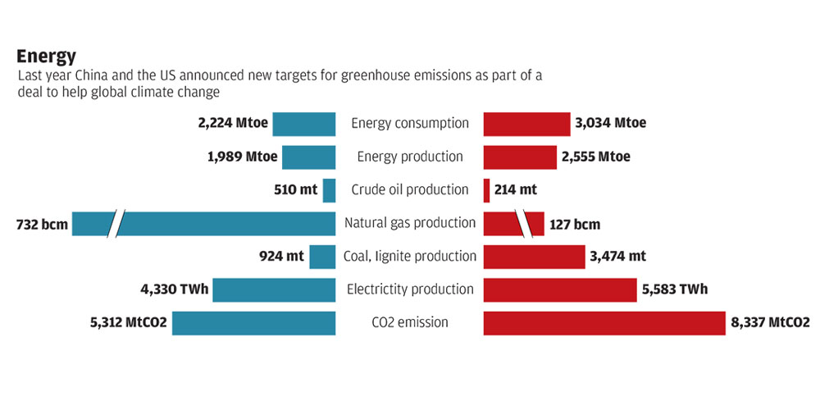

As evident from the 2013 data, the gap between energy consumption and the production is higher than in the United States of America. One possible reason for this fact could be Chinas ongoing industrialisation. Therefore, they need more energy. The way it is right now, coal is one of the biggest sources of energy. However, this will change with further industrialisation. Over time the usage of coal as a source of energy will decline because it is not the most efficient way to get energy. Also, because of the use of coal CO2 emissions in China is enormous.

## Conclusion

Based on key performance indicators, one can say that currently, the American economy to China. However, with the expected progress of industrialisation in China, the Chinese economy will grow and in one or two decades China might even be able to surpass America in areas like health care, education and energy consumption and production. On the other hand, America will not stop developing, either which means that competition will remain fierce. The current conflict over tariffs may be seen in the context of this competition.