# **Air travel and its problems**

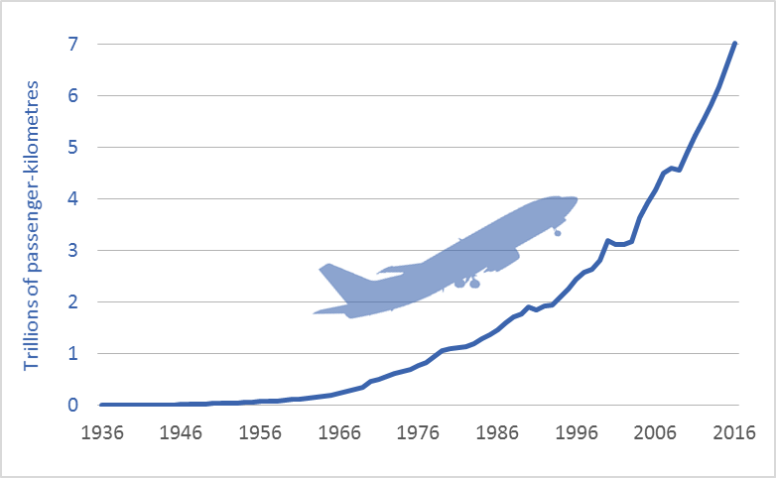**Introduction**

The aim of this report is to show why global air travel should be reduced, not only for the sake of the environment but also for the benefit of personal health.

**Development of air travel**

The graph shows an exponential growth of air travel. The number of passenger-kilometers doubles every 15 years and it is predicted to continue increasing.

**The problem**

Aircraft engines emit heat, noise, particles and gases which contribute to climate change. A study shows that air travel is the reason for nearly 1/10 of world’s carbon emissions. Beside the environmental damage it also causes some health hazards like an increased risk of transmission of airborne infections, vascular diseases like the deep vein thrombosis and typical airsickness.

**Advantages**

The main reason for people who choose air travel over alternative forms of transportation are the short travel duration, the lower price and the fact that air travel is the safest method to travel.

**Proposed solution**

To avoid air travel it does make sense to switch to its alternatives like going by car, bus, boat or train. The best option is to invest more decidedly in high-speed rails, if possible. High-speed rail systems are better for the environment and come with fewer health hazards for the body. The disadvantage are the higher prices and limited availability.

**Conclusion**

According to recent numbers there is no improvement in sight. To fix this problem the government should provide more high-speed rails but also the population has to be ready to invest in more eco-friendly travel methods.