***WhatsApp Usage and Data Collection***

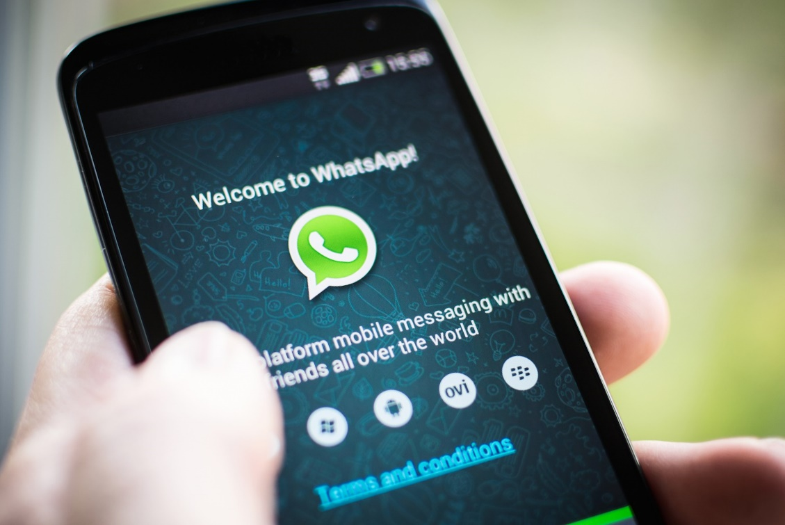

“I don’t care if WhatsApp has my data! It isn’t relevant anyway”, said one of my fellow colleagues when I asked him if he knows about the extensive data collection by WhatsApp.

But data is always worth something and WhatsApp has a lot of data! Every person that uses WhatsApp has at least a few hundred pages of data about them stored on its servers. This data can be used as WhatsApp pleases and subject to no conditions.

But the data isn’t just stored there. They are worth something and WhatsApp could sell them to companies that are interested in specific users. One of them could be you and your data are then transferred to another company. You don’t have any control over your data and what happens to them. But, in theory at least, you know about that, because you accepted the “terms and conditions”. But did you really read them?

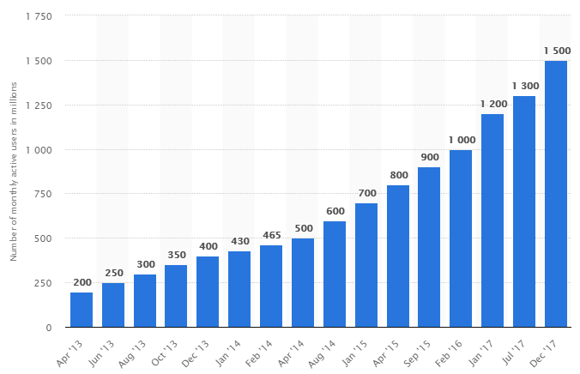***The amount of data WhatsApp has***

As you can see, WhatsApp has 1.5 billion active users every month. This means that WhatsApp has about 150 billion pages of information. But that is just the active users and only based on an assumed 100 pages per user. There is far more information stored and sold to companies, but we, as the users, accept this fact. Even though we literally give them our money in the form of data, we just let it happen.

But are you as an individual okay with that? Are you okay with the fact, that some companies could have a lot of information about you? But, mostly, are you okay with the fact that you are transparent?

***Are there any safer options than WhatsApp?***

Of course, there are, but one major problem of these is that not many people use them yet. One of the biggest and safer messenger apps is Telegram. This app is not only more secure than WhatsApp, but also does not collect data about you. One reason why we, as the user, know why it doesn’t collect data is that the API and the protocols are open to everyone. So you can see what the messenger is doing.

**Other alternatives:**

-Telegram

-Wire

-Signal

***Why don’t more people switch to other messengers?***

As mentioned above, not that many people use the alternatives. And that is the biggest reason why people do not switch. WhatsApp has the numbers advantage and that keeps people on WhatsApp.

Would you switch to another messenger even though not many of your friends use it? Would you recommend the messenger to your friends and explain why they should use it?

Sources:

<http://www.businessofapps.com/data/whatsapp-statistics/>

<https://www.statista.com/statistics/260819/number-of-monthly-active-whatsapp-users/>

<https://telegram.org>