# Future of Formula 1?

Many people say, that Formula 1 is dying. But does Formula 1 has a future? Or is it going to be replaced by Formula E? And how is it going to change in the future?

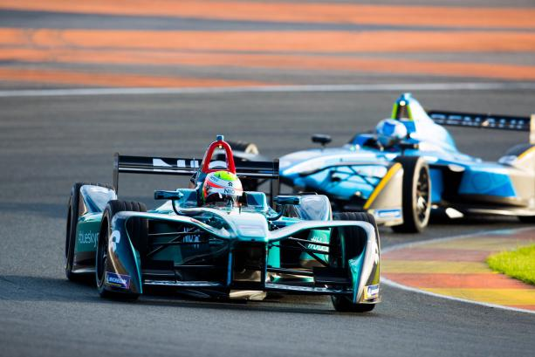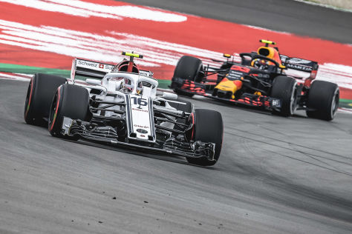

(Formula E (left side), Formula 1(right side)

Formula 1 is getting an interesting change at the end of the season in 2020. At the moment, every team is able to spend as much money as they want and as they have available. The consequence are 3 strong teams with enough money (also called A-Group), and 7 other teams (B-Group). The cars of the A-Group are so strong, they can start last and win the race. This is going to change, because the rules say that there are going to be many parts that every team has to use, so there are not that many differences.

At the moment, another racing series is growing and getting more popular: Formula E. Many people say Formula E is going to replace the formula 1. But this might never happen.In fact, Formula 1 and Formula E are different. One point are racetracks. While Formula 1 only has 3 city-tracks, Formula E races are held in big city centers like Paris, New York and Montreal. Another point is speed. At the moment a Formula 1 car is going up to 375 km/h, while a Formula E car is only going up to 225 km/h, because of the limitations that come with current battery technology. But this won’t last forever.

The new rules for 2021 are going to reform Formula 1. The challenge engineers are working on is to make the engines faster, louder and more powerful. Many people would say, why should the engines get louder? That is because of the fans. Before 2014 and the introduction of hybrid engines, engines were much louder. Now, because of a new car design, they have lost down force, that is the energy that is created by special parts on the car and is the force, that presses the car onto the road. So they are going to be faster on straights, but in corners they are getting slower.

Bringing back the excitement?  
Together with the new rules for 2020, Formula 1 is going to be more interesting, because it is going to remove the A- and B-Groups and everyone has a car, that is not bad compared to others.

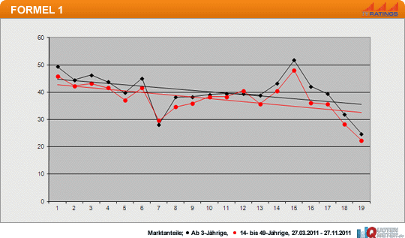

At the moment Formula 1 is losing viewers, because Formula 1 is not that interesting. The new rules in 2021 are going to help because this is a big problem. Fewer views mean less money.

So at the moment, Formula 1 is dying, but will hopefully recover after 2021. Formula E is always going to be a competitor, but it is not going to replace Formula 1. It is obvious that either Lewis Hamilton or Sebastian Vettel are going to win the world championship in 2019 and 2020, but who knows what is going to happen after 2020.

Sources:

Google Pictures

<https://www.stuttgarter-zeitung.de/inhalt.formel-1-vs-formel-e-die-groessten-unterschiede-der-rennserien.b7a274d9-34df-4f58-972c-a072bbfc5720.html>

<https://www.motorsport-magazin.com/formel1/news-250220-formel-1-regeln-2021-reglement-konzept-zeigt-technik-zukunft-langsamer-aber-besser/>