Death Sentences and Executions

## Introduction

During 2017 there were 993 documented executions and many more undocumented ones, especially in China where there are no official documents or information available on the thousands of people executed each year. Though this is a high number it is still down 37% from the previous year’s 1360. While Europe (except Belarus), South and North America (with the exception of the USA) and Oceania have abolished the death penalty entirely, it is still common practice in many Middle Eastern, North African and Asian countries.

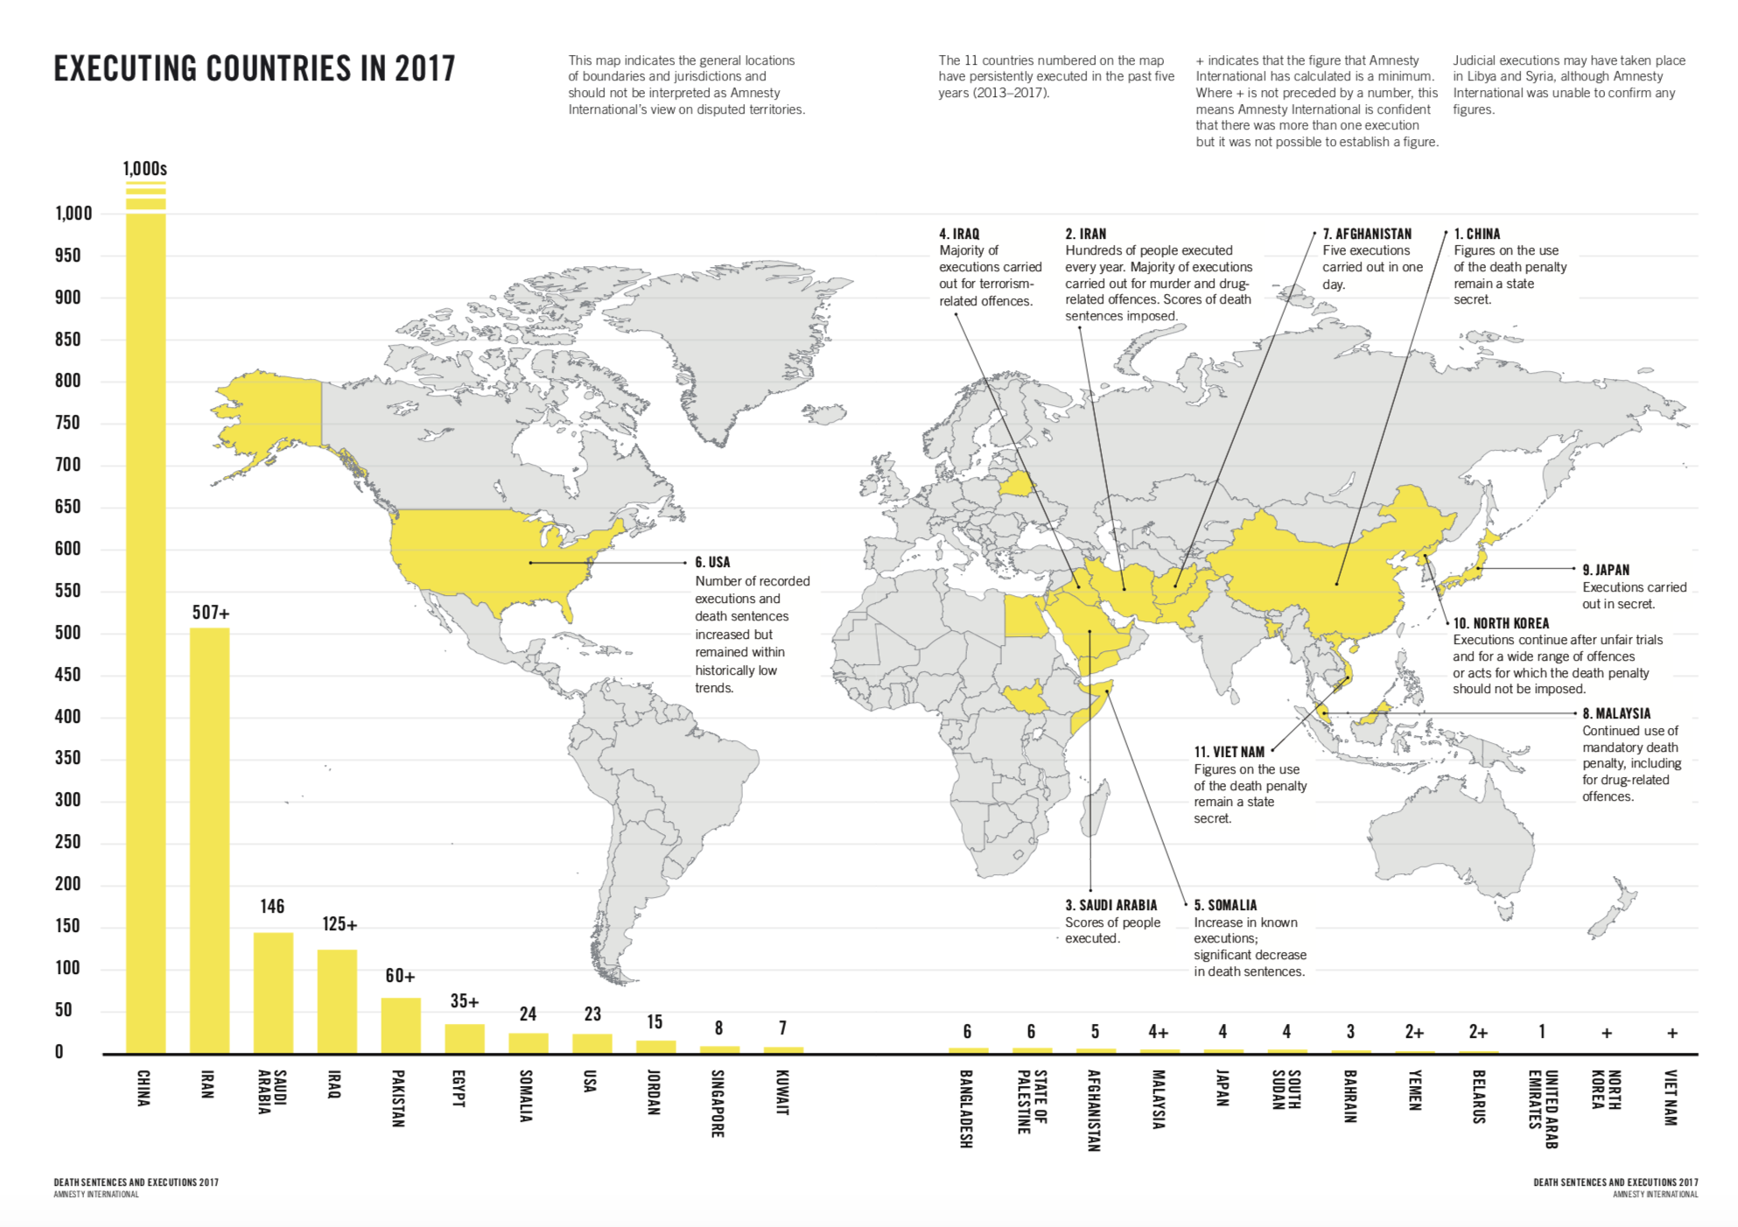

## Middle East

Middle Eastern countries mostly use the death penalty according to Sharia law which is religious law derived from the Quran and Hadith, two important writings in Islam. Those include punishments like beheading and stoning for certain crimes such as drug trafficking and homosexuality. Saudi Arabia executed 143 people during 2017. Iran carried out mass executions for terrorism.

## China

China still leads the world in executions per annum, though no official numbers are available due to the fact that those are a state secret in the People’s Republic. China enforces the death penalty, similar to other Asian nations such as Indonesia and Malaysia, mainly for murder and drug trafficking.

## USA

The United States of America has continued its downward trend in executions with 23 executions during 2013 with most of them being administered by lethal injection. The death penalty in the US is mostly handed down for aggravated murder.

## Austria

In Austria the last death sentence was executed in 1950 and 1968 the death penalty was removed from legal code entirely. There have been rare occurrences of individual politicians advocating for the reintroduction of the death penalty in Austria though those motions were quickly quashed by the politician’s respective party.

## Conclusion

The death penalty is sadly still fairly common today. The ever-decreasing number of executions makes us hope the death penalty might one day be universally abolished. This can be achieved by clearly separating religion from state matters and accepting the human right to life, an essential right as declared in the Universal Declaration of Human Rights and with those human dignity.

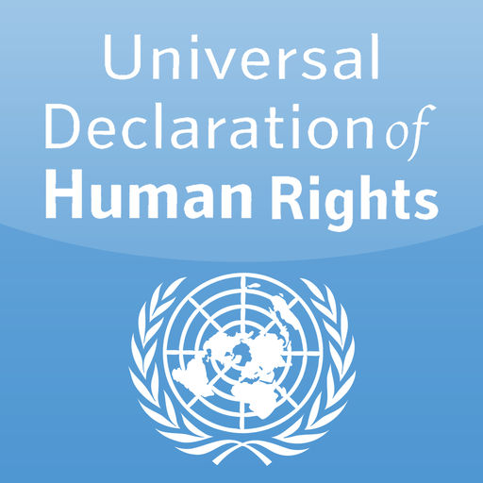

Source: https://www.amnesty.org/download/Documents/ACT5079552018ENGLISH.PDF