# India’s population crisis – and why it affects the world.

Daniel Zimmermann 5.1.2019

**Introduction:**

Many see India as a poor and underdeveloped country because of high poverty, high crime rates, low average income, low life expectancy and limited access to education among large demographics. However, in the last few decades the country has experienced a shift towards the better. The economy is thriving; a wealthy middle class is now able to travel and experience a ‘western’ lifestyle. As nice as this sounds, it causes numerous problems. The aim of this report is to examine these problems and state why and how the world is affected by them.

**Limited resources**

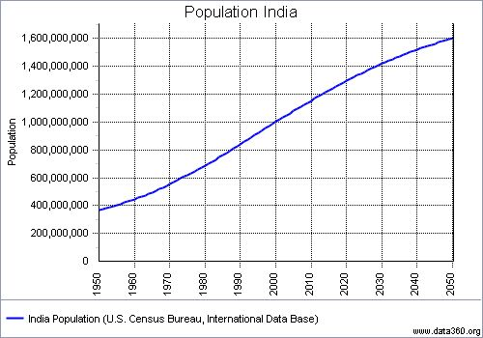India is now already the second most populated country in the world. Forecasts show that in the year of 2030 over 1.4 billion people are going to be of Indian origin. Providing food for such a huge population presents a very difficult problem, that no one has solved to this day. More than 800 million people who were living in India were considered poor in 2010. China once had a similar problem. Their population was growing too fast, the Communist party feared that it could not provide for the whole country and that if people felt betrayed by the government, protests could be the consequence. In order to solve their problem, they introduced the once child policy, allowing each couple to have one child. If a couple had more than one child, there would be a financial penalty. The Communist party even went so far as to say that people could lose their jobs if they had more than two offspring. This system was successful in so far as population growth was controlled, but it was not perfect and resulted in some such problems as mass abortion of female embryos causing an excess of male citizen that is still detectable to this day. This policy was made possible because there was one party in control. In India, this would not be possible, since it is a democracy.

**The middle class**

The Indian economy is booming. In the last 10 years India’s average GDP increase was never less than 6%. As the country itself is getting richer, citizens are, too. A middle class that was previously not present has established itself in India. People in this middle class can afford a variety of things, among those are e.g. cars, houses, holidays etc. And this is part of the problem. If more people can afford cars, more people will buy cars and so more people are driving cars and if more people drive cars, more carbon dioxide is emitted.

*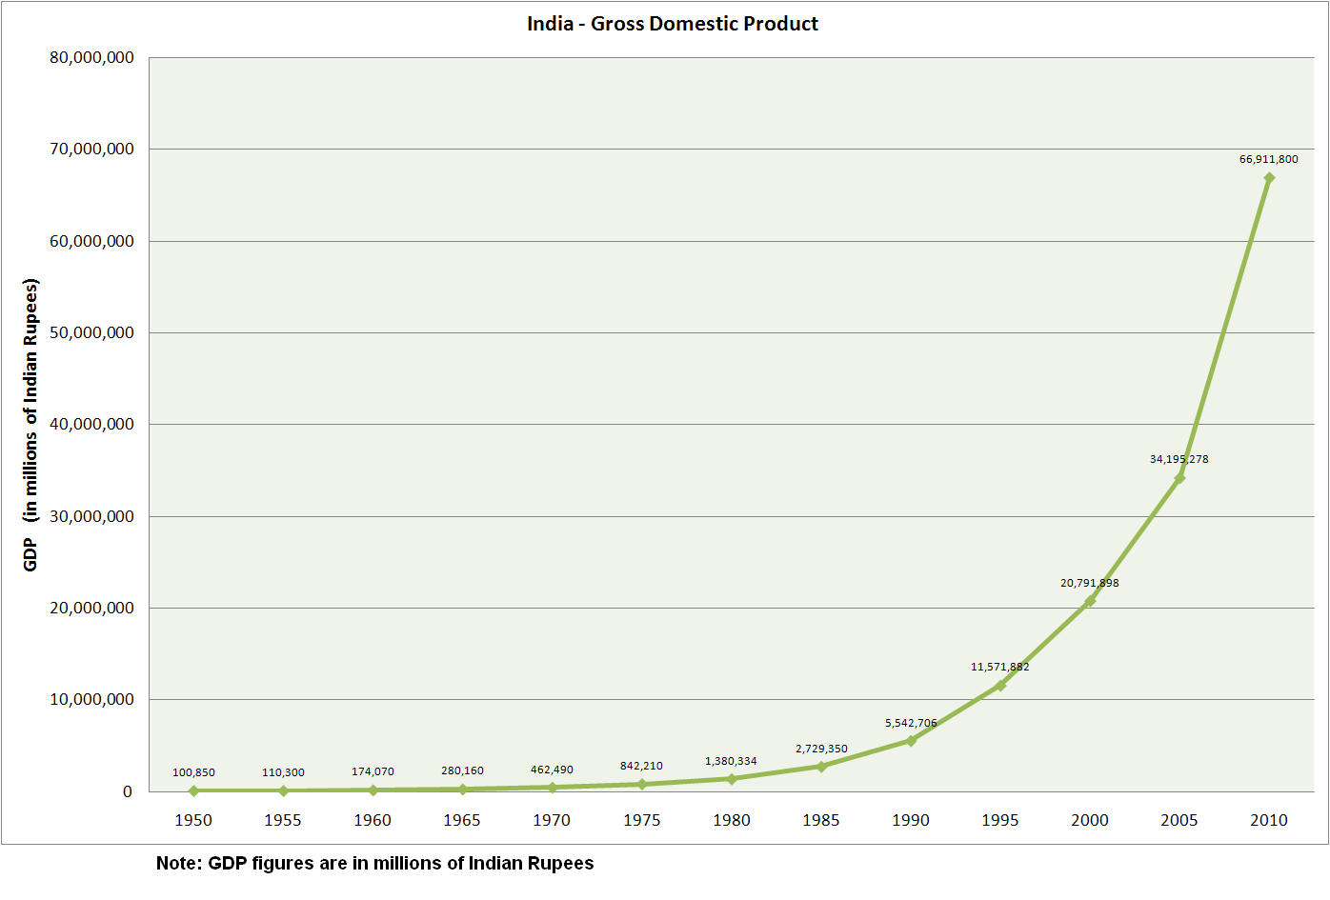Image source: Data by Ministry of Statistics and Programme Implementation, Government of India*

**With growth comes waste**

Early on in India’s economic expansion the government realised that their current energy supply would not be able to power big industries and mining cooperations. The logical decision would be to build power plants – and they did – in fact they built so many that the coal and gas power plants alone supply 56% of the country`s demands. The government also tried to introduce renewable energy sources like wind and hydropower, but since they are more complicated in terms of where to put them, they just decided to build more coal power plants. These old and inefficient power plants emit an unhealthy amount of carbon dioxide thus driving climate change.

As India is becoming wealthier, their problems start to look somewhat like the problems of western countries. The country has an overall bad infrastructure in rural areas and this presents a huge challenge in waste management. Recycling rates have to be improved, waste is still widely discarded of where convenient. Trash piles will eventually be burned and all the pollution of groundwater, farmland and air that comes with this practice contributes to local health problems.

What does affect the world is that there are no effective regulations in place regarding the disposal of toxic substances. Basically, companies try to build their production sites near rivers, so that it is easier for them to dispose of toxic substances. The government is well aware of this phenomenon but building up a solid legal network and ensuring effective monitoring will require enormous efforts. The absence of strict environmental standards is another reason why the economy is growing so fast. As more and more European, and even a few Asian countries, introduce strict laws regarding the disposal of toxic waste, India does no such thing. So, companies move their production to India, simply because producing there is cheaper.

**Conclusion**

The image that India had in the past is no longer authentic – with Bangalore, India has succeeded in setting up an Asian “Silicon Valley” which is a symbol of the progress achieved in the past decades. However, there is a very big gap between urban and rural areas in terms of poverty, crime and wealth. The country will continue to grow and the economy will continue to boom. Anyhow the country will not be able to maintain this rate of growth. India is going to have to put laws in place so that they may slow down the destruction of natural resources.