More Exercise = Better Student?

Physical exercise is one most important activities to put into your weekly routine. Many successful people such as Tim Cook, Mark Zuckerberg, Barack Obama and many more, all have exercise as a part of their weekly routine. For example Mark Cuban, Owner of the Dallas Mavericks and successful investor, does one hour of cardio five to six times a week. But you might say, “I’m a TGM student, I don’t have time to do that !”. It might be true that you have a tightly packed schedule, with four big exams next week, but it might be a good idea to take exercising more seriously, because without it, there will be a lot of benefits that you will miss out on. Everyone has probably heard the typical phrase, “Exercise helps you to lose weight”. Yeah, that might be true, but there are much more significant benefits than that. After finishing this article you will know two big benefits of exercise and a way to incorporate it into your own TGM-student`s routine.
So let’s start !

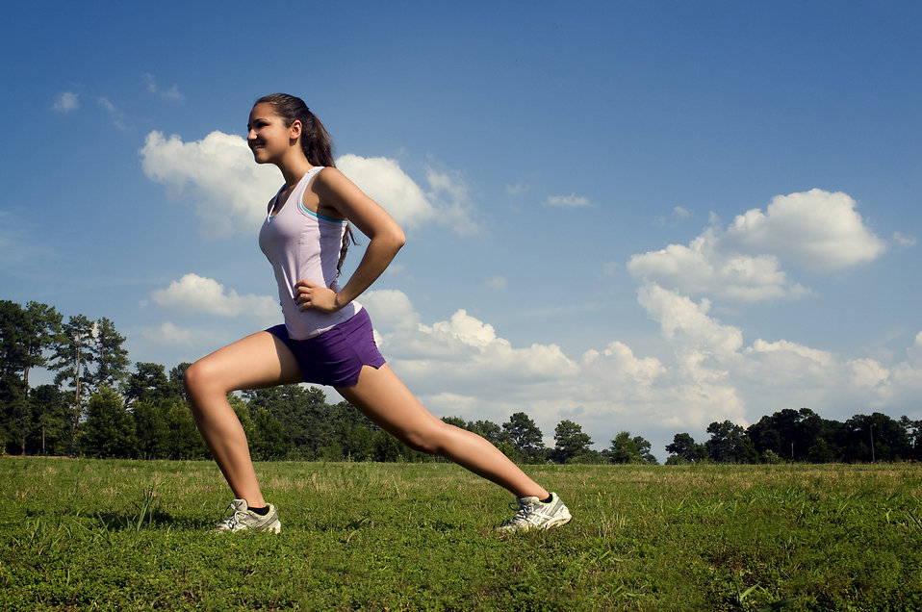

Physical Benefits
Weight control
Whether your goal is to look like Superman or to fit into the new jeans you bought, exercise can help achieve that. If your goal is to lose weight, you should burn more calories than you eat. But, if goal is to get buff like the Hulk, you should do exact opposite, by eating more calories than you consume. As you have probably noticed, it is all about calorie balancing and exercise is an essential part of that. There are a lot apps, like MyfitnessPal, that can help you track your calorie intake and help you get that dream body you have always wanted.
Increases your chances of a longer healthier life
Science has shown that physical activity can reduce the risk of strokes, diabetes and even some cancers. Studies have declared that the risk of breast cancer in women that exercise regularly is lower than in women that are not active. A lack of exercise and an unhealthy diet can cause high cholesterol, high blood pressure, obesity and high blood sugar levels, which can lead to a higher risk of diabetes Type 2. Now, while adolescents may feel healthy in spite of a high-risk lifestyle, they will feel the consequences in ten or twenty years and will not be able to turn back the clock.
Strengthening your bones and buscles
Activities like weight lifting or calisthenics, exercise involving only bodyweight, are not just a great way to gain muscles, but also a great way to keep your joints nice and healthy. They help with arthritis, a condition that causes inflammation of joints, or other joint conditions. Exercise can help you increase the density of your bones, which will reduce the risk of osteoporosis and even a hip fracture in your older age.

Mental Benefits
Beating depression and anxiety
Exercise is a scientifically proven mood booster, decreasing symptoms of both depression and anxiety. Even just a little bit of exercise can improve depression and anxiety, in general, so much so that some doctors recommend trying out an exercise regimen for these conditions before using medication. Working our regularly can also help reduce anxiety – and many students are anxious about a certain subject or even a teacher.

Better sleep
As TGM-Students we all know how exhausting schoolwork can be and that we are not even getting enough close to the recommended eight hours of sleep. The best thing we can do is to improve the quality of our sleep and that is, as you have probably guessed, exercise. Physical activity increases body temperature, which can have calming effects on the mind, enabling you to fall asleep faster and sleep more soundly.

Brain boost
Our brain needs a lot power, because of the amount of complex information students have to process, especially in Maths.
Exercise boosts brainpower in a number of ways. Studies on mice and humans show that cardiovascular exercise creates new brain cells ,a process called neurogenesis, and improves overall brain performance. Studies also indicate that physical activity boosts creativity and mental energy. So, if you feel mentally drained or you are just the in need of inspiration, it might be a good idea to go for a walk or jog.

But, how can I incorporate exercise into my own life?
It’s actually pretty easy. There are number of ways you can go about this. You can:
- Get a membership pass in your local gym

Membership in a gym is probably the best strategy to incorporate exercise into your life. You will be able to use the best equipment, you will be around likeminded people and since you are spending your own money, your motivation will be higher, because you will be wasting YOUR OWN money. Because you will be paying for something that you will not even use – powerful motivation, indeed.

- Go to calisthenics parks

Calisthenics is a form of exercise, which relies on using your body weight. For example pull ups or dips are great way to build strength. The thing about calisthenics is that it is free. You just need to look out for calisthenics parks in your area and there you go, you can workout. It is also a great introduction to doing weights in the gym, which is also a great way of burning calories.

- Or exercise at home
HIIT, or High Interval Training is an excellent way to not just build endurance, it is also a great way to burn calories. There are specific HIIT workouts for Endurance or Strength that go for five to fifteen minutes. It is a great way to start incorporating exercise into your life and saves a lot of time – ideal for students who have more than a full-time job at the TGM..

In conclusion, exercise is very important and it is something that you cannot ignore. There are a lot of benefits that come with it. We are not saying that you should hit the gym right away, we are just saying that you need to do something now: Get your body moving and do not hide behind your laptop all the time. Whether it is half an hour`s workout in the gym or a five-minute walk around the park, do something every day. Your body and your brain will thank you.

