# Should government control social media?

Is it legitimate for governments to have total control of what is allowed in social media or is it an infringement of free speech?

**Pros – Cons**

First of all, we need to find the motivation for possible control.

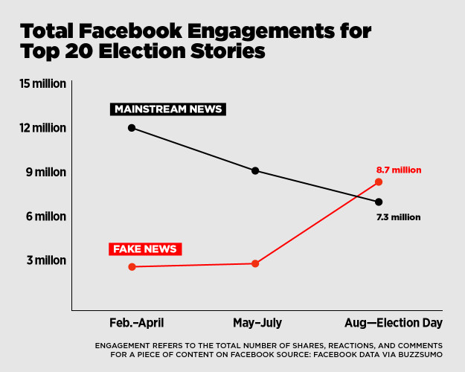Many want social networks to regulate their platforms themselves. But can this work: Facebook, Twitter and co. are already trying exactly that. It may work for obviously violent or hateful posts, but it doesn't seem to work for fake news.

Figure 1| vox.com

An important argument in favour of censoring fake news is that they can influence voters and thereby decide elections. It is possible that it has even already changed the outcome of some.

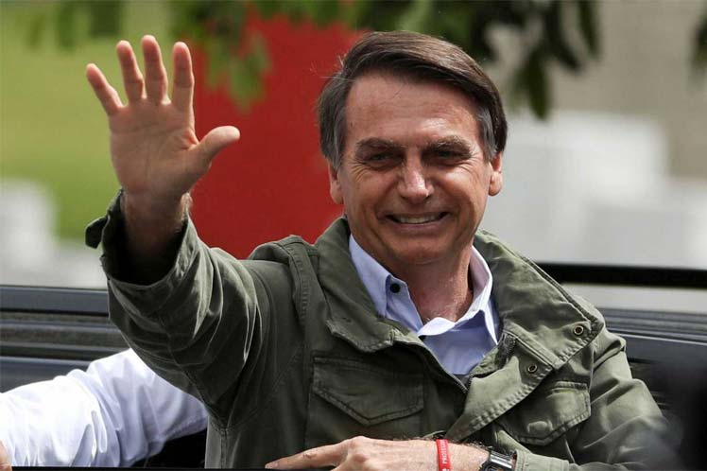But it is very difficult, if not impossible, to determine when something should be treated as fake news. Do half-truths, where important context was left out, fall under fake news? Do conspiracy theories that cannot be proven wrong count as that? What if the moderator who deletes the postings is not neutral on political issues?

Figure 2| Brazilian President-elect Jair Bolsonaro, accused of benefiting of false Information spread on Whatsapp.

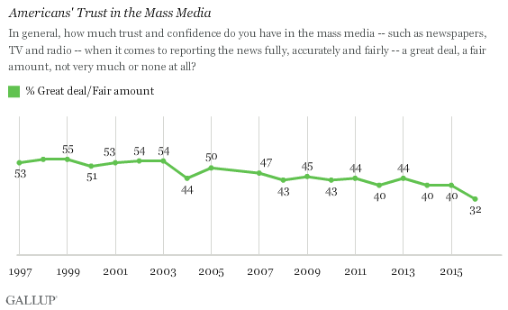

You could also tackle this issue otherwise. An important reason for the success of fake news is that trust in mass media is decreasing. As you can see in the graph, the confidence of Americans in media has declined to only 32% in 2016, the year of the last presidential election. A lot of people looked for other news sources, also on social media. Maybe mass mainstream media could try to restore the trust people once had.

Figure 3| Washington Post

**Should social media companies be held accountable for what their users post?**

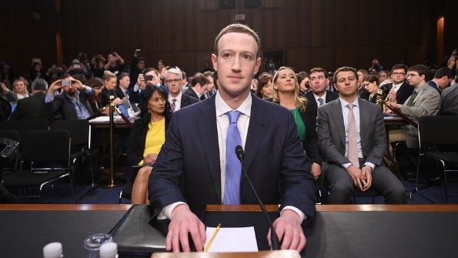In January, Facebook Twitter and YouTube testified before the American Senate, that means they were asked questions by senators to gather information on an issue. They were asked what steps they are taking to take terrorist propaganda offline. Facebook, Twitter and YouTube all have a “human review” team to review reported posts. At Facebook this review staff already counts 20.000 employees. Google also has a large review teams, but is also working on better algorithms for automatic reviewing of posts.

Figure 4| Mark Zuckerberg

This progress raises the question of whether it is still necessary for the government to review social networks. The companies also mostly claim to allow free speech like political matters, public affairs and personal expression, and only limit fraudulent speech (false statements) and violent speech, which are actually not protected by free speech. This is also the case in US-law. It looks like government involvement would be unnecessary here. Another problem is that there are different laws in different countries making something illegal in one country, which is legal in other countries, and could make it a lot more difficult for social media.