# Report - Voting Age and Voter Turnout

Liam Baumann 3BHIT

**Introduction**

The aim of this report is to compare the legal voting age and voter turnout of different democracies around the world, how it affects the outcome of elections and if lowering the voting age or introducing mandatory elections is beneficial.

**Voting age**

The voting age is the minimum age a person must be to become eligible to vote in a public election. This age is usually between 16 and 21, but in most countries it is 18. In Austria, people are allowed to vote from the age of 16 since 2007. This is an exception in Europe because practically all other countries on the continent have their voting age set to 18.

**Lowering the voting age**

In the last few decades many countries had debates on whether 16- and 17-year-old teenagers should also have the right to vote. Only a few countries changed their voting age recently, after these debates. These include Austria, Brazil and Scotland (only in local elections).

**Voter turnout**

Voter turnout is the percentage of legally allowed voters who cast a vote in an election. 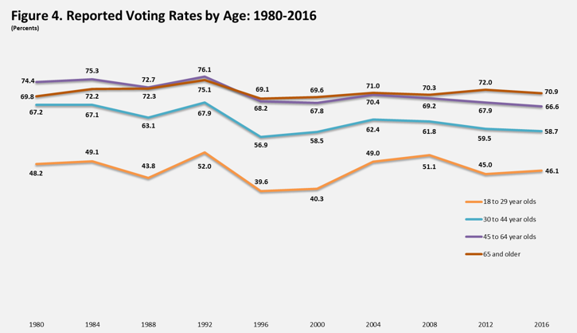

Fig. 1: Reported Voting Rates by Age in the USA ([www.census.gov](http://www.census.gov))

Around the world, young people have a lower voter turnout almost everywhere than older people. As seen in the graph, in the US this has not changed in the last 40 years. Less young people are interested in politics and more old people see it as their duty to vote.

**Compulsory voting**

We speak of compulsory voting when a country forces its citizens to participate in an election. In some countries you can end up with a non-voting fine for not showing up at the polls. Though compulsory voting increases voter turnout, making it easier for politicians to justify decisions based on elections, there are also many counter arguments. Some religious groups believe voting should either be a choice of the individual or even avoided. Denying them this right could be an infringement on religious freedom. Another reason why we should avoid compulsory voting is that typical non-voters, having no knowledge of the candidates, are now forced to choose one of them.

Compulsory voting however, will also motivates citizens not politically interested to inform themselves. However, many still boycott these laws. In Australia, a country with compulsory voting, at the federal election of 2013, 6% of voters left their ballots blank or filled it out in an invalid way. For comparison, in the Austrian National Elections of 2013, that number was only 1.9%.

Consequences of Compulsory Voting

A Swiss study found that compulsory voting increased the support for leftist parties, in some cases by up to 20% (M. Bechtel; 2015). One reason for this is simply that citizens at the bottom of the income spectrum are mobilized by compulsory voting, while proportionally supporting more leftist policies. Another reason could be that young people tend to have a lower voter turnout but a higher support for leftist ideas.

Conclusion

On the basis of the facts mentioned, it is hard to make any real conclusion about whether or not compulsory voting and lowering the voting age is beneficial. There are many arguments for and against both, but I would say it is most important to keep in mind that changes to the voting law will most often benefit one part of the political spectrum, so there will always be two large groups in favour or against these changes.

Resources:

Bechtel, Michael & Hangartner, Dominik & Schmid, Lukas. (2015). Does Compulsory Voting Increase Support for Leftist Policy?. American Journal of Political Science. 60. 10.1111/ajps.12224.

<https://www.parlament.gv.at/PAKT/PR/JAHR_2007/PK0439/index.shtml>

<https://www.aec.gov.au/FAQs/Voting_Australia.htm#not-vote>

<https://www.statista.com/chart/4424/how-does-the-voting-age-vary-worldwide/>

<https://www.census.gov/library/visualizations/2017/comm/voting-rates-age.html>

<https://en.wikipedia.org/wiki/Voting_age>

<https://www.theguardian.com/politics/2005/jul/04/voterapathy.uk>

<https://en.wikipedia.org/wiki/Compulsory_voting>