# Public and private healthcare

Is there a fair healthcare system? The common understanding of a healthcare system should be that it ensures everybody unlimited access, whenever help is needed. But is this really the case?

No, it is not, at least if you have a public healthcare plan. Some treatments are not covered, including some cosmetic surgery that does not present a severe health problem or treatment of mental illnesses. On the other hand, if you have a private insurance plan, you might pay considerable fees, but you will be guaranteed shorter waiting times and better service such as single room, which seems to be a key factor most of the times. For example, if you need eye surgery, which isn’t done because of an emergency, it can take up to a year to wait for the first appointment. However, if you have private insurance, it may be done within a month and this might well make up for the monthly fee.

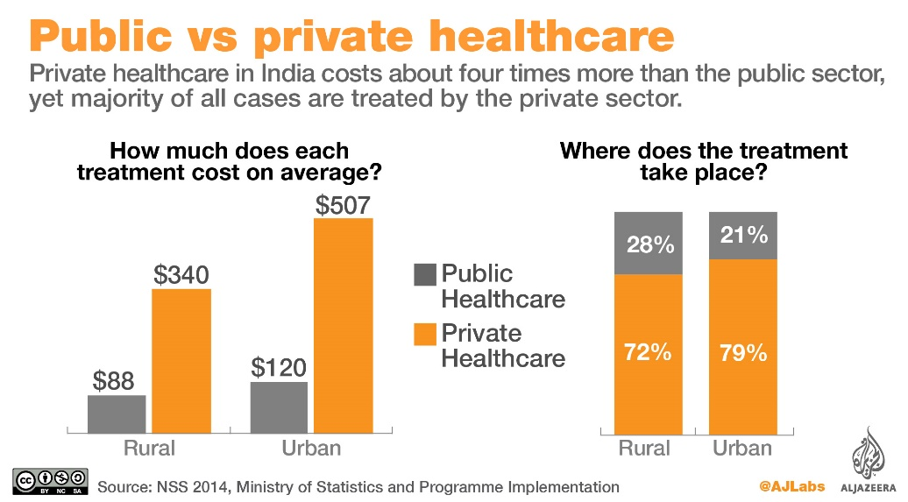  
The financial logic of private healthcare: Pivate businesses will maximise profits which will result in higher cost.

**How we do things in Austria**

In Austria the majority of people use the public healthcare system, because it is already paid for and deducted from your income with the taxes or there is a contract between a local health insurance provider and your employer. For the last ten years the trend has been to increasingly contract additional private insurance services as an upgrade to the public health insurance every citizen has. This means that you basically stay within the public system, but if you need a medical appointment earlier than this plan can offer you, you pay it out of your own pocket.

**Med school: Free acces or yet another business opportunity?**Another topic related to public healthcare are tuition fees for med school. If you compare Austria and the United States, you see that Austrian students pay only 363,36 Euros per term, while in the US students must take very large loans to afford medical studies. In the US it takes young doctors several years to pay back their loans.

All in all, we can say that Austria has a highly functional healthcare system, especially if you combine public and private plans. Unfortunately, there is a tendency towards strengthening the private tier which prioritizes wealthy over poor people.

Among the changes planned by the current government is uniting the different public healthcare insurance providers, a measure that the current government has already agreed upon. They also plan on adding fees for day clinics. It remains to be seen, how current changes will affect the Austrian healthcare system in the future.