## The role of the stock exchange in today’s economy

… and why one should know about it - Daniel Zimmermann

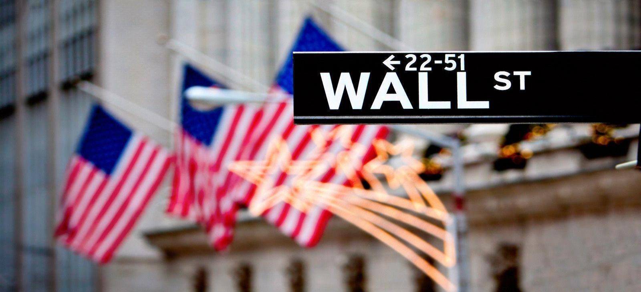

**Fast money?**

The stock exchange is often associated with easy and fast money. Especially in times of bitcoin and other less regulated forms of investment a lot of false information has been spread around the internet about how stock exchanges work and when one should buy which shares. It should be mentioned that various experts have concluded that bitcoin is probably the next bubble to burst. Among those is John Wasik, an international expert on investment and money protection and author of more than seventeen books. In an article published in Forbes he stated that he thought that bitcoin would fail because of its competition and because it is not accepted as currency in most countries. Nevertheless, the thought of “getting rich fast” motivates a lot of people to invest money into highly volatile cryptocurrencies just like bitcoin.

**So how do I get rich?**

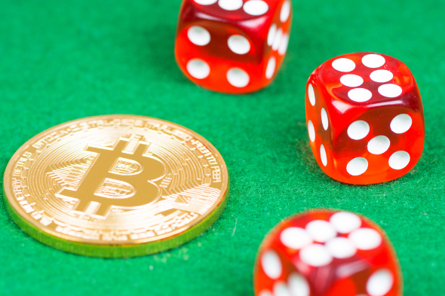A stock exchange is a place where companies sell parts of themselves called shares. Owners of these shares, the shareholders, can enforce their say in the decisions of the company. For example, they are able to vote members of the board and have the right to attend the general meeting of the company. The list goes on and on but is not relevant for understanding stock exchanges and is left out for the sake of simplicity. A company’s value and therefore the value of its shares usually changes multiple times in a day. Profit is made by buying some shares at a lower price and then selling them at a higher price. It should be mentioned that trading on the stock exchange is taxed whereas buying bitcoins and other shady cryptocurrencies is not. Regardless of the type of investment in the end it comes down to luck. Trading is in some ways quite like gambling and therefor the same rules apply: Do not gamble with money you cannot afford to lose.

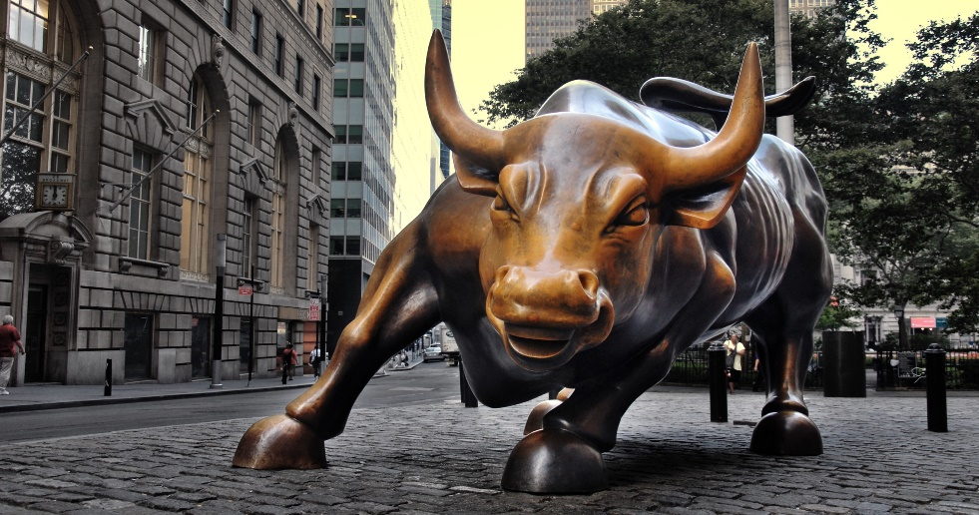

**What are potential risks?**

Trading is all about predicting trends. If a market is expected to rise or already rising it is usually called a bullish market. The opposite of a bullish market would be called a bearish market. Since the value of a share is ruled through supply and demand the general rule of thumb is that shares that are rare are expensive. A very nice example of this behaviour and furthermore the first stock market crash in history was the tulip crisis. Tulips were brought to the Netherlands from Turkey in the first half of the 17th century and quickly became one of the most valuable items that were sold on a daily basis. A tulip could simply be purchased by buying a piece of paper, a contract. The owner of a tulip rarely got to see the actual flower. The system was working just fine, but as tulips became more and more popular and because the amount of tulips was very limited, since cultivating them took a lot of time, prices skyrocketed in a matter of months to far more than ten times the original value. People bought and sold these contracts and made profits, until someday no one was willing to pay the price anymore. Immediately owners of a tulip wanted to cut their losses and so prices dropped back to the original value within a matter of days. The market was flooded with tulips, but there was no demand anymore.

During the tulip crisis, a small number of people, the ones who had sold at the right moment, got very rich but the by far larger number lost all their saving in the crash. There is a saying that goes: “If it is too good to be true it probably is” and this applies to most aspects of life, but especially stock market trading (see Bitcoin etc.).

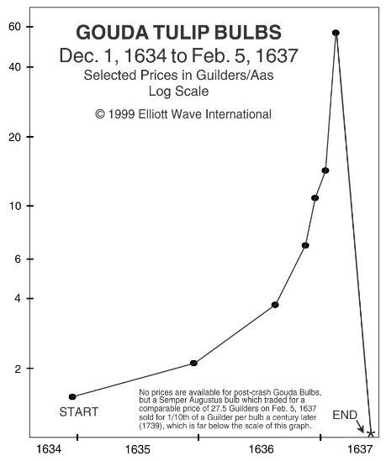

Obviously, in our digital age no one is buying a piece of paper anymore. Nearly every transaction is done remotely through the internet. The invention of computers in the second half of the 20th century has changed the trading game completely. Brokers were replaced with supercomputers which can make split-second decisions on whether to buy, hold or sell a share based on sophisticated algorithms.

**What will the future look like?**

The financial world has seen many ups and downs. People often thought that investing money into a company would be a safe way to protect it against inflation and even make a profit in the process. They did when the markets crashed in 2008 and they will do again when it comes to the next major crash. Alternative types of investments, for example cryptocurrencies, are also prone to this phenomenon. The magic way to make money simply does not exist. No matter the type of investment, be it in shares or real estate or bitcoin, there will always be highs and lows, there will always be a risk if one puts money into a system that is too complex, too complicated, for a single person to understand.

**Waiver**

Please note that this article does in no way provide sufficient knowledge for you to start your career as a trader. I am not a professional on the topic and therefor my advice should be enjoyed with extreme care. I do not guarantee that the information presented in this article is correct. Never invest money you cannot afford to lose. Always consult a professional before investing.

Sources:

<https://www.youtube.com/watch?v=F3QpgXBtDeo>

<https://www.youtube.com/watch?v=fn3y1hNVgA4>

<https://en.wikipedia.org/wiki/Tulip_mania>

<https://www.youtube.com/watch?v=l3t406oTmss>

<https://www.thebalance.com/stocks-4073971>

<https://www.investopedia.com/terms/i/ipo.asp>

<https://finance.zacks.com/stock-stocks-affect-economy-2233.html>

<https://www.economicshelp.org/blog/221/stock-market/how-does-the-stock-market-effect-the-economy-2/>