The Amazon empire

# Introduction

On the fifth of July 1994 Jeff Bezos started a book selling website called Amazon. Fast forward 24 years, and Amazon is the largest online retailer, with a huge selection and 97000 employees and an annual revenue of 61.09 billion US-Dollars. Amazon has over 200 million products on their website listed. Jeff Bezos is now in 2018 the richest man alive with approximately 150 Billion US-Dollars in Amazon stock shares.

# The beginning

Jeff Bezos was 30 years old and working on Wall Street when he saw the internet revolution take place. He quickly made the decision to quit his job and create an internet company selling products, but he did not know what to sell. He created a “top 20” list of things that he could sell online. He eventually set on selling books, because they are cheap and in worldwide demand.

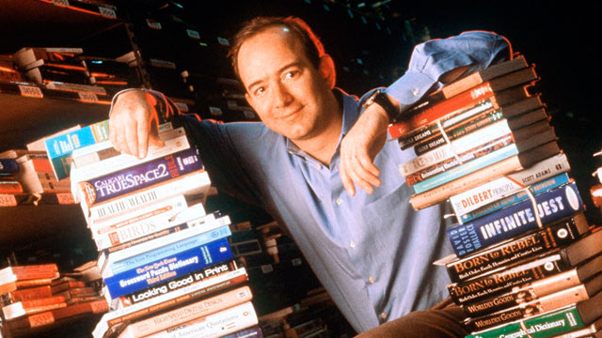

# Jeff Bezos´ funding

The first investment was not from a big company, but from his parents. They invested more than USD 300000, but they were not interested in

the company. The first question Jeff Bezos´ dad asked him was, “What is the internet?”. “They believed in me, not the company.”, said Jeff Bezos. After 3 years, Amazon went public with an IPO (initial public offering) of USD 18 per share.

# Jeff Bezos´ advice for starting a business

Jeff Bezos was determined to never give up, because it took Amazon some time to get third party seller business to work. Also, your company should have a long-term view, so that it will not get irrelevant after a few years.

# Amazon controversies

Like all online retailers, customers cannot try the goods before purchase. If you buy a product you can only rely on the experience of other customers. There is no guarantee of delivery for the actual product. Like in all online shops, shipping costs apply, which can be even more expensive than the product costs.

Amazon`s expansion is also very controversial. Amazon claims to create more jobs by investing in warehouses all around the globe, but what are the working conditions like? Looking back at the 2018 Axel Springer Awards ceremony, angry Amazon employees were protesting outside the building. And that was not the first time that Amazon workers protested. For example, in Germany (where strikes are possible), a multi-day strike for an increase of wage, resulted in delivery delays.

“Amazon destroys more jobs than it creates.”, states Forbes, a reputable online magazine. Most jobs in Amazon warehouses consist of packaging, delivery and sortation in part time and part benefit, say Amazon insiders.

Price pressure keeps getting bigger, as people like to spend less money on things. That is why it is like a cat and mouse game between sellers to sell things more cheaply. And when things are cheaper, Amazon will decrease wages or fire employees because they want to maximize profits. In the end, it’s an endless dilemma – as long as consumers are going after low prices that can only be offered if employees work under horrible working – and manufacturing conditions.

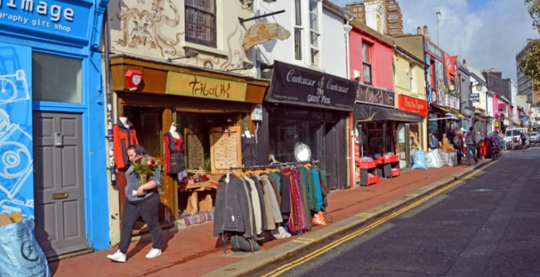

Small shops in Brighton

For towns and cities, the “death” of small businesses presents a huge problem. Retailers must close, because more people buy their things on Amazon, because its cheaper. High street will be deserted everywhere.

The 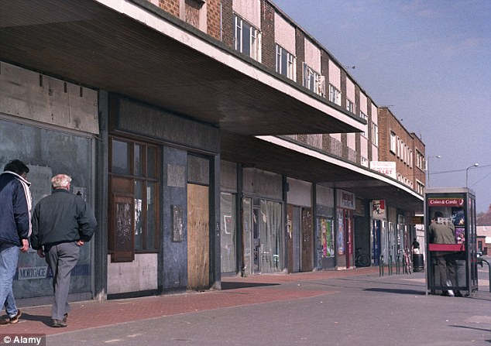

Closed stores in NYC due to Amazon

And that will result in massive unemployment, lack of individual advice and knowledge, loss of creativity and will ultimately result in formation of monopolies.

Unfortunately, it is a fact that professions in health care service or education, dealing with the future of people, are not getting paid adequately.

Amazon is part of globalization, which is an economic wave that is sweeping over the world, with influence on political decisions, for example regarding tax payments.

# Summary

In summary, Amazon is one of the fastest growing companies in 2018 with enormous gains in stock prices. And now with the title of the richest man in the world, Bezos invests his income in his own space agency and cancer research. his actions are still very controversial.

Resources:

<https://www.marketwatch.com/story/its-not-just-amazon-and-whole-foods-heres-jeff-bezos-enormous-empire-in-one-chart-2017-06-21>

<https://www.referralcandy.com/blog/jeff-bezos-quotes/>

<https://www.fundable.com/learn/startup-stories/amazon>

<https://www.forbes.com/sites/timworstall/2017/01/12/of-course-amazon-destroys-more-jobs-than-it-creates-thats-the-whole-darn-point/>