**The (dis-)advantages of e-shops**

*By DORIAN RAUSCHAN NOV. 05, 2018*

Online shops are getting more and more popular these days and from food to clothes they nearly offer everything. You can easily order from the comfort of your home and don’t have carry your purchases. This is why many people nowadays prefer e-shopping over local shopping. But is it possible that online shops will ever completely replace physical stores?

One of the main advantages is that the customer doesn’t have to leave the house for shopping. But not only that, on the internet you can buy stuff from all over the world. You are not limited to your national offer of goods. For example if Europeans want to buy a special candy which is only produced and sold in the USA, they do not have to travel to another continent just for buying this candy, instead they can easily order it on the internet and let it ship to their home.

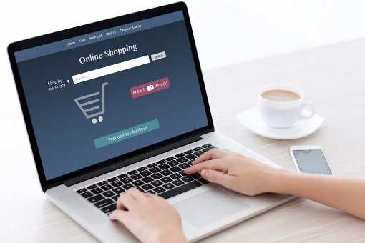With worldwide delivery, however, there comes the shipping, which is not just pretty expensive sometimes, but until your order arrives it could take some time, which brings us to the first disadvantage of e-shopping.

A major advantage of e-stores is that they never close their shops. You can order 365 days a year, 24 hours a day, while local stores are typically closed in the evenings and on Sundays and holidays.

Unfortunately, you cannot try your clothes on before buying it when ordering them online. There is a chance your clothes will not fit well, so you might have to send them back to the seller, which results in extra effort.

“Is it possible that online shops will ever completely replace physical stores?”

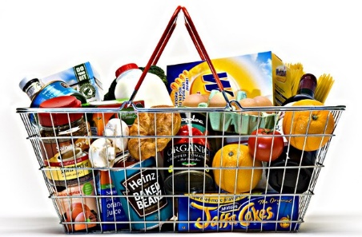At the moment e-shopping cannot **completely** replace local shops, especially when it comes to food. If you need something the same day, online shopping will not work for you in most cases, just because of the shipping time. It is to be expected that if technology advances and “same-day-shipping” is possible for every single product in every region, there is a chance that online shops will fully replace physical shops in the future – with a huge impact on our cities.

What do YOU prefer? Local shops or e-shops? [Click here to vote](https://www.strawpoll.me/17277398)!

Sources:

<https://www.nytimes.com/2010/08/26/education/26JOBS.html>

<https://www.doofinder.com/en/blog/physical-store-vs-online-shop-advantages-and-disadvantages>

<https://www.quora.com/Which-one-do-you-prefer-Shopping-online-or-purchasing-in-a-local-store?redirected_qid=4221018>