**How to protect security on the internet**

Everyone knows that there is danger on the Internet, but not everyone knows how to protect themselves from these dangers.

In 2013, Edward Snowden (picture on the right) revealed top secret data about US-American monitoring tools. His motivation was “I do not want to live in a world where everything I do and say is recorded”.

Would it bother you if everything you wrote were visible to all?

Would it bother you if all your private photos appeared on the internet?

Would it bother you if people could watch you through your webcam?

If your answer in one of the above situations is yes, then you should follow these rules:

# RULE 1 - SURFING

To surf the Internet, you can use a virtual machine, that will make it harder for attackers to hack your computer.

You can also use adblockers, they can protect you.

# RULE 2 - MAILS

Never open e-mail attachments if you do not know the sender.

Don’t click on links, if you don’t know they are trustworthy.

Content can be read relatively easily by strangers.

# C:\Users\Birgit\AppData\Local\Microsoft\Windows\INetCache\Content.MSO\D82586BE.tmpRULE 3 - PASSWORDS

Minimum length: 12 symbols

Character types: capital letters, lower case letters, numbers and special characters

Also, password managers which can be found on the Internet or in any App Store, can be very helpful.   
Tip by Ed Snowden: Use sentences that include a number and a special character and tell a story that you remember easily like “*Mrs Thatcher is 99% human*.”

# RULE 4 - UPDATES

If you install the updates, they will fix bugs, your computer or phone will become more secure.

**RULE 5 - SOFTWARE**

Illegally modified versions of paid software are dangerous.

Software should only be downloaded from the original manufacturer's site.

# RULE 6 - FIREWALL

Always use a firewall on your computer and preferably one on your DSL router.

Two firewalls on a computer usually make no sense.

# C:\Users\Birgit\AppData\Local\Microsoft\Windows\INetCache\Content.MSO\981645DD.tmpRULE 7 - VIRUS

Install only professional software, paid versions may offer more security than free programs.

Keep the programs up to date, otherwise they will not provide protection.

Some good Virus-protection programs are Kaspersky, Avast or McAfee.

**RULE 8 - SECURE WI-FI**

Turn on Wi-Fi only when needed.

Minimum length of the Wi-Fi password: 20 symbols (Rule 4)

WPA2 is a safety standard that has been used on all certified Wi-Fi hardware since 2006. It is based on the IEEE 802.11i technology standard for data encryption.

# RULE 9 - NO ADMIN

Do not surf in the Internet with admin rights, they make it easy to hack your computer. If you only have user rights, attacks are made more difficult.

To avoid this problem, you could make a new user without admin rights. For that you should click on the Windows symbol and on settings. Now you can choose accounts, on this site you have the option ‘family and other persons’, click the one you like. On the new window you must choose ‘I didn’t have this person’s sign-in information ‘.

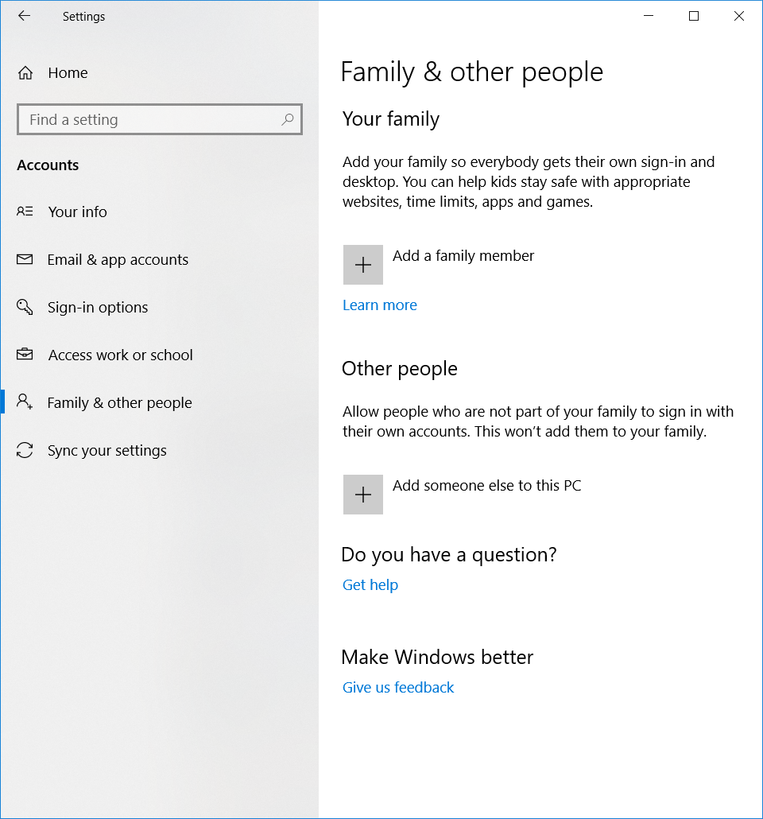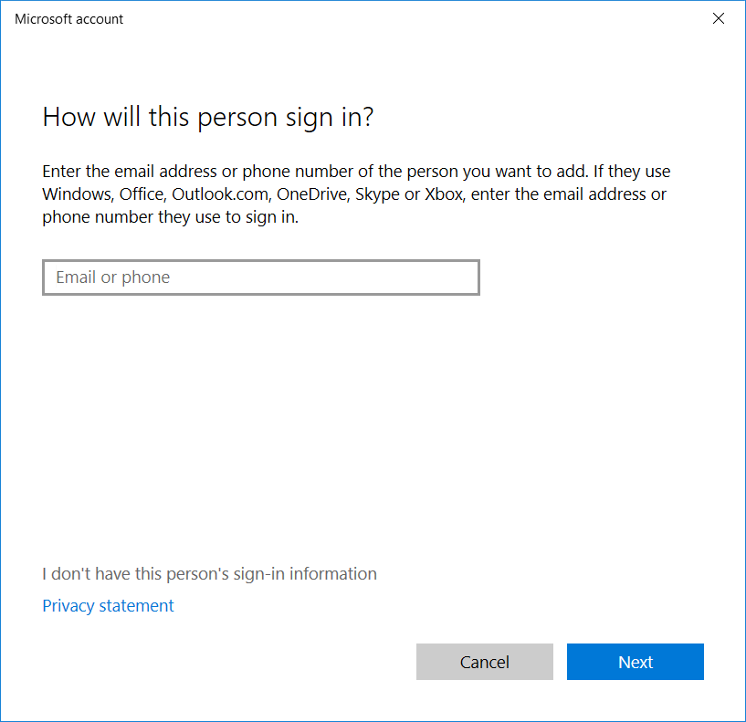

Now you choose ‘without Microsoft account’. After the chosen password and account name you finished and have an account without admin rights.

# RULE 10 - “Less is more”

"Less is more" - publish as little personal information as possible.

Be suspicious and never send intimate photos of yourself.

If following these 10 rules, surfing the internet is almost secure. Follow them and you have nothing to fear.

**SHARE YOUR EXPERIENCES**

Recommend any good products you have been using from anti-virus software to encryption software. Tell us why you think they’re good. Send your comments to bmayer@student.tgm.ac.at

Sources:

<https://thenextweb.com/insider/2015/08/18/7-ways-to-protect-your-privacy-on-the-internet/>

<https://www.forbes.com/sites/quora/2018/05/07/what-can-you-do-to-protect-your-data-online/#1ed5156e68e2>

<https://www.forbes.com/sites/nextavenue/2013/01/22/7-steps-to-protect-your-online-security/#1575160d2aa6>

<https://www.safervpn.com/blog/what-is-internet-security/>

<https://www.infosec.gov.hk/english/genuser/data.html>

<https://www.theguardian.com/technology/2013/sep/16/10-ways-keep-personal-data-safe>

<http://www.who.int/goe/publications/goe_security_web.pdf>