***Smart Homes:* Modern helpers or monitoring devices?**

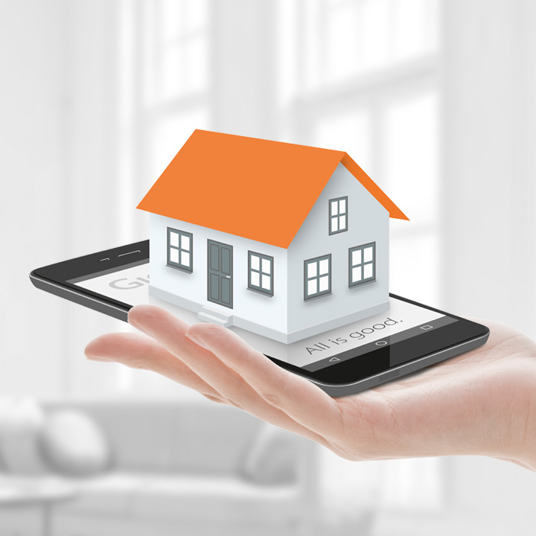Alexa, Google Home and Apple`s Home Pod – it seems tech companies launch yet another smart and highly intelligent assistant for your home every month – and people seem to love them. More than 60 % of Britons have smart home devices in their homes. But the question is: Do these systems help us to secure our homes or do they help the government to observe the people?

Smart homes can help you to control all “smart” devices of your house or flat. But what is “SMART” exactly? Today`s smart homes are quite intelligent, in the future, however, devices will be collecting data and trying to take decisions based on that input. If you have ever searched for something on “amazon.com”, then you will see advertisements for these or similar in your browser for some time. Businesses use data-based algorithms to target consumers with tailor-made ads based on the consumer`s specific interest and needs.

With a smart thermostat you will be able to control the heating, also when you are not at home. The problem is that most of those smart home appliances out there do not have a password and could also be accessed by third parties. There are more and more “hackers” out there, who can enter the functions easily. If you own a smart device, then I would recommend you think about the safety of these devices again.

One of the most widely used technologies is Amazon’s Alexa, which is a speaker that can talk to and interact with you. With the command “Alexa, turn on the music”, you can play some music from your music service like “Spotify” or “Deezer”. It is a smart speaker, which can follow instructions that can access systems by connecting you to services.

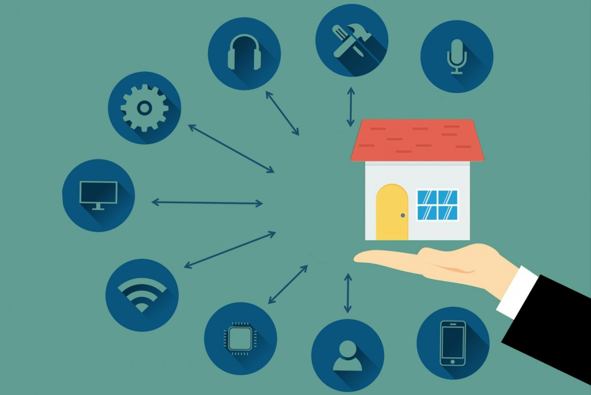Inviting big business into your homes  
 The disconcerting fact is that the speaker will be listening to all that you are saying as soon as it is on. Amazon’s Speaker has to answer and start recording when the following four words “Alexa”, “Computer”, “Amazon” and “Echo” are uttered. Researchers have found out that Alexa will also start acting when synonyms like “Alexander” or “Amazonas” are used and the results might not be the desired ones at all.

In most cases, smart home technology may assist you with a number of basic tasks. However, if you have one of those Smart Home devices, you shall take care of your privacy.

Sources

<https://www.theguardian.com/technology/smart-homes>