# Do AIs deserve their own rights?

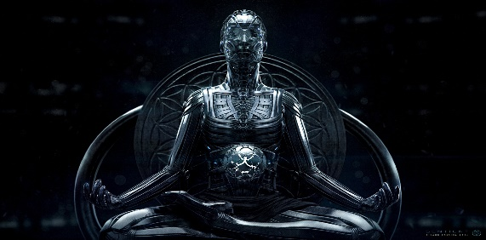As Artificial Intelligence is becoming widely used in everyday applications and development is expected to be teadily advancing over the coming years, questions begin to pop up. Could AIs be compared to humans in the future? Are they better than us? And finally, do they deserve rights?

## Animals and sentience

Before we start with the actual philosophy of what being a human means, let`s talk about animals. Animal rights are seen very differently around the world, especially when it comes to our beloved meat. Speciesism describes the philosophy that animals should no longer be viewed as property to be owned. It is very controversial since so many people around the world keep pets. They would defend their right to live, since they love and care for them. Livestock can be killed for our food though, just because we do not share our homes?

Animal philosophers say that all animals are entitled to the possession of their own lives and have the right to avoid suffering if they are sentient. A sentient being in law is described as a being that can experience pain and pleasure on both physical and psychological levels. It must also be able to perceive, reason and think. And as of now we know that every animal is capable of meeting these requirements, even fish.

AIs are seen similar to pets, we keep them, but we also created them. Therefore, we see no reason to give them their rights, especially the right to possess their own lives. Also, we do not know if they experience feelings as we do. Current AIs are on the level of “general”, this means that they can execute tasks like problem solving or reasoning. The next level would be “Super AI”, they will then be able to experience and reciprocate feelings.   
AIs have already come far and will advance more in the future, one thing is still missing though, for them to be sentient: The ability to feel pain.

## The Zombie argument

It says that something can behave like a human but does not experience things like us, therefore making them possibly non-sentient. For example, it comes in too close contact with fire and burns itself. It will not feel pain but has learned how to act like a human in these situations and scream or cry. This is something advanced AIs would be able to learn very fast. Artificial Intelligences could therefore easily trick us into thinking they are actually sentient.

## The Turing Test

The test was created in 1950 by Alan Turing. It was made to see if an Artificial Intelligence can pass as a human. Two humans and an AI are needed for this test. It will solely be executed through computers without the two humans being able to see each other or communicate directly. One of the human testers will ask the AI and the other human questions through a computer.   
The AI is allowed to lie, so as to not be distinguished as the AI. The other human has to do everything possible to tell the interviewer that he is the human. If the AI cannot be differentiated from the human often enough, the AI has passed the Turing Test. However, there is no specification of how often it has to succeed in order to pass.  
So far only a few AIs have passed the Turing test, though no experience of feelings in machines has been proven.

And as long as this remains the case, and they do not suddenly become sentient and feel pain, there is no reason for them to have their own rights, at least by law’s definitions. But maybe AIs will be able to deceive us into thinking they feel pain? And then the real discussion if they deserve their own rights will begin.