# **Humans, the multiplanetary species: Sci-fi or reality?**

## Are Sci-fi movies totally wrong?

Overall, unfortunately yes. We are most likely not able to achieve a hyper-futuristic world such as in “Star Trek” within our lifetimes, though the foundation stones have already been laid by the tremendous technological possibilities that we already have. Some say we must become a multi-planetary species, otherwise we will become extinct as the dinosaurs did. Many fear that we are one giant disaster away from the end of our species, and the only thing that can prevent us from extinction due to a giant disaster on earth is expanding onto other planets and populating another planet. The most famous company specializing on space programs this large is SpaceX.

## What is SpaceX?

Founded by Elon Musk, SpaceX is the most futuristic private company when it comes to modern space program matters. Elon Musk expects to have tens of thousands of people living in a city-like colony on Mars by the year of 2040. SpaceX predicts human beings to have constructed a high-tech million human civilization on Mars within the next 100 years. Humanity is eventually about to be catching up with the all Sci-fi movies. What makes SpaceX so interesting is the exotic and unusual way they use their rockets. NASA lets their rockets crash into the ocean. Therefore they are not reusable, leading to their space program being very expensive. SpaceX on the other hand is very innovative: They land their rockets on a swimming platform or even at land. Therefore they save up a lot of money, which they can invest again in their space program in order to further advance their technology. 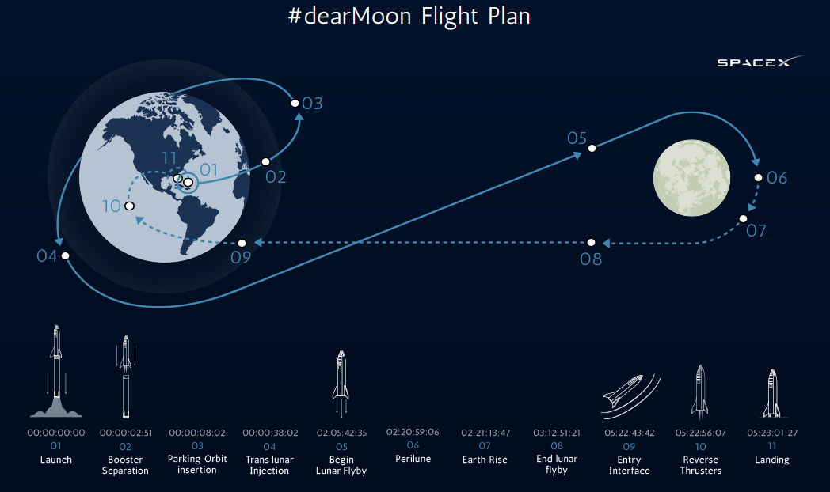

## Commercial Space

SpaceX is also planning to provide commercial rocket flights in outer space within the next few decades. The first evidence of such progress is presented by one of their newest projects: “Dear Moon”, where 10 Artist fly around the moon. This project is scheduled to take place in 2023, and it is planned to take less than a week.

**an article by Michael Scholz 3Ahit** src: futurism.com/ & dearmoon.earth/

**Comment by the editor:**

While fans celebrate Musk`s visions, there are many who question his motives: Is this another billionaire`s crazy dream? Do the super-rich plan to create an escape for the chosen few – like Musk`s idea of a colony on Mars or indeed, Jeff Bezos` dreams of eternal youth? Silicon Valley is full of wealthy people investing millions and billions in projects defying laws and limitations that apply to the common people. Psychiatrists may want to talk about grandeur and hybris. As to thethe Mars project: How do you feel the settlers should be chosen? Money? Fitness? Science expertise? Social skills? Or simply luck?