**Artificial Intelligence**

# Introduction

What is Artificial Intelligence, machine learning and robotics? The aim of this report is to give insights into these modern technologies and is focusing on basic to more specific facts and figures to that topic.

# The two big parts

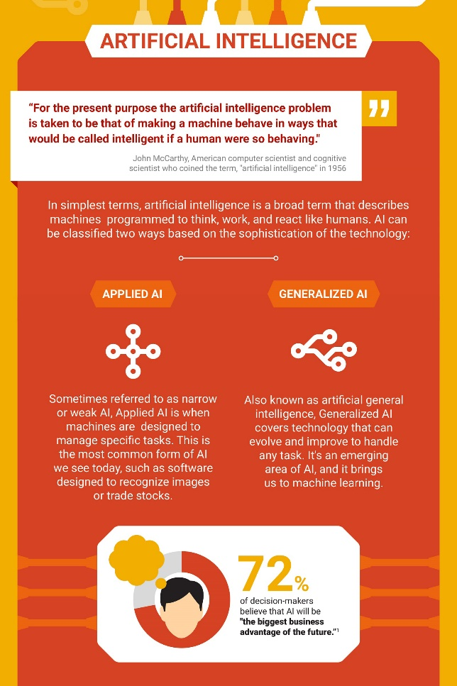  
Most of the people that know something about artificial intelligence often consider them as working robots that can handle their given tasks, but that is not always the case. One must split artificial intelligence into two main parts. There is the “Applied artificial intelligence” that defines machines and other devices that can handle – most of the time just one – specific task. They were applied with code that cannot expand in intelligence and efficiency. This is the bigger part of artificial intelligences on the market.

Coming to the more interesting part. It is called “Artificial general intelligence”. This area includes machine learning, or even more specific deep learning. Devices and machines this kind of intelligence are trying to improve in their tasks they were given. They are supposed to handle every type of tasks like human would.

# Machine learning

As one may read above, improving the intelligence of machines is a part of the artificial general intelligence that covers the machine learning part.

Machine learning is the way that machines learn from task they handle. Many of these machines are just improving by their mistakes. Deep learning is the way to handle tasks by using an artificial neural network. It should act like the human’s brain that uses a natural neural network.

An example provided by Google is their own machine-based dog that is using an artificial intelligence to act like a brain of a dog would. This machine was not able to walk until it saw another dog walking on its legs.

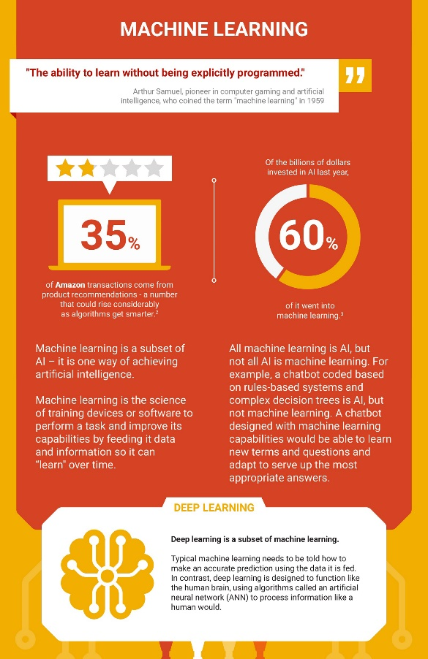The improvement of artificial intelligences is a lot faster and more efficient than a natural intelligence. Humans need years to speak fluent. A well programmed and designed artificial general intelligence that just listened to humans and recognized their actions learnt that in a much shorter time span.

# Robotics

In case of artificial intelligences that interact like a human, robotics just come right. Robots can be built to look like a human as one may see in Star Wars movies. For example, C3-PO is capable of translation, human interactions and many more interesting abilities, which can be used to make the life easier. There is no robot yet that can handle the tasks mentioned. Fortunately, the world is about to find out how to do something similar. 