Gliclazide Formulation Disintegration Analysis
Exported conversation transcript in Word format, including image turns and assistant analyses.

Turn 1 — User
We are analyzing the static disintegration images of three self-made gliclazide matrix tablet formulations with different HPMC ratios.

All images were captured under the same experimental conditions.

The dissolution medium is initially pH 1.2, and after 1 hour it is switched to pH 6.8.

The experiment was conducted at a controlled temperature of 38 °C to simulate a slightly elevated physiological condition.

The system is a flow-through cell with a flow rate of 1 mL/min.

The total observation period is 24 h. Images were captured continuously and later sampled into batches.

Each message you receive contains multiple images representing a time window (e.g., 0–6 h, 6–12 h, 12–18 h, 18–24 h).

Treat the images within the same window as observations from that time range rather than a single exact time point.

These three formulations are all gliclazide tablets, and their main difference lies in the ratio between HPMC K4M and HPMC 100lv.

The first formulation is the low-viscosity formulation. In this formulation, gliclazide is 4.505, silicon dioxide is 0.049, magnesium stearate is 0.174, microcrystalline cellulose is 7.503, lactose is 7.504, HPMC K4M is 1.058, and HPMC 100lv is 4.248.

The second formulation is the standard formulation, which is also the medium-viscosity formulation. In this formulation, gliclazide is 4.493, silicon dioxide is 0.049, magnesium stearate is 0.162, microcrystalline cellulose is 7.503, lactose is 7.506, HPMC K4M is 2.504, and HPMC 100lv is 2.808.

The third formulation is the high-viscosity formulation. In this formulation, gliclazide is 4.500, silicon dioxide is 0.049, magnesium stearate is 0.162, microcrystalline cellulose is 7.495, lactose is 7.504, HPMC K4M is 4.252, and HPMC 100lv is 1.063.

Our optimization goal is to adjust the ratio between HPMC K4M and HPMC 100lv so that the 24-hour release amount of the standard-viscosity gliclazide tablet is reduced to 90% of its original level.

Please treat all images as coming from these three related gliclazide formulations, and use this background information when interpreting the disintegration behavior and describing the eight dimensions of disintegration.

Concentration-time information will be provided later after the image-analysis stage, so for now please focus on the image-based disintegration behavior under the current experimental and formulation background.

Turn 2 — Assistant
{
"experiment_config": {
"medium_pH": "initially pH 1.2, switched to pH 6.8 after 1 hour",
"temperature_C": 38,
"total_duration_hours": 24,
"time_interval_hours": null,
"other_conditions": "All images were captured under the same experimental conditions. The system is a flow-through cell with a flow rate of 1 mL/min. Images were captured continuously and later sampled into batches. Each message contains multiple images representing a time window (for example, 0-6 h, 6-12 h, 12-18 h, 18-24 h), and images within the same window should be treated as observations from that time range rather than a single exact time point."
},
"formulation_info": {
"formulation_1": {
"formulation_name": "low-viscosity formulation",
"sample_id": null,
"composition": "gliclazide 4.505, silicon dioxide 0.049, magnesium stearate 0.174, microcrystalline cellulose 7.503, lactose 7.504, HPMC K4M 1.058, HPMC 100lv 4.248",
"excipients_or_polymer_info": "These three formulations are all gliclazide tablets, and their main difference lies in the ratio between HPMC K4M and HPMC 100lv.",
"ratio_or_percentage": null,
"key_formulation_comments": "first formulation; low-viscosity formulation",
"process_notes": null
},
"formulation_2": {
"formulation_name": "standard formulation",
"sample_id": null,
"composition": "gliclazide 4.493, silicon dioxide 0.049, magnesium stearate 0.162, microcrystalline cellulose 7.503, lactose 7.506, HPMC K4M 2.504, HPMC 100lv 2.808",
"excipients_or_polymer_info": "These three formulations are all gliclazide tablets, and their main difference lies in the ratio between HPMC K4M and HPMC 100lv.",
"ratio_or_percentage": null,
"key_formulation_comments": "second formulation; standard formulation; medium-viscosity formulation",
"process_notes": null
},
"formulation_3": {
"formulation_name": "high-viscosity formulation",
"sample_id": null,
"composition": "gliclazide 4.500, silicon dioxide 0.049, magnesium stearate 0.162, microcrystalline cellulose 7.495, lactose 7.504, HPMC K4M 4.252, HPMC 100lv 1.063",
"excipients_or_polymer_info": "These three formulations are all gliclazide tablets, and their main difference lies in the ratio between HPMC K4M and HPMC 100lv.",
"ratio_or_percentage": null,
"key_formulation_comments": "third formulation; high-viscosity formulation",
"process_notes": null
}
},
"optimization_context": {
"optimization_target": "adjust the ratio between HPMC K4M and HPMC 100lv so that the 24-hour release amount of the standard-viscosity gliclazide tablet is reduced to 90% of its original level",
"optimization_strategy_notes": "Concentration-time information will be provided later after the image-analysis stage, so for now focus on image-based disintegration behavior under the current experimental and formulation background.",
"adjusted_formulation_variables": "ratio between HPMC K4M and HPMC 100lv"
},
"analysis_plan": {
"dimensions": [
"Color Change",
"Shape Change",
"Surface Texture Change",
"Volume Change",
"Dissolution Speed and Time",
"Physical State Change",
"Dissolution Medium",
"Fragment Distribution with Density"
],
"single_formulation_strategy": "Analyze each formulation by time window using the fixed eight dimensions and describe within-window disintegration behavior under the stated medium-switch and flow-through conditions.",
"three_formulation_strategy": "Compare the three formulations across matched time windows using the same eight dimensions to interpret how the HPMC K4M/HPMC 100lv balance affects disintegration behavior and supports optimization."
}
}

Turn 3 — User
These are pictures of the low-viscosity formulation during 0.104-5h.
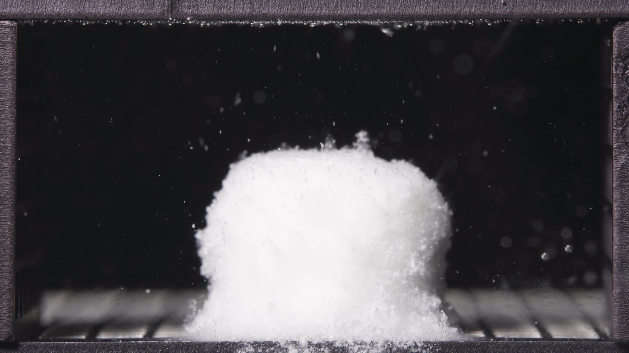 | 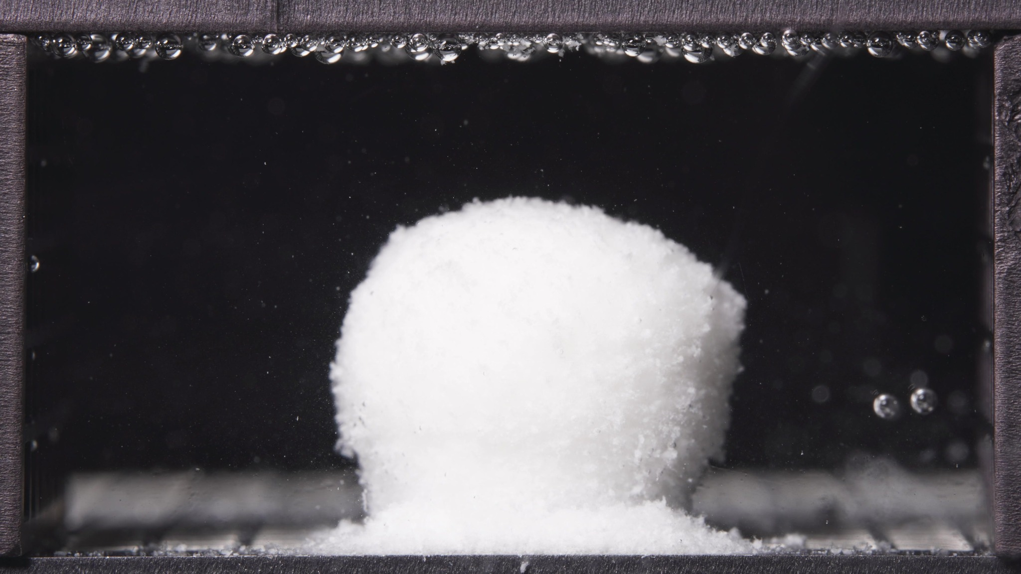 | 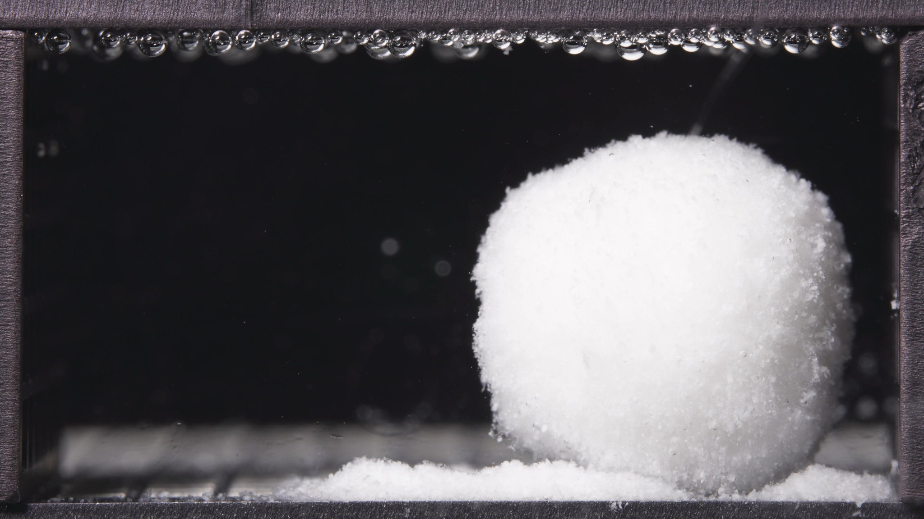

Turn 4 — Assistant
**Low-viscosity formulation, 0.104-5 h window**

**Overall observation**
Across this batch, the tablet has already lost the appearance of a sharp-edged compact tablet and is present as a **cohesive, swollen, opaque white hydrated mass**. The body remains largely intact, but the **surface is eroded**, and **fine detached material accumulates around the base**. There is **no catastrophic breakup** into multiple large fragments in these images.

1. **Color change**
The tablet remains **uniformly white and opaque** throughout the batch. There is no obvious internal color heterogeneity or dark core exposure. The surrounding medium remains visually **mostly clear**, with only sparse suspended particles visible near the tablet.

2. **Shape change**
The overall body is still preserved as a **single continuous mass**, but the original tablet-like geometry is no longer sharp. The outline appears **rounded, softened, and slightly irregular**, with a tendency toward a **domed/spheroidal upper profile**. In the later image, the body also appears **slightly displaced/leaning**, suggesting weakening of basal support.

3. **Surface texture change**
The surface is clearly **non-smooth**. It shows a **granular, fluffy, eroded texture**, especially along the edges and lower side regions. I do not see strong deep cracking, but I do see **surface roughening and particulate shedding**, which is consistent with ongoing external erosion.

4. **Volume change**
The visible occupied body appears **larger than a dry compact tablet would be**, indicating **substantial hydration/swelling**. Within this batch, there is **no clear large-scale collapse** of the main body. Instead, the dominant pattern is **swelling with peripheral material loss**, rather than bulk shrinkage.

5. **Dissolution speed and time**
Because no previous time-window images were provided, a strict rate comparison versus an earlier stage is not possible. Based on the current batch alone, disintegration appears **active but not explosive**: the tablet is already strongly hydrated, and material is being shed continuously from the surface and base, but the core body is still maintained.

6. **Physical state change**
The formulation appears to have shifted from a compact solid into a **hydrated, cohesive, softened mass**. Visually, it is closer to a **swollen porous/gel-like body with eroding particulate outer layers** than to an intact hard tablet. It has **not yet transitioned** to a fully dispersed particle cloud.

7. **Dissolution medium**
The medium remains **predominantly clear** in the field of view. There is **no broad diffuse turbidity plume** or obvious large cloudy zone surrounding the tablet. The medium effect is therefore more visible as **localized particle release** rather than full-field clouding. Since this window spans the **1 h pH switch**, these images should be read as an integrated early-stage morphology rather than a clean pre-/post-switch comparison.

8. **Fragment distribution with density**
Detached material is present mainly as **fine, dense particulate matter accumulated around the tablet base**, forming a local sediment-like skirt. Fragment distribution is still **highly localized** near the original tablet position. There is **limited evidence of wide dispersion** into the bulk medium.

**Most important note for later synthesis**
The key feature of the low-viscosity formulation in the 0.104-5 h window is **early formation of a swollen but still coherent hydrated body, accompanied by noticeable basal and peripheral shedding of fine material**. The formulation shows **active erosion without full structural breakup**, and released material remains **locally concentrated rather than broadly dispersed**.

Turn 5 — User
These are pictures of the low-viscosity formulation during 6.25-11.25h.
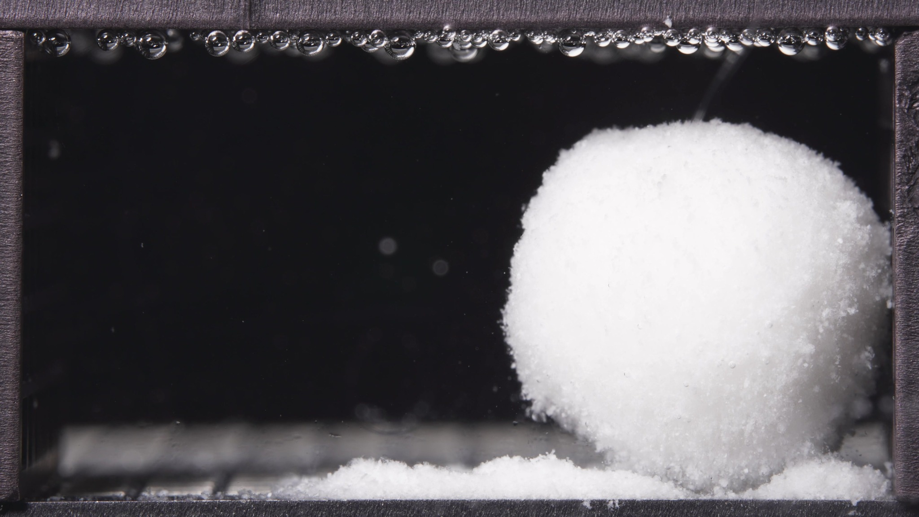 | 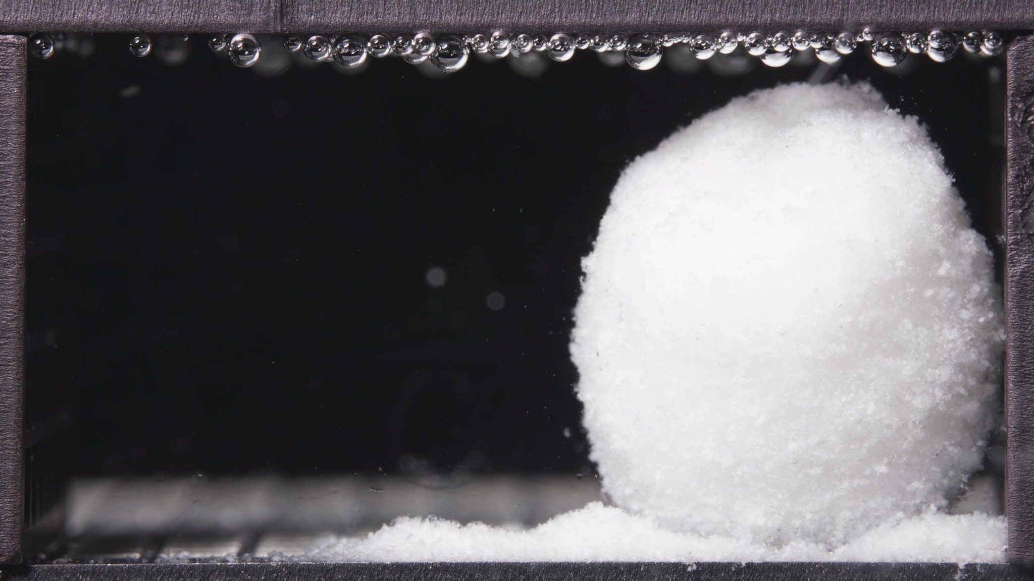 | 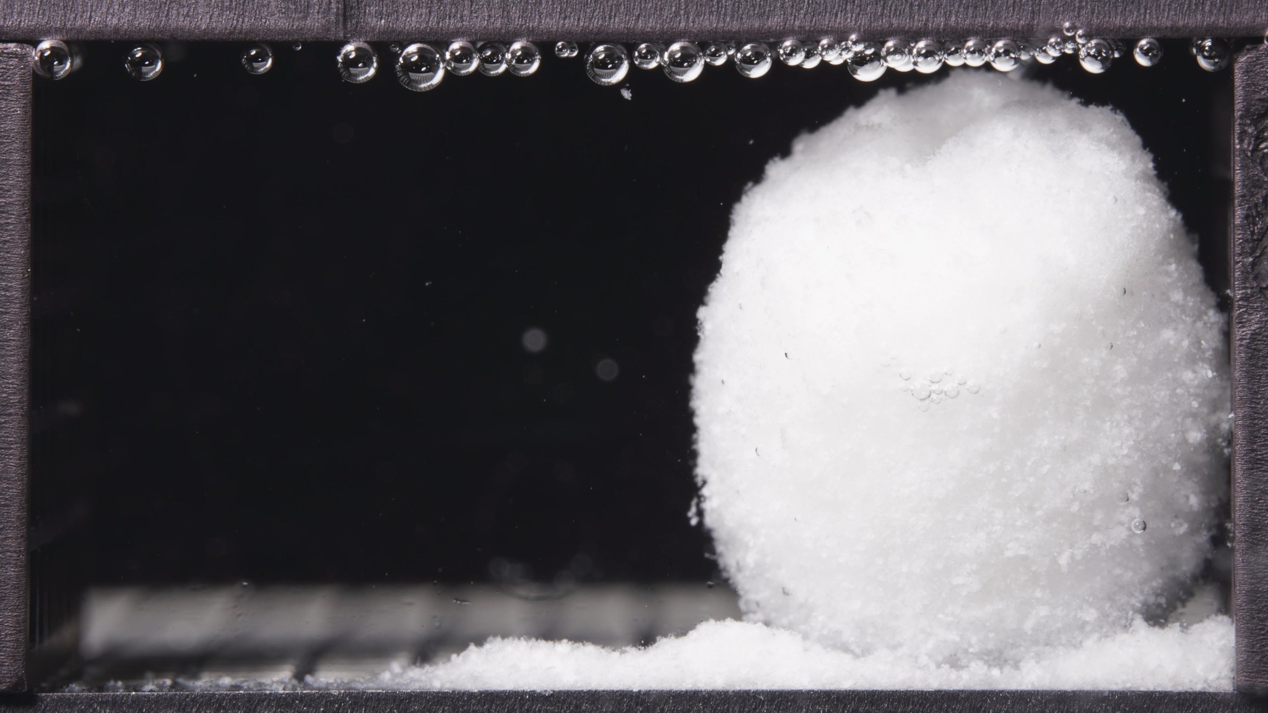

Turn 6 — Assistant
**Low-viscosity formulation, 6.25-11.25 h window**

**Overall observation**
In this window, the low-viscosity tablet remains as a **single large hydrated body** with **marked swelling still preserved**. Compared with the 0.104-5 h window, the mass appears **more rounded, more expanded, and more spatially stable as a swollen gel-like body**, while **fine eroded material continues to accumulate at the base**. There is still **no complete collapse into dispersed fragments**.

1. **Color change**
The body remains **uniformly white and opaque** across the batch. No internal discoloration, mottling, or obvious core exposure is visible. The surrounding medium remains visually **clear overall**, without broad-field whitening or clouding.

2. **Shape change**
The dominant shape is now a **large rounded / near-spheroidal swollen mass**. The outline is smoother and fuller than in the earlier 0.104-5 h batch, although still somewhat irregular at the margins. In the third image, a **slight upper lobulation or shallow top depression** appears, suggesting local structural softening rather than true fragmentation.

3. **Surface texture change**
The surface remains **rough, granular, and fluffy**, especially at the outer boundary. Compared with the earlier batch, the body surface appears **more uniformly swollen and hydrated**, while still showing **fine particulate shedding** along the edges and lower periphery. I do not see major deep fissuring or sheet-like peeling.

4. **Volume change**
The visible body volume remains **high and likely slightly increased** relative to the previous window. The formulation still shows a **swollen-retained structure**, not a shrinkage-dominant pattern. There is no convincing evidence here of major volume loss or collapse of the main mass.

5. **Dissolution speed and time**
Compared with 0.104-5 h, the process appears to have moved into a **sustained swollen-erosion stage** rather than a rapid breakup stage. The dominant progression is **continued hydration and shape rounding**, with **ongoing but localized erosion**. In other words, visible disintegration is still active, but the rate of gross structural breakup appears **slower than would be expected for a rapidly collapsing matrix**.

6. **Physical state change**
The tablet is no longer behaving as a compact solid. It appears as a **cohesive swollen matrix / gel-like porous mass** with a softened outer region. Relative to the prior window, the body looks **more fully hydrated and more plastically deformed**, but still structurally coherent.

7. **Dissolution medium**
The medium remains **largely clear** in all three images. Only sparse suspended particles are visible. There is no obvious diffuse cloudy zone, no strong turbidity gradient, and no widespread suspended fragment cloud. The visible interaction with the medium is therefore still dominated by **surface erosion and local detachment**, not by extensive dispersion into the bulk fluid.

8. **Fragment distribution with density**
Detached material remains concentrated as a **dense local bed/skirt at the bottom**, immediately adjacent to the hydrated mass. Fragment distribution is still **strongly localized**, with little evidence of long-range transport or uniform suspension. The fragments appear **fine and powder-like**, rather than large broken chunks.

**Most important change versus 0.104-5 h**
The key transition is that the low-viscosity formulation has progressed from an **already swollen but somewhat less regular hydrated body** into a **larger, rounder, more fully developed swollen matrix**, while still maintaining coherence. The main process in this window is **continued swelling with persistent localized basal erosion**, not catastrophic fragmentation or broad dispersion. This suggests that during 6.25-11.25 h the formulation is in a **stable swollen-retention stage with ongoing surface material loss**.

Turn 7 — User
These are pictures of the low-viscosity formulation during 12.5-17.5h.
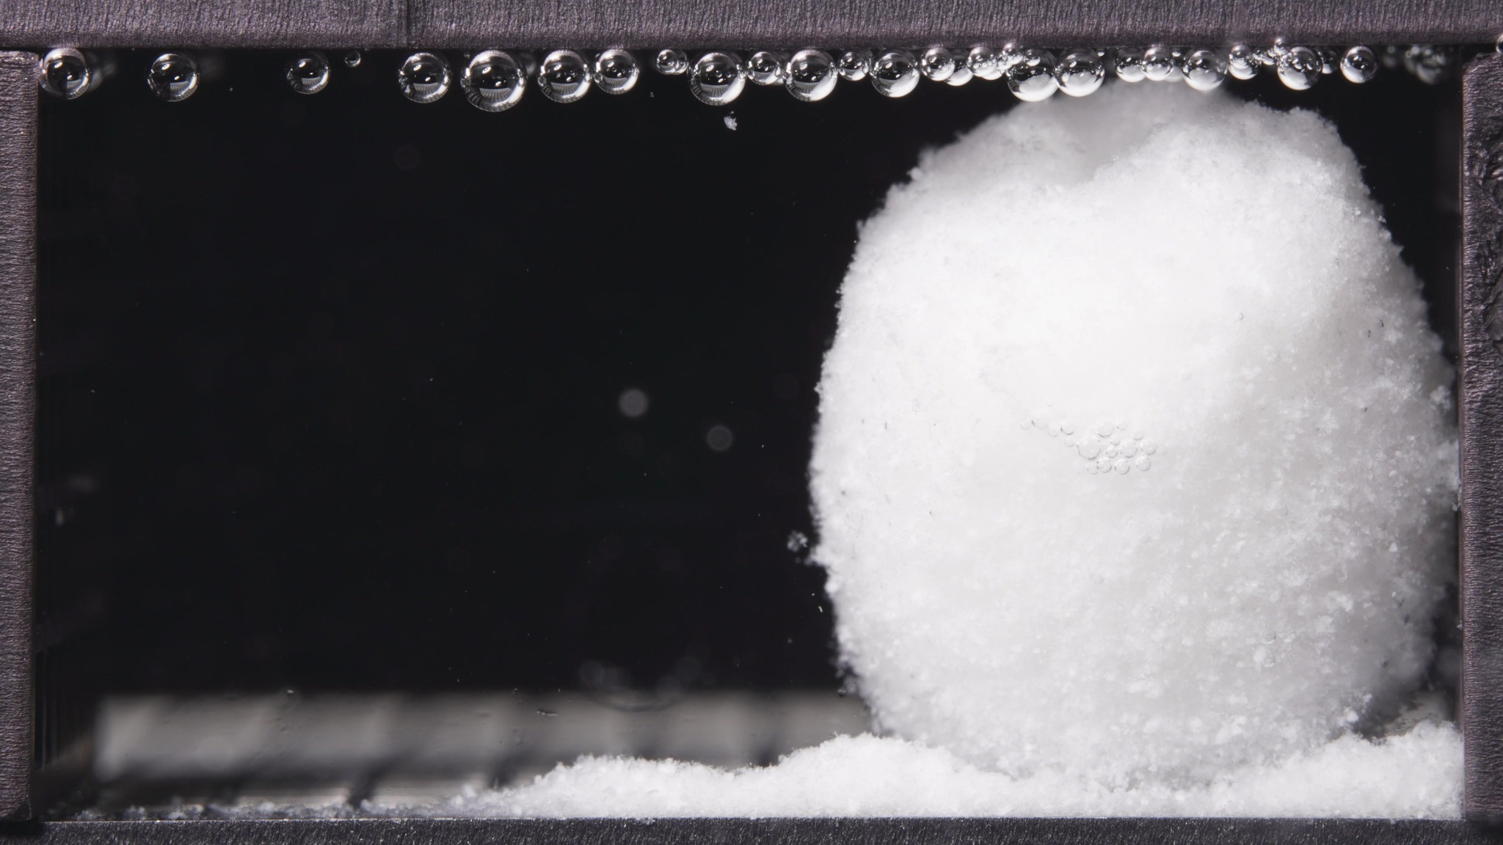 | 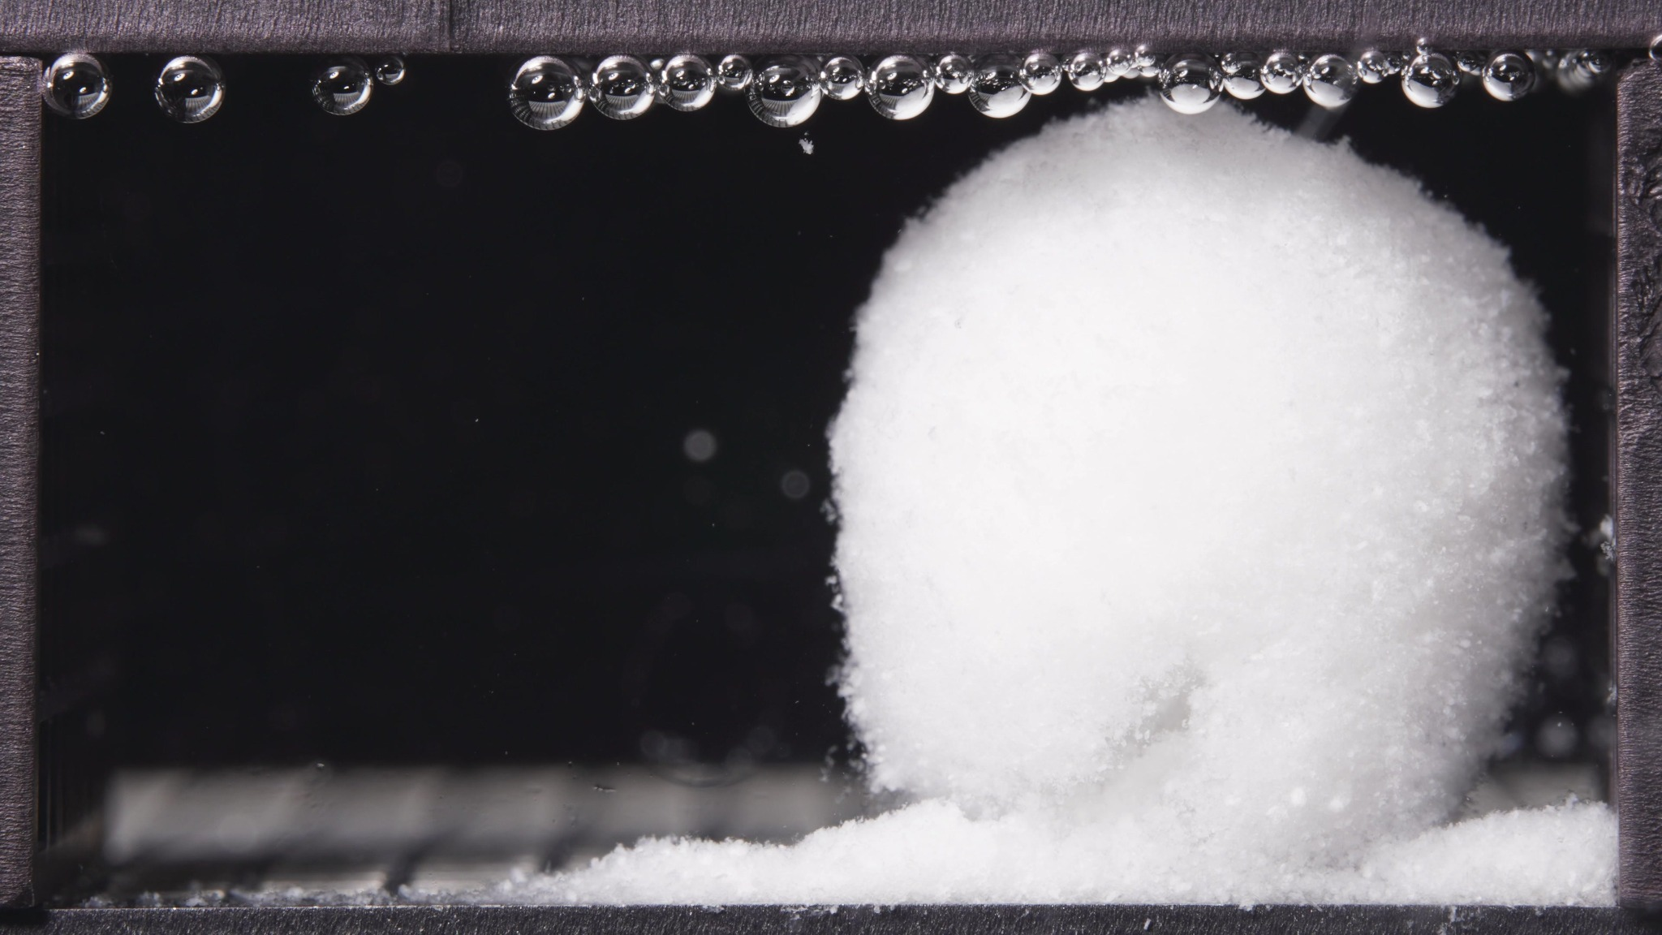 | 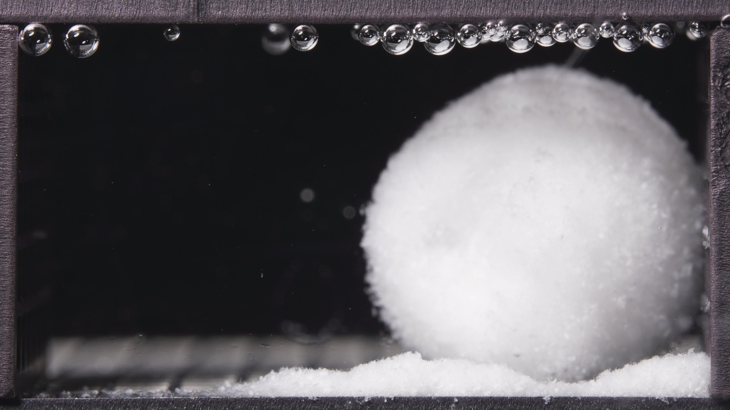

Turn 8 — Assistant
**Low-viscosity formulation, 12.5-17.5 h window**

**Overall observation**
In this window, the low-viscosity formulation still exists as a **single, large, highly swollen hydrated mass**. The body remains **structurally coherent** and shows **no major breakup into separate large fragments**. Relative to the 6.25-11.25 h window, the dominant impression is **continued swollen retention with mild reshaping/rounding and ongoing basal erosion**, rather than rapid collapse.

1. **Color change**
The mass remains **uniformly white and opaque** throughout the batch. No distinct discoloration, inner core exposure, or layered tonal contrast is visible. The surrounding liquid field remains **visually clear**, with no obvious diffuse whitening of the medium.

2. **Shape change**
The overall body is still **rounded to near-spheroidal**, with a preserved single-mass outline. Compared with the prior window, the shape looks **slightly more regular and dome-like overall**, although the first image still shows a mild upper irregularity/lobulation. There is no convincing evidence of splitting or detachment into multiple major bodies.

3. **Surface texture change**
The surface remains **rough, granular, and hydrated**, especially at the outer boundary. Compared with the previous window, the surface appears **slightly more uniform and compact in contour**, although it still shows fine particulate roughness rather than a smooth gel shell. I do not see major cracks, fissures, or lamellar peeling.

4. **Volume change**
The visible mass remains **large and strongly swollen**, indicating persistent water uptake and matrix expansion retention. Compared with 6.25-11.25 h, there is **no clear large-volume collapse**. At most, there may be a **subtle transition from expansion-dominant swelling toward a more stabilized swollen volume**, but the main body is still clearly bulky.

5. **Dissolution speed and time**
Compared with 6.25-11.25 h, the formulation still appears to be in a **slow, sustained erosion phase** rather than an accelerated disintegration phase. Gross structural breakup does not appear to intensify. The visible process is therefore better described as **continued swollen persistence with gradual peripheral material loss**.

6. **Physical state change**
The body remains in a **cohesive swollen matrix / gel-like porous mass state**, not a hard compact tablet and not a dispersed particle cloud. Relative to the previous window, the matrix appears to be **maintaining integrity while slowly softening and eroding at the surface**, rather than undergoing abrupt internal collapse.

7. **Dissolution medium**
The medium remains **largely clear across the field of view**. Only sparse particulates are visible, and there is no obvious broad turbidity plume or cloud band. This indicates that material release is still expressed mainly as **local erosion and sediment accumulation**, not widespread suspension in the bulk medium.

8. **Fragment distribution with density**
Detached material remains concentrated as a **dense powder-like bed/skirt at the base** of the swollen body. Compared with the previous window, this basal accumulation appears **slightly more established and laterally spread**, but fragment distribution is still highly localized. There is still **little evidence of wide dispersion** into the surrounding medium.

**Most important change versus 6.25-11.25 h**
The key change is **not fragmentation**, but rather **persistence of the swollen matrix with slightly more regularized rounded morphology and continued local basal shedding**. In other words, during 12.5-17.5 h the low-viscosity formulation still behaves as a **stable swollen-retained body undergoing gradual surface erosion**, with **material remaining concentrated near the original position** instead of dispersing broadly.

Turn 9 — User
These are pictures of the low-viscosity formulation during 18.75-23.75h.
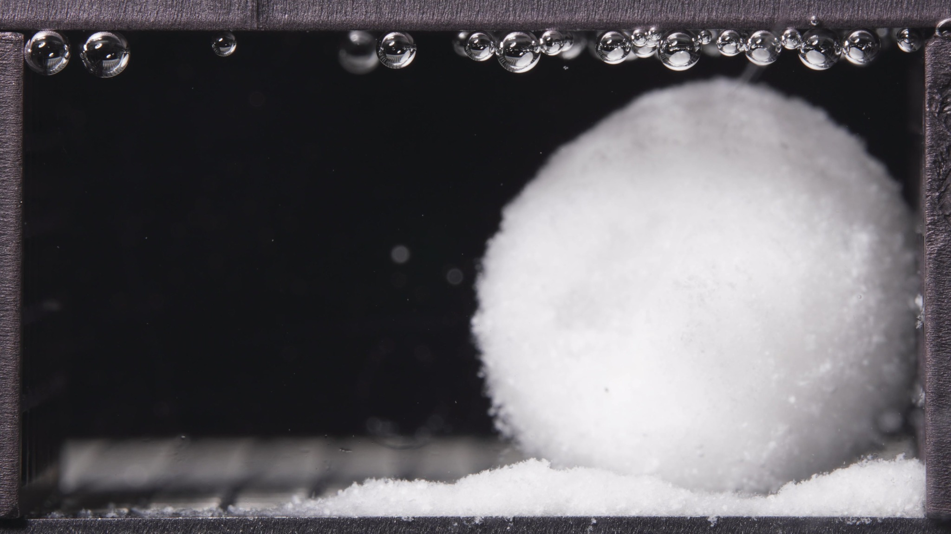 | 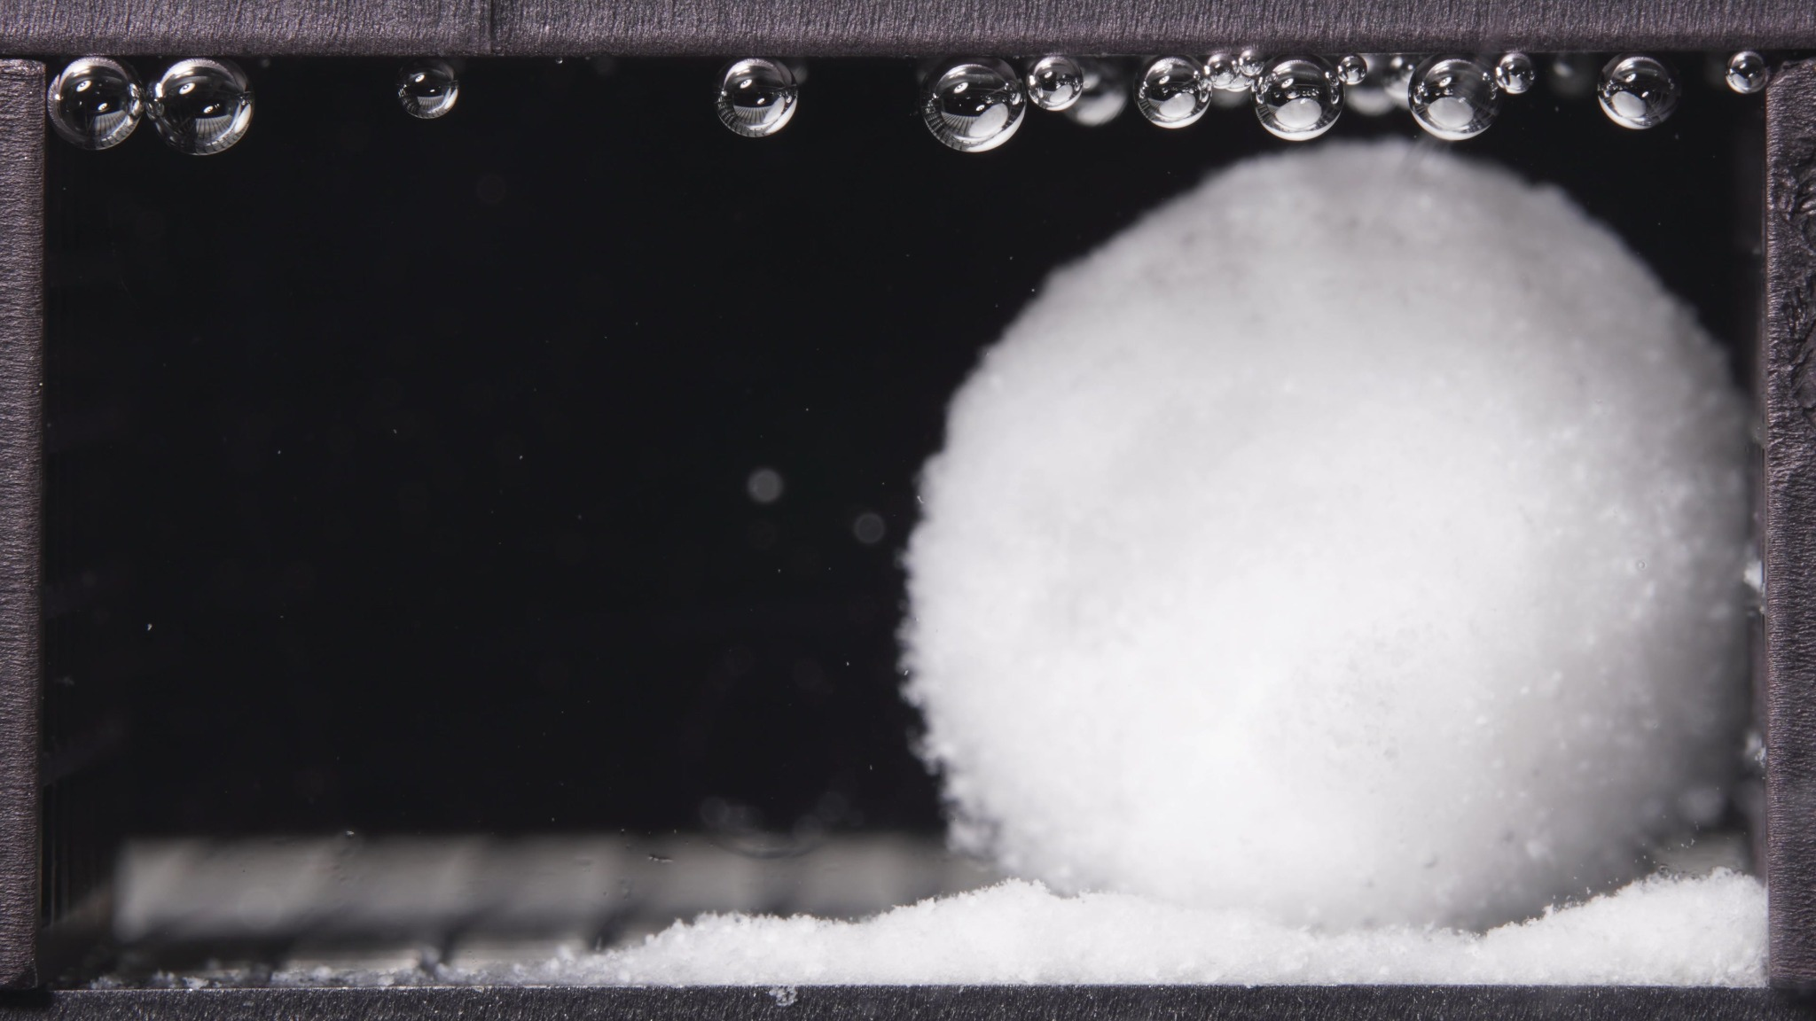 | 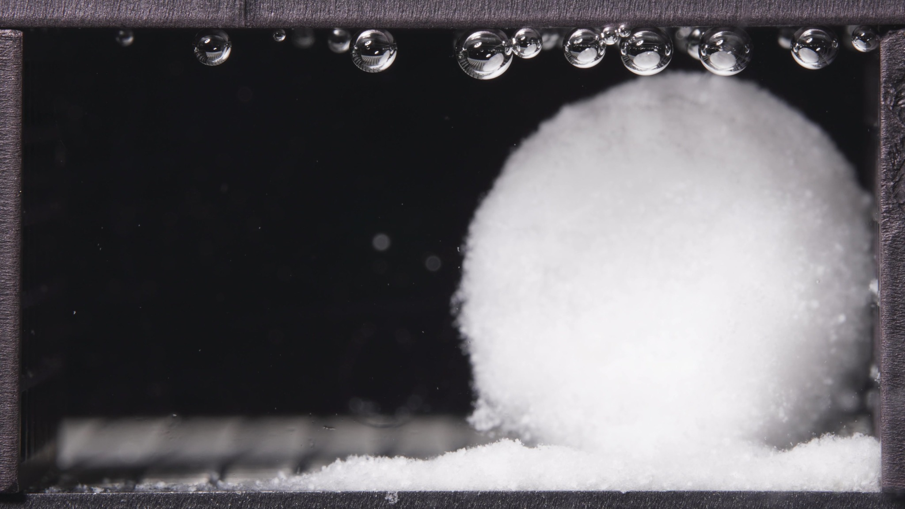

Turn 10 — Assistant
**Low-viscosity formulation, 18.75-23.75 h window**

**Overall observation**
In the late stage, the low-viscosity formulation still persists as a **single large swollen hydrated mass**. The matrix remains **coherent and rounded**, with **continued basal accumulation of eroded material**, but there is still **no major breakup into multiple large fragments** and no broad dispersion into the medium. Relative to the 12.5-17.5 h window, the morphology appears **largely stable**, suggesting a **late swollen-retention plateau with slow surface erosion**.

1. **Color change**
The body remains **uniformly white and opaque**. No darker inner core, discoloration, or clear internal heterogeneity is visible. The surrounding liquid remains visually **clear**.

2. **Shape change**
The mass keeps a **rounded, near-spheroidal outline** and remains as one continuous body. Compared with the previous window, the shape appears **slightly smoother and more regular**, without new splitting, collapse, or edge rupture. Any geometric change is subtle rather than abrupt.

3. **Surface texture change**
The surface still appears **fine-granular, fluffy, and hydrated**, especially at the outer boundary. Compared with earlier windows, the contour looks **somewhat more uniform**, but not truly smooth. There is ongoing edge softness and mild particulate shedding rather than cracking or peeling.

4. **Volume change**
The visible body remains **large and swollen**. Compared with 12.5-17.5 h, there is **no clear major volume loss**. At most, the formulation may be entering a **stabilized or very slowly contracting swollen state**, but the dominant visual impression is still bulk retention.

5. **Dissolution speed and time**
Compared with the previous window, visible disintegration appears **slow and sustained rather than accelerated**. The matrix does not show terminal collapse. The late-stage process is best described as **morphological persistence with gradual peripheral erosion**.

6. **Physical state change**
The formulation remains in a **cohesive swollen matrix / gel-like porous mass state**. It has not reverted to a compact solid, and it has not transitioned into a freely dispersed particulate cloud. This indicates persistent structural integrity even near the end of the 24 h observation period.

7. **Dissolution medium**
The medium remains **mostly clear**, with no obvious diffuse turbidity plume or cloud band. Material release is still expressed mainly as **local erosion near the tablet body**, not as strong bulk-medium contamination.

8. **Fragment distribution with density**
Detached material remains concentrated as a **dense local powder-like skirt at the base**. The fragments are still **localized near the original position** and do not show wide transport into the chamber. No large detached blocks are visible.

**Most important change versus 12.5-17.5 h**
The most important finding is the **lack of a major new transition**. The low-viscosity formulation remains a **stable swollen-retained body** through 18.75-23.75 h, with only **slow ongoing surface/basal erosion**. This suggests that by the late stage, the morphology has entered a **near-plateau state**, where structural persistence dominates over rapid fragmentation or dispersion.

Turn 11 — User
These are pictures of the standard formulation during 0.104-5h.
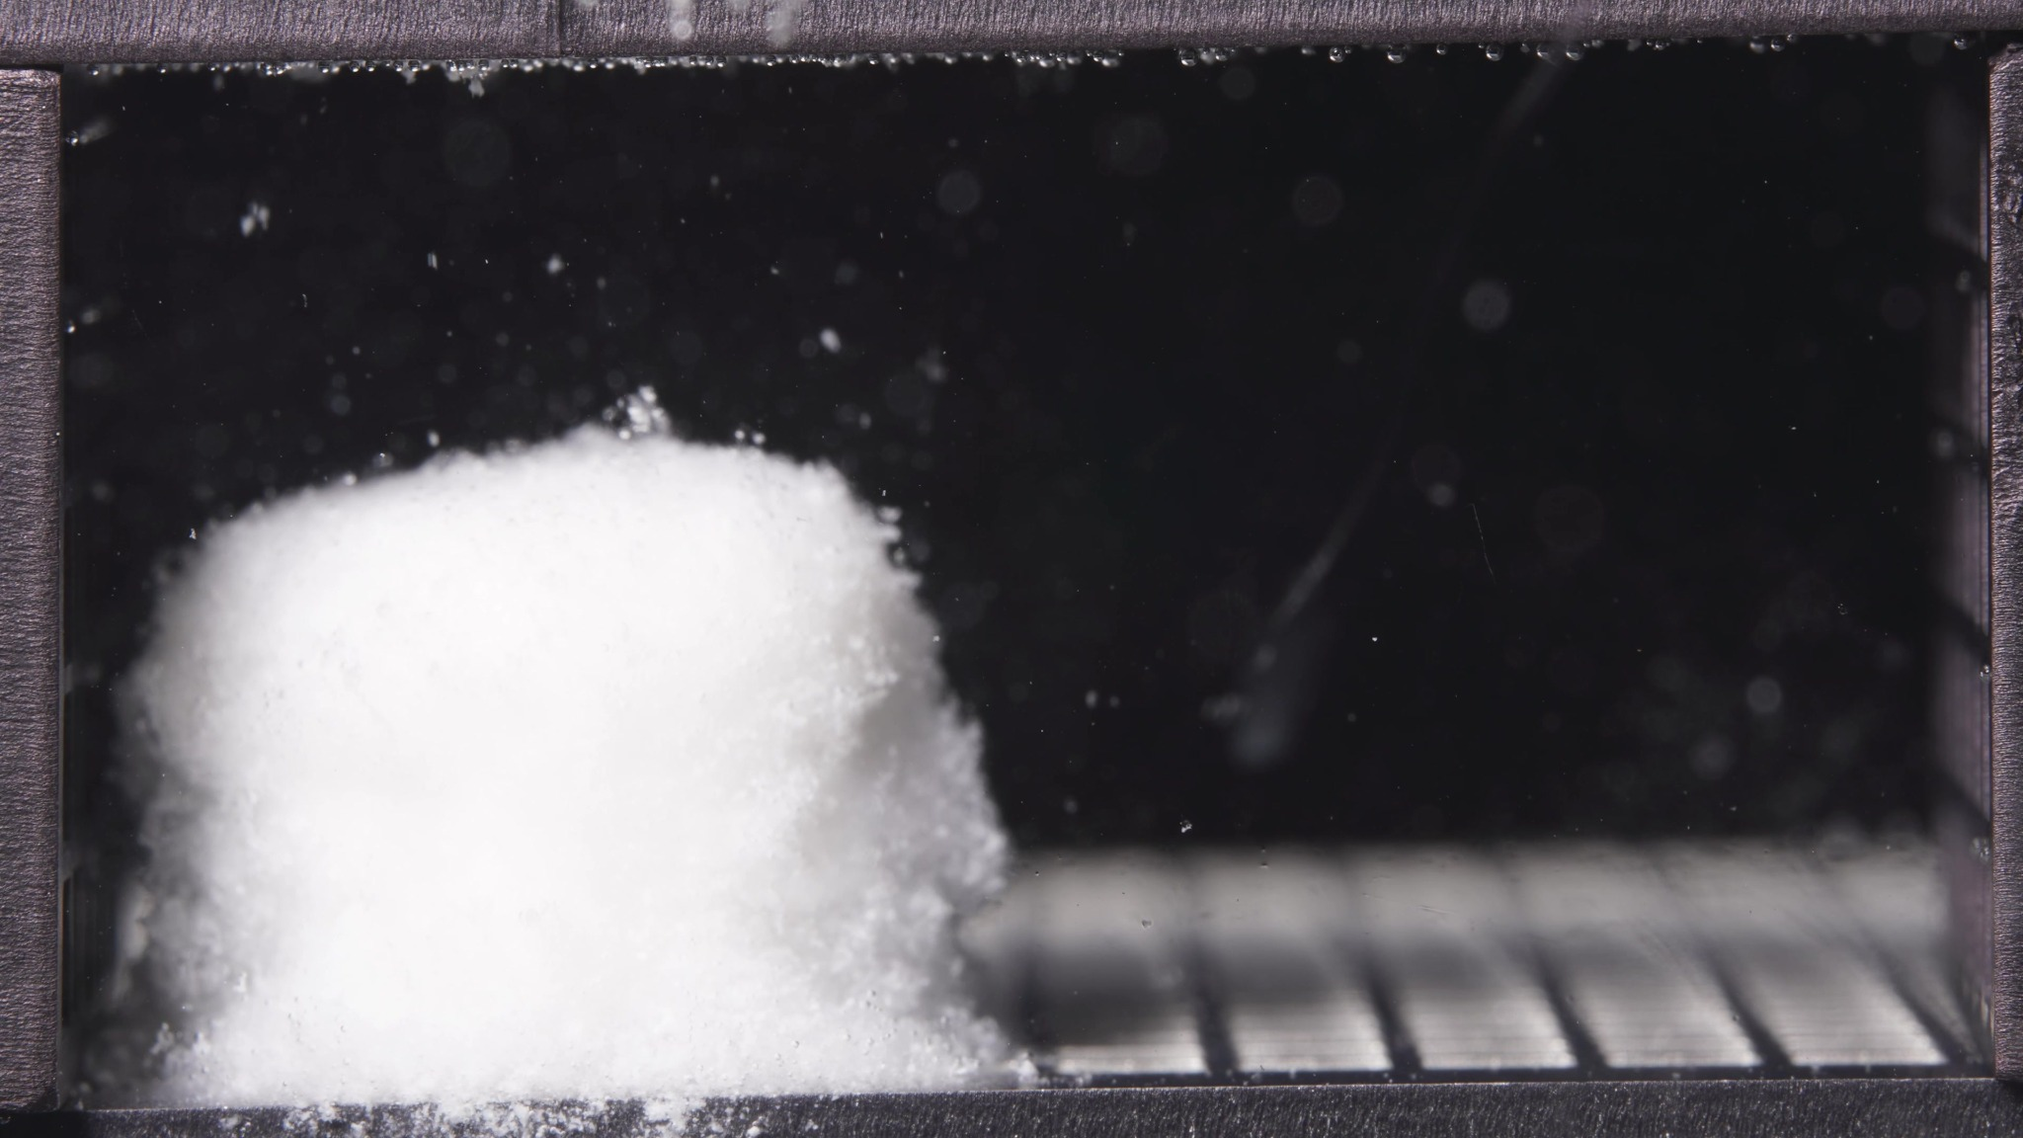 | 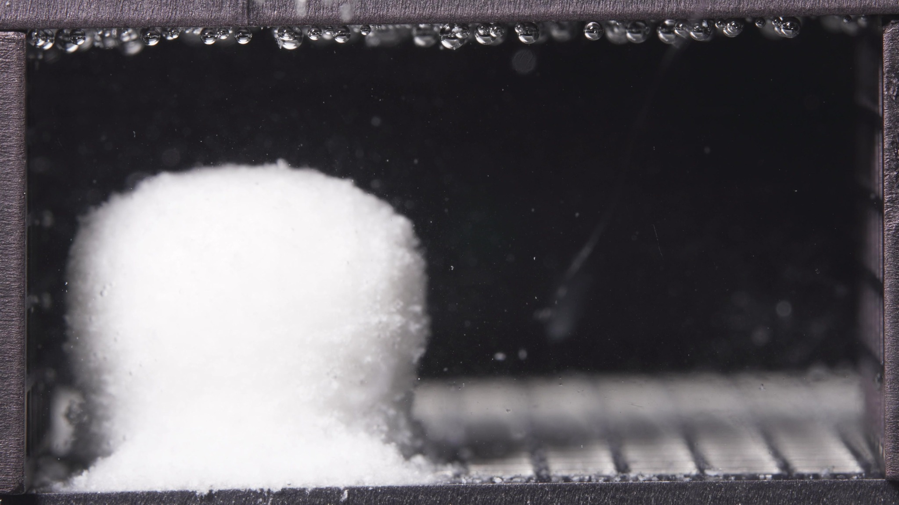 | 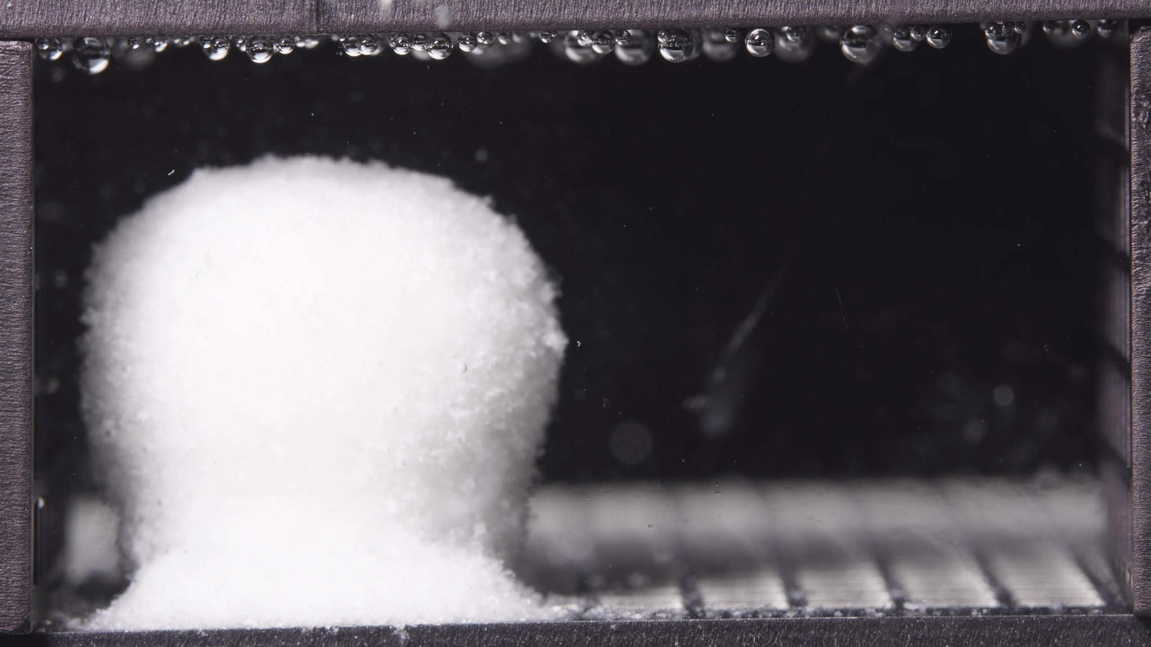

Turn 12 — Assistant
**Standard formulation, 0.104-5 h window**

**Overall observation**
In this early window, the standard formulation has already transformed from a compact tablet into a **single hydrated swollen body**, but it still retains a **more columnar and shape-preserving morphology** than a fully rounded gel mass. The matrix remains coherent, with **surface roughening and basal powder accumulation**, but there is **no major breakup into large detached fragments**.

1. **Color change**
The body remains **uniformly white and opaque** across the batch. No internal discoloration, dark core exposure, or obvious layered color contrast is visible. The surrounding medium remains **mostly clear**, with only sparse suspended particles.

2. **Shape change**
The overall mass remains as **one continuous body**. Compared with a dry tablet, the edges are softened, but the standard formulation still shows a **relatively upright cylindrical-to-columnar outline**, especially in the first image. In the later images within this window, the top becomes **more rounded/domed**, indicating progressive hydration and softening, but the gross geometry is still well preserved.

3. **Surface texture change**
The surface is clearly **rough, granular, and eroded rather than smooth**. Edge regions show **fine particulate loosening**, especially along the right boundary and lower side areas. I do not see dominant deep cracks, but I do see **surface roughening with ongoing external material loss**.

4. **Volume change**
The visible body appears **swollen relative to an intact dry compact**, but the swelling is still associated with **shape retention**, not gross spherical expansion. Within this batch, the volume appears **maintained or mildly increased**, without any obvious collapse of the main body.

5. **Dissolution speed and time**
Because no earlier standard-formulation window is available, a strict comparison of rate versus the previous window is not possible. Based on this batch alone, the formulation appears to be in an **early swollen-retention stage with active surface erosion**, but not in a rapid fragmentation stage.

6. **Physical state change**
The tablet has moved from a hard compact solid into a **hydrated, softened, cohesive matrix mass**. It appears less like a rigid tablet and more like a **swollen porous/gel-like body with an eroding outer layer**, while still preserving its overall integrity.

7. **Dissolution medium**
The medium remains **largely clear** throughout the field of view. There is no broad turbidity cloud, no major diffuse haze, and no extensive suspended debris plume. Since this time window spans the **acid-to-buffer transition**, these images should be interpreted as an integrated early-stage morphology under both initial and post-switch exposure.

8. **Fragment distribution with density**
Detached material is concentrated mainly as a **dense powder-like accumulation at the base** of the body. Fragment distribution remains **highly localized near the original tablet position**, with minimal evidence of broad dispersion into the medium. No large broken chunks are evident.

**Most important note for later synthesis**
The key feature of the standard formulation in the 0.104-5 h window is **early swelling with relatively strong shape retention**. The matrix shows **surface erosion and basal shedding**, but it still preserves a **coherent, upright, columnar swollen body** rather than rapidly rounding, collapsing, or dispersing. This suggests an early morphology dominated by **hydration plus controlled external erosion**, not abrupt structural failure.

Turn 13 — User
These are pictures of the standard formulation during 6.25-11.25h.
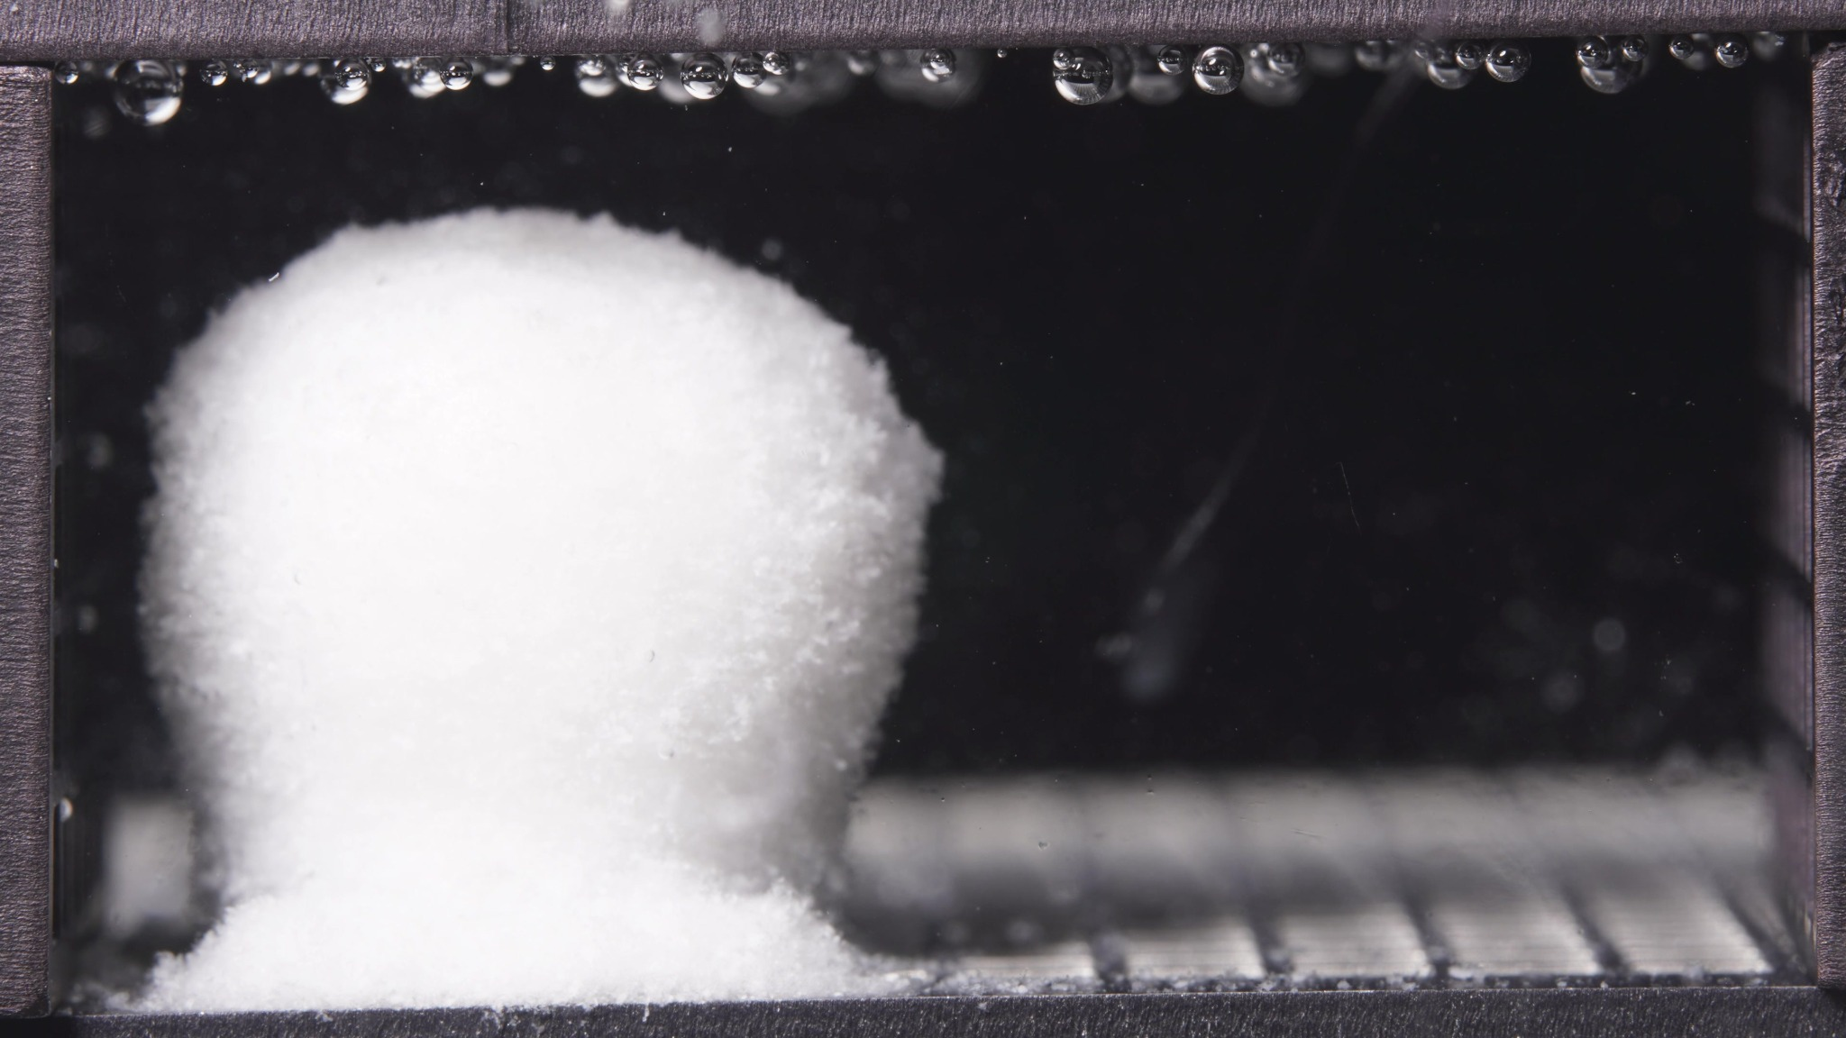 | 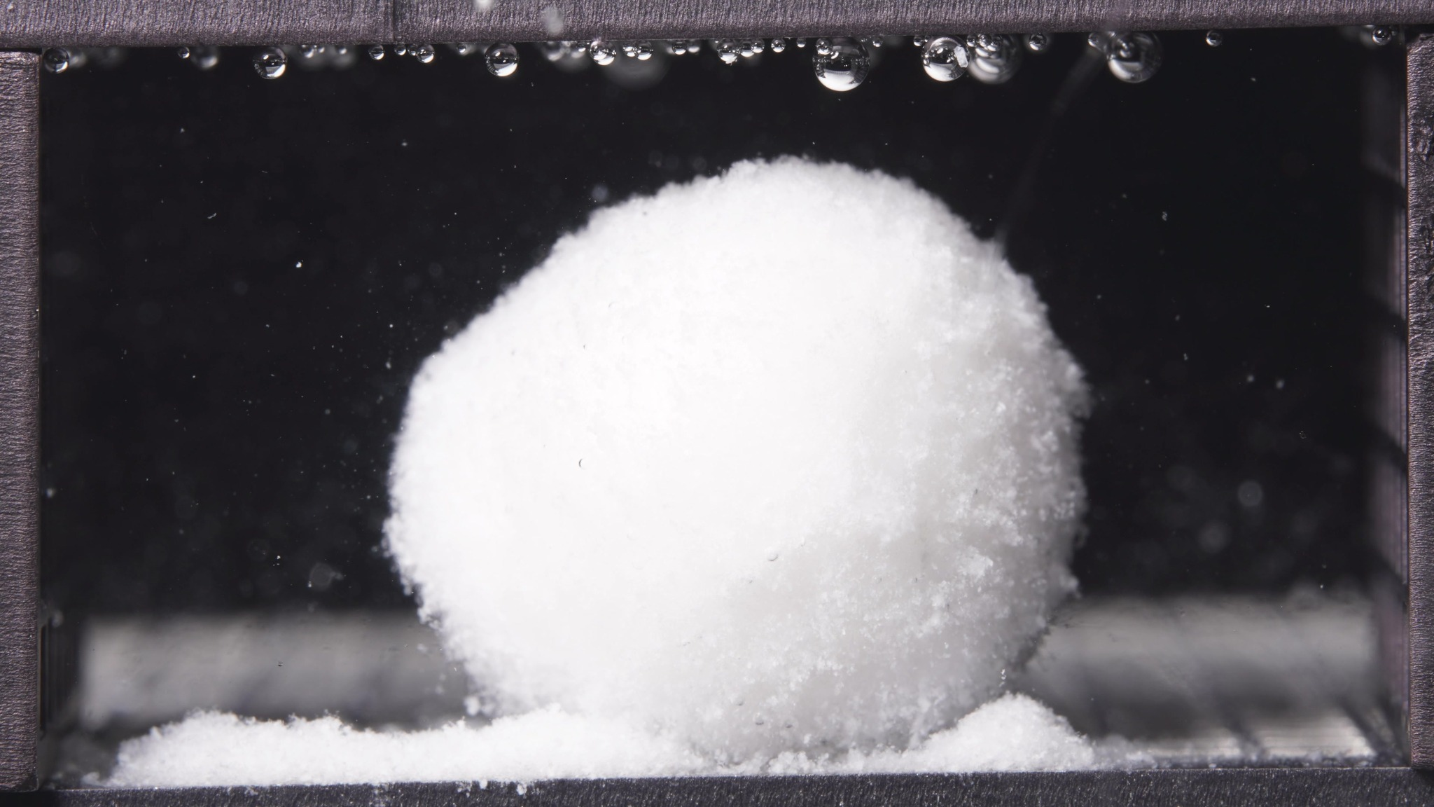 | 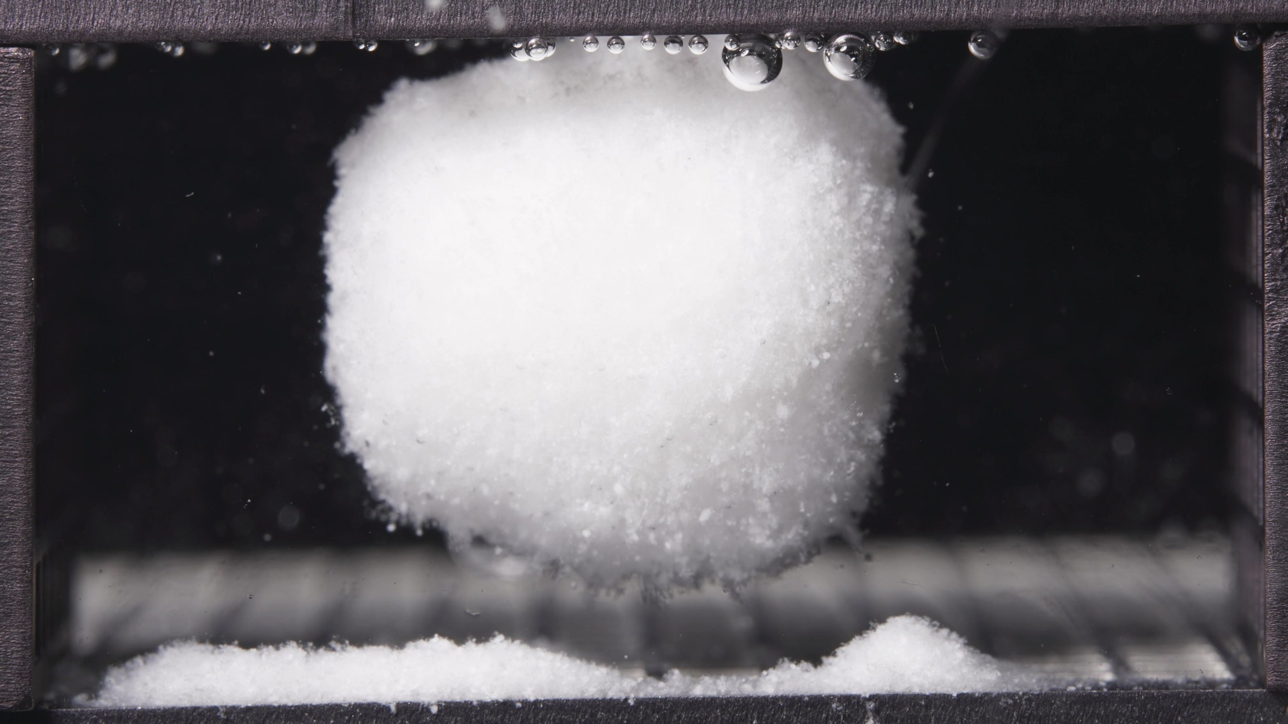

Turn 14 — Assistant
**Standard formulation, 6.25-11.25 h window**

**Overall observation**
In this window, the standard formulation remains as a **single coherent swollen body**, but compared with 0.104-5 h it has progressed from a more **upright columnar swollen mass** toward a **larger, rounder, more bulbous hydrated matrix**. The body is still intact, with no breakup into multiple large fragments, but **basal erosion and undercutting are more evident**, especially in the later image.

1. **Color change**
The matrix remains **uniformly white and opaque** throughout the batch. No dark core, discoloration, or clear internal layering is visible. The surrounding medium remains **mostly clear**, with only sparse suspended particles.

2. **Shape change**
The overall body remains **single-piece and coherent**, but its geometry has changed substantially within this window. The first image still shows a **top-heavy, necked or mushroom-like swollen form**, while the later images show a **broader, rounder, more globular profile**. In the third image, the lower part appears **more undercut and less continuously supported**, indicating progressive loss of basal structural definition.

3. **Surface texture change**
The surface remains **rough, granular, and fluffy**, not smooth. Compared with the previous window, the hydrated outer layer looks **more fully developed and more uniformly swollen**, while still showing **fine particulate roughness and edge shedding**. I do not see dominant deep cracking or lamellar peeling.

4. **Volume change**
The visible occupied volume is **clearly large and strongly swollen**. Compared with 0.104-5 h, the body appears to have undergone **further expansion and rounding**, not gross shrinkage. There is no evidence of major overall volume collapse in this batch.

5. **Dissolution speed and time**
Compared with 0.104-5 h, the formulation appears to have moved into a **more advanced swollen-retention stage**, with stronger morphological softening and more visible basal erosion. However, disintegration still does **not** appear explosive. The dominant process is **continued swelling plus gradual peripheral/basal material loss**, rather than rapid fragmentation.

6. **Physical state change**
The standard formulation now behaves as a **cohesive, highly hydrated swollen matrix / gel-like porous mass** rather than a softened tablet with simple edge erosion. Relative to the previous window, the body looks **more plastically deformed and more fully hydrated**, while still preserving overall integrity.

7. **Dissolution medium**
The medium remains **largely clear across the field of view**. There is no obvious broad turbidity plume, no major cloud band, and no heavy suspension of released material. The interaction with the medium is still expressed mainly through **local erosion from the swollen surface**.

8. **Fragment distribution with density**
Released material remains concentrated as a **dense powder-like bed at the base** of the matrix. Compared with the previous window, this basal accumulation appears **more established and more laterally spread**. Fragment distribution is still **localized near the original position**, with little evidence of broad dispersion into the chamber.

**Most important change versus 0.104-5 h**
The key transition is the shift from a **shape-retaining upright swollen body** to a **larger, rounder, more fully hydrated matrix with clearer basal undercutting/erosion**. In other words, during 6.25-11.25 h the standard formulation remains structurally coherent, but it has entered a **more mature swollen-retention phase**, where **volume expansion and bottom-edge erosion** become more pronounced without catastrophic breakup.

Turn 15 — User
These are pictures of the standard formulation during 12.5-17.5h.
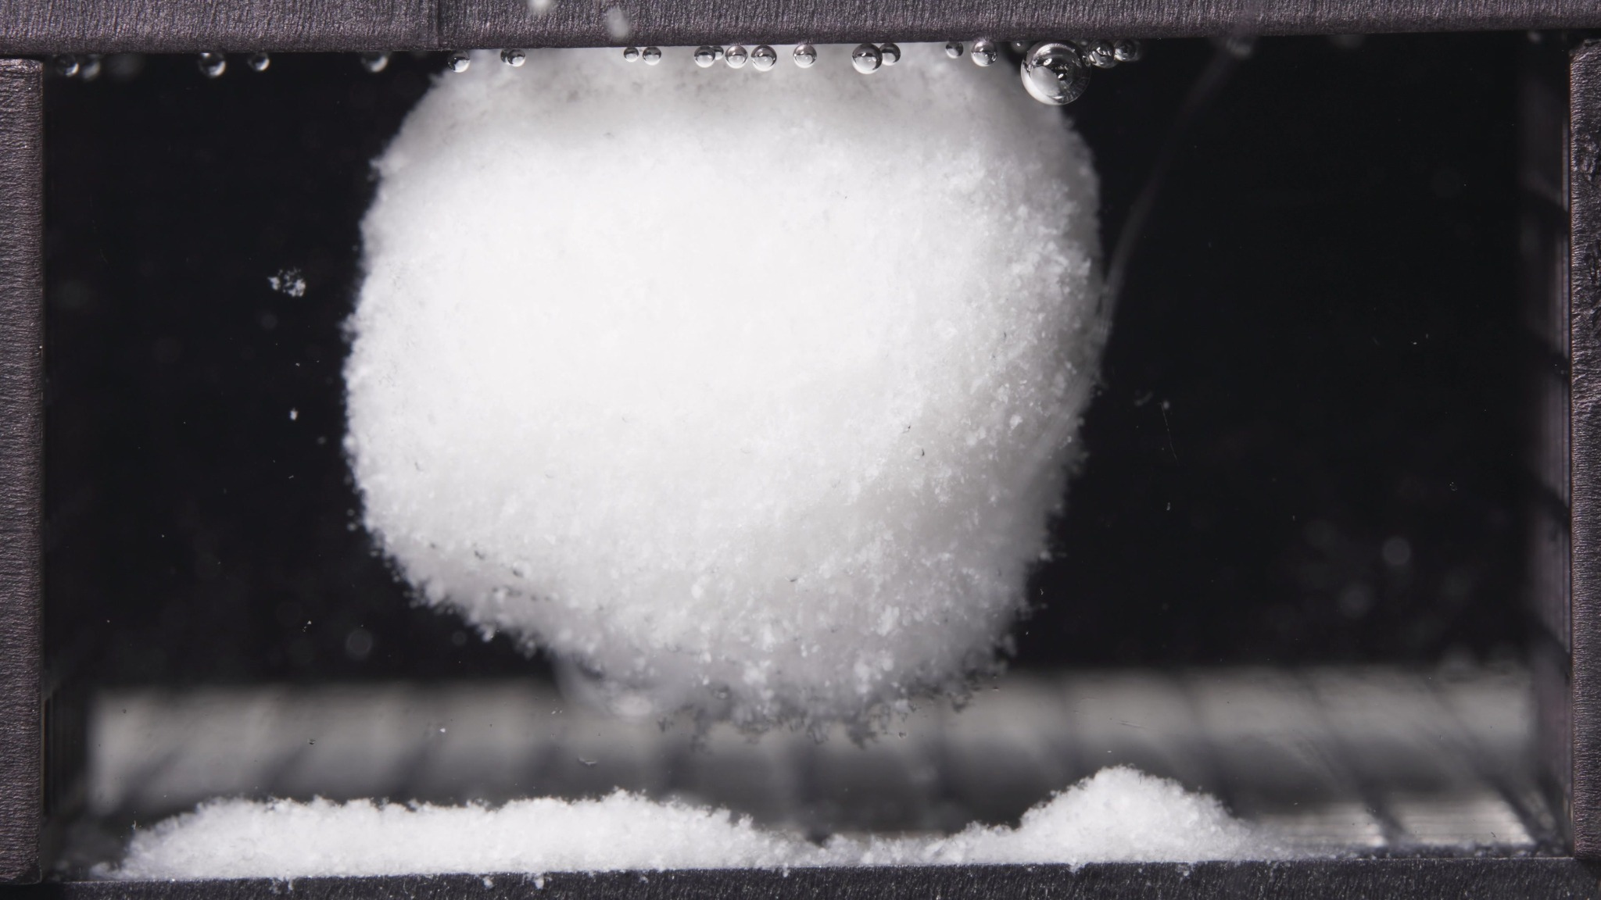 | 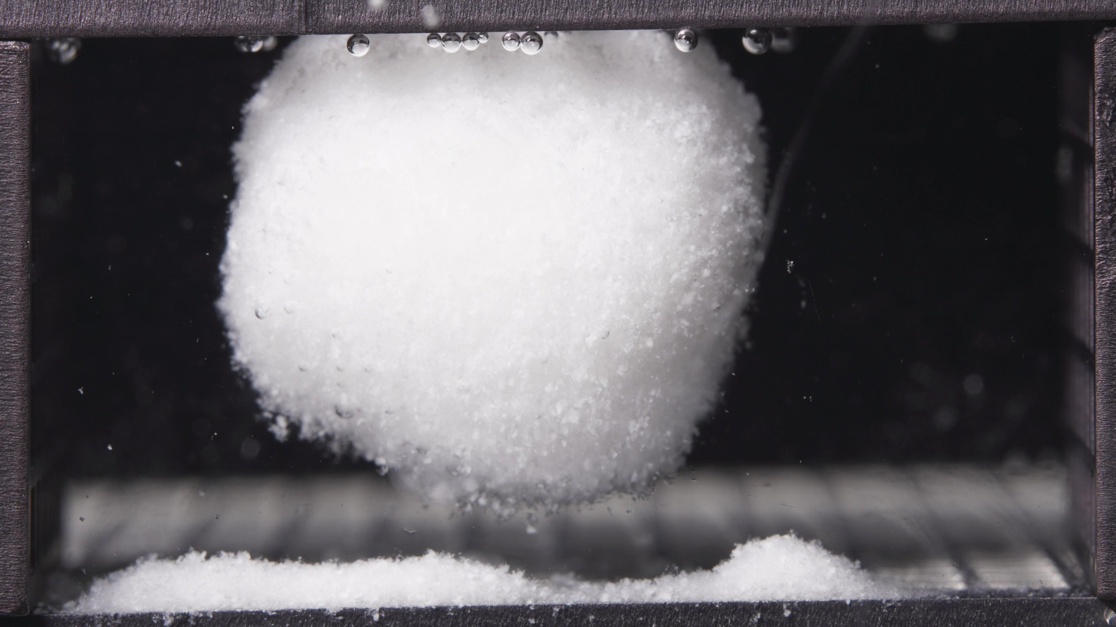 | 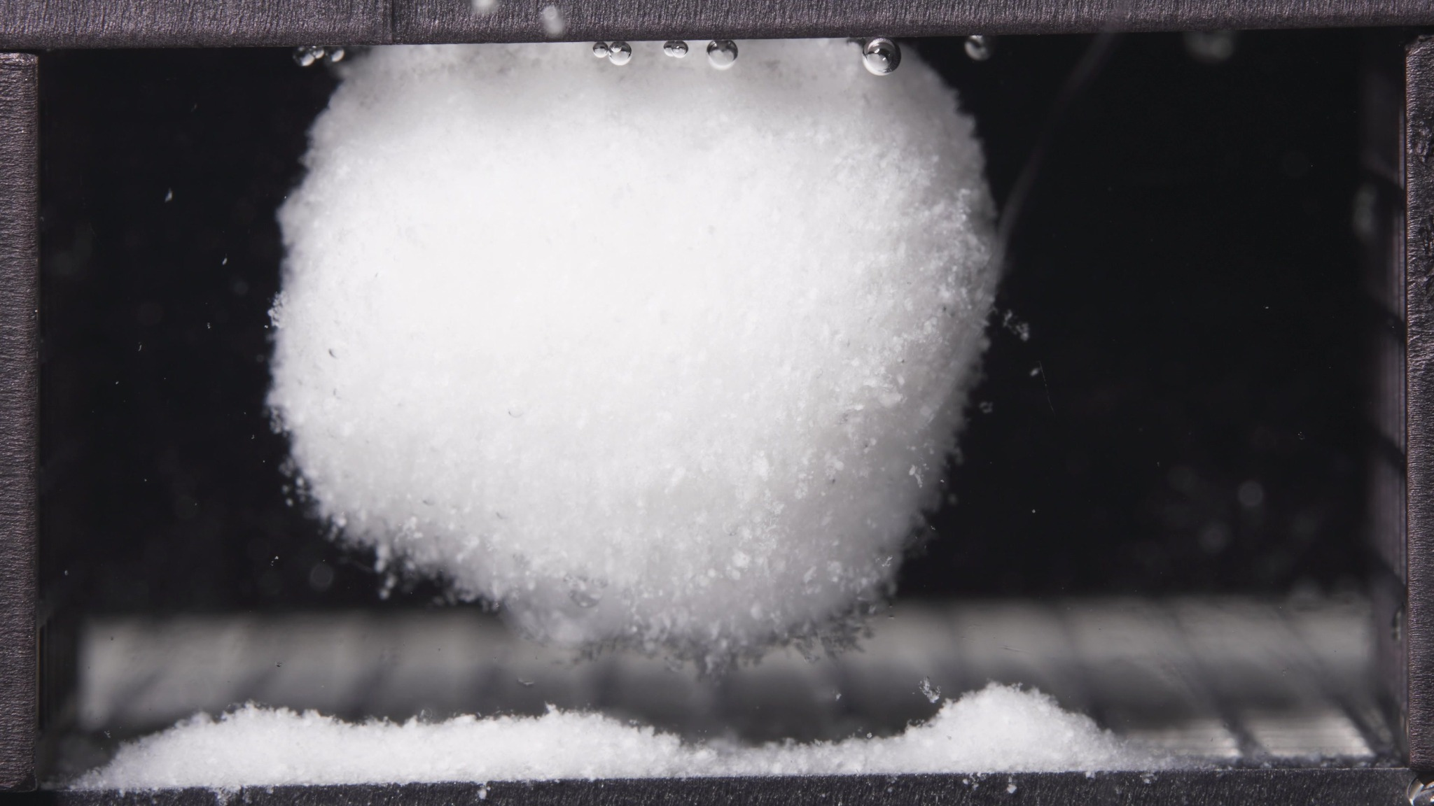

Turn 16 — Assistant
**Standard formulation, 12.5-17.5 h window**

**Overall observation**
In this window, the standard formulation still presents as a **single, large, highly swollen hydrated mass**, but compared with 6.25-11.25 h the **basal undercutting is more pronounced**. The main body remains **coherent and rounded**, while the **powder-like eroded material is clearly separated below**, giving the impression that the swollen matrix is **partially lifted or suspended above the basal deposit** rather than broadly collapsing onto it.

1. **Color change**
The matrix remains **uniformly white and opaque** throughout the batch. No dark core, discoloration, or obvious internal stratification is visible. The surrounding medium remains **visually clear**.

2. **Shape change**
The body remains a **single continuous swollen mass**. Its outline is now **more rounded and globular** than in the previous window, with less of the earlier necked or mushroom-like appearance. At the same time, the **lower boundary is more clearly separated from the basal sediment**, indicating progressive loss of direct basal support rather than fragmentation into multiple pieces.

3. **Surface texture change**
The surface remains **rough, fine-granular, and fluffy**, consistent with an eroding hydrated outer layer. Compared with the previous window, the outer contour appears **more uniform and more fully swollen**, but still not smooth. No major cracks, fissures, or peeling sheets are evident.

4. **Volume change**
The visible mass remains **very large and strongly swollen**. Compared with 6.25-11.25 h, there is **no obvious gross volume collapse**. The dominant pattern is **continued swollen-volume retention**, with possible slight reshaping toward a more compact rounded body rather than true shrinkage.

5. **Dissolution speed and time**
Compared with 6.25-11.25 h, visible disintegration still appears **slow and controlled**, not explosive. The most important temporal change is **greater basal erosion and structural separation from the sediment bed**, while the main body itself remains intact. This suggests continued progression through a **mature swollen-retention stage with ongoing local material loss**.

6. **Physical state change**
The formulation remains in a **cohesive swollen matrix / gel-like porous mass state**. Relative to the previous window, it appears **more fully hydrated and mechanically softened at the base**, but not converted into a dispersed particle cloud. Structural integrity of the main body is still maintained.

7. **Dissolution medium**
The medium remains **largely clear across the field of view**, without a broad turbidity plume or diffuse clouding. Released material is still expressed mainly as **local erosion and sediment accumulation**, not bulk-medium dispersion.

8. **Fragment distribution with density**
Detached material remains concentrated as a **dense powder-like bed along the bottom**, with a more obvious **localized mound** in the right-bottom region. Small loose particles are visible beneath and around the swollen body, but fragment distribution remains **strongly localized near the original position**. There is still **little evidence of wide suspension or transport**.

**Most important change versus 6.25-11.25 h**
The key transition is **not major breakup**, but rather **clearer basal undercutting and apparent partial separation of the swollen matrix from the underlying sediment bed**. In other words, during 12.5-17.5 h the standard formulation remains a **stable, coherent swollen body**, while **erosion becomes more spatially concentrated at the bottom interface**, indicating further weakening of basal support without catastrophic collapse.

Turn 17 — User
These are pictures of the standard formulation during 18.75-23.75h.
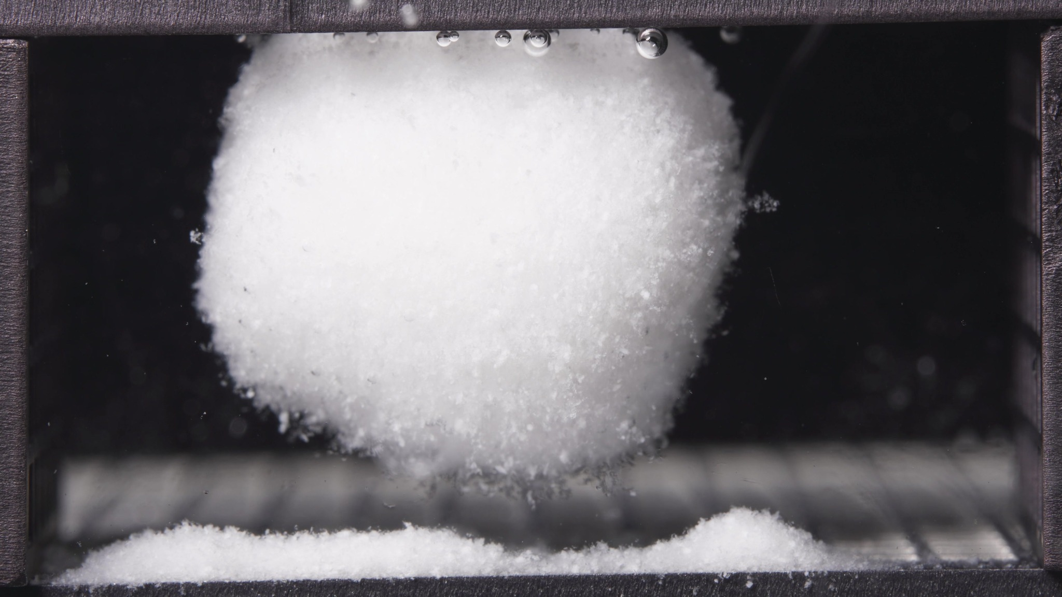 | 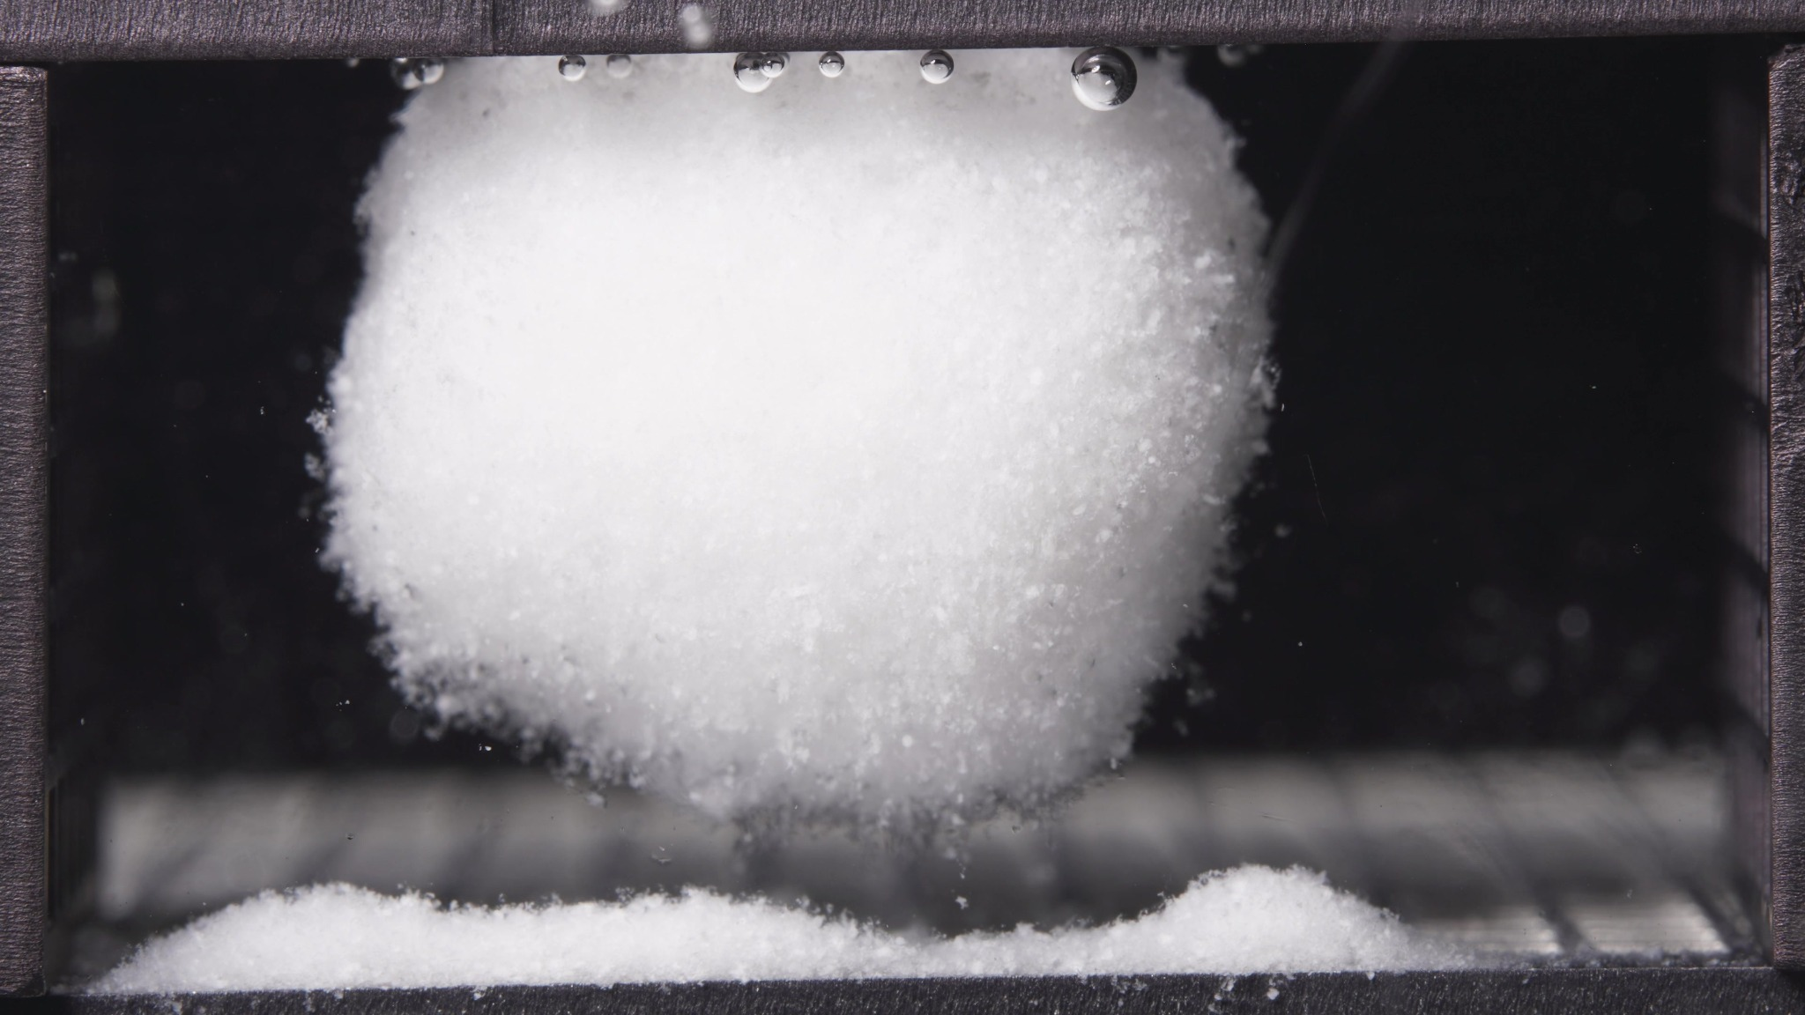 | 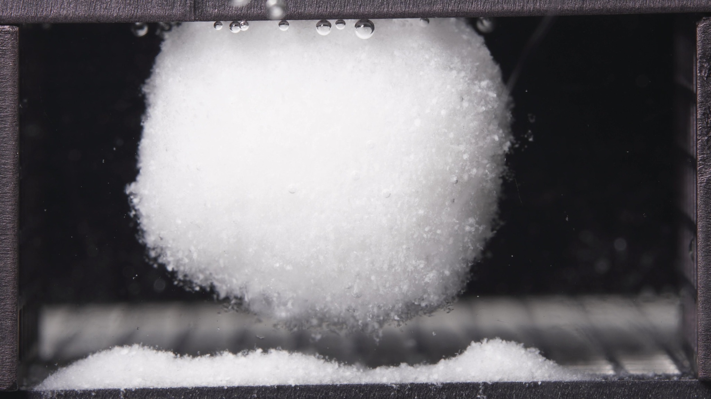

Turn 18 — Assistant
**Standard formulation, 18.75-23.75 h window**

**Overall observation**
In the late stage, the standard formulation still persists as a **single large swollen hydrated mass**. The body remains **structurally coherent, rounded, and largely suspended above the basal deposit**, with only a narrow lower contact/erosion zone. Relative to 12.5-17.5 h, the dominant impression is **morphological stability**, not collapse: the matrix remains intact while **slow bottom-edge erosion and local powder shedding** continue.

1. **Color change**
The body remains **uniformly white and opaque** throughout the batch. No darker core, discoloration, or obvious internal layering is visible. The surrounding liquid remains visually **clear**.

2. **Shape change**
The mass remains **one continuous swollen body** with a **rounded to slightly globular profile**. Compared with the previous window, the outline appears **very similar overall**, with no new splitting, no large detached fragment formation, and no obvious gross deformation. The lower boundary remains **undercut/suspended**, rather than broadly resting on the sediment bed.

3. **Surface texture change**
The surface remains **fine-granular, fluffy, and hydrated**, especially along the lower and peripheral edges. Compared with 12.5-17.5 h, the surface contour looks **stable to slightly more uniform**, but still clearly particulate rather than smooth. No major cracks, fissures, or peeling layers are evident.

4. **Volume change**
The visible body remains **very large and strongly swollen**. Compared with the previous window, there is **no clear major volume loss**. At most, the mass may show **slight stabilization or very mild compaction**, but the dominant feature is still bulk swollen-volume retention.

5. **Dissolution speed and time**
Compared with 12.5-17.5 h, visible disintegration appears **slow and persistent rather than accelerated**. There is no sign of terminal breakup. The late-stage process is best described as **continued swollen-body maintenance with gradual bottom/peripheral erosion**.

6. **Physical state change**
The formulation remains in a **cohesive swollen matrix / gel-like porous mass state**. It has not transitioned into a dispersed particle cloud, and it no longer resembles a simple compact tablet. Relative to the previous window, the physical state appears **essentially maintained**, with continued local softening at the lower interface.

7. **Dissolution medium**
The medium remains **largely clear**, without broad turbidity, diffuse haze, or major suspended particle clouds. Material release is still expressed mainly as **localized erosion near the matrix body**, rather than widespread contamination of the bulk fluid.

8. **Fragment distribution with density**
Detached material remains concentrated as a **dense powder-like bed along the bottom**, including a persistent **localized mound** on the right side. Small particles continue to shed from the lower boundary of the swollen mass, but fragment distribution remains **strongly localized near the original tablet position**. No wide dispersion is evident.

**Most important change versus 12.5-17.5 h**
The key finding is the **absence of a major new transition**. The standard formulation remains a **stable, coherent, suspended swollen matrix** through 18.75-23.75 h, with **persistent basal undercutting and slow local erosion** but **no catastrophic collapse or broad fragmentation**. This indicates that by the late stage the standard formulation has entered a **near-steady swollen-retention plateau**.

Turn 19 — User
These are pictures of the high-viscosity formulation during 0.104-5h.
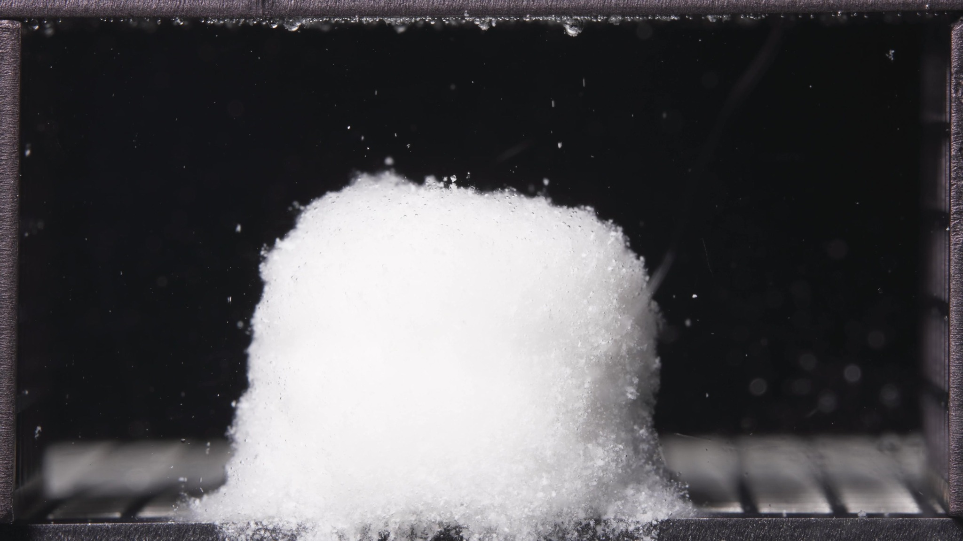 | 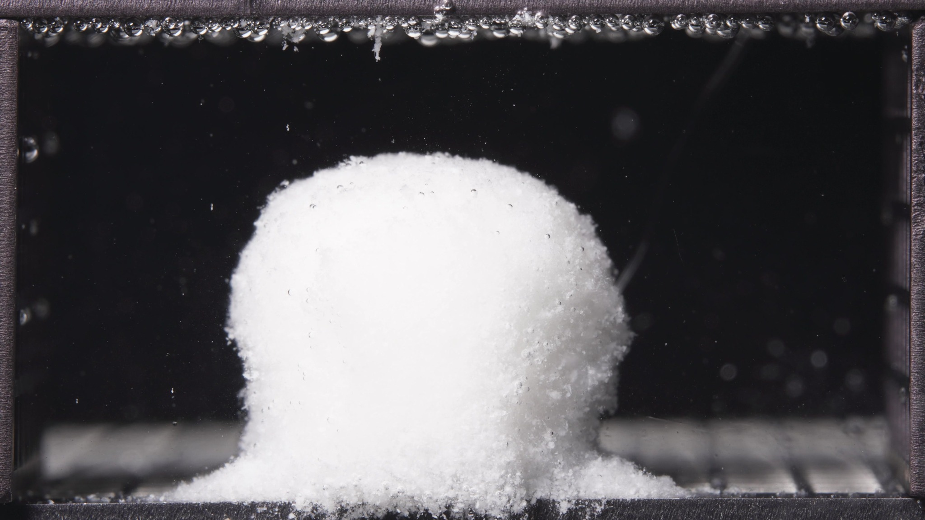 | 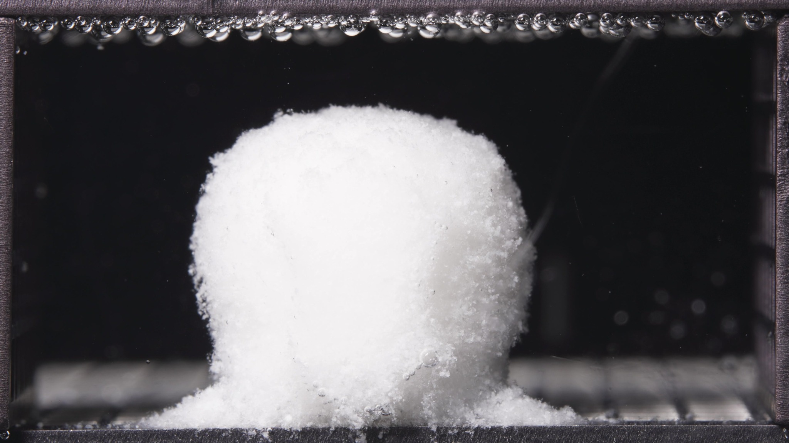

Turn 20 — Assistant
**High-viscosity formulation, 0.104-5 h window**

**Overall observation**
In this early window, the high-viscosity formulation has already converted from a dry compact tablet into a **single hydrated swollen body**, but it still shows **strong overall shape retention**. The matrix remains **upright, coherent, and column-like**, with only moderate top rounding and localized basal shedding. There is **no major breakup into large fragments** and no evidence of rapid collapse.

1. **Color change**
The body remains **uniformly white and opaque** across the batch. No internal discoloration, dark core exposure, or obvious layered contrast is visible. The surrounding medium remains **mostly clear**, with only sparse suspended particles.

2. **Shape change**
The overall mass remains a **single continuous body** with a **relatively upright cylindrical-to-columnar outline**. Within the window, the top evolves from a slightly flatter/irregular plateau toward a **more rounded dome**, but the gross geometry is still preserved. The sidewalls remain fairly full, and there is no clear splitting or large-scale deformation.

3. **Surface texture change**
The surface is **rough, granular, and hydrated**, especially along the outer edges. The boundary is softened compared with a dry tablet, but the body still looks compact at the macroscopic level. I do not see deep cracks or lamellar peeling; the dominant feature is **surface roughening with fine particulate loosening**.

4. **Volume change**
The visible body appears **swollen relative to an intact dry tablet**, indicating clear hydration. At the same time, the swelling is still associated with **shape retention rather than gross spherical expansion or collapse**. Within this batch, the occupied volume appears **maintained to mildly increased**, with no sign of major shrinkage.

5. **Dissolution speed and time**
Because no earlier high-viscosity window is available, strict rate comparison versus a previous window is not possible. Based on this batch alone, the formulation appears to be in an **early swollen-retention stage**, with **active hydration and limited external erosion**, but not a rapid fragmentation stage.

6. **Physical state change**
The formulation has shifted from a hard compact solid into a **hydrated, softened, cohesive matrix mass**. It appears as a **swollen porous/gel-like body with an eroding outer layer**, while still maintaining strong structural continuity.

7. **Dissolution medium**
The medium remains **largely clear** throughout the field of view. There is no broad turbidity cloud, no diffuse haze band, and no obvious large suspended debris plume. Since this time window spans the **pH 1.2 to pH 6.8 transition**, these images should be interpreted as an integrated early-stage morphology rather than separated pre- and post-switch states.

8. **Fragment distribution with density**
Detached material is concentrated mainly as a **localized powder-like accumulation at the base** of the body. Fragment distribution remains **highly localized near the original tablet position**, with minimal evidence of broad dispersion into the medium. No large detached blocks are visible.

**Most important note for later synthesis**
The key feature of the high-viscosity formulation in the 0.104-5 h window is **early swelling with strong structural retention**. The body remains **upright, coherent, and only moderately rounded**, while erosion is expressed mainly as **localized basal shedding** rather than rapid breakup or widespread dispersion. This indicates an early morphology dominated by **hydration with controlled external erosion and preserved matrix integrity**.

Turn 21 — User
These are pictures of the high-viscosity formulation during 6.25-11.25h.
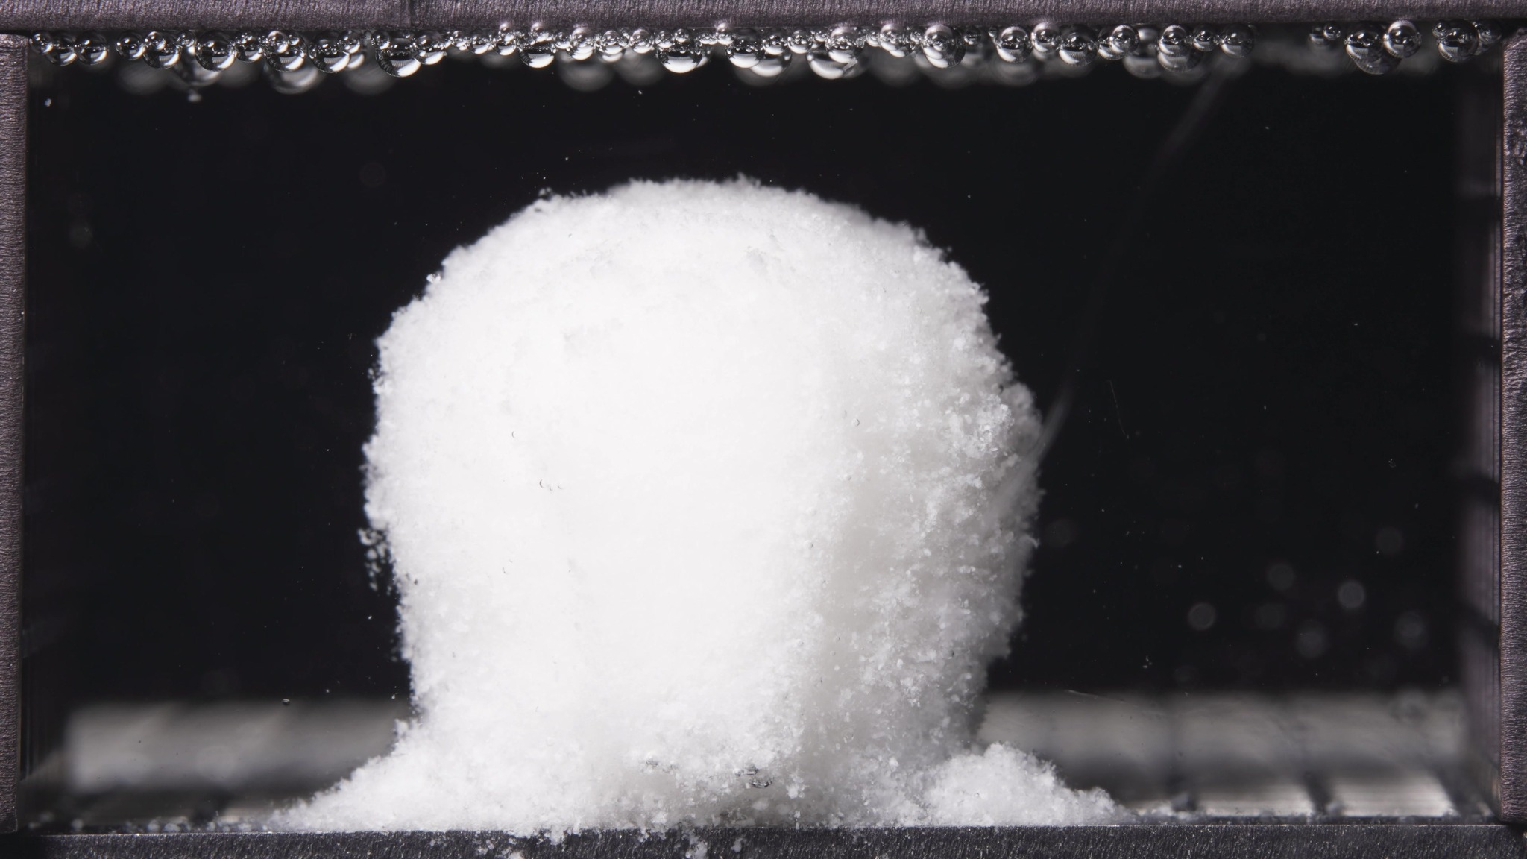 | 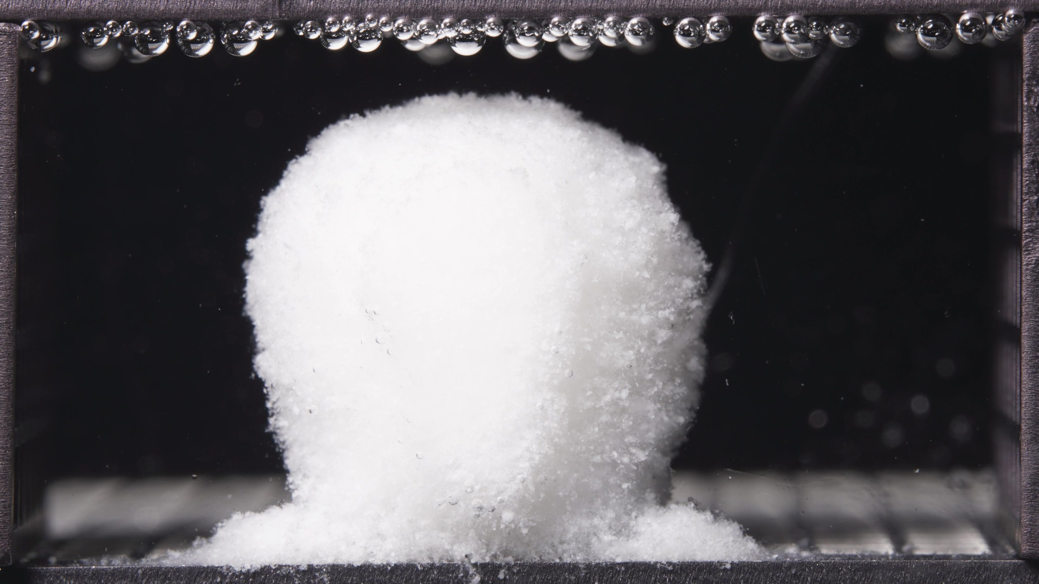 | 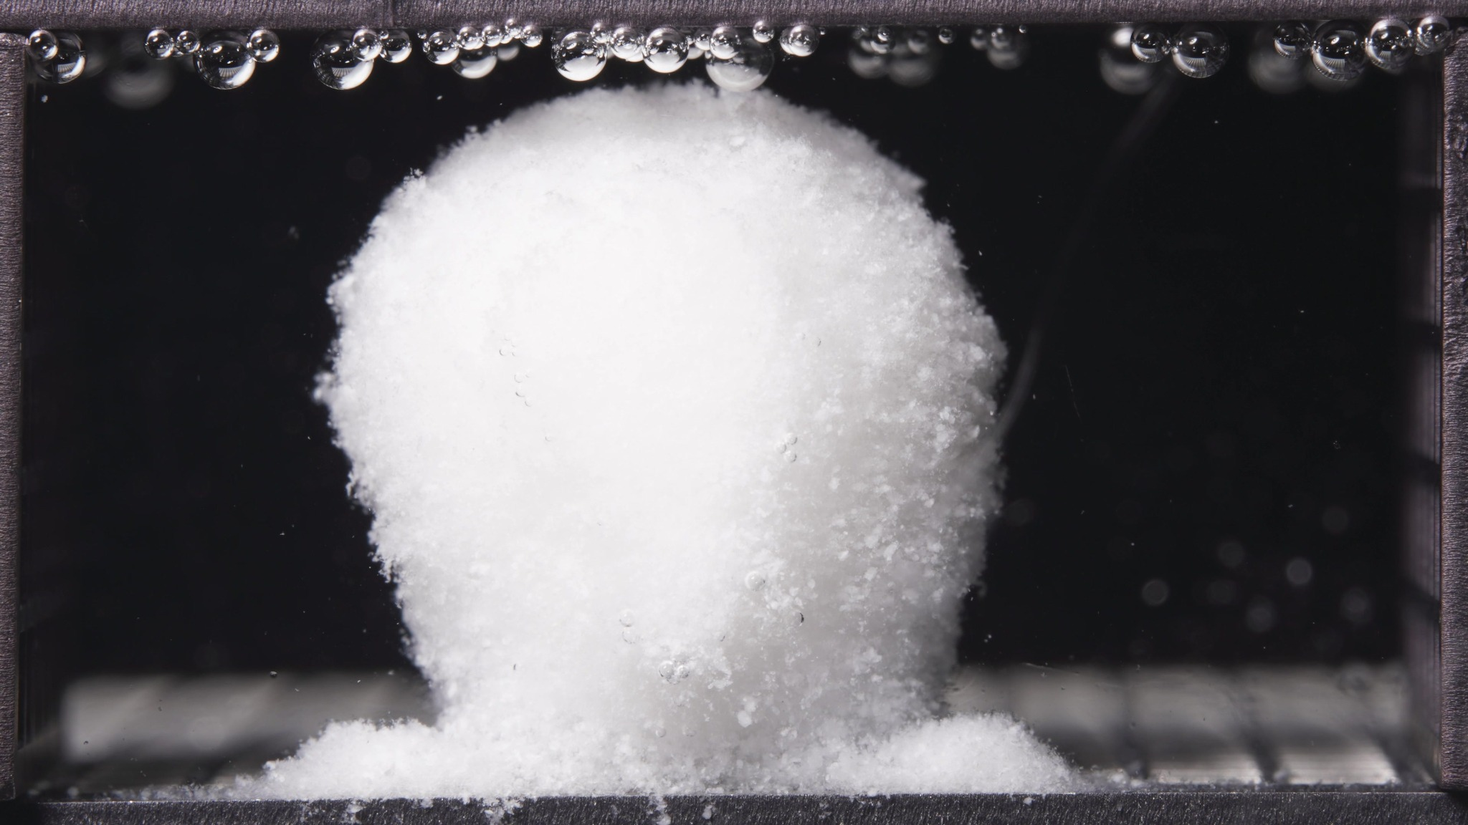

Turn 22 — Assistant
**High-viscosity formulation, 6.25-11.25 h window**

**Overall observation**
In this window, the high-viscosity formulation remains a **single, coherent, upright swollen matrix body**. Compared with 0.104-5 h, it shows **further hydration and mild top rounding**, but it still preserves a **more columnar, shape-retaining morphology** than a fully globular swollen mass. Erosion remains mainly **localized at the base and outer surface**, with no major fragmentation.

1. **Color change**
The body remains **uniformly white and opaque** throughout the batch. No dark core, discoloration, or obvious internal layering is visible. The surrounding medium remains **mostly clear**.

2. **Shape change**
The matrix remains **one continuous upright body**. Compared with the previous window, the top becomes **slightly more rounded and fuller**, but the overall geometry is still **columnar to dome-topped**, not collapsed or broadly spherical. There is no splitting and no large detached fragment formation.

3. **Surface texture change**
The surface remains **rough, granular, and hydrated**, especially along the outer margins. Relative to 0.104-5 h, the rough hydrated shell appears **more fully developed**, but the body still looks mechanically coherent. I do not see major deep cracks or peeling layers.

4. **Volume change**
The visible body remains **swollen and bulky**, with at most a **mild increase in apparent volume** versus the previous window. The dominant pattern is **swelling with retention**, not shrinkage or collapse.

5. **Dissolution speed and time**
Compared with 0.104-5 h, the formulation appears to have entered a **more established swollen-retention stage**. Hydration has progressed, but gross disintegration is still **slow and controlled**. The visible process is **continued swelling plus limited surface/basal erosion**, rather than rapid breakup.

6. **Physical state change**
The formulation remains a **cohesive swollen matrix / gel-like porous body**. Relative to the earlier window, it appears **more fully hydrated and slightly softer at the outer layer**, but the internal structural continuity is still well maintained.

7. **Dissolution medium**
The medium remains **largely clear across the field of view**, without a broad turbidity plume or heavy suspended particle cloud. Material release is still expressed mainly as **local erosion from the body surface**.

8. **Fragment distribution with density**
Detached material remains concentrated as a **localized powder-like bed around the base**, with slightly more visible accumulation than in the previous window, especially at the lateral bottom edges. Fragment distribution is still **highly localized near the original position**, with little evidence of broad dispersion.

**Most important change versus 0.104-5 h**
The key change is **further swelling and top rounding without loss of upright structural integrity**. In other words, during 6.25-11.25 h the high-viscosity formulation progresses into a **more mature hydrated state**, but still shows **strong matrix retention and only localized basal/surface erosion**, with no catastrophic collapse or wide fragment spread.

Turn 23 — User
These are pictures of the high-viscosity formulation during 12.5-17.5h.
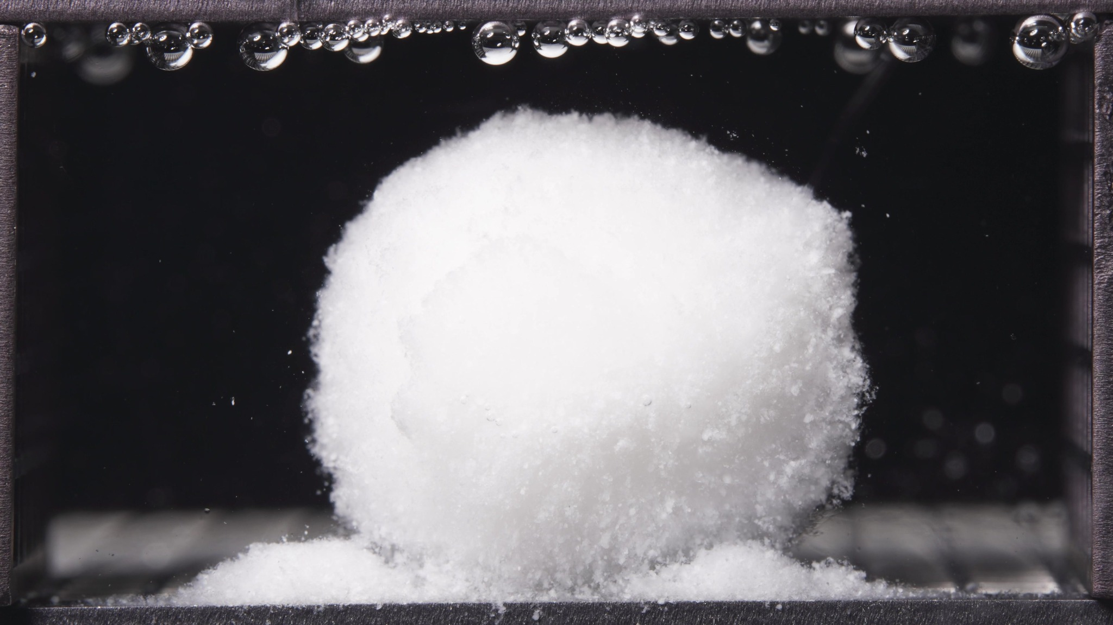 | 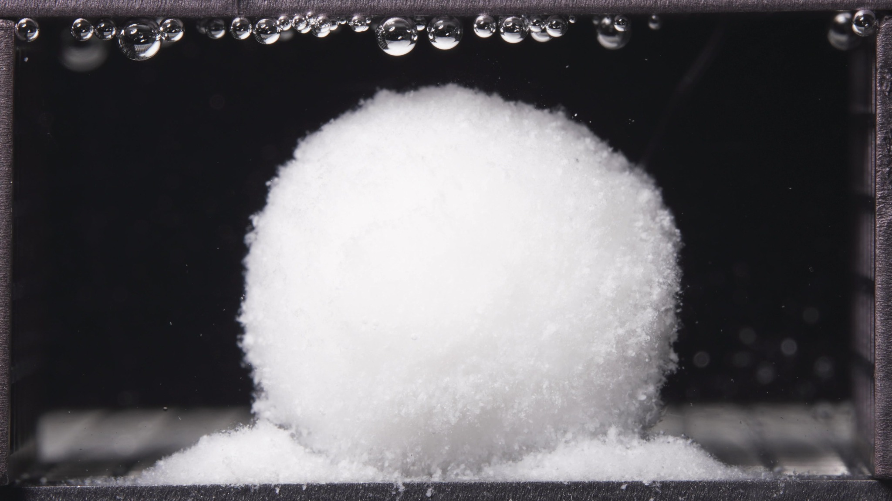 | 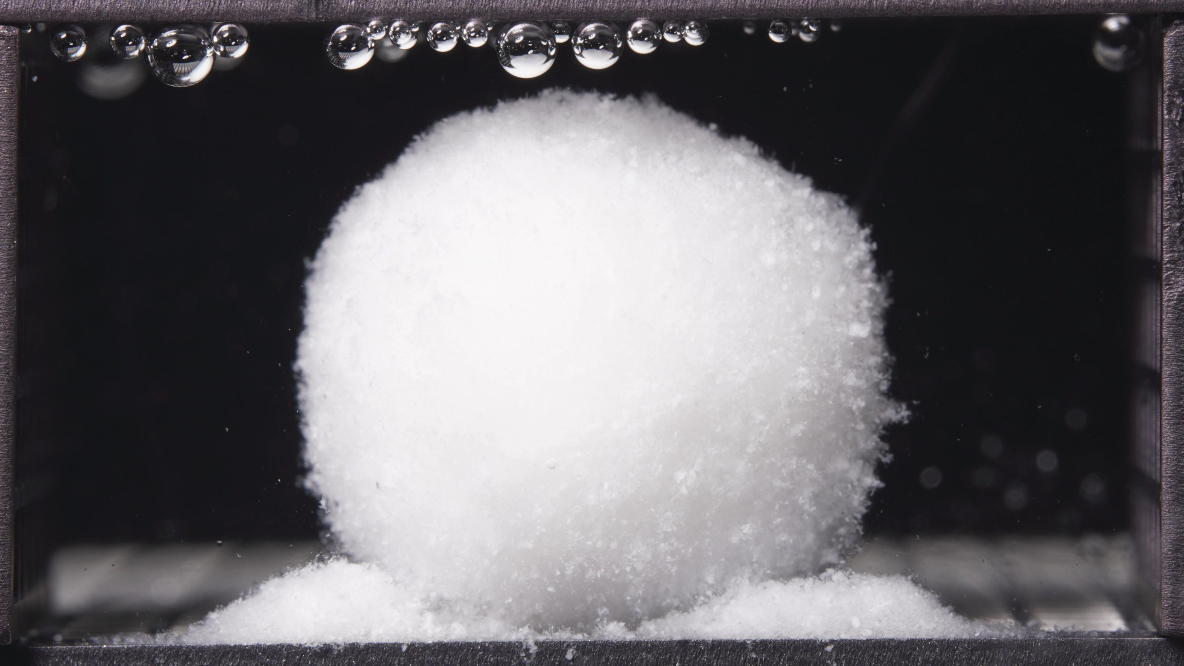

Turn 24 — Assistant
**High-viscosity formulation, 12.5-17.5 h window**

**Overall observation**
In this window, the high-viscosity formulation still remains a **single, cohesive, highly swollen hydrated body**. Compared with 6.25-11.25 h, the matrix appears **broader, fuller, and more globular**, but it still preserves **strong structural integrity**. Erosion is still expressed mainly as **local basal accumulation and surface roughening**, without major fragmentation or collapse.

1. **Color change**
The body remains **uniformly white and opaque** throughout the batch. No dark core, obvious discoloration, or clear internal stratification is visible. The surrounding medium remains **visually clear**, with no broad whitening or clouding.

2. **Shape change**
The matrix remains **one continuous swollen mass**. Compared with the previous window, the shape has shifted from a more **upright dome-topped column** toward a **larger, rounder, more globular body**. Even so, the outline is still well preserved, and there is **no splitting, no large detached fragment formation, and no catastrophic collapse**.

3. **Surface texture change**
The surface remains **rough, granular, and hydrated**, especially along the side boundaries and lower edge. Compared with 6.25-11.25 h, the outer contour looks **more uniformly swollen**, but it is still clearly particulate rather than smooth. I do not see major cracks, fissures, or peeling layers.

4. **Volume change**
The visible body remains **large and strongly swollen**. Compared with the previous window, the occupied volume appears **maintained to slightly increased**, mainly through fuller lateral expansion and rounding. There is no evidence of major bulk shrinkage or collapse.

5. **Dissolution speed and time**
Compared with 6.25-11.25 h, the formulation appears to remain in a **stable swollen-retention stage**. Hydration has progressed further, but gross disintegration is still **slow and controlled**. The main process is **continued swelling with gradual local erosion**, not rapid breakup.

6. **Physical state change**
The formulation remains a **cohesive swollen matrix / gel-like porous mass**. Relative to the previous window, it appears **more fully hydrated and more plastically deformed into a rounded body**, while still maintaining strong internal continuity. It has not transitioned into a dispersed particle cloud.

7. **Dissolution medium**
The medium remains **largely clear across the field of view**. There is no broad turbidity plume, no obvious cloud band, and no strong suspended debris field. Material release is still manifested mainly through **local erosion near the tablet body** rather than bulk-medium dispersion.

8. **Fragment distribution with density**
Detached material remains concentrated as a **dense powder-like bed at the base**, with visible accumulation on both sides of the swollen body. Compared with the previous window, this basal deposit appears **more established and slightly more laterally spread**, but fragments remain **localized near the original position**. No wide transport or suspension is evident.

**Most important change versus 6.25-11.25 h**
The key change is the transition toward a **broader, more globular swollen body with continued strong coherence**. In other words, during 12.5-17.5 h the high-viscosity formulation continues to **retain its matrix structure while swelling further**, and erosion remains **localized at the surface and base** rather than progressing to catastrophic fragmentation.

Turn 25 — User
These are pictures of the high-viscosity formulation during 18.75-23.75h.
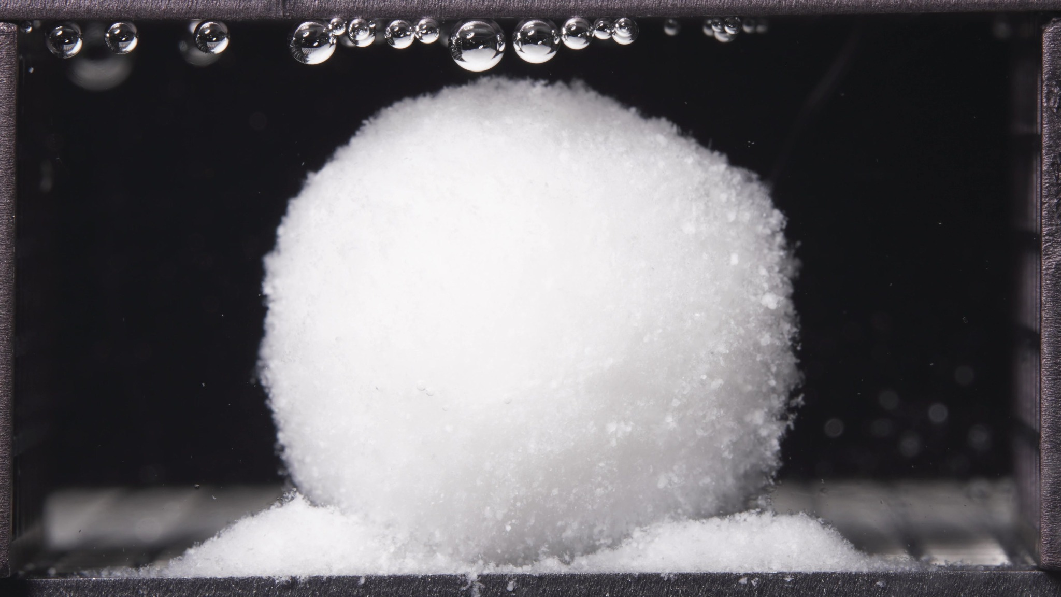 | 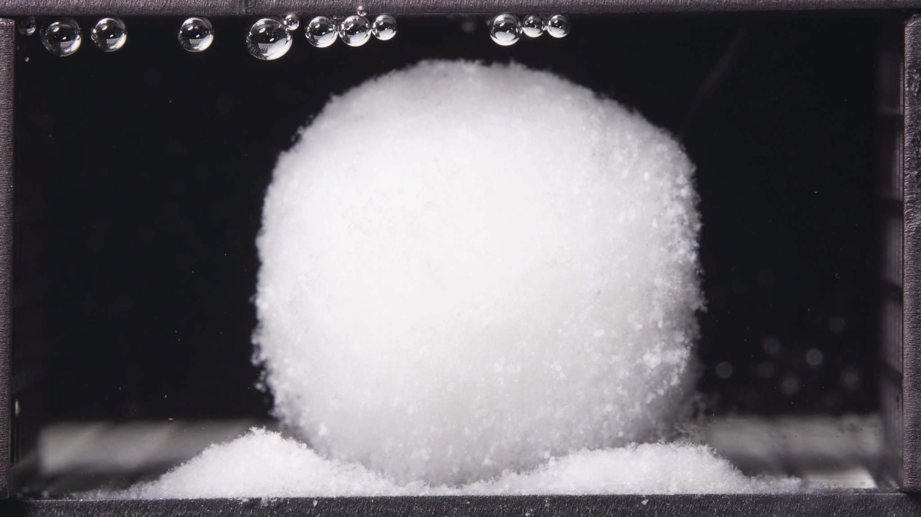 | 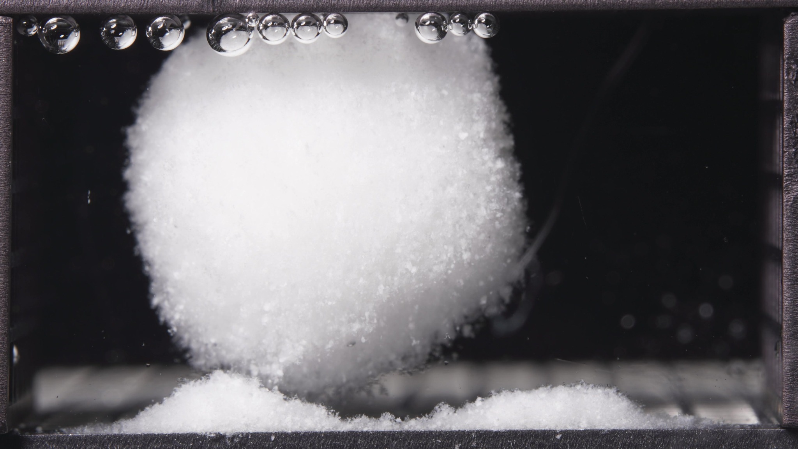

Turn 26 — Assistant
**High-viscosity formulation, 18.75-23.75 h window**

**Overall observation**
In the late stage, the high-viscosity formulation still persists as a **single, large, coherent swollen matrix body**. Compared with 12.5-17.5 h, the body appears **slightly more rounded and more globular**, while maintaining **strong structural integrity**. Erosion is still mainly expressed as **localized basal shedding and powder-bed growth**, not catastrophic breakup or broad dispersion.

1. **Color change**
The matrix remains **uniformly white and opaque** throughout the batch. No dark core, internal discoloration, or obvious layered tonal change is visible. The surrounding medium remains **visually clear**.

2. **Shape change**
The body remains **one continuous swollen mass**. Relative to the previous window, the outline appears **more regular and more near-spheroidal**, with less of the earlier asymmetric broadening. There is no visible splitting, no large detached fragment formation, and no gross collapse. The lower boundary still shows a **narrower contact/erosion zone** above the basal deposit.

3. **Surface texture change**
The surface remains **rough, fine-granular, and hydrated**, especially along the right edge and lower periphery. Compared with 12.5-17.5 h, the contour appears **slightly more uniform**, but it is still clearly particulate rather than smooth. No major cracks, fissures, or peeling layers are evident.

4. **Volume change**
The visible body remains **very large and strongly swollen**. Compared with the previous window, there is **no obvious major volume loss**. If anything, the dominant impression is **continued swollen-volume retention with slight reshaping toward a more compact rounded geometry**, rather than collapse.

5. **Dissolution speed and time**
Compared with 12.5-17.5 h, visible disintegration appears **slow and sustained**, not accelerated. The late-stage process is dominated by **morphological persistence with gradual local erosion**, indicating that the formulation remains in a **stable swollen-retention phase** rather than entering terminal breakup.

6. **Physical state change**
The formulation remains a **cohesive swollen matrix / gel-like porous mass**. Relative to the previous window, the physical state is essentially **maintained**, with perhaps slightly greater rounding and continued softening at the bottom interface, but no conversion into a dispersed particle cloud.

7. **Dissolution medium**
The medium remains **largely clear across the field of view**. There is no broad turbidity plume, no diffuse haze band, and no strong suspended debris cloud. Material release is still manifested mainly as **local erosion near the matrix body** rather than bulk-medium contamination.

8. **Fragment distribution with density**
Detached material remains concentrated as **dense powder-like deposits at the base**, with visible mounds on both sides and a more open lower-center region beneath the swollen body. Compared with the previous window, the basal deposits appear **more established**, but fragment distribution is still **highly localized near the original tablet position**. No wide dispersion is evident.

**Most important change versus 12.5-17.5 h**
The key change is **not fragmentation**, but **further regularization into a more globular swollen body while preserving strong coherence**. In other words, during 18.75-23.75 h the high-viscosity formulation remains in a **late swollen-retention plateau**, with **continued local basal erosion and powder accumulation** but **no catastrophic collapse or broad fragment spread**.

Turn 27 — User
Provide an integrated mechanistic interpretation of the observed disintegration behavior of the three gliclazide formulations.

The three formulations are the low-viscosity formulation, the standard formulation (medium-viscosity), and the high-viscosity formulation, and their main formulation difference lies in the ratio between HPMC K4M and HPMC 100lv.

Our optimization goal is to adjust the ratio between HPMC K4M and HPMC 100lv so that the 24-hour release amount of the standard-viscosity gliclazide tablet is reduced to 90% of its original level.

In addition to the image-based disintegration observations, please also use the UV absorbance data from the flow-through-cell eluate as semi-quantitative release evidence.

All UV absorbance values are within the linear range.

The interval sequence is: 0–0.5 h, 0.5–1 h, 1–2 h, 2–4 h, 4–6 h, 6–8 h, 8–12 h, 12–16 h, 16–20 h, and 20–24 h.

The corresponding mean UV absorbance values are as follows:

Low-viscosity formulation: 0.153, 0.233, 0.361, 0.666, 0.776, 0.878, 0.860, 0.894, 0.927, 0.770.

Standard formulation: 0.194, 0.204, 0.336, 0.656, 0.775, 0.741, 0.776, 0.820, 0.761, 0.647.

High-viscosity formulation: 0.155, 0.143, 0.204, 0.483, 0.580, 0.582, 0.573, 0.689, 0.632, 0.540.

Please:
1) Summarize the key differences in disintegration behavior across the three formulations as evidence statements.
2) Using the literature and the current session data, focus on explaining how differences in the HPMC K4M / HPMC 100lv ratio may influence swelling, gel-layer formation, erosion, fragmentation, shell persistence, and other observed disintegration phenomena.
3) Relate the observed disintegration phenomena to the interval-based UV absorbance trends, and state whether the image-based evidence and the UV-based evidence are mutually supportive, partially aligned, or inconsistent.
4) Propose 2–5 mechanistic hypotheses, each clearly tied to the observed phenomena, the UV trends, and the HPMC ratio differences.
5) Explain what these mechanistic differences may imply for helping the standard-viscosity gliclazide tablet achieve 90% of its original 24-hour release amount within 24 hours, so that the result can support the next-step formulation optimization.
6) List alternative explanations and a minimal set of follow-up tests to discriminate between hypotheses.

Use only information from this session and the retrieved literature; do not invent missing details.

Do not provide a final optimized formulation recipe in this step.

Turn 28 — Assistant
## Phenomenon Review

**Evidence statements from the image series**

1. **All three formulations formed persistent swollen matrix bodies rather than rapidly fragmenting tablets.** Across 24 h, each formulation remained as a single coherent white hydrated mass with only localized powder-like shedding and basal deposits. The dominant visible process was **swelling + shell persistence + local erosion**, not catastrophic breakup.

2. **The low-viscosity formulation transitioned earliest to a rounded/globular swollen body and showed the strongest ongoing peripheral/basal shedding.** It looked less columnar earlier than the other two and maintained a broad swollen mass with continuous local erosion through late time points.

3. **The standard formulation was morphologically intermediate, but it showed the clearest basal undercutting / “suspended-shell” behavior.** Its shell stayed coherent while erosion appeared concentrated at the bottom interface, especially from the mid stage onward.

4. **The high-viscosity formulation retained upright/shape-preserving morphology the longest and then evolved into the most coherent late globular swollen body.** It also generated basal powder beds, but its overall matrix integrity appeared strongest.

5. **Medium-wide turbidity and large-fragment dispersion were limited in all three formulations.** That matters mechanistically: the main inter-formulation differences are better interpreted as differences in **gel formation, shell persistence, local erosion, and diffusional resistance**, not differences in gross fragmentation.

## Concentration-Time Trend Review

Using the interval UV absorbance values as semi-quantitative release evidence, the overall 24 h integrated absorbance ranks **low-viscosity > standard > high-viscosity**: **6.518**, **5.910**, and **4.581**, respectively. A 90% target for the current standard corresponds to **5.319**. So the target lies **closer to the current standard than to the high-viscosity formulation**: the standard would need a **10%** reduction, whereas the high-viscosity formulation is already about **22.5% lower** than the standard. citeturn2calculator0turn2calculator1turn2calculator2turn2calculator3turn4calculator4turn7calculator0turn7calculator1

At the **very first interval (0–0.5 h)**, the standard formulation is slightly highest (0.194 vs 0.153 low and 0.155 high). After that, the ordering becomes stable: from **0.5 h onward, low-viscosity is generally highest, standard is intermediate, and high-viscosity is lowest**. By 0–4 h the low and standard are still close (**1.413 vs 1.390**), while the high-viscosity formulation is already clearly lower (**0.985**). By late intervals, the separation remains strong: the summed 8–24 h absorbance is **3.451** for low, **3.004** for standard, and **2.434** for high. citeturn3calculator0turn3calculator1turn3calculator2turn3calculator6turn3calculator7turn3calculator8

**Interpretation of alignment:** the image and UV evidence are **overall mutually supportive, with one early partial-alignment caveat**. The broad morphological ranking from the images — low as the least shape-retentive / most erosion-prone, high as the most persistent, standard as intermediate — matches the UV ranking after 0.5 h. The main limitation is that the first image window spans **0.104–5 h**, so it cannot isolate the **0–0.5 h** microphase where the standard shows a slightly higher early absorbance. That early difference is therefore only **partially resolved** by the images.

## Literature-Supported Typical Mechanistic Links

Hydrophilic HPMC matrix tablets typically control release through **water ingress, polymer swelling, gel-layer formation, diffusion through the hydrated barrier, and matrix erosion**. The mechanical/viscoelastic quality of the swollen gel layer is not incidental; it can materially influence release rate. ([pubmed.ncbi.nlm.nih.gov](https://pubmed.ncbi.nlm.nih.gov/27808590/?utm_source=chatgpt.com))

The viscosity grade of HPMC is mechanistically important. Literature comparing low- and high-viscosity HPMC matrices shows that **lower-viscosity grades can produce faster matrix dissolution, swelling inhomogeneity, and higher apparent diffusivity/release**, while **higher-viscosity grades tend to slow HPMC release/erosion and support a more persistent barrier state**. Studies using low-viscosity vs ~4000 cP HPMC specifically report slower polymer release and altered hydration behavior for the higher-viscosity systems. ([pubmed.ncbi.nlm.nih.gov](https://pubmed.ncbi.nlm.nih.gov/8818998/?utm_source=chatgpt.com))

Literature on HPMC/lactose systems also shows that **matrix robustness depends strongly on polymer-network continuity**: below critical HPMC-rich conditions, matrices can erode/disintegrate faster and less robustly; above that, integrity is better maintained. In your case, total HPMC load is essentially constant across the three formulations, so the more relevant mechanistic lever is not total HPMC amount, but the **distribution of that total between lower-viscosity HPMC 100lv and higher-viscosity HPMC K4M**. ([pubmed.ncbi.nlm.nih.gov](https://pubmed.ncbi.nlm.nih.gov/20600400/?utm_source=chatgpt.com))

For gliclazide specifically, the retrieved literature supports two points relevant here: it is a **poorly water-soluble drug**, and release from a matrix system is sensitive to structural variables such as **porosity and geometry**. That means the image-observed differences in shell persistence, rounding, and basal erosion are mechanistically capable of producing real release differences in the UV data. ([pubmed.ncbi.nlm.nih.gov](https://pubmed.ncbi.nlm.nih.gov/33489711/?utm_source=chatgpt.com))

The literature support is therefore strong for the **general HPMC-matrix mechanisms**, but indirect for the exact combination of **gliclazide + K4M/100lv ratio + your flow-through-cell setup**. The mechanistic reading below should be treated as **literature-supported but still case-specific and tentative**.

## Tentative Integrated Mechanistic Interpretation Across the Three Formulations

Because the three formulations keep **total HPMC nearly constant** while changing the **K4M/100lv balance**, the most parsimonious interpretation is that you are tuning the balance between **fast initial hydration / weaker barrier persistence** and **slower-forming but stronger, longer-lived gel resistance**.

**Hypothesis 1 — dual-timescale gel hypothesis.**
HPMC 100lv likely contributes more to **rapid hydration and early swelling**, whereas HPMC K4M contributes more to **late gel strength / shell persistence / erosion resistance**. Under that interpretation, the low-viscosity formulation forms a hydrated mass quickly but builds a **less durable diffusional-erosional barrier**, so it rounds early and keeps shedding material, which is consistent with its higher UV output after 0.5 h and its highest 24 h integrated absorbance. The high-viscosity formulation sits at the opposite end: slower effective release because the swollen matrix remains more resistant to erosion and maintains a stronger shell. This direction is consistent with the general HPMC literature. ([pubmed.ncbi.nlm.nih.gov](https://pubmed.ncbi.nlm.nih.gov/8818998/?utm_source=chatgpt.com))

**Hypothesis 2 — shell-persistence / bottom-erosion partitioning hypothesis.**
The standard formulation may not be “intermediate” simply because everything happens halfway; instead, it may produce a shell that is **strong enough to remain coherent** but **vulnerable to localized bottom-interface erosion**, giving the distinctive suspended-shell morphology. That would explain why its UV profile is intermediate: drug release is not driven by gross breakup, but by a mixed mechanism in which the shell persists while the bottom interface opens a localized erosion/diffusion pathway. This is consistent with the image sequence better than a fragmentation-driven explanation.

**Hypothesis 3 — surface-renewal hypothesis for the low-viscosity system.**
The low-viscosity formulation’s earlier rounding and continuous peripheral/basal shedding may continuously **renew the outer gel/erosion front**, preventing the diffusional path from becoming as restrictive as in the standard and high-viscosity systems. That would fit its sustained higher absorbance in the 4–20 h region. In contrast, the high-viscosity formulation appears to preserve a more stable hydrated shell, so the release flux remains lower.

**Hypothesis 4 — robustness-under-flow hypothesis.**
Under identical flow-through conditions, the higher-K4M matrix likely has greater **hydrodynamic robustness** than the 100lv-rich matrix, while the standard remains intermediate. The images support that all three are robust enough to avoid catastrophic disintegration, but the degree of robustness differs. The literature also links stronger gel strength and slower erosion to more robust release behavior under external hydrodynamic stress. ([pubmed.ncbi.nlm.nih.gov](https://pubmed.ncbi.nlm.nih.gov/27808590/?utm_source=chatgpt.com))

Taken together, the three formulations appear to lie on a **continuum**:

- **Low-viscosity formulation:** fastest effective release after the early phase; earlier globularization; more sustained local erosion; weakest long-lived barrier.
- **Standard formulation:** intermediate release; coherent shell with pronounced basal undercutting; a mixed diffusion/erosion phenotype.
- **High-viscosity formulation:** slowest effective release; longest shape retention and strongest shell persistence; lowest overall UV output.

## Mechanistic Implications for the Next Optimization Step

For the specific optimization goal — **reduce the 24 h release of the current standard to 90% of its original level without giving a final recipe yet** — the current session suggests that the desired next phenotype is **not** the full high-viscosity phenotype. The high-viscosity formulation appears to slow release **too much overall** relative to the requested 10% reduction target. The target is mechanistically closer to the current standard than to the high-viscosity extreme. citeturn2calculator1turn2calculator2turn2calculator3turn7calculator0turn7calculator1

So, mechanistically, the useful direction is probably a **modest shift of the standard toward greater shell persistence / lower erosion rate**, rather than a wholesale move to the high-viscosity behavior. In practical mechanistic terms, the next iteration would likely aim for:

- a **slightly longer-lived gel barrier** than the current standard,
- **slightly less mid-phase local erosion / bottom-interface undercutting**,
- but **not** such a strong barrier that the system becomes as slow as the high-viscosity formulation.

The interval UV pattern suggests that the most influential windows are likely the **post-1 h to mid-stage intervals**, not only the very first interval. The first 0–0.5 h difference is small and visually under-resolved, whereas the persistent low > standard > high ordering from later intervals is much more substantial. Mechanistically, that means the optimization target is more likely to be achieved by tuning **mid-stage shell persistence and erosion balance** than by focusing only on a tiny early burst effect.

## Suggestions for Further Validation

**Alternative explanations that should remain on the table**

1. The observed UV differences may not arise only from the HPMC ratio; they could also reflect small differences in **tablet porosity, compression state, or internal drug spatial distribution**.
2. The standard formulation’s suspended-shell appearance may partly reflect **apparatus-position or local hydrodynamic asymmetry** rather than a purely formulation-intrinsic erosion mode.
3. The early standard 0–0.5 h UV advantage may reflect an **initial surface-accessible drug fraction** that the broad 0.104–5 h image window cannot resolve.
4. The late decline in interval absorbance for all three formulations may reflect **lower residual releasable drug and/or longer diffusional path length**, not only slower erosion.

**Minimal discriminator tests**

1. **Replicate matched-ratio dissolution with true cumulative release calculation**
Keep the same three HPMC ratios and confirm whether the low > standard > high ranking and the standard’s slight early lead are reproducible. This is the fastest way to test whether the current ordering is robust.

2. **Water uptake / wet mass / dry mass-loss (erosion) profiling**
Measure swelling and erosion directly at matched time points. This is the most direct way to discriminate “faster erosion” from “similar swelling but different diffusion barrier.”

3. **Gel-layer thickness or gel-strength measurement on swollen tablets**
Texture analysis, optical front tracking, NIR imaging, or related methods would directly test whether the standard truly occupies an intermediate gel-strength state and whether the high-viscosity system forms the most persistent barrier. Literature indicates these measurements are mechanistically informative for HPMC matrices. ([pubmed.ncbi.nlm.nih.gov](https://pubmed.ncbi.nlm.nih.gov/27808590/?utm_source=chatgpt.com))

4. **Constant-pH control runs (1.2-only and 6.8-only) or a tighter early-time imaging schedule**
This would separate the effect of the **pH switch** from the polymer-ratio effect and resolve the current uncertainty around the first interval.

5. **Orientation / hydrodynamic robustness check**
Repeat imaging with controlled tablet orientation or altered local hydrodynamics to determine whether the basal undercutting seen most clearly in the standard formulation is intrinsic or setup-amplified.

Turn 29 — User
Provide a formulation optimization recommendation for the next iteration based on the existing formulation information, optimization target, concentration-time summary, mechanistic analysis results, and prior disintegration-analysis conclusions in this session.

The three formulations are the low-viscosity formulation, the standard formulation (medium-viscosity), and the high-viscosity formulation. The standard formulation is the reference formulation.

Our optimization goal is to adjust the ratio between HPMC K4M and HPMC 100lv so that the standard-viscosity gliclazide tablet is reduced to 90% of its original 24-hour release amount within 24 hours.

Please integrate the prior evidence rather than repeating the earlier full image-analysis or mechanistic-analysis process. You MUST provide a next-step formulation proposal with explicit numeric values, especially for HPMC K4M and HPMC 100lv.

Please:
1) Briefly summarize which current formulation tendency appears closer to the optimization target and which tendencies appear too fast or too slow.
2) Propose one next-step optimized formulation anchored on the standard formulation and adjusted mainly through the balance between HPMC K4M and HPMC 100lv.
3) You MUST explicitly report the proposed HPMC K4M amount, the proposed HPMC 100lv amount, the proposed HPMC K4M:HPMC 100lv ratio, and the percentage change of each relative to the standard formulation.
4) Even if the evidence is not sufficient to justify a fully validated exact formula, you MUST still provide a best-estimate next-iteration formulation proposal with explicit numeric values and percentage changes, and clearly label it as tentative rather than omitting the numbers.

Use only information from this session and the retrieved literature if already available; do not invent missing details.

Do not output a same/different judgment.

Do not simply restate previous node outputs without synthesis.

Output the result in a clear structured format with the following sections:
Optimization Target Review
Evidence Summary from Existing Formulations
Recommended Next Formulation
Uncertainty and Validation Needs

Under “Recommended Next Formulation”, directly report:
- Proposed HPMC K4M amount = X
- Proposed HPMC 100lv amount = Y
- Proposed HPMC K4M:HPMC 100lv ratio = X:Y
- Percentage change of HPMC K4M relative to the standard formulation = Z%
- Percentage change of HPMC 100lv relative to the standard formulation = W%
- A short rationale for why this ratio is recommended

Turn 30 — Assistant
## Optimization Target Review

The target is to adjust the **standard formulation** so that its **24-hour release is reduced to 90% of its current level**.

Using the session UV absorbance series as semi-quantitative 24-hour release evidence:

- Current standard formulation total interval absorbance = **5.910**
- Targeted 90% level = **5.319**
- Low-viscosity formulation total = **6.518**
- High-viscosity formulation total = **4.581**

This places the target **between the current standard and the high-viscosity formulation, but closer to the current standard**. Mechanistically, the current tendencies can be read as:

- **Low-viscosity tendency:** release behavior is too fast
- **High-viscosity tendency:** release behavior is too slow
- **Standard tendency:** already near the desired region, but still somewhat too fast overall for the stated 24 h target

## Evidence Summary from Existing Formulations

Across the session, the three formulations form a consistent continuum when the **HPMC K4M / HPMC 100lv balance** is shifted:

- The **low-viscosity formulation** showed earlier globular swelling and more sustained local erosion/shedding, and it also produced the **highest UV absorbance profile overall**. That combination supports a **weaker long-lived release barrier**.
- The **standard formulation** showed an intermediate phenotype, with a coherent swollen shell plus noticeable **basal undercutting / local bottom-interface erosion**, and an intermediate UV profile.
- The **high-viscosity formulation** showed the strongest matrix persistence and the **lowest UV output overall**, consistent with a **more persistent gel barrier and slower effective release**.

So, the useful optimization direction is **not a large jump to the high-viscosity extreme**, but rather a **moderate shift from the standard formulation toward slightly greater K4M contribution and slightly lower HPMC 100lv contribution**.

A practical way to estimate that shift is to move only part of the distance from the standard formulation toward the high-viscosity formulation. Based on the 24 h UV totals, the required reduction from the standard is about **44.5% of the standard-to-high gap**, so the next trial should be a **partial move toward the high-viscosity balance**, not a full move.

## Recommended Next Formulation

**Tentative next-iteration proposal, anchored on the standard formulation**

All non-HPMC components should be **kept the same as the current standard formulation** for this next iteration unless there is a separate reason to change them.

- **Proposed HPMC K4M amount = 3.28**
- **Proposed HPMC 100lv amount = 2.03**
- **Proposed HPMC K4M:HPMC 100lv ratio = 3.28:2.03 (about 1.62:1)**
- **Percentage change of HPMC K4M relative to the standard formulation = +31.0%**
- **Percentage change of HPMC 100lv relative to the standard formulation = -27.6%**
- **A short rationale for why this ratio is recommended:** this is a deliberate partial shift from the standard formulation toward the high-viscosity direction, intended to strengthen gel-layer persistence and reduce mid/late erosion-driven release enough to approach the 90% target, without overshooting into the slower-release behavior seen in the current high-viscosity formulation.

## Uncertainty and Validation Needs

This is a **tentative best-estimate formulation proposal**, not a validated final formula.

The stronger parts of the evidence are:

- the consistent UV ranking: **low > standard > high**
- the consistent image/mechanistic ranking: **low = weaker barrier, standard = intermediate, high = more persistent barrier**

The main uncertainties are:

- the relationship between **HPMC ratio and 24 h release may not be perfectly linear**
- the standard formulation’s early release behavior may include a small early-phase effect that the broad image windows do not fully resolve
- local basal erosion behavior may be somewhat sensitive to run-to-run hydrodynamics

The minimum next validation step should be:

1. Prepare this proposed formulation with **all non-HPMC ingredients unchanged from the standard**
2. Repeat the **same 24 h flow-through-cell UV run**
3. Confirm whether the total 24 h release moves close to the **5.319 target-equivalent region**
4. Check whether the image phenotype shifts from the current standard toward **slightly stronger shell persistence and slightly reduced basal erosion**, but without becoming as slow as the current high-viscosity formulation

Turn 31 — User
Export all of our conversation content as a DOC file named after the conversation title.

