Gliclazide HPMC Disintegration Analysis and Optimization
Conversation export as a Word document
Note: I do not have direct access to the chat UI title, so the filename uses an inferred conversation title based on the actual topic. Internal tool calls and hidden system/developer messages are not part of the visible conversation transcript and are therefore omitted.

Turn 1: User
"We are analyzing the static disintegration images of three self-made gliclazide matrix tablet formulations with different HPMC ratios."
"All images were captured under the same experimental conditions."
"The dissolution medium is initially pH 1.2, and after 1 hour it is switched to pH 6.8."
"The experiment was conducted at a controlled temperature of 38 °C to simulate a slightly elevated physiological condition."
"The system is a flow-through cell with a flow rate of 1 mL/min."
"The total observation period is 24 h. Images were captured continuously and later sampled into batches."
"Each message you receive contains multiple images representing a time window (e.g., 0–6 h, 6–12 h, 12–18 h, 18–24 h)."
"Treat the images within the same window as observations from that time range rather than a single exact time point."
"These three formulations are all gliclazide tablets, and their main difference lies in the ratio between HPMC K4M and HPMC 100lv."
"The first formulation is the low-viscosity formulation. In this formulation, gliclazide is 4.505, silicon dioxide is 0.049, magnesium stearate is 0.174, microcrystalline cellulose is 7.503, lactose is 7.504, HPMC K4M is 1.058, and HPMC 100lv is 4.248."
"The second formulation is the standard formulation, which is also the medium-viscosity formulation. In this formulation, gliclazide is 4.493, silicon dioxide is 0.049, magnesium stearate is 0.162, microcrystalline cellulose is 7.503, lactose is 7.506, HPMC K4M is 2.504, and HPMC 100lv is 2.808."
"The third formulation is the high-viscosity formulation. In this formulation, gliclazide is 4.500, silicon dioxide is 0.049, magnesium stearate is 0.162, microcrystalline cellulose is 7.495, lactose is 7.504, HPMC K4M is 4.252, and HPMC 100lv is 1.063."
"Our optimization goal is to adjust the ratio between HPMC K4M and HPMC 100lv so that the 24-hour release amount of the standard-viscosity gliclazide tablet is reduced to 90% of its original level."
"Please treat all images as coming from these three related gliclazide formulations, and use this background information when interpreting the disintegration behavior and describing the eight dimensions of disintegration."
"Concentration-time information will be provided later after the image-analysis stage, so for now please focus on the image-based disintegration behavior under the current experimental and formulation background."

Turn 2: Assistant
{
"experiment_config": {
"medium_pH": "initially pH 1.2, switched to pH 6.8 after 1 hour",
"temperature_C": 38,
"total_duration_hours": 24,
"time_interval_hours": null,
"other_conditions": "All images were captured under the same experimental conditions. The system is a flow-through cell with a flow rate of 1 mL/min. Images were captured continuously and later sampled into batches. Each message contains multiple images representing a time window (e.g., 0–6 h, 6–12 h, 12–18 h, 18–24 h). Images within the same window should be treated as observations from that time range rather than a single exact time point."
},
"formulation_info": {
"formulation_1": {
"formulation_name": "low-viscosity formulation",
"sample_id": null,
"composition": "gliclazide is 4.505, silicon dioxide is 0.049, magnesium stearate is 0.174, microcrystalline cellulose is 7.503, lactose is 7.504, HPMC K4M is 1.058, and HPMC 100lv is 4.248",
"excipients_or_polymer_info": "This formulation is one of three related gliclazide matrix tablets. The main difference among the three formulations lies in the ratio between HPMC K4M and HPMC 100lv.",
"ratio_or_percentage": null,
"key_formulation_comments": "low-viscosity formulation",
"process_notes": null
},
"formulation_2": {
"formulation_name": "standard formulation",
"sample_id": null,
"composition": "gliclazide is 4.493, silicon dioxide is 0.049, magnesium stearate is 0.162, microcrystalline cellulose is 7.503, lactose is 7.506, HPMC K4M is 2.504, and HPMC 100lv is 2.808",
"excipients_or_polymer_info": "This formulation is one of three related gliclazide matrix tablets. The main difference among the three formulations lies in the ratio between HPMC K4M and HPMC 100lv.",
"ratio_or_percentage": null,
"key_formulation_comments": "standard formulation; medium-viscosity formulation",
"process_notes": null
},
"formulation_3": {
"formulation_name": "high-viscosity formulation",
"sample_id": null,
"composition": "gliclazide is 4.500, silicon dioxide is 0.049, magnesium stearate is 0.162, microcrystalline cellulose is 7.495, lactose is 7.504, HPMC K4M is 4.252, and HPMC 100lv is 1.063",
"excipients_or_polymer_info": "This formulation is one of three related gliclazide matrix tablets. The main difference among the three formulations lies in the ratio between HPMC K4M and HPMC 100lv.",
"ratio_or_percentage": null,
"key_formulation_comments": "high-viscosity formulation",
"process_notes": null
}
},
"optimization_context": {
"optimization_target": "adjust the ratio between HPMC K4M and HPMC 100lv so that the 24-hour release amount of the standard-viscosity gliclazide tablet is reduced to 90% of its original level",
"optimization_strategy_notes": "Please treat all images as coming from these three related gliclazide formulations, and use this background information when interpreting the disintegration behavior and describing the eight dimensions of disintegration. Concentration-time information will be provided later after the image-analysis stage, so for now focus on the image-based disintegration behavior under the current experimental and formulation background.",
"adjusted_formulation_variables": "the ratio between HPMC K4M and HPMC 100lv"
},
"analysis_plan": {
"dimensions": [
"Color Change",
"Shape Change",
"Surface Texture Change",
"Volume Change",
"Dissolution Speed and Time",
"Physical State Change",
"Dissolution Medium",
"Fragment Distribution with Density"
],
"single_formulation_strategy": "Analyze each formulation within each sampled time window using the fixed eight dimensions, treating the images as range-based observations rather than exact time points.",
"three_formulation_strategy": "Compare the low-, standard-, and high-viscosity formulations across matched time windows using the same eight dimensions, with emphasis on how the HPMC K4M/HPMC 100lv balance changes disintegration behavior and supports the optimization goal."
}
}

Turn 3: User
These are pictures of the low-viscosity formulation during 0.104-5h.
Attached images
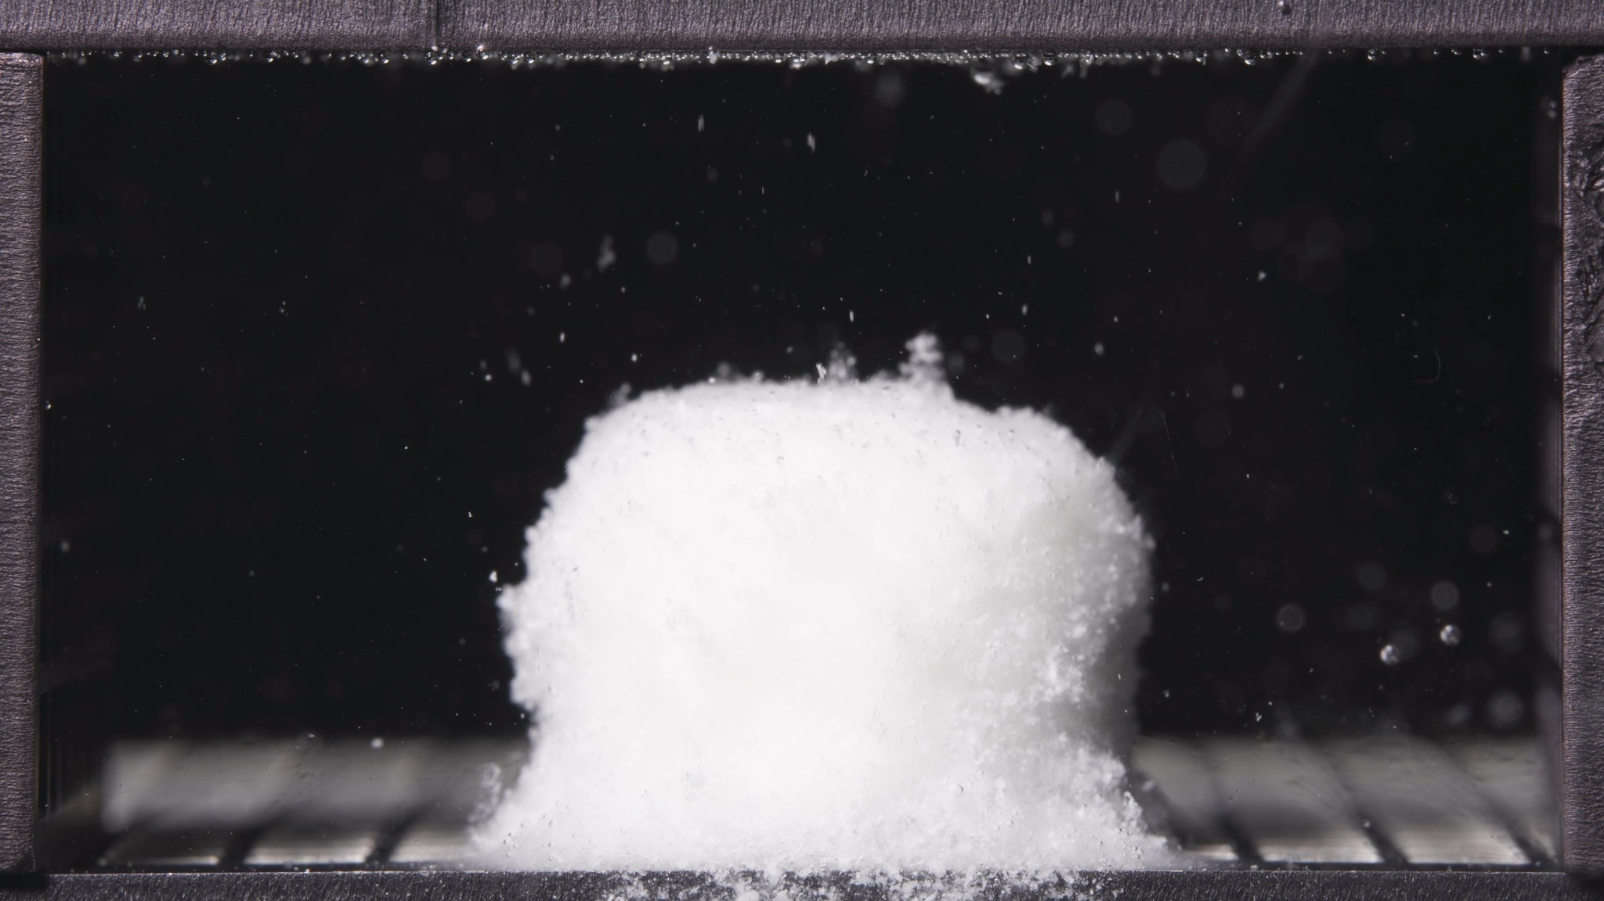 | 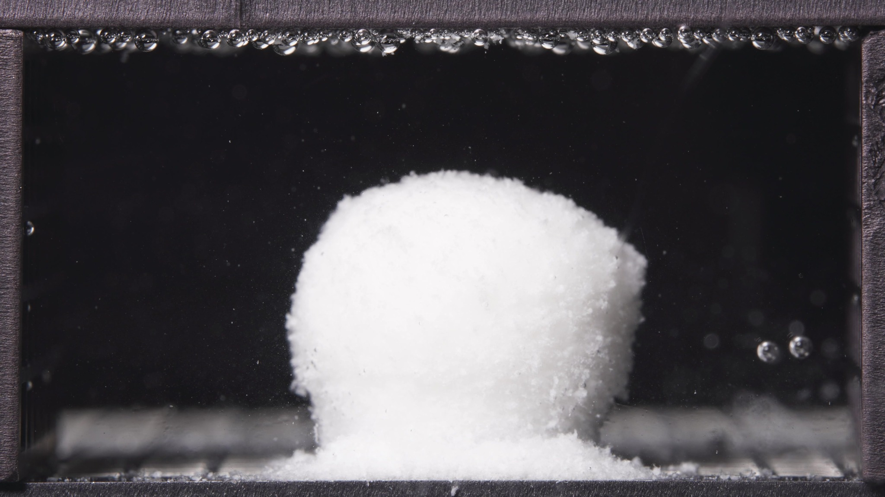 | 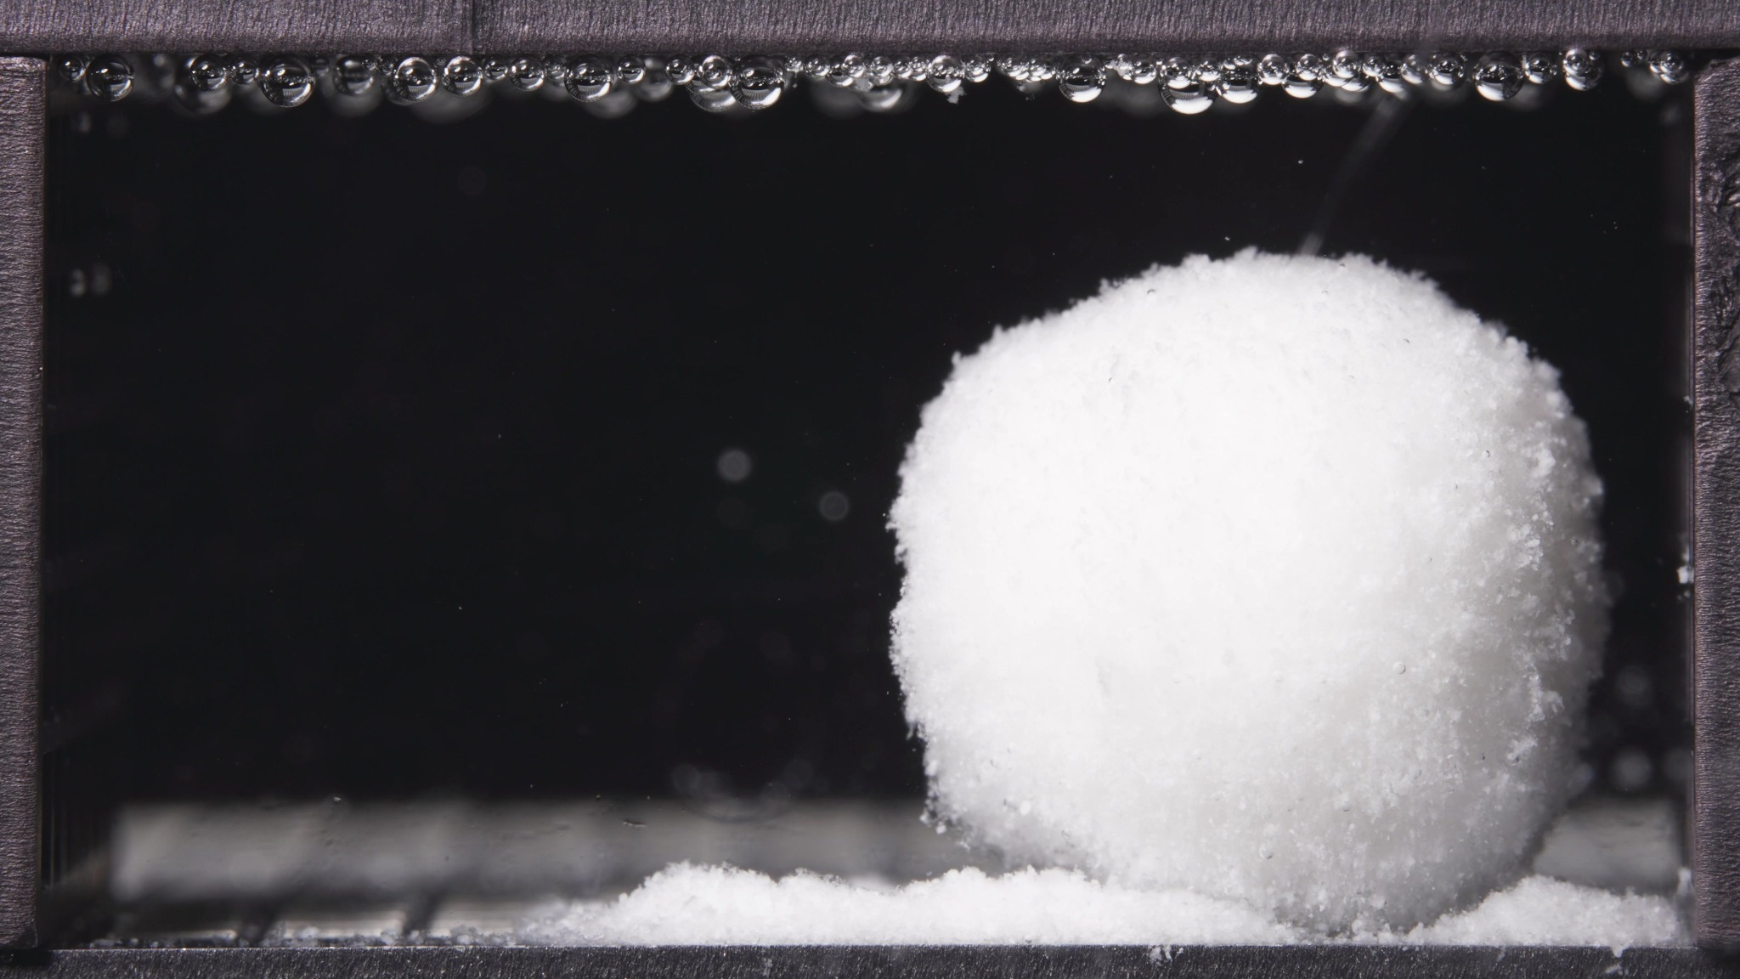

Turn 4: Assistant
{
"group_id": "LOW-VISCOSITY",
"time_range_h": [0.104, 5.0],
"time_h": null,
"eight_dimension_description": {
"color_change": "Across this batch, the tablet remains predominantly white and opaque. No obvious yellowing or darkening is visible. The surrounding medium is still visually mostly clear overall, with only slight localized whitening or haze immediately adjacent to the tablet and detached material.",
"shape_change": "The formulation still appears as one main coherent body, but the original compact tablet outline has already become more rounded, softened, and less sharply defined. Edge regularity is reduced, and the body shows slight asymmetry within the window, with one image showing a more right-shifted and less centered mass.",
"surface_texture_change": "The surface is no longer smooth and compact. It appears rough, fluffy, and granular, especially along the sidewalls and upper boundary. The outer layer looks loosened and eroded rather than sharply fractured, consistent with progressive surface softening and material shedding.",
"volume_change": "The visible mass remains relatively large during this window, suggesting early swelling or at least preservation of a substantial hydrated body rather than rapid collapse. At the same time, there is clear basal spreading of detached material around the bottom, indicating that part of the occupied space is shifting from a compact core to a broader powdery or softened deposit.",
"dissolution_speed_time": "Because no previous-window images were provided, a strict rate comparison versus an earlier stage is limited. Based on the current batch alone, the formulation appears to be in an early-to-intermediate disintegration stage characterized by surface erosion and peripheral material loss, but not yet by abrupt breakup into multiple large fragments.",
"physical_state_change": "The body appears to have transitioned from an initially compact tablet toward a swollen, softened, weakly coherent mass. It still retains a central bulk structure, but the outer region looks more porous and friable, with signs of ongoing conversion into loose particulate or paste-like material near the base.",
"dissolution_medium": "The bulk medium remains visually clear in most of the field, without strong uniform turbidity. Changes are mainly local: fine suspended particles and slight cloudiness are visible around the tablet, while detached white material accumulates near the bottom support region. This suggests localized release of solids rather than full-field medium opacification at this stage.",
"fragment_distribution_density": "Detached material is concentrated near the original tablet position, especially at the bottom where a dense powdery or granular layer has formed. Broad dispersion into the full chamber is limited. The fragments are predominantly fine and closely clustered rather than large, widely scattered pieces."
},
"notes_for_later_summary": "Previous-window comparison is unavailable, so the major timeline change versus an earlier stage cannot be stated directly. The dominant observation in the 0.104-5 h batch is that the low-viscosity formulation has already developed a large softened and rounded hydrated body with obvious rough surface erosion and dense basal accumulation of fine detached material, while the main mass remains intact rather than fully fragmented."
}

Turn 5: User
These are pictures of the low-viscosity formulation during 6.25-11.25h.
Attached images
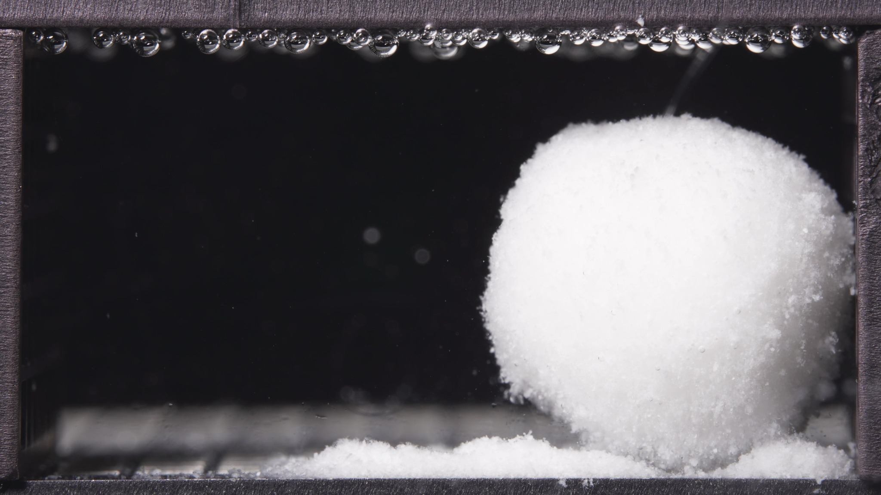 | 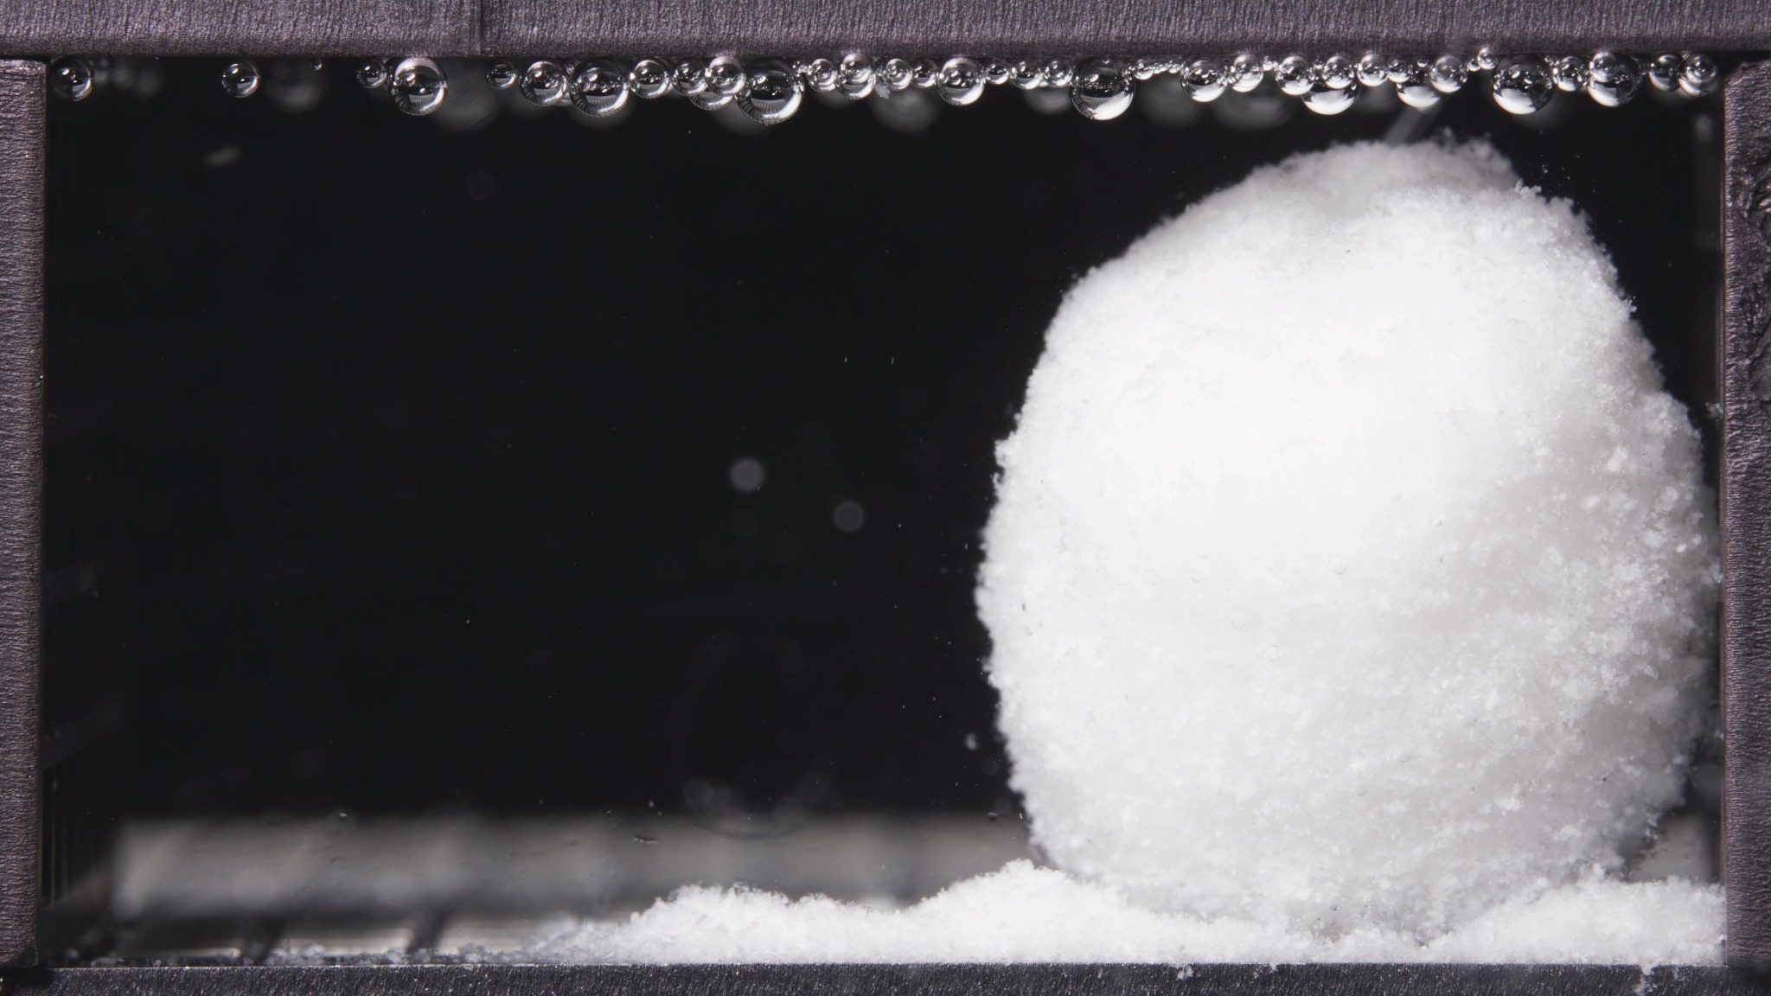 | 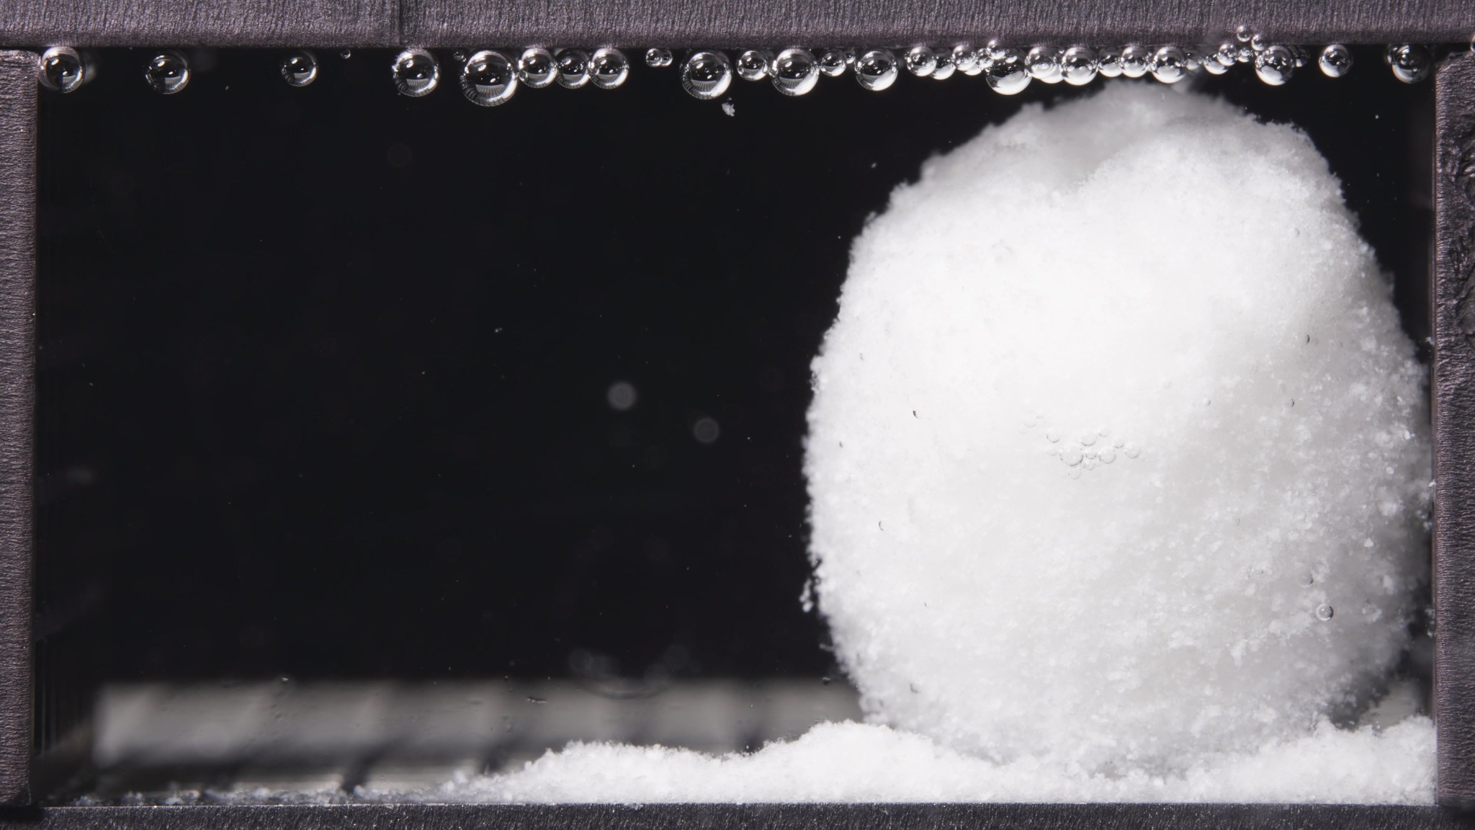

Turn 6: Assistant
{
"group_id": "LOW-VISCOSITY",
"time_range_h": [6.25, 11.25],
"time_h": null,
"eight_dimension_description": {
"color_change": "Across this batch, the tablet body remains uniformly white and opaque, with no obvious discoloration. Compared with the 0.104-5 h window, the visual color state is essentially unchanged, and the surrounding medium still appears mostly clear rather than diffusely whitened.",
"shape_change": "The formulation still presents as one dominant intact body rather than multiple large fragments. Compared with the earlier window, the hydrated mass appears more upright, rounded, and consolidated, with a clearer dome-like or cylindrical contour. In some images the top contour becomes slightly lobulated or uneven, but there is still no major structural breakup.",
"surface_texture_change": "The outer surface remains rough and granular, especially along the edges and lower right side. Relative to the previous window, the main body surface looks somewhat more uniform and compact in its central region, while the upper edge still shows a fluffy or friable texture. The surface therefore suggests continued hydration with ongoing superficial erosion rather than sharp cracking.",
"volume_change": "The visible occupied volume remains large during 6.25-11.25 h, with no obvious large-scale collapse. Compared with 0.104-5 h, the mass appears to have maintained or slightly increased its effective hydrated bulk, especially in height and rounded fullness, while detached material continues to accumulate at the base.",
"dissolution_speed_time": "Compared with the 0.104-5 h window, the current batch suggests that gross disintegration has not accelerated into rapid breakup. Instead, the process appears to have entered a more sustained hydrated-body stage: the tablet continues to shed fine material from the exterior, but the main body remains coherent and volumetrically preserved.",
"physical_state_change": "The formulation appears to have progressed from a softened, eroding mass into a more established swollen hydrated body with weak but persistent coherence. It is no longer just a roughening compact tablet, but it has also not transitioned into dispersed fine particles or multiple separate fragments. The dominant state is a swollen, gel-like or paste-supported bulk mass with friable outer material.",
"dissolution_medium": "The surrounding medium remains visually clear across most of the chamber, with only limited local particulate presence near the tablet and bottom sediment zone. Compared with the previous window, there is no strong evidence of new full-field turbidity; the visible medium change remains localized rather than broadly diffused.",
"fragment_distribution_density": "Fine detached material is still concentrated near the original tablet location, especially as a dense sediment-like layer along the bottom. Compared with the earlier window, the basal accumulation is more established and continuous, but wide dispersion into the chamber remains limited. Large detached fragments are not prominent."
},
"notes_for_later_summary": "Most critical change versus the 0.104-5 h window: the low-viscosity formulation has shifted from an early roughened and eroding swollen mass to a more stable, large hydrated bulk body that remains intact while continuing to shed fine material locally at the base. This indicates continued hydration and external erosion without transition to rapid whole-body fragmentation in the 6.25-11.25 h window."
}

Turn 7: User
These are pictures of the low-viscosity formulation during 12.5-17.5h.
Attached images
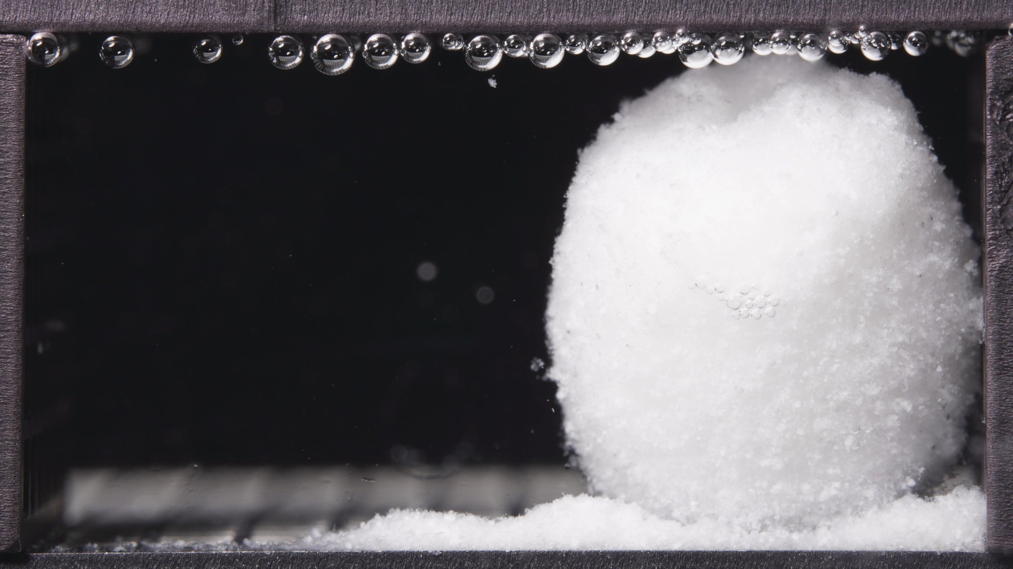 | 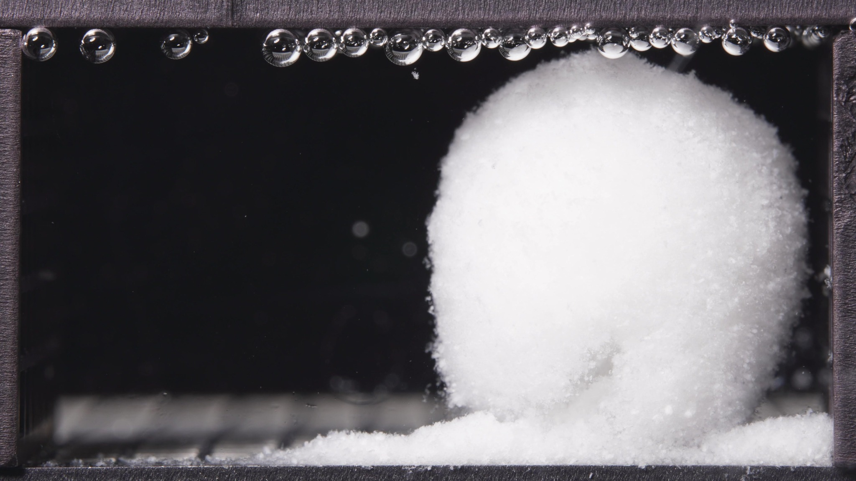 | 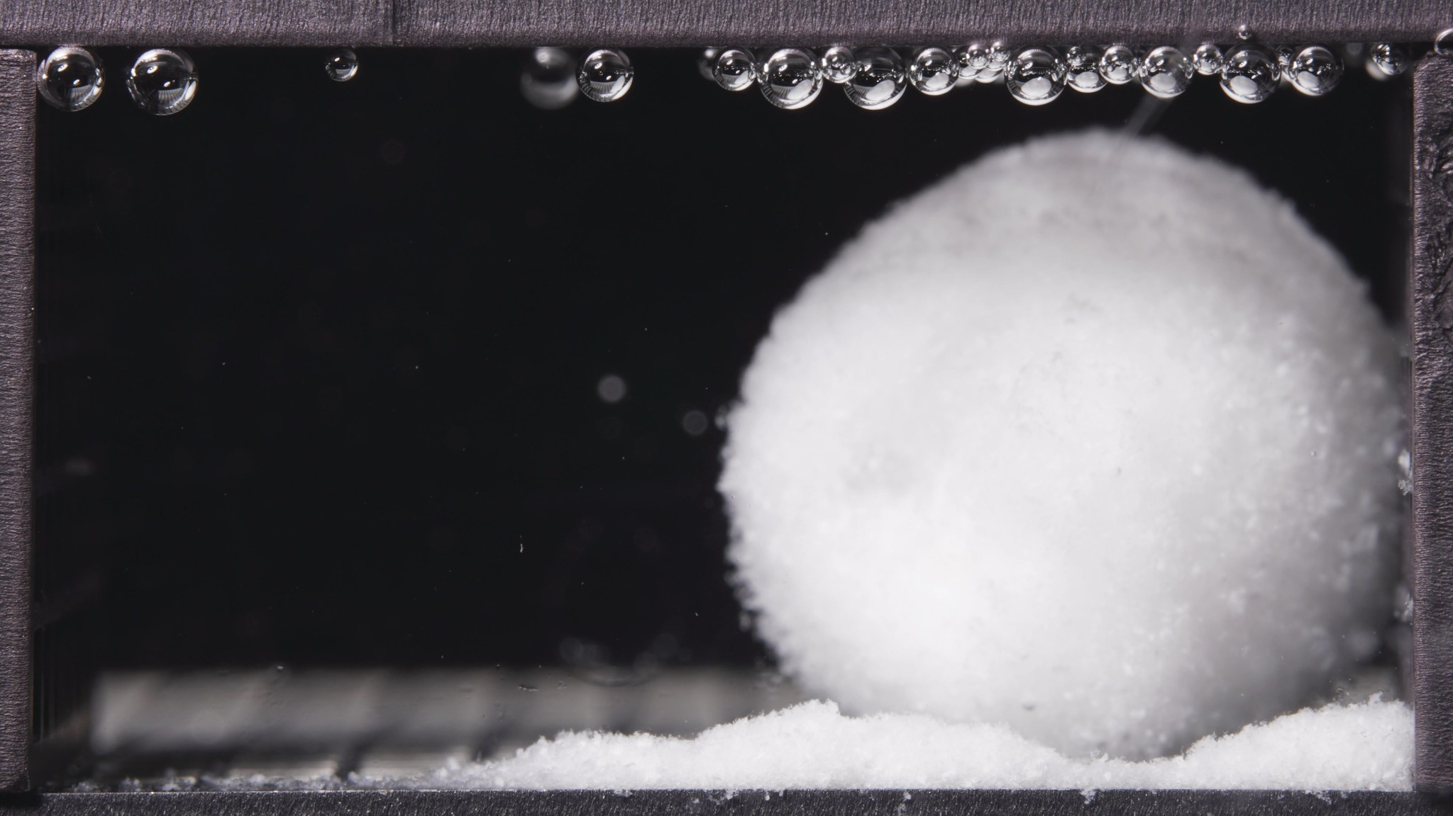

Turn 8: Assistant
{
"group_id": "LOW-VISCOSITY",
"time_range_h": [12.5, 17.5],
"time_h": null,
"eight_dimension_description": {
"color_change": "Across this batch, the tablet body remains white and opaque without visible discoloration. Compared with the 6.25-11.25 h window, there is no meaningful color change in the main mass, and the surrounding medium still appears largely clear rather than broadly turbid.",
"shape_change": "The formulation still exists as one dominant hydrated body with no breakup into multiple major fragments. Compared with the previous window, the outline becomes more rounded and ball-like, with slightly less pronounced upright cylindrical character. The top contour remains somewhat uneven in some images, but the overall geometry is still continuous and coherent.",
"surface_texture_change": "The surface continues to appear rough, granular, and fluffy at the periphery. Relative to 6.25-11.25 h, the central visible surface looks slightly more uniform and less sharply irregular, while the edges remain friable and powdery. There is no clear evidence of large cracks or peeling sheets; the change is dominated by persistent superficial erosion.",
"volume_change": "The visible occupied volume remains substantial throughout 12.5-17.5 h, indicating preservation of a large hydrated core. Compared with the previous window, the mass does not show major expansion and may show slight rounding and mild compaction or contraction of the upper profile, but there is no abrupt collapse. Basal deposited material remains prominent.",
"dissolution_speed_time": "Compared with the 6.25-11.25 h window, disintegration still appears slow and controlled at the gross structural level. The batch suggests continued external material loss and gradual reshaping of the hydrated body rather than acceleration into rapid fragmentation or full structural failure.",
"physical_state_change": "The formulation remains in a swollen, gel-like or paste-supported bulk state with weak but persistent integrity. Relative to the previous window, it appears to be transitioning slightly further from an upright swollen block toward a more rounded, softened hydrated mass, but not toward dispersed fine-particle dominance.",
"dissolution_medium": "The surrounding medium remains visually clear across most of the chamber. Changes remain localized near the tablet and bottom sediment layer, with no clear development of full-field haze. Compared with the previous window, the medium appearance is essentially stable.",
"fragment_distribution_density": "Detached material remains concentrated near the original tablet position, especially as a dense basal layer along the bottom support region. Compared with 6.25-11.25 h, this deposited layer remains established and continuous, while broad fragment dispersion into the chamber is still limited. Large separate fragments are not evident."
},
"notes_for_later_summary": "Most critical change versus the 6.25-11.25 h window: the low-viscosity formulation still retains one large hydrated mass, but its outline becomes more rounded and slightly more compact, indicating slow late-stage surface erosion and reshaping rather than rapid breakup. The key pattern in 12.5-17.5 h is persistence of structural coherence despite continued basal shedding of fine material."
}

Turn 9: User
These are pictures of the low-viscosity formulation during 18.75-23.75h.
Attached images
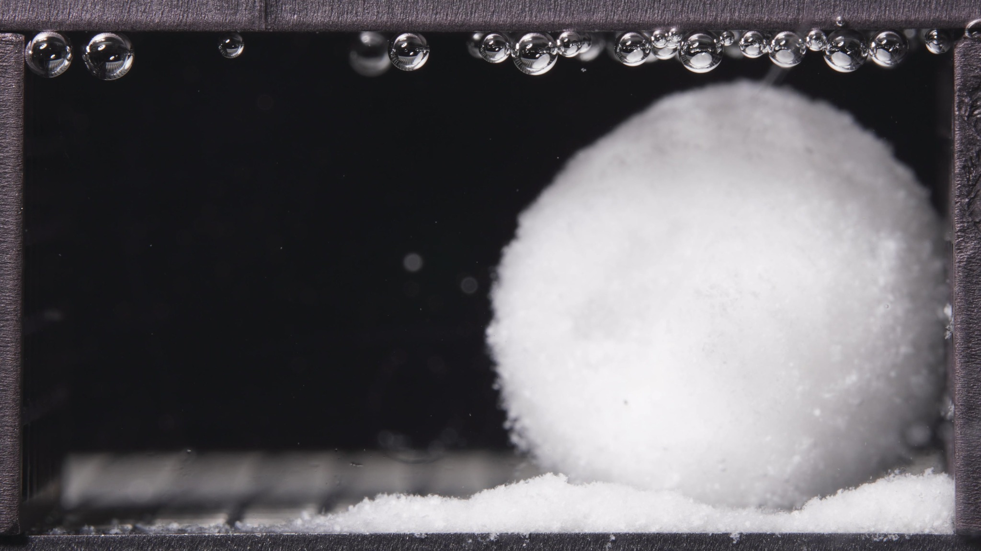 | 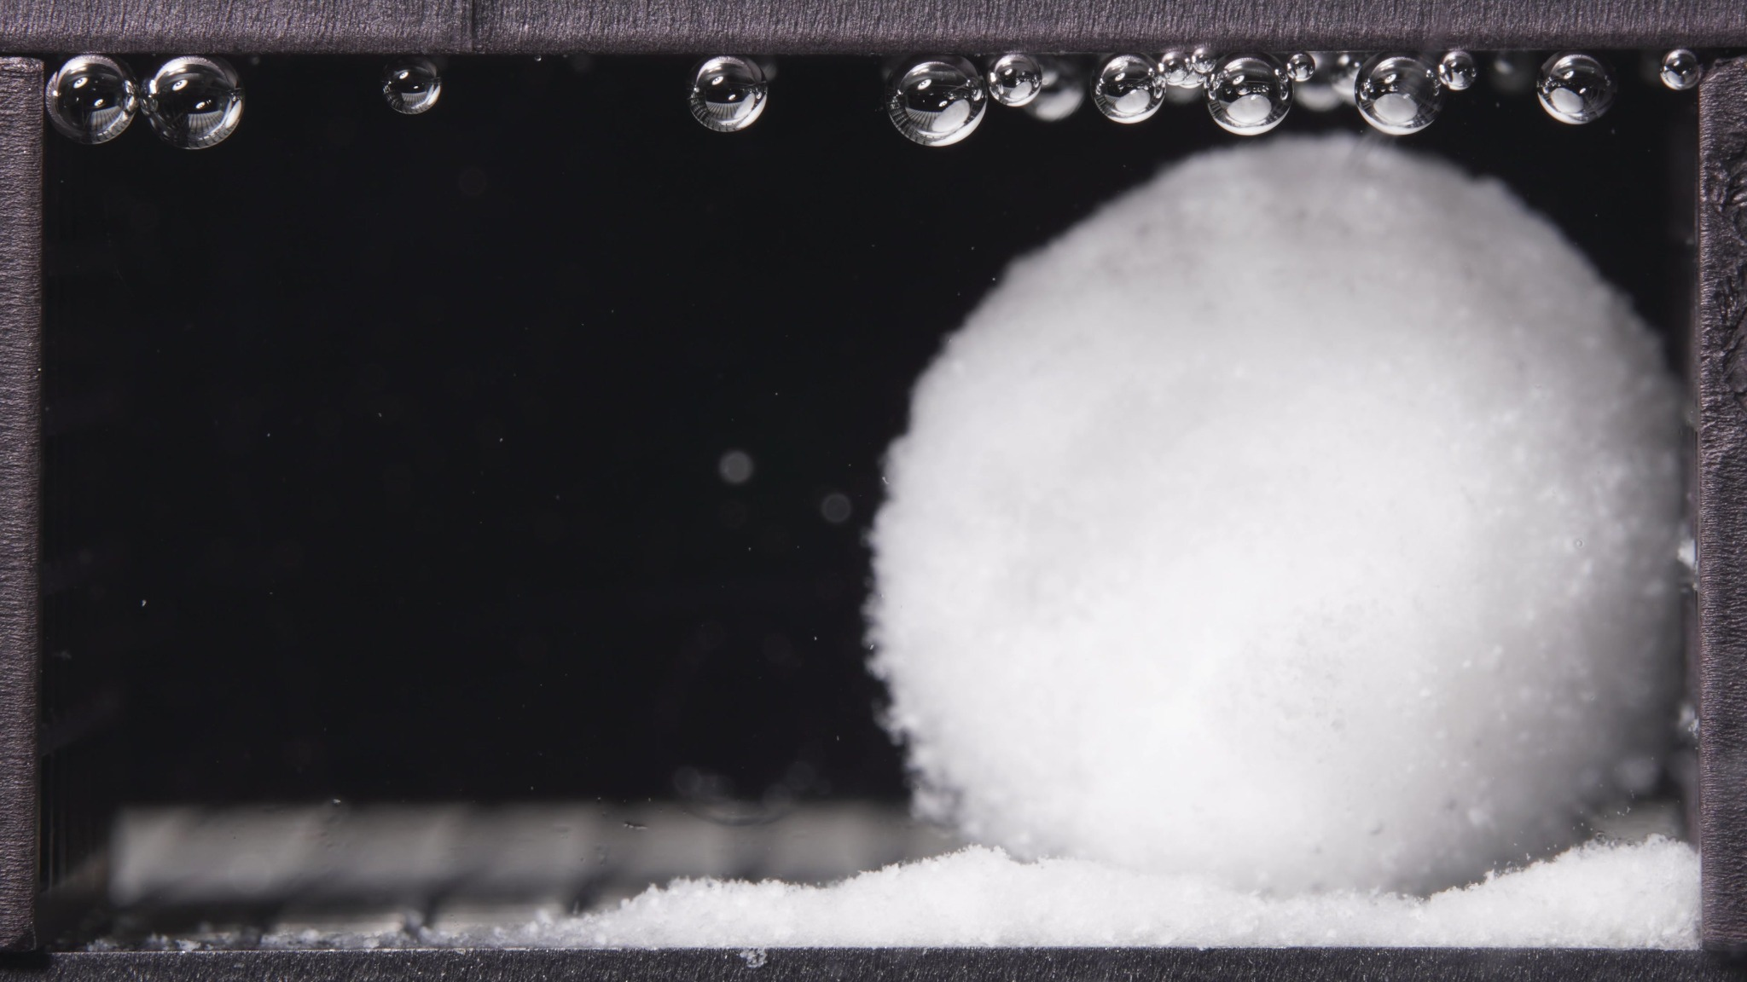 | 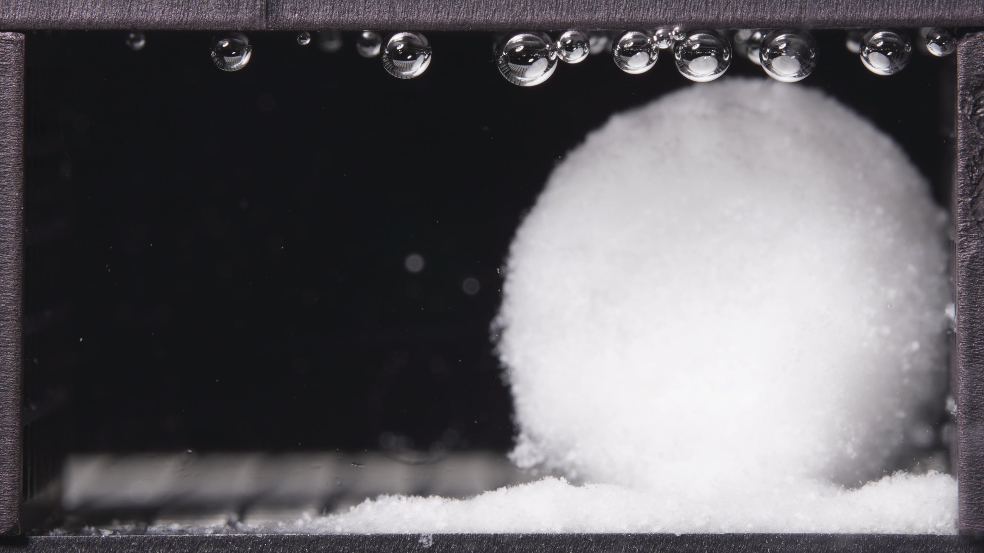

Turn 10: Assistant
{
"group_id": "LOW-VISCOSITY",
"time_range_h": [18.75, 23.75],
"time_h": null,
"eight_dimension_description": {
"color_change": "Across this batch, the main hydrated body remains white and opaque, without visible discoloration. Compared with the 12.5-17.5 h window, the color appearance is essentially unchanged, and the surrounding medium still does not show broad diffuse whitening.",
"shape_change": "The formulation still appears as one single dominant mass rather than multiple separated fragments. Compared with the previous window, the outline remains rounded and dome-like, but the boundary looks slightly softer and less sharply defined. Gross structural breakup is still absent, although the body appears somewhat more settled and smoothly contoured.",
"surface_texture_change": "The surface remains fine-granular and fluffy at the periphery. Relative to 12.5-17.5 h, the visible exterior looks slightly more uniform and less irregular, with fewer obvious local contour undulations. The change suggests continued superficial erosion and smoothing rather than cracking or peeling.",
"volume_change": "The visible occupied volume is still substantial in this late window, indicating retention of a large hydrated core. Compared with the previous window, there may be slight late-stage compaction or mild reduction in apparent height or fullness, but there is no abrupt collapse. The basal deposited layer remains prominent and broad.",
"dissolution_speed_time": "Compared with the 12.5-17.5 h window, the disintegration pattern still appears slow and controlled. The formulation does not enter a rapid terminal breakup stage during 18.75-23.75 h. Instead, it shows persistence of the main swollen body with only gradual surface loss and continued local deposition of fine material.",
"physical_state_change": "The formulation remains in a swollen, weakly coherent, gel-like or paste-supported bulk state. Relative to the previous window, it appears to progress slightly further toward a softened and externally smoothed late-stage hydrated mass, but not toward full dispersion into particles or collapse into multiple fragments.",
"dissolution_medium": "The surrounding medium remains visually clear across most of the chamber. As in the previous window, visible changes are localized near the tablet and bottom sediment region, with no clear full-field turbidity or cloud band formation. The medium appearance is therefore largely stable.",
"fragment_distribution_density": "Fine detached material continues to remain concentrated near the original tablet position, especially as a dense and continuous basal layer along the bottom. Compared with 12.5-17.5 h, this local deposition persists and may be slightly more consolidated, while broad chamber-wide fragment dispersion remains limited. Large detached fragments are still not evident."
},
"notes_for_later_summary": "Most critical change versus the 12.5-17.5 h window: the low-viscosity formulation still retains one large hydrated body, but the outer contour appears slightly smoother, softer, and more settled, suggesting continued late-stage surface erosion and mild compaction rather than rapid final fragmentation. The dominant 18.75-23.75 h pattern is prolonged structural persistence with ongoing local basal accumulation of fine shed material."
}

Turn 11: User
These are pictures of the standard formulation during 0.104-5h.
Attached images
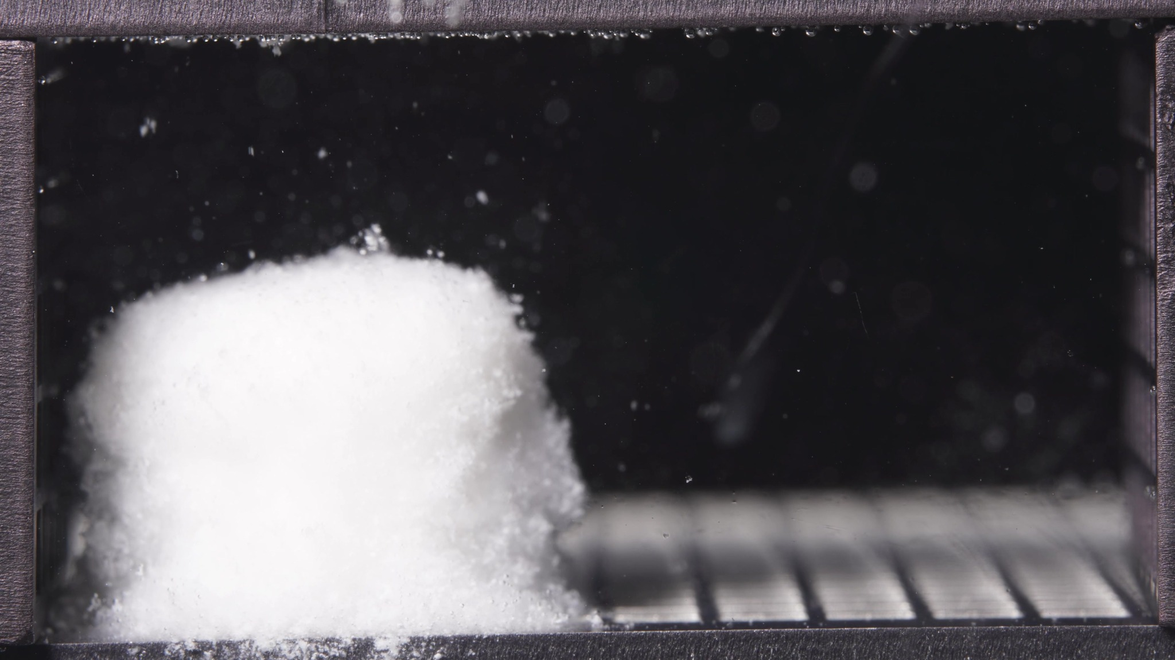 | 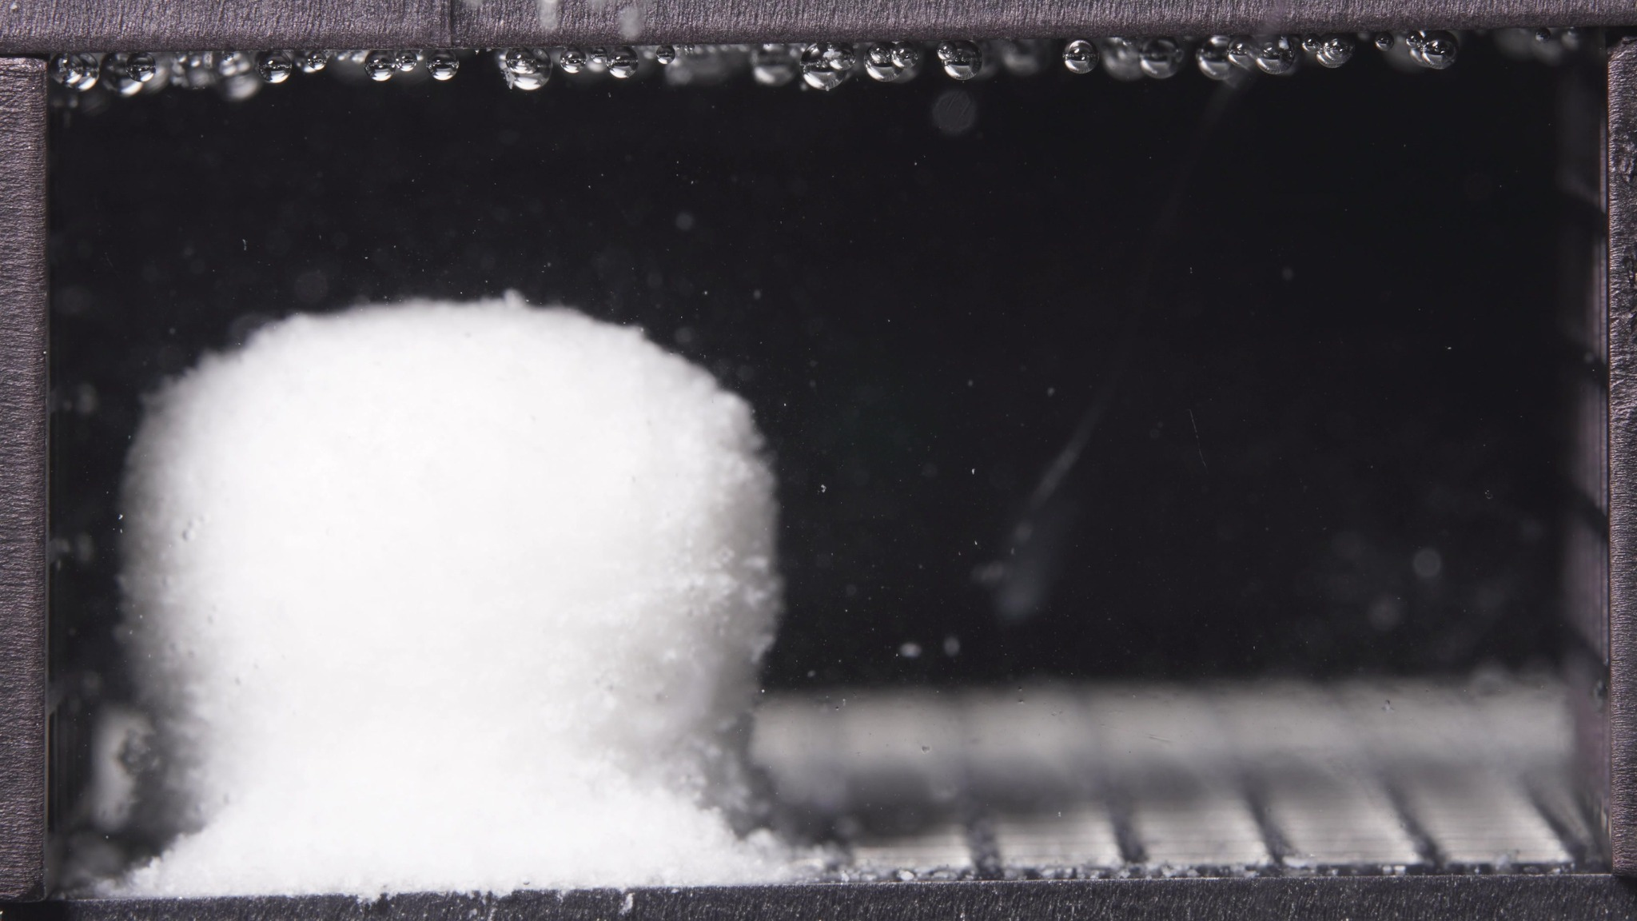 | 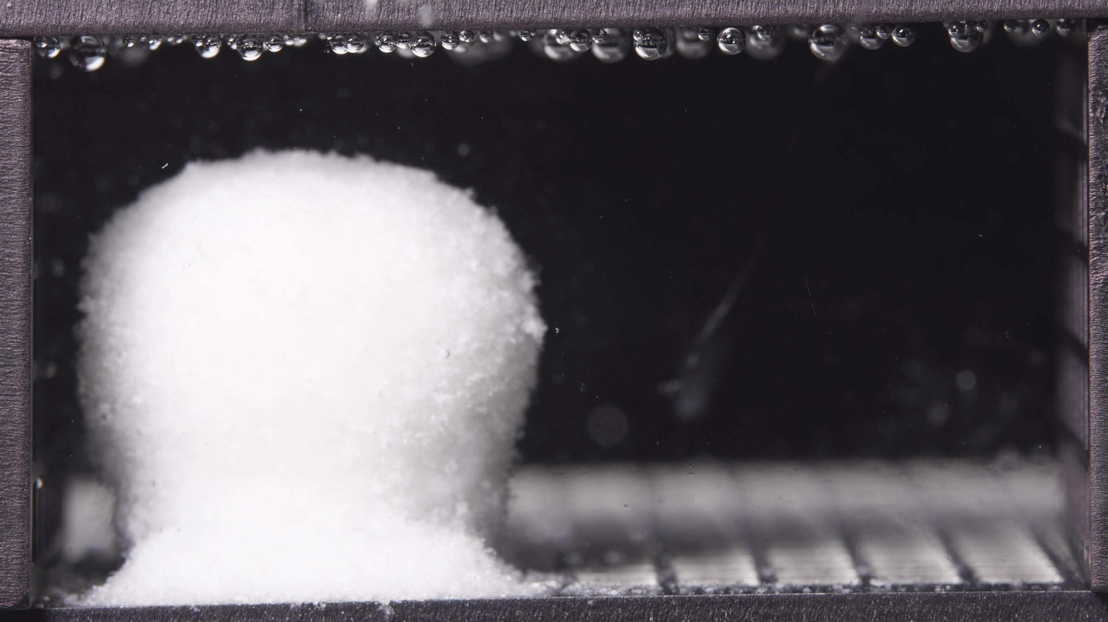

Turn 12: Assistant
{
"group_id": "STANDARD-VISCOSITY",
"time_range_h": [0.104, 5.0],
"time_h": null,
"eight_dimension_description": {
"color_change": "Across this batch, the tablet remains uniformly white and opaque, without visible yellowing or darkening. The surrounding medium is visually mostly clear, with only slight local whitening or fine suspended matter near the tablet boundary and basal deposit region.",
"shape_change": "The formulation remains as one dominant coherent body with the overall tablet outline still preserved. The mass shows a softened, rounded upper contour and slightly blurred edges, especially on the right side, but there is no breakup into multiple large fragments. The shape is still upright and block-like rather than collapsed.",
"surface_texture_change": "The surface is no longer fully smooth and compact. It appears rough, fine-granular, and fluffy at the periphery, with mild edge irregularity and superficial loosening. No major cracks or sheet-like peeling are evident; the dominant change is external roughening with local erosion.",
"volume_change": "The visible occupied volume remains substantial throughout this window, indicating preservation of a large hydrated core. The body appears to have undergone early swelling or at least volumetric maintenance rather than shrinkage, while a limited amount of detached material accumulates at the base. No obvious large-scale collapse is visible.",
"dissolution_speed_time": "Because no previous-window images were provided, a strict rate comparison versus an earlier stage is limited. Based on the current batch alone, the standard formulation appears to be in an early-to-intermediate disintegration stage characterized by controlled hydration and surface erosion, without rapid fragmentation.",
"physical_state_change": "The formulation appears to have transitioned from an initially compact solid toward a swollen, softened, weakly coherent hydrated mass. The main body remains intact, while the exterior becomes more friable and particulate. It has not yet progressed to a fully dispersed particle state or a clearly collapsed gel mass.",
"dissolution_medium": "The medium remains visually clear across most of the chamber, with changes mainly localized around the tablet and bottom support region. Slight particulate haze is present near the body, but there is no broad chamber-wide turbidity or obvious cloud-band formation at this stage.",
"fragment_distribution_density": "Detached material is concentrated near the original tablet position, primarily as a dense fine-particle deposit at the bottom and around the base of the tablet. Dispersion into the wider chamber is limited, and large separated fragments are not prominent."
},
"notes_for_later_summary": "Previous-window comparison is unavailable, so the major timeline change versus an earlier stage cannot be stated directly. The dominant observation in the 0.104-5 h batch is that the standard-viscosity formulation has already formed a large upright hydrated mass with preserved bulk shape, mild surface roughening, and localized basal shedding of fine material, while remaining intact without major fragmentation."
}

Turn 13: User
These are pictures of the standard formulation during 6.25-11.25h.
Attached images
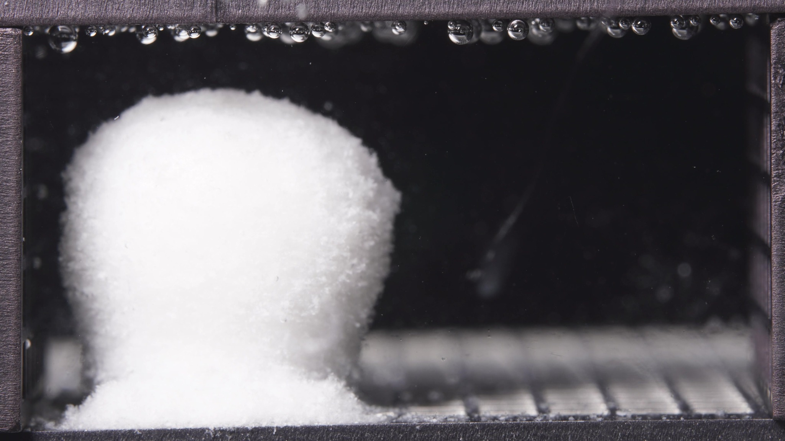 | 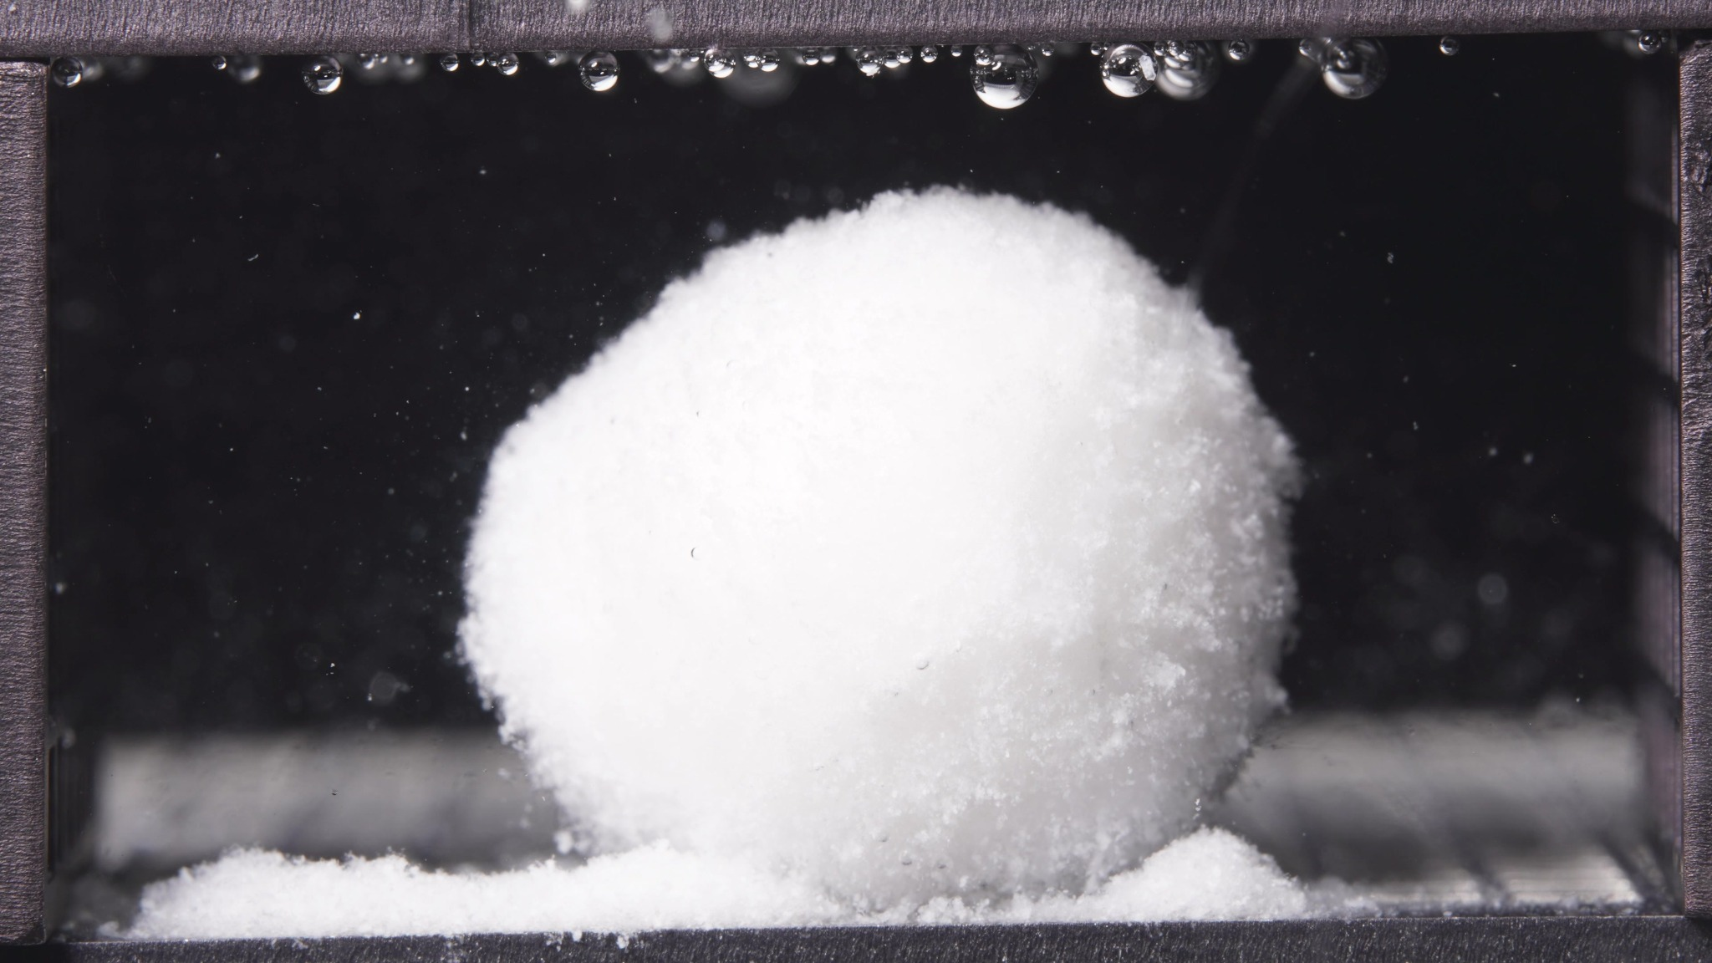 | 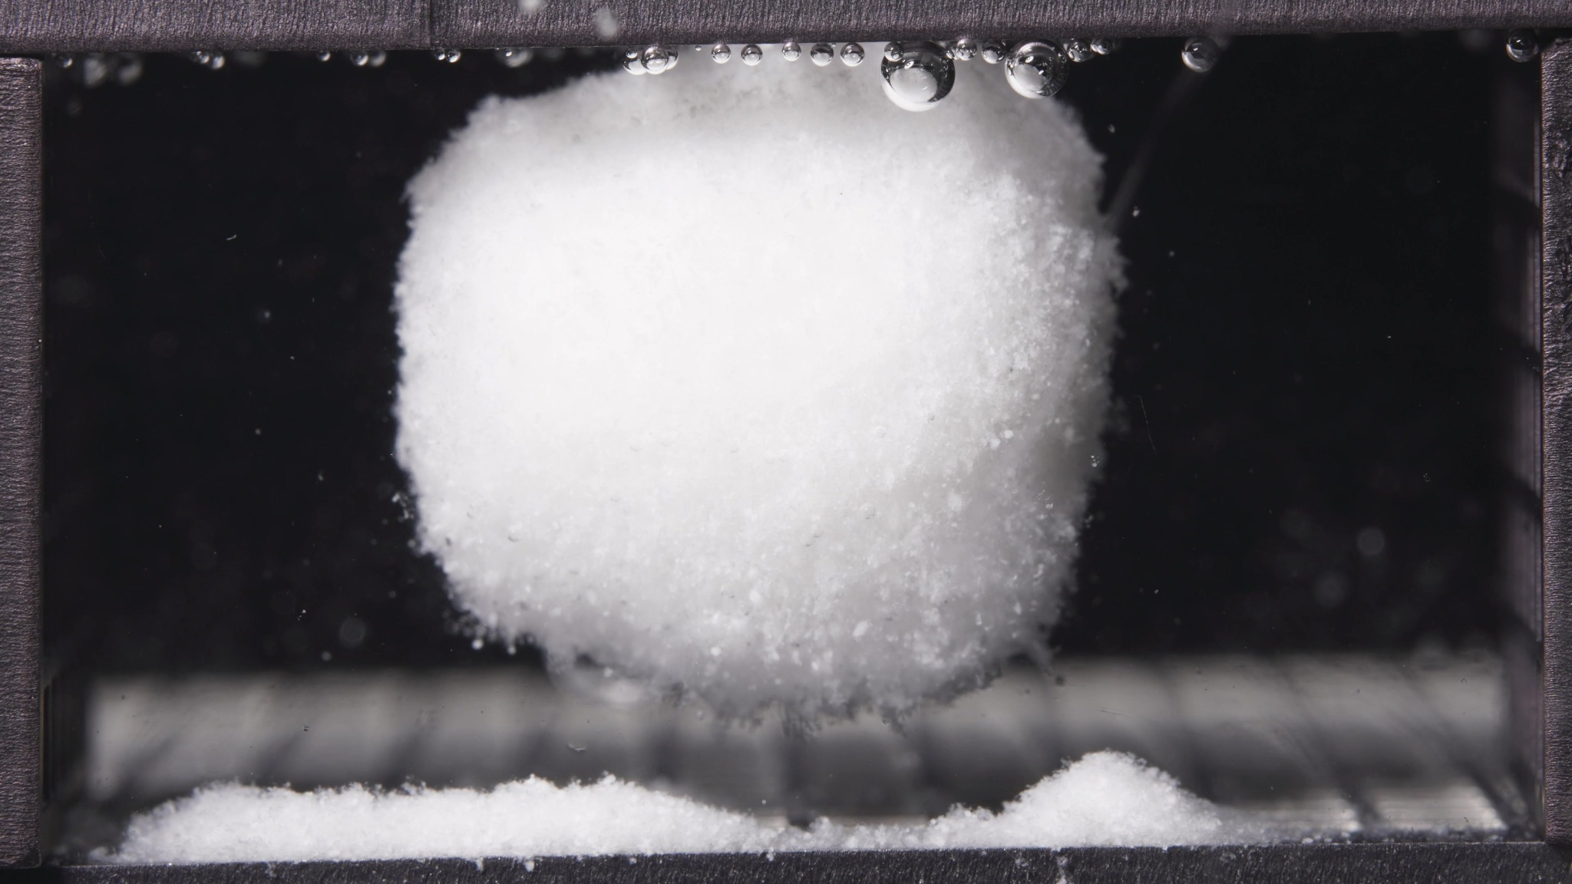

Turn 14: Assistant
{
"group_id": "STANDARD-VISCOSITY",
"time_range_h": [6.25, 11.25],
"time_h": null,
"eight_dimension_description": {
"color_change": "Across this batch, the tablet body remains uniformly white and opaque, without visible discoloration. Compared with the 0.104-5 h window, the visual color state is essentially unchanged. The surrounding medium still appears mostly clear, with only slight local haze or fine suspended matter near the tablet and the basal deposit region.",
"shape_change": "The formulation still appears as one dominant coherent body rather than multiple large fragments. Compared with the previous window, the outline changes more markedly: the initially upright, block-like swollen mass becomes more rounded and globular, and the lower part becomes narrowed or undercut in some images. By the later image in this window, the main body appears partially elevated above the basal deposit, indicating loss of direct broad-base support and stronger local erosion beneath the mass.",
"surface_texture_change": "The surface remains rough, fine-granular, and fluffy at the periphery. Relative to 0.104-5 h, the edge roughening is more developed, especially along the lower sidewalls and right boundary. The exterior still shows superficial erosion rather than large cracks or sheet-like peeling, but the surface now looks more friable and less compact than in the earlier window.",
"volume_change": "The visible occupied volume remains substantial, indicating preservation of a large hydrated core. Compared with the previous window, the mass does not show gross collapse; however, its volume distribution changes. The body becomes more rounded and less columnar, while the contact region at the base narrows and the detached material at the bottom becomes more obvious, suggesting redistribution from a broad supported swollen body toward a suspended or necked hydrated core above a growing basal deposit.",
"dissolution_speed_time": "Compared with the 0.104-5 h window, disintegration appears to have progressed from early controlled swelling and mild surface erosion into a more active structural-erosion stage. The main body is still intact, but basal undercutting, contour reshaping, and partial separation from the bottom support indicate that disintegration has advanced, even though rapid whole-body fragmentation has still not occurred.",
"physical_state_change": "The formulation remains in a swollen, softened, weakly coherent hydrated state, but compared with the previous window it appears less like a swollen block and more like a rounded gel-like or paste-supported core with an eroded underside. The bulk body still persists, yet the support structure beneath it is weaker, indicating progression toward a more fragile hydrated mass rather than transition into dispersed particles.",
"dissolution_medium": "The surrounding medium remains visually clear across most of the chamber. Relative to the earlier window, there is no strong development of broad turbidity; visible changes remain localized near the tablet and bottom deposit. The medium therefore suggests continued local shedding rather than extensive chamber-wide clouding.",
"fragment_distribution_density": "Detached material remains concentrated near the original tablet position, especially as a dense fine-particle layer at the bottom. Compared with 0.104-5 h, the local basal accumulation is more distinct and appears to support less of the main body's weight directly. Dispersion into the wider chamber remains limited, and large separate fragments are still not prominent."
},
"notes_for_later_summary": "Most critical change versus the 0.104-5 h window: the standard-viscosity formulation shifts from an upright swollen mass with a broad base to a more rounded hydrated body with evident basal undercutting and partial elevation above the bottom deposit. This indicates progression from early surface erosion to more advanced local structural erosion beneath the main mass, while overall integrity is still preserved and rapid fragmentation is still absent."
}

Turn 15: User
These are pictures of the standard formulation during 12.5-17.5h.
Attached images
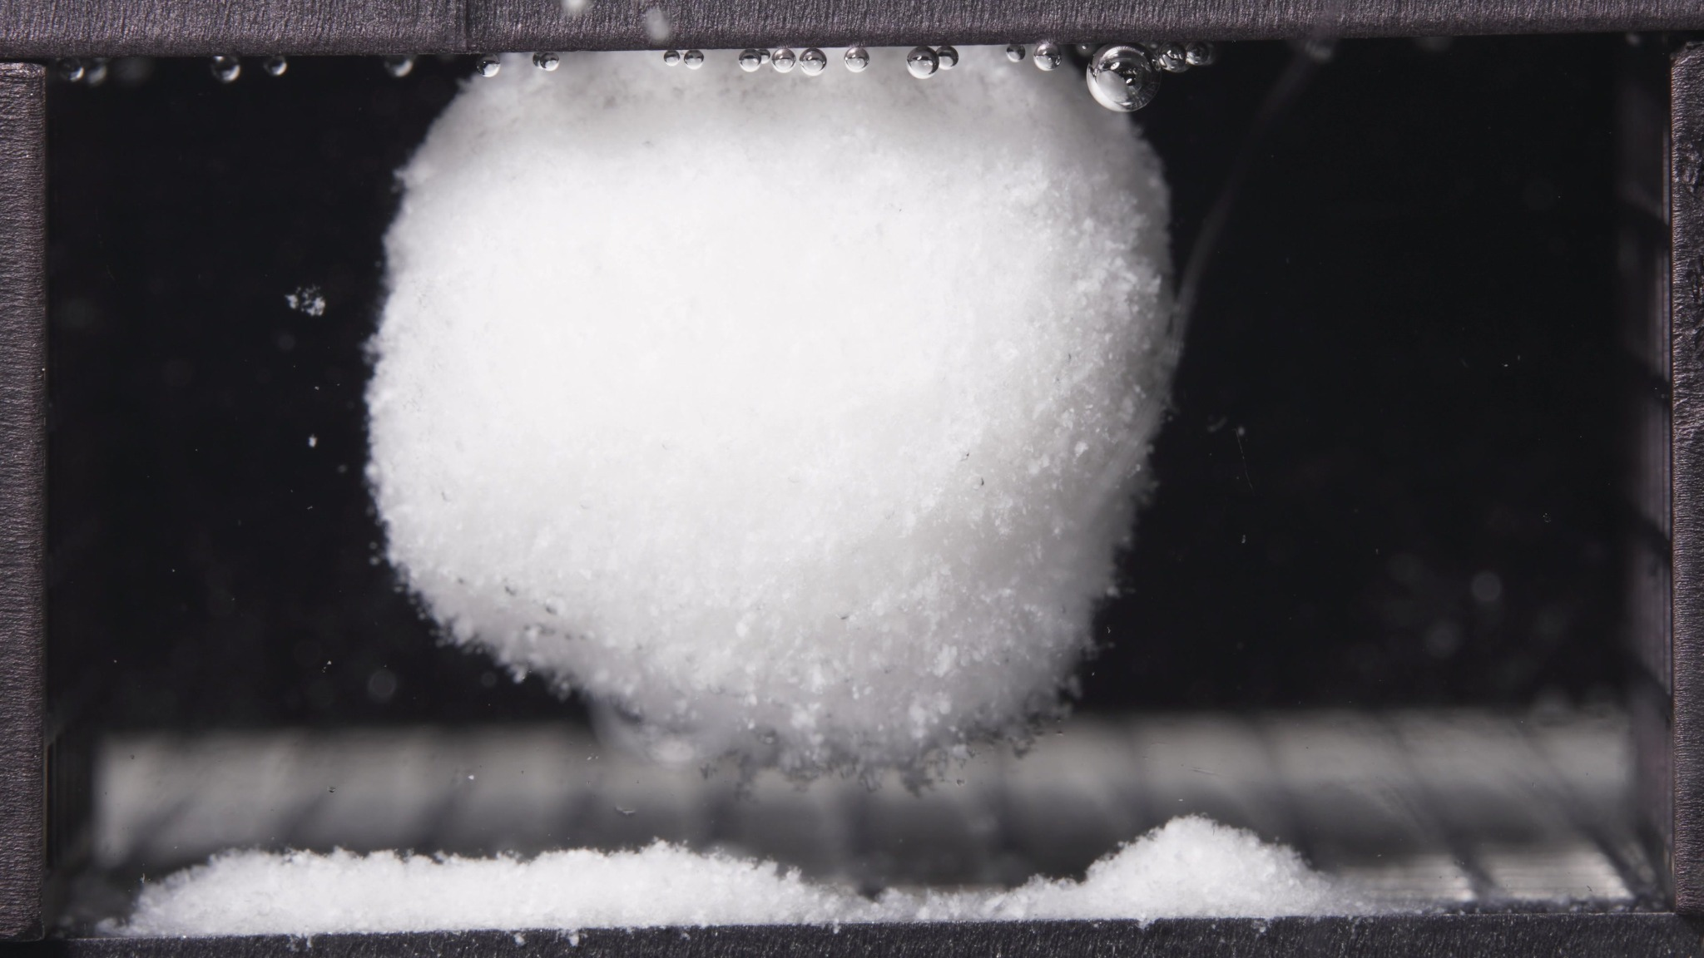 | 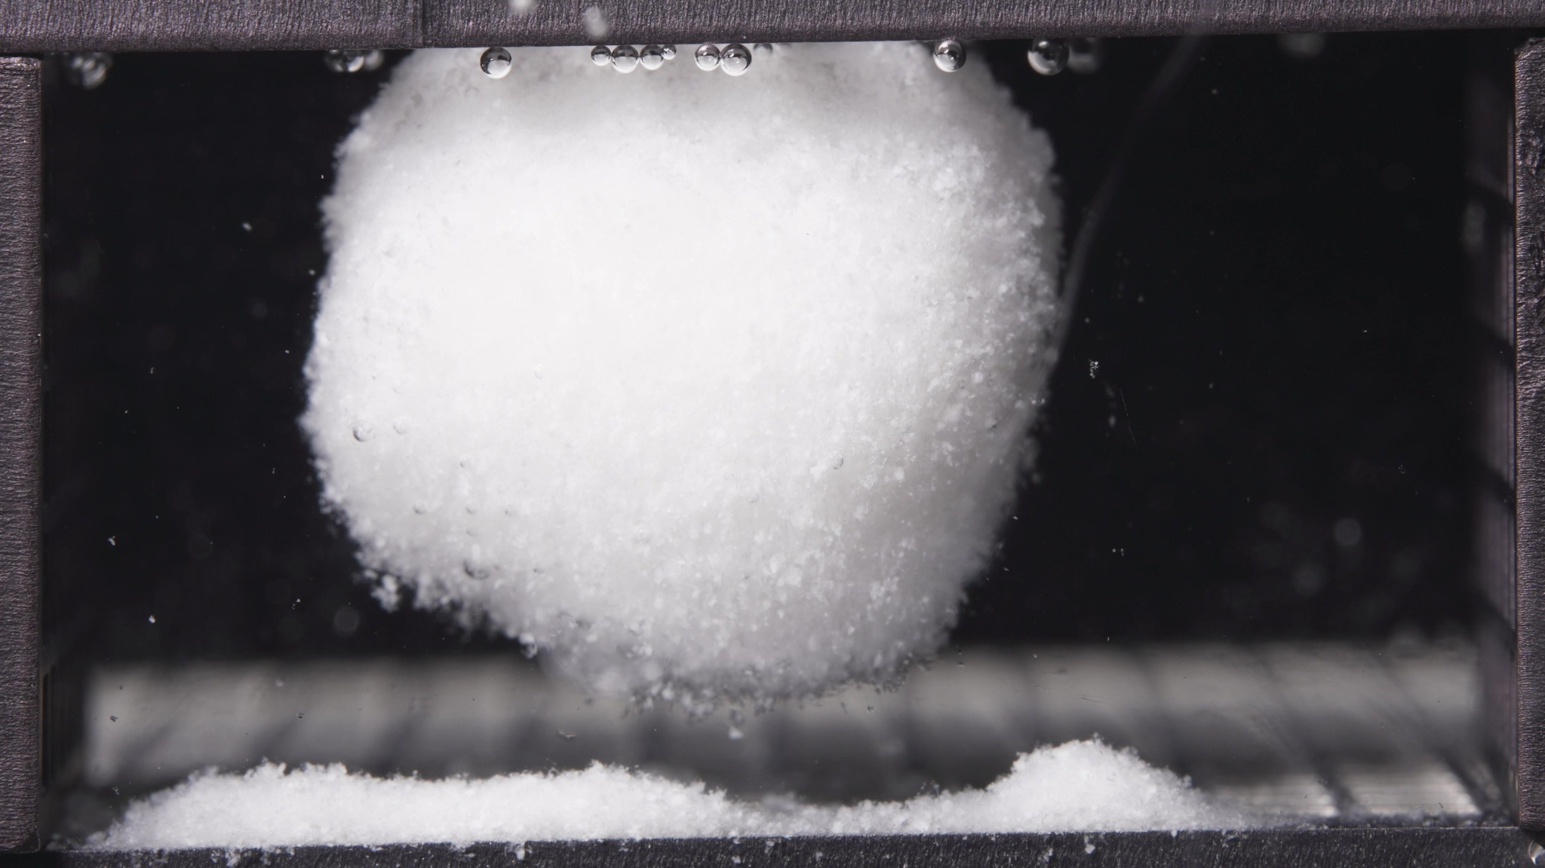 | 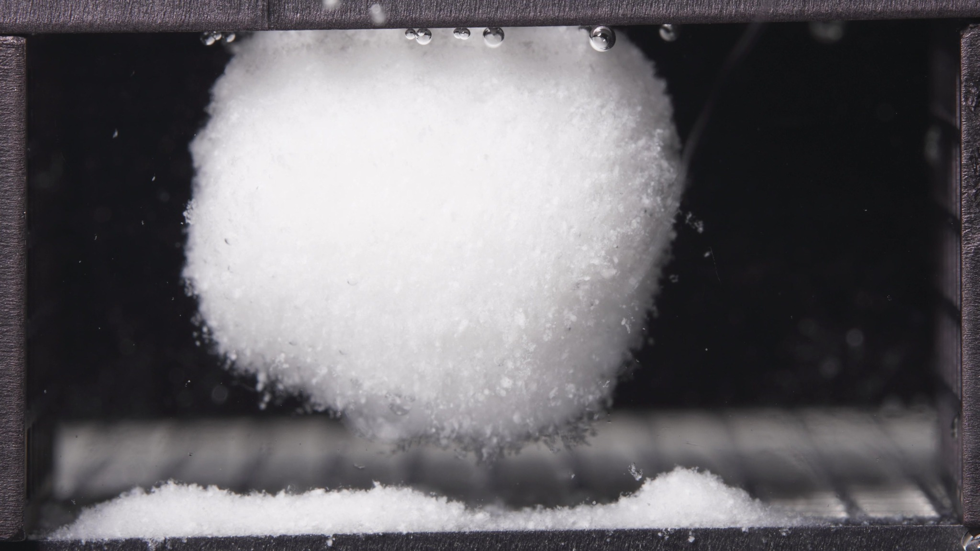

Turn 16: Assistant
{
"group_id": "STANDARD-VISCOSITY",
"time_range_h": [12.5, 17.5],
"time_h": null,
"eight_dimension_description": {
"color_change": "Across this batch, the main hydrated body remains uniformly white and opaque, without visible discoloration. Compared with the 6.25-11.25 h window, the color appearance is essentially unchanged. The surrounding medium still appears mostly clear, with only slight localized haze and fine particulate visibility near the body and bottom deposit.",
"shape_change": "The formulation still appears as one dominant coherent body rather than multiple large fragments. Compared with the previous window, the rounded globular shape is preserved and becomes more clearly established as a suspended or partially suspended mass above the basal deposit. The outline remains continuous, with no major rupture, but the underside appears more eroded and less broadly supported from below.",
"surface_texture_change": "The surface remains rough, fine-granular, and fluffy along the periphery. Relative to 6.25-11.25 h, the exterior looks slightly more uniformly friable, especially along the lower margin, with persistent superficial erosion rather than formation of large cracks, fissures, or sheet-like peeling.",
"volume_change": "The visible occupied volume remains large throughout 12.5-17.5 h, indicating continued preservation of a substantial hydrated core. Compared with the previous window, there is no obvious gross collapse. The main change is redistribution of support and mass geometry: the body stays bulky while the lower contact zone narrows and the deposited material below becomes more spatially distinct from the suspended core.",
"dissolution_speed_time": "Compared with the 6.25-11.25 h window, disintegration appears to continue in a controlled but advancing manner. The process is not accelerating into rapid whole-body fragmentation; instead, it is progressing through persistent underside erosion and gradual separation of the swollen core from the bottom deposit while overall integrity is still maintained.",
"physical_state_change": "The formulation remains in a swollen, weakly coherent, gel-like or paste-supported bulk state. Relative to the previous window, it appears slightly more like a suspended hydrated core with ongoing erosion at the lower boundary, rather than a broadly bottom-supported swollen mass. It has still not transitioned into dispersed particles or a collapsed residue.",
"dissolution_medium": "The surrounding medium remains visually clear across most of the chamber. Compared with the previous window, there is no strong new chamber-wide turbidity. Visible medium changes remain localized near the tablet and the sedimented material beneath it, consistent with continued local shedding rather than diffuse clouding.",
"fragment_distribution_density": "Detached material remains concentrated near the original tablet position, primarily as a dense bottom deposit with a small mound-like accumulation in part of the basal region. Compared with 6.25-11.25 h, the separation between the main body and the basal fragments is more evident, but broad chamber-wide dispersion is still limited and large independent fragments are not prominent."
},
"notes_for_later_summary": "Most critical change versus the 6.25-11.25 h window: the standard-viscosity formulation continues to retain one large hydrated core, but the suspended globular morphology becomes more pronounced, with clearer underside erosion and clearer separation from the basal deposit. This indicates continued controlled disintegration dominated by local bottom-side material loss rather than rapid fragmentation of the whole body."
}

Turn 17: User
These are pictures of the standard formulation during 18.75-23.75h.
Attached images
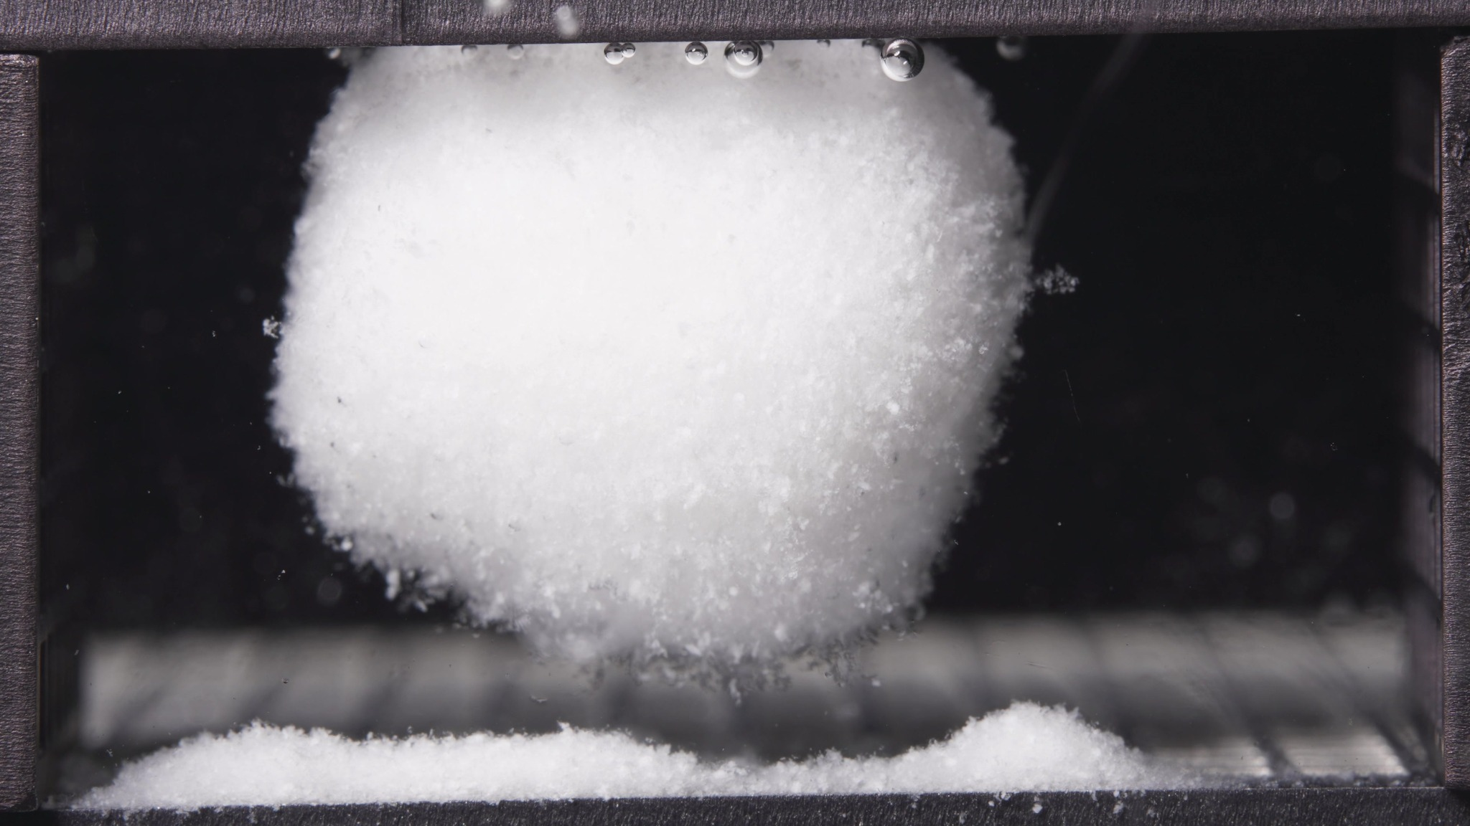 | 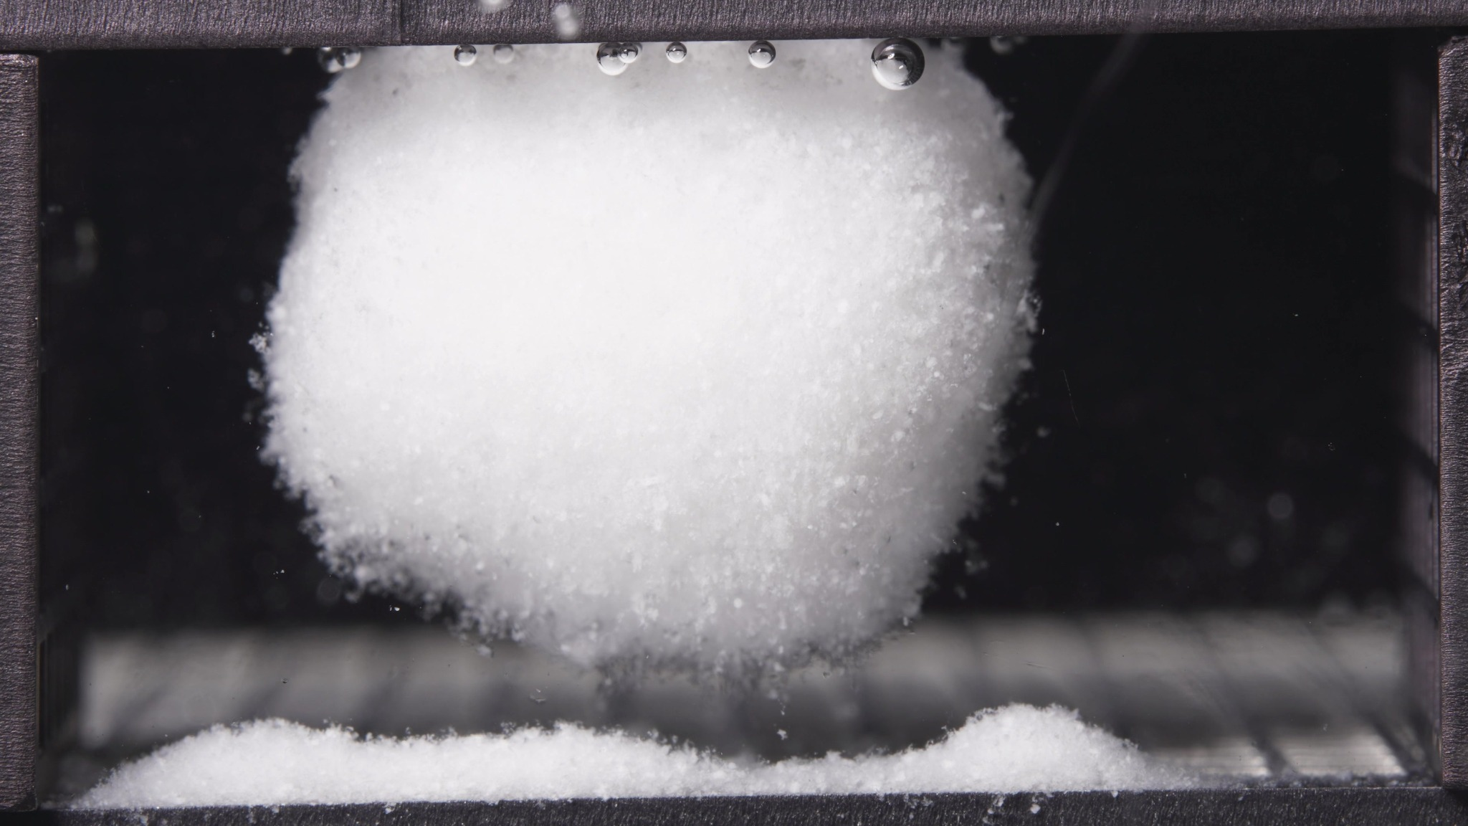 | 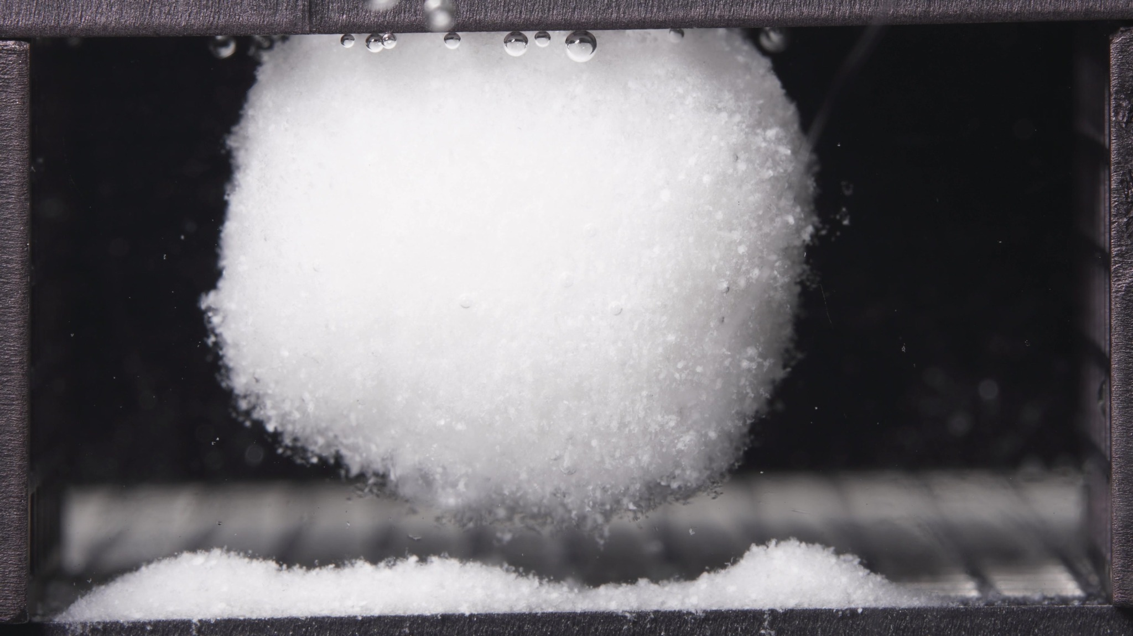

Turn 18: Assistant
{
"group_id": "STANDARD-VISCOSITY",
"time_range_h": [18.75, 23.75],
"time_h": null,
"eight_dimension_description": {
"color_change": "Across this batch, the main hydrated body remains uniformly white and opaque, without visible discoloration. Compared with the 12.5-17.5 h window, the overall color appearance is essentially unchanged. The surrounding medium still appears largely clear, with only slight localized particulate visibility near the suspended body and basal deposit.",
"shape_change": "The formulation still exists as one dominant coherent mass rather than multiple separated fragments. Compared with the previous window, the suspended globular morphology is maintained, but the outline appears slightly more regular and steady, with no new major rupture or collapse. The underside remains narrowed relative to the widest part of the body, so the mass continues to appear partially separated from the bottom deposit.",
"surface_texture_change": "The exterior remains rough, fine-granular, and fluffy along the periphery. Relative to 12.5-17.5 h, the surface looks slightly more uniform and externally settled, although friable edge material is still present, especially along the lower margins. The dominant pattern remains persistent superficial erosion rather than large cracks, fissures, or peeling layers.",
"volume_change": "The visible occupied volume remains large in this late window, indicating continued preservation of a substantial hydrated core. Compared with the previous window, there is no obvious gross expansion or collapse. At most, the body shows mild late-stage stabilization or slight compaction while retaining its bulk size, and the basal deposited material remains clearly separated below.",
"dissolution_speed_time": "Compared with the 12.5-17.5 h window, disintegration appears to remain slow and controlled. There is no evidence of transition into rapid whole-body fragmentation. Instead, the formulation continues in a prolonged late-stage hydrated state, with ongoing minor peripheral shedding and persistent underside erosion while the main body stays structurally intact.",
"physical_state_change": "The formulation remains a swollen, weakly coherent, gel-like or paste-supported bulk mass. Relative to the previous window, it appears slightly more stabilized as a suspended hydrated core rather than progressing toward full collapse or particle-dominated dispersion. The physical state therefore remains late-stage swollen and coherent, with only gradual external attrition.",
"dissolution_medium": "The surrounding medium remains visually clear across most of the chamber. Compared with the previous window, there is no clear increase in full-field turbidity or diffuse clouding. Visible medium changes are still localized near the body and the bottom sediment zone, consistent with continued local shedding rather than broad dispersion.",
"fragment_distribution_density": "Detached material remains concentrated near the original tablet location, mainly as a dense bottom layer with a mound-like accumulation on one side. Compared with 12.5-17.5 h, the spatial separation between the suspended core and the basal deposit remains clear, but chamber-wide fragment dispersion is still limited. Large independent fragments are not prominent."
},
"notes_for_later_summary": "Most critical change versus the 12.5-17.5 h window: the standard-viscosity formulation shows continued persistence of a large suspended hydrated core with only slight late-stage surface settling and ongoing local basal accumulation, but no transition to rapid fragmentation. The dominant 18.75-23.75 h pattern is structural retention with slow peripheral erosion and sustained separation between the main body and the bottom deposit."
}

Turn 19: User
These are pictures of the high-viscosity formulation during 0.104-5h.
Attached images
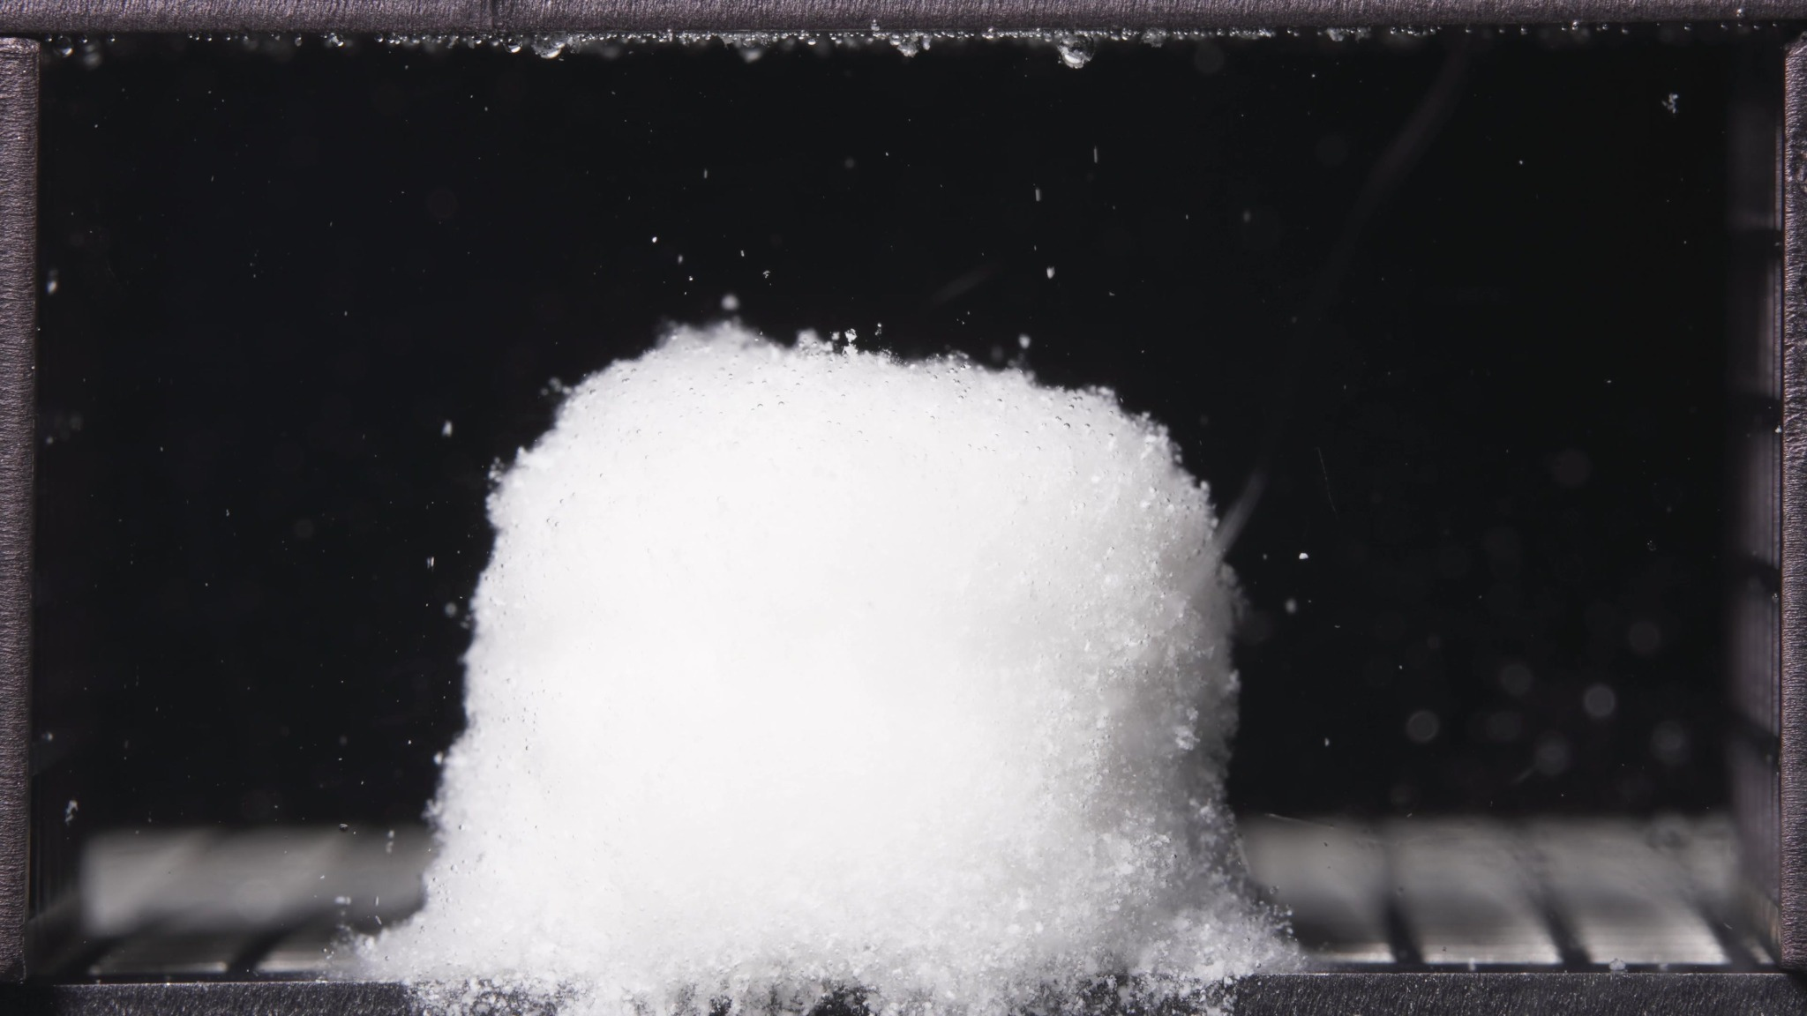 | 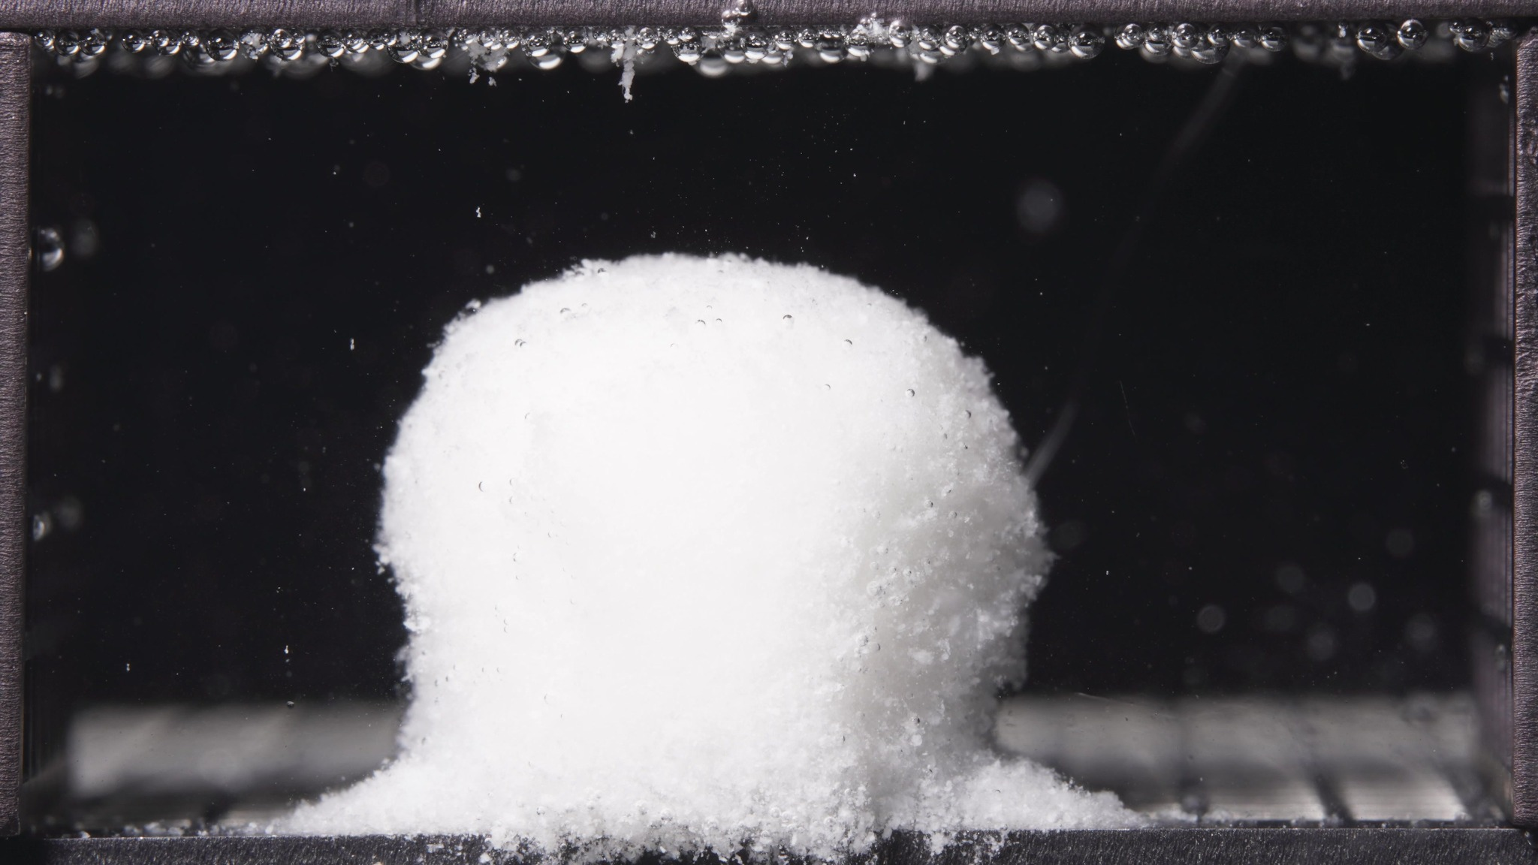 | 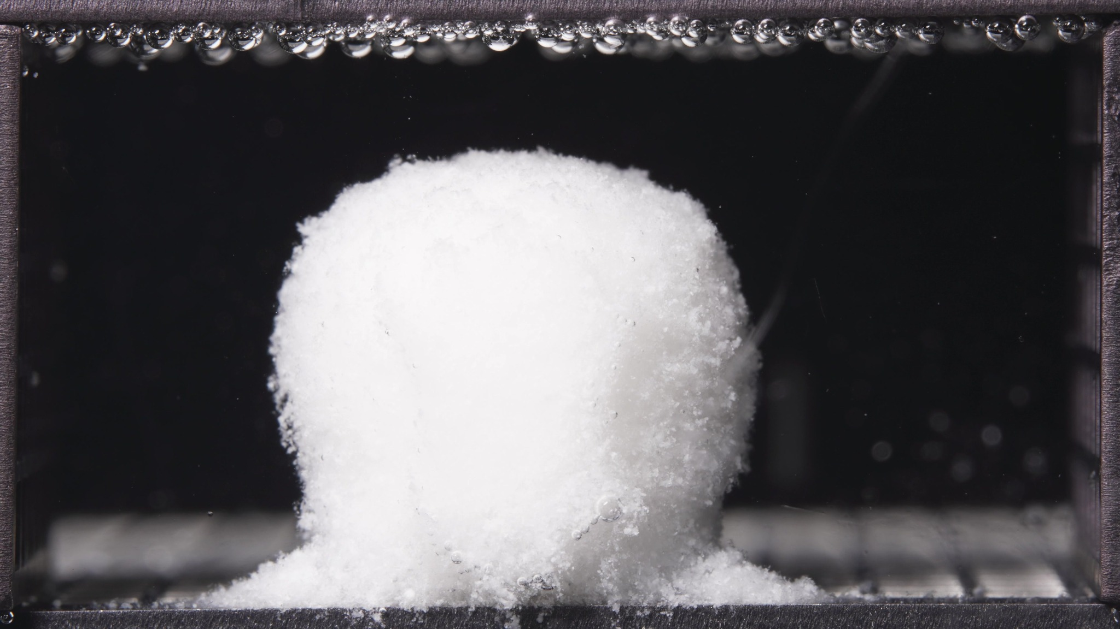

Turn 20: Assistant
{
"group_id": "HIGH-VISCOSITY",
"time_range_h": [0.104, 5.0],
"time_h": null,
"eight_dimension_description": {
"color_change": "Across this batch, the tablet remains uniformly white and opaque, without visible yellowing or darkening. The surrounding medium is visually mostly clear, with only slight localized whitening or fine particulate presence close to the tablet surface and base.",
"shape_change": "The formulation remains as one dominant coherent body with the overall tablet outline well preserved. The mass is still upright and block-like, with a broad lower support region and a slightly rounded or flattened upper contour. Compared with the low- and standard-viscosity early windows observed previously, this body appears more structurally retained and less reshaped into a globular form during the same broad early period.",
"surface_texture_change": "The surface is no longer perfectly smooth, but the roughening is still relatively moderate. The periphery appears fine-granular and slightly fluffy, especially along the right boundary and upper edge, yet the outer layer still looks comparatively compact and continuous rather than strongly loosened or extensively eroded.",
"volume_change": "The visible occupied volume remains substantial throughout this window, indicating maintenance of a large hydrated core. The body shows early swelling or volumetric preservation rather than collapse, and the swollen mass remains vertically supported with only limited basal spreading of detached material.",
"dissolution_speed_time": "Because no previous-window images were provided, a strict rate comparison versus an earlier stage is limited. Based on the current batch alone, the high-viscosity formulation appears to be in an early controlled hydration stage, with relatively slow gross disintegration, preserved body integrity, and only modest peripheral erosion rather than rapid breakup.",
"physical_state_change": "The formulation appears to have transitioned from an initially compact solid toward a swollen, softened, weakly coherent hydrated mass. However, the bulk body still looks comparatively dense and self-supporting, suggesting a swollen gel-like core with limited external loosening rather than a fragile or collapsing structure.",
"dissolution_medium": "The medium remains visually clear across most of the chamber. Observable changes are mainly localized near the tablet surface and the base, with no obvious chamber-wide turbidity, cloud band, or strongly diffused particulate field at this stage.",
"fragment_distribution_density": "Detached material is concentrated near the original tablet position, mainly as a modest fine-particle deposit around the base. Dispersion into the wider chamber is limited, and large separated fragments are not evident. Relative to the other formulations in comparable early windows, the fragment field appears less extensive and more tightly confined."
},
"notes_for_later_summary": "Previous-window comparison is unavailable, so the major timeline change versus an earlier stage cannot be stated directly. The dominant observation in the 0.104-5 h batch is that the high-viscosity formulation already forms a large upright hydrated mass with strong outline retention, only moderate surface roughening, and limited local basal shedding, consistent with slower early-stage disintegration and greater structural persistence."
}

Turn 21: User
These are pictures of the high-viscosity formulation during 6.25-11.25h.
Attached images
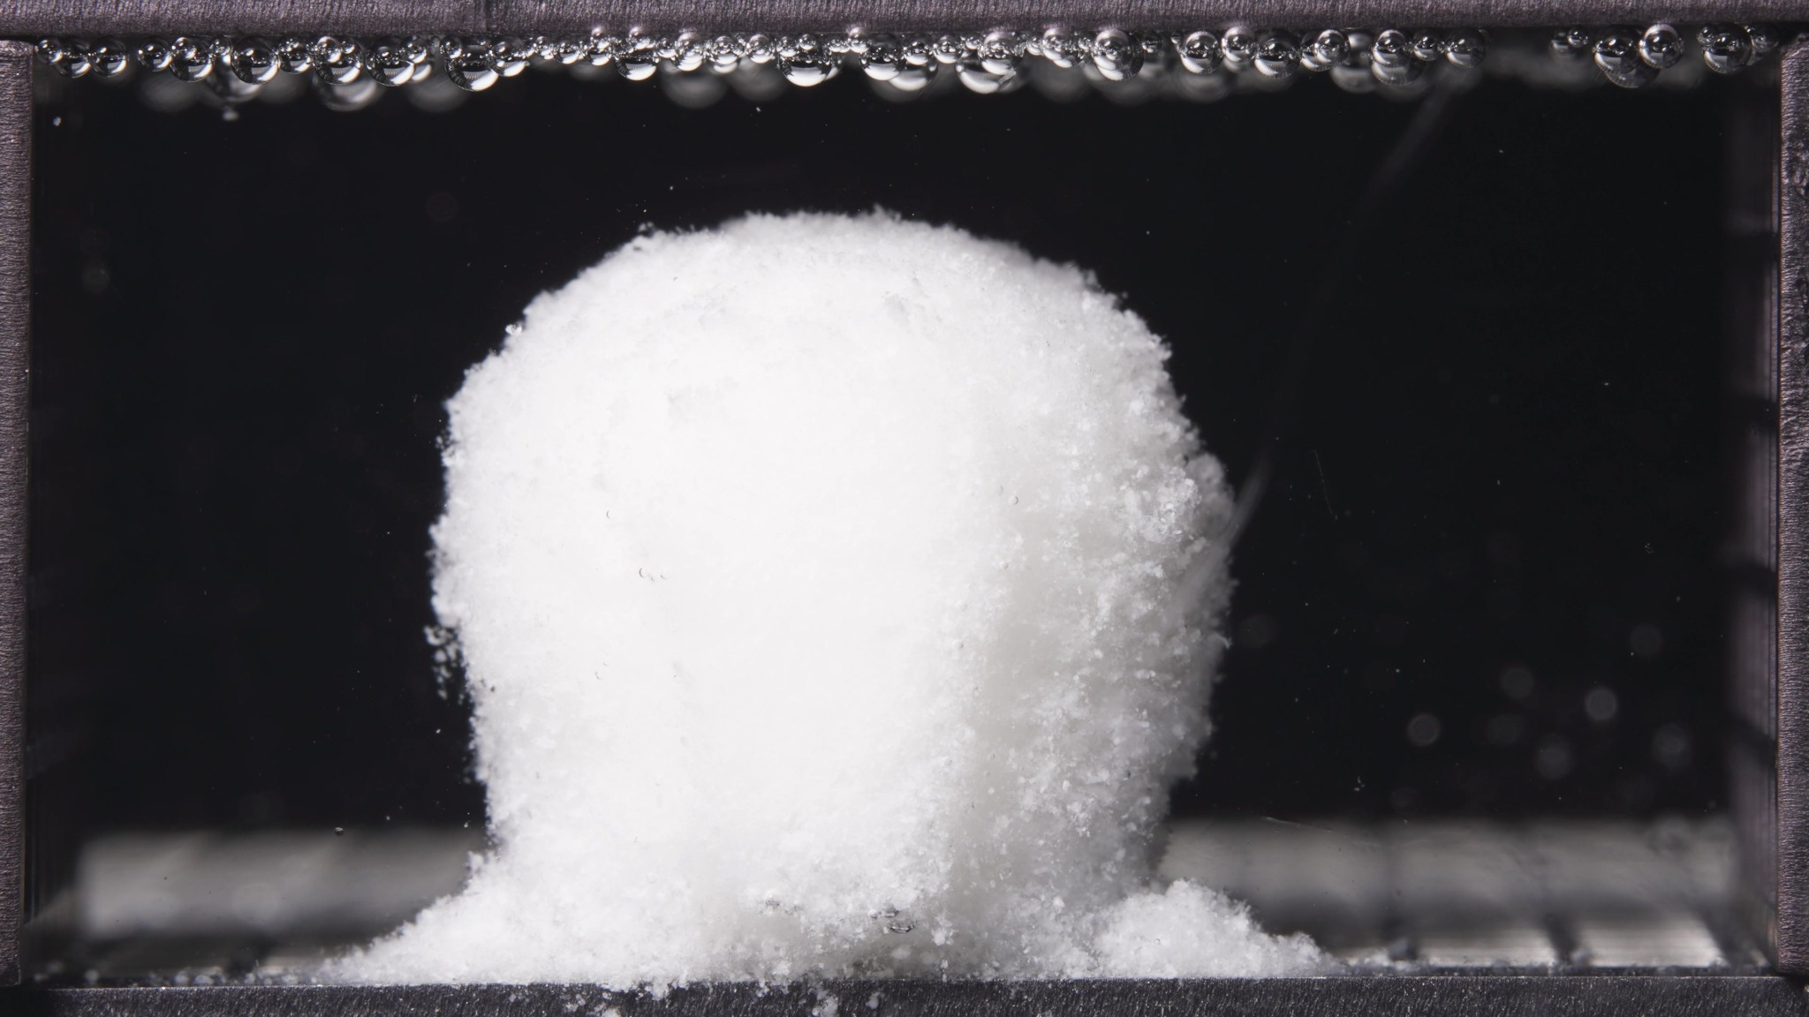 | 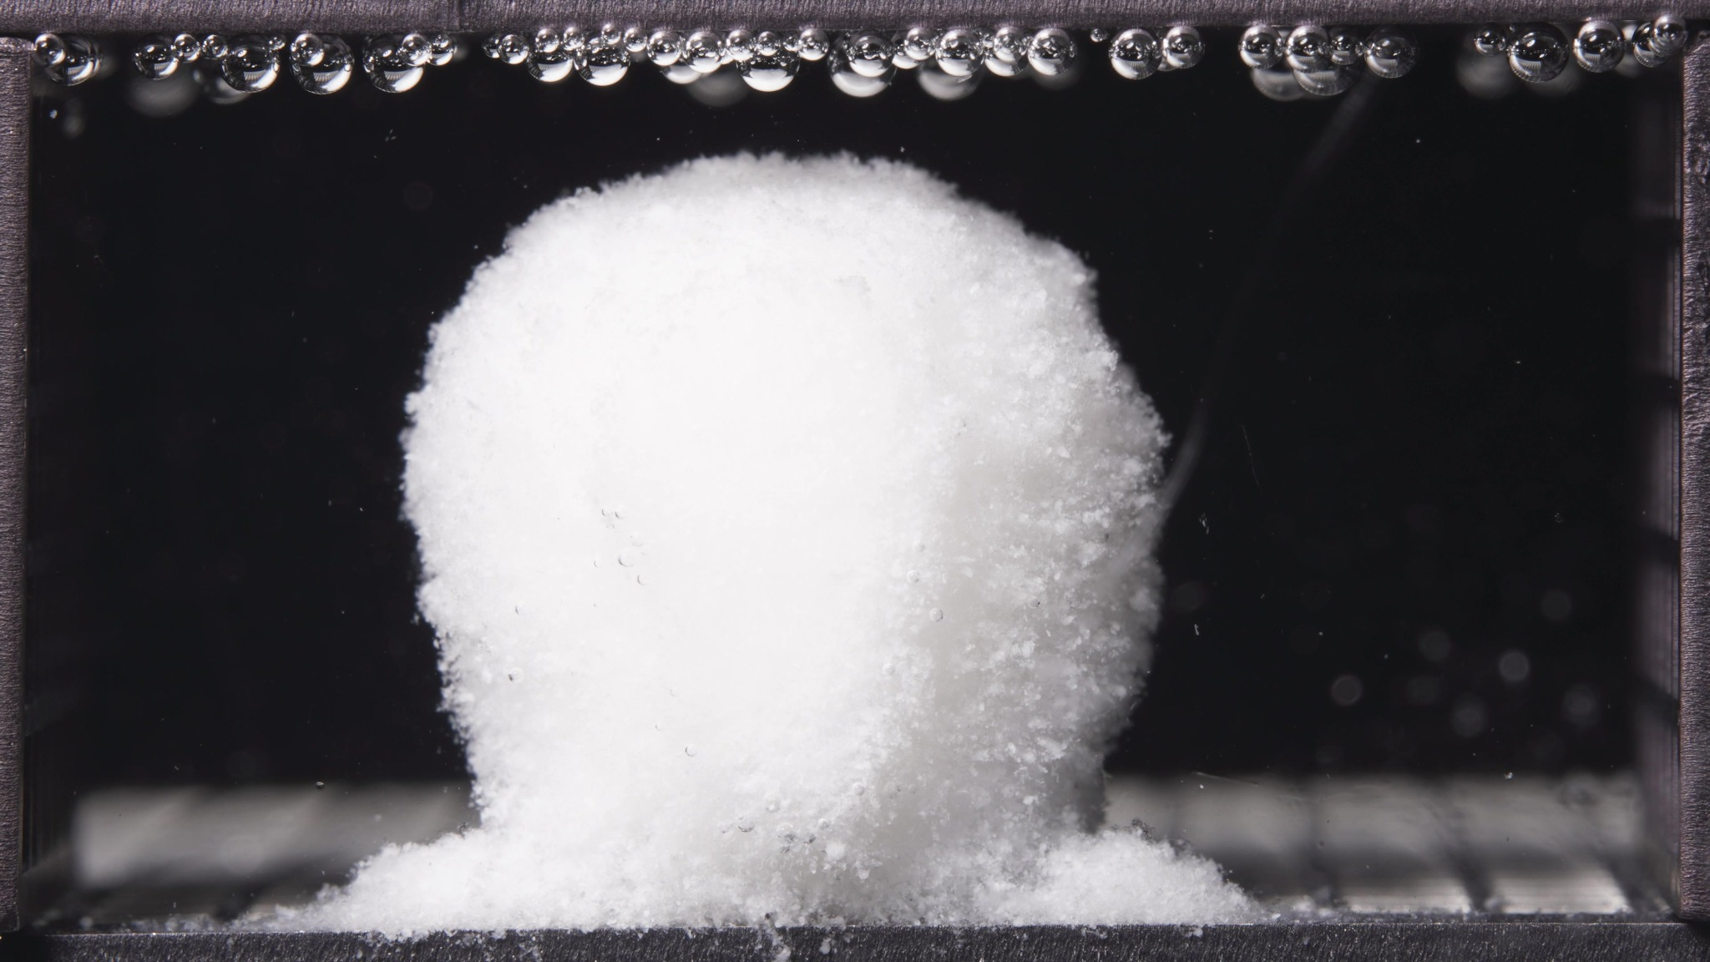 | 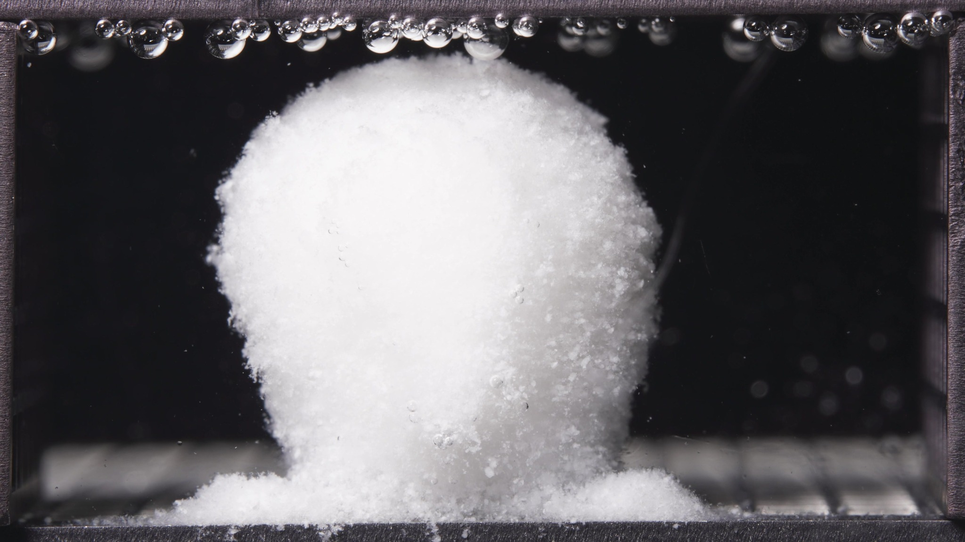

Turn 22: Assistant
{
"group_id": "HIGH-VISCOSITY",
"time_range_h": [6.25, 11.25],
"time_h": null,
"eight_dimension_description": {
"color_change": "Across this batch, the tablet body remains uniformly white and opaque, without visible discoloration. Compared with the 0.104-5 h window, the color appearance is essentially unchanged. The surrounding medium still appears mostly clear, with only slight localized haze or fine particulate visibility close to the tablet surface and basal deposit zones.",
"shape_change": "The formulation still remains as one dominant coherent body with strong outline retention. Compared with the previous window, the mass becomes slightly more rounded at the upper contour and somewhat fuller laterally, but it still preserves an upright block-like profile with a broad supported base. No breakup into separate large fragments is visible.",
"surface_texture_change": "The surface remains fine-granular and slightly fluffy at the periphery. Relative to 0.104-5 h, the edge roughening is somewhat more evident, especially along the right side and upper boundary, but the exterior still appears comparatively compact and continuous. The dominant change is mild progressive surface loosening rather than pronounced cracking or peeling.",
"volume_change": "The visible occupied volume remains large throughout 6.25-11.25 h, indicating continued preservation of a substantial hydrated core. Compared with the previous window, the body appears to maintain or slightly increase its swollen bulk while remaining vertically supported. There is no obvious large-scale collapse, and only limited redistribution of mass into the basal deposits.",
"dissolution_speed_time": "Compared with the 0.104-5 h window, disintegration appears to have advanced only modestly. The formulation continues in a slow, controlled hydration-and-erosion stage, with slightly greater peripheral roughening and local shedding, but without progression into rapid fragmentation or marked structural failure.",
"physical_state_change": "The formulation remains in a swollen, softened, weakly coherent hydrated state, but the bulk body still looks dense and self-supporting. Relative to the previous window, it appears slightly more gel-like or paste-supported at the surface while maintaining a strong internal core. It has not transitioned toward a suspended globular body or dispersed particle-dominant state.",
"dissolution_medium": "The medium remains visually clear across most of the chamber. Compared with the earlier window, there is no strong development of chamber-wide turbidity or cloud bands. Observable changes remain localized near the tablet and the bottom contact regions, consistent with limited local material shedding.",
"fragment_distribution_density": "Detached material remains concentrated near the original tablet position, mainly as low mound-like fine-particle deposits around the base on both sides. Compared with 0.104-5 h, the basal accumulation is slightly more established, but dispersion into the wider chamber remains limited and large separated fragments are still not evident."
},
"notes_for_later_summary": "Most critical change versus the 0.104-5 h window: the high-viscosity formulation remains strongly intact, with only mild additional rounding of the upper contour, slightly more obvious peripheral roughening, and somewhat more established local basal deposits. This indicates continued slow controlled hydration and superficial erosion, while overall structural persistence remains stronger than would be expected for a faster-disintegrating system."
}

Turn 23: User
These are pictures of the high-viscosity formulation during 12.5-17.5h.
Attached images
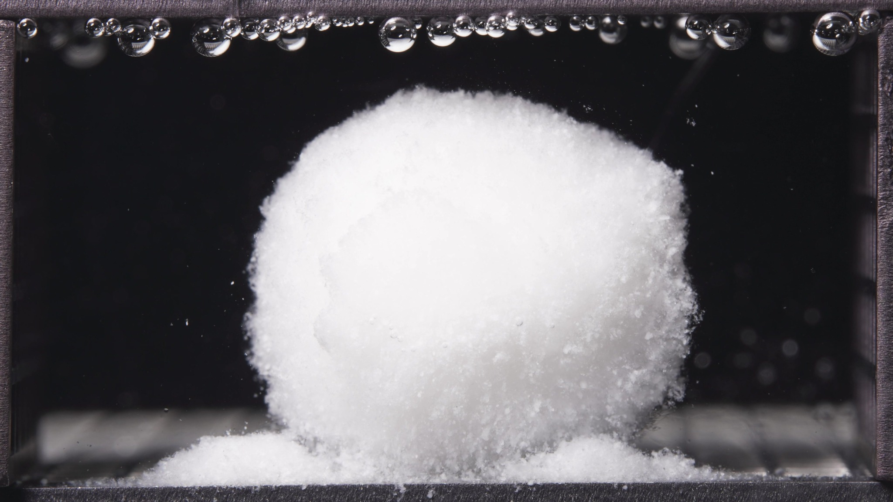 | 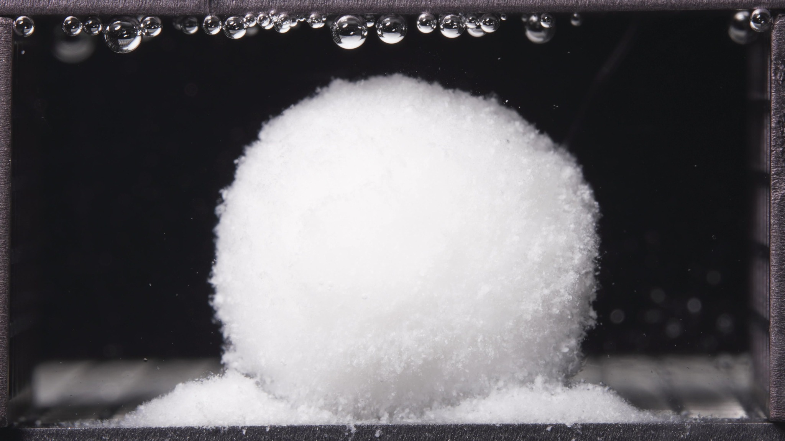 | 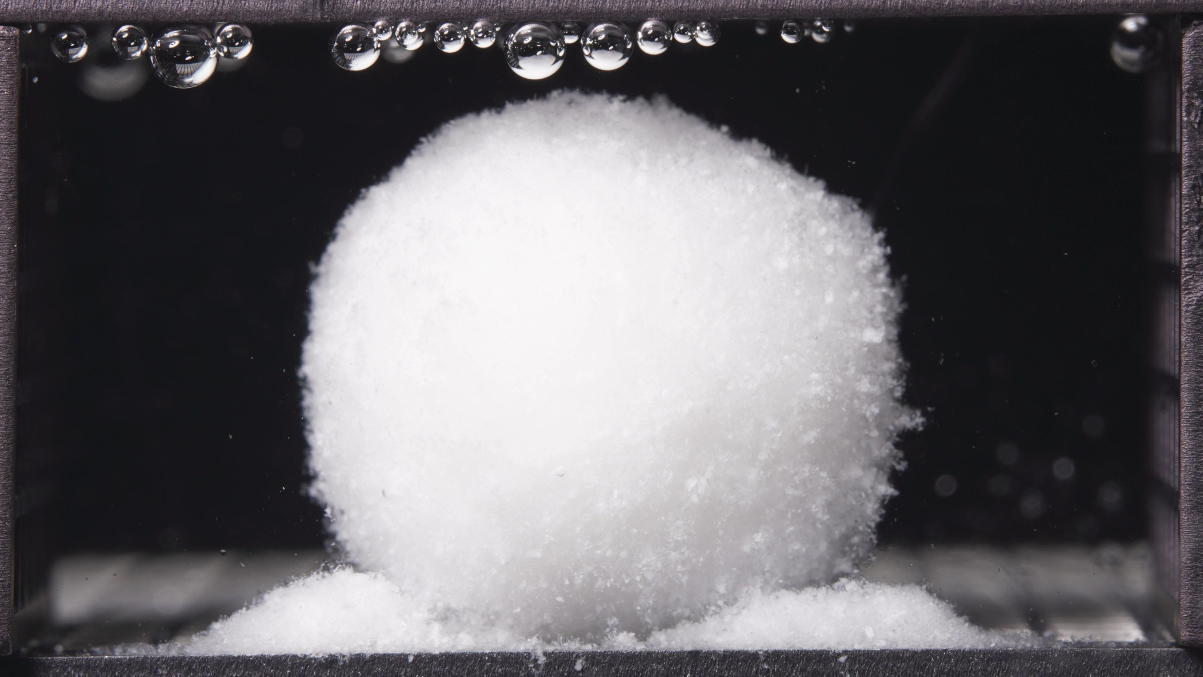

Turn 24: Assistant
{
"group_id": "HIGH-VISCOSITY",
"time_range_h": [12.5, 17.5],
"time_h": null,
"eight_dimension_description": {
"color_change": "Across this batch, the tablet body remains uniformly white and opaque, without visible discoloration. Compared with the 6.25-11.25 h window, the overall color appearance is essentially unchanged. The surrounding medium still appears mostly clear, with only slight localized particulate visibility near the tablet surface and the basal deposit regions.",
"shape_change": "The formulation still remains as one dominant coherent body with strong structural retention. Compared with the previous window, the mass appears more rounded and laterally fuller, with a more dome-like upper contour and slightly less sharply columnar profile. However, it still preserves a broad supported base and does not break into multiple large fragments.",
"surface_texture_change": "The surface remains fine-granular and fluffy at the periphery. Relative to 6.25-11.25 h, peripheral roughening is still evident, especially along the right boundary and lower margins, but the exterior continues to look comparatively compact and continuous overall. The dominant change remains gradual superficial erosion rather than crack formation or peeling.",
"volume_change": "The visible occupied volume remains large throughout 12.5-17.5 h, indicating continued preservation of a substantial hydrated core. Compared with the previous window, the body shows no obvious collapse and appears to maintain a broad swollen bulk, with mass distribution becoming slightly more rounded and settled while basal deposits on both sides become more established.",
"dissolution_speed_time": "Compared with the 6.25-11.25 h window, disintegration appears to continue slowly and in a controlled manner. The formulation shows modest further contour rounding and local peripheral shedding, but there is still no evidence of rapid fragmentation or major structural failure. The rate of visible gross disintegration therefore remains low.",
"physical_state_change": "The formulation remains in a swollen, softened, weakly coherent hydrated state with a dense self-supporting core. Relative to the previous window, it appears slightly more gel-like at the outer regions and more globally rounded, but it still does not transition into a suspended globular residue, a collapsed mass, or a particle-dominant dispersed state.",
"dissolution_medium": "The medium remains visually clear across most of the chamber. Compared with the earlier window, there is no clear development of chamber-wide turbidity, cloud bands, or diffuse haze. Observable medium changes remain localized around the tablet and the bottom contact zones, consistent with limited local shedding only.",
"fragment_distribution_density": "Detached material remains concentrated near the original tablet position, mainly as fine-particle mound-like deposits at the base on both sides. Compared with 6.25-11.25 h, these basal accumulations appear slightly more pronounced and spatially established, but dispersion into the wider chamber remains limited and large separated fragments are still not evident."
},
"notes_for_later_summary": "Most critical change versus the 6.25-11.25 h window: the high-viscosity formulation becomes more rounded and laterally full while remaining strongly intact, with slightly more established bilateral basal deposits but still no rapid fragmentation. This indicates continued slow controlled hydration and superficial erosion with persistent structural retention through 12.5-17.5 h."
}

Turn 25: User
These are pictures of the high-viscosity formulation during 18.75-23.75h.
Attached images
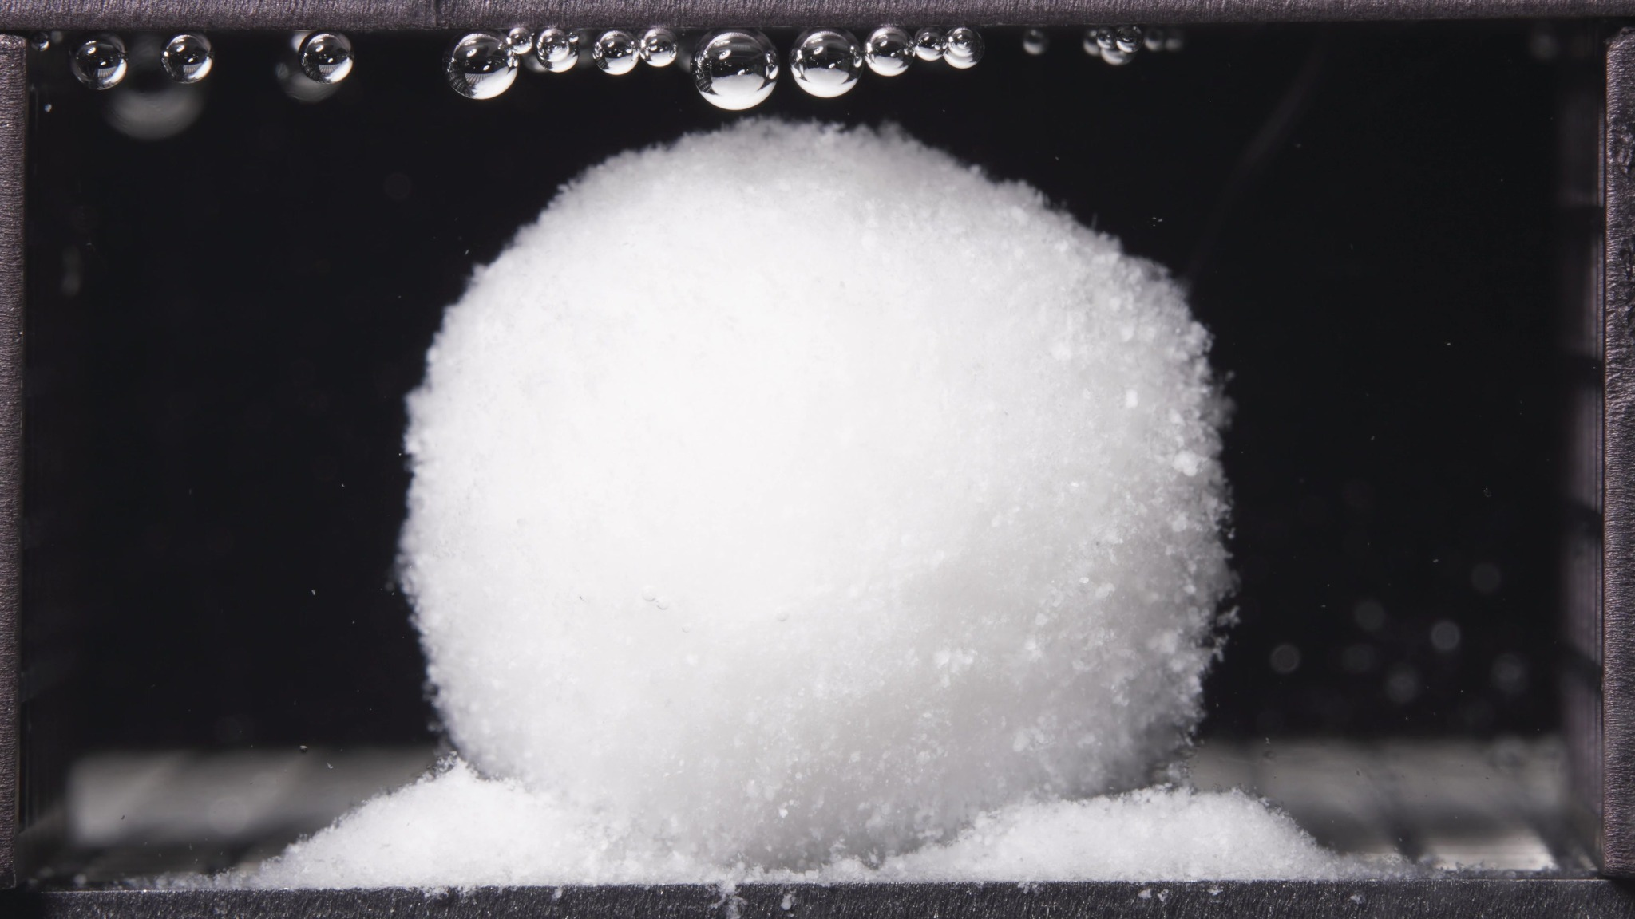 | 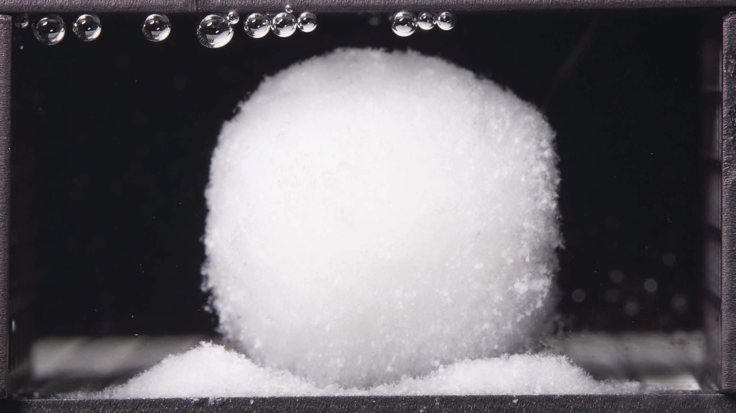 | 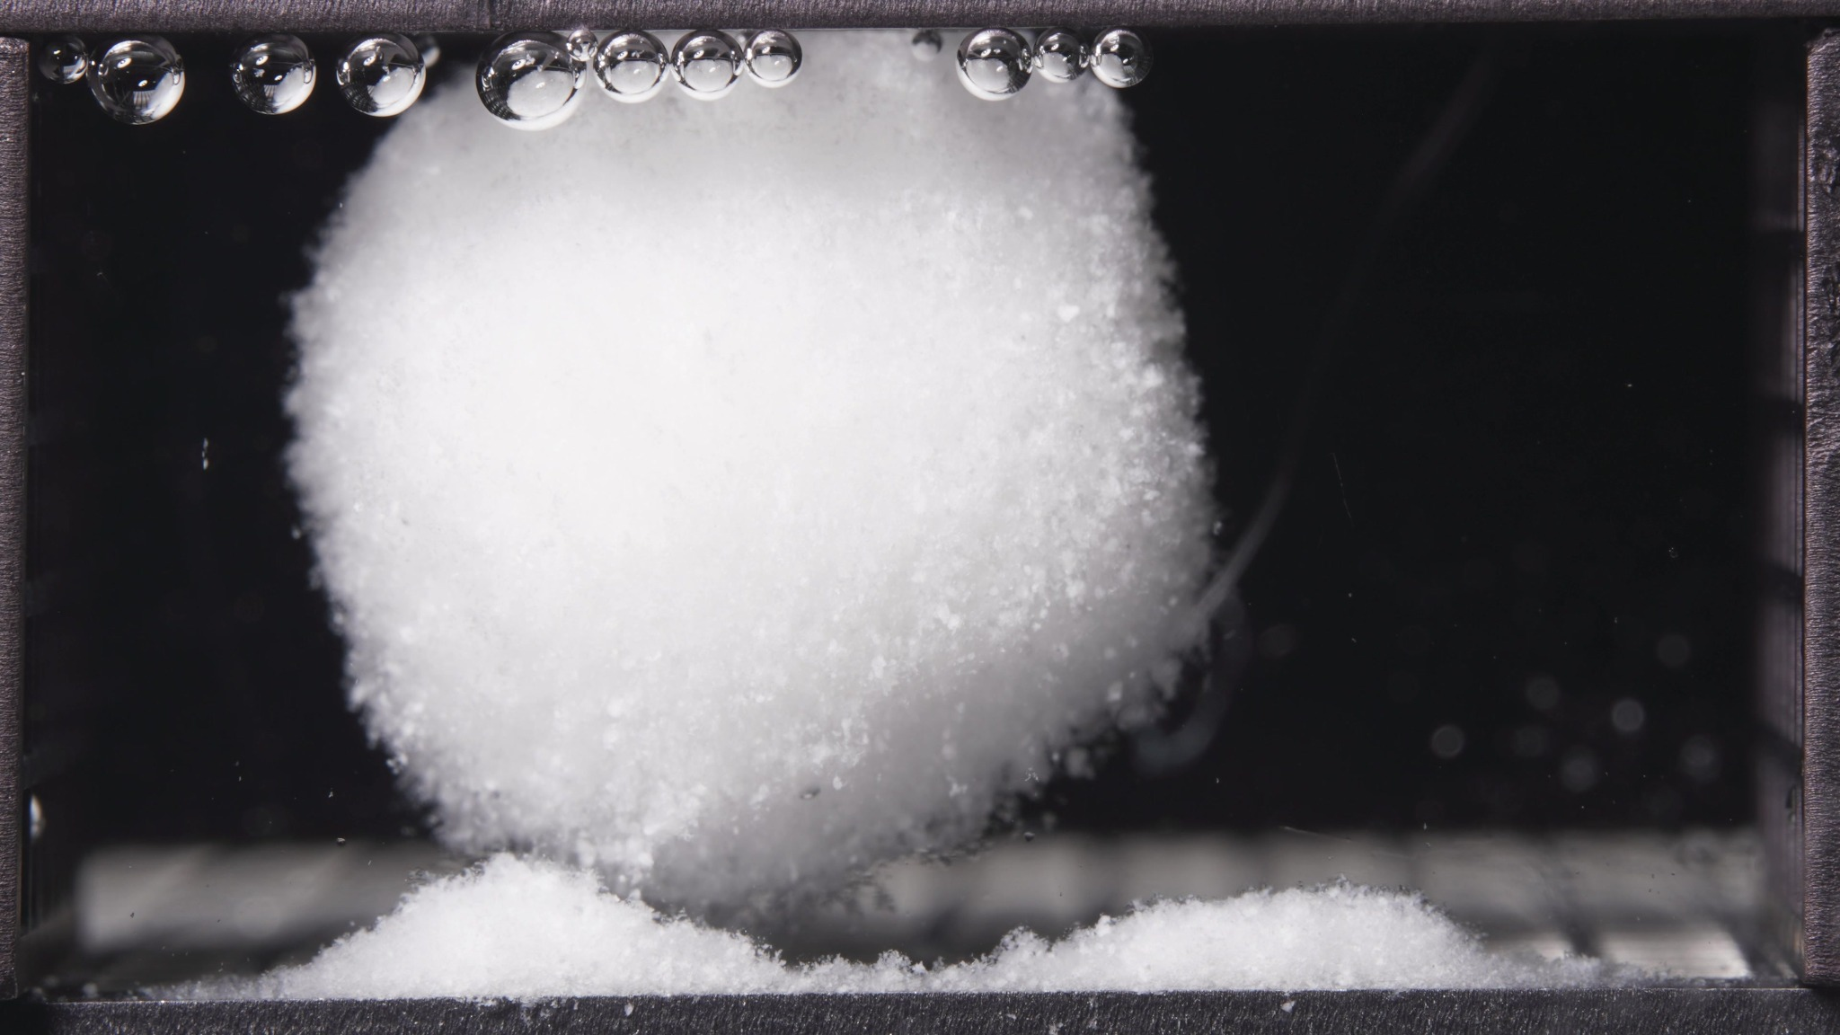

Turn 26: Assistant
{
"group_id": "HIGH-VISCOSITY",
"time_range_h": [18.75, 23.75],
"time_h": null,
"eight_dimension_description": {
"color_change": "Across this batch, the tablet body remains uniformly white and opaque, without visible discoloration. Compared with the 12.5-17.5 h window, the color appearance is essentially unchanged. The surrounding medium still appears mostly clear, with only slight localized particulate visibility near the tablet surface and basal deposit regions.",
"shape_change": "The formulation still remains as one dominant coherent body with no breakup into multiple large fragments. Compared with the previous window, the outline becomes more globally rounded and closer to a near-spherical or dome-like mass, with slightly less obvious broad basal support. The body still rests near the bottom deposits, but the central mass appears more distinctly separated from the side mounds than before.",
"surface_texture_change": "The surface remains fine-granular and fluffy at the periphery. Relative to 12.5-17.5 h, the exterior looks slightly more uniformly settled and rounded, although friable edge material is still visible, especially along the lower margins and right boundary. The dominant pattern remains slow superficial erosion rather than cracking, fissuring, or peeling.",
"volume_change": "The visible occupied volume remains large in this late window, indicating continued preservation of a substantial hydrated core. Compared with the previous window, there is no gross collapse. At most, the body shows mild late-stage reshaping toward a more compact rounded bulk while the bilateral basal deposits become more spatially distinct from the central mass.",
"dissolution_speed_time": "Compared with the 12.5-17.5 h window, disintegration still appears slow and controlled. The formulation does not enter a rapid terminal breakup stage. Instead, it shows continued late-stage contour rounding, minor peripheral shedding, and gradual reduction in broad bottom support while the main body remains intact.",
"physical_state_change": "The formulation remains in a swollen, softened, weakly coherent hydrated state with a dense self-supporting core. Relative to the previous window, it appears slightly more like a rounded late-stage gel-like bulk mass with less broad contact at the base, but it still has not transitioned into a suspended globular residue, collapsed debris, or particle-dominant dispersion.",
"dissolution_medium": "The medium remains visually clear across most of the chamber. Compared with the earlier window, there is no clear development of chamber-wide turbidity, cloud bands, or diffuse haze. Observable medium changes remain localized around the tablet and the bottom contact zones, consistent with limited local shedding only.",
"fragment_distribution_density": "Detached material remains concentrated near the original tablet position, mainly as bilateral mound-like fine-particle deposits at the base. Compared with 12.5-17.5 h, these side deposits appear more clearly separated from the central hydrated mass, but dispersion into the wider chamber remains limited and large independent fragments are still not evident."
},
"notes_for_later_summary": "Most critical change versus the 12.5-17.5 h window: the high-viscosity formulation becomes more globally rounded and slightly less broadly supported at the base, while the bilateral basal deposits become more clearly distinct from the central mass. This indicates continued very slow late-stage erosion and reshaping, but the formulation still retains a large coherent hydrated core without rapid fragmentation."
}

Turn 27: User
"Provide an integrated mechanistic interpretation of the observed disintegration behavior of the three gliclazide formulations."
"The three formulations are the low-viscosity formulation, the standard formulation (medium-viscosity), and the high-viscosity formulation, and their main formulation difference lies in the ratio between HPMC K4M and HPMC 100lv."
"Our optimization goal is to adjust the ratio between HPMC K4M and HPMC 100lv so that the 24-hour release amount of the standard-viscosity gliclazide tablet is reduced to 90% of its original level."
"In addition to the image-based disintegration observations, please also use the UV absorbance data from the flow-through-cell eluate as semi-quantitative release evidence."
"All UV absorbance values are within the linear range."
"The interval sequence is: 0–0.5 h, 0.5–1 h, 1–2 h, 2–4 h, 4–6 h, 6–8 h, 8–12 h, 12–16 h, 16–20 h, and 20–24 h."
"The corresponding mean UV absorbance values are as follows:"
"Low-viscosity formulation: 0.153, 0.233, 0.361, 0.666, 0.776, 0.878, 0.860, 0.894, 0.927, 0.770."
"Standard formulation: 0.194, 0.204, 0.336, 0.656, 0.775, 0.741, 0.776, 0.820, 0.761, 0.647."
"High-viscosity formulation: 0.155, 0.143, 0.204, 0.483, 0.580, 0.582, 0.573, 0.689, 0.632, 0.540."
"Please:"
"1) Summarize the key differences in disintegration behavior across the three formulations as evidence statements."
"2) Using the literature and the current session data, focus on explaining how differences in the HPMC K4M / HPMC 100lv ratio may influence swelling, gel-layer formation, erosion, fragmentation, shell persistence, and other observed disintegration phenomena."
"3) Relate the observed disintegration phenomena to the interval-based UV absorbance trends, and state whether the image-based evidence and the UV-based evidence are mutually supportive, partially aligned, or inconsistent."
"4) Propose 2–5 mechanistic hypotheses, each clearly tied to the observed phenomena, the UV trends, and the HPMC ratio differences."
"5) Explain what these mechanistic differences may imply for helping the standard-viscosity gliclazide tablet achieve 90% of its original 24-hour release amount within 24 hours, so that the result can support the next-step formulation optimization."
"6) List alternative explanations and a minimal set of follow-up tests to discriminate between hypotheses."
"Use only information from this session and the retrieved literature; do not invent missing details."
"Do not provide a final optimized formulation recipe in this step."

Turn 28: Assistant
Phenomenon Review
1. **Evidence statements from the images**
1. All three formulations formed **large, persistent hydrated bodies** rather than rapidly disintegrating into many large fragments. Across the full 24 h observation, the dominant visible process was **swelling plus surface erosion/basal shedding**, not catastrophic breakup.
2. The **low-viscosity formulation** became rounded relatively early, showed persistent rough/fluffy surface erosion, and continuously generated **dense basal fine-material deposits**, but the main body still remained coherent through late time windows.
3. The **standard formulation** showed the most obvious **basal undercutting / partial “suspended-core” morphology** from about 6.25 h onward: a large swollen core persisted while the underside eroded and separated more clearly from the bottom deposit.
4. The **high-viscosity formulation** retained the most upright, supported, and structurally conservative morphology in the early and middle windows, then gradually rounded later, with **less extensive visible shedding** than the other two and the strongest overall shell persistence.
5. The key rank order from the image set is therefore not “more fragmentation = more release.” Instead, it is:
- **Low viscosity:** most evidence of a loose, continuously shedding, permeable hydrated mass
- **Standard viscosity:** intermediate overall behavior, but with the most obvious shell/core-support heterogeneity
- **High viscosity:** strongest structural persistence and slowest visible erosion
Concentration-Time Trend Review
I treated the UV absorbance data as **semi-quantitative interval release evidence**. Because the eluate flow rate was constant and absorbance was stated to be linear, **mean absorbance × interval duration** is a reasonable proxy for interval drug amount eluted.
1. **Key UV evidence statements**
1. The 24 h cumulative proxy ranks as **low > standard > high**:
- Low viscosity: about **19.00**
- Standard viscosity: about **16.90**
- High viscosity: about **13.38**
2. Relative to the standard formulation, the low-viscosity formulation is about **12.4% higher**, while the high-viscosity formulation is about **20.8% lower**.
3. The user’s optimization target is **90% of the standard’s original 24 h release**, which corresponds to a cumulative proxy of about **15.21**. That target lies **between the standard and high-viscosity formulations**, and is **closer to the standard** than to the high-viscosity formulation.
4. Interval-wise, the **standard formulation is highest only in the first 0–0.5 h interval**. After that, the **low-viscosity formulation becomes equal to or higher than standard**, and from **6 h onward it is consistently the highest**. The **high-viscosity formulation is consistently the lowest after 0.5 h**.
5. When normalized to each formulation’s own 24 h total, the cumulative fractions by 12 h are fairly similar (roughly **44–47%**), so the dominant between-formulation difference is not a dramatic shift in *when* release occurs, but mainly a difference in the **absolute magnitude of release through the hydrated matrix**, especially from **6–24 h**.
2. **Alignment between image and UV evidence**
Overall, the image and UV evidence are **partially aligned, but broadly supportive**.
- They are **mutually supportive** for the conclusion that the **high-viscosity formulation is the slowest / most retarding**.
- They are also broadly supportive that the **low-viscosity formulation is the fastest / most releasing**.
- But they are **not perfectly one-to-one** morphologically: the standard formulation shows the most obvious macroscopic undercutting / suspended-core appearance, yet its UV output remains intermediate rather than highest. That means the visible outline alone is **not sufficient** to infer release rate; **gel permeability and shell quality** are likely as important as gross shape.
- The earliest UV differences are also difficult to map directly to the images because the first image window is broad (**0.104–5 h**) and the medium changes from **pH 1.2 to pH 6.8 at 1 h**, so the earliest release behavior is temporally under-resolved by the image batches.
Literature-Supported Typical Mechanistic Links
Hydrophilic HPMC matrices generally release drug through a combination of **water uptake, gel-layer formation, diffusion through the swollen gel, and matrix erosion**. The gel layer is not just a passive shell: its **viscoelastic properties** strongly influence release, and the movement of swelling/diffusion/erosion fronts is mechanistically important. ([pubmed.ncbi.nlm.nih.gov](https://pubmed.ncbi.nlm.nih.gov/27808590/?utm_source=chatgpt.com))
Relevant mixed-grade HPMC literature indicates that formulations containing a **larger proportion of high-molecular-weight / high-viscosity HPMC** tend to erode more slowly, while formulations richer in lower-molecular-weight grades erode faster; similarly, lower overall HPMC content tends to accelerate erosion and reduce robustness. In older mechanistic swelling work, lower-viscosity systems were also associated with **faster-dissolving behavior, swelling inhomogeneity, and higher apparent diffusivity/release** under some conditions. ([pubmed.ncbi.nlm.nih.gov](https://pubmed.ncbi.nlm.nih.gov/24818771/?utm_source=chatgpt.com))
The literature support is relevant but not perfect. The strongest support here comes from the **general HPMC matrix literature** and from mixed-grade studies that include **K4M / low-viscosity HPMC comparisons**. The retrieved gliclazide-specific paper mainly supports the broader point that **matrix structure, shape, and porosity materially affect gliclazide release**, rather than directly proving the exact mechanism in this session’s three formulations. ([pubmed.ncbi.nlm.nih.gov](https://pubmed.ncbi.nlm.nih.gov/24818771/?utm_source=chatgpt.com))
Tentative Integrated Mechanistic Interpretation Across the Three Formulations
**User-provided formulation fact:** the main controlled variable is the **HPMC K4M / HPMC 100lv ratio**, moving from **100lv-rich (low-viscosity formulation)** to **intermediate blend (standard)** to **K4M-rich (high-viscosity formulation)**.
1. **Low-viscosity formulation**
The image set suggests that the low-viscosity formulation hydrates readily and forms a **large but relatively loose, erosion-prone hydrated body**. Its persistent basal shedding, rough surface, and early rounding are consistent with a gel layer that forms quickly but is **less resistant to ongoing disentanglement / erosion** and likely **more permeable** than the other two. That interpretation fits the UV data: it is not dramatically burst-like after 2 h, but it sustains the **highest interval output from 6–24 h** and the highest 24 h cumulative proxy. In mechanistic terms, this formulation may not be “failing” by gross fragmentation; instead, it may be **releasing efficiently through a relatively permeable, continuously renewing hydrated layer**. ([pubmed.ncbi.nlm.nih.gov](https://pubmed.ncbi.nlm.nih.gov/8818998/?utm_source=chatgpt.com))
2. **Standard formulation**
The standard formulation is the most interesting because its morphology is not simply intermediate. It shows the clearest **basal undercutting and partial suspended-core behavior**, yet its cumulative UV output is only intermediate. A plausible tentative interpretation is that the balanced K4M/100lv ratio creates a **structurally coherent outer shell / gel network** that is still strong enough to maintain a large swollen core, while local underside erosion proceeds beneath it. In other words, the standard may display more dramatic **macroscopic shell/core heterogeneity** than the low-viscosity formulation, but still provide a **more restrictive mass-transfer barrier** than the low-viscosity gel. That would explain why it can look more undercut yet still release less than the low-viscosity formulation. ([pubmed.ncbi.nlm.nih.gov](https://pubmed.ncbi.nlm.nih.gov/27808590/?utm_source=chatgpt.com))
3. **High-viscosity formulation**
The high-viscosity formulation shows the strongest evidence of a **persistent, slowly eroding gel barrier**: best early shape retention, least obvious shedding, slow progressive rounding, and the lowest UV output at almost every interval after 0.5 h. The most straightforward interpretation is that the higher K4M fraction yields a **stronger, more elastic, more persistent gel layer** with slower disentanglement/erosion and lower effective transport. This is the cleanest case in which the image ranking and UV ranking converge. ([pubmed.ncbi.nlm.nih.gov](https://pubmed.ncbi.nlm.nih.gov/24818771/?utm_source=chatgpt.com))
4. **Mechanistic hypotheses**
1. **Permeable-gel hypothesis for the low-viscosity formulation.** A 100lv-rich matrix forms a hydrated layer quickly, but that layer is less viscous / less resistant, so it supports continuous diffusion plus surface renewal. This explains the combination of persistent coherent shape **and** the highest cumulative UV output.
2. **Persistent-shell hypothesis for the high-viscosity formulation.** A K4M-rich matrix forms a stronger, more elastic gel shell that resists erosion and limits transport, producing the lowest UV output and strongest shape retention.
3. **Heterogeneous-shell / undercut-core hypothesis for the standard formulation.** The balanced blend may generate the most obvious shell/core-support heterogeneity: the underside erodes, but the remaining shell is still sufficiently coherent to slow transport. This explains why the standard can appear more undercut than the low-viscosity formulation without exceeding it in UV release.
4. **Early-acid / surface-access hypothesis for the standard’s first interval.** The standard formulation’s leading 0–0.5 h absorbance may reflect early surface-accessible drug release or early wetting behavior before the mature gel architecture is established. Because the first window is broad in the image set and the medium switches at 1 h, this early difference should be treated as real but mechanistically unresolved.
5. **Late-stage aging/depletion hypothesis across all three.** The 20–24 h decline in interval absorbance for all three, despite persistent hydrated bodies, suggests that late release becomes limited by **depletion of more accessible drug and/or increasing transport resistance in an aged gel**, not by sudden matrix collapse.
Mechanistic Implications for the Next Optimization Step
For the stated goal—**reduce the standard formulation’s 24 h release to 90% of its current level, without moving to the branch-4 final recipe step**—the key implication is that the standard likely needs only a **modest shift toward the high-viscosity mechanism**, not a full conversion into the high-viscosity behavior.
More specifically:
1. The standard’s target cumulative proxy is about **15.21**, while the current standard is **16.90** and the high-viscosity formulation is **13.38**. So the target is a **small retardation from the current standard**, whereas the current high-viscosity formulation appears to **overshoot** that retardation.
2. Because the normalized cumulative fractions are fairly similar across formulations, the next optimization probably does **not** need a wholesale reshaping of the whole profile. The larger opportunity is to **lower the absolute release magnitude**, especially in the **mid/late windows (roughly 6–24 h)** where low > standard > high separates most clearly.
3. Mechanistically, that points toward wanting the standard formulation to preserve slightly more of the **high-viscosity formulation’s shell persistence / erosion resistance / lower gel permeability**, while avoiding a shift so far that the system becomes as retarding as the current high-viscosity formulation.
4. The image evidence suggests that simply increasing visible undercutting or shell/core separation is **not** the goal. The more relevant lever is likely the balance between:
- **gel permeability**
- **gel strength / persistence**
- **rate of peripheral and underside erosion**
- **extent of continuous fine-material shedding**
Suggestions for Further Validation
1. **Alternative explanations that remain plausible**
1. The earliest UV differences may partly reflect **surface drug distribution, wetting differences, or compression-related heterogeneity**, not only HPMC-ratio effects.
2. The **pH switch at 1 h** may affect the earliest rank ordering independently of the later gel-state behavior.
3. The side-view images report **external morphology**, but not internal gel density, shell thickness, pore structure, or effective diffusion path length; two tablets can look similar externally while releasing differently.
4. The standard formulation’s suspended-core appearance may reflect **localized underside erosion mechanics** more than globally higher permeability.
5. Late-stage UV decline may reflect **drug depletion, gel aging, or changing internal transport resistance**, rather than only slower erosion.
2. **Minimal follow-up tests to discriminate between hypotheses**
1. **Finer time-resolution imaging + UV sampling from 0–2 h and 4–10 h**, especially around the 1 h pH switch.
2. **Interval wet-mass uptake and dry-mass erosion measurements** on the same three formulations.
3. **Gel-layer front tracking or cross-sectional imaging** (optical sectioning, dye penetration, NMR/micro-imaging, or similar).
4. **Replicated release runs with polymer-loss or gel-strength readouts** in the swollen state.
Overall, the current session supports a cautious mechanistic continuum: **100lv-rich low viscosity = more permeable / more continuously shedding hydrated matrix; K4M-rich high viscosity = more persistent / more retarding gel barrier; standard = intermediate cumulative release but morphologically heterogeneous shell/core behavior**. That is enough to support the next optimization step mechanistically, but not enough yet to collapse the explanation to a single validated mechanism.

Turn 29: User
"Provide a formulation optimization recommendation for the next iteration based on the existing formulation information, optimization target, concentration-time summary, mechanistic analysis results, and prior disintegration-analysis conclusions in this session."
"The three formulations are the low-viscosity formulation, the standard formulation (medium-viscosity), and the high-viscosity formulation. The standard formulation is the reference formulation."
"Our optimization goal is to adjust the ratio between HPMC K4M and HPMC 100lv so that the standard-viscosity gliclazide tablet is reduced to 90% of its original 24-hour release amount within 24 hours."
"Please integrate the prior evidence rather than repeating the earlier full image-analysis or mechanistic-analysis process. You MUST provide a next-step formulation proposal with explicit numeric values, especially for HPMC K4M and HPMC 100lv."
"Please:"
"1) Briefly summarize which current formulation tendency appears closer to the optimization target and which tendencies appear too fast or too slow."
"2) Propose one next-step optimized formulation anchored on the standard formulation and adjusted mainly through the balance between HPMC K4M and HPMC 100lv."
"3) You MUST explicitly report the proposed HPMC K4M amount, the proposed HPMC 100lv amount, the proposed HPMC K4M:HPMC 100lv ratio, and the percentage change of each relative to the standard formulation."
"4) Even if the evidence is not sufficient to justify a fully validated exact formula, you MUST still provide a best-estimate next-iteration formulation proposal with explicit numeric values and percentage changes, and clearly label it as tentative rather than omitting the numbers."
"Use only information from this session and the retrieved literature if already available; do not invent missing details."
"Do not output a same/different judgment."
"Do not simply restate previous node outputs without synthesis."
"Output the result in a clear structured format with the following sections:"
"Optimization Target Review"
"Evidence Summary from Existing Formulations"
"Recommended Next Formulation"
"Uncertainty and Validation Needs"
"Under “Recommended Next Formulation”, directly report:"
"- Proposed HPMC K4M amount = X"
"- Proposed HPMC 100lv amount = Y"
"- Proposed HPMC K4M:HPMC 100lv ratio = X:Y"
"- Percentage change of HPMC K4M relative to the standard formulation = Z%"
"- Percentage change of HPMC 100lv relative to the standard formulation = W%"
"- A short rationale for why this ratio is recommended"

Turn 30: Assistant
## Optimization Target Review
The target is to reduce the **24-hour release of the standard formulation to 90% of its current level** while staying within a 24 h profile.
From the existing session evidence, the practical tendency ranking is:
- **Low-viscosity formulation:** too fast
- **Standard formulation:** closest to target, but still slightly too fast
- **High-viscosity formulation:** too slow / over-retarded
Using the interval UV absorbance as a semi-quantitative 24 h release proxy, the cumulative tendency is **low > standard > high**, and the target lies **between the standard and high-viscosity formulations**, slightly closer to the standard.
## Evidence Summary from Existing Formulations
The current synthesis points to a consistent formulation-behavior continuum driven mainly by the **HPMC K4M / HPMC 100lv balance**.
- The **low-viscosity formulation** showed the loosest hydrated structure, more continuous surface erosion and basal shedding, and the highest UV-based 24 h release tendency. Mechanistically, it behaves as a more permeable and more continuously renewing hydrated matrix.
- The **high-viscosity formulation** showed the strongest shell persistence, slowest gross erosion, and the lowest UV-based 24 h release tendency. Mechanistically, it behaves as the most retarding gel barrier.
- The **standard formulation** remained intermediate in total release, but its image pattern suggested shell/core heterogeneity and underside erosion while still maintaining a relatively restrictive matrix compared with the low-viscosity formulation.
For optimization purposes, this means the next iteration should move the **standard formulation modestly toward the high-viscosity direction**, but not all the way to the current high-viscosity composition. The evidence does not support changing the non-HPMC components at this step; the best-supported lever is the **K4M/100lv balance**.
## Recommended Next Formulation
This is a **tentative next-iteration proposal**, not a validated final formula.
Anchor the next formulation on the **standard formulation**, keep the other ingredients unchanged for this iteration, and adjust mainly the HPMC balance while keeping total HPMC approximately constant.
- Proposed HPMC K4M amount = **3.343**
- Proposed HPMC 100lv amount = **1.970**
- Proposed HPMC K4M:HPMC 100lv ratio = **3.343:1.970** (approximately **1.70:1**)
- Percentage change of HPMC K4M relative to the standard formulation = **+33.5%**
- Percentage change of HPMC 100lv relative to the standard formulation = **-29.8%**
- A short rationale for why this ratio is recommended: **this shifts the standard formulation partway toward the slower, more persistent gel behavior of the high-viscosity formulation, but not so far that it is likely to overshoot into the clearly over-retarded region. It is the best estimate from the current three-formulation dataset because the target release level lies between the standard and high-viscosity formulations, and a partial interpolation toward the high-viscosity HPMC balance is more consistent with both the UV trend and the mechanistic interpretation than a larger jump.**
For clarity, the full tentative next-step composition would therefore be:
- Gliclazide = **4.493**
- Silicon dioxide = **0.049**
- Magnesium stearate = **0.162**
- Microcrystalline cellulose = **7.503**
- Lactose = **7.506**
- HPMC K4M = **3.343**
- HPMC 100lv = **1.970**
## Uncertainty and Validation Needs
This proposal is reasonably supported, but still tentative.
Main uncertainties:
- The numeric recommendation assumes that the response to the **K4M/100lv shift is approximately monotonic and locally interpolable** between the current standard and high-viscosity formulations.
- The image evidence and UV evidence are broadly supportive, but not perfectly one-to-one morphologically; gross external shape alone is not a sufficient predictor of release.
- The early phase is under-resolved because the first image window is broad and the medium switches from **pH 1.2 to pH 6.8 at 1 h**.
Minimal validation needed for the next iteration:
- Prepare **this single proposed formulation first** and run the same 24 h flow-through-cell test with UV collection.
- Confirm whether the **24 h cumulative release is near 90% of the current standard**.
- Check whether the adjusted formulation shows the expected behavior shift: **slightly stronger gel persistence and slightly lower mid/late-stage release than the current standard, without dropping to the current high-viscosity level**.
- If it still releases too much, the next move should be a **smaller additional shift toward K4M**. If it releases too little, the next move should be a **small return toward the current standard balance**.

Turn 31: User
Export all of our conversation content as a DOC file named after the conversation title.

