Methylene Blue Sustained-Release Tablet Disintegration Analysis and Optimization
Export of user–assistant conversation content

Turn 1 - User
We are analyzing the static disintegration images of three self-made methylene blue sustained-release tablet formulations with different HPMC ratios.
All images were captured under the same experimental conditions.
The dissolution medium is initially pH 1.2, and after 1 hour it is switched to pH 6.8.
The experiment was conducted at a controlled temperature of 38 °C to simulate a slightly elevated physiological condition.
The system is a flow-through cell with a flow rate of 1 mL/min.
The total observation period is 24 h. Images were captured continuously and later sampled into batches.
Each message you receive contains multiple images representing a time window (e.g., 0–6 h, 6–12 h, 12–18 h, 18–24 h).
Treat the images within the same window as observations from that time range rather than a single exact time point.
These three formulations are all methylene blue sustained-release tablets, and their main difference lies in the ratio between HPMC K4M and HPMC 100lv.
The first formulation is the low-viscosity formulation. In this formulation, methylene blue is 0.1436, silicon dioxide is 0.0501, magnesium stearate is 0.1274, microcrystalline cellulose is 9.6862, lactose is 9.686, HPMC K4M is 1.0624, and HPMC 100lv is 4.2484.
The second formulation is the standard formulation, which is also the medium-viscosity formulation. In this formulation, methylene blue is 0.142, silicon dioxide is 0.0503, magnesium stearate is 0.1278, microcrystalline cellulose is 9.6893, lactose is 9.683, HPMC K4M is 2.5037, and HPMC 100lv is 2.8171.
The third formulation is the high-viscosity formulation. In this formulation, methylene blue is 0.1446, silicon dioxide is 0.0502, magnesium stearate is 0.1276, microcrystalline cellulose is 9.6846, lactose is 9.6845, HPMC K4M is 4.246, and HPMC 100lv is 1.0653.
Our optimization goal is to adjust the ratio between HPMC K4M and HPMC 100lv so that the cumulative release amount of the standard-viscosity methylene blue sustained-release tablet over the first 4 hours is increased to 105% of its original level.
Concentration-time information will be provided later after the image-analysis stage, so for now please focus on the image-based disintegration behavior under the current experimental and formulation background.

Turn 2 - Assistant
{
"experiment_config": {
"medium_pH": "initially pH 1.2, switched to pH 6.8 after 1 hour",
"temperature_C": 38,
"total_duration_hours": 24,
"time_interval_hours": null,
"other_conditions": "Static disintegration images of three self-made methylene blue sustained-release tablet formulations were captured under the same experimental conditions. The system is a flow-through cell with a flow rate of 1 mL/min. Images were captured continuously and later sampled into batches representing time windows (e.g., 0–6 h, 6–12 h, 12–18 h, 18–24 h), and images within the same window should be treated as observations from that time range rather than a single exact time point."
},
"formulation_info": {
"formulation_1": {
"formulation_name": "low-viscosity formulation",
"sample_id": null,
"composition": "methylene blue 0.1436, silicon dioxide 0.0501, magnesium stearate 0.1274, microcrystalline cellulose 9.6862, lactose 9.686, HPMC K4M 1.0624, HPMC 100lv 4.2484",
"excipients_or_polymer_info": "Main difference among formulations lies in the ratio between HPMC K4M and HPMC 100lv. In this formulation, HPMC K4M is 1.0624 and HPMC 100lv is 4.2484.",
"ratio_or_percentage": null,
"key_formulation_comments": "Low-viscosity methylene blue sustained-release tablet formulation.",
"process_notes": null
},
"formulation_2": {
"formulation_name": "standard formulation",
"sample_id": null,
"composition": "methylene blue 0.142, silicon dioxide 0.0503, magnesium stearate 0.1278, microcrystalline cellulose 9.6893, lactose 9.683, HPMC K4M 2.5037, HPMC 100lv 2.8171",
"excipients_or_polymer_info": "Main difference among formulations lies in the ratio between HPMC K4M and HPMC 100lv. In this formulation, HPMC K4M is 2.5037 and HPMC 100lv is 2.8171.",
"ratio_or_percentage": null,
"key_formulation_comments": "Standard formulation; also identified as the medium-viscosity formulation.",
"process_notes": null
},
"formulation_3": {
"formulation_name": "high-viscosity formulation",
"sample_id": null,
"composition": "methylene blue 0.1446, silicon dioxide 0.0502, magnesium stearate 0.1276, microcrystalline cellulose 9.6846, lactose 9.6845, HPMC K4M 4.246, HPMC 100lv 1.0653",
"excipients_or_polymer_info": "Main difference among formulations lies in the ratio between HPMC K4M and HPMC 100lv. In this formulation, HPMC K4M is 4.246 and HPMC 100lv is 1.0653.",
"ratio_or_percentage": null,
"key_formulation_comments": "High-viscosity methylene blue sustained-release tablet formulation.",
"process_notes": null
}
},
"optimization_context": {
"optimization_target": "Adjust the ratio between HPMC K4M and HPMC 100lv so that the cumulative release amount of the standard-viscosity methylene blue sustained-release tablet over the first 4 hours is increased to 105% of its original level.",
"optimization_strategy_notes": "Concentration-time information will be provided later after the image-analysis stage; for now, focus on the image-based disintegration behavior under the current experimental and formulation background.",
"adjusted_formulation_variables": "Ratio between HPMC K4M and HPMC 100lv"
},
"analysis_plan": {
"dimensions": [
"Color Change",
"Shape Change",
"Surface Texture Change",
"Volume Change",
"Dissolution Speed and Time",
"Physical State Change",
"Dissolution Medium",
"Fragment Distribution with Density"
],
"single_formulation_strategy": "Analyze each formulation across time windows using the fixed eight dimensions and identify key transition features within each window.",
"three_formulation_strategy": "Compare the three formulations across matched time windows using the same eight dimensions to support optimization interpretation of the HPMC K4M/HPMC 100lv ratio effect."
}
}

Turn 3 - User
These are pictures of the low-viscosity formulation during 0.104–5 h.
Attached images
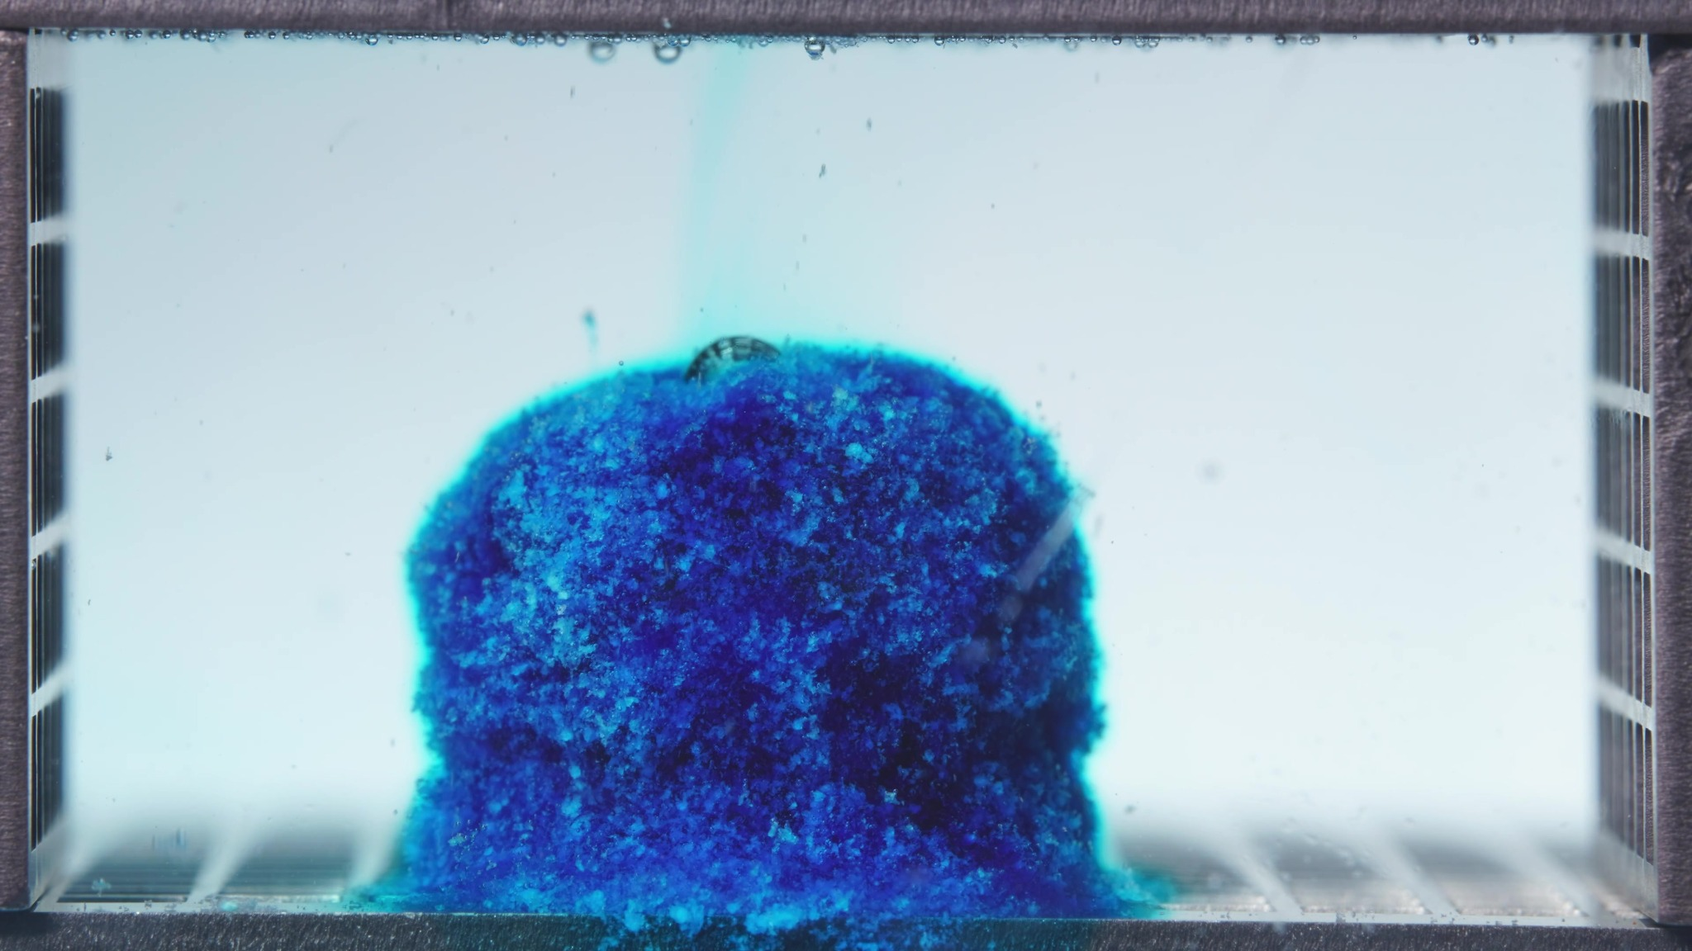 | 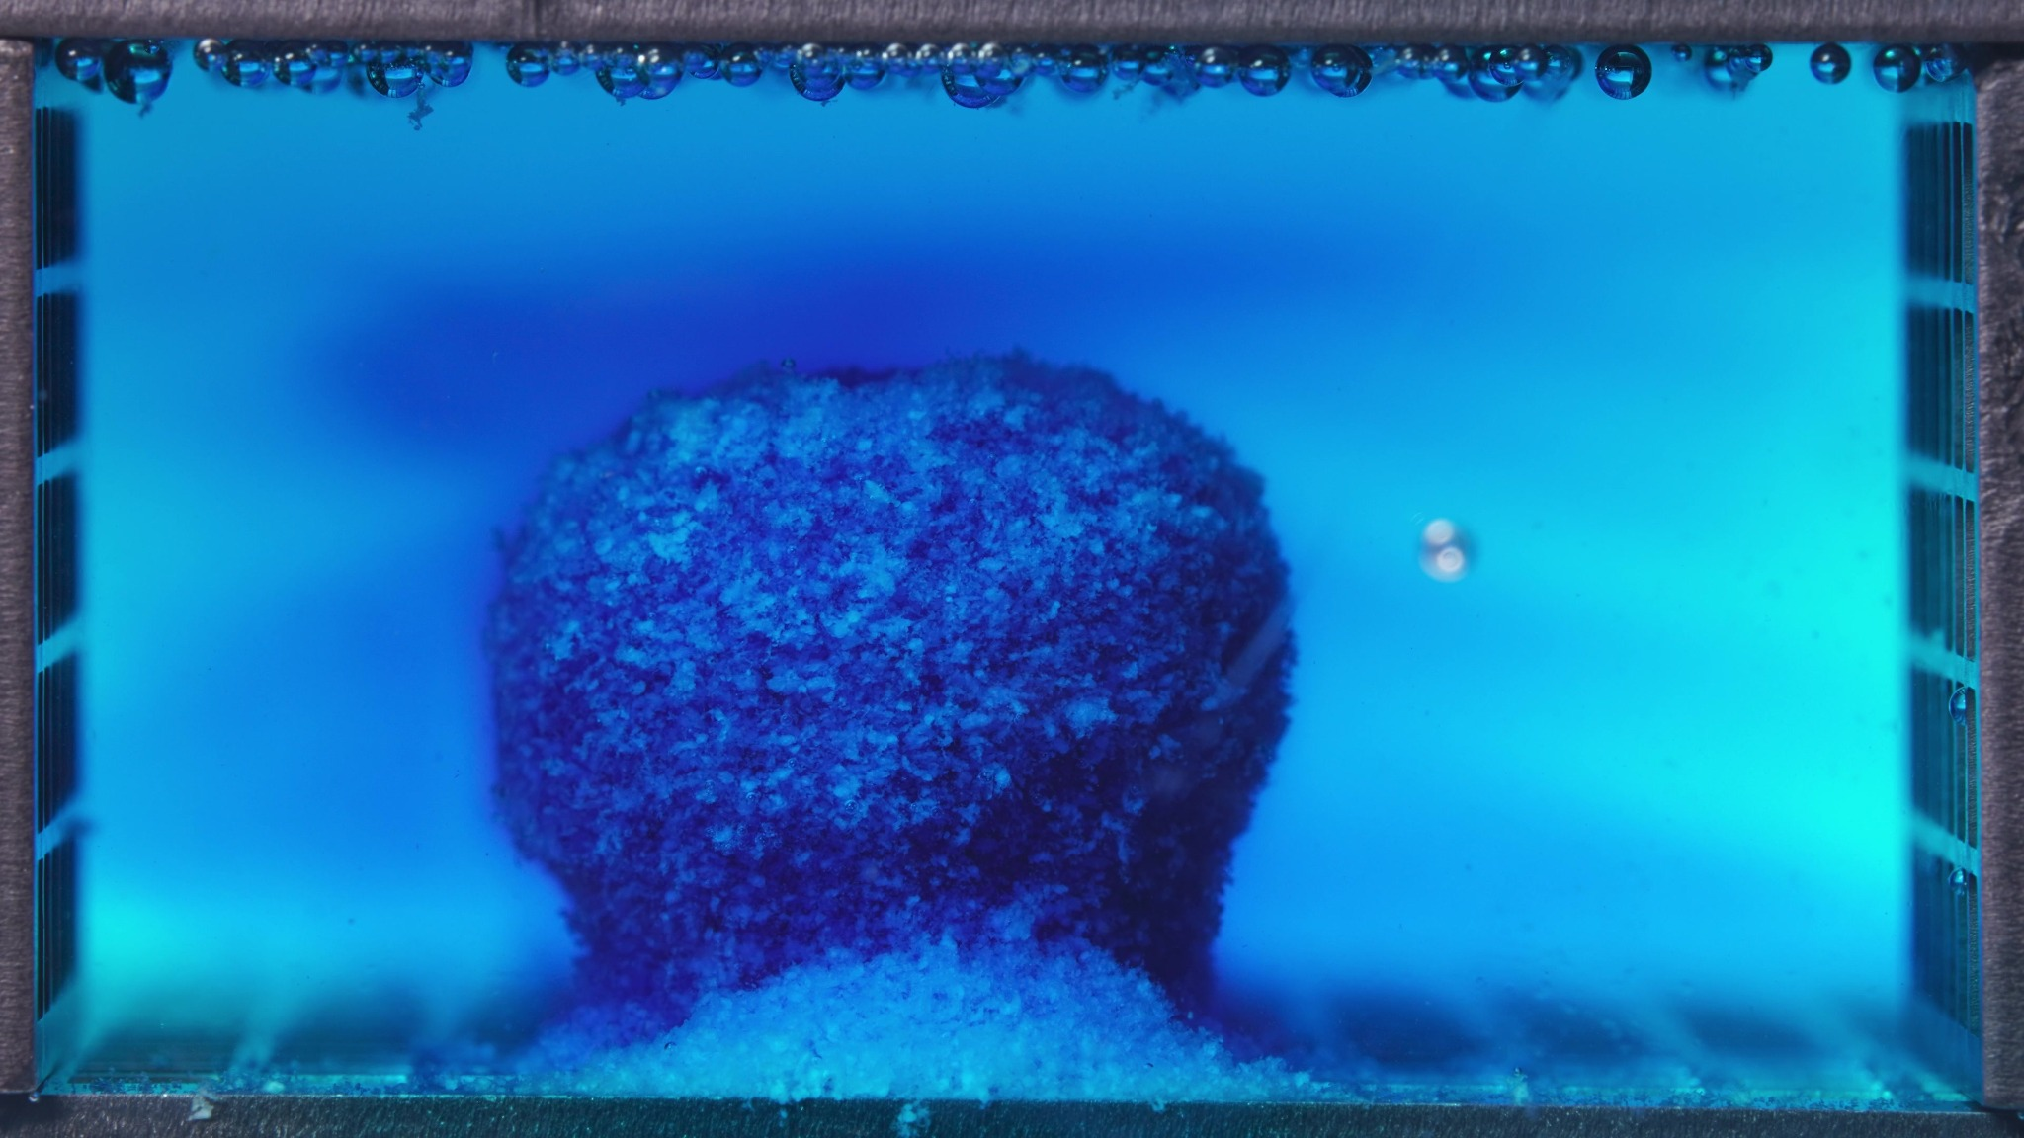 | 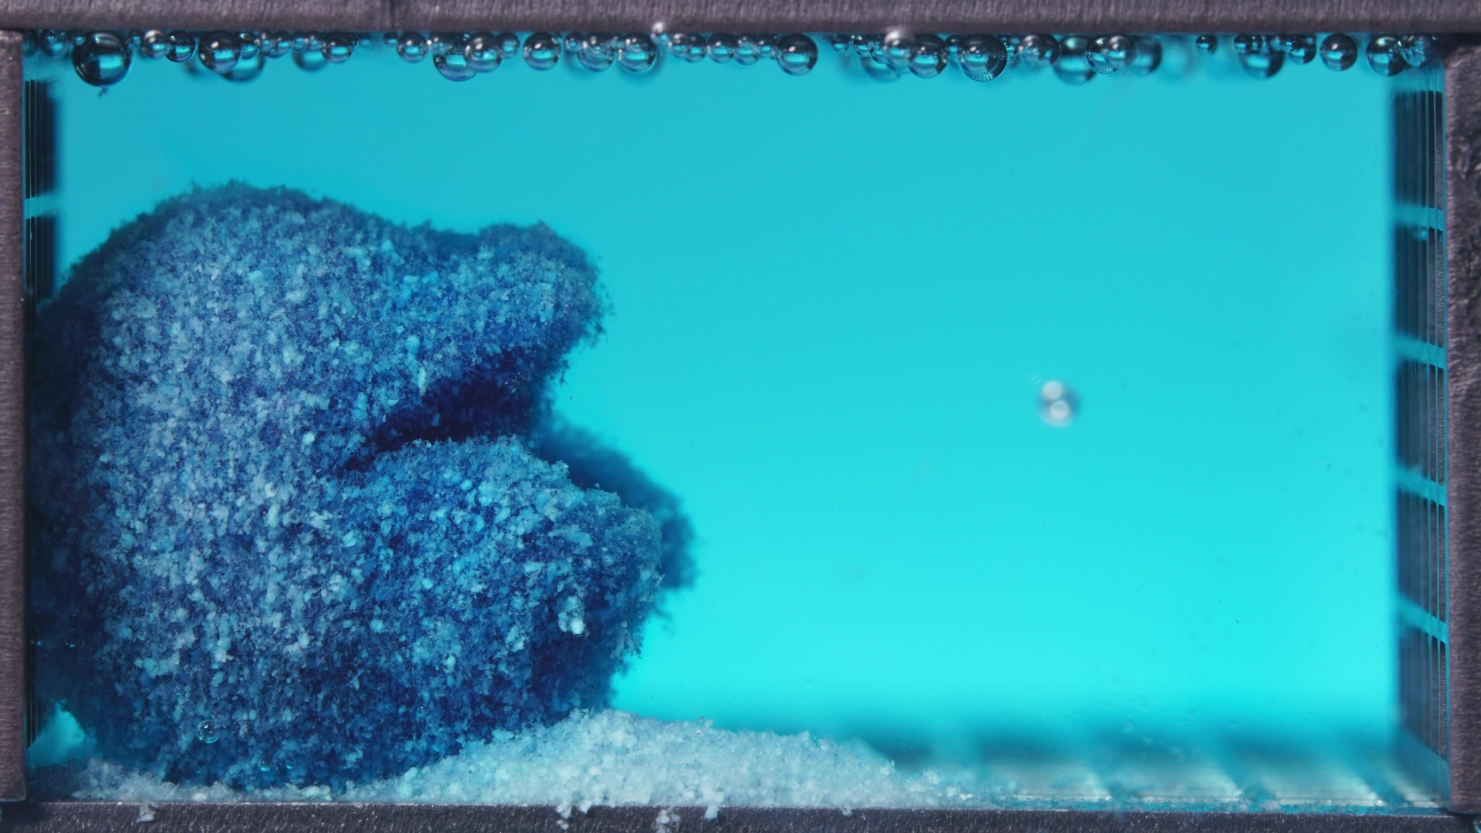

Turn 4 - Assistant
I am treating these three images as one batch for the low-viscosity formulation in the 0.104–5 h window, not as a single exact time point.
Overall interpretation: this batch shows a partially disintegrated but still coherent matrix mass. The tablet body remains visibly present, but its surface is strongly roughened, the edges are unstable, blue material is diffusing into the medium, and a clear basal accumulation of detached material has formed. Across the batch, the morphology shifts from a more upright compact mound to a more eroded, laterally collapsed structure, indicating ongoing breakup during this window.
Eight-dimension analysis: (1) Color change: the tablet remains deep blue overall, with a darker central core and lighter blue/cyan halo at the periphery. The surrounding medium is no longer fully clear and shows visible blue staining and localized diffusion. (2) Shape change: the original compact tablet outline is not fully preserved; it is still present as a single main body, but the contour becomes increasingly irregular. (3) Surface texture change: the surface is coarse, granular, and heterogeneous rather than smooth, with visible roughness across the whole exterior. (4) Volume change: the occupied volume remains substantial, but the batch suggests a transition from a taller, more compact body to a shorter and more laterally deformed mass. (5) Dissolution speed and time: disintegration appears active and ongoing within this window, but strict comparison versus an earlier stage is limited. (6) Physical state change: the tablet appears to have transitioned into a hydrated, softened, partially cohesive matrix mass. (7) Dissolution medium: the medium shows clear evidence of dye ingress/release, changing from nearly clear to visibly blue/cyan. (8) Fragment distribution with density: detached material is not widely dispersed throughout the chamber; most fragments remain clustered near the original tablet position, especially as a dense basal layer.
Batch summary for later synthesis: the most important feature of this batch is that the low-viscosity formulation already shows marked surface erosion, medium bluing, and basal particle accumulation while still retaining a recognizable central matrix body.

Turn 5 - User
These are pictures of the low-viscosity formulation during 6.25–11.25 h.
Attached images
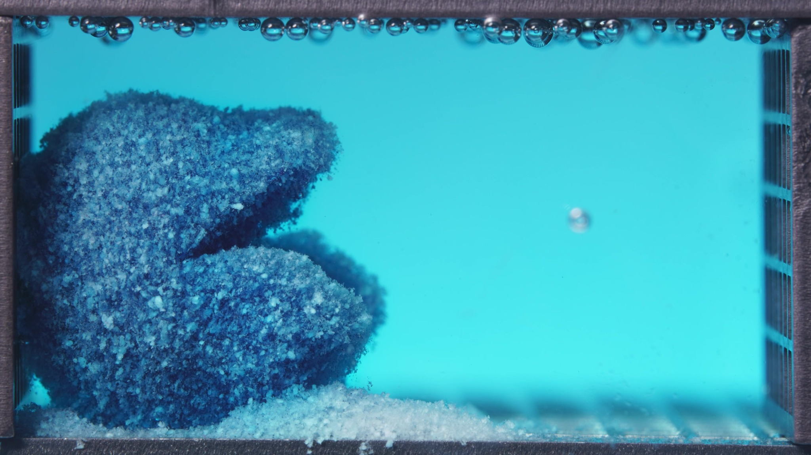 |  | 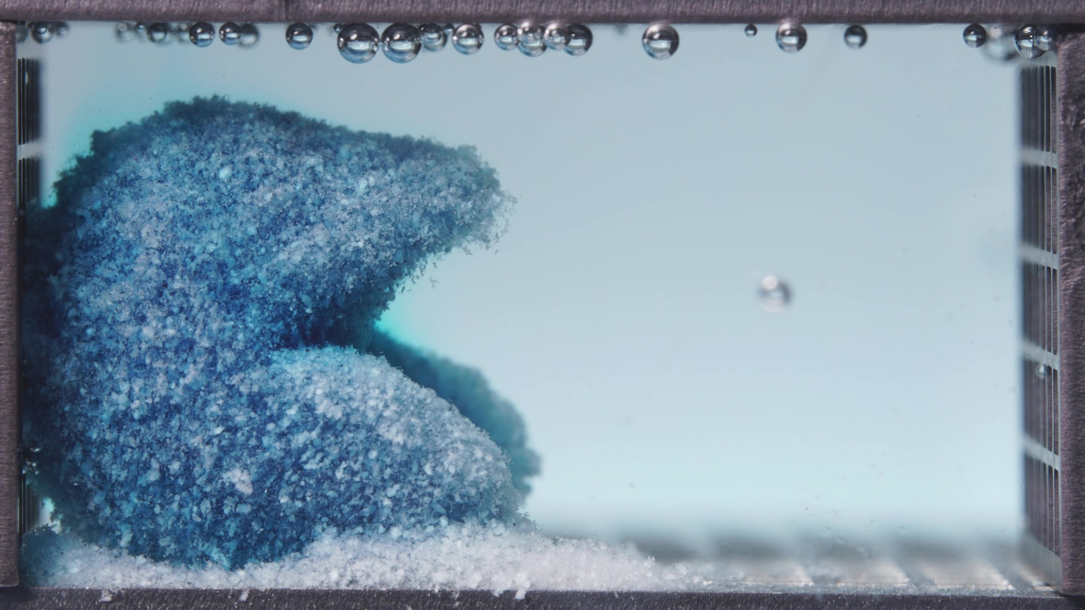

Turn 6 - Assistant
Treating these three images as one batch for the low-viscosity formulation during 6.25–11.25 h.
Overall interpretation: in this window, the low-viscosity formulation has progressed from a single partially collapsed mass into a more distinctly eroded residual structure with a pronounced two-lobed profile and a deeper central recess. The matrix is still present as a cohesive remnant, but it is now more obviously undercut, rough, and locally thinned, with detached material remaining concentrated at the bottom. Compared with the 0.104–5 h batch, this looks like continued erosion of the remaining matrix rather than complete breakup into freely dispersed particles.
Eight-dimension analysis: the remnant remains predominantly blue, but the surface appears paler and more mottled than in the earlier window. The overall structure is a more irregular asymmetric residual body with an upper projecting lobe and a lower basal lobe separated by a clear recessed gap. The surface remains coarse and friable. Volume change is characterized by localized collapse and erosion-driven redistribution rather than uniform shrinkage. Disintegration still progresses, but the pattern now looks like slower persistence of eroding remnants than an abrupt acceleration into total fragmentation. The material behaves as a hydrated, softened, partially cohesive residual matrix. The medium appears uniformly light blue and relatively stable. Fragments remain highly localized near the original tablet position, especially as a dense bottom sediment.
Comparison with the previous window: the most important change is the emergence of a more clearly segmented residual structure with a pronounced central undercut/cavity, together with a paler, rougher surface and persistent bottom accumulation.

Turn 7 - User
These are pictures of the low-viscosity formulation during 12.5–17.5 h.
Attached images
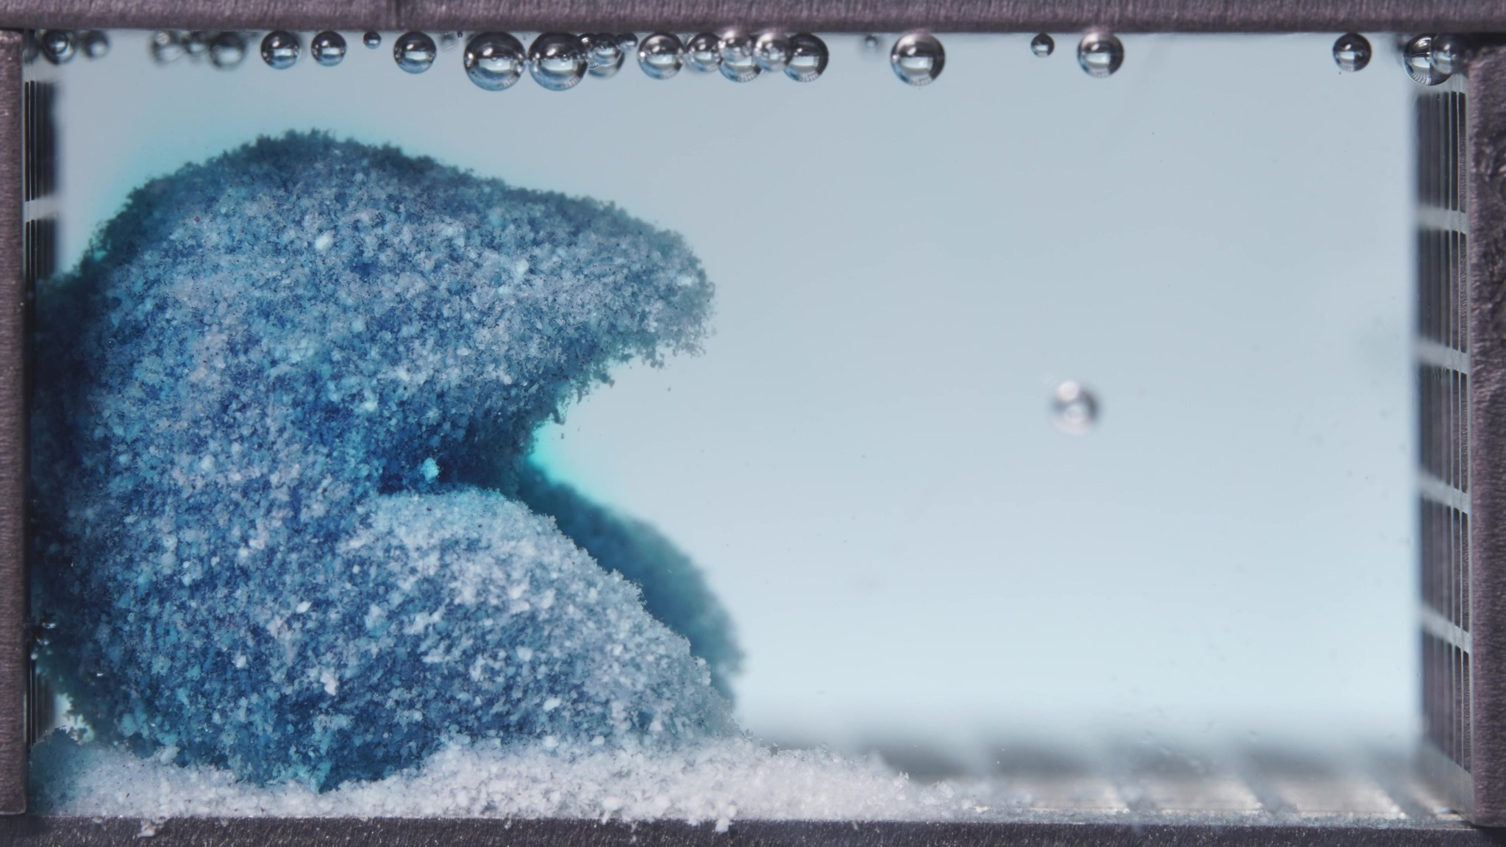 | 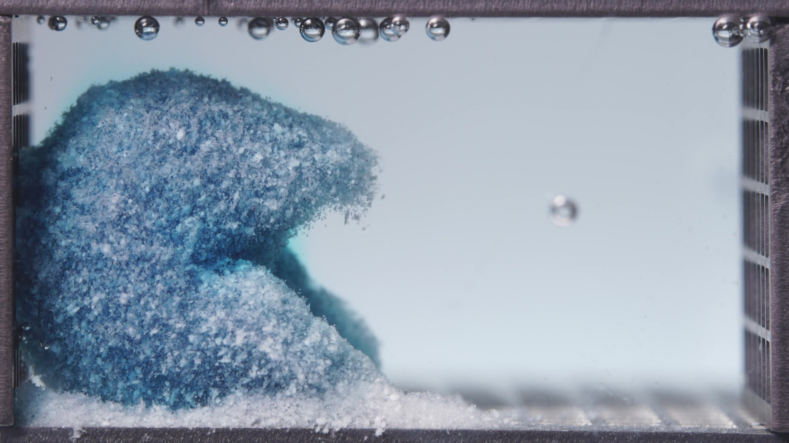 | 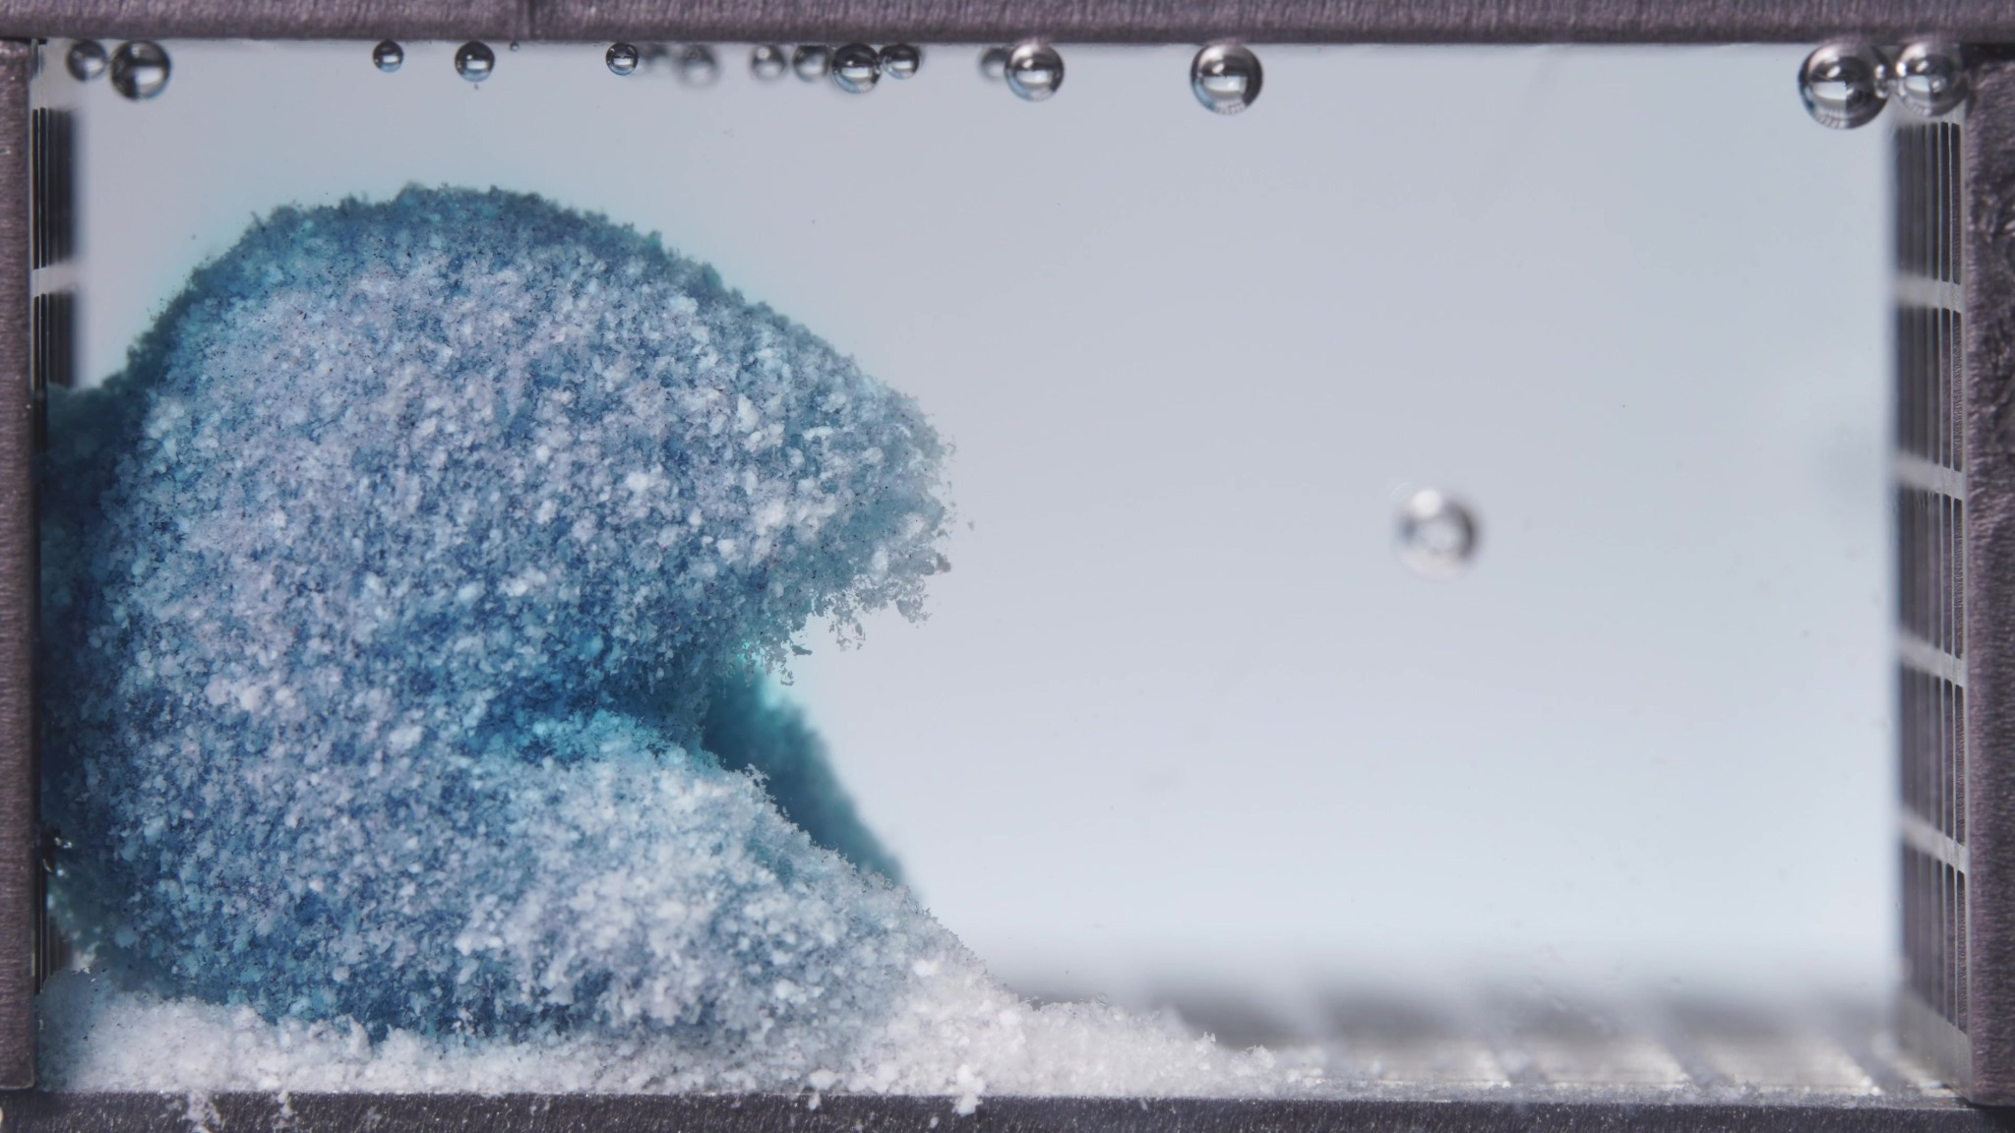

Turn 8 - Assistant
Treating these three images as one batch for the low-viscosity formulation during 12.5–17.5 h.
Overall interpretation: this window shows the low-viscosity formulation in a late residual-matrix stage. A coherent remnant is still clearly present, but compared with 6.25–11.25 h it appears more rounded, more blanched/paler, and more slowly eroding, with no evidence of sudden breakup into freely dispersed fragments. The dominant pattern is continued surface depletion and gradual reshaping of the residual body, while most detached material remains deposited near the bottom.
Eight-dimension analysis: the residual mass remains blue, but the surface is lighter and more washed-out overall. The two-level residual structure is still present, but the outline now looks more rounded and somewhat more compact. The surface remains rough, granular, and friable, but slightly more uniformly softened and matte. A sizable remnant remains with only slow continued shrinkage and rounding. Compared with the previous window, the process appears to have slowed further into a persistent residual phase. The material still behaves as a hydrated, partially cohesive residual matrix. The medium appears visually stable and lightly tinted. Fragmented material remains strongly concentrated near the original tablet position, especially along the bottom.
Comparison with the previous window: the most important change is that the residual structure becomes paler, rounder, and less sharply segmented, with signs of continued but slower erosion rather than further dramatic collapse.

Turn 9 - User
These are pictures of the low-viscosity formulation during 18.75–23.75 h.
Attached images
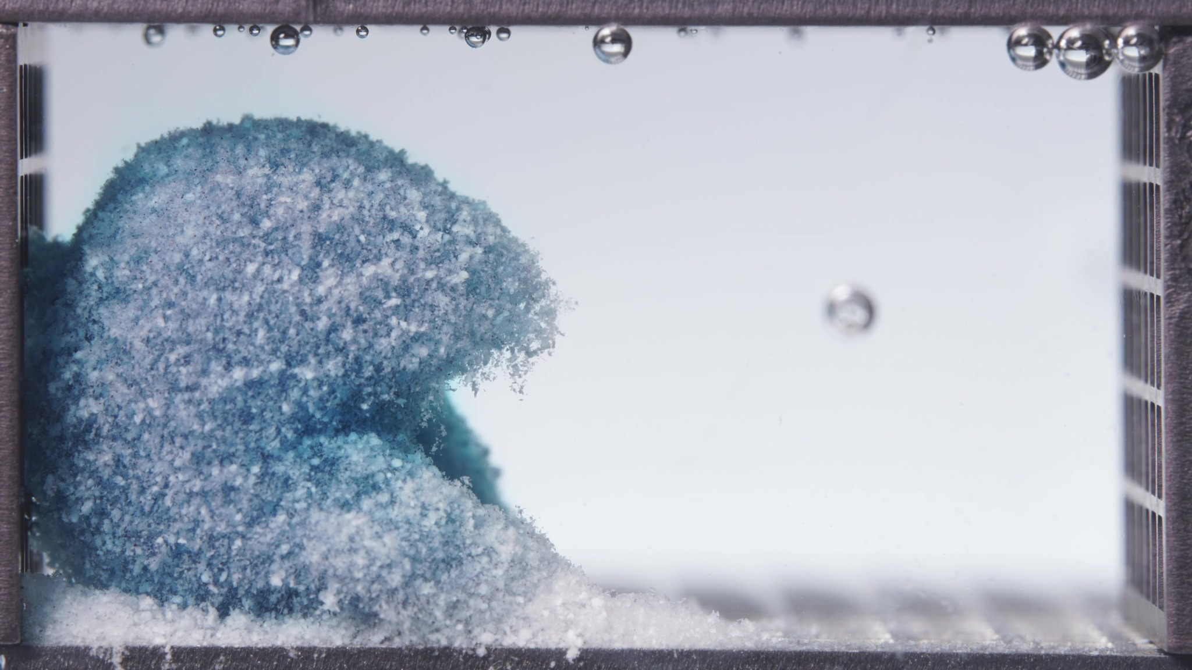 | 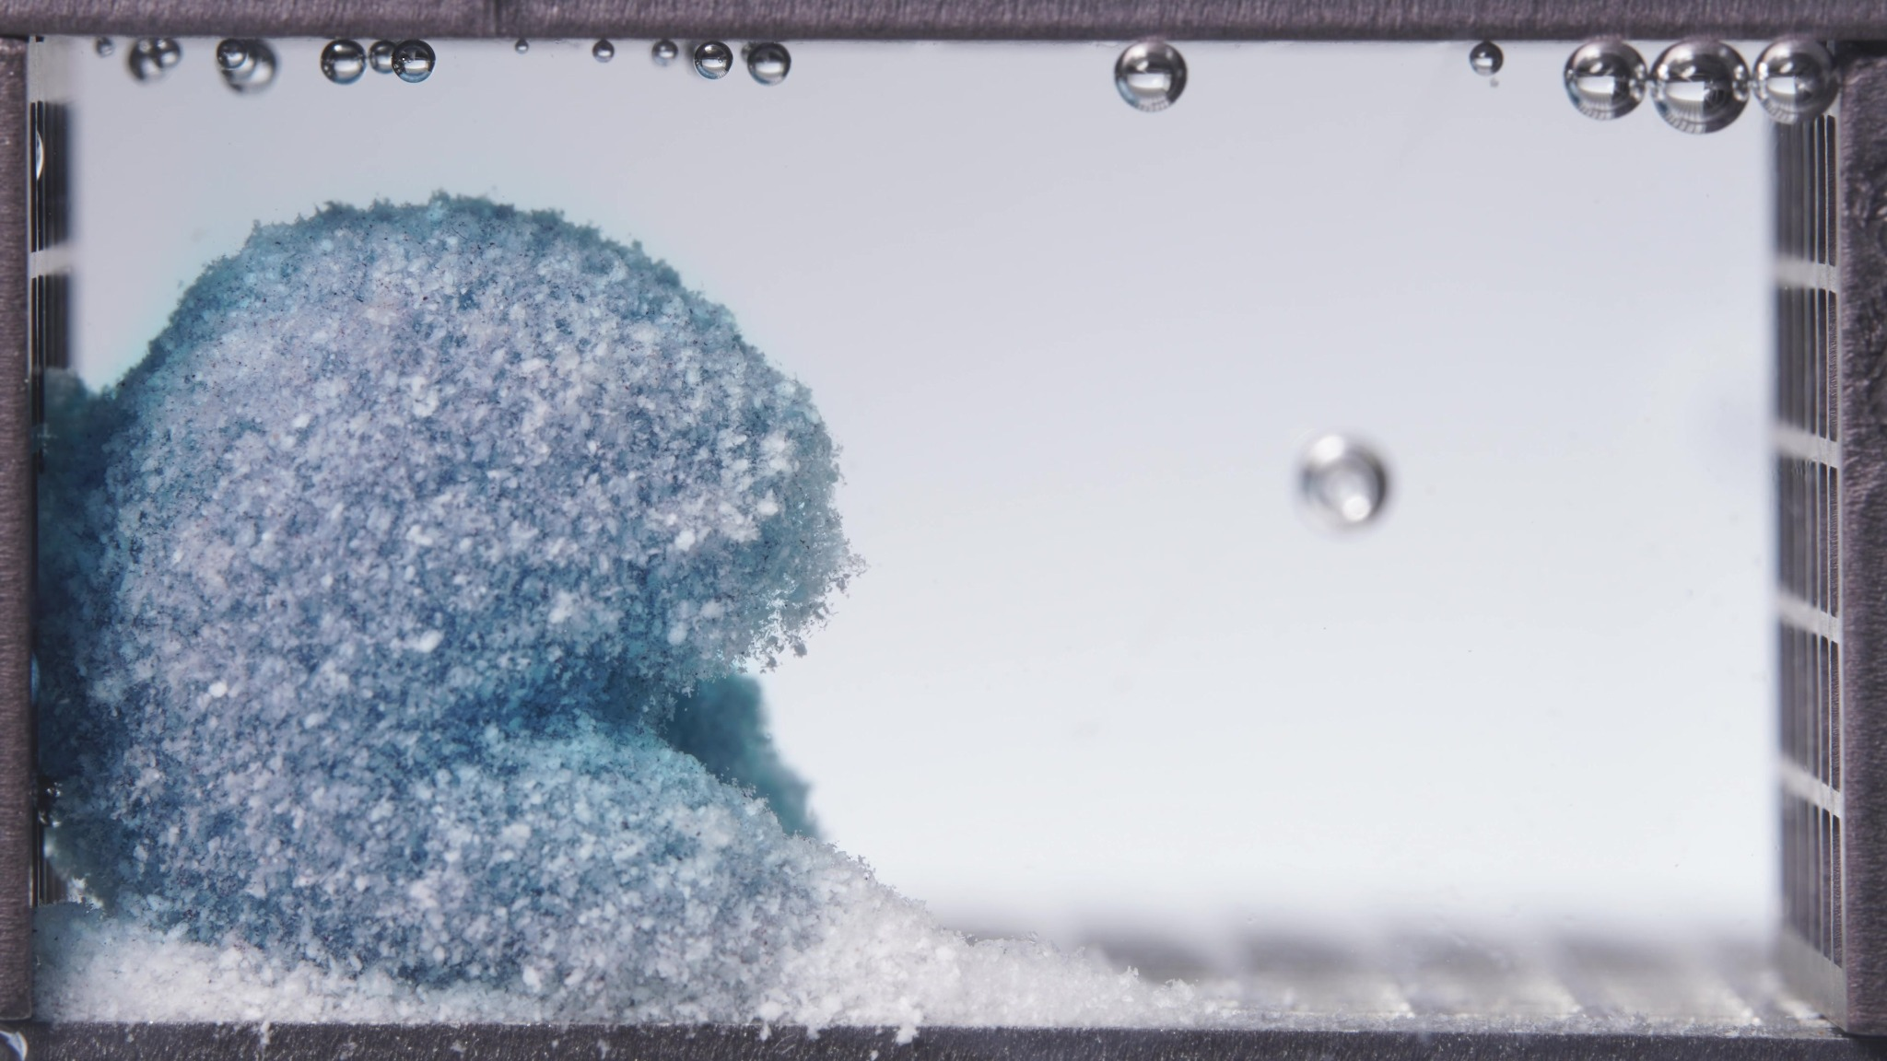 | 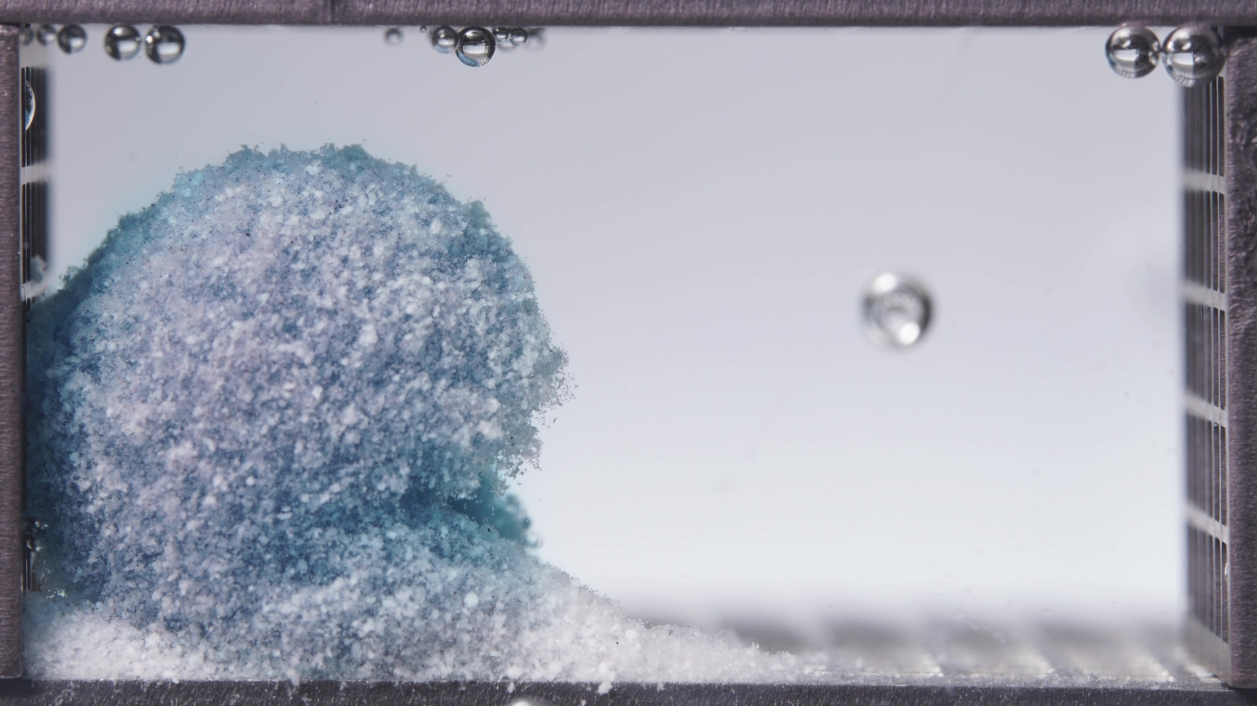

Turn 10 - Assistant
Treating these three images as one batch for the low-viscosity formulation during 18.75–23.75 h.
Overall interpretation: this final window shows the low-viscosity formulation in a persistent end-stage residual form. A substantial coherent remnant is still present near the original position, but it is now very pale, highly roughened, and only slowly changing. Compared with 12.5–17.5 h, the dominant feature is not major new breakup, but rather continued gradual surface depletion, rounding, and stabilization of the residual body. By the end of the observation period, the formulation still has not fully dispersed.
Eight-dimension analysis: the remaining matrix is still blue, but it is markedly blanched to a light blue/whitish-blue appearance over most of the visible surface. The remnant keeps a two-level residual profile, but the geometry is more rounded, more upright, and less sharply segmented. The surface remains coarse, powdery-granular, and friable. The visible residual body is still substantial, with only small gradual change. Compared with the previous window, the process appears to have slowed further, approaching a near-plateau residual state. The material remains a hydrated, partially cohesive residual matrix mass. The medium looks clear to faintly blue-gray and quite stable. Detached material remains localized near the tablet remnant, especially as a dense basal deposit.
Comparison with the previous window: the most important change is the shift into an even more stable terminal-residue appearance with further stabilization and slowing of erosion, not complete disintegration. Across all four low-viscosity windows, the overall trajectory is early active erosion and collapse to persistent undercut residual structure to gradual rounding and pallor increase to late slow residual erosion without complete disappearance.

Turn 11 - User
These are pictures of the standard formulation during 0.104–5 h.
Attached images
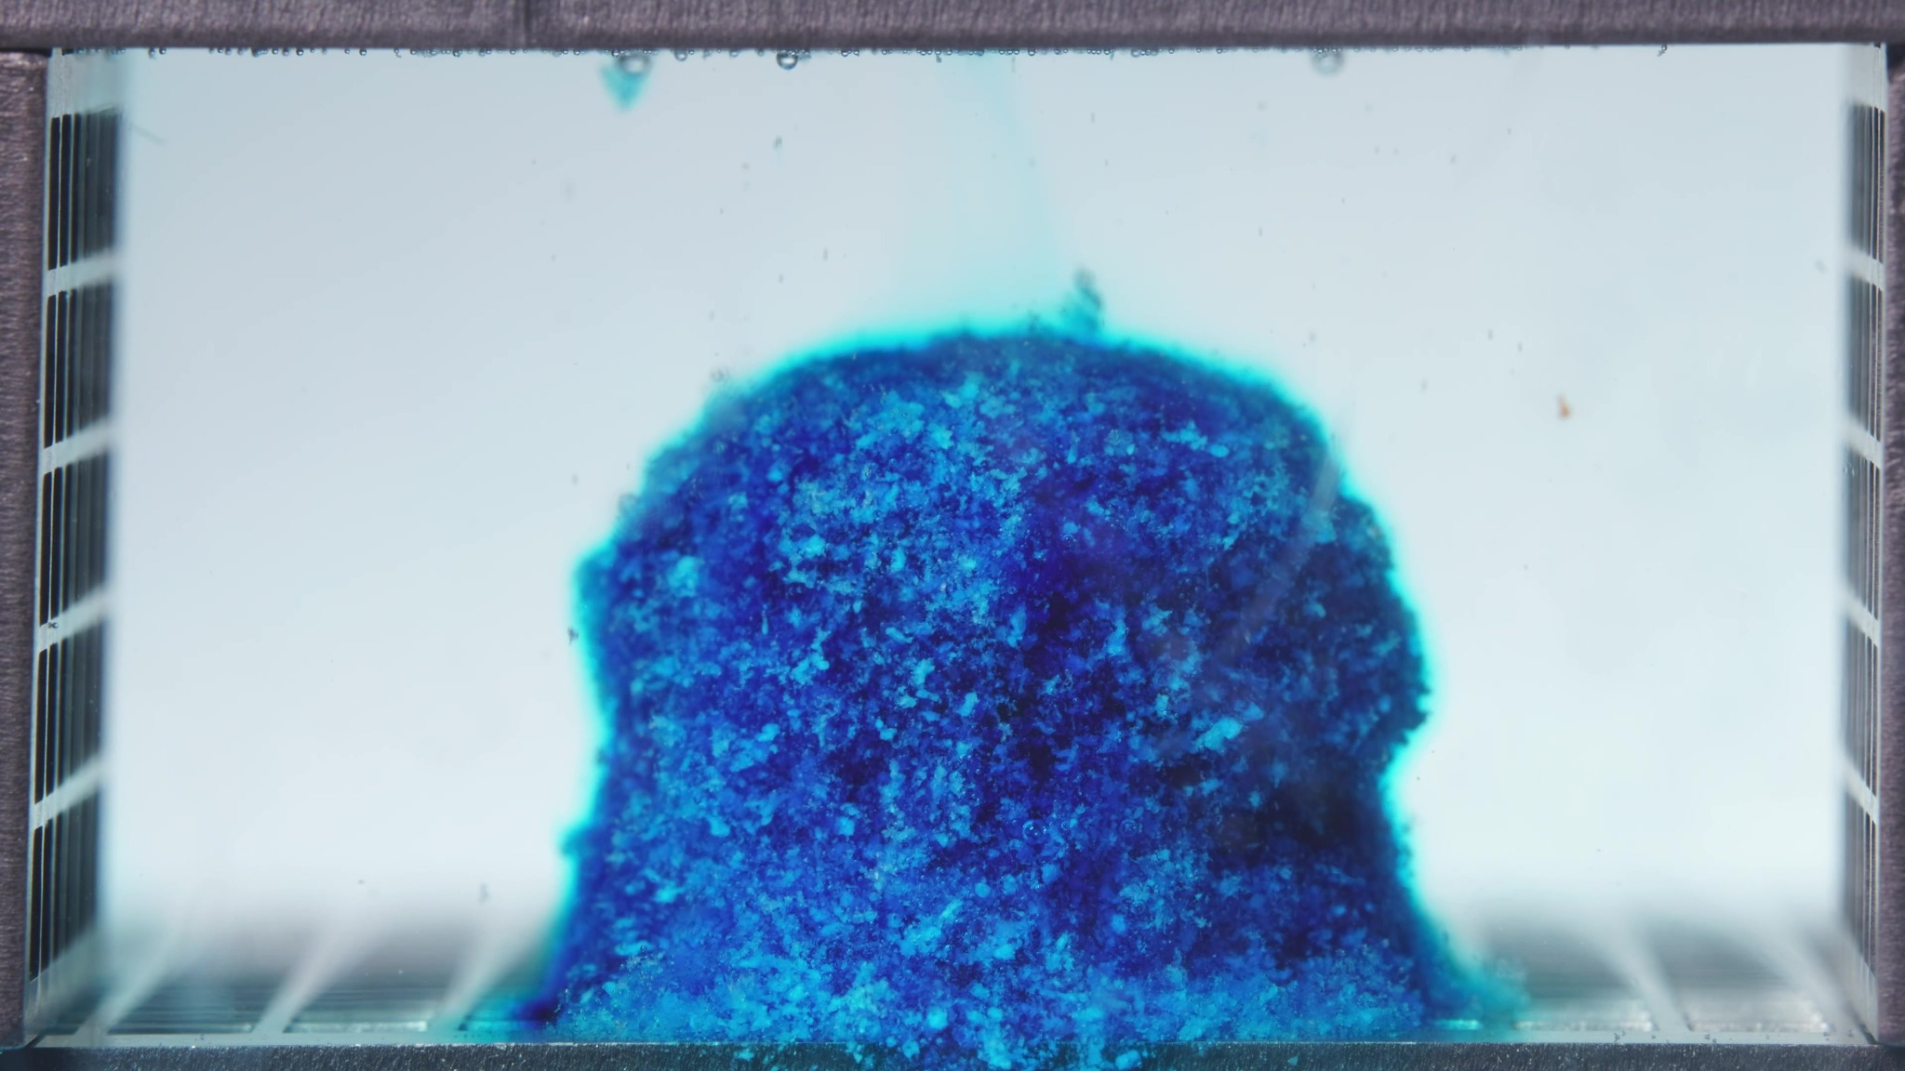 | 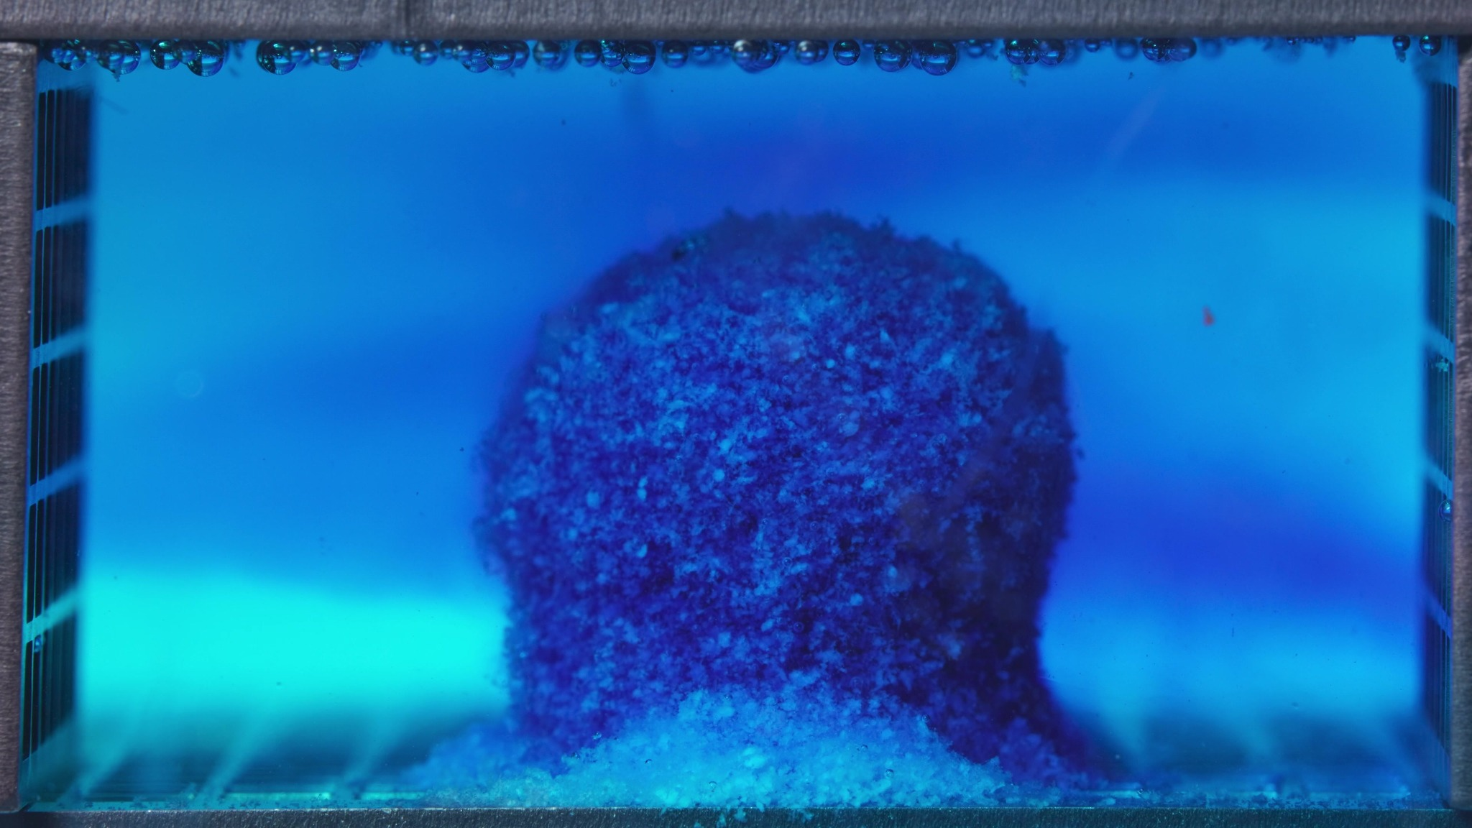 | 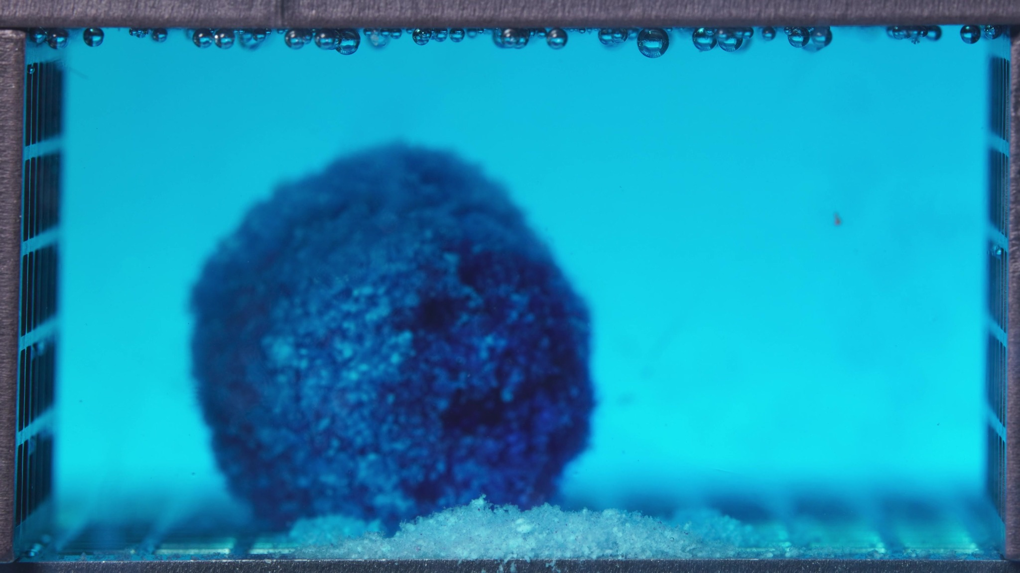

Turn 12 - Assistant
Treating these three images as one batch for the standard formulation during 0.104–5 h.
Overall interpretation: this batch shows the standard formulation in an early hydration and dye-release stage with strong structural retention. The tablet remains as a single upright, compact residual body with a broadly cylindrical outline and rounded top. The most obvious change in this window is progressive blue diffusion into the surrounding medium, while the solid matrix itself still remains largely intact. At this stage, color release is more prominent than gross structural collapse.
Eight-dimension analysis: the tablet body remains deep blue to dark blue, with a lighter cyan halo at the edges, and the surrounding medium becomes more broadly blue-stained. The overall outline is well preserved as a thick upright cylindrical or column-like body with only mild rounding. The surface is rough and granular, but there are no major fissures or obvious peeling fronts. The visible occupied volume remains substantial with possible mild swelling or soft rounding. Strict rate comparison with a previous window is limited, but medium coloration increases more clearly than structural deformation. The material behaves as a hydrated, cohesive matrix mass. The medium change is dominated by dye diffusion rather than strong particulate turbidity. Some material accumulation near the base remains localized.
Summary note: the most important observation is that blue release into the medium becomes clearly established while the tablet body still retains a strong, upright, coherent structure.

Turn 13 - User
These are pictures of the standard formulation during 6.25–11.25 h.
Attached images
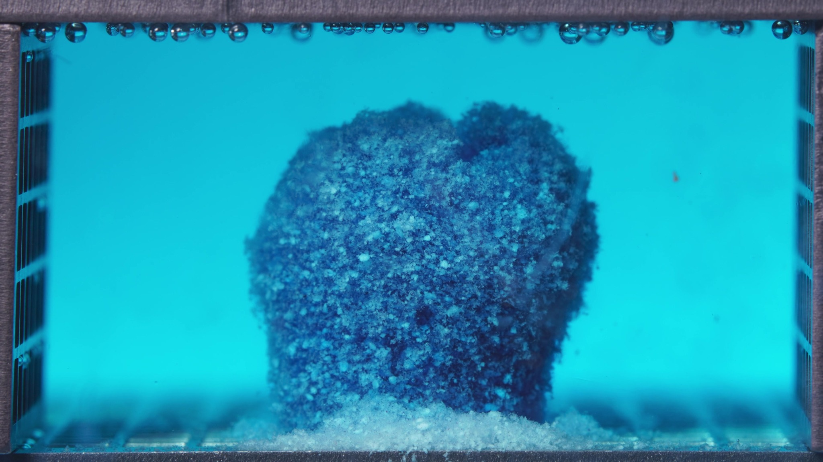 | 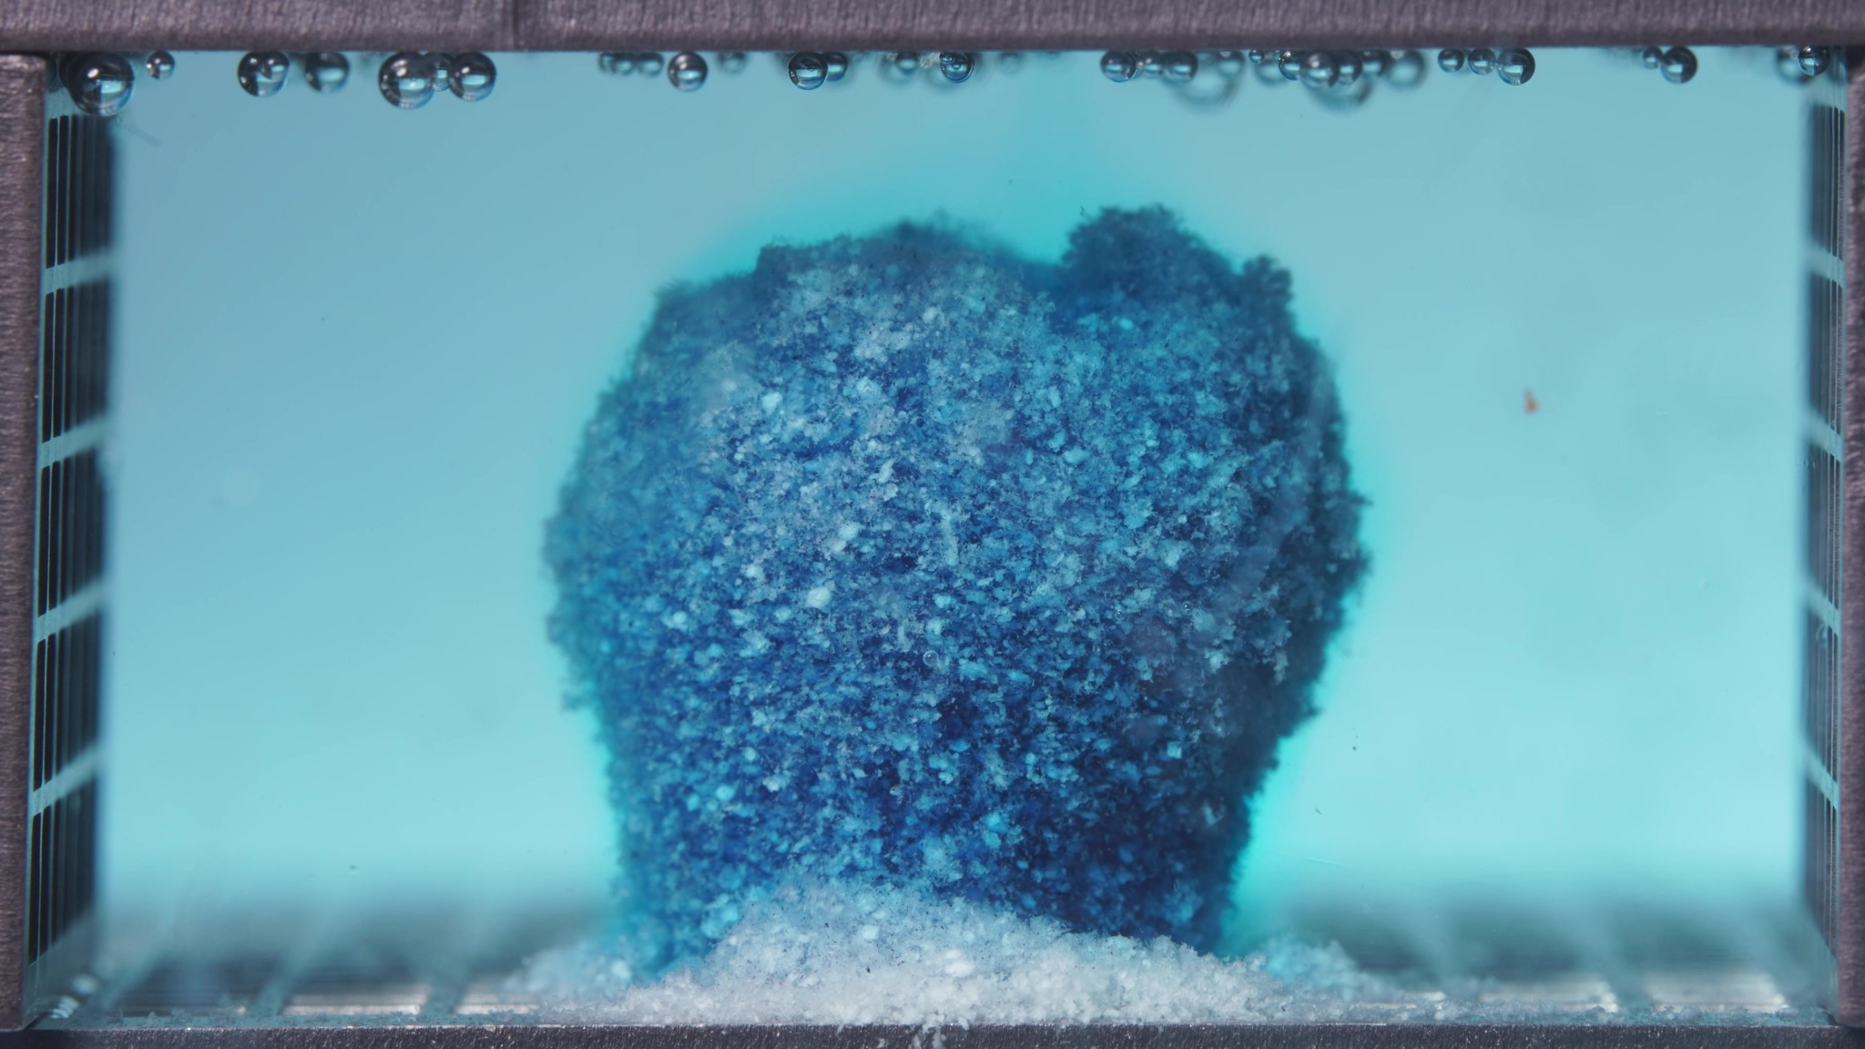 | 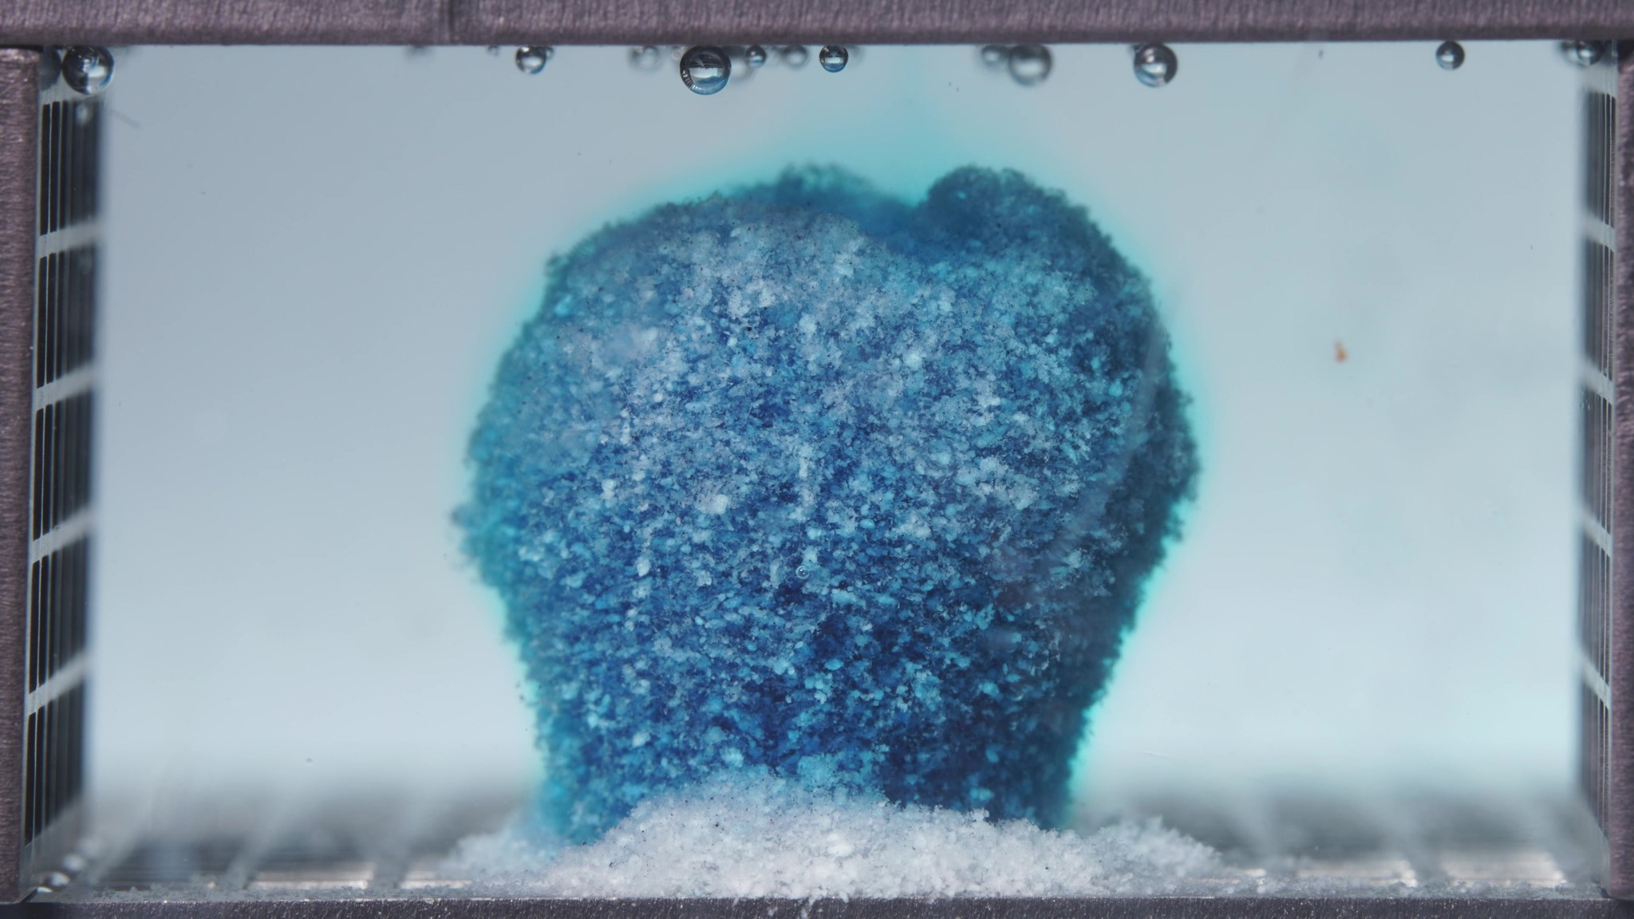

Turn 14 - Assistant
Treating these three images as one batch for the standard formulation during 6.25–11.25 h.
Overall interpretation: the standard formulation still shows strong matrix integrity and sustained structural persistence. The tablet remains as a single upright residual body with only limited contour deformation. Compared with the 0.104–5 h window, the most notable change is slight top-edge irregularization and further surface roughening, while the bulk shape is still well maintained. The dominant pattern is therefore continued controlled release with slow erosion, not pronounced collapse.
Eight-dimension analysis: the tablet remains dark blue overall, with lightly to moderately blue medium that appears more uniformly colored and visually steadier than earlier. The body still preserves a compact upright cylindrical-to-columnar profile. The surface remains coarse and heterogeneous, with roughness slightly more evident, especially around the upper edge, but no large fissures or major cavities. The visible volume remains substantial and largely preserved. Compared with the earlier window, the formulation continues disintegrating at a slow, controlled rate. The material continues to behave as a hydrated but cohesive matrix mass. The medium is visibly dyed but relatively stable, and any detached material remains as a localized basal accumulation.
Comparison with the previous window: the most important change is the development of slightly greater top irregularity and surface roughening while the main body remains highly intact.

Turn 15 - User
These are pictures of the standard formulation during 12.5–17.5 h.
Attached images
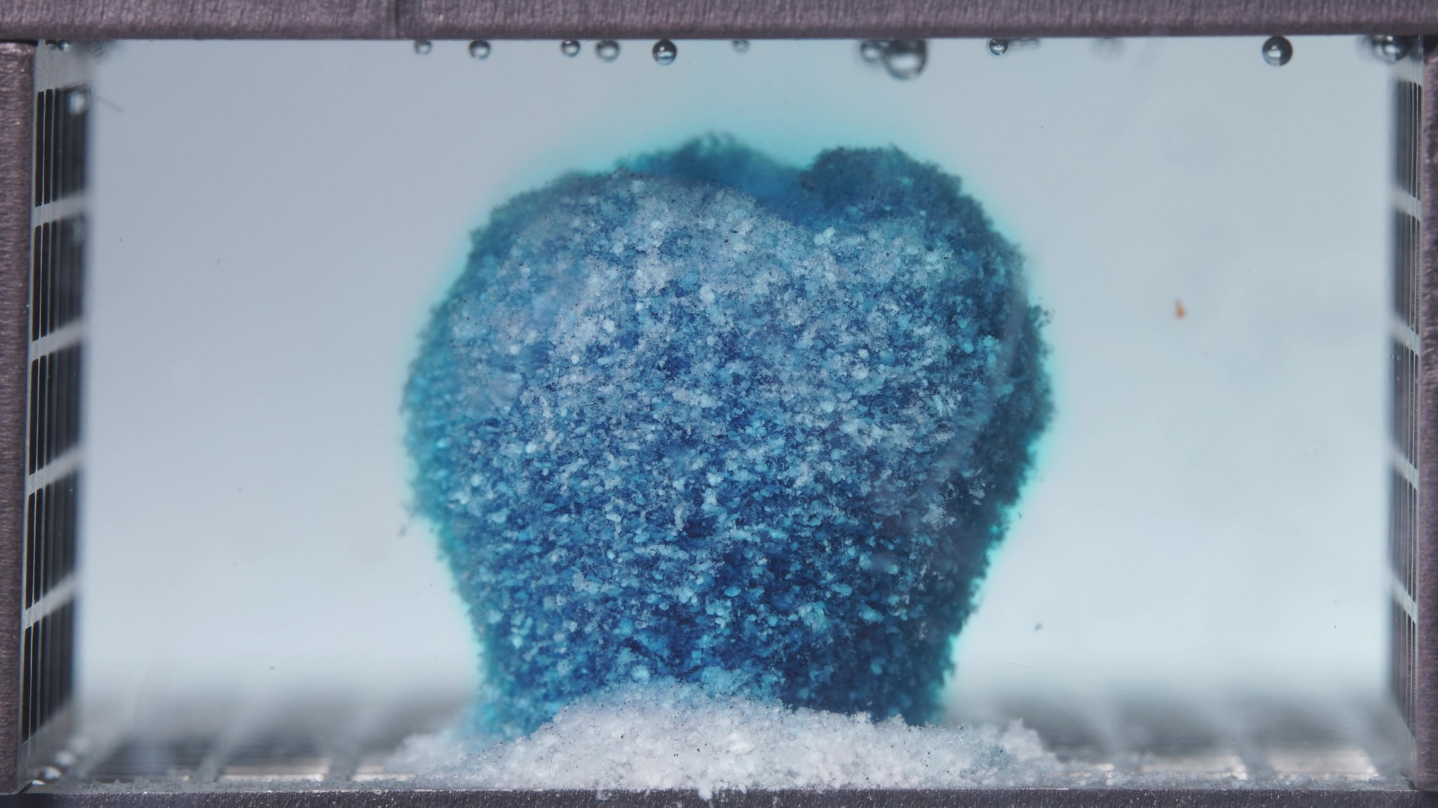 | 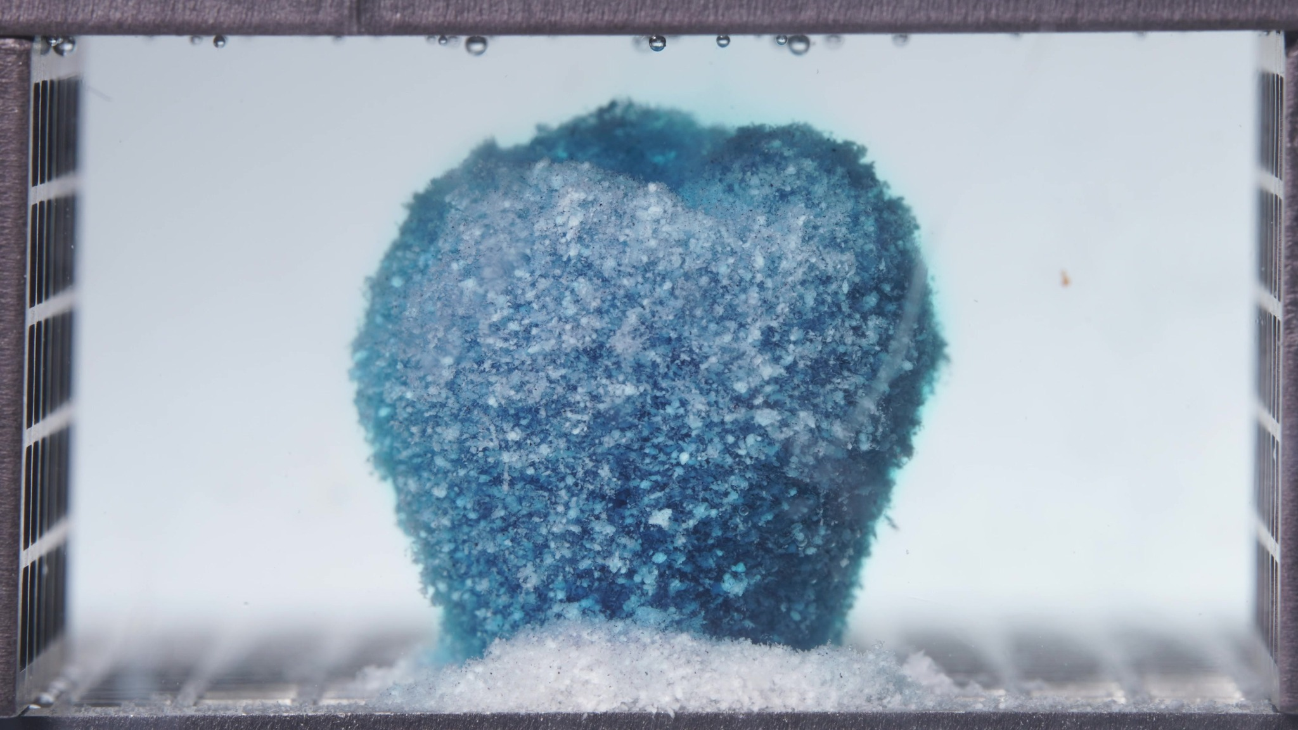 | 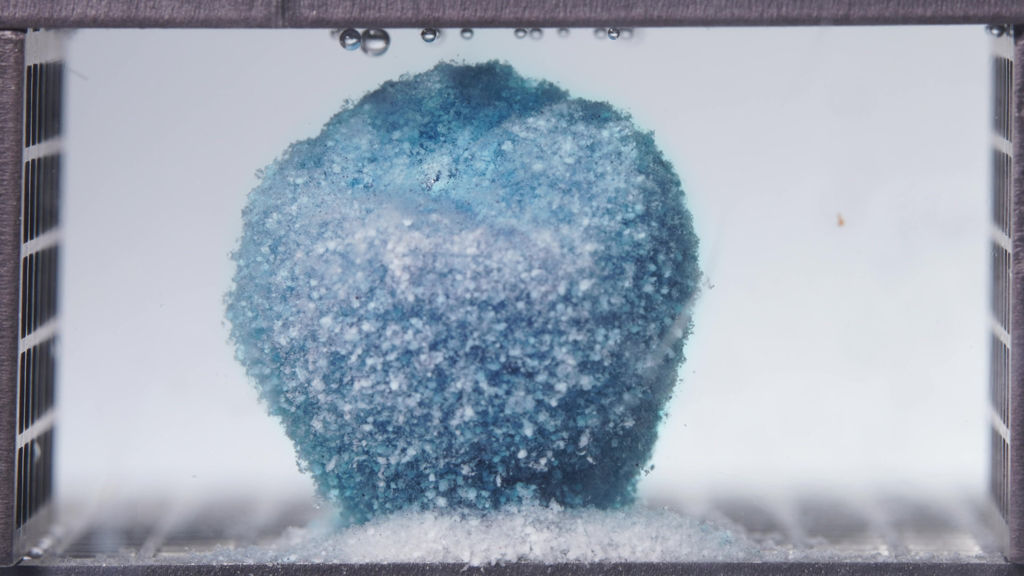

Turn 16 - Assistant
Treating these three images as one batch for the standard formulation during 12.5–17.5 h.
Overall interpretation: this window shows the standard formulation in a mid-to-late sustained residual stage with very strong structural persistence. The tablet is still present as a single cohesive upright body, and compared with 6.25–11.25 h, the dominant change is slow rounding/broadening of the upper part and further surface blanching, not major breakup. The matrix remains far more intact than a rapidly collapsing system; the visible process is gradual external erosion under preserved core coherence.
Eight-dimension analysis: the body remains blue overall, but the outer surface becomes more pale blue to whitish-blue. The tablet still maintains a single upright columnar-to-block-like profile, though the upper region appears broader, rounder, and slightly more dome-like. The surface remains coarse and granular but now appears more uniformly matte and softened. The visible mass remains substantial, with only mild outward rounding and slight broadening in the upper zone. Compared with 6.25–11.25 h, the system continues evolving at a slow, controlled rate. The material still behaves as a hydrated, cohesive sustained-release matrix. The medium looks clear to faintly blue and relatively stable. A localized basal deposit remains beneath the tablet.
Comparison with the previous window: the most important change is that the standard formulation becomes paler at the surface and more rounded in the upper contour while still preserving a coherent upright structure.

Turn 17 - User
These are pictures of the standard formulation during 18.75–23.75 h.
Attached images
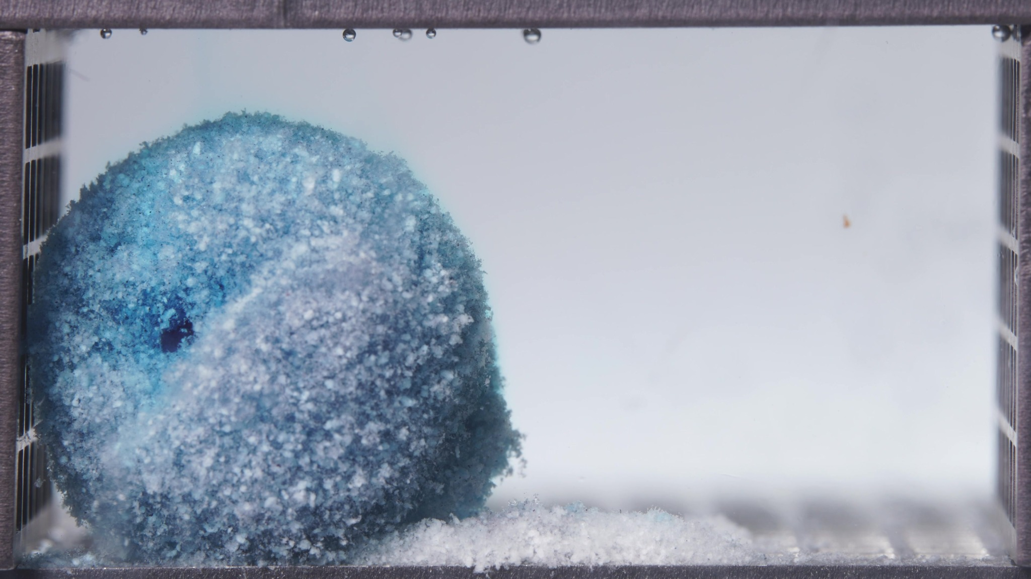 | 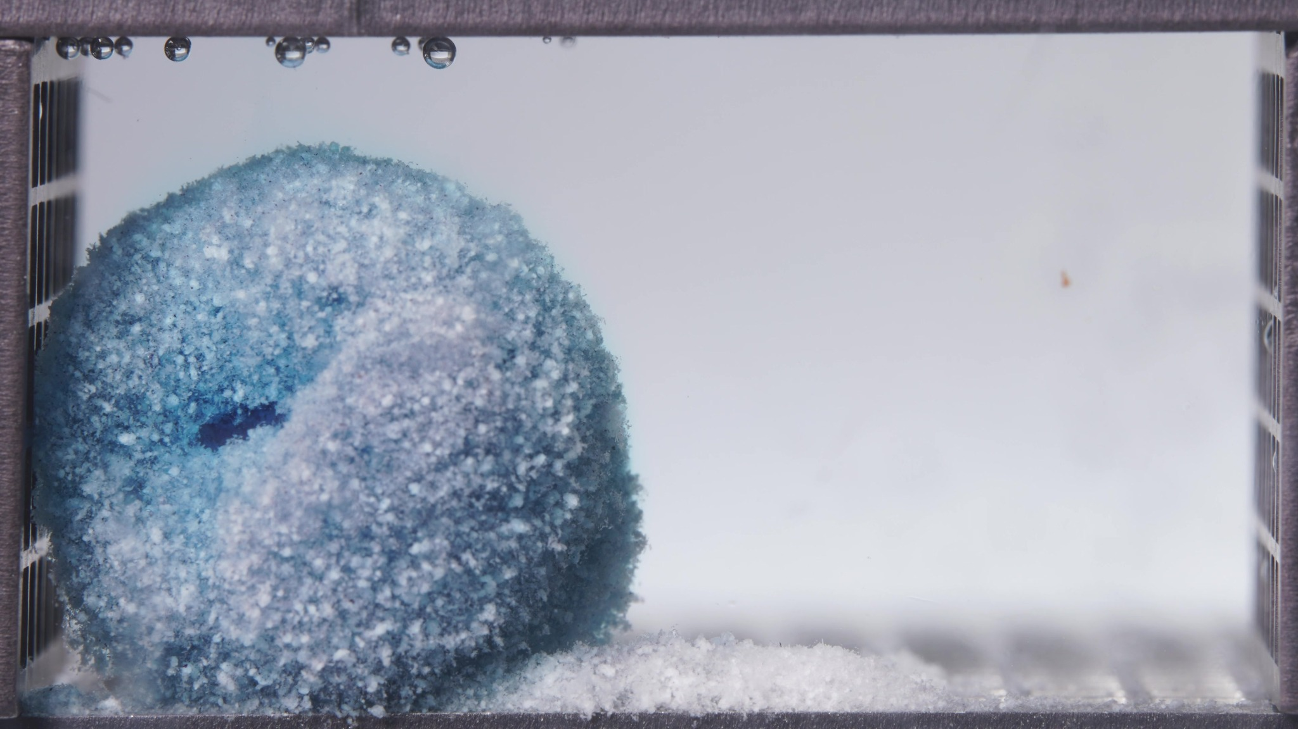 | 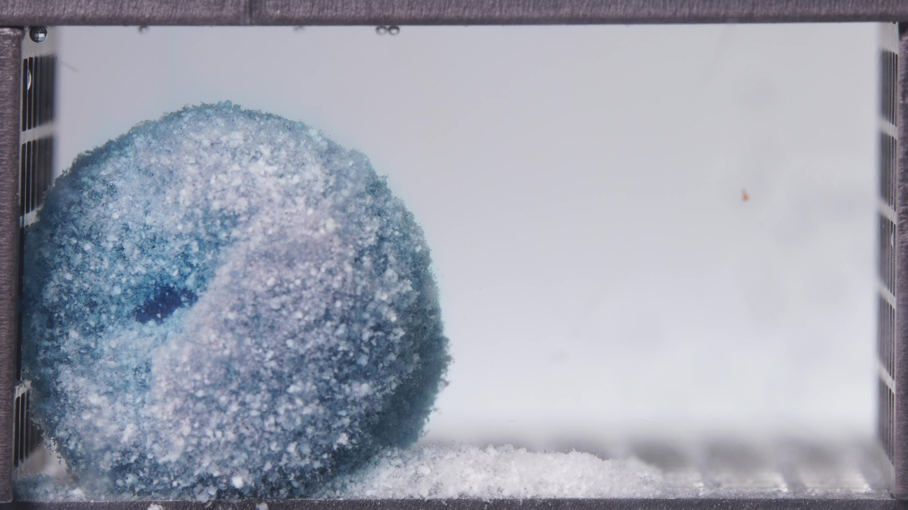

Turn 18 - Assistant
Treating these three images as one batch for the standard formulation during 18.75–23.75 h.
Overall interpretation: this final window shows the standard formulation in a late persistent residual-matrix stage with very strong bulk integrity. A large coherent remnant is still present, and compared with 12.5–17.5 h the dominant changes are further surface blanching, stronger rounding of the whole body, and the appearance of a localized recessed pit/cavity on one side. The matrix still does not undergo major fragmentation or full disappearance by 24 h.
Eight-dimension analysis: the remnant is now paler overall, with much of the outer surface appearing light blue to whitish-blue, while deeper regions remain darker blue. The tablet has evolved into a more rounded, dome-like residual mass with a distinct lateral indentation/pit. The surface remains granular and matte, but the recessed cavity-like area is a notable local feature. A substantial bulk remnant is still present. Compared with 12.5–17.5 h, the process remains slow and controlled, but with a new sign of localized structural penetration. The material continues to behave as a hydrated, cohesive sustained-release matrix remnant. The medium looks clear to faintly blue-gray and relatively quiescent. Detached material remains localized near the base as a bottom-associated deposit.
Comparison with the previous window: the most important change is the emergence of a more clearly defined side recess/cavity together with continued global rounding and surface pallor increase. Across all four standard-formulation windows, the overall trajectory is early dye diffusion with preserved cylindrical body to slow top-edge irregularization under strong integrity to gradual surface blanching and rounding to late persistent rounded remnant with localized cavity formation but no complete collapse.

Turn 19 - User
These are pictures of the high-viscosity formulation during 0.104–5 h.
Attached images
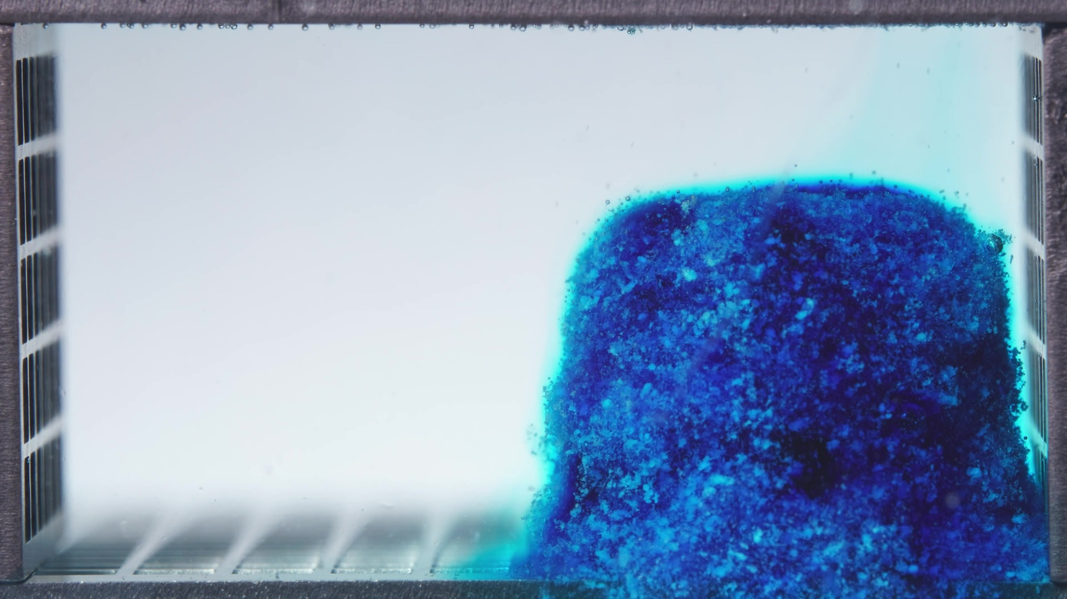 | 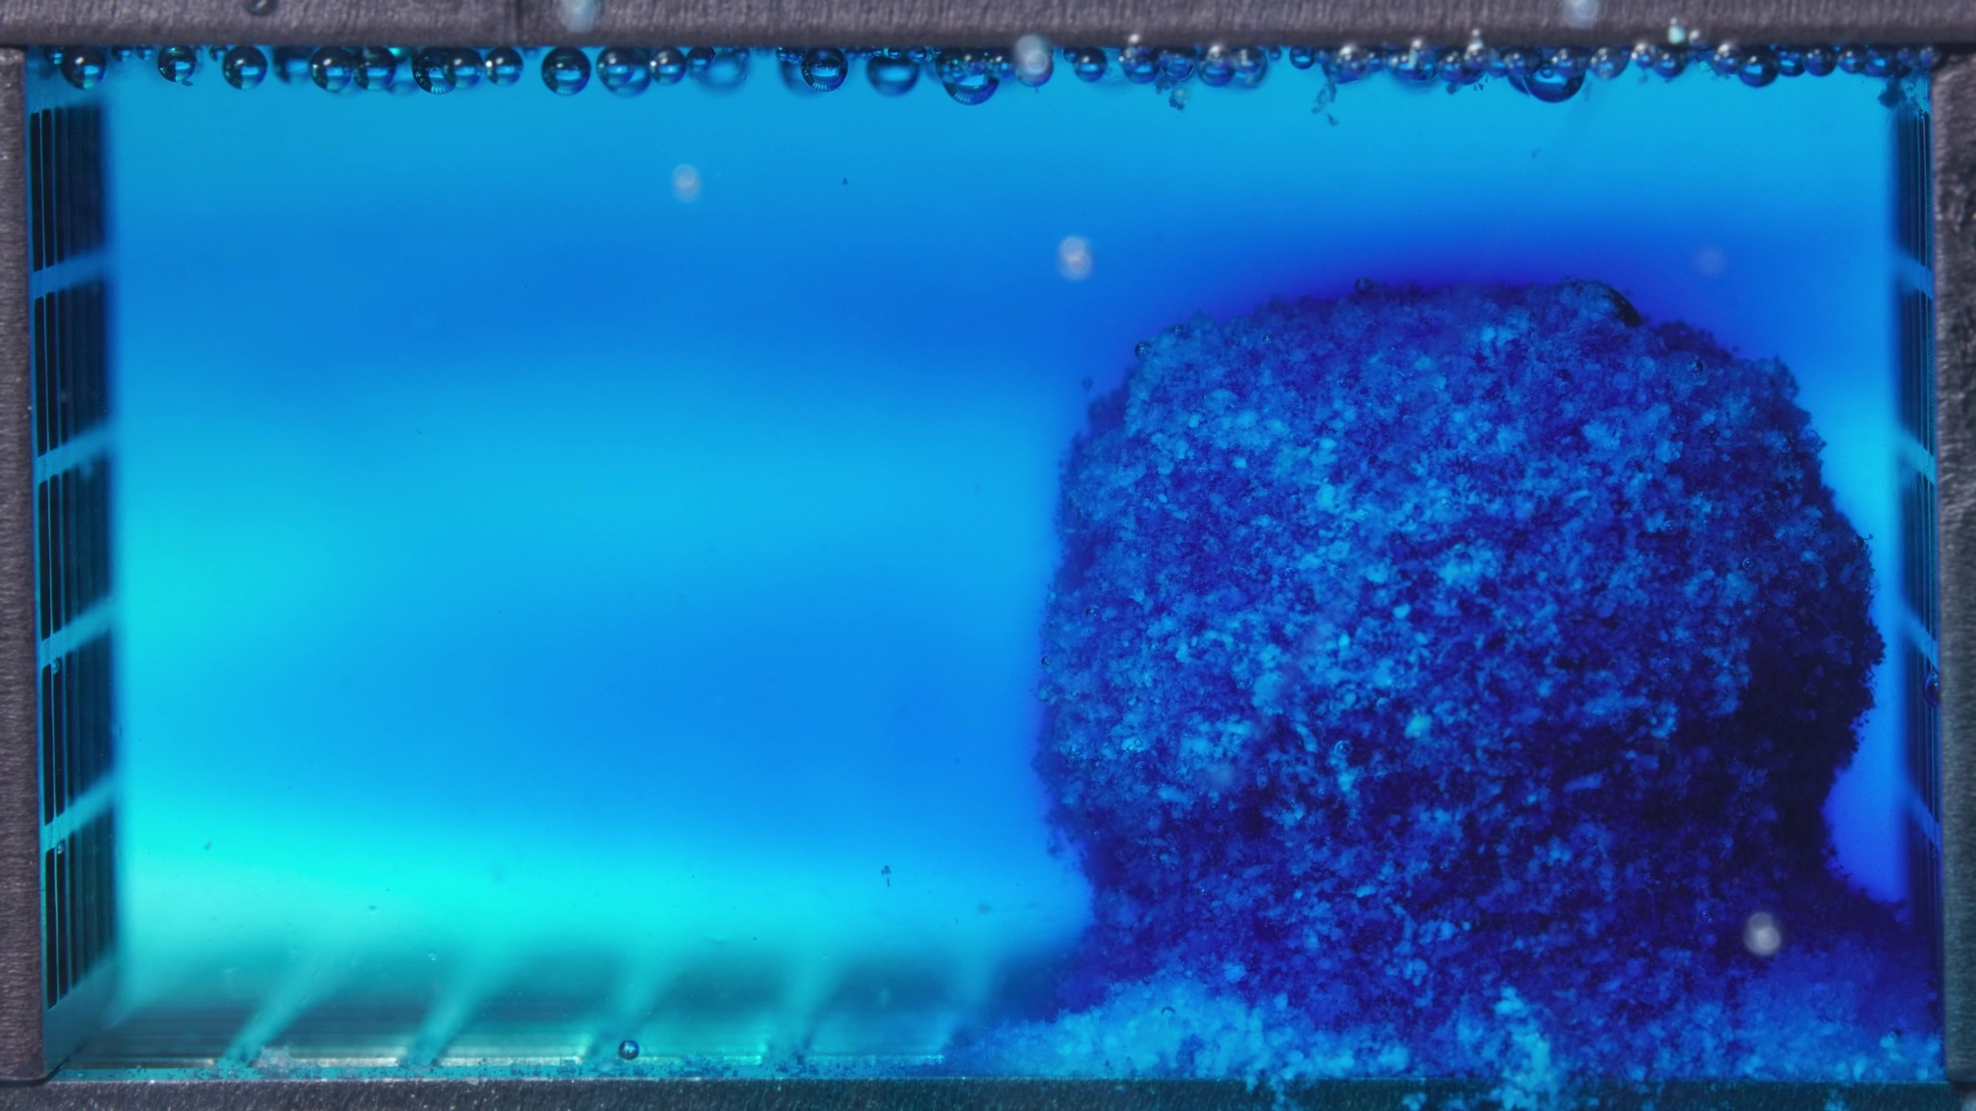 | 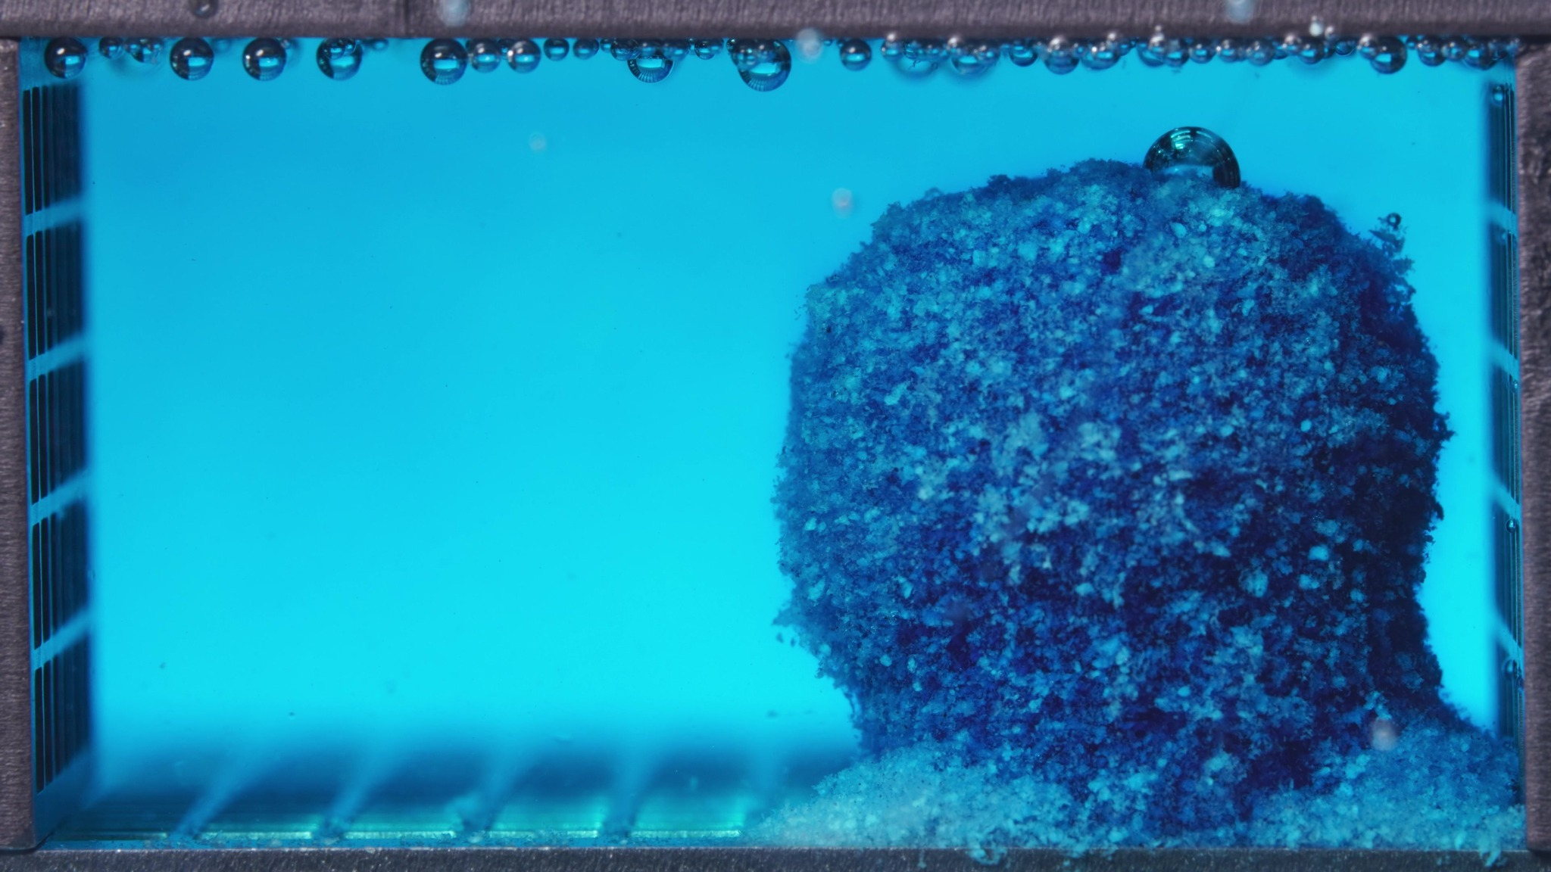

Turn 20 - Assistant
Treating these three images as one batch for the high-viscosity formulation during 0.104–5 h.
Overall interpretation: this batch shows the high-viscosity formulation in an early hydration and release stage with very strong matrix retention. The tablet remains as a single upright, compact residual body with a broad rounded top and largely preserved sidewalls. The most obvious development within this window is progressive blue diffusion into the surrounding medium, while the solid body itself undergoes only limited structural deformation. The dominant pattern is therefore early dye release under strong bulk integrity.
Eight-dimension analysis: the tablet body remains deep blue to dark blue, with a bright cyan diffusion halo along the outer boundary. Across the batch, the surrounding medium changes from nearly clear to a more broadly blue-stained field. The overall outline is well preserved as a thick upright columnar/block-like body with a rounded upper surface. The surface is rough, granular, and heterogeneous, but there are no large cracks or cavity-like defects. The visible occupied volume remains large and stable. Strict comparison with a previous window is limited, but within the current batch the most evident progression is increasing medium coloration while the solid matrix changes only modestly. The material behaves as a hydrated but strongly cohesive matrix mass. The medium change is dominated by dye diffusion rather than heavy particulate turbidity. Detached material is limited and localized near the base.
Summary note: the most important observation is that the medium becomes progressively blue while the tablet body still retains a very strong upright cohesive structure.

Turn 21 - User
These are pictures of the high-viscosity formulation during 6.25–11.25 h.
Attached images
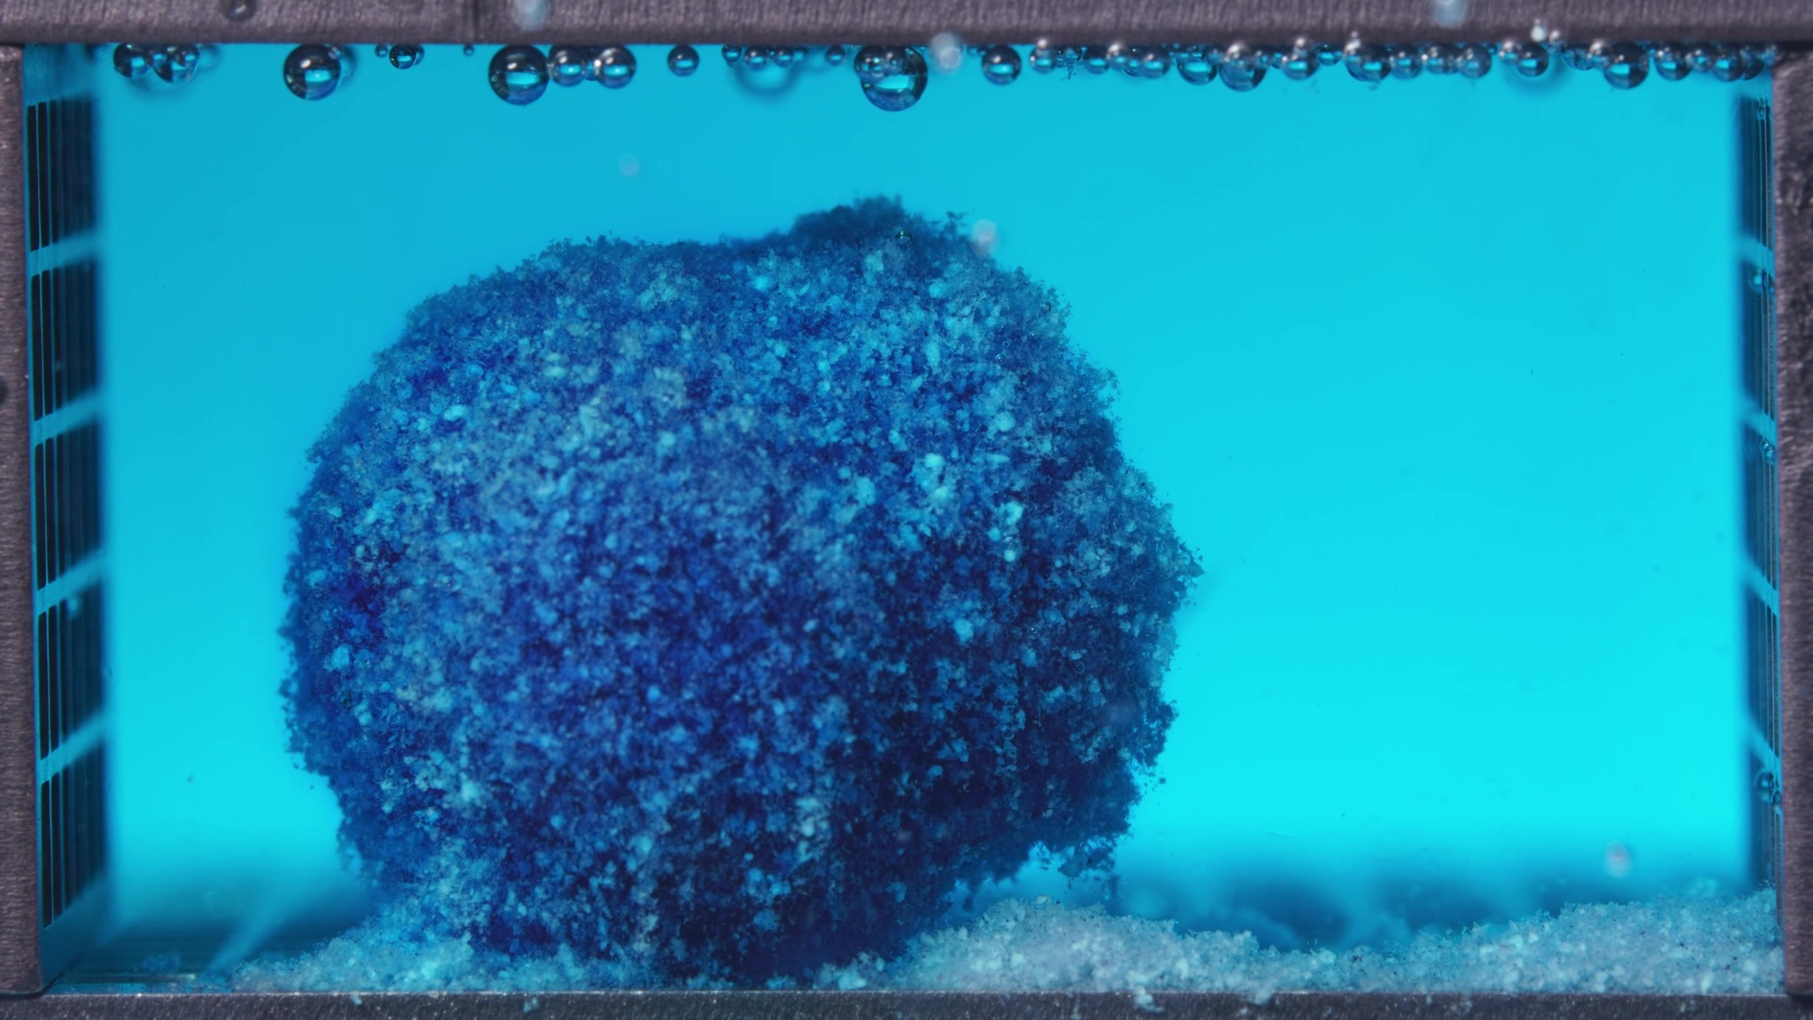 | 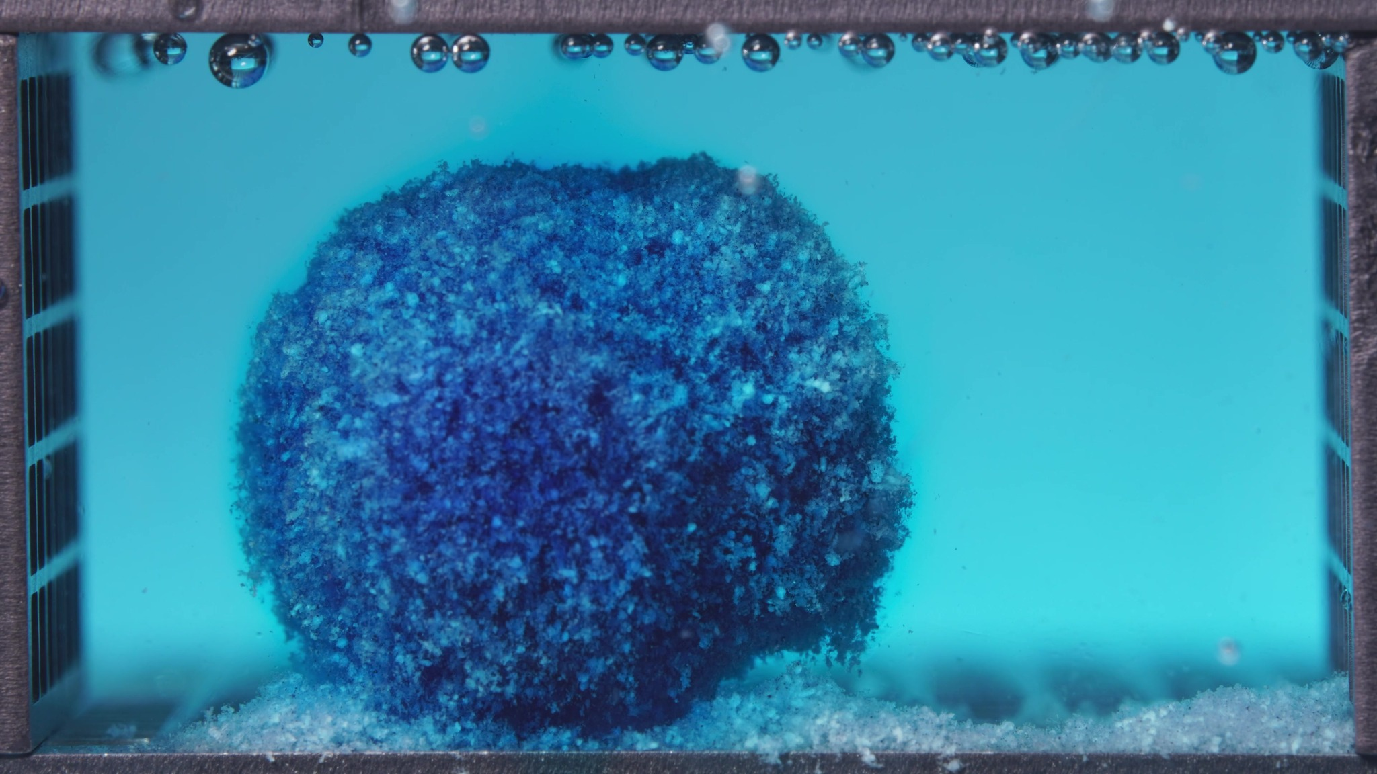 | 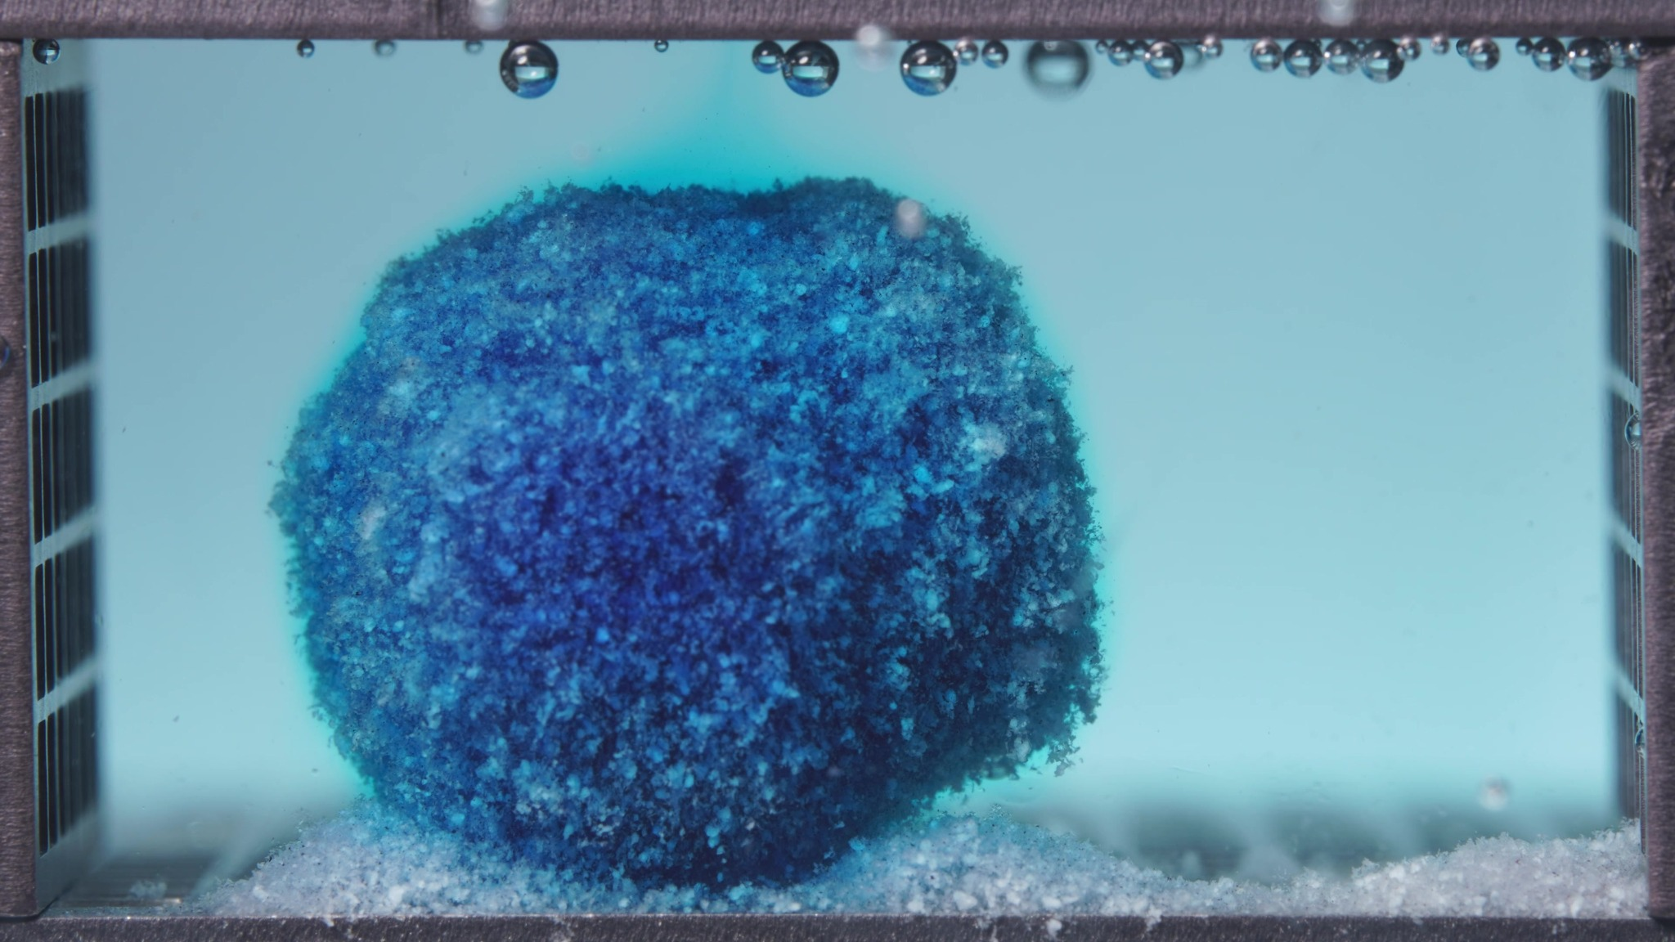

Turn 22 - Assistant
Treating these three images as one batch for the high-viscosity formulation during 6.25–11.25 h.
Overall interpretation: in this window, the high-viscosity formulation still shows very strong matrix integrity and the slowest apparent structural evolution among the patterns seen so far. The tablet remains as a single large cohesive body, with the main visible change being a shift toward a more rounded, dome-like to near-spherical contour rather than any clear collapse or fragmentation. Compared with the 0.104–5 h batch, the dominant behavior is continued controlled release with shape smoothing and persistent bulk retention.
Eight-dimension analysis: the tablet body remains dark blue overall, with lighter mottled blue-white spots on the surface. The surrounding medium is now more uniformly blue/cyan. The body remains a single intact mass, but its outline appears more rounded and globular than before. The surface continues to appear rough and heterogeneous, with a slightly fuzzy outer boundary, but without large cracks, peeling layers, or cavity-like defects. The visible occupied volume remains large and well preserved. Compared with the earlier batch, evolution continues at a slow, controlled rate. The material behaves as a hydrated, strongly cohesive matrix mass. The medium appears more uniformly blue, and fragments remain minimal and localized near the base.
Comparison with the previous window: the most important change is the shift from a more upright block-like body to a smoother, rounder, more globular remnant, together with a more uniformly blue medium.

Turn 23 - User
These are pictures of the high-viscosity formulation during 12.5–17.5 h.
Attached images
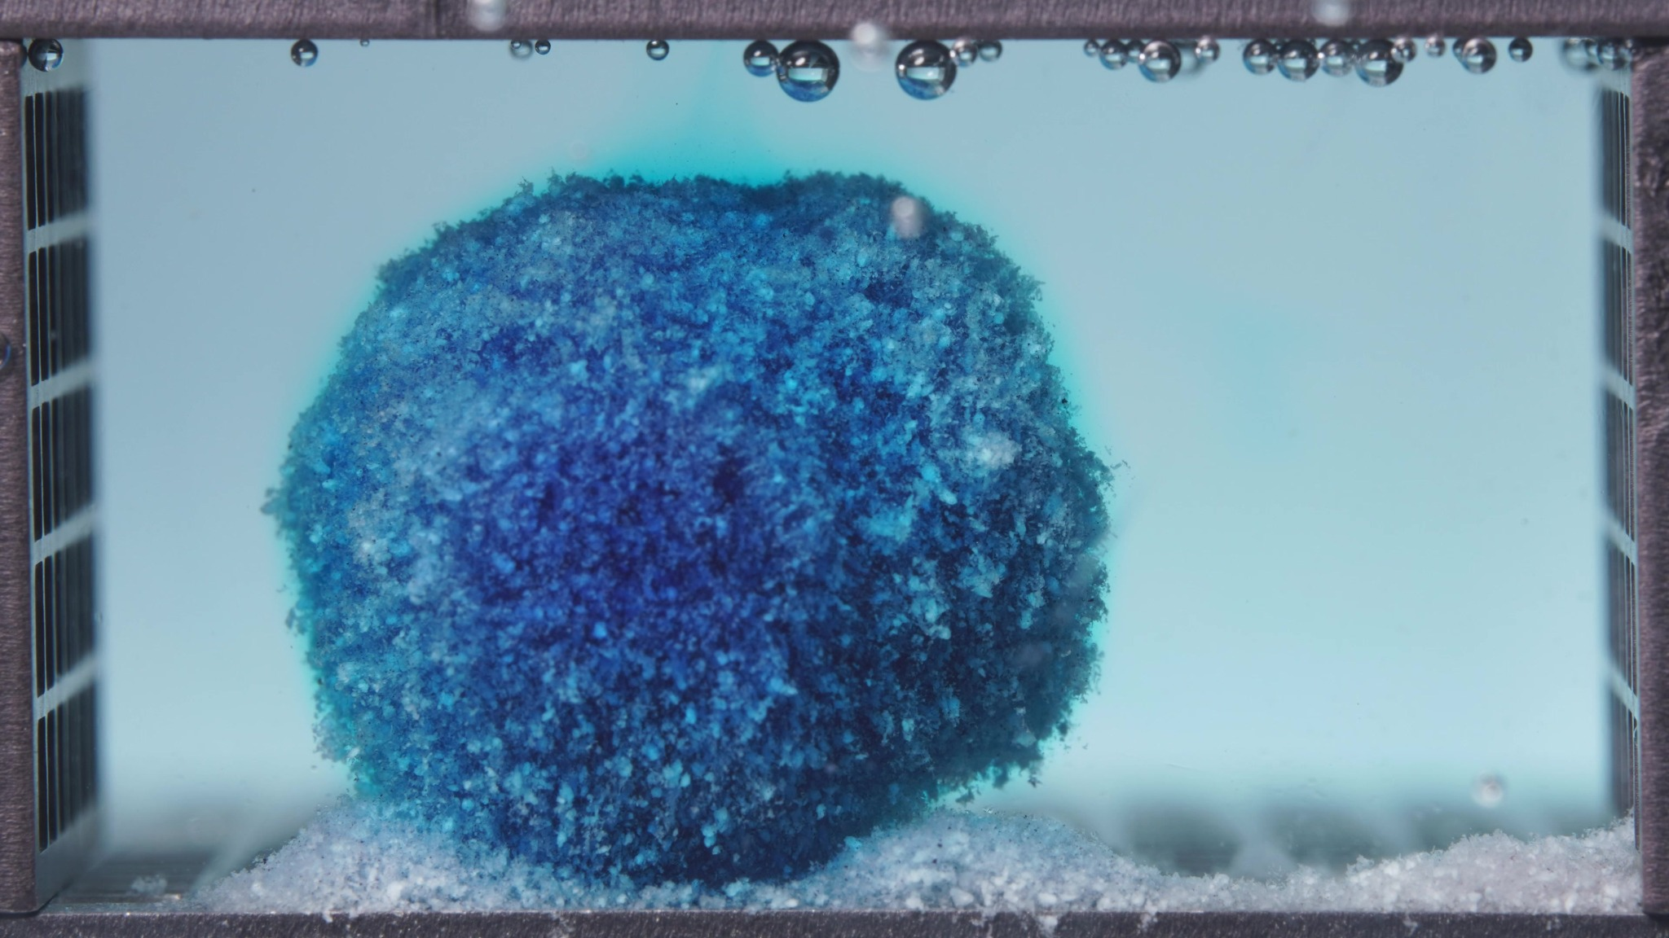 | 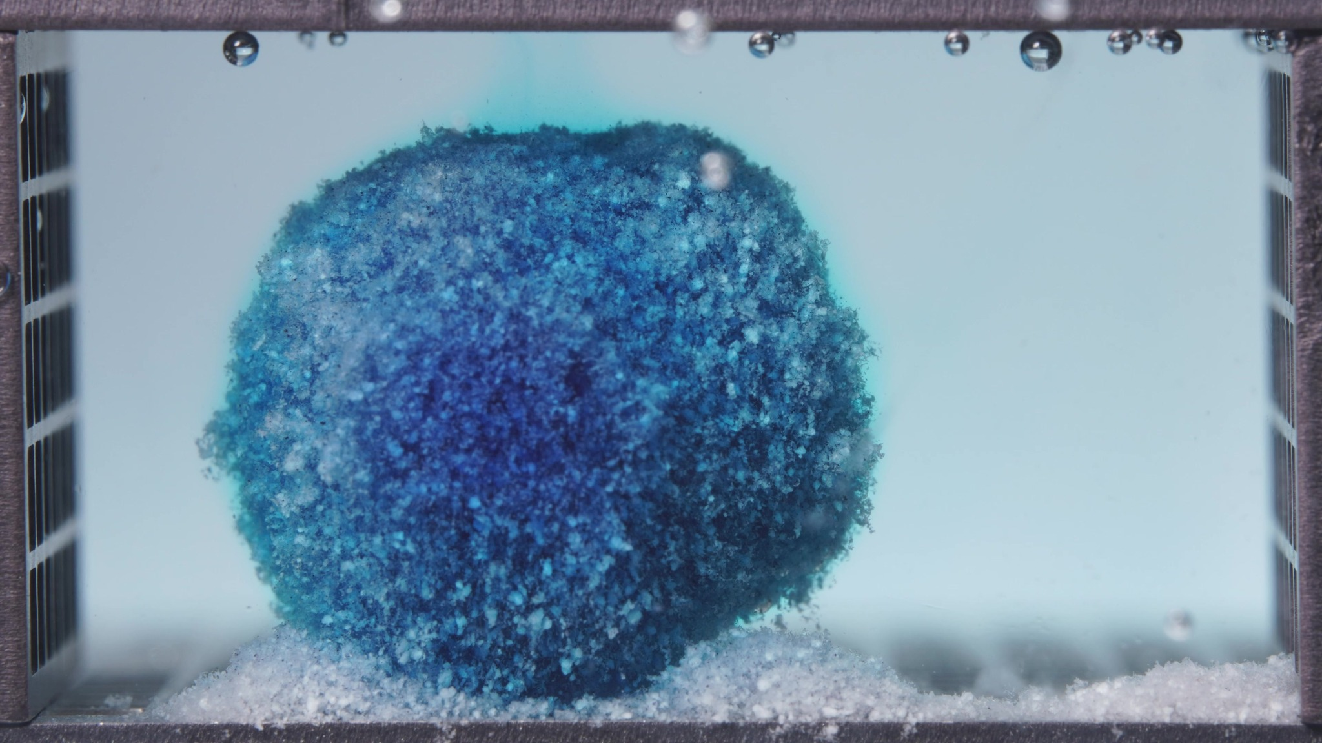 | 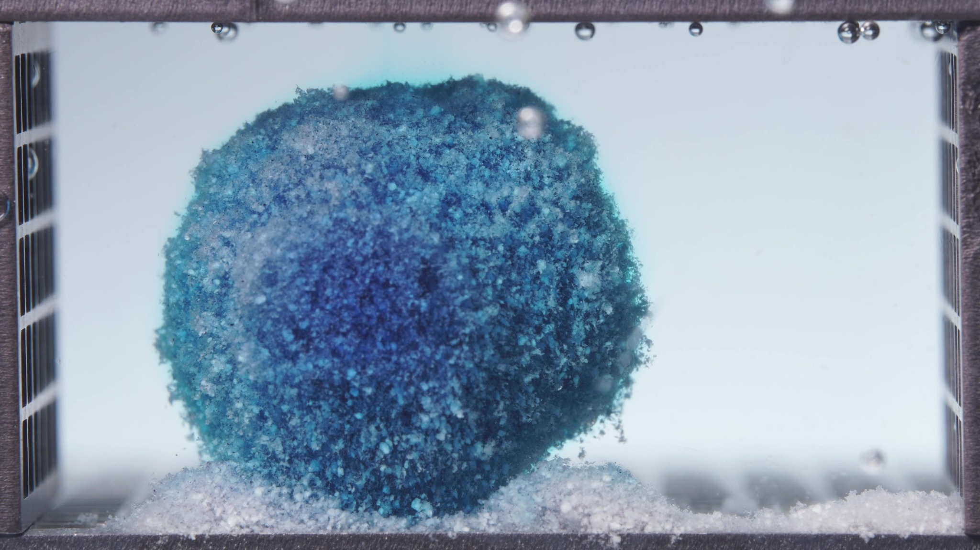

Turn 24 - Assistant
Treating these three images as one batch for the high-viscosity formulation during 12.5–17.5 h.
Overall interpretation: this window shows the high-viscosity formulation in a mid-to-late persistent residual stage with extremely strong structural retention. The tablet remains as a single large cohesive body with a rounded to slightly dome-like profile. Compared with 6.25–11.25 h, the dominant change is subtle surface lightening and slight contour regularization, not collapse. The overall pattern is still slow external erosion under preserved bulk integrity.
Eight-dimension analysis: the matrix remains dark blue overall, with a somewhat paler blue-white mottled outer surface, especially in the upper and lateral regions. The surrounding medium appears lightly blue and visually uniform. The body remains single, intact, and highly cohesive. There is no obvious fragmentation, undercut region, or cavity formation. The surface remains coarse, granular, and heterogeneous. The visible occupied volume remains large and well preserved. Compared with the previous window, the formulation still appears to be evolving at a very slow, controlled rate. The material behaves as a hydrated, swollen, strongly cohesive sustained-release matrix. The medium looks lightly blue, relatively clear, and stable, and detached material remains localized at the base as a bottom-associated deposit.
Comparison with the previous window: the most important change is the shift toward an even more stable rounded residual form, with slight surface blanching and very limited additional contour change.

Turn 25 - User
These are pictures of the high-viscosity formulation during 18.75–23.75 h.
Attached images
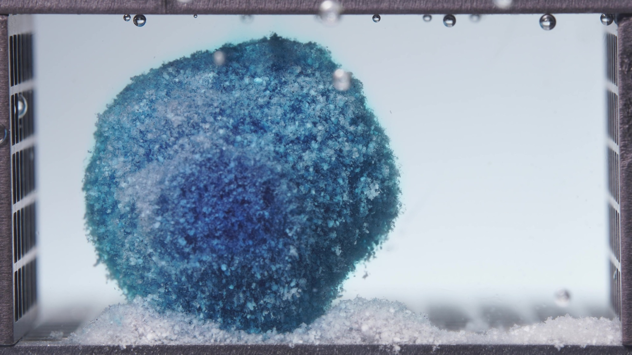 | 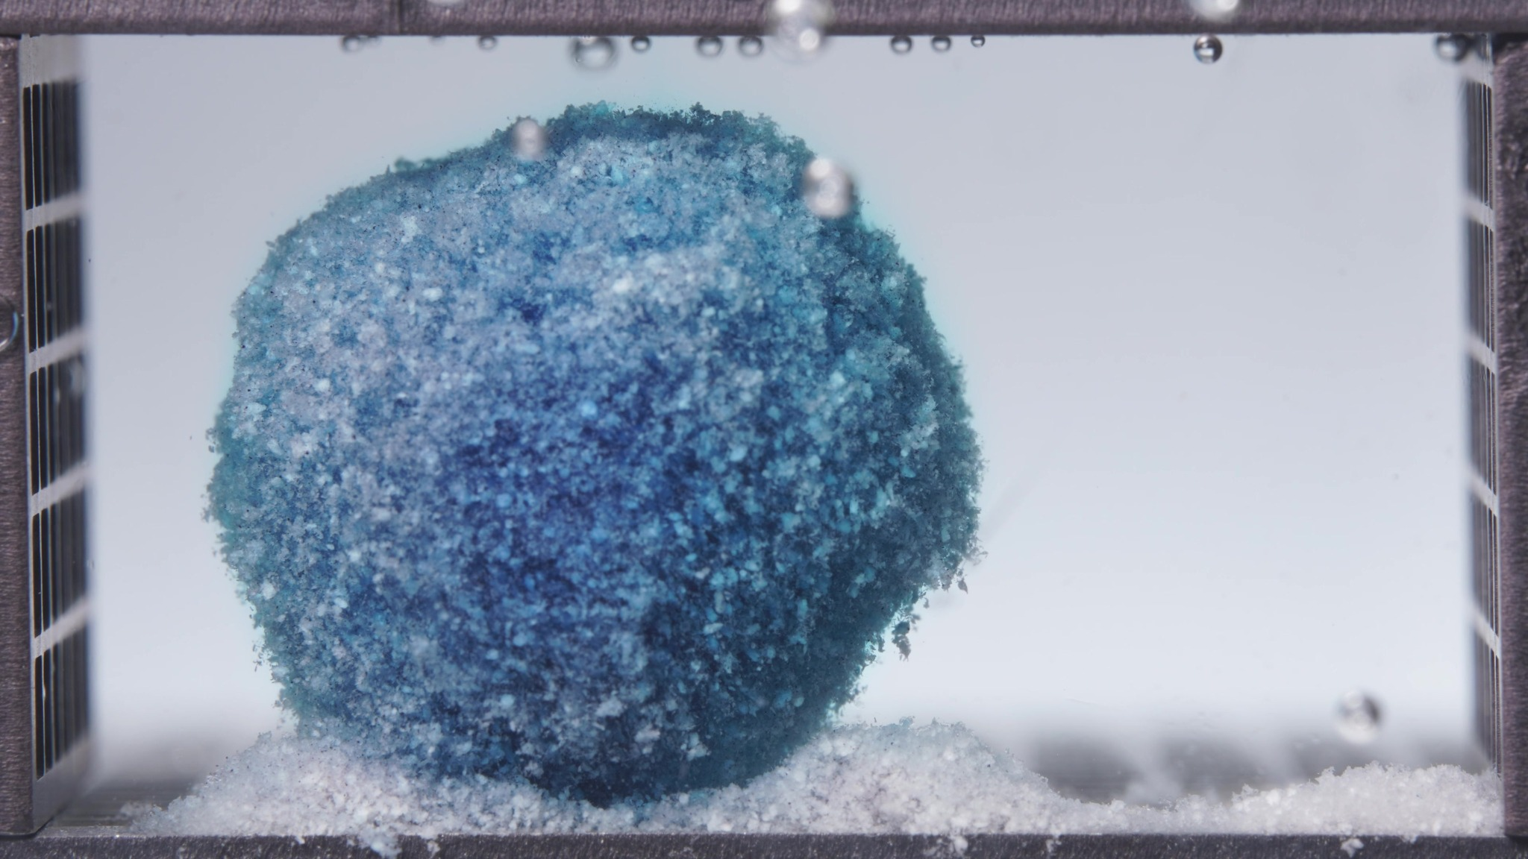 | 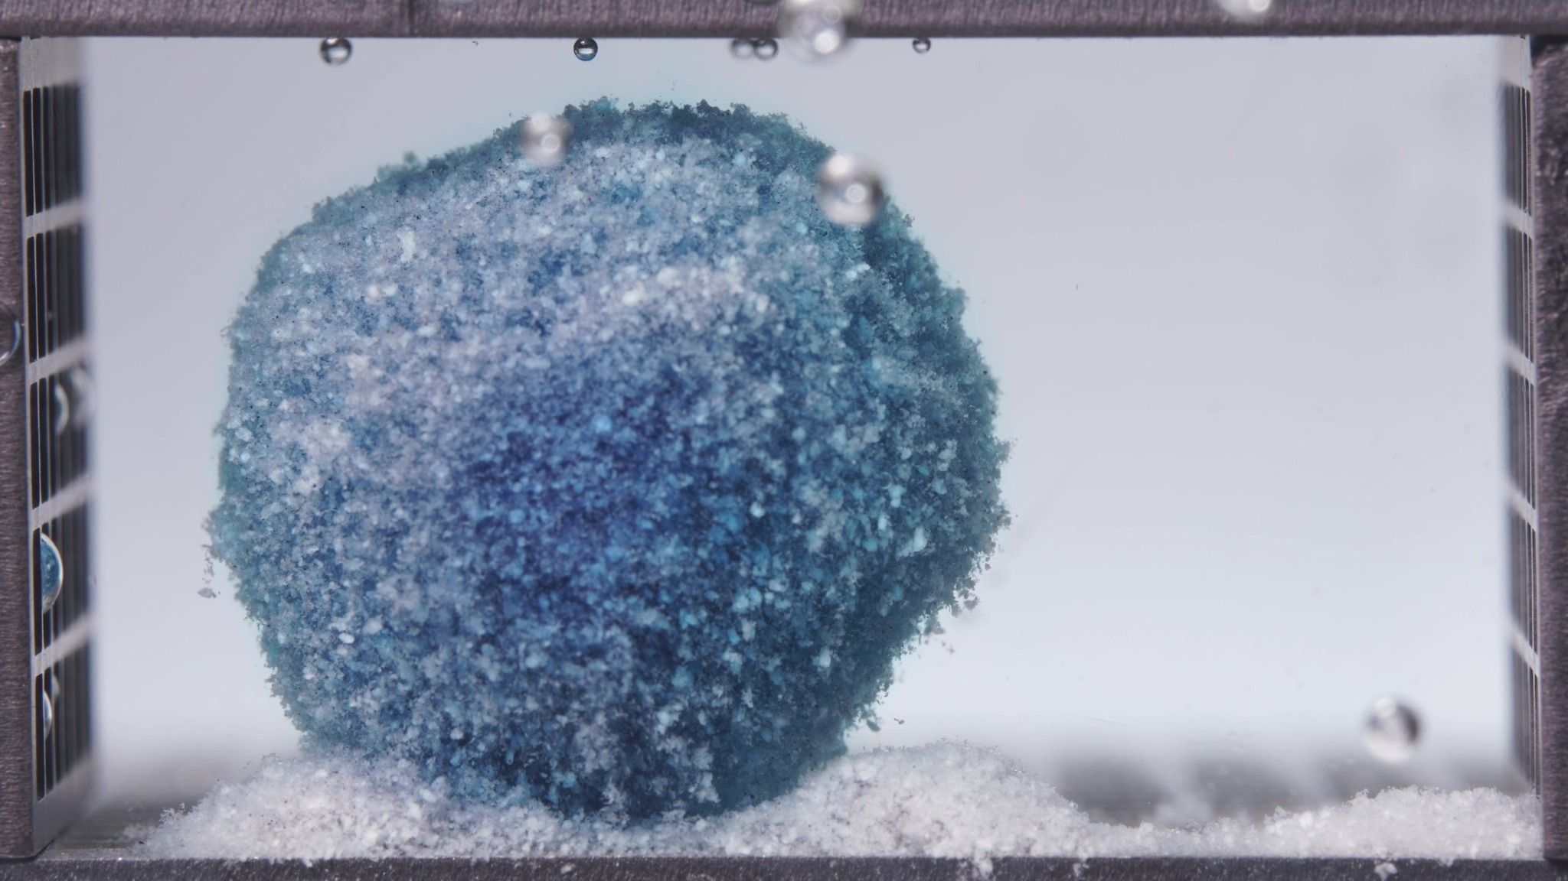

Turn 26 - Assistant
Treating these three images as one batch for the high-viscosity formulation during 18.75–23.75 h.
Overall interpretation: this final window shows the high-viscosity formulation in a terminal persistent-matrix stage with the strongest structural retention among the three formulations. A single large cohesive remnant is still present, and compared with 12.5–17.5 h, the dominant change is only very slight surface blanching and minor contour smoothing/flattening, not collapse. By the end of 24 h, the tablet still behaves as a stable residual matrix body.
Eight-dimension analysis: the remnant remains dark blue in the inner region, while the outer surface appears paler blue to whitish-blue, especially over the upper and lateral exterior. The medium is only faintly blue and visually uniform. The body remains single, intact, and large, with a broadly rounded to slightly dome-like/block-rounded outline. The surface is coarse, granular, and matte, with a slightly fuzzy boundary caused by fine outer erosion. The visible occupied volume remains substantial. Compared with 12.5–17.5 h, the formulation appears to have entered a near-plateau slow-erosion stage. The material continues to behave as a hydrated, swollen, strongly cohesive sustained-release matrix remnant. The medium appears clear to faintly blue-gray and relatively quiet, and detached material remains localized near the base.
Comparison with the previous window: the most important change is that the high-viscosity formulation becomes only slightly paler and marginally more contour-smoothed, while the bulk body remains essentially intact. Across all four high-viscosity windows, the overall trajectory is early dye diffusion with preserved compact body to gradual rounding into a globular remnant to persistent large cohesive matrix with slow surface blanching to final near-plateau residual stage with minimal structural loss by 24 h.

Turn 27 - User
Provide an integrated mechanistic interpretation of the observed disintegration behavior of the three methylene blue sustained-release tablet formulations.
The three formulations are the low-viscosity formulation, the standard formulation (medium-viscosity), and the high-viscosity formulation, and their main formulation difference lies in the ratio between HPMC K4M and HPMC 100lv.
Our optimization goal is to adjust the ratio between HPMC K4M and HPMC 100lv so that the cumulative release amount of the standard-viscosity methylene blue sustained-release tablet over the first 4 hours is increased to 105% of its original level.
In addition to the image-based disintegration observations, please also use the UV absorbance data from the flow-through-cell eluate as semi-quantitative release evidence.
All UV absorbance values are within the linear range.
The interval sequence is: 0–0.5 h, 0.5–1 h, 1–2 h, 2–4 h, 4–6 h, 6–8 h, 8–12 h, 12–16 h, 16–20 h, and 20–24 h.
The corresponding mean UV absorbance values are as follows:
Low-viscosity formulation: 0.0273, 0.0727, 0.1967, 0.5963, 0.3347, 0.0230, 0.0123, 0.0027, -0.0010, -0.0007.
Standard formulation: 0.0320, 0.0520, 0.1680, 0.5153, 0.5532, 0.0777, 0.0167, 0.0143, 0.0043, -0.0013.
High-viscosity formulation: 0.0243, 0.0403, 0.1213, 0.4743, 0.3490, 0.0890, 0.0217, 0.0077, 0.0047, 0.0010.
Please:
1) Summarize the key differences in disintegration behavior across the three formulations as evidence statements.
2) Using the literature and the current session data, focus on explaining how differences in the HPMC K4M / HPMC 100lv ratio may influence swelling, gel-layer formation, erosion, fragmentation, shell persistence, and other observed disintegration phenomena.
3) Relate the observed disintegration phenomena to the interval-based UV absorbance trends, and state whether the image-based evidence and the UV-based evidence are mutually supportive, partially aligned, or inconsistent.
4) Propose 2–5 mechanistic hypotheses, each clearly tied to the observed phenomena, the UV trends, and the HPMC ratio differences.
5) Explain what these mechanistic differences may imply for increasing the cumulative release amount of the standard-viscosity methylene blue sustained-release tablet over the first 4 hours to 105% of its original level, so that the result can support the next-step formulation optimization.
6) List alternative explanations and a minimal set of follow-up tests to discriminate between hypotheses.
Use only information from this session and the retrieved literature; do not invent missing details.
Do not provide a final optimized formulation recipe in this step.

Turn 28 - Assistant
Phenomenon Review
1. Low-viscosity formulation (K100LV-rich, K4M-poor) showed the earliest visible structural destabilization. It moved from an initially coherent body to a more clearly eroded, undercut, partially collapsed remnant with basal deposits by the mid windows, then persisted as a pale residual body through 24 h. The dominant visible pattern was early peripheral erosion/local collapse plus late residual-matrix persistence.
2. Standard formulation (medium-viscosity) retained a coherent upright body throughout the experiment more effectively than the low-viscosity formulation, but it was not as over-retentive as the high-viscosity formulation. Its image sequence showed controlled surface roughening, gradual blanching/rounding, and later localized cavity formation, with less obvious early undercutting than the low-viscosity batch.
3. High-viscosity formulation (K4M-rich, K100LV-poor) showed the strongest bulk integrity. Across windows it became more rounded/globular, but there was minimal fragmentation, minimal undercutting, and the most persistent late residual body. The dominant visible pattern was shell/gross-shape persistence with slow superficial erosion.
Concentration-Time Trend Review
Using the session UV data as a semi-quantitative release index under constant 1 mL/min flow and linear-range absorbance, the first-4-hour cumulative absorbance-time indices are:
- Low viscosity: 1.439
- Standard: 1.241
- High viscosity: 1.102
Relative to the current standard formulation, the low-viscosity formulation is about 116.0% of the standard first-4-hour index, while the high-viscosity formulation is about 88.8%. The user’s optimization target for the standard formulation corresponds to about 1.303 on the same first-4-hour index basis, so the required gain is modest: about +5% versus the current standard.
Interval-level UV trends also differ clearly: the low-viscosity formulation rises fastest through 2–4 h (0.5963), then drops sharply after 4–6 h (0.3347) and becomes very small thereafter. The standard formulation rises less aggressively than low viscosity in the first 4 h, but reaches its highest interval mean at 4–6 h (0.5532), and has the largest overall cumulative index over 24 h. The high-viscosity formulation has the lowest early UV values through 4 h, with slower overall early release and only modest later continuation.
Taken together, the image evidence and UV evidence are partially aligned overall, with strong directional agreement in the early-to-mid phase. They agree that low viscosity is the fastest early system, high viscosity is the slowest early system, and standard is intermediate. The important non-identity is that all three formulations still show visible late residual bodies, whereas the UV data indicate very different amounts of remaining releasable dye. That is not a contradiction; it means that residual visible mass is not equivalent to residual releasable drug mass.
Literature-Supported Typical Mechanistic Links
For HPMC hydrophilic matrices, drug release is typically governed by some combination of water uptake, gel-layer formation, diffusion through the hydrated gel, and matrix erosion. The mechanical/viscoelastic quality of the swollen gel layer is an important determinant of how well the matrix resists breakup and how fast drug can escape.
Literature supports that HPMC viscosity grade/molecular weight changes erosion behavior and gel persistence. Low-viscosity HPMC systems around the ≤100 cps range show faster-dissolving behavior and higher apparent diffusivity, whereas higher-viscosity grades above about 4000 cps behave as slower-dissolving matrices with more persistent gel-layer development. A cited study specifically examined formulations containing a fixed total HPMC content but different K100LV/K4M proportions and found that formulations with a larger proportion of high-molecular-weight HPMC showed slower erosion, while those with a larger low-molecular-weight fraction eroded faster. Low-viscosity HPMC matrices such as K100LV are also more sensitive to hydrodynamic stress than K4M/K15M/K100M matrices.
Tentative Integrated Mechanistic Interpretation Across the Three Formulations
Hypothesis 1: Early-gel weakness/fast-access hypothesis for the low-viscosity formulation. Because the low-viscosity formulation contains the highest K100LV fraction and the lowest K4M fraction, it most plausibly formed a faster-hydrating but mechanically weaker and less persistent gel barrier than the other two formulations. In the session images, that is consistent with earlier undercutting, local collapse, and basal debris formation. In the UV data, it is consistent with the largest first-4-hour cumulative index and the sharp early dominance at 2–4 h.
Hypothesis 2: Balanced gel-renewal/balanced permeability hypothesis for the standard formulation. The standard formulation appears to sit between the two extremes: its matrix stayed structurally coherent much better than the low-viscosity system, but it did not show the same degree of late globular shell persistence as the high-viscosity system. Mechanistically, this suggests a more balanced gel layer: strong enough to prevent premature structural failure, but still permeable/erodible enough to sustain release after 4 h. That interpretation fits the UV profile well: first-4-hour release is intermediate, but the formulation shows the highest 4–6 h interval absorbance and the largest 24 h cumulative index, implying that release was shifted slightly later rather than collapsing early.
Hypothesis 3: Over-persistent shell/over-retardation hypothesis for the high-viscosity formulation. Because the high-viscosity formulation contains the largest K4M fraction, it most plausibly formed the strongest and most persistent gel shell, with the greatest resistance to erosion and fragmentation. In the images, that is consistent with the large rounded/globular body that persists with minimal structural disruption through late windows. In the UV profile, it is consistent with the lowest first-4-hour cumulative index and generally slower early release.
Hypothesis 4: Late remnant ≠ late releasable drug hypothesis. A second mechanism is needed to explain why the low-viscosity formulation still shows visible late residue even though its post-6-hour UV signal is very small. The most parsimonious interpretation is that the late remnant is increasingly polymer-rich/drug-depleted, rather than a large reservoir of still-releasable methylene blue.
Mechanistic Implications for the Next Optimization Step
The standard formulation’s first-4-hour release is not grossly deficient; it is only about 5% below the target index. That means the next optimization step should be understood as a fine-tuning problem, not an extreme reformulation problem. The goal is not to make the standard formulation behave like the low-viscosity formulation, because that system already exceeds the 105% target and then drops off sharply after 4–6 h. The high-viscosity formulation is also not the correct direction for the stated goal, because it is too retarded in the first 4 h. The mechanistically relevant direction is slightly more early permeability and/or slightly less early gel resistance than the current standard, but without recreating the low-viscosity formulation’s early undercutting/early depletion pattern and without sacrificing the standard formulation’s useful sustained 4–6 h continuation.
Suggestions for Further Validation
Alternative explanations that remain plausible include tablet-to-tablet differences in porosity, hardness, or compression history; geometric placement/contact conditions in the flow-through cell; and nonlinear behavior in mixed-grade HPMC systems. Minimal follow-up tests include replicate runs with matched hardness/porosity measurements, water uptake and polymer erosion measurements at key time points, residual drug-content assay in the remaining tablet mass at 4 h, 6 h, and 24 h, cross-section/front-tracking imaging, and a narrow targeted comparison around the current standard ratio while holding total HPMC constant.

Turn 29 - User
Provide a formulation optimization recommendation for the next iteration based on the existing formulation information, optimization target, concentration-time summary, mechanistic analysis results, and prior disintegration-analysis conclusions in this session.
The three formulations are the low-viscosity formulation, the standard formulation (medium-viscosity), and the high-viscosity formulation. The standard formulation is the reference formulation.
Our optimization goal is to adjust the ratio between HPMC K4M and HPMC 100lv so that the cumulative release amount of the standard-viscosity methylene blue sustained-release tablet over the first 4 hours is increased to 105% of its original level.
Please integrate the prior evidence rather than repeating the earlier full image-analysis or mechanistic-analysis process. You MUST provide a next-step formulation proposal with explicit numeric values, especially for HPMC K4M and HPMC 100lv.
Please:
1) Briefly summarize which current formulation tendency appears closer to the optimization target and which tendencies appear too fast or too slow.
2) Propose one next-step optimized formulation anchored on the standard formulation and adjusted mainly through the balance between HPMC K4M and HPMC 100lv.
3) You MUST explicitly report the proposed HPMC K4M amount, the proposed HPMC 100lv amount, the proposed HPMC K4M:HPMC 100lv ratio, and the percentage change of each relative to the standard formulation.
4) Even if the evidence is not sufficient to justify a fully validated exact formula, you MUST still provide a best-estimate next-iteration formulation proposal with explicit numeric values and percentage changes, and clearly label it as tentative rather than omitting the numbers.
Use only information from this session and the retrieved literature if already available; do not invent missing details.
Do not output a same/different judgment.
Do not simply restate previous node outputs without synthesis.
Output the result in a clear structured format with the following sections:
Optimization Target Review
Evidence Summary from Existing Formulations
Recommended Next Formulation
Uncertainty and Validation Needs
Under “Recommended Next Formulation”, directly report:
- Proposed HPMC K4M amount = X
- Proposed HPMC 100lv amount = Y
- Proposed HPMC K4M:HPMC 100lv ratio = X:Y
- Percentage change of HPMC K4M relative to the standard formulation = Z%
- Percentage change of HPMC 100lv relative to the standard formulation = W%
- A short rationale for why this ratio is recommended

Turn 30 - Assistant
Optimization Target Review
The optimization target is to increase the cumulative 0–4 h release of the standard formulation to 105% of its current level by adjusting the HPMC K4M / HPMC 100lv balance.
Using the session UV data as a semi-quantitative release proxy over 0–4 h, the low-viscosity formulation shows the fastest early release tendency and appears too fast for the target; the high-viscosity formulation shows the slowest early release tendency and appears too slow for the target; the standard formulation is already the closest tendency to the target, but it appears slightly under-releasing in the first 4 h and therefore needs only a modest shift toward the low-viscosity direction, not a large shift.
Evidence Summary from Existing Formulations
The session evidence supports a consistent three-formulation continuum. From the disintegration images, the low-viscosity formulation showed the earliest structural destabilization, more obvious erosion/undercutting, and faster early breakdown tendency. The standard formulation preserved matrix integrity better than the low-viscosity formulation, but was still more dynamic than the high-viscosity formulation. The high-viscosity formulation showed the strongest shell/matrix persistence, the most globular residual body, and the slowest visible structural evolution.
From the UV absorbance trends, the low-viscosity formulation had the highest early-phase output and a strong 2–4 h contribution, consistent with faster early release. The standard formulation was intermediate in the first 4 h, but had a stronger 4–6 h contribution than the low-viscosity formulation, suggesting that part of its release is shifted slightly later than desired. The high-viscosity formulation had the lowest 0–4 h output, consistent with stronger gel persistence and slower early transport.
From the integrated mechanistic interpretation, increasing the K100LV contribution tends to shift the system toward faster early hydration/weaker early barrier persistence/more early release, while increasing the K4M contribution tends to shift the system toward stronger gel-layer persistence/slower erosion/slower early release. So the next iteration should remain anchored on the standard formulation, but should make a small-to-moderate decrease in HPMC K4M and a matching increase in HPMC 100lv so that some release is pulled forward from the 4–6 h region into the 0–4 h region without reproducing the low-viscosity formulation’s overly fast early erosion tendency.
Recommended Next Formulation
Tentative next-step proposal, anchored on the standard formulation:
- Methlyene blue = 0.1420
- Silicon dioxide = 0.0503
- Magnesium stearate = 0.1278
- Microcrystalline cellulose = 9.6893
- Lactose = 9.6830
- Proposed HPMC K4M amount = 2.0520
- Proposed HPMC 100lv amount = 3.2688
- Proposed HPMC K4M:HPMC 100lv ratio = 2.0520:3.2688 (approximately 1:1.59)
- Percentage change of HPMC K4M relative to the standard formulation = -18.0%
- Percentage change of HPMC 100lv relative to the standard formulation = +16.0%
- A short rationale for why this ratio is recommended: this is a deliberately moderate shift from the standard formulation toward the low-viscosity direction, intended to raise the first-4-hour release by about 5% while avoiding the low-viscosity formulation’s clearly over-fast early erosion tendency. Mechanistically, it should slightly weaken early gel-barrier persistence and increase early permeability/erosion enough to move part of the release from the 4–6 h window into the target 0–4 h window.
Uncertainty and Validation Needs
This recommendation is tentative, not a validated optimum. The better-supported parts are the direction of change (lower K4M/higher K100LV relative to the current standard), the conclusion that the standard formulation is already closest to the target, and the conclusion that the required optimization is modest, not extreme. The less certain parts are the exact numeric magnitude needed to achieve precisely 105% of the current 0–4 h cumulative release; whether the response to the K4M/K100LV shift is sufficiently linear to make this single-step estimate exact; and whether a slightly faster 0–4 h release might also introduce unwanted extra early erosion or reduce the useful sustained behavior after 4 h. Minimal next validation includes preparing this proposed formulation and repeating the same UV flow-through test, comparing the 2–4 h and 4–6 h intervals specifically, repeating the image-based disintegration observation, and using the result as the anchor for a narrow second-round ratio adjustment if needed.

Turn 31 - User
Export all of our conversation content as a DOC file named after the conversation title.

