Methylene Blue Sustained-Release Tablet Disintegration Analysis
Conversation export
This export includes the user and assistant transcript, plus embedded user-shared images.

1. User
We are analyzing the static disintegration images of three self-made methylene blue sustained-release tablet formulations with different HPMC ratios.
All images were captured under the same experimental conditions.
The dissolution medium is initially pH 1.2, and after 1 hour it is switched to pH 6.8.
The experiment was conducted at a controlled temperature of 38 °C to simulate a slightly elevated physiological condition.
The system is a flow-through cell with a flow rate of 1 mL/min.
The total observation period is 24 h. Images were captured continuously and later sampled into batches.
Each message you receive contains multiple images representing a time window (e.g., 0–6 h, 6–12 h, 12–18 h, 18–24 h).
Treat the images within the same window as observations from that time range rather than a single exact time point.
These three formulations are all methylene blue sustained-release tablets, and their main difference lies in the ratio between HPMC K4M and HPMC 100lv.
The first formulation is the low-viscosity formulation. In this formulation, methylene blue is 0.1436, silicon dioxide is 0.0501, magnesium stearate is 0.1274, microcrystalline cellulose is 9.6862, lactose is 9.686, HPMC K4M is 1.0624, and HPMC 100lv is 4.2484.
The second formulation is the standard formulation, which is also the medium-viscosity formulation. In this formulation, methylene blue is 0.142, silicon dioxide is 0.0503, magnesium stearate is 0.1278, microcrystalline cellulose is 9.6893, lactose is 9.683, HPMC K4M is 2.5037, and HPMC 100lv is 2.8171.
The third formulation is the high-viscosity formulation. In this formulation, methylene blue is 0.1446, silicon dioxide is 0.0502, magnesium stearate is 0.1276, microcrystalline cellulose is 9.6846, lactose is 9.6845, HPMC K4M is 4.246, and HPMC 100lv is 1.0653.
Our optimization goal is to adjust the ratio between HPMC K4M and HPMC 100lv so that the cumulative release amount of the standard-viscosity methylene blue sustained-release tablet over the first 4 hours is increased to 105% of its original level.
Concentration-time information will be provided later after the image-analysis stage, so for now please focus on the image-based disintegration behavior under the current experimental and formulation background.
2. Assistant
{
"experiment_config": {
"medium_pH": "initially pH 1.2, switched to pH 6.8 after 1 hour",
"temperature_C": 38,
"total_duration_hours": 24,
"time_interval_hours": null,
"other_conditions": "All images were captured under the same experimental conditions. The system is a flow-through cell with a flow rate of 1 mL/min. Images were captured continuously and later sampled into batches. Each message contains multiple images representing a time window and should be treated as observations from that time range rather than a single exact time point."
},
"formulation_info": {
"formulation_1": {
"formulation_name": "low-viscosity formulation",
"sample_id": null,
"composition": "methylene blue 0.1436, silicon dioxide 0.0501, magnesium stearate 0.1274, microcrystalline cellulose 9.6862, lactose 9.686, HPMC K4M 1.0624, HPMC 100lv 4.2484",
"excipients_or_polymer_info": "These are methylene blue sustained-release tablets. The main difference among formulations lies in the ratio between HPMC K4M and HPMC 100lv.",
"ratio_or_percentage": null,
"key_formulation_comments": "low-viscosity formulation",
"process_notes": null
},
"formulation_2": {
"formulation_name": "standard formulation",
"sample_id": null,
"composition": "methylene blue 0.142, silicon dioxide 0.0503, magnesium stearate 0.1278, microcrystalline cellulose 9.6893, lactose 9.683, HPMC K4M 2.5037, HPMC 100lv 2.8171",
"excipients_or_polymer_info": "These are methylene blue sustained-release tablets. The main difference among formulations lies in the ratio between HPMC K4M and HPMC 100lv.",
"ratio_or_percentage": null,
"key_formulation_comments": "standard formulation; medium-viscosity formulation",
"process_notes": null
},
"formulation_3": {
"formulation_name": "high-viscosity formulation",
"sample_id": null,
"composition": "methylene blue 0.1446, silicon dioxide 0.0502, magnesium stearate 0.1276, microcrystalline cellulose 9.6846, lactose 9.6845, HPMC K4M 4.246, HPMC 100lv 1.0653",
"excipients_or_polymer_info": "These are methylene blue sustained-release tablets. The main difference among formulations lies in the ratio between HPMC K4M and HPMC 100lv.",
"ratio_or_percentage": null,
"key_formulation_comments": "high-viscosity formulation",
"process_notes": null
}
},
"optimization_context": {
"optimization_target": "Adjust the ratio between HPMC K4M and HPMC 100lv so that the cumulative release amount of the standard-viscosity methylene blue sustained-release tablet over the first 4 hours is increased to 105% of its original level.",
"optimization_strategy_notes": "Concentration-time information will be provided later after the image-analysis stage. For now, focus on image-based disintegration behavior under the current experimental and formulation background.",
"adjusted_formulation_variables": "ratio between HPMC K4M and HPMC 100lv"
},
"analysis_plan": {
"dimensions": [
"Color Change",
"Shape Change",
"Surface Texture Change",
"Volume Change",
"Dissolution Speed and Time",
"Physical State Change",
"Dissolution Medium",
"Fragment Distribution with Density"
],
"single_formulation_strategy": "Analyze each formulation across time windows using the fixed eight dimensions and identify major transition patterns within each window.",
"three_formulation_strategy": "Compare the three formulations across matched time windows using the same eight dimensions to relate image-based disintegration behavior to HPMC ratio differences and later optimization interpretation."
}
}
3. User
These are pictures of the low-viscosity formulation during 0.104–5 h.
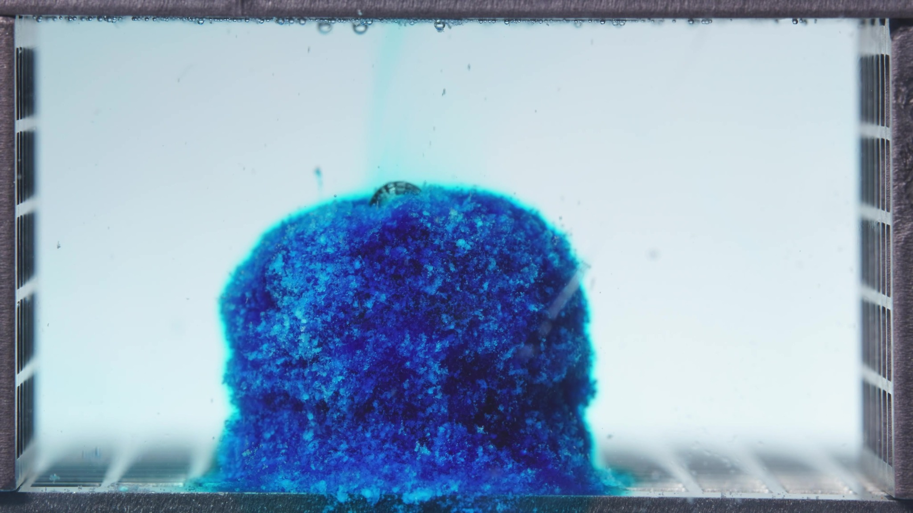 | 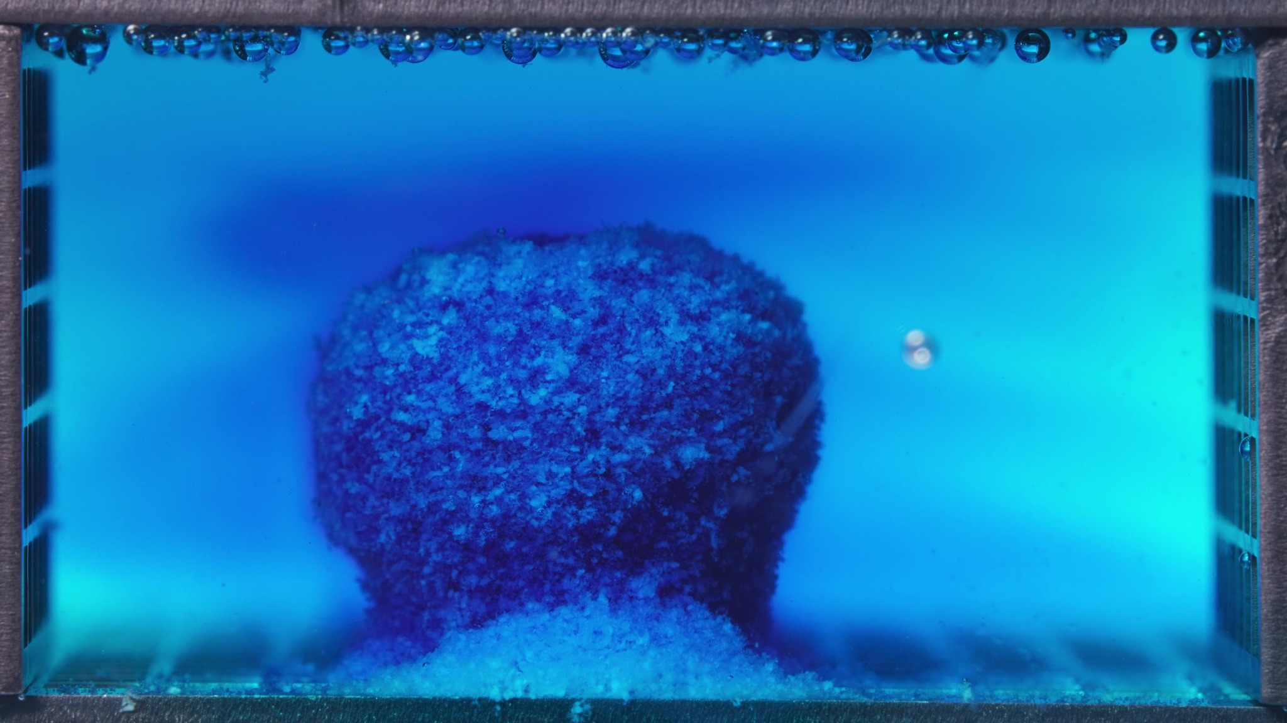 | 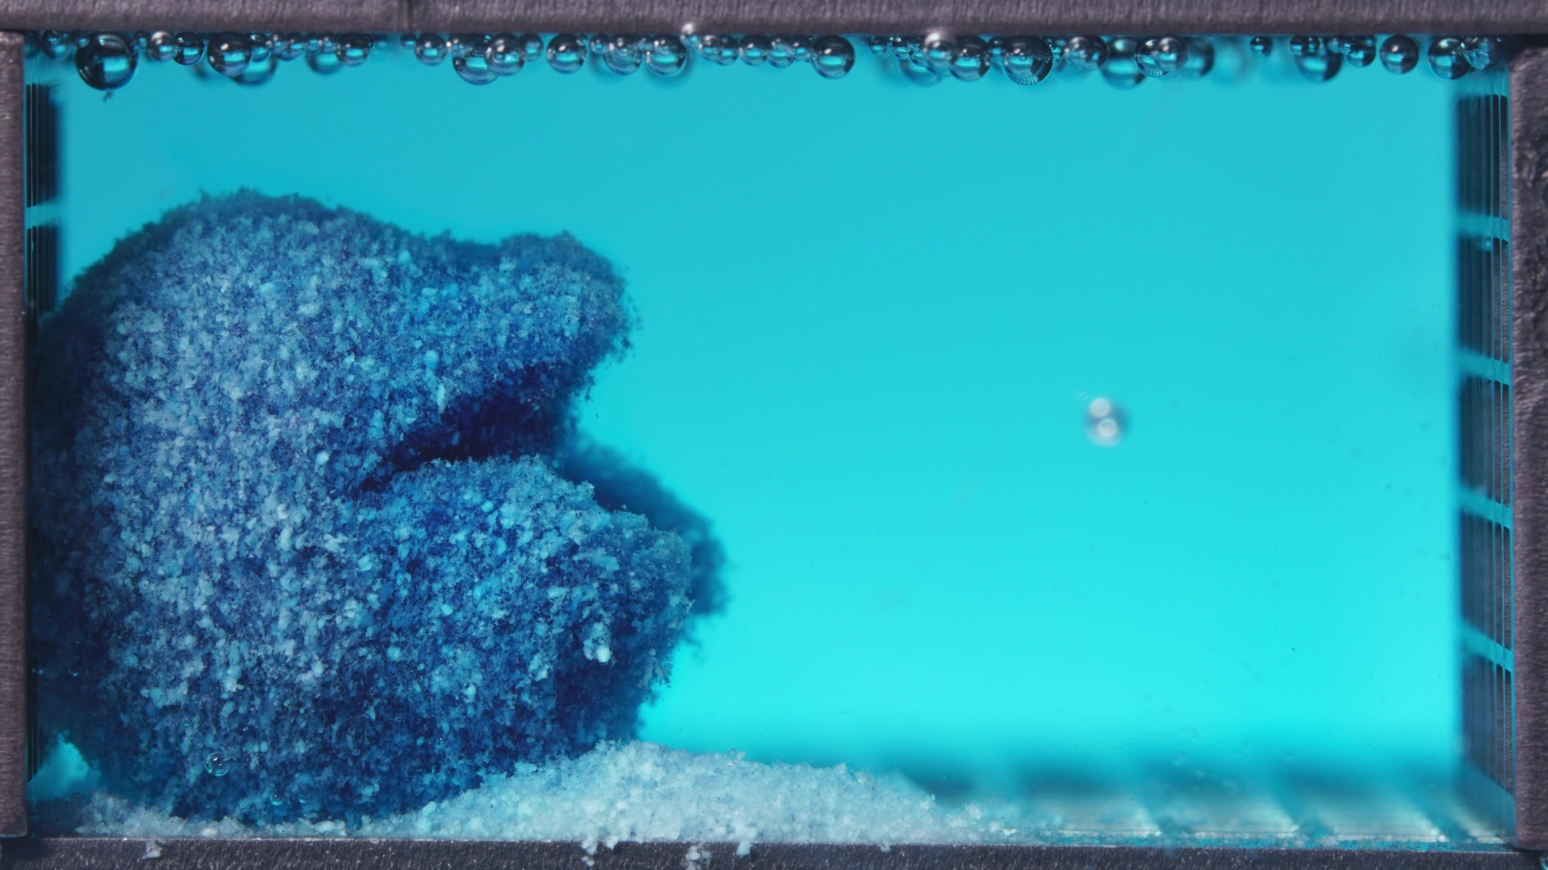
Embedded images shared in this message
4. Assistant
{
"group_id": "LOW-VISCOSITY",
"time_range_h": null,
"time_h": null,
"eight_dimension_description": {
"color_change": "Across this batch, the tablet remains intensely dark blue, but the surrounding medium shifts from mostly clear with only a faint local blue halo to a much more visibly blue/cyan field. The blue release is initially localized around the tablet and then becomes more broadly distributed through the chamber.",
"shape_change": "The body is initially a mostly intact rounded cylindrical mass sitting on the bottom of the cell. As the batch progresses, the outline becomes less regular, with clearer edge recession, asymmetry, and a later-stage side indentation/undercut suggesting partial structural loss rather than complete breakup.",
"surface_texture_change": "The surface is rough and granular in all images, with visible coarse particulate texture rather than a smooth gel coat. Over the batch, the exterior appears more crumbly and uneven, especially at the edges, where erosion and local collapse become more evident.",
"volume_change": "A large central mass is still retained throughout the batch, so there is no abrupt total collapse at this stage. However, the visible occupied volume shows gradual loss at the margins, with some material shifting downward and accumulating near the base, consistent with early erosion-driven reduction rather than major swelling.",
"dissolution_speed_time": "Comparison with a previous window is unavailable. Within the current batch itself, the sequence suggests progression from early wetting and localized dye release to more active erosion, stronger medium staining, and detectable fragment shedding by the later image, indicating that disintegration is already underway and becoming more pronounced.",
"physical_state_change": "The formulation appears to transition from a compact solid granular tablet toward a looser, softened, erosion-prone mass. It has not yet become a fully dispersed fine-particle cloud, but it is no longer behaving as a sharply bounded intact solid by the end of the batch.",
"dissolution_medium": "The medium shows a clear increase in blue coloration over the batch. Early on, the field is relatively transparent except for local diffusion near the tablet; later, the chamber becomes visibly more blue/cyan, with a more continuous stained zone and reduced visual contrast between the tablet boundary and surrounding medium.",
"fragment_distribution_density": "Detached material remains concentrated near the original tablet location, especially as a basal deposit or sediment-like accumulation at the bottom. There is no evidence of broad, uniform fragment dispersion across the whole chamber; fragment density remains highest close to the parent mass."
},
"notes_for_later_summary": "Most critical limitation: the exact time window could not be parsed confidently from the provided text string, and no previous-window images were available for strict comparison. Most critical visible change within this batch: the low-viscosity formulation progresses from a largely intact rough blue mass with localized dye leakage to a more eroded and asymmetric body with clearer edge loss, stronger medium staining, and increased basal fragment accumulation, indicating relatively rapid early surface disintegration."
}
5. User
These are pictures of the low-viscosity formulation during 6.25–11.25 h.
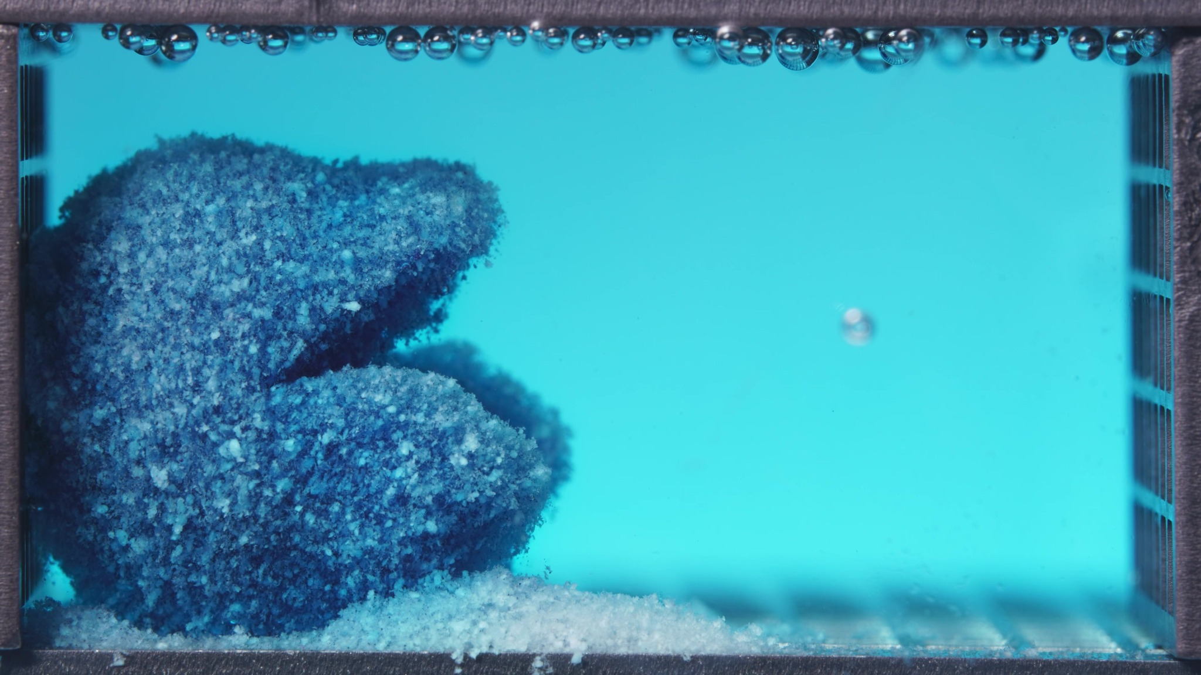 | 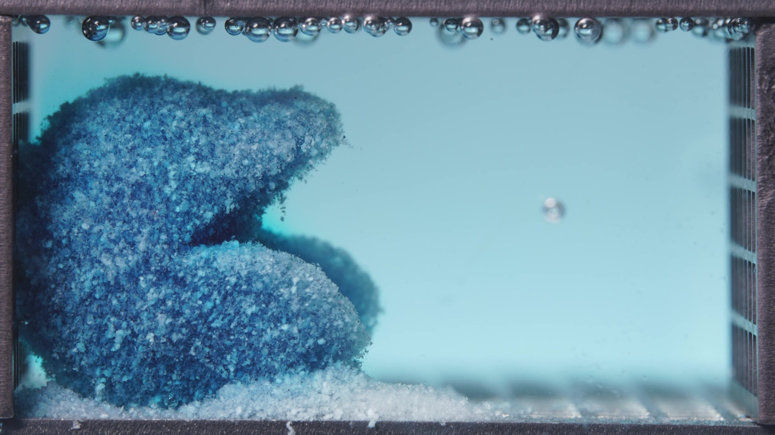 | 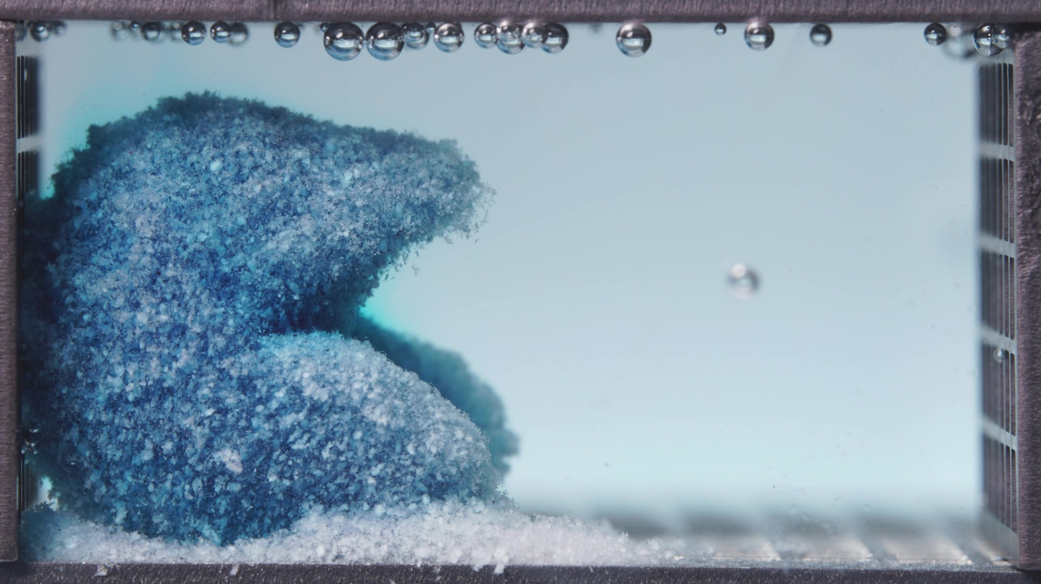
Embedded images shared in this message
6. Assistant
{
"group_id": "LOW-VISCOSITY",
"time_range_h": [
6.25,
11.25
],
"time_h": null,
"eight_dimension_description": {
"color_change": "The remaining body is still blue, but compared with the earlier 0.104–5 h window it appears paler overall, with more whitish particulate domains exposed on the surface. The surrounding medium is now a lighter and more weakly stained blue than before, indicating less visually intense local dye accumulation in the chamber at this stage.",
"shape_change": "The formulation no longer appears as a single compact rounded mass. It now presents as a clearly eroded, left-localized residual structure with an upper and lower lobe separated by a pronounced recessed gap or undercut region. Across this batch, the outline changes only modestly, suggesting that the major geometric collapse occurred earlier and the current window is dominated by retention of an already deformed remnant.",
"surface_texture_change": "The surface remains distinctly coarse, granular, and uneven. Compared with the previous window, the exterior looks drier/looser in appearance rather than newly smoothed, with more exposed pale particles and a more porous-looking outer layer. Edge friability is visible, especially around the projecting upper lobe.",
"volume_change": "Relative to the previous window, the occupied solid volume appears reduced and redistributed into an irregular two-part residual mass with surrounding basal deposits. Within the current window, however, the gross volume change is gradual rather than abrupt, indicating ongoing but not catastrophic loss of material.",
"dissolution_speed_time": "Compared with the 0.104–5 h window, the formulation appears to have transitioned from a more actively eroding and strongly medium-staining stage into a later stage characterized by persistent residual structure and slower visible morphological change. Disintegration is still ongoing, but the apparent rate of new collapse within this window is lower than in the earlier period.",
"physical_state_change": "The tablet has progressed from a rough but still more mass-like body into a weakened residual framework with clearer internal recession and separated lobes. It does not appear gel-like; instead, it behaves as a porous, erosion-prone particulate remnant with accumulated loose material at the base.",
"dissolution_medium": "The medium is relatively uniform and pale blue throughout the chamber, with less intense local clouding than in the previous window. No strong new dye plume or dense turbidity band is evident here; instead, the chamber looks more washed-through and visually clearer despite persistent light blue coloration.",
"fragment_distribution_density": "Fragments remain concentrated near the original tablet position, especially as bottom sediment and clustered loose material around the left-side residual mass. Widespread dispersion into the full chamber is still limited, and fragment density remains highest adjacent to the parent remnant rather than uniformly suspended."
},
"notes_for_later_summary": "Most critical change versus the previous window: the low-viscosity formulation has shifted from an earlier actively eroding, strongly blue-staining mass to a later porous residual structure with a pronounced central undercut, paler surface, and relatively clearer medium. This suggests that substantial early erosion has already occurred, while the 6.25–11.25 h window is dominated by slower persistence and gradual attrition of the remaining remnant rather than rapid new breakup."
}
7. User
These are pictures of the low-viscosity formulation during 12.5–17.5 h.
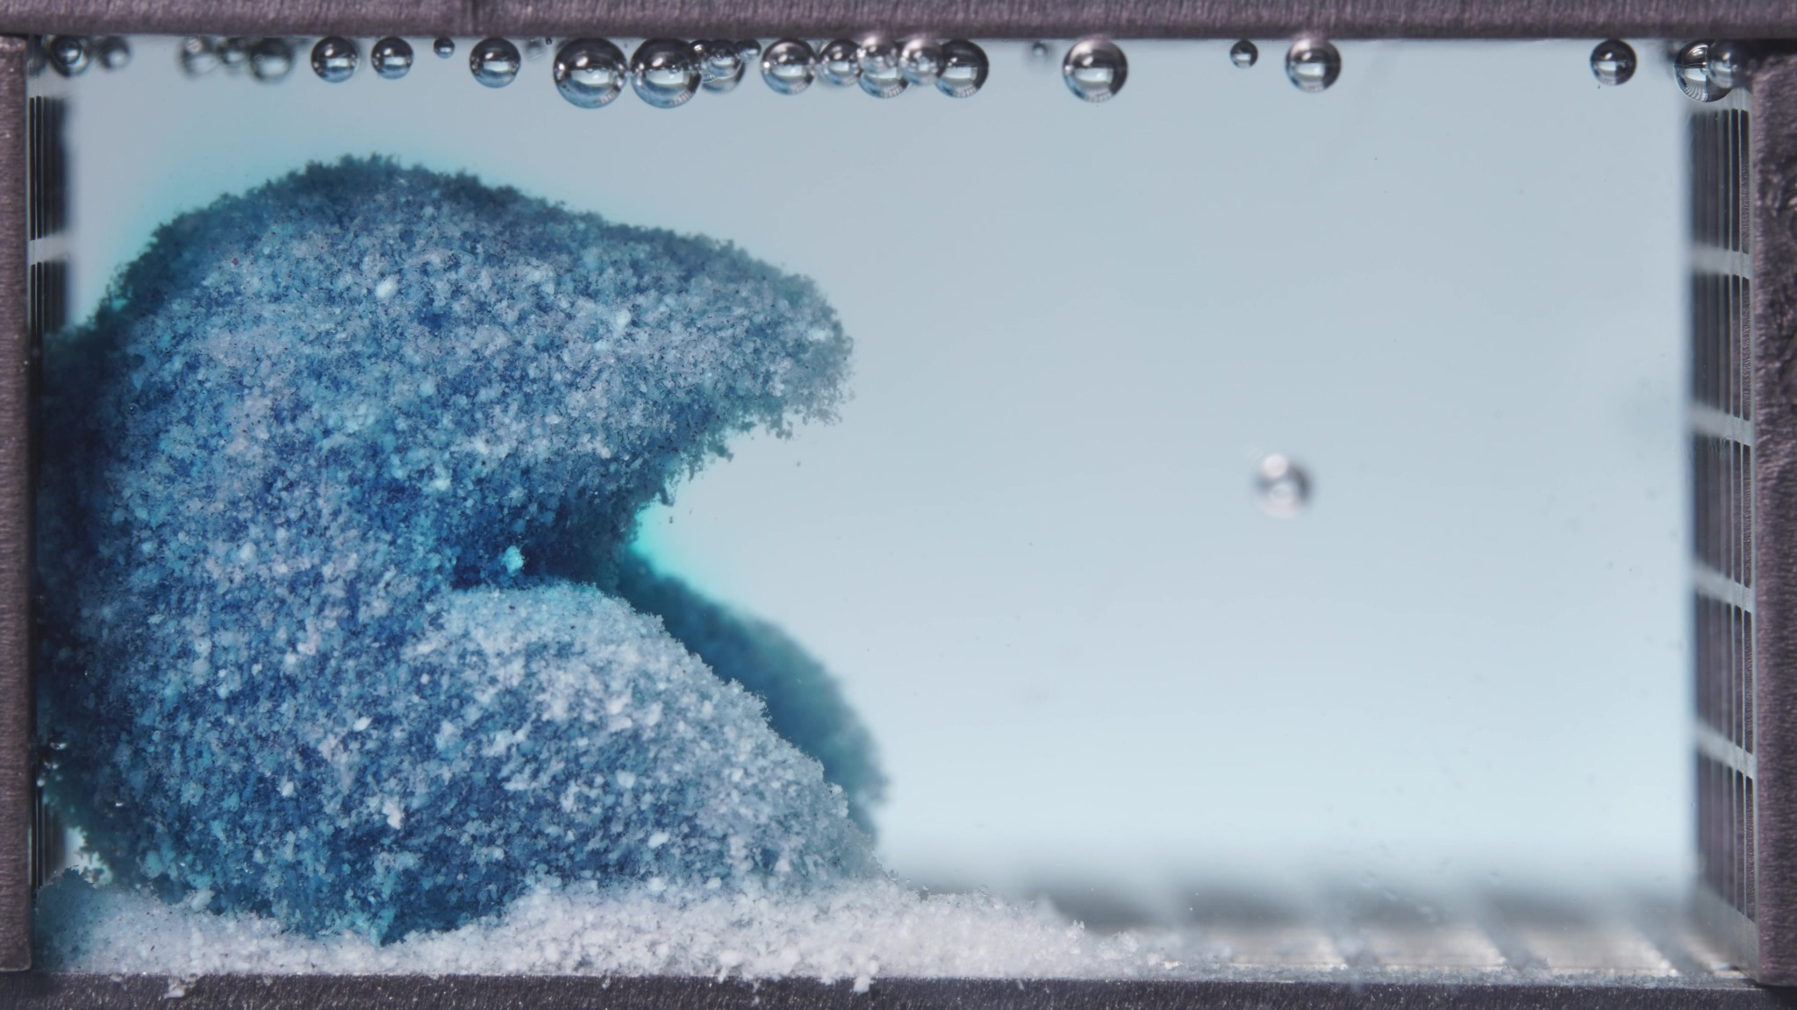 | 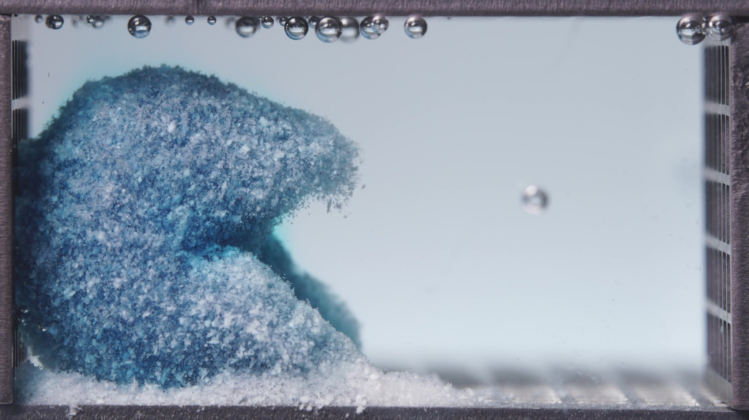 | 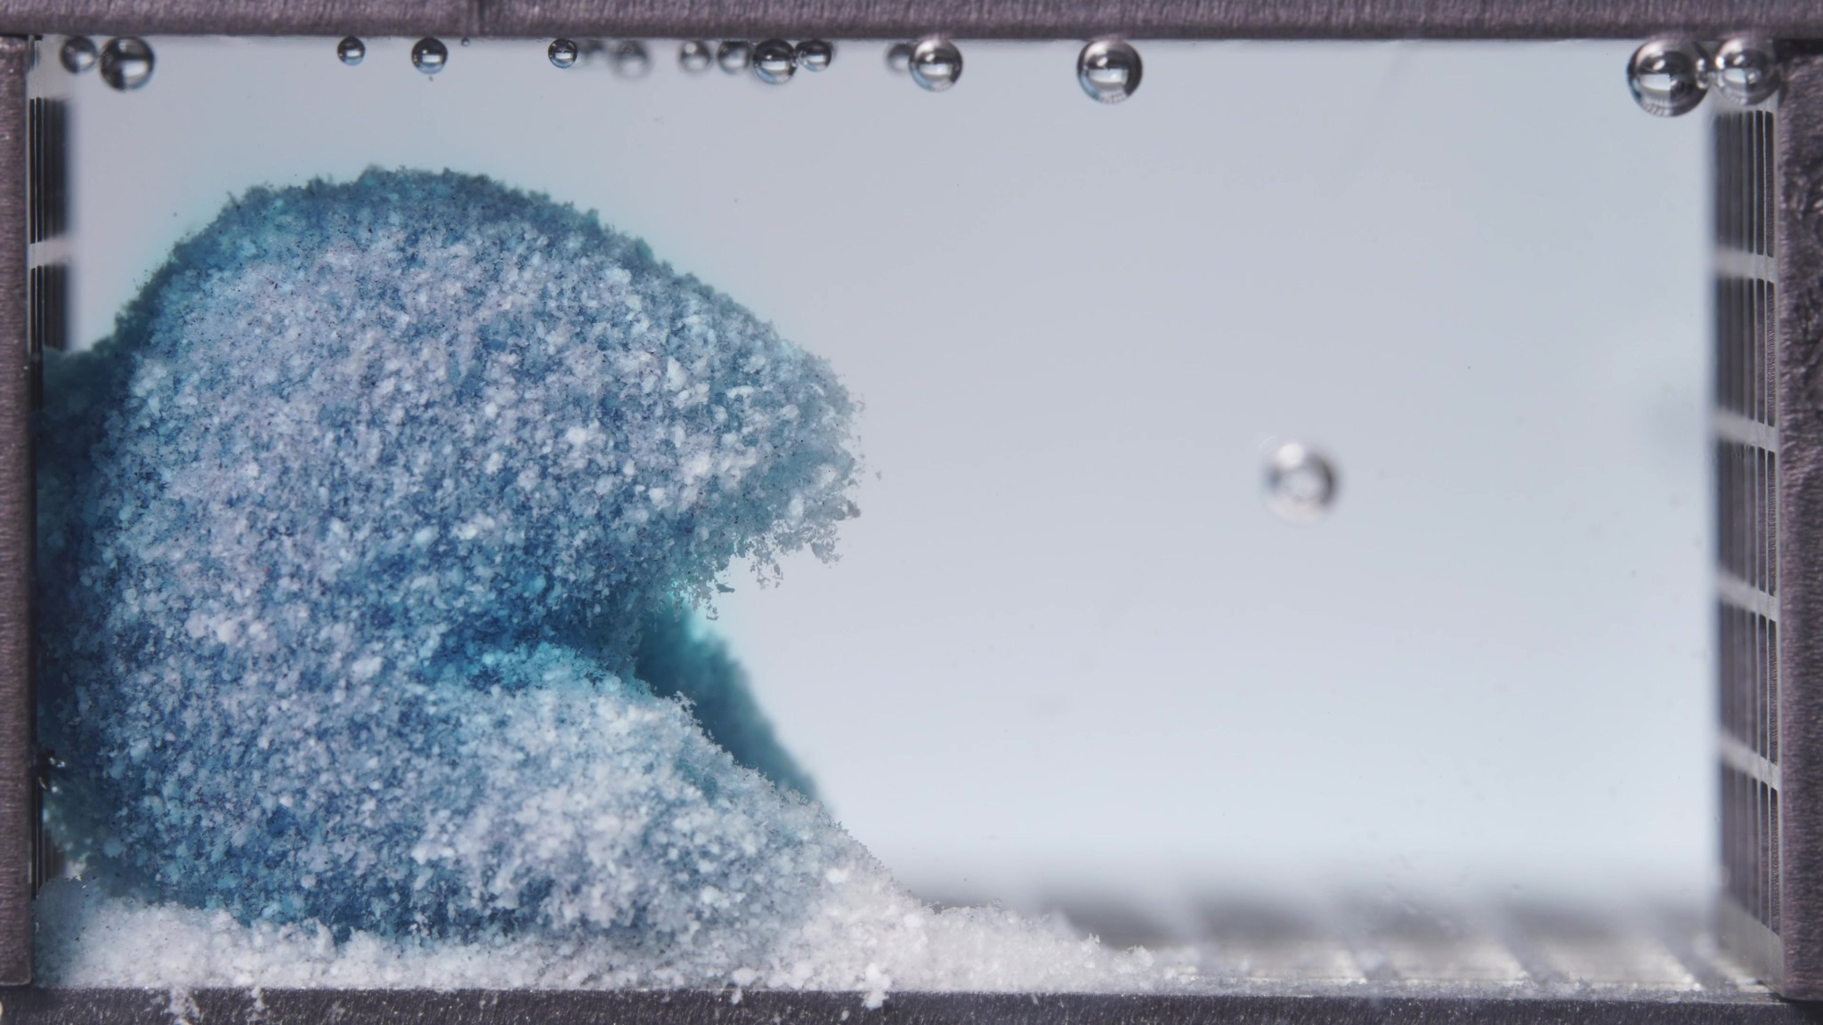
Embedded images shared in this message
8. Assistant
{
"group_id": "LOW-VISCOSITY",
"time_range_h": [
12.5,
17.5
],
"time_h": null,
"eight_dimension_description": {
"color_change": "The residual body remains blue but is overall paler than in the 6.25–11.25 h window, with more whitish granular domains visible across the exposed surface. The surrounding medium is now very lightly blue and close to visually clear, indicating further reduction in obvious dye-rich zones within the chamber.",
"shape_change": "The residual structure is still localized on the left side and retains the previously established upper-lower two-lobed morphology with a recessed central notch. Compared with the previous window, the outline appears slightly more rounded and trimmed, with less prominent protrusion of the upper lobe and a somewhat more contracted overall remnant, consistent with gradual edge attrition rather than fresh large-scale collapse.",
"surface_texture_change": "The surface remains coarse and particulate, but it appears somewhat finer and more uniformly eroded than before. The exposed exterior shows persistent granular friability, while sharp irregularities are slightly reduced, suggesting ongoing removal of loose outer material and progressive surface smoothing by erosion.",
"volume_change": "Compared with the 6.25–11.25 h window, the visible occupied volume appears modestly reduced. The loss is gradual and mainly expressed as trimming of protruding regions and thinning around the notch and outer margins, rather than abrupt fragmentation or major collapse.",
"dissolution_speed_time": "Compared with the previous window, visible disintegration appears slower and more incremental. The formulation seems to have entered a late residual-erosion stage in which structural change continues but at a lower apparent rate than the earlier active collapse and deformation period.",
"physical_state_change": "The formulation remains a porous, erosion-prone particulate remnant rather than an intact compact tablet. It does not show a smooth gel layer; instead, it persists as a weakened granular framework undergoing slow attrition and consolidation of the remaining mass.",
"dissolution_medium": "The medium looks more washed-through and visually clearer than in the previous window, with only faint blue coloration and no prominent local plume, dense clouding, or obvious turbidity band. This suggests limited new visually intense release events during this interval.",
"fragment_distribution_density": "Loose material and sediment-like deposits remain concentrated around the base of the residual mass. Fragment dispersion across the wider chamber remains low, and the highest density of particulate matter is still adjacent to the parent remnant and along the bottom."
},
"notes_for_later_summary": "Most critical change versus the previous window: the low-viscosity formulation shows further but modest reduction of the already deformed residual structure, with paler coloration, clearer medium, and slightly smoother/trimmed contours. This indicates progression from the earlier porous remnant stage into a later slow-erosion phase, where mass loss continues but major structural rearrangement is limited."
}
9. User
These are pictures of the low-viscosity formulation during 18.75–23.75 h.
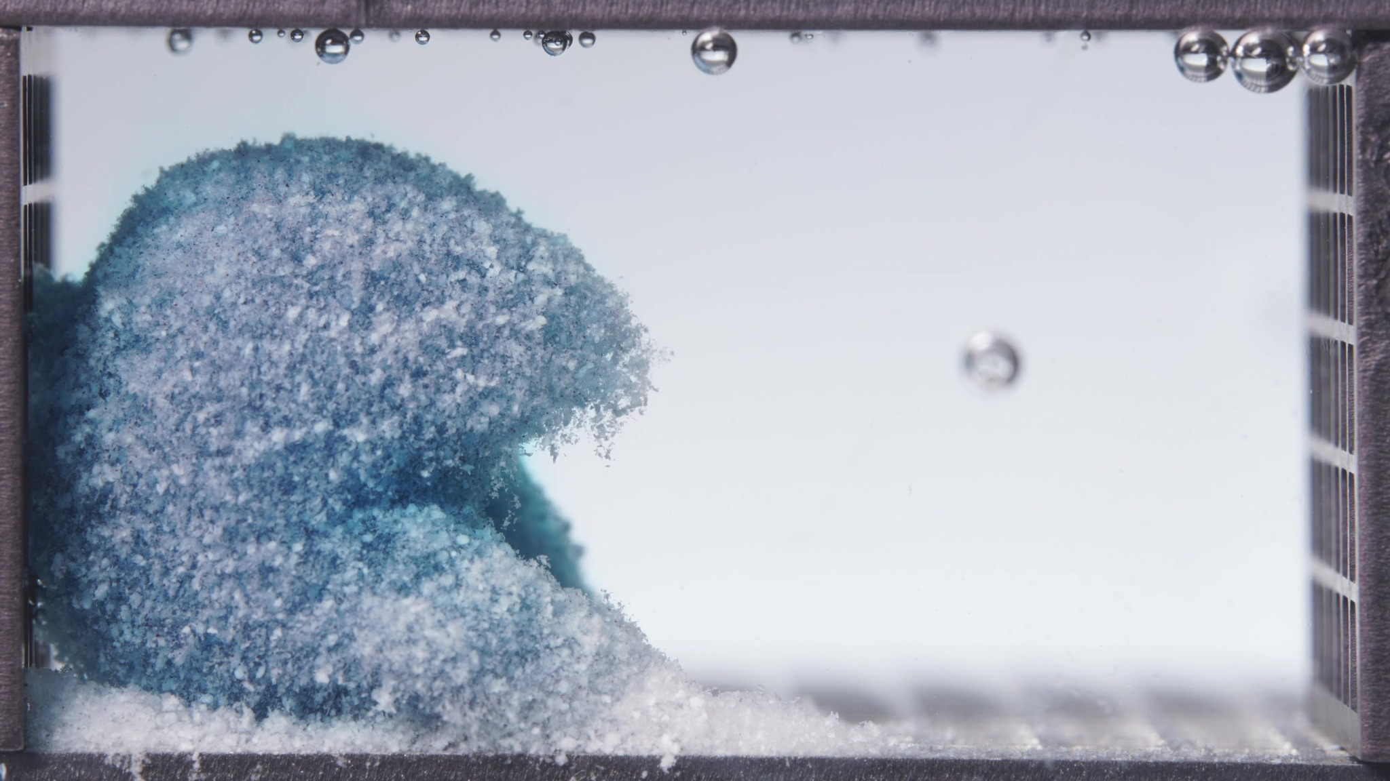 | 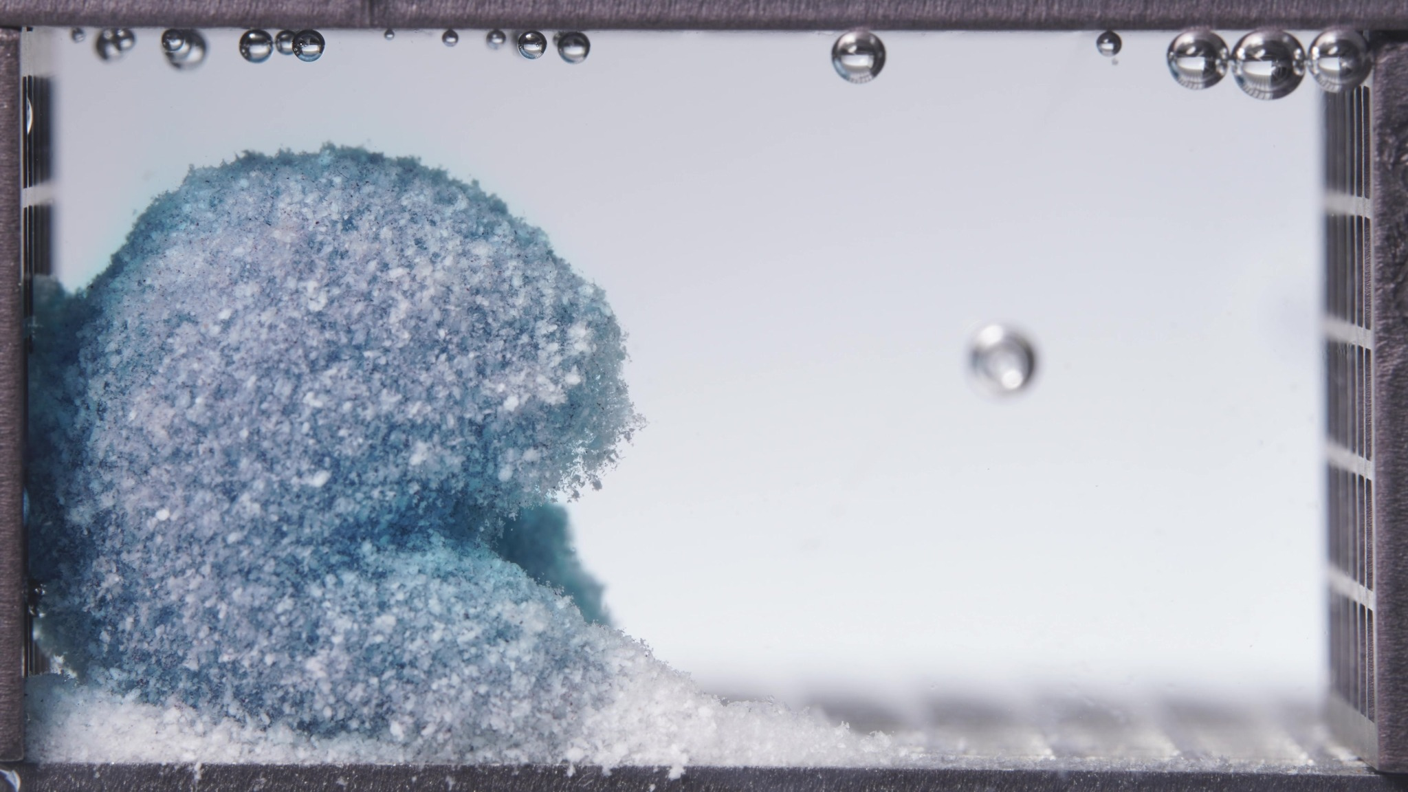 | 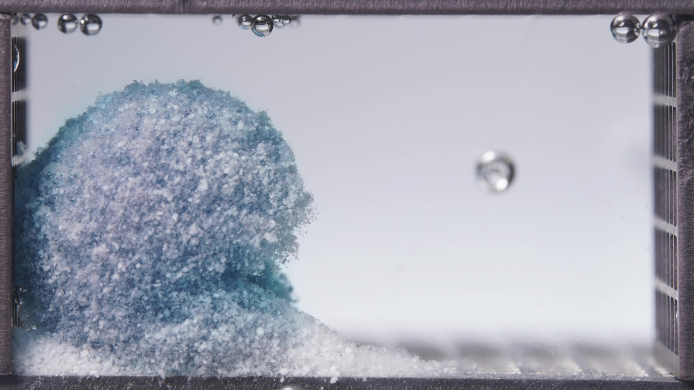
Embedded images shared in this message
10. Assistant
{
"group_id": "LOW-VISCOSITY",
"time_range_h": [
18.75,
23.75
],
"time_h": null,
"eight_dimension_description": {
"color_change": "The residual body is now very pale blue-white overall, with only faint blue domains remaining beneath the surface. Compared with the 12.5–17.5 h window, the remnant appears further decolorized and more dominated by whitish granular material. The surrounding medium is essentially visually clear, with only minimal residual blue tint.",
"shape_change": "The left-localized remnant still preserves the general upper-lower residual architecture seen previously, but the morphology becomes progressively more contracted and rounded across this batch. The central recessed notch remains visible, yet the lower lobe appears reduced and less prominent by the end of the window, making the structure look closer to a single compact residual mound than a sharply separated two-lobed body.",
"surface_texture_change": "The surface remains coarse, powdery, and particulate, with persistent granular friability at the outer boundary. Compared with the previous window, the exterior looks more uniformly eroded and slightly smoother in contour, not because it has become truly smooth, but because loose protruding irregularities have been worn down by continued attrition.",
"volume_change": "Visible occupied volume continues to decrease modestly during this window. The reduction is gradual and mainly reflected by contraction of the lower portion, trimming of edge projections, and overall compaction of the remnant rather than any abrupt fragmentation or collapse.",
"dissolution_speed_time": "Compared with the 12.5–17.5 h window, visible disintegration remains slow and incremental. The formulation appears to be in a terminal residual-erosion stage, where mass loss continues at a low apparent rate and morphological change is subtle rather than dramatic.",
"physical_state_change": "The formulation persists as a porous, weakly coherent granular remnant. It no longer behaves like a compact original tablet and still does not show a smooth continuous gel layer; instead, it appears as a late-stage eroded particulate framework gradually shrinking toward a smaller residual mass.",
"dissolution_medium": "The medium is highly transparent and nearly colorless in appearance throughout the chamber. Compared with the previous window, there is even less visible dye staining and no obvious plume, haze, or turbidity, indicating very limited visually detectable fresh release into the bulk medium during this interval.",
"fragment_distribution_density": "Fragmented material remains concentrated at the base and immediately around the parent remnant, forming persistent bottom deposits. Broad chamber-wide dispersion is still minimal, and the particulate density remains strongly localized near the original tablet position."
},
"notes_for_later_summary": "Most critical change versus the previous window: the low-viscosity formulation advances from a late slow-erosion remnant to an even more contracted, paler, and more weakly staining residual mass, with the lower lobe becoming less prominent and the overall structure approaching a smaller rounded mound. This indicates continuation of terminal-stage attrition with limited new structural rearrangement and very low visually apparent ongoing release into the medium."
}
11. User
These are pictures of the standard formulation during 0.104–5 h.
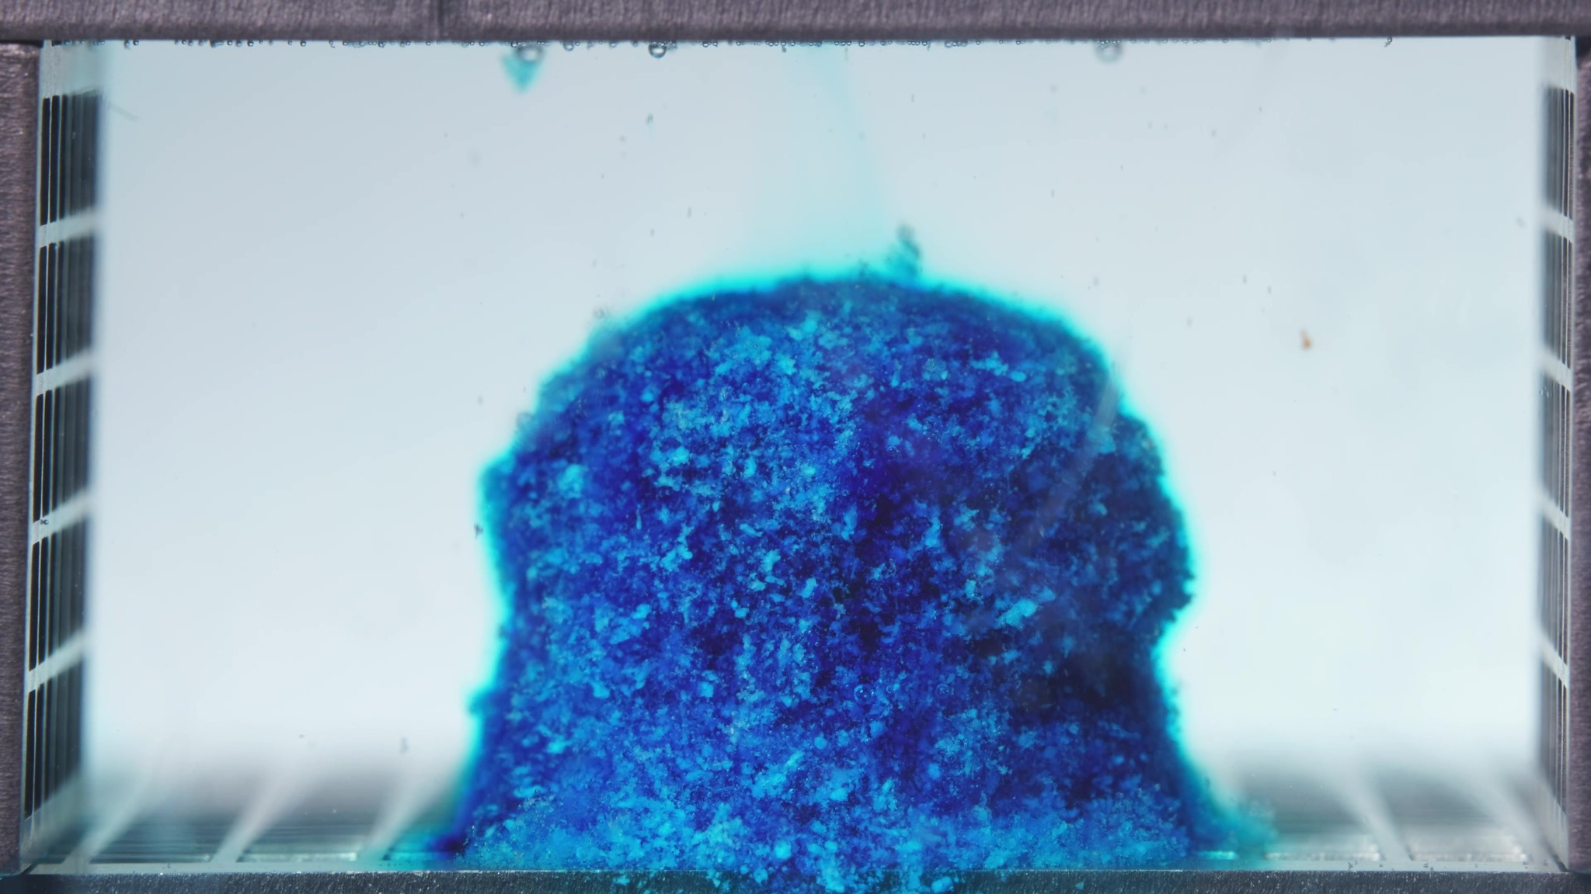 | 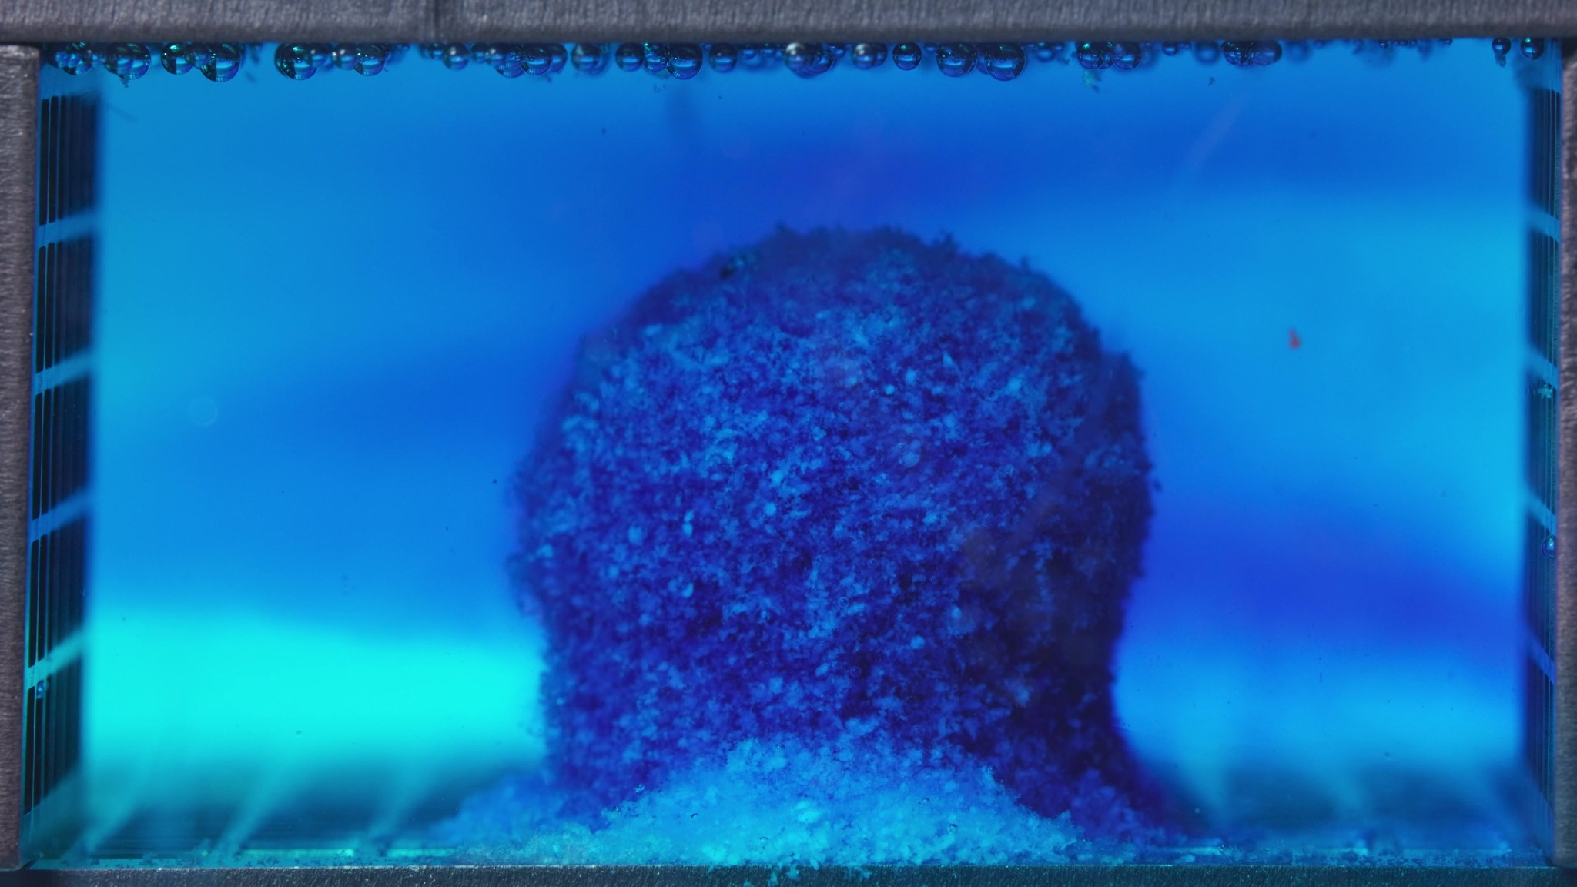 | 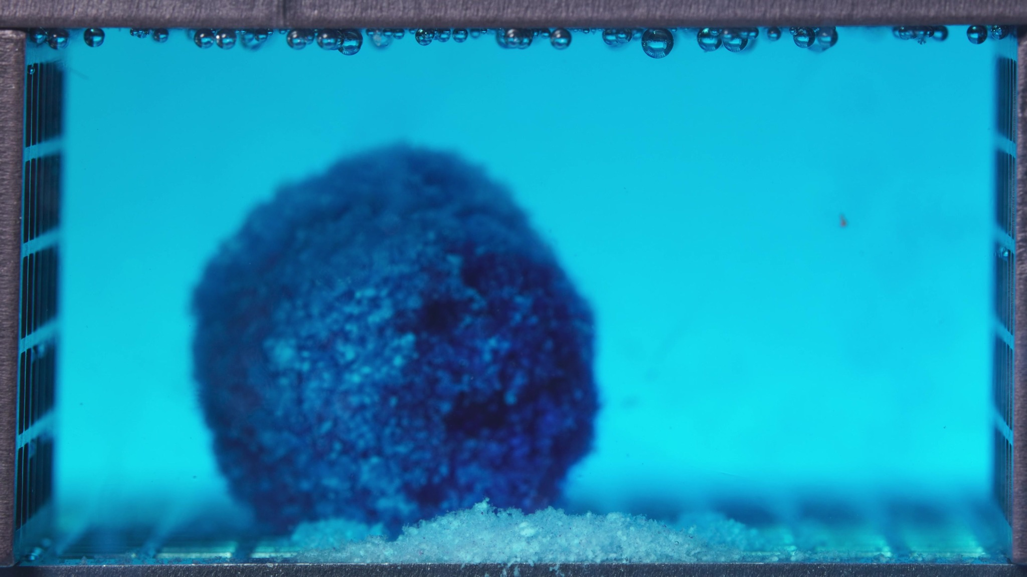
Embedded images shared in this message
12. Assistant
{
"group_id": "STANDARD",
"time_range_h": [
0.104,
5.0
],
"time_h": null,
"eight_dimension_description": {
"color_change": "Across this batch, the tablet remains intensely dark blue, while the surrounding medium changes from nearly clear with only a faint peripheral blue halo to a much more obviously blue-stained chamber. The color release is initially localized around the tablet and then becomes more broadly distributed through the medium.",
"shape_change": "The body remains largely intact throughout the window and preserves a coherent upright cylindrical-to-rounded mass. Compared within the batch, the outline becomes slightly more rounded and less sharply columnar, but there is no clear large-scale breakup or severe edge collapse during this stage.",
"surface_texture_change": "The surface is rough, granular, and particulate in all images. Outer boundaries appear somewhat softened by wetting, but the surface does not become smooth; instead, it retains a coarse texture with visible heterogeneous particles embedded across the exterior.",
"volume_change": "The visible occupied volume is largely maintained during this window. Any change appears modest and is expressed mainly as slight contour rounding rather than major swelling-collapse behavior or major loss of bulk material.",
"dissolution_speed_time": "Comparison with a previous window is unavailable. Within the current batch, the most evident progression is an increase in dye release into the medium while the core structure remains comparatively stable, suggesting that early dissolution/disintegration is occurring but has not yet advanced to marked structural failure.",
"physical_state_change": "The formulation behaves as a compact but wetted solid mass with a rough particulate exterior. It does not yet appear as a loose remnant or highly fragmented body; rather, it is transitioning from an intact tablet toward an early softened and erosion-prone state while still retaining strong cohesion.",
"dissolution_medium": "The medium shows a clear progression from mostly transparent to strongly blue/cyan colored. A diffuse stained zone develops across much of the chamber, indicating substantial solute transfer to the surrounding liquid, but without obvious dense sediment clouding throughout the bulk medium.",
"fragment_distribution_density": "Most solid material remains concentrated at the original tablet position. A basal deposit is visible near the bottom, but broad fragment dispersion into the chamber is limited, indicating that detached material remains localized rather than widely suspended."
},
"notes_for_later_summary": "Most critical limitation: no previous-window images were available for strict temporal comparison. Most critical visible change within this batch: the standard formulation shows pronounced medium blueing and outward dye diffusion while the tablet core remains largely intact and coherent, indicating substantial early release with comparatively limited gross structural disintegration during 0.104–5 h."
}
13. User
These are pictures of the standard formulation during 6.25–11.25 h.
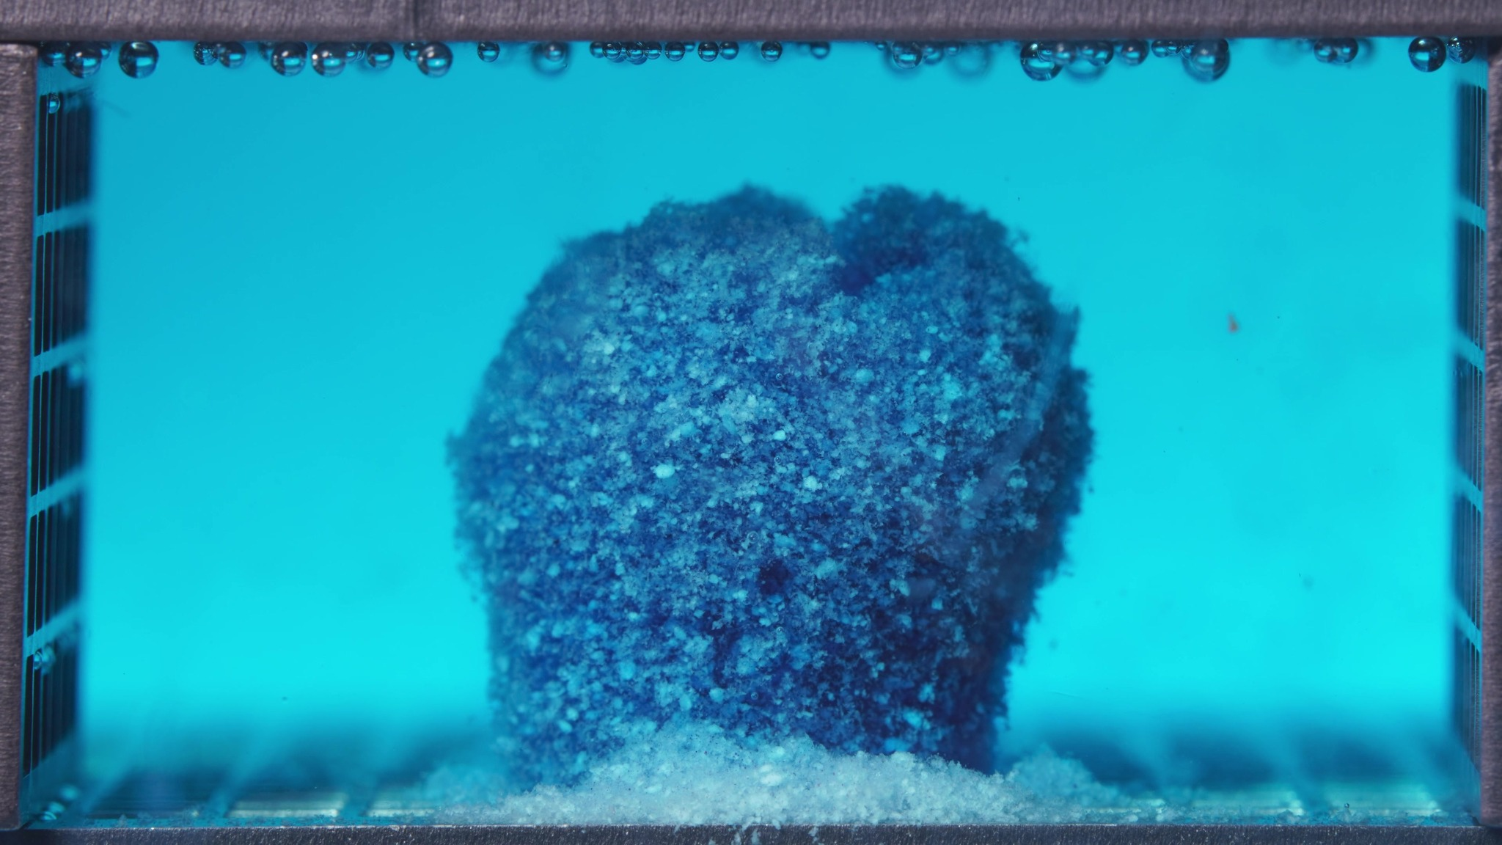 | 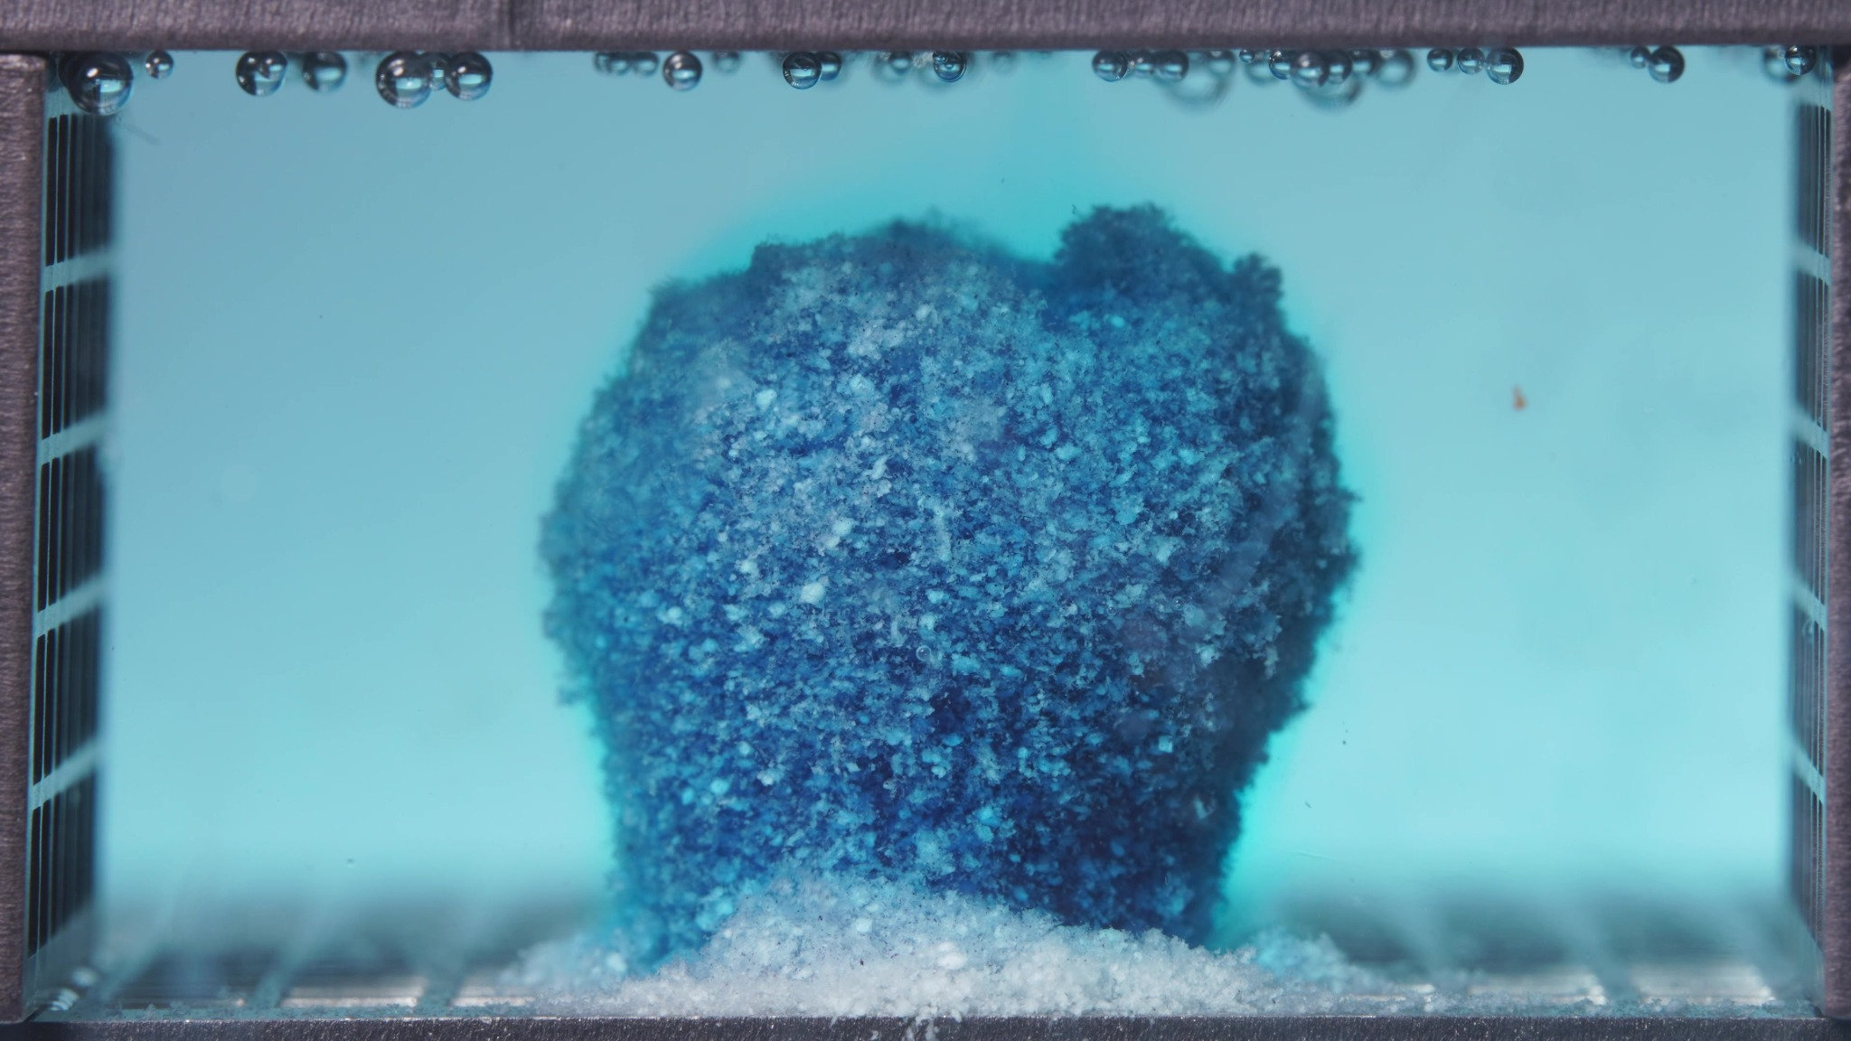 | 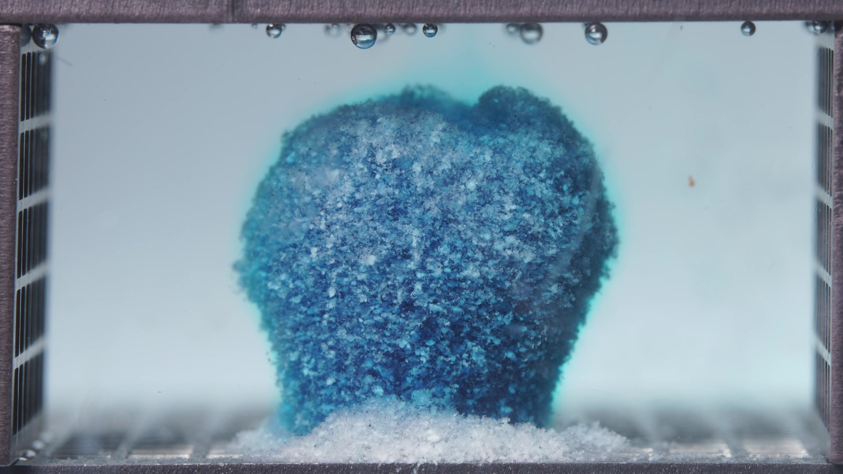
Embedded images shared in this message
14. Assistant
{
"group_id": "STANDARD",
"time_range_h": [
6.25,
11.25
],
"time_h": null,
"eight_dimension_description": {
"color_change": "The tablet remains dark blue overall, but compared with the 0.104–5 h window the surrounding medium appears less intensely blue and more washed-through, while the tablet surface shows slightly more pale granular domains. Color release is still evident, but the visual contrast now shifts toward a retained blue core within a less strongly stained bulk medium.",
"shape_change": "The body remains largely upright and coherent, preserving a single central mass rather than breaking into separated lobes or fragments. Compared with the previous window, the outline is still intact but becomes somewhat more irregular at the top, with a shallow upper notch and minor asymmetry indicating limited surface erosion without major structural collapse.",
"surface_texture_change": "The surface continues to appear coarse, rough, and particulate. Relative to the earlier window, the exterior looks slightly more porous and heterogeneous, with more clearly exposed pale particles and a less uniformly compact appearance, but it still lacks deep cracks or large peeled regions.",
"volume_change": "The visible occupied volume is still largely maintained. Compared with the 0.104–5 h window, any reduction appears modest and mainly expressed as slight trimming or rounding of the upper contour rather than major shrinkage, swelling-collapse, or loss of bulk mass.",
"dissolution_speed_time": "Compared with the previous window, the formulation appears to shift from strong early medium staining with minimal gross deformation to a stage of continued but slower visible erosion. Structural disintegration remains limited, suggesting that the dominant process in this window is sustained surface-level attrition and retention of the core rather than rapid breakup.",
"physical_state_change": "The formulation remains a cohesive wetted solid mass with a rough particulate shell. It has not transitioned into a loose residual remnant or heavily fragmented body; instead, it shows persistence of core integrity with gradual progression toward a more erosion-prone and slightly more porous state.",
"dissolution_medium": "The medium remains blue/cyan but looks more uniform and somewhat less intensely stained than in the previous window, consistent with a chamber that has already undergone substantial dye release and is now visually more equilibrated. No dense local plume or strongly localized clouding dominates this batch.",
"fragment_distribution_density": "Most solid material remains clustered at the original tablet position. A basal deposit persists near the bottom, but broad fragment dispersion into the chamber is still limited, indicating that detached material remains localized and that large-scale fragmentation has not yet occurred."
},
"notes_for_later_summary": "Most critical change versus the previous window: the standard formulation continues to preserve a coherent central mass while showing only mild top-edge irregularity, slightly more porous surface texture, and a more washed-through medium. This suggests that after the early high-visibility dye release stage, the 6.25–11.25 h window is characterized by sustained structural retention and comparatively slower, surface-dominated erosion rather than major morphological breakdown."
}
15. User
These are pictures of the standard formulation during 12.5–17.5 h.
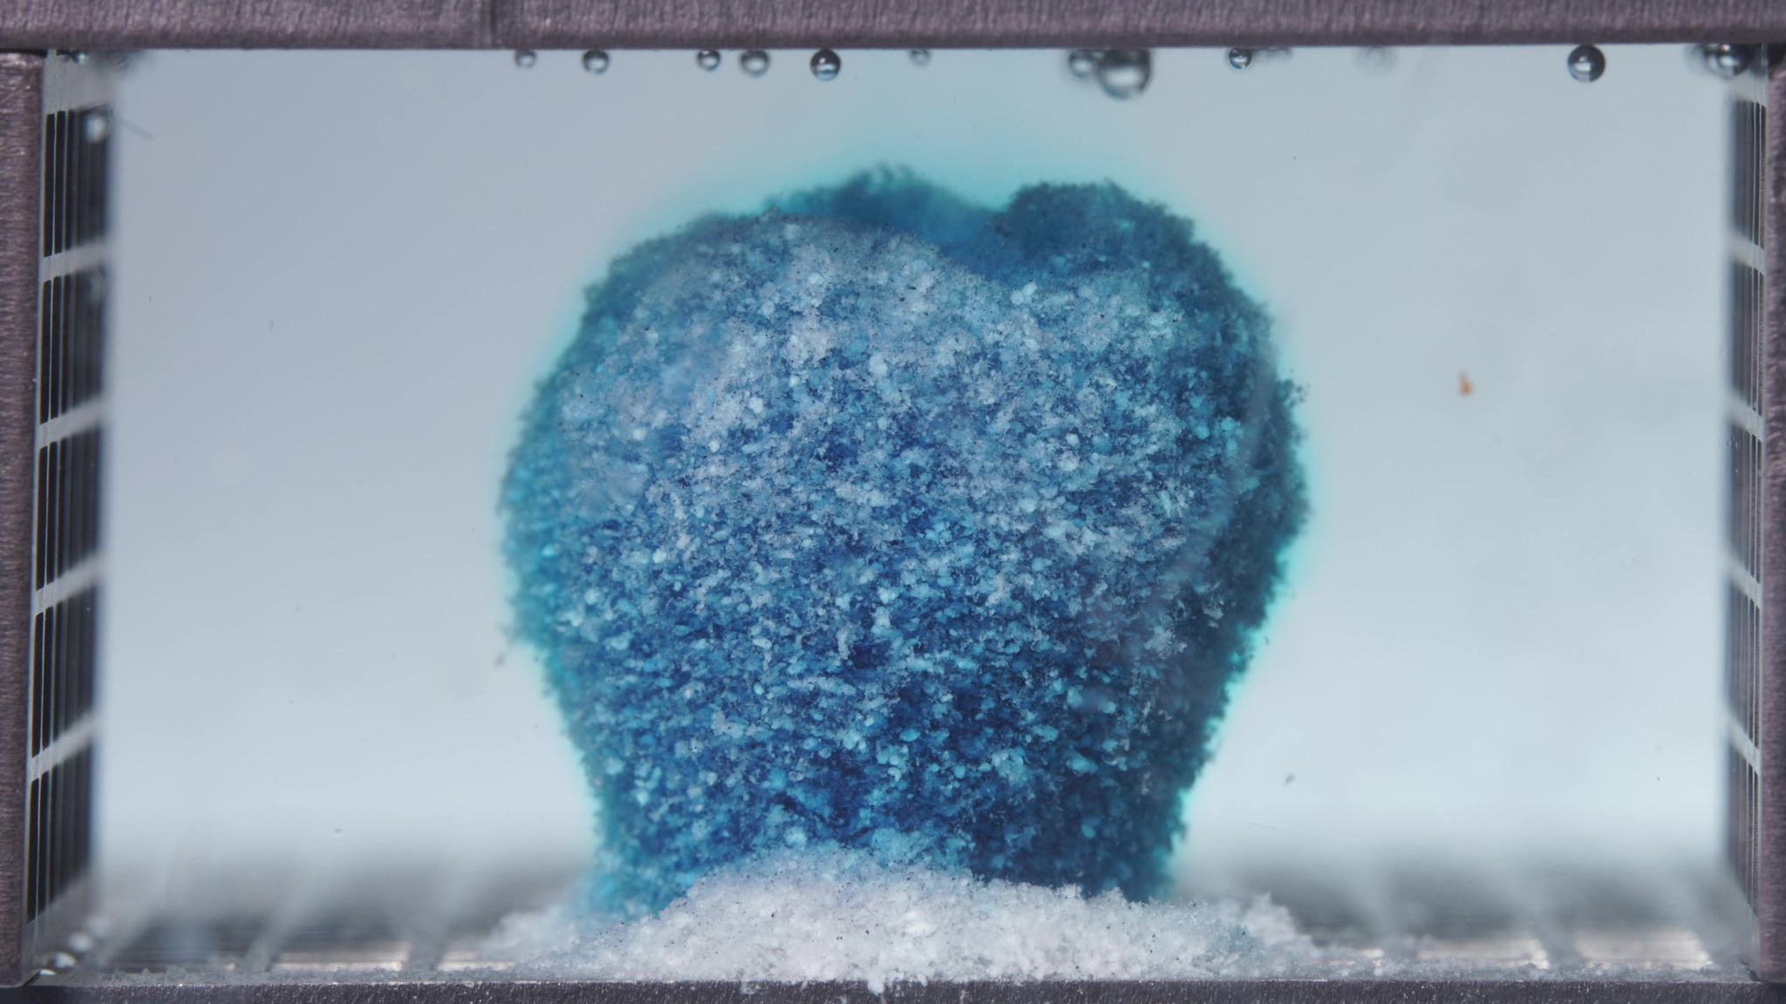 | 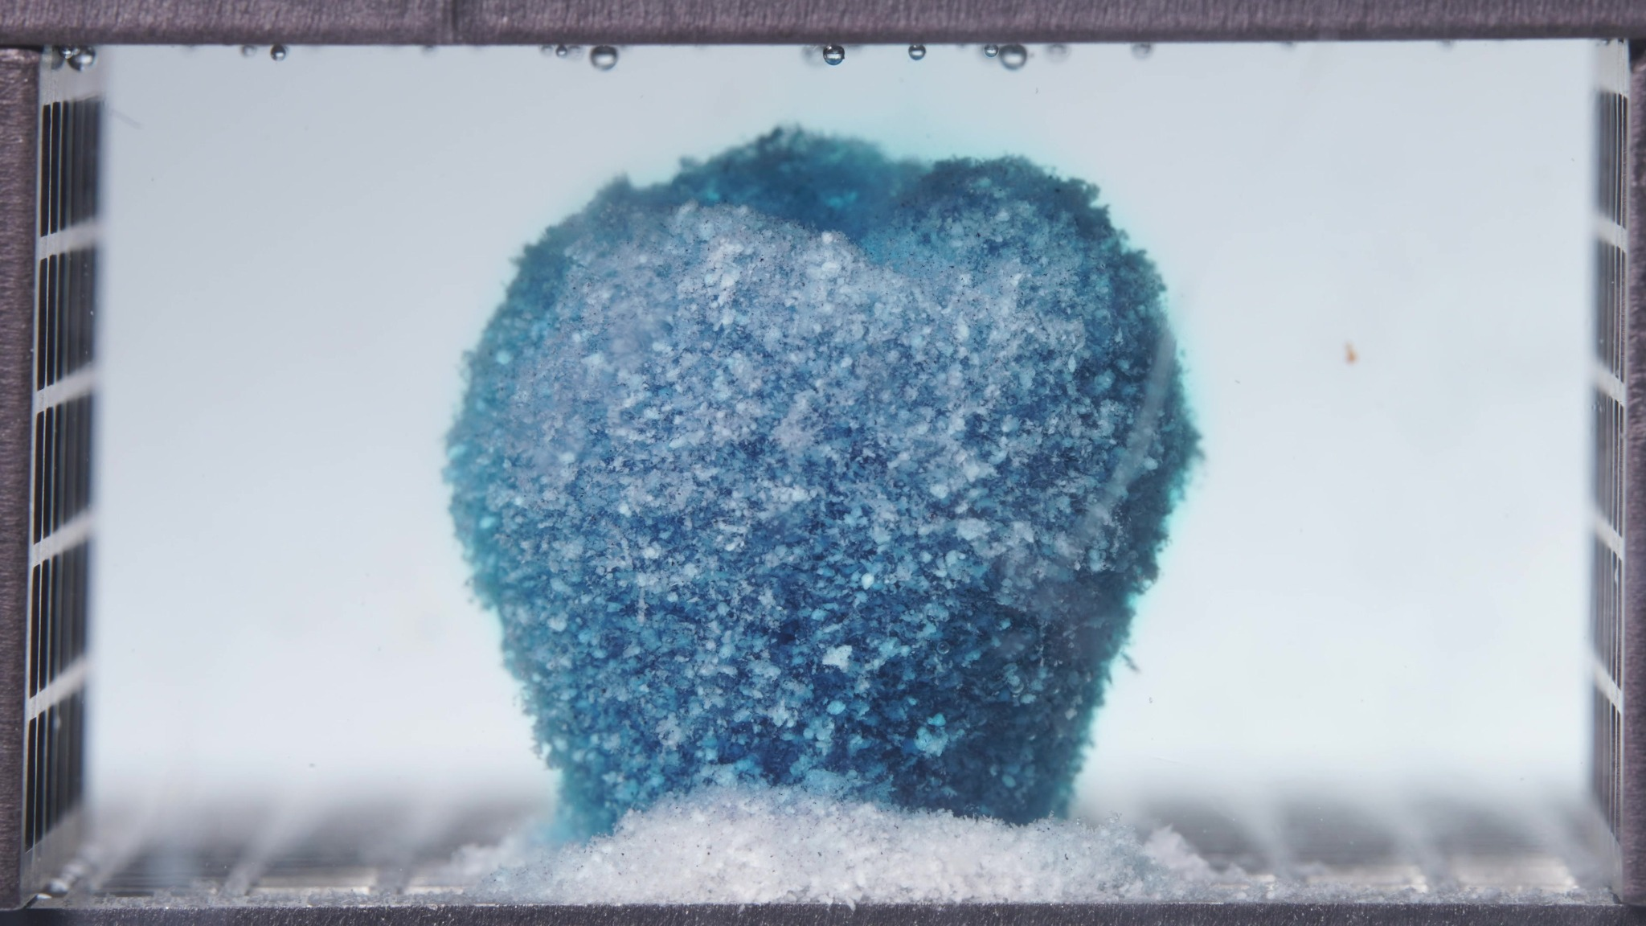 | 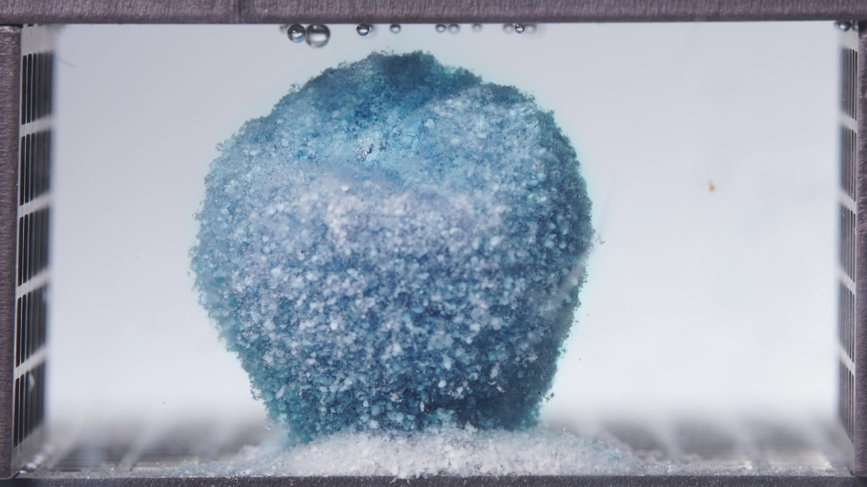
Embedded images shared in this message
16. Assistant
{
"group_id": "STANDARD",
"time_range_h": [
12.5,
17.5
],
"time_h": null,
"eight_dimension_description": {
"color_change": "The tablet remains blue overall, but compared with the 6.25–11.25 h window the surface appears paler and more mottled, with a larger proportion of whitish granular domains visible across the exterior. The surrounding medium is now very lightly stained and close to visually clear, indicating reduced visually obvious dye accumulation in the bulk chamber during this stage.",
"shape_change": "The body remains as a single coherent upright mass with no major breakup. Compared with the previous window, the outline is still largely preserved but becomes slightly more rounded and broadened at the upper region, while minor top irregularities persist. There is no formation of separated lobes or deep recessed collapse.",
"surface_texture_change": "The surface continues to be coarse, rough, and particulate. Relative to the previous window, the exterior looks somewhat more porous and more uniformly weathered, with pale granular components more clearly exposed, but without development of large cracks, peeling sheets, or a smooth gel coat.",
"volume_change": "The visible occupied volume remains largely retained. Compared with the 6.25–11.25 h window, any net change is modest and mainly reflected by slight contour rounding and mild redistribution of the upper profile rather than marked shrinkage, collapse, or fragment loss.",
"dissolution_speed_time": "Compared with the previous window, visible disintegration appears to remain slow and controlled. The formulation continues to show strong structural retention, and the main progression is subtle surface-level erosion and continued depletion of visually obvious dye release rather than rapid morphological breakdown.",
"physical_state_change": "The formulation still behaves as a cohesive wetted solid with a rough particulate shell. It has not transitioned into a loose remnant, paste-like body, or fragmented aggregate; instead, it remains a persistent core structure that is gradually becoming more surface-eroded and slightly more porous.",
"dissolution_medium": "The medium appears clearer than in the 6.25–11.25 h window, with only faint residual blue coloration and no dense local plume or marked chamber-wide staining. This suggests that visually prominent release into the medium is less intense during this interval than earlier in the test.",
"fragment_distribution_density": "Most solid material remains concentrated at the original tablet position. Basal deposits are still present near the bottom, but widespread fragment dispersion into the chamber remains limited, indicating that detached material stays localized and that large-scale fragmentation is still minimal."
},
"notes_for_later_summary": "Most critical change versus the previous window: the standard formulation continues to preserve a highly coherent central mass while the medium becomes even clearer and the tablet surface becomes paler and more granularly mottled. This indicates progression into a slower, controlled erosion stage with sustained core integrity and reduced visually apparent ongoing release, rather than entry into rapid structural disintegration."
}
17. User
These are pictures of the standard formulation during 18.75–23.75 h.
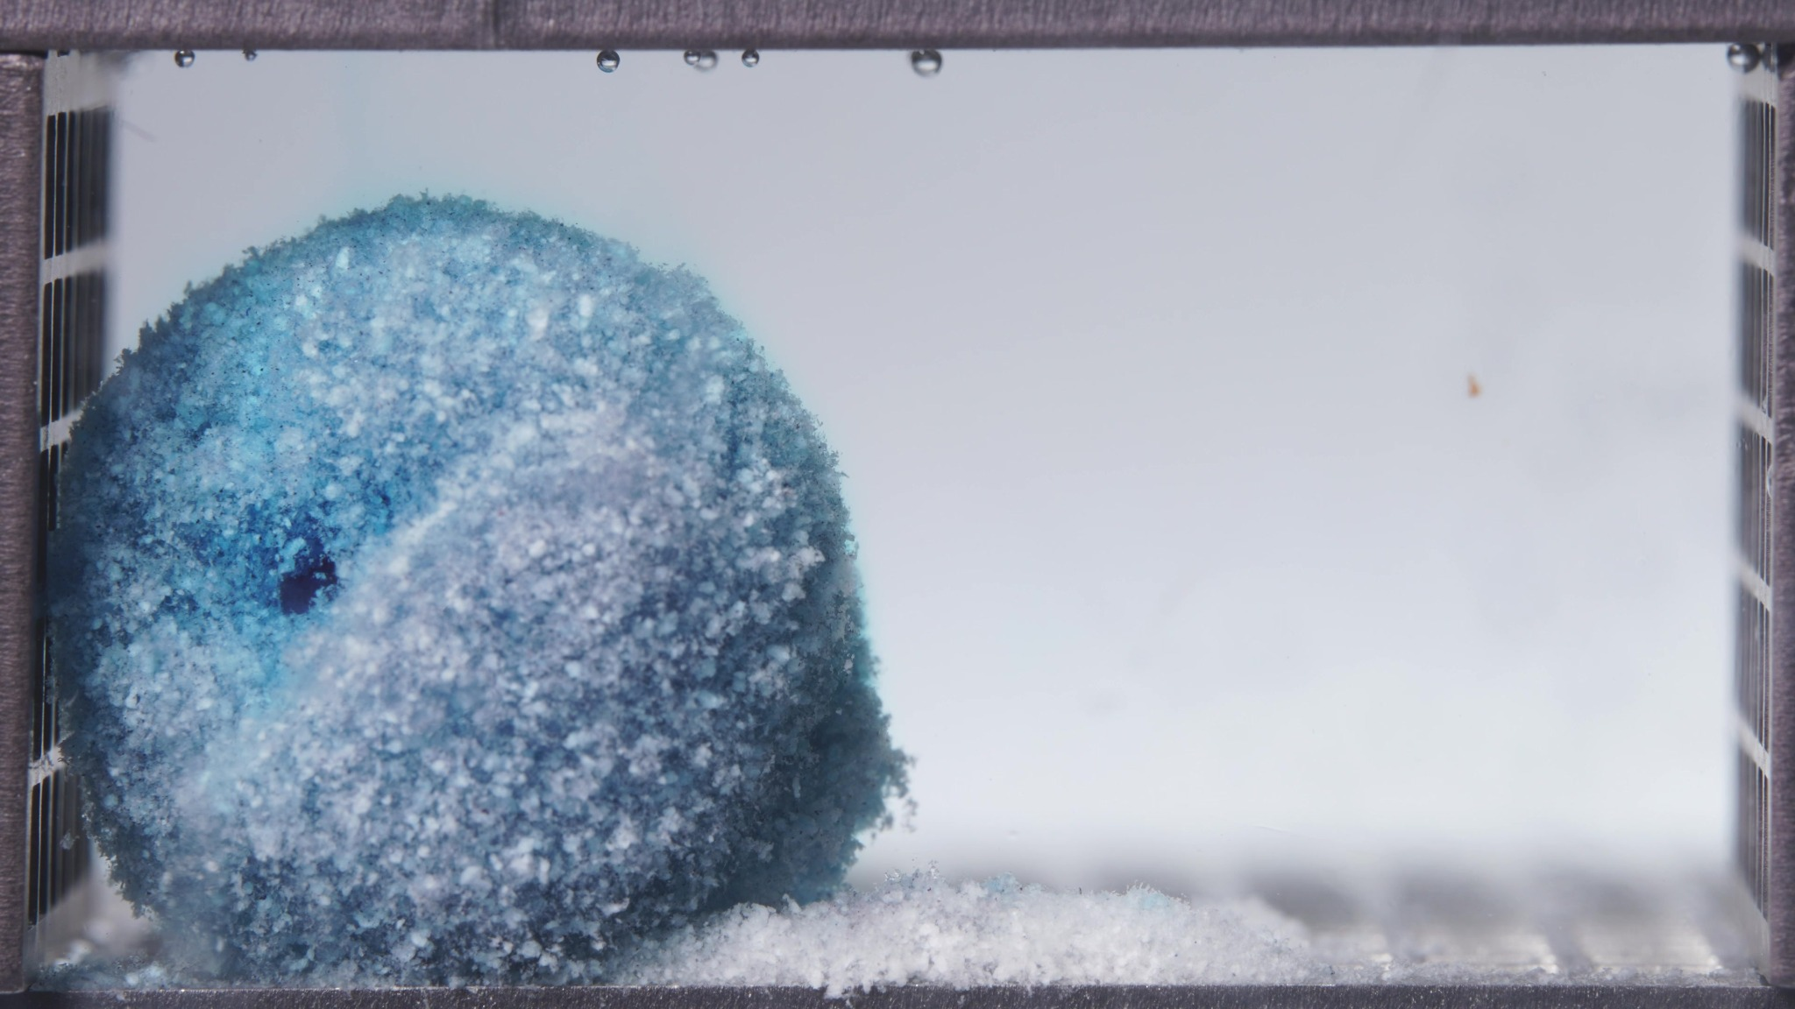 | 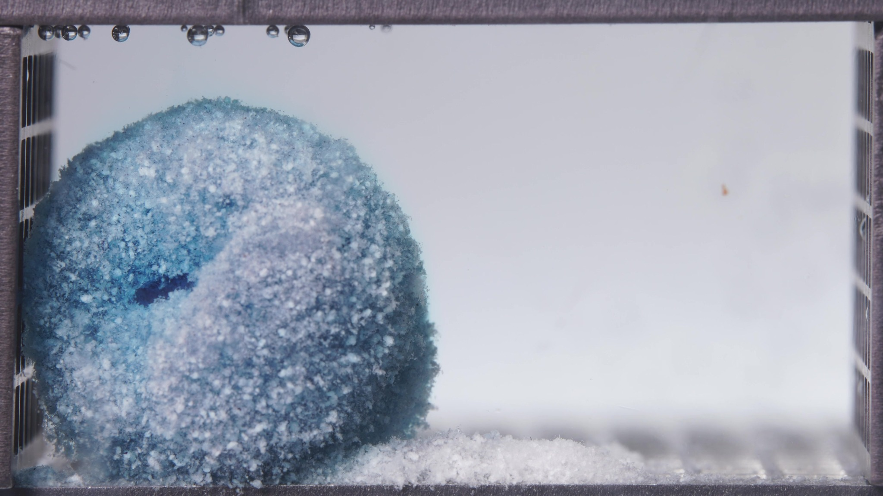 | 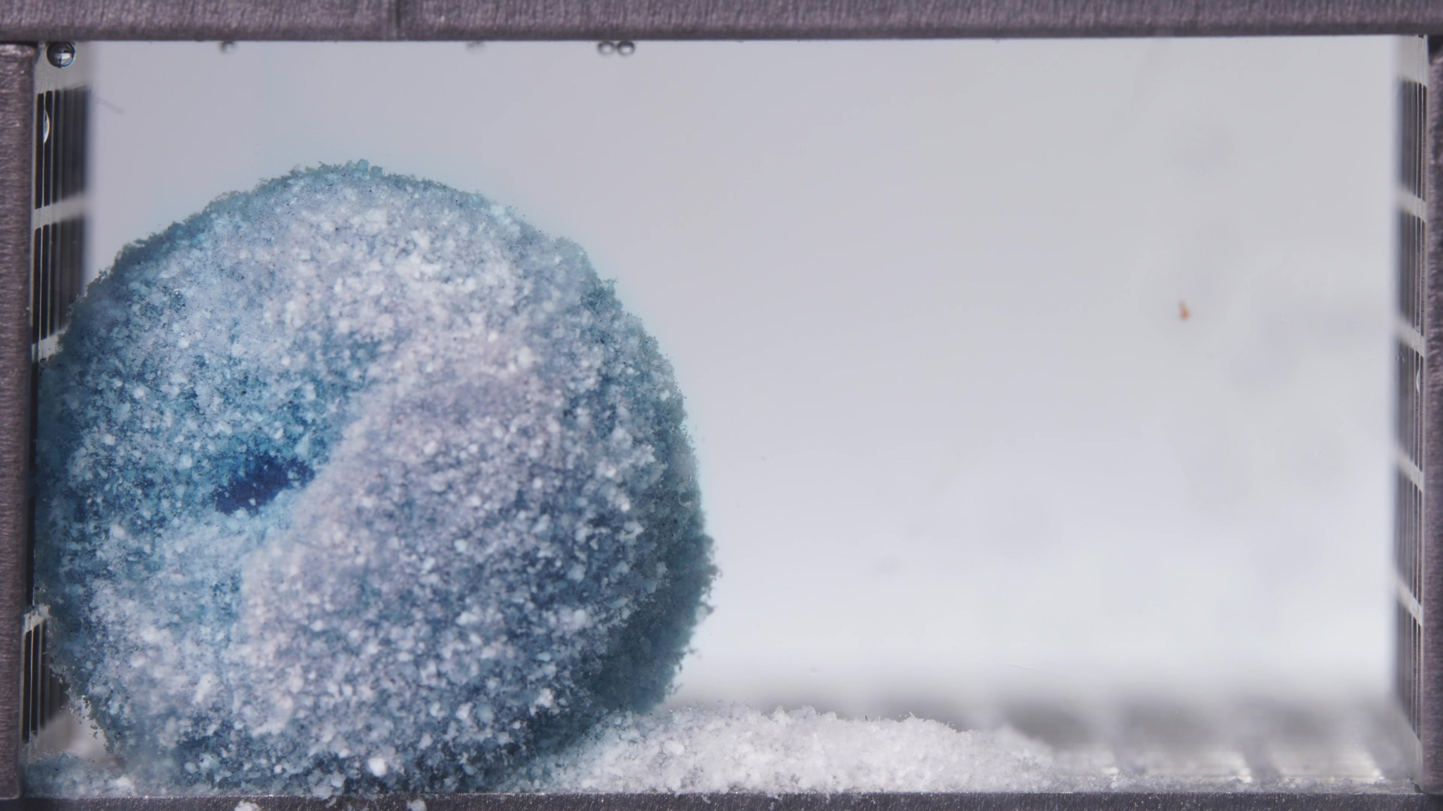
Embedded images shared in this message
18. Assistant
{
"group_id": "STANDARD",
"time_range_h": [
18.75,
23.75
],
"time_h": null,
"eight_dimension_description": {
"color_change": "The residual body remains blue but is noticeably paler than in the 12.5–17.5 h window, with a larger fraction of whitish-blue granular domains across the exterior. The surrounding medium is essentially clear to only very faintly blue, indicating that visually prominent fresh dye release into the bulk chamber is now minimal.",
"shape_change": "Compared with the previous window, the formerly more upright coherent mass has evolved into a more rounded and slightly left-leaning residual body. A distinct recessed cavity or hole-like indentation becomes visible on the left/front side, indicating localized internal or surface collapse rather than simple uniform contour smoothing. The body still remains as one connected remnant, without breakup into multiple separated fragments.",
"surface_texture_change": "The surface remains coarse, granular, and particulate, but it appears more uniformly weathered and chalky than before. Pale exposed particles dominate the outer layer, and the cavity margin shows friable, irregular erosion. No smooth gel coat is visible; instead, the surface suggests persistent particulate attrition.",
"volume_change": "Relative to the 12.5–17.5 h window, the visible occupied volume appears modestly reduced, with the main change being contraction of the upper and lateral contours and development of a local hollowed region. The reduction is gradual rather than catastrophic, and the remnant still preserves substantial bulk.",
"dissolution_speed_time": "Compared with the previous window, visible disintegration remains slow and controlled, but the nature of change shifts from mainly external surface attrition to more obvious localized structural recession, as shown by the new cavity-like indentation. This suggests continued late-stage erosion with some internal weakening, while overall mass loss remains limited.",
"physical_state_change": "The formulation persists as a cohesive but weakened granular remnant. It no longer behaves like a simple intact tablet core; instead, it appears as a late-stage porous body with localized hollowing and progressive loss of internal support, while still avoiding full fragmentation into loose debris.",
"dissolution_medium": "The medium is highly transparent and nearly colorless throughout the chamber. Compared with the previous window, there is no increase in visible plume formation, haze, or chamber-wide staining, indicating very low visually detectable ongoing release into the surrounding liquid at this stage.",
"fragment_distribution_density": "Detached material remains concentrated near the base and immediately adjacent to the parent remnant. Broad dispersion into the chamber is still minimal, and although the cavity suggests local material loss, the released solids do not appear widely suspended; they remain localized as basal deposits or closely associated loose particulate matter."
},
"notes_for_later_summary": "Most critical change versus the previous window: the standard formulation progresses from a still-upright, highly coherent residual mass to a more rounded late-stage remnant with a distinct cavity-like indentation, indicating localized internal recession/collapse during continued slow erosion. Despite this new structural weakening, the medium remains visually clear and bulk fragmentation is still limited, showing that late-stage release/disintegration is controlled rather than abrupt."
}
19. User
These are pictures of the high-viscosity formulation during 0.104–5 h.
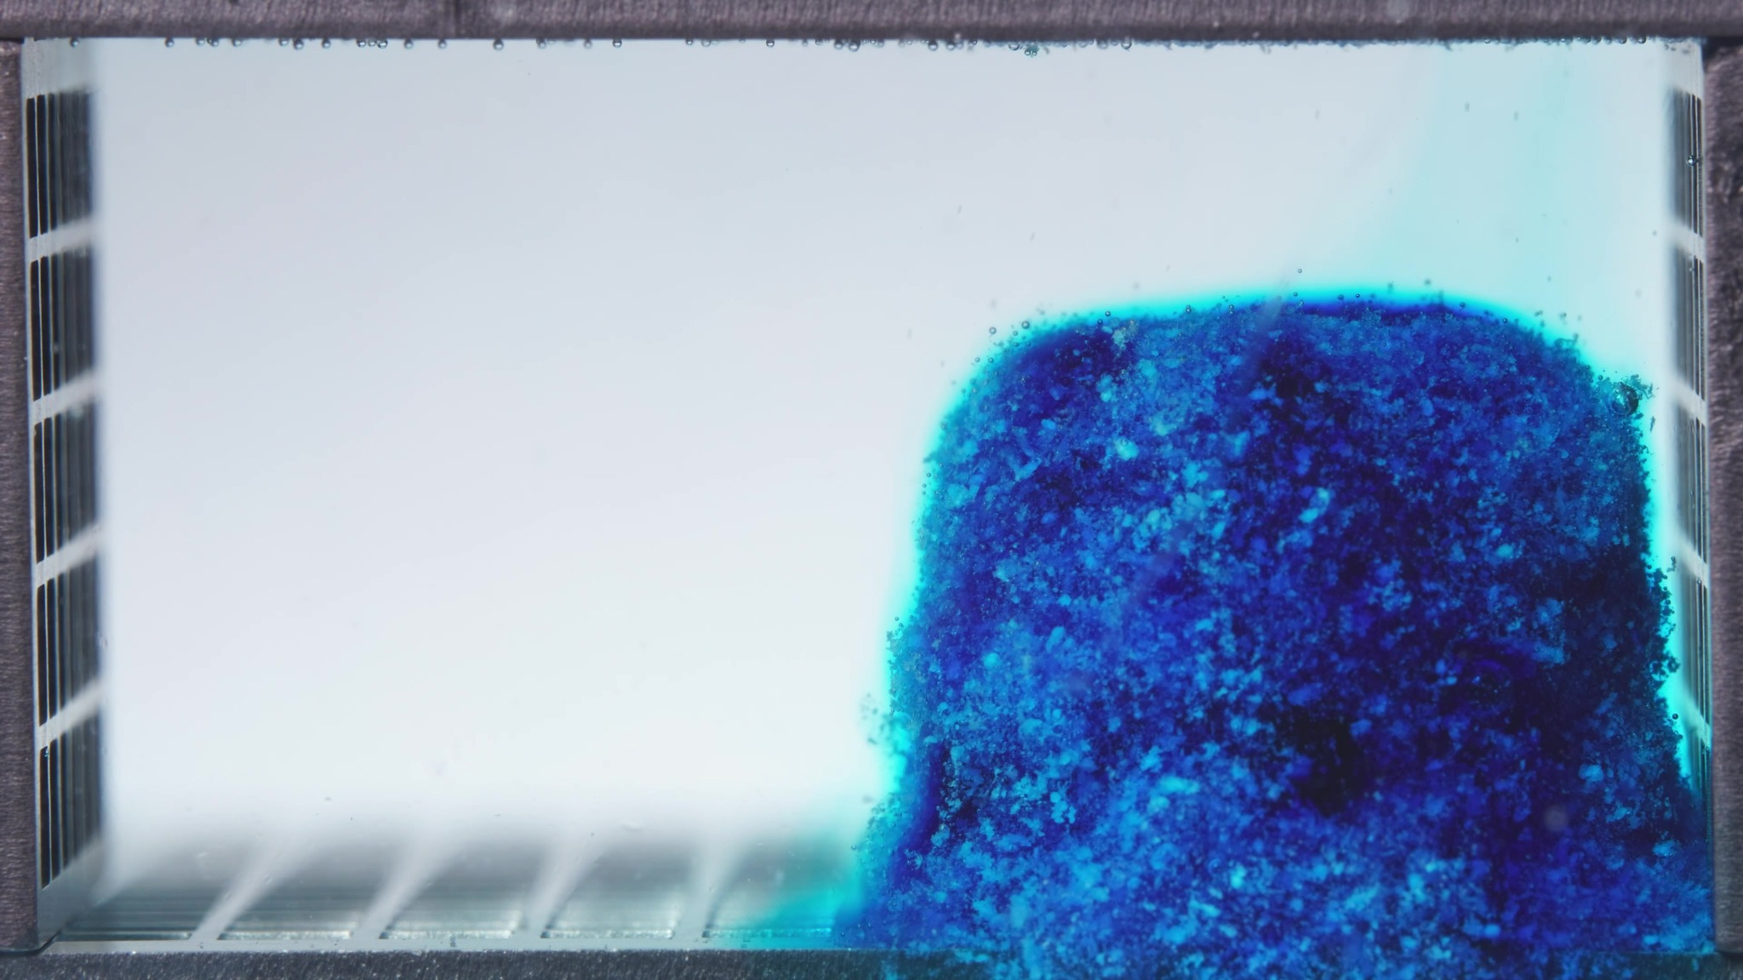 | 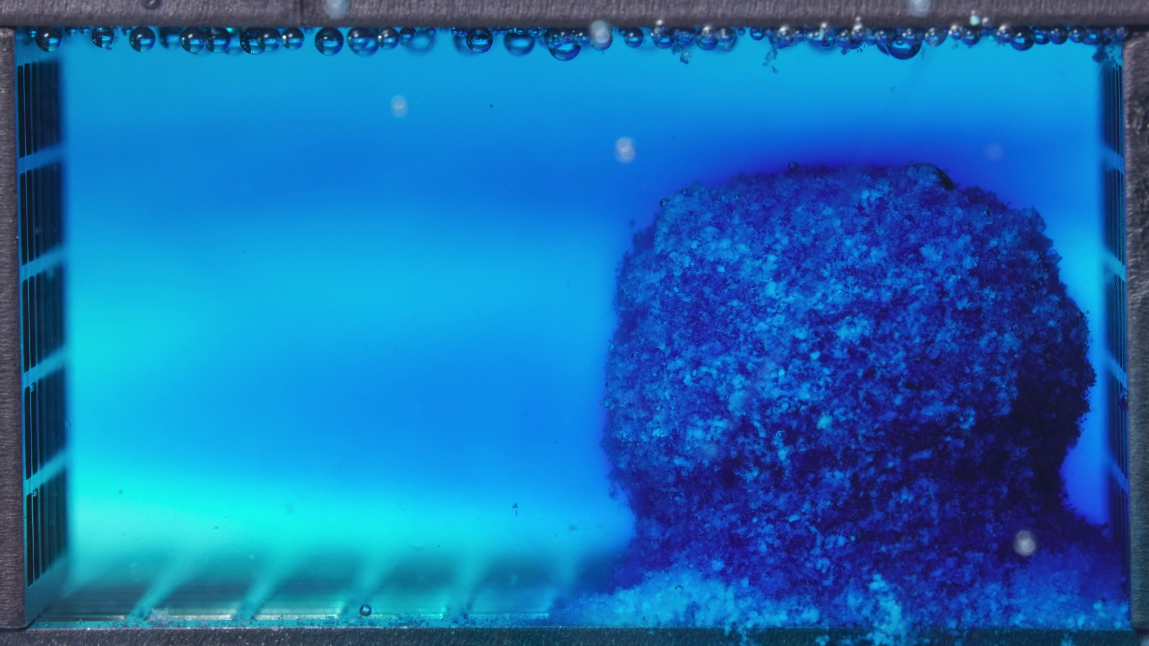 | 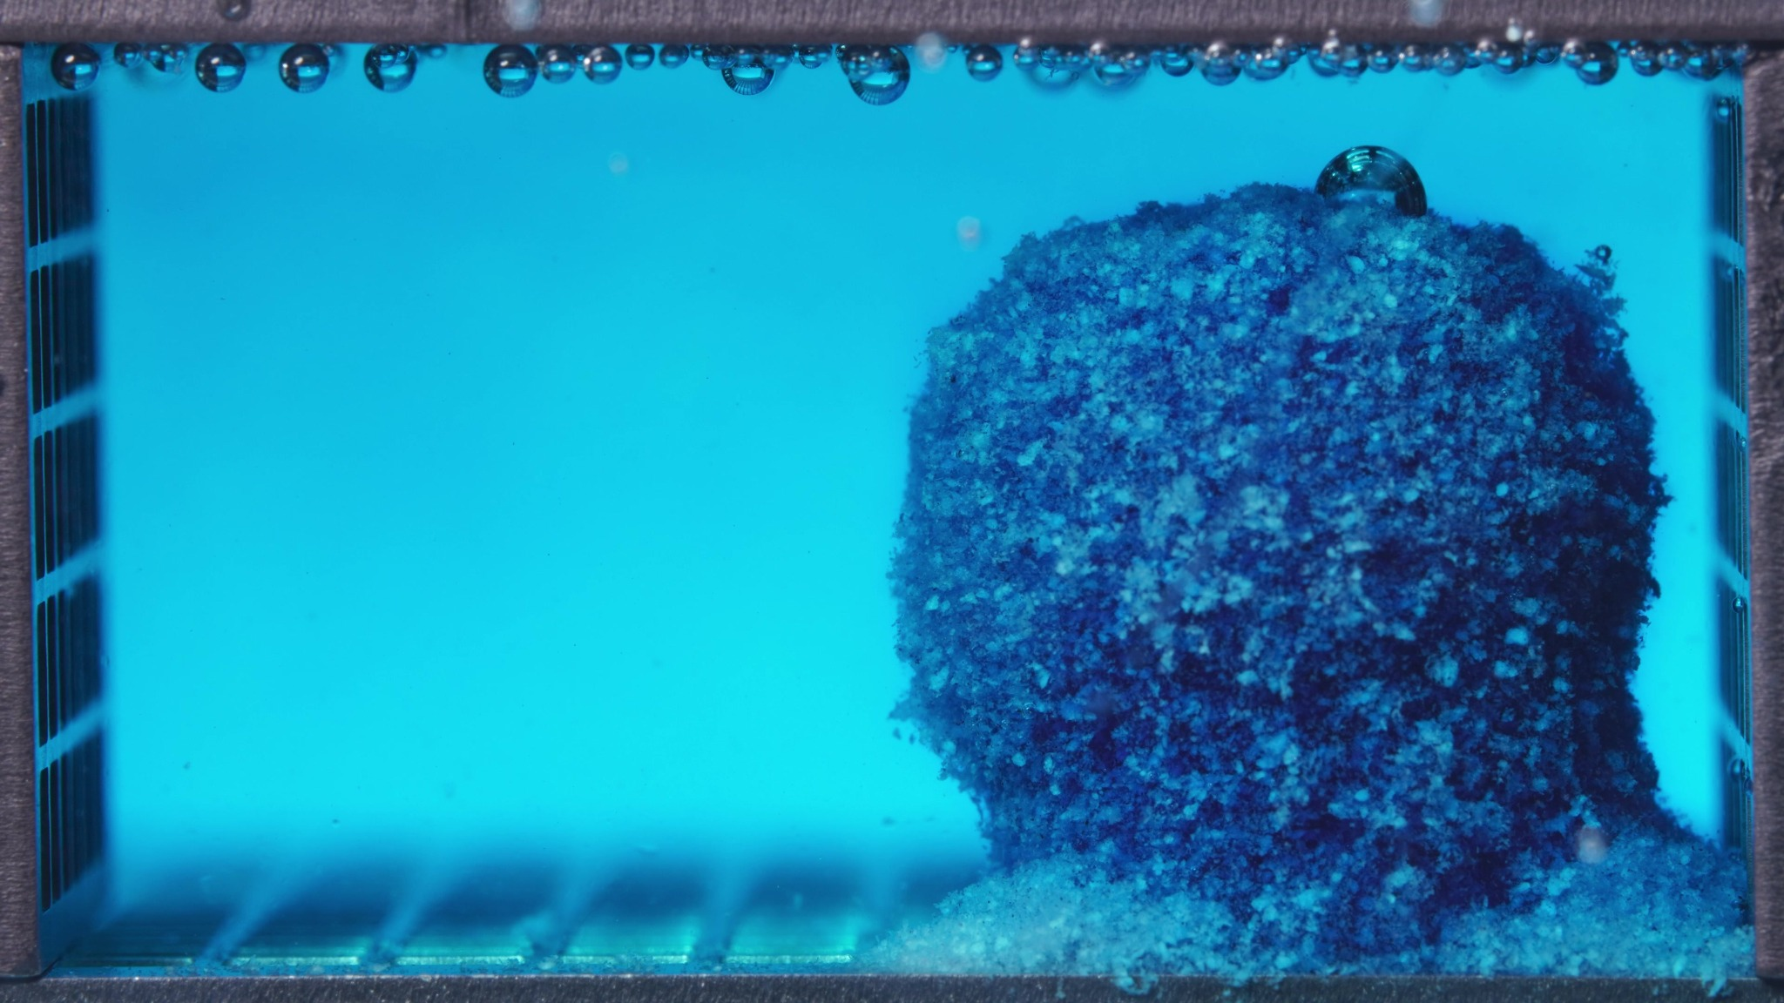
Embedded images shared in this message
20. Assistant
{
"group_id": "HIGH-VISCOSITY",
"time_range_h": [
0.104,
5.0
],
"time_h": null,
"eight_dimension_description": {
"color_change": "Across this batch, the tablet remains intensely dark blue, while the surrounding medium changes from nearly clear with only a narrow local cyan halo to a distinctly blue/cyan-stained chamber. The color release is initially concentrated around the tablet boundary and later becomes more broadly distributed through the medium, but the core still appears strongly dye-rich.",
"shape_change": "The body remains as a single coherent upright mass throughout the window. Its outline stays largely preserved, with only mild contour softening and slight top-edge rounding or flattening as the batch progresses. No major splitting, deep indentation, or gross collapse is evident during this stage.",
"surface_texture_change": "The surface is rough, granular, and heterogeneous in all images. Boundary wetting becomes more apparent over the batch, but the exterior does not become smooth; instead, it retains a compact coarse particulate texture with only limited edge loosening.",
"volume_change": "The visible occupied volume is largely maintained during this window. Any change appears modest and is expressed mainly as slight contour smoothing rather than marked swelling, shrinkage, or erosion-driven bulk loss.",
"dissolution_speed_time": "Comparison with a previous window is unavailable. Within the current batch, the dominant progression is increasing blue diffusion into the medium while the tablet body remains structurally stable, indicating that early release is already active but visible disintegration of the solid mass is still limited.",
"physical_state_change": "The formulation behaves as a cohesive wetted solid with a rough particulate exterior. It has not transitioned into a loose remnant, fragmented aggregate, or obvious gel-collapsed body; instead, it remains a compact mass showing early hydration and surface-level erosion only.",
"dissolution_medium": "The medium progresses from mostly transparent to clearly blue/cyan colored across the chamber. A diffuse stained field develops around and beyond the tablet, but there is no dominant dense cloud, heavy turbidity band, or obvious chamber-wide particulate suspension obscuring the view.",
"fragment_distribution_density": "Most solid material remains concentrated at the original tablet position. Some loose material or basal accumulation is visible near the bottom around the base, but broad fragment dispersion into the chamber is limited, and detached particles remain localized rather than widely suspended."
},
"notes_for_later_summary": "Most critical limitation: no previous-window images were available for strict comparison. Most critical visible change within this batch: the high-viscosity formulation shows substantial early medium blueing and outward dye diffusion while preserving a highly coherent upright solid core with only minor contour softening, indicating active early release but comparatively limited gross structural disintegration during 0.104–5 h."
}
21. User
These are pictures of the high-viscosity formulation during 6.25–11.25 h.
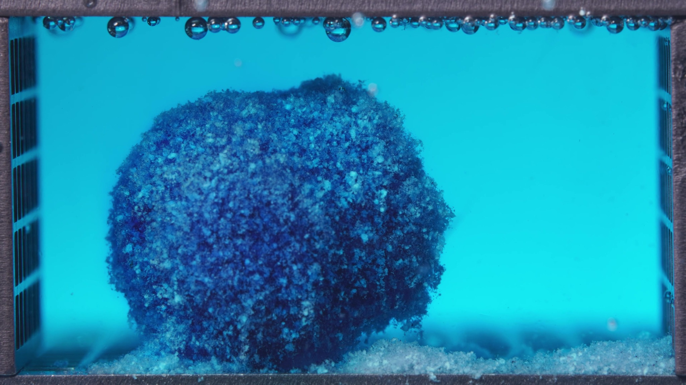 | 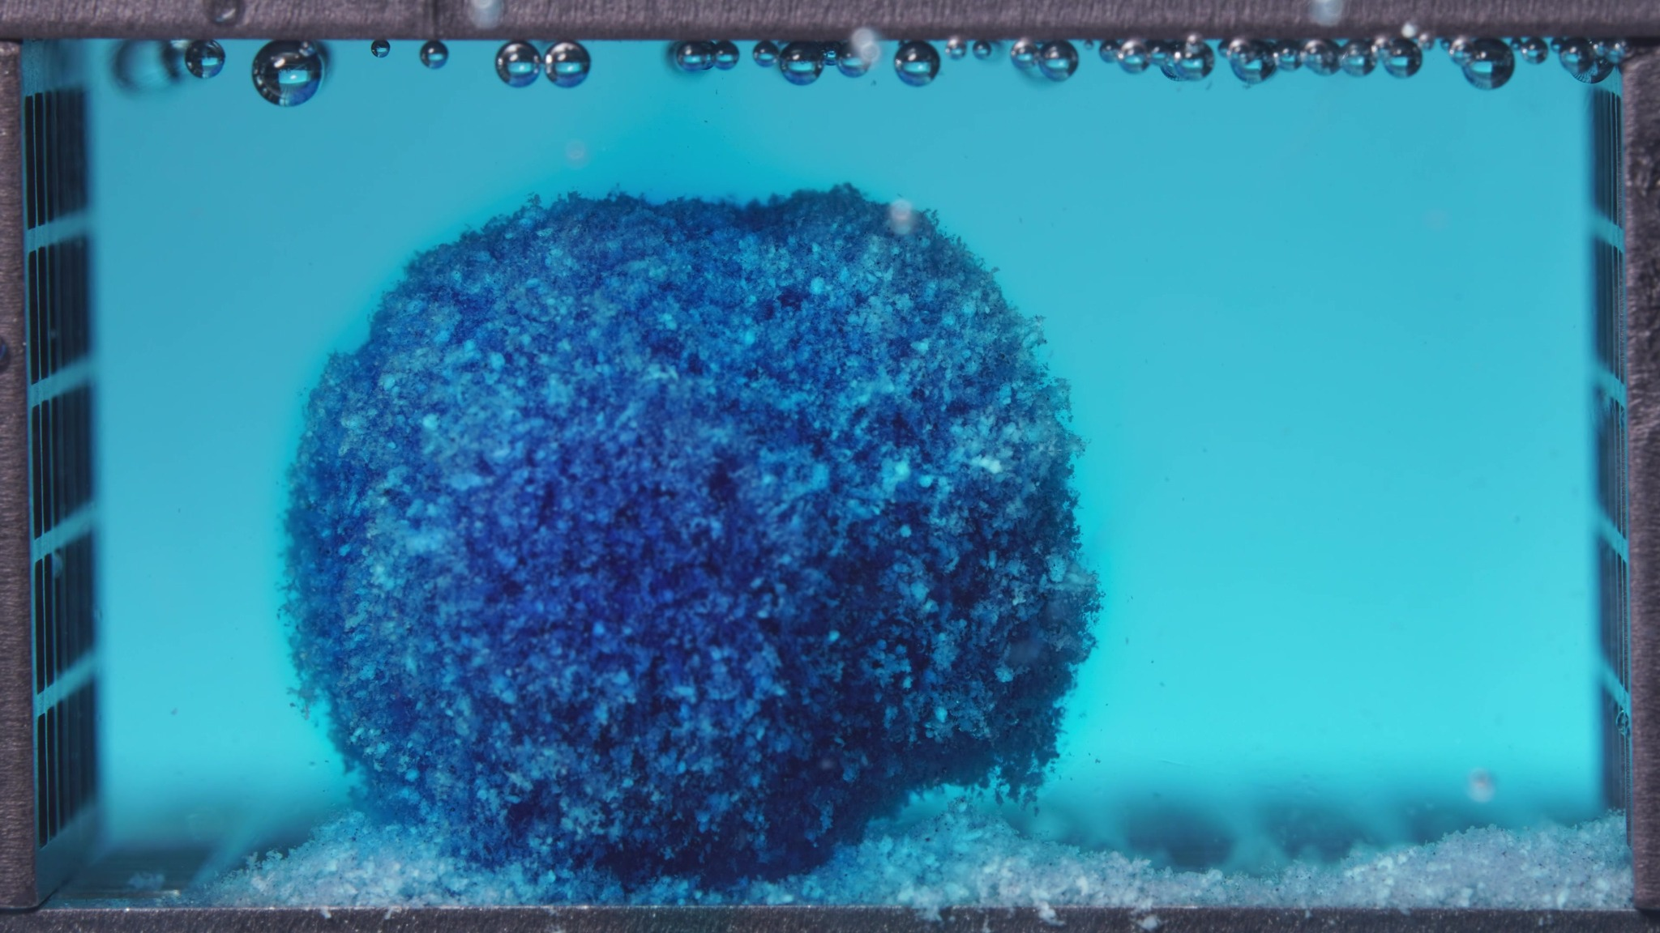 | 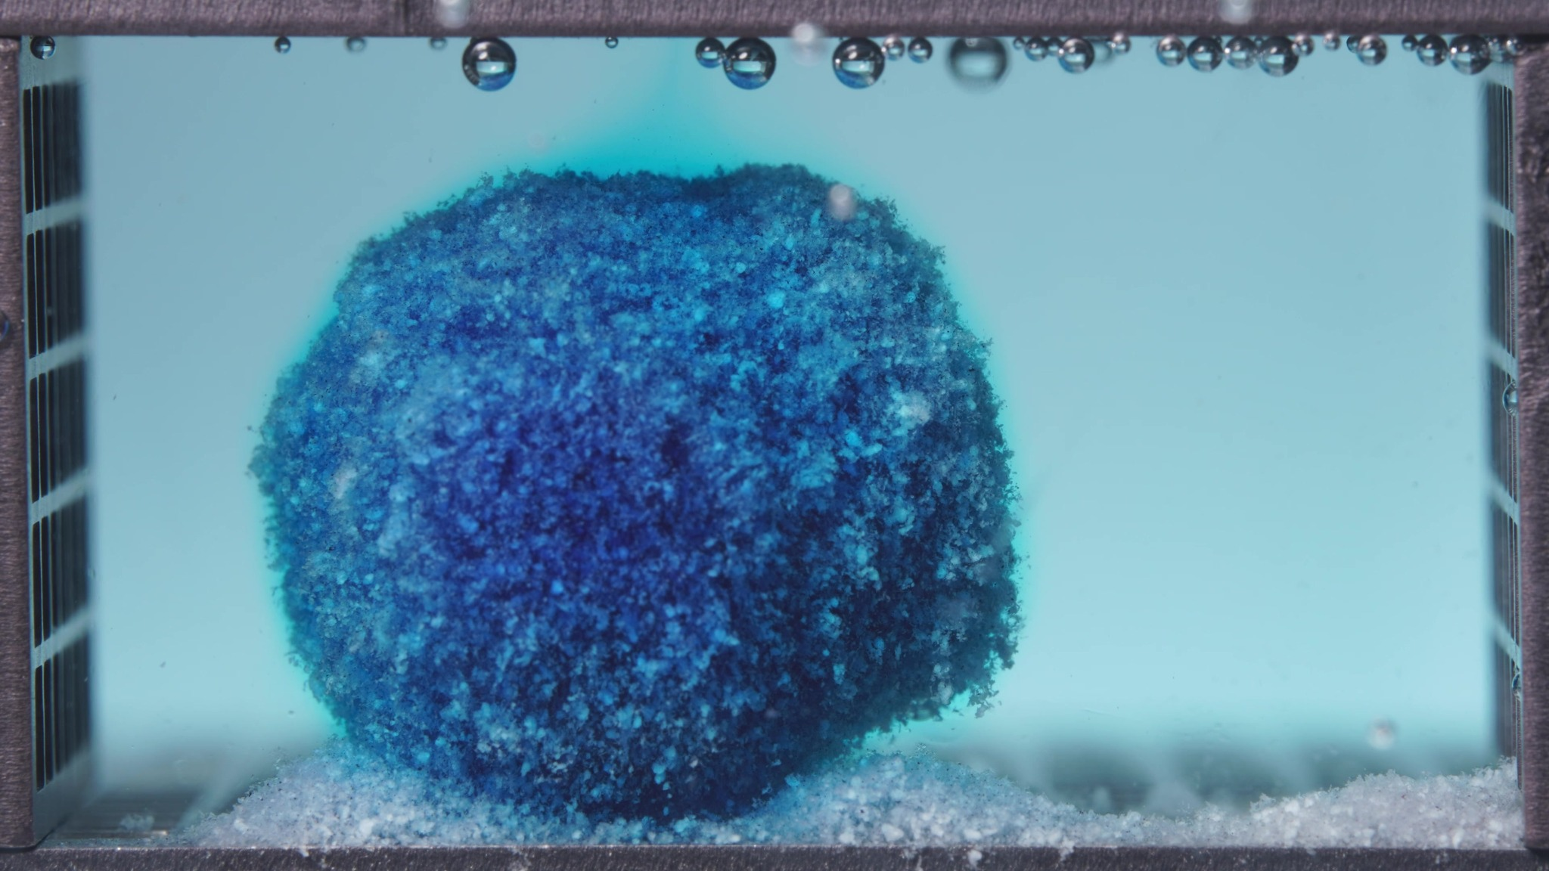
Embedded images shared in this message
22. Assistant
{
"group_id": "HIGH-VISCOSITY",
"time_range_h": [
6.25,
11.25
],
"time_h": null,
"eight_dimension_description": {
"color_change": "The tablet remains intensely dark blue overall, with only limited pale granular domains visible on the surface. Compared with the 0.104–5 h window, the surrounding medium is still clearly blue/cyan but appears more uniform and visually equilibrated across the chamber rather than showing only early boundary-centered staining. The core remains strongly dye-rich, indicating persistent internal color retention.",
"shape_change": "The body remains as a single coherent mass with no splitting or major collapse. Compared with the previous window, the outline appears more rounded and ovoid rather than upright-blocklike, suggesting contour softening and reshaping while still preserving overall integrity. No deep notch, cavity, or detached secondary lobe is evident in this interval.",
"surface_texture_change": "The surface continues to be coarse, granular, and heterogeneous. Relative to the earlier window, the exterior appears slightly more uniformly roughened and softened at the margins, but it still does not develop a smooth gel shell or large crack network. Edge loosening is mild and remains confined to the periphery.",
"volume_change": "The visible occupied volume remains largely retained. Compared with the 0.104–5 h window, any change is modest and is expressed mainly as shape redistribution toward a rounder residual mass rather than marked shrinkage, swelling-collapse, or bulk erosion.",
"dissolution_speed_time": "Compared with the previous window, visible disintegration still appears slow and controlled. The main progression is continued dye exchange with the medium and subtle contour rounding, while gross structural breakdown remains limited. This suggests sustained release with stronger structural retention than would be expected for a rapidly eroding body.",
"physical_state_change": "The formulation continues to behave as a cohesive wetted solid with a rough particulate exterior. It has not transitioned into a loose remnant, fragmented aggregate, or obvious gel-collapsed structure. Instead, it remains a compact hydrated mass with only gradual external weakening.",
"dissolution_medium": "The medium remains distinctly blue/cyan and fairly uniform across the chamber. Compared with the earlier window, the field looks more evenly stained and less dominated by a localized halo, indicating continued solute distribution through the bulk liquid without obvious dense turbidity bands or heavy particulate clouding.",
"fragment_distribution_density": "Most solid material remains concentrated at the original tablet location. Basal loose material is present near the bottom, but widespread fragment dispersion into the chamber is still minimal. Detached particles remain localized around the parent mass rather than becoming broadly suspended."
},
"notes_for_later_summary": "Most critical change versus the previous window: the high-viscosity formulation remains highly coherent but shifts from an earlier upright compact core to a more rounded, still strongly dye-retaining mass within a more uniformly blue medium. This indicates continued release and surface softening with very limited gross disintegration, supporting a slower and more structurally stable erosion pattern during 6.25–11.25 h."
}
23. User
These are pictures of the high-viscosity formulation during 12.5–17.5 h.
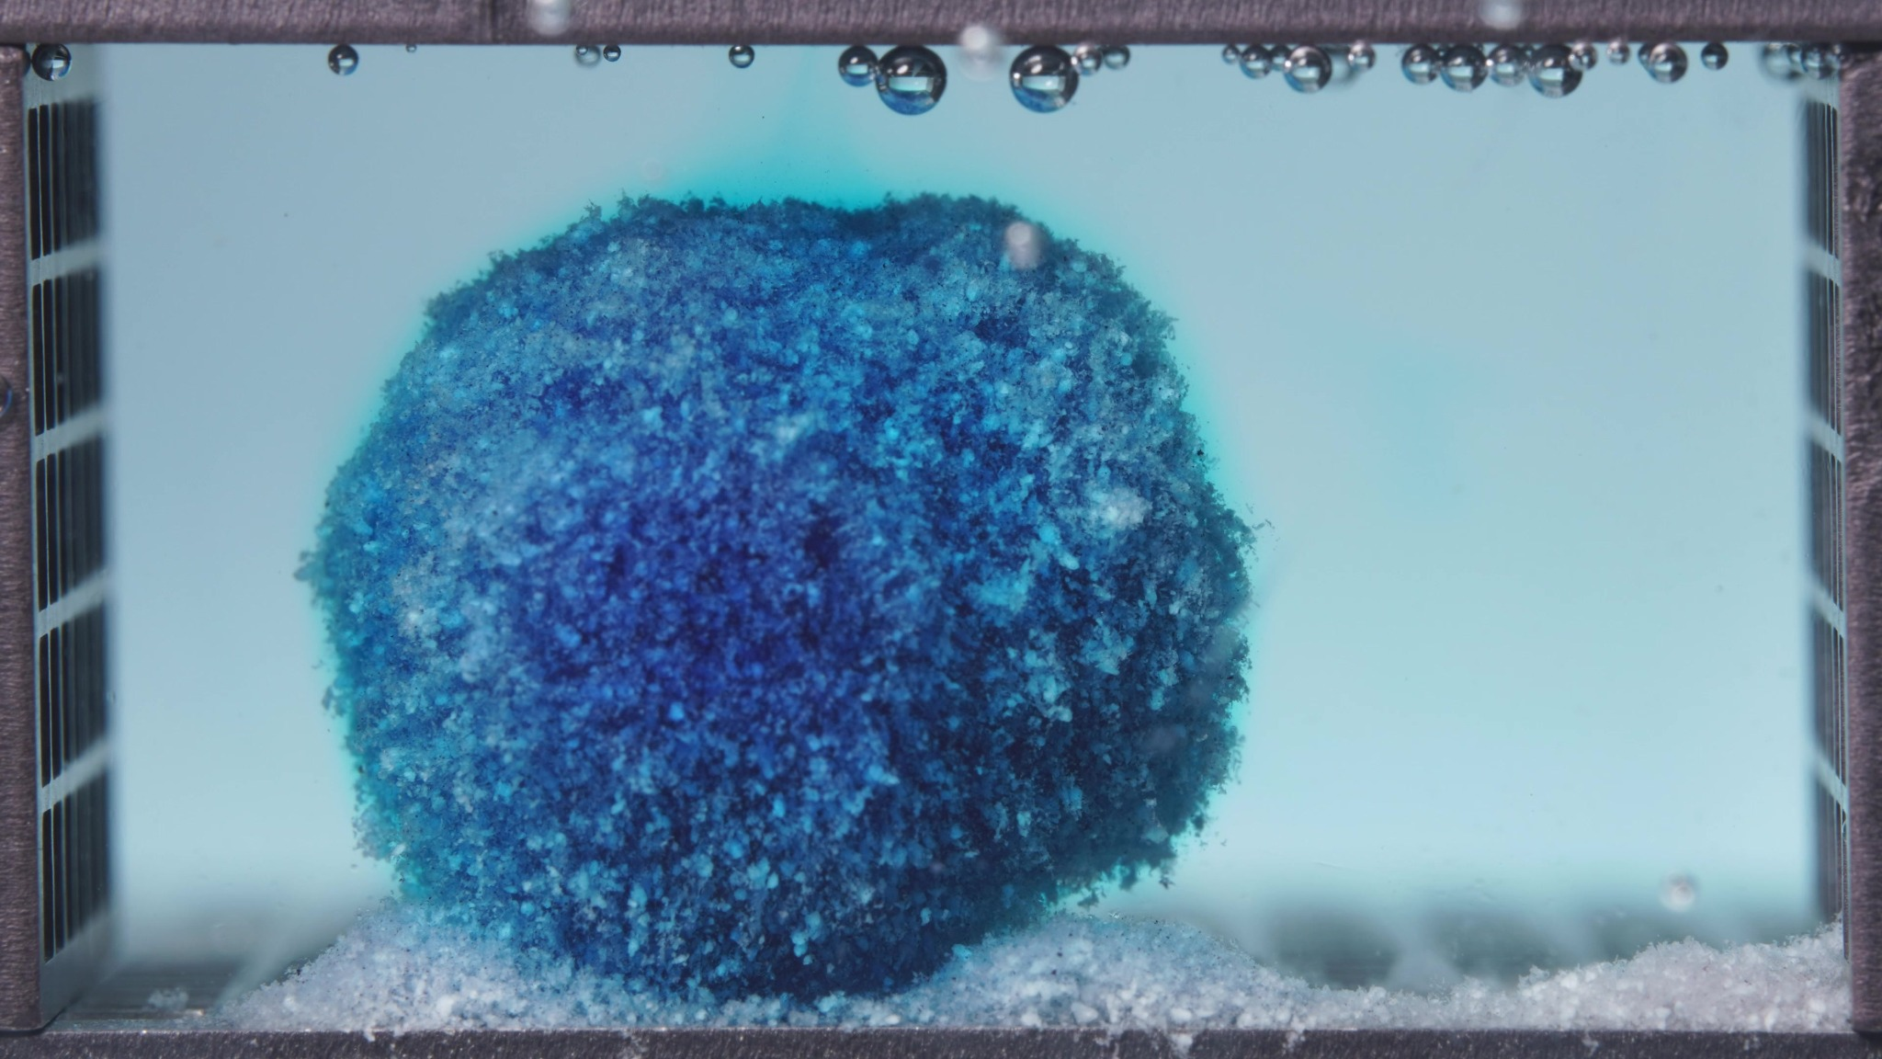 | 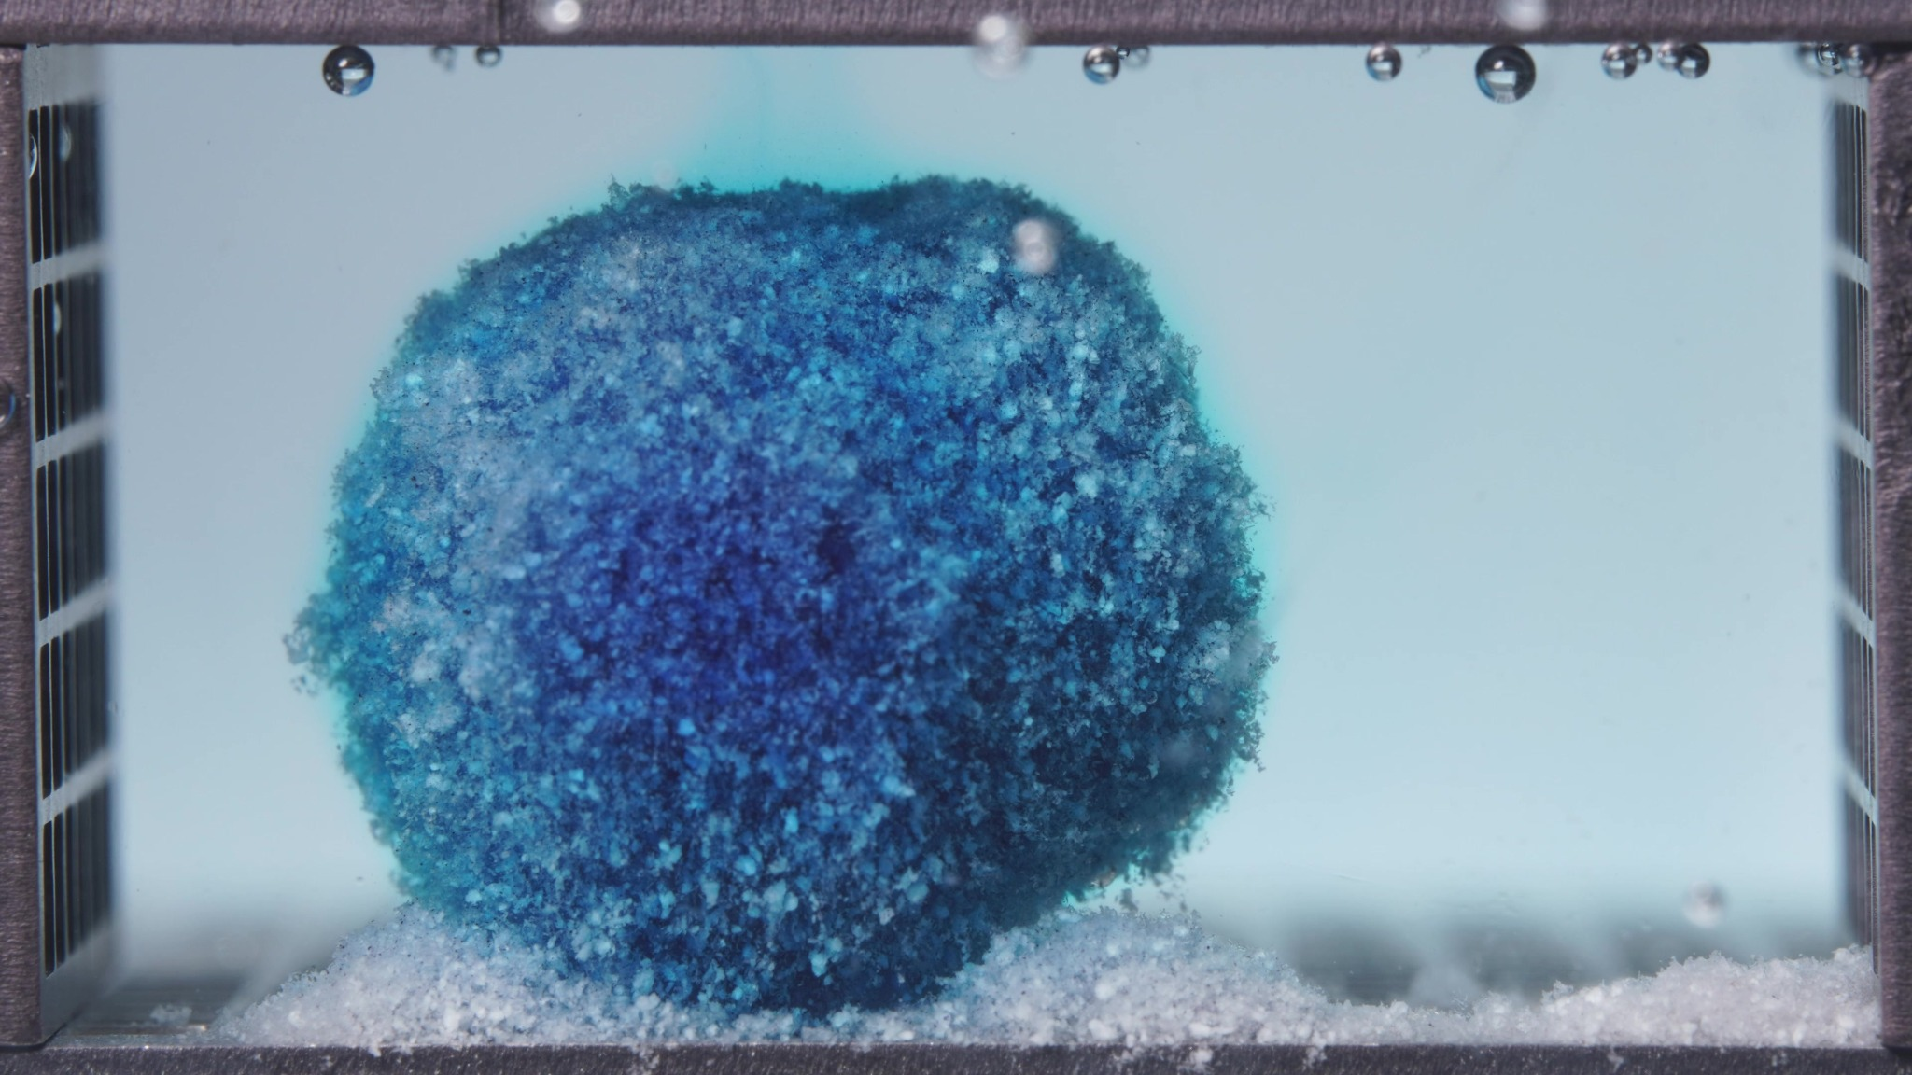 | 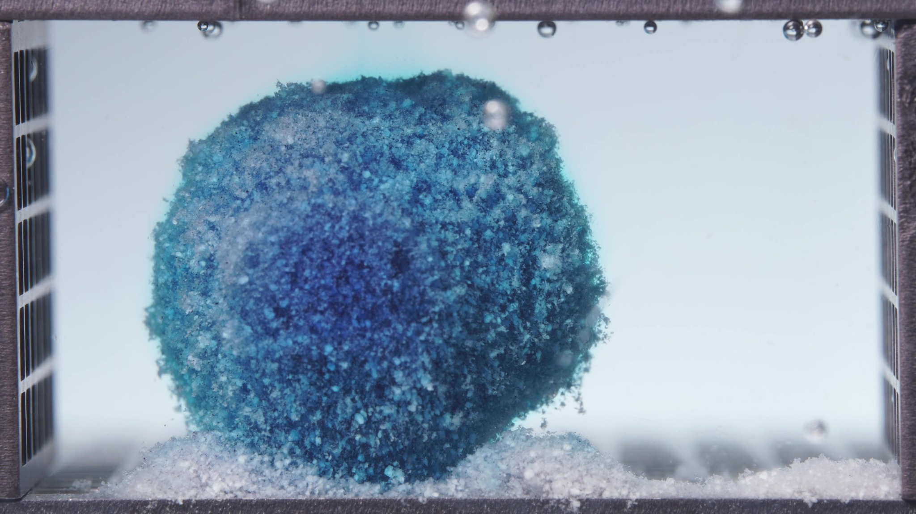
Embedded images shared in this message
24. Assistant
{
"group_id": "HIGH-VISCOSITY",
"time_range_h": [
12.5,
17.5
],
"time_h": null,
"eight_dimension_description": {
"color_change": "The tablet remains strongly blue overall, with a dark blue core and some lighter blue-white granular mottling near the outer surface. Compared with the 6.25–11.25 h window, the surrounding medium appears much less intensely blue and is closer to visually clear, while the tablet itself still retains substantial internal color, indicating continued dye retention within the solid body.",
"shape_change": "The formulation remains as a single, coherent, rounded mass with no splitting, deep indentation, or obvious collapse. Relative to the previous window, the outline appears slightly more regular and compact, with the earlier ovoid character shifting toward a more stable rounded block-like remnant. Gross morphology is therefore highly preserved.",
"surface_texture_change": "The surface continues to be coarse, granular, and heterogeneous. The exterior looks slightly more uniformly weathered than before, with a fine particulate fringe at the margins, but there is still no smooth gel shell, no major cracking, and no large peeling regions. Edge loosening remains mild.",
"volume_change": "The visible occupied volume is still largely retained. Compared with the 6.25–11.25 h window, any change appears small and is expressed mainly as subtle compaction and contour stabilization rather than marked shrinkage, swelling-collapse, or extensive erosional loss.",
"dissolution_speed_time": "Compared with the previous window, visible disintegration appears to slow further. The dominant change is reduction of bulk-medium blueing while the solid mass remains highly intact, suggesting that the system has entered a more controlled, slower-release stage with limited gross structural erosion.",
"physical_state_change": "The formulation still behaves as a cohesive hydrated solid with a rough particulate exterior. It has not transitioned into a loose remnant, fragmented aggregate, or collapsed gel-like body. Instead, it persists as a structurally stable late-stage mass undergoing only gradual surface-level weakening.",
"dissolution_medium": "The medium is much less intensely stained than in the previous window and appears only faintly blue to nearly clear across most of the chamber. There is no obvious dense dye plume, strong clouding, or heavy turbidity band. This indicates limited visually apparent fresh release into the bulk liquid during this interval.",
"fragment_distribution_density": "Most solid material remains concentrated at the original tablet position. Basal deposits persist near the bottom around the base, but widespread fragment dispersion into the chamber is still minimal. Any detached particles remain localized close to the parent mass."
},
"notes_for_later_summary": "Most critical change versus the previous window: the high-viscosity formulation remains highly coherent and rounded, but the surrounding medium becomes noticeably less blue while the tablet core stays strongly dye-retaining. This indicates continued strong structural retention with a further slowdown in visually apparent release and only minor surface attrition during 12.5–17.5 h."
}
25. User
These are pictures of the high-viscosity formulation during 18.75–23.75 h.
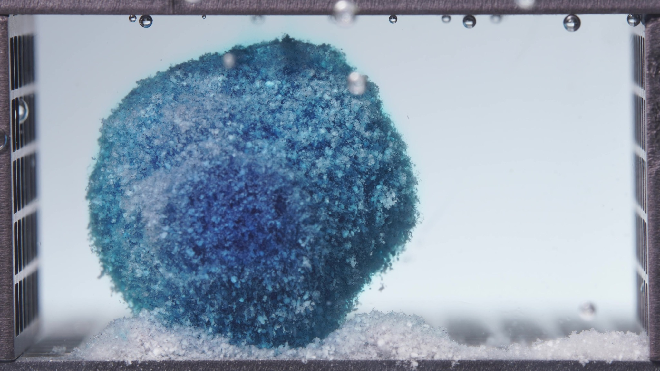 | 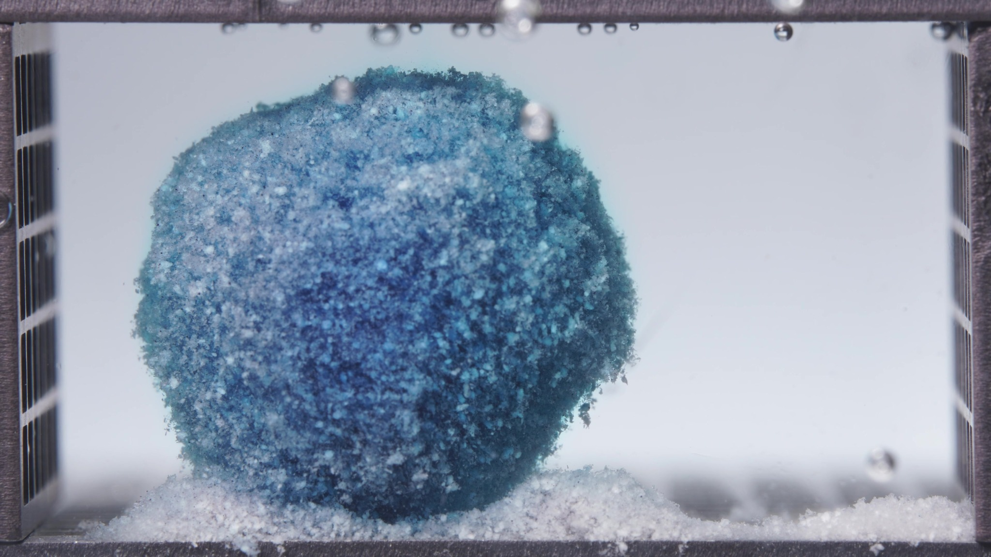 | 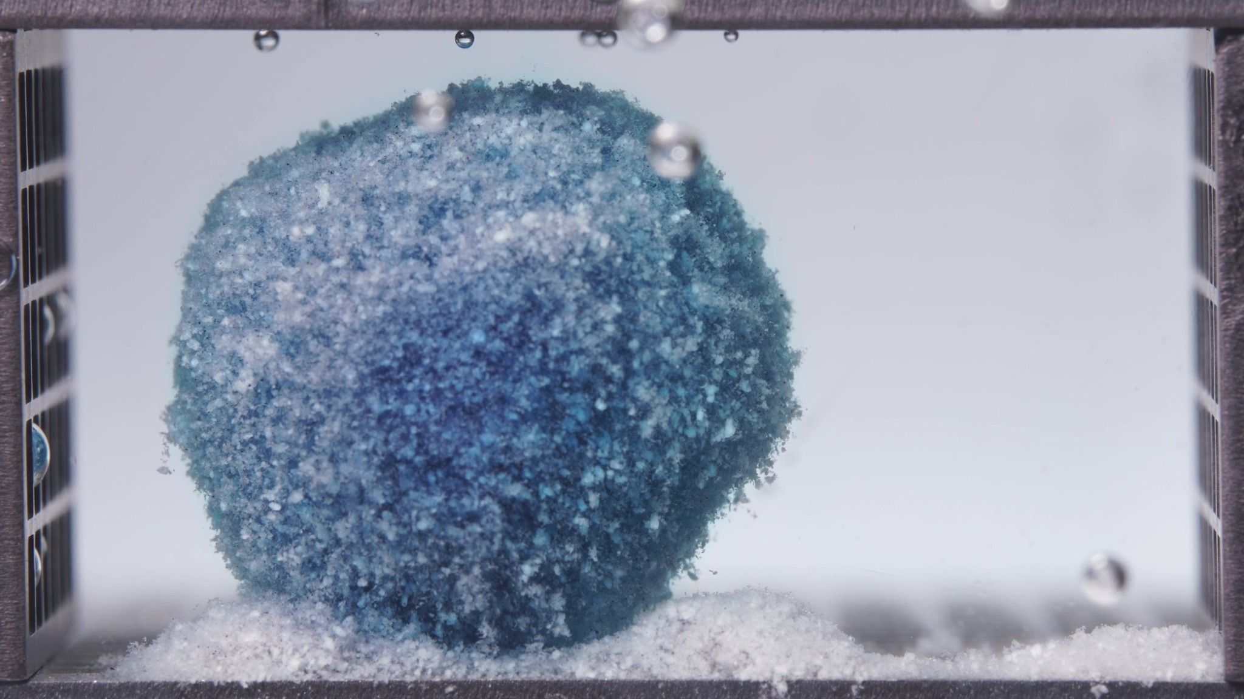
Embedded images shared in this message
26. Assistant
{
"group_id": "HIGH-VISCOSITY",
"time_range_h": [
18.75,
23.75
],
"time_h": null,
"eight_dimension_description": {
"color_change": "The tablet remains distinctly blue, but the outer region appears paler and more blue-white mottled than in the 12.5–17.5 h window, while a darker blue core is still retained centrally. The surrounding medium is essentially visually clear with only a very faint residual blue tint, indicating minimal additional bulk-medium staining during this late stage.",
"shape_change": "The formulation remains as one connected rounded residual mass with no splitting, cavity formation, or major collapse. Compared with the previous window, the outline appears slightly more compact and gently trimmed at the top and lateral margins, but the overall morphology is still highly preserved and coherent.",
"surface_texture_change": "The surface stays coarse, granular, and heterogeneous, with a fine particulate fringe along the perimeter. Relative to the 12.5–17.5 h window, the exterior looks a little more uniformly weathered and chalkier, with more exposed pale particles, but there are still no large cracks, peeling sheets, or smooth gel-like regions.",
"volume_change": "Visible occupied volume remains largely retained. Compared with the previous window, any reduction is modest and is expressed mainly as slight compaction and edge trimming rather than marked shrinkage, swelling-collapse, or abrupt erosional loss.",
"dissolution_speed_time": "Compared with the 12.5–17.5 h window, visible disintegration appears to remain very slow and controlled. The dominant change is continued preservation of the rounded mass with only subtle surface attrition, indicating that the system is in a late residual stage with limited incremental structural change.",
"physical_state_change": "The formulation still behaves as a cohesive hydrated solid with a rough particulate exterior. It has not transitioned into a loose remnant, fragmented aggregate, or collapsed hollow body; instead, it persists as a stable late-stage residual mass undergoing only minor surface-level weakening.",
"dissolution_medium": "The medium is highly transparent and nearly colorless across the chamber. Compared with the previous window, there is no new visually obvious dye plume, haze, or chamber-wide blueing, which suggests very low visually detectable ongoing release into the bulk liquid during this interval.",
"fragment_distribution_density": "Most solid material remains concentrated at the original tablet position. Basal deposits are still present near the bottom around the base, but broad fragment dispersion into the chamber remains minimal, and any detached particles stay closely localized to the parent mass."
},
"notes_for_later_summary": "Most critical change versus the previous window: the high-viscosity formulation shows only subtle further pallor of the outer layer and slight contour compaction while maintaining a highly coherent rounded residual body and a nearly clear medium. This indicates continuation of a terminal slow-erosion stage with very strong structural retention and minimal visually apparent ongoing release or fragmentation."
}
27. User
Provide an integrated mechanistic interpretation of the observed disintegration behavior of the three methylene blue sustained-release tablet formulations.
The three formulations are the low-viscosity formulation, the standard formulation (medium-viscosity), and the high-viscosity formulation, and their main formulation difference lies in the ratio between HPMC K4M and HPMC 100lv.
Our optimization goal is to adjust the ratio between HPMC K4M and HPMC 100lv so that the cumulative release amount of the standard-viscosity methylene blue sustained-release tablet over the first 4 hours is increased to 105% of its original level.
In addition to the image-based disintegration observations, please also use the UV absorbance data from the flow-through-cell eluate as semi-quantitative release evidence.
All UV absorbance values are within the linear range.
The interval sequence is: 0–0.5 h, 0.5–1 h, 1–2 h, 2–4 h, 4–6 h, 6–8 h, 8–12 h, 12–16 h, 16–20 h, and 20–24 h.
The corresponding mean UV absorbance values are as follows:
Low-viscosity formulation: 0.0273, 0.0727, 0.1967, 0.5963, 0.3347, 0.0230, 0.0123, 0.0027, -0.0010, -0.0007.
Standard formulation: 0.0320, 0.0520, 0.1680, 0.5153, 0.5532, 0.0777, 0.0167, 0.0143, 0.0043, -0.0013.
High-viscosity formulation: 0.0243, 0.0403, 0.1213, 0.4743, 0.3490, 0.0890, 0.0217, 0.0077, 0.0047, 0.0010.
Please: 1) Summarize the key differences in disintegration behavior across the three formulations as evidence statements. 2) Using the literature and the current session data, focus on explaining how differences in the HPMC K4M / HPMC 100lv ratio may influence swelling, gel-layer formation, erosion, fragmentation, shell persistence, and other observed disintegration phenomena. 3) Relate the observed disintegration phenomena to the interval-based UV absorbance trends, and state whether the image-based evidence and the UV-based evidence are mutually supportive, partially aligned, or inconsistent. 4) Propose 2–5 mechanistic hypotheses, each clearly tied to the observed phenomena, the UV trends, and the HPMC ratio differences. 5) Explain what these mechanistic differences may imply for increasing the cumulative release amount of the standard-viscosity methylene blue sustained-release tablet over the first 4 hours to 105% of its original level, so that the result can support the next-step formulation optimization. 6) List alternative explanations and a minimal set of follow-up tests to discriminate between hypotheses. Use only information from this session and the retrieved literature; do not invent missing details. Do not provide a final optimized formulation recipe in this step.
28. Assistant
Phenomenon Review
Evidence statements from the current session
1. Low-viscosity formulation: the tablet showed the earliest visible boundary destabilization. By 0.104–5 h it had already progressed from a rough coherent mass to clearer edge loss, stronger medium staining, and basal deposit buildup. By 6.25–11.25 h it had become an irregular residual structure with a pronounced undercut/two-lobed appearance, and by 12.5–23.75 h it evolved into a progressively paler, contracted remnant. This is the strongest image-based evidence for early erosion, earlier shell failure, and earlier structural recession.
2. Standard formulation: the tablet retained a single coherent upright mass for much longer. From 0.104–17.5 h the dominant image pattern was persistent core integrity with gradual surface weathering, not gross breakup. Only in 18.75–23.75 h did a more obvious cavity-like recession appear, indicating late localized internal/surface collapse rather than early fragmentation.
3. High-viscosity formulation: the tablet showed the greatest structural persistence. Across 0.104–23.75 h it remained a rounded, coherent, strongly dye-retaining mass with only subtle contour smoothing, slight outer pallor, and limited basal shedding. Among the three, it provides the strongest image-based evidence for persistent hydrated shell/barrier behavior and slow erosion.
4. Across the full image set, the rank order for shell persistence / structural integrity is: high-viscosity > standard > low-viscosity.
5. Across the full image set, the rank order for early erosion / shape destabilization / fragmentation tendency is: low-viscosity > standard > high-viscosity.
A cautious mechanistic reading is that all three tablets likely formed hydrated HPMC-controlled matrices, but the lifetime and mechanical robustness of the hydrated barrier differed markedly: shortest in the low-viscosity formulation, intermediate in the standard formulation, and longest in the high-viscosity formulation.
Concentration-Time Trend Review
Using the user-provided UV absorbance values as a semi-quantitative release proxy, and because the flow rate is constant and absorbance is within the linear range, the first-4-hour cumulative release proxy is proportional to the interval-weighted sum A × Δt. From the session data, the 0–4 h cumulative proxy is approximately:
- Low-viscosity: 1.4393 absorbance·h
- Standard: 1.2406 absorbance·h
- High-viscosity: 1.1022 absorbance·h
So relative to the current standard, the low-viscosity formulation is about +16.0%, while the high-viscosity formulation is about −11.2% over the first 4 h.
Trend-level evidence from the UV data:
- Low-viscosity rises fastest early: 0–2 h already exceeds the standard and high-viscosity formulations, and it reaches its maximum interval signal in 2–4 h (0.5963), then drops sharply in 4–6 h (0.3347) and approaches baseline rapidly thereafter.
- Standard is intermediate in 0–4 h, but it has the most sustained mid-phase output: 4–6 h (0.5532) is even slightly higher than its 2–4 h (0.5153) interval, and its 0–6 h cumulative proxy is the largest of the three.
- High-viscosity shows the lowest early signal overall: 0–0.5 h, 0.5–1 h, 1–2 h, and 2–4 h are all below the corresponding low-viscosity values, and its later decline is slower than low-viscosity but still occurs from a lower early base.
Alignment call
- Low-viscosity: image and UV evidence are mutually supportive. Early visible destabilization aligns with the highest 0–4 h release proxy and the earliest sharp decline after the peak.
- High-viscosity: image and UV evidence are also mutually supportive. Strong shell persistence aligns with the lowest 0–4 h release proxy and the slowest apparent structural change.
- Standard: image and UV evidence are partially aligned, not inconsistent. The tablet remains structurally coherent in the images, yet UV remains high through 2–6 h. That pattern is compatible with substantial diffusion through a retained hydrated barrier, rather than requiring gross fragmentation.
Overall, the image-based and UV-based datasets are mutually supportive at the formulation-ranking level, with a partial-alignment nuance for the standard formulation because high release can coexist with preserved tablet shape when transport is diffusion-dominant through a persistent hydrated matrix.
Literature-Supported Typical Mechanistic Links
Hydrophilic HPMC matrix tablets typically release drug through a combination of water ingress, polymer swelling, gel-layer formation, diffusion through the gel, and progressive erosion. The balance between diffusion and erosion depends strongly on the properties of the hydrated gel layer rather than on gross tablet breakup alone. (PubMed: https://pubmed.ncbi.nlm.nih.gov/27808590/)
Literature also shows that HPMC viscosity grade / molecular weight affects matrix dissolution, gel-layer development, and erosion behavior. In the classic swelling study, faster-dissolving low-viscosity HPMC systems were associated with higher apparent drug diffusivity and faster release, whereas higher-viscosity HPMC systems showed slower matrix dissolution and more persistent gel behavior. (PubMed: https://pubmed.ncbi.nlm.nih.gov/8818998/)
A study using formulations with a fixed total HPMC level but varying K4M/K100LV proportions found that matrices with a larger proportion of higher-molecular-weight HPMC (K4M) eroded more slowly, whereas increasing the lower-molecular-weight/low-viscosity fraction accelerated erosion. (PubMed: https://pubmed.ncbi.nlm.nih.gov/24818771/)
The swollen-gel literature further shows that gel viscoelasticity and gel strength correlate with release behavior and robustness: stronger, more elastic gels resist agitation- or erosion-driven failure better, while weaker gels lose robustness earlier and are more erosion-sensitive. (PubMed: https://pubmed.ncbi.nlm.nih.gov/27808590/)
There is also evidence that mixtures of HPMC grades can behave nonlinearly, rather than as a simple arithmetic midpoint, with diffusion and erosion contributions shifting in an antagonistic/non-Fickian way depending on the blend. (PubMed: https://pubmed.ncbi.nlm.nih.gov/10219537/)
Tentative Integrated Mechanistic Interpretation Across the Three Formulations
From the current session alone, the three formulations distribute along a coherent mechanistic continuum:
- Low-viscosity formulation: shortest-lived protective shell, fastest transition from hydrated mass to erosion-dominated remnant.
- Standard formulation: intermediate barrier persistence, with strong shape retention but substantial 2–6 h release.
- High-viscosity formulation: longest-lived protective shell, slowest visible erosion, lowest early release.
The most parsimonious session-consistent interpretation is that increasing the HPMC K4M fraction increased the mechanical persistence and lifetime of the hydrated gel barrier, while increasing the HPMC 100lv fraction increased the tendency toward faster gel dilution/disentanglement, earlier erosion, and earlier structural recession. That direction of effect is consistent with the HPMC matrix literature, but the case-specific strength of each effect here remains inferential rather than proven. (PubMed: https://pubmed.ncbi.nlm.nih.gov/8818998/)
Mechanistic hypotheses
Hypothesis 1: low-viscosity-rich matrices form a shorter-lived, less erosion-resistant hydrated barrier.
Session tie-in: the low-viscosity formulation shows the earliest edge loss, undercut remnant formation, and fastest collapse toward a pale residual mound; UV shows the highest 0–4 h cumulative proxy and an early peak followed by rapid decay. Mechanistic implication: a higher HPMC 100lv fraction likely allowed rapid hydration and early solute escape, but the barrier then lost integrity quickly, so release became front-loaded rather than sustained. This is consistent with literature linking lower-viscosity HPMC systems to faster matrix dissolution / higher apparent release rates. (PubMed: https://pubmed.ncbi.nlm.nih.gov/8818998/)
Hypothesis 2: K4M-rich matrices generate a stronger, longer-lived gel shell that suppresses early release and delays erosion.
Session tie-in: the high-viscosity formulation retains a rounded coherent body throughout 24 h, with minimal fragmentation and only subtle outer pallor; UV shows the lowest 0–4 h cumulative proxy and no evidence of an early burst beyond the other groups. Mechanistic implication: the higher K4M fraction likely increased gel viscoelasticity/strength and slowed shell attrition, thereby limiting early transport and preserving structure. (PubMed: https://pubmed.ncbi.nlm.nih.gov/24818771/)
Hypothesis 3: the standard formulation occupies a mixed diffusion–erosion regime, not simply a midpoint in gross breakup.
Session tie-in: the standard tablet remains coherent much longer than the low-viscosity formulation, yet UV remains high through 2–6 h and the 4–6 h interval is its maximum. Mechanistic implication: the standard K4M/100lv balance may allow enough early hydration/permeability for substantial dye transport while still keeping the barrier structurally intact, so release can remain high without early fragmentation. Literature on HPMC gels supports this separation between shape retention and ongoing diffusion through a hydrated gel layer. (PubMed: https://pubmed.ncbi.nlm.nih.gov/27808590/)
Hypothesis 4: late cavities/undercuts reflect localized recession behind a partially persistent outer shell.
Session tie-in: the low-viscosity formulation develops early undercut/two-lobed recession, while the standard formulation develops a later cavity-like indentation, and the high-viscosity formulation largely avoids this phenomenon. Mechanistic implication: once outer-shell integrity becomes spatially nonuniform, internal depletion plus local erosion can produce cavity/hollow features before complete fragmentation. The timing of this feature appears delayed as the K4M fraction increases. This is session-consistent, but the literature support is indirect rather than formulation-specific. (PubMed: https://pubmed.ncbi.nlm.nih.gov/27808590/)
Mechanistic Implications for the Next Optimization Step
The stated goal is to increase the first-4-hour cumulative release of the current standard formulation to 105% of its present level. On the current semi-quantitative UV proxy, that means moving from about 1.2406 to about 1.3026 absorbance·h over 0–4 h.
Mechanistically, the three formulations imply the following:
- The low-viscosity formulation already exceeds that target substantially (~116% of the current standard over 0–4 h), but it does so together with the fastest visible structural destabilization and the sharpest post-peak decline. Mechanistically, it looks too fast / too erosion-prone if the aim is only a modest first-4-hour increase.
- The high-viscosity formulation is clearly too slow early for the stated target.
- The standard formulation appears closest to the desired zone, but its release is shifted somewhat later, with a pronounced 4–6 h contribution rather than a slightly larger 0–4 h contribution.
So the next-step optimization, mechanistically, should probably aim for a modest increase in early permeability / early effective diffusion and-or mild acceleration of early shell relaxation, while avoiding the earlier shell failure pattern seen in the low-viscosity formulation. In other words, the target is not “make the standard behave like the low-viscosity tablet,” but rather “move the standard slightly toward faster early transport without crossing into fast early erosion.”
That interpretation also means the most relevant mechanistic control variable for the next iteration is likely the balance between early gel permeability and gel persistence, not simply total visible disintegration. The standard formulation already demonstrates that strong shape retention can coexist with substantial UV output; therefore, the desired improvement may come from subtle early barrier tuning rather than inducing gross fragmentation.
Suggestions for Further Validation
Alternative explanations that remain plausible
1. Some differences could reflect not only the K4M/100lv ratio, but also microstructural differences not directly visualized here: local porosity, compression density, or granule packing could shift ingress and erosion behavior.
2. The cavity / undercut features could partly reflect local flow-field asymmetry or tablet orientation effects in the flow-through cell, rather than only intrinsic formulation behavior.
3. The late near-zero or slightly negative UV values likely reflect baseline noise around zero, so late-phase comparisons should be interpreted qualitatively.
4. Because the images do not directly visualize a transparent gel front, “gel-layer persistence” here is still an inference from shell integrity + UV behavior, not a directly measured gel property.
Minimal follow-up tests to discriminate between hypotheses
1. Replicate flow-through-cell image + UV runs for the three current formulations, focused on 0–6 h and 6–12 h, to confirm that the observed rank order and cavity/undercut timing are reproducible.
2. Water-uptake / remaining-mass / erosion-balance measurements versus time on the same formulations, especially at 0.5, 1, 2, 4, and 6 h, to separate “faster diffusion through an intact shell” from “faster shell loss.”
3. Gel-layer robustness testing on partially hydrated tablets, such as texture analysis or swollen-matrix mechanical probing, to test whether K4M-rich systems truly maintain a stronger shell than the low-viscosity-rich system. This is directly motivated by the gel-strength/viscoelasticity literature. (PubMed: https://pubmed.ncbi.nlm.nih.gov/27808590/)
4. Cross-sectional or front-tracking imaging at matched timepoints (for example, cut-tablet imaging, dye-front mapping, or optical front analysis) to determine whether the standard formulation’s higher 2–6 h UV output occurs through a still-intact diffusion barrier rather than through hidden internal recession.
5. A narrowly spaced ratio series around the current standard while holding other excipients and process conditions constant, to determine whether the early-release gain is monotonic or nonlinear. This is important because mixed HPMC grades can show nonlinear behavior. (PubMed: https://pubmed.ncbi.nlm.nih.gov/10219537/)
This integrated interpretation supports the next optimization step, but it does not yet justify a final ratio recommendation.
29. User
Provide a formulation optimization recommendation for the next iteration based on the existing formulation information, optimization target, concentration-time summary, mechanistic analysis results, and prior disintegration-analysis conclusions in this session.
The three formulations are the low-viscosity formulation, the standard formulation (medium-viscosity), and the high-viscosity formulation. The standard formulation is the reference formulation.
Our optimization goal is to adjust the ratio between HPMC K4M and HPMC 100lv so that the cumulative release amount of the standard-viscosity methylene blue sustained-release tablet over the first 4 hours is increased to 105% of its original level.
Please integrate the prior evidence rather than repeating the earlier full image-analysis or mechanistic-analysis process. You MUST provide a next-step formulation proposal with explicit numeric values, especially for HPMC K4M and HPMC 100lv.
Please: 1) Briefly summarize which current formulation tendency appears closer to the optimization target and which tendencies appear too fast or too slow. 2) Propose one next-step optimized formulation anchored on the standard formulation and adjusted mainly through the balance between HPMC K4M and HPMC 100lv. 3) You MUST explicitly report the proposed HPMC K4M amount, the proposed HPMC 100lv amount, the proposed HPMC K4M:HPMC 100lv ratio, and the percentage change of each relative to the standard formulation. 4) Even if the evidence is not sufficient to justify a fully validated exact formula, you MUST still provide a best-estimate next-iteration formulation proposal with explicit numeric values and percentage changes, and clearly label it as tentative rather than omitting the numbers. Use only information from this session and the retrieved literature if already available; do not invent missing details. Do not output a same/different judgment. Do not simply restate previous node outputs without synthesis.
Output the result in a clear structured format with the following sections: Optimization Target Review / Evidence Summary from Existing Formulations / Recommended Next Formulation / Uncertainty and Validation Needs. Under “Recommended Next Formulation”, directly report: Proposed HPMC K4M amount = X; Proposed HPMC 100lv amount = Y; Proposed HPMC K4M:HPMC 100lv ratio = X:Y; Percentage change of HPMC K4M relative to the standard formulation = Z%; Percentage change of HPMC 100lv relative to the standard formulation = W%; A short rationale for why this ratio is recommended.
30. Assistant
Optimization Target Review
The target is to increase the 0–4 h cumulative release of the current standard formulation to 105% of its present level by adjusting the HPMC K4M / HPMC 100lv balance.
From the current session evidence:
- The low-viscosity formulation is too fast for this target. Its first-4-hour UV-release tendency is already clearly above the standard, and its images show earlier shell failure and earlier erosion.
- The high-viscosity formulation is too slow for this target. Its first-4-hour UV-release tendency is below the standard, and its images show the strongest shell persistence.
- The standard formulation is the correct anchor, but its release appears slightly too delayed, because it retains a coherent shell while a substantial part of its release remains shifted into the 2–6 h region rather than being pulled slightly earlier into 0–4 h.
Evidence Summary from Existing Formulations
The integrated session evidence supports a clear mechanistic continuum:
- Low-viscosity: weakest barrier persistence, earliest edge recession, earliest undercut/collapse features, and the highest early UV-release tendency.
- Standard: intermediate shell persistence, sustained structural integrity, and a relatively strong 2–6 h release contribution.
- High-viscosity: strongest shell persistence, slowest visible erosion, and the lowest early UV-release tendency.
Using the interval UV absorbance values as a semi-quantitative early-release proxy, the first-4-hour cumulative tendency ranked: Low-viscosity > Standard > High-viscosity.
Relative to the current standard, the low-viscosity formulation appears to overshoot the target, while the high-viscosity formulation undershoots it. Therefore, the most evidence-supported direction is to move the standard formulation modestly toward the low-viscosity side, but only partially, so that early release increases without reproducing the low-viscosity formulation’s rapid shell destabilization.
That implies a moderate decrease in HPMC K4M and a moderate increase in HPMC 100lv, while keeping the rest of the formulation anchored to the standard formulation.
Recommended Next Formulation
Tentative next-iteration proposal anchored on the standard formulation
Assuming all non-HPMC ingredients remain unchanged from the current standard formulation, the recommended next step is:
- Proposed HPMC K4M amount = 2.05
- Proposed HPMC 100lv amount = 3.27
- Proposed HPMC K4M:HPMC 100lv ratio = 2.05:3.27 (approximately 1:1.60)
- Percentage change of HPMC K4M relative to the standard formulation = -18.1%
- Percentage change of HPMC 100lv relative to the standard formulation = +16.1%
- A short rationale for why this ratio is recommended: this is a controlled shift of the standard formulation partway toward the low-viscosity formulation, rather than a full move to the low-viscosity extreme. Based on the current UV and image evidence, this should be large enough to pull part of the release earlier into the first 4 hours, but still conservative enough to reduce the risk of reproducing the low-viscosity formulation’s earlier shell failure and overly front-loaded release.
For clarity, this recommendation keeps the total HPMC load essentially at the standard level and changes mainly the internal balance between the higher-viscosity K4M fraction and the lower-viscosity 100lv fraction.
Uncertainty and Validation Needs
This recommendation is tentative, not a validated final formula.
Main uncertainties:
- The optimization is inferred from only three anchor formulations.
- The UV dataset is semi-quantitative, though suitable for relative comparison in this session.
- The recommendation assumes that the early-release response to K4M/100lv rebalance is approximately monotonic and locally near-linear around the standard formulation.
- The image evidence is strong for ranking shell persistence, but it does not directly quantify gel strength or diffusion-path thickness.
Minimum validation for the next round:
1. Prepare this proposed formulation and repeat the same flow-through-cell UV collection, focusing especially on 0–4 h cumulative release.
2. Confirm that the 0–4 h cumulative value reaches about 105% of the current standard, rather than overshooting toward the low-viscosity behavior.
3. Re-check static disintegration images to verify that the tablet still behaves closer to the standard shell-persistence pattern than to the low-viscosity early-collapse pattern.
4. If the proposed formula still releases too slowly, the next step would be a small additional shift in the same direction; if it releases too fast, the next step should move slightly back toward the current standard ratio.

