Methylene Blue Tablet Analysis
Conversation Export
User/assistant messages and uploaded image batches

Contents
Experiment background and parsed metadata
Low-viscosity formulation image-analysis sequence
Standard formulation image-analysis sequence
High-viscosity formulation image-analysis sequence
Integrated mechanistic interpretation
Next-iteration formulation recommendation
Export request

Experiment Background and Parsed Metadata
User
We are analyzing the static disintegration images of three self-made methylene blue sustained-release tablet formulations with different HPMC ratios.
All images were captured under the same experimental conditions.
The dissolution medium is initially pH 1.2, and after 1 hour it is switched to pH 6.8.
The experiment was conducted at a controlled temperature of 38 °C to simulate a slightly elevated physiological condition.
The system is a flow-through cell with a flow rate of 1 mL/min.
The total observation period is 24 h. Images were captured continuously and later sampled into batches.
Each message you receive contains multiple images representing a time window (e.g., 0-6 h, 6-12 h, 12-18 h, 18-24 h).
Treat the images within the same window as observations from that time range rather than a single exact time point.
These three formulations are all methylene blue sustained-release tablets, and their main difference lies in the ratio between HPMC K4M and HPMC 100lv.
The first formulation is the low-viscosity formulation. In this formulation, methylene blue is 0.1436, silicon dioxide is 0.0501, magnesium stearate is 0.1274, microcrystalline cellulose is 9.6862, lactose is 9.686, HPMC K4M is 1.0624, and HPMC 100lv is 4.2484.
The second formulation is the standard formulation, which is also the medium-viscosity formulation. In this formulation, methylene blue is 0.142, silicon dioxide is 0.0503, magnesium stearate is 0.1278, microcrystalline cellulose is 9.6893, lactose is 9.683, HPMC K4M is 2.5037, and HPMC 100lv is 2.8171.
The third formulation is the high-viscosity formulation. In this formulation, methylene blue is 0.1446, silicon dioxide is 0.0502, magnesium stearate is 0.1276, microcrystalline cellulose is 9.6846, lactose is 9.6845, HPMC K4M is 4.246, and HPMC 100lv is 1.0653.
Our optimization goal is to adjust the ratio between HPMC K4M and HPMC 100lv so that the cumulative release amount of the standard-viscosity methylene blue sustained-release tablet over the first 4 hours is increased to 110% of its original level.
Concentration-time information will be provided later after the image-analysis stage, so for now please focus on the image-based disintegration behavior under the current experimental and formulation background.
Assistant
{
"experiment_config": {
"medium_pH": "initially pH 1.2, switched to pH 6.8 after 1 hour",
"temperature_C": 38,
"total_duration_hours": 24,
"time_interval_hours": null,
"other_conditions": "All images were captured under the same experimental conditions. The system is a flow-through cell with a flow rate of 1 mL/min. Images were captured continuously and later sampled into batches. Each message contains multiple images representing a time window rather than a single exact time point."
},
"formulation_info": {
"formulation_1": {
"formulation_name": "low-viscosity formulation",
"sample_id": null,
"composition": {
"methylene_blue": 0.1436,
"silicon_dioxide": 0.0501,
"magnesium_stearate": 0.1274,
"microcrystalline_cellulose": 9.6862,
"lactose": 9.686,
"HPMC_K4M": 1.0624,
"HPMC_100lv": 4.2484
},
"excipients_or_polymer_info": "Main difference lies in the ratio between HPMC K4M and HPMC 100lv.",
"ratio_or_percentage": null,
"key_formulation_comments": "First formulation; low-viscosity formulation.",
"process_notes": null
},
"formulation_2": {
"formulation_name": "standard formulation / medium-viscosity formulation",
"sample_id": null,
"composition": {
"methylene_blue": 0.142,
"silicon_dioxide": 0.0503,
"magnesium_stearate": 0.1278,
"microcrystalline_cellulose": 9.6893,
"lactose": 9.683,
"HPMC_K4M": 2.5037,
"HPMC_100lv": 2.8171
},
"excipients_or_polymer_info": "Main difference lies in the ratio between HPMC K4M and HPMC 100lv.",
"ratio_or_percentage": null,
"key_formulation_comments": "Second formulation; standard formulation; medium-viscosity formulation; reference basis for optimization.",
"process_notes": null
},
"formulation_3": {
"formulation_name": "high-viscosity formulation",
"sample_id": null,
"composition": {
"methylene_blue": 0.1446,
"silicon_dioxide": 0.0502,
"magnesium_stearate": 0.1276,
"microcrystalline_cellulose": 9.6846,
"lactose": 9.6845,
"HPMC_K4M": 4.246,
"HPMC_100lv": 1.0653
},
"excipients_or_polymer_info": "Main difference lies in the ratio between HPMC K4M and HPMC 100lv.",
"ratio_or_percentage": null,
"key_formulation_comments": "Third formulation; high-viscosity formulation.",
"process_notes": null
}
},
"optimization_context": {
"optimization_target": "Adjust the ratio between HPMC K4M and HPMC 100lv so that the cumulative release amount of the standard-viscosity methylene blue sustained-release tablet over the first 4 hours is increased to 110% of its original level.",
"optimization_strategy_notes": "Concentration-time information will be provided later after the image-analysis stage. Current stage should focus on image-based disintegration behavior under the stated experimental and formulation background.",
"adjusted_formulation_variables": "HPMC K4M and HPMC 100lv ratio"
},
"analysis_plan": {
"dimensions": [
"Color Change",
"Shape Change",
"Surface Texture Change",
"Volume Change",
"Dissolution Speed and Time",
"Physical State Change",
"Dissolution Medium",
"Fragment Distribution with Density"
],
"single_formulation_strategy": "Analyze each formulation over time using the fixed eight dimensions and preserve key transition points.",
"three_formulation_strategy": "Compare the three formulations across matched time windows using the same eight dimensions to support optimization interpretation."
}
}

Low-viscosity formulation: Image-Analysis Sequence

0.104-5 h
User
These are pictures of the low-viscosity formulation during 0.104-5 h.
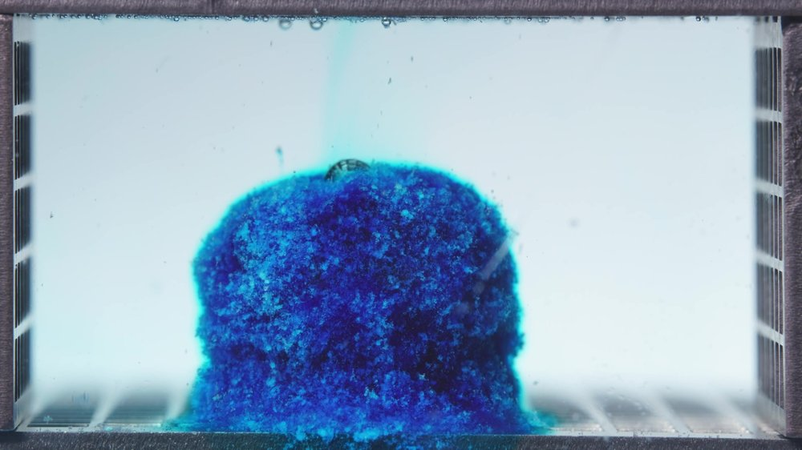  Low-viscosity formulation, 0.104-5 h image 1 | 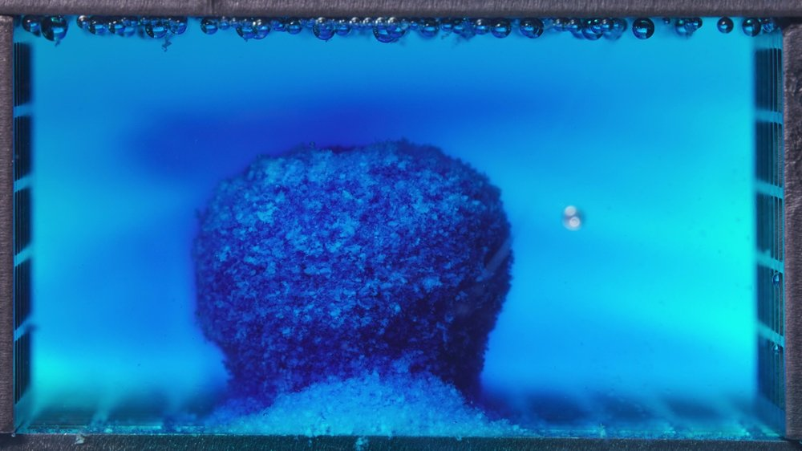  Low-viscosity formulation, 0.104-5 h image 2
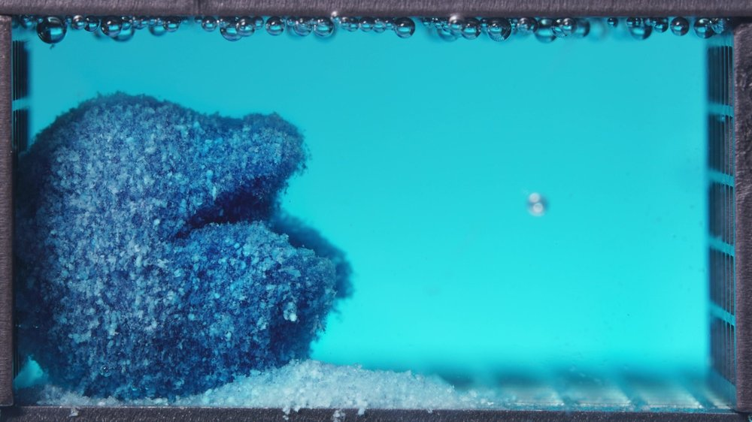
Low-viscosity formulation, 0.104-5 h image 3
Assistant
{
"group_id": "LOW-VISCOSITY",
"time_range_h": [0.104, 5],
"time_h": null,
"eight_dimension_description": {
"color_change": "Across this 0.104-5 h window, the tablet changes from a strongly blue, locally stained swollen body to a more extensively leached structure with lighter blue-white exposed regions. The dissolution medium becomes rapidly and broadly blue/cyan, indicating early and extensive dye diffusion rather than only localized release near the tablet surface.",
"shape_change": "The tablet initially retains a largely block-like or cylindrical outline, but the boundary is already softened and irregular. Later in the window, the structure shows obvious deformation, lateral collapse, and partial loss of the original compact outline, especially with material spreading along the bottom of the cell.",
"surface_texture_change": "The surface is rough, granular, and porous from the early images onward. Progressive loosening, flaking, and particulate shedding are visible, with the later image showing a much coarser, eroded surface and exposed lighter excipient-rich regions.",
"volume_change": "The apparent occupied volume first appears swollen and expanded relative to a compact tablet core, then transitions toward collapse and spreading. The visible mass does not simply shrink uniformly; it shows swell-then-erosion behavior, with lower-layer material accumulating as a sediment-like bed.",
"dissolution_speed_time": "Because no previous time window is available, direct rate comparison against an earlier stage is limited. Within this window, however, the low-viscosity formulation shows rapid early dye release, fast medium coloration, and clear structural weakening before 5 h.",
"physical_state_change": "The formulation transitions from a hydrated but still coherent swollen mass toward a loose, partially collapsed, gel-particle aggregate. The later image suggests substantial weakening of matrix integrity, with a mixture of swollen matrix, detached granules, and sedimented material.",
"dissolution_medium": "The medium changes from faint local blue diffusion to nearly uniform cyan-blue coloration across the visible chamber. Turbidity and suspended fine material increase near the tablet and bottom surface, while blue diffusion extends far beyond the immediate tablet boundary.",
"fragment_distribution_density": "Fragments and eroded material are initially concentrated around the tablet base. Later, a dense layer of detached blue-white particles accumulates along the bottom, with larger loosened matrix portions remaining close to the original tablet position and some fine material dispersed into the surrounding medium."
},
"notes_for_later_summary": "No previous-window comparison is available for this first low-viscosity batch. The critical observation is that substantial dye diffusion, surface roughening, base erosion, and partial matrix collapse are already evident within 0.104-5 h, indicating relatively fast early disintegration and release behavior."
}

6.25-11.25 h
User
These are pictures of the low-viscosity formulation during 6.25-11.25 h.
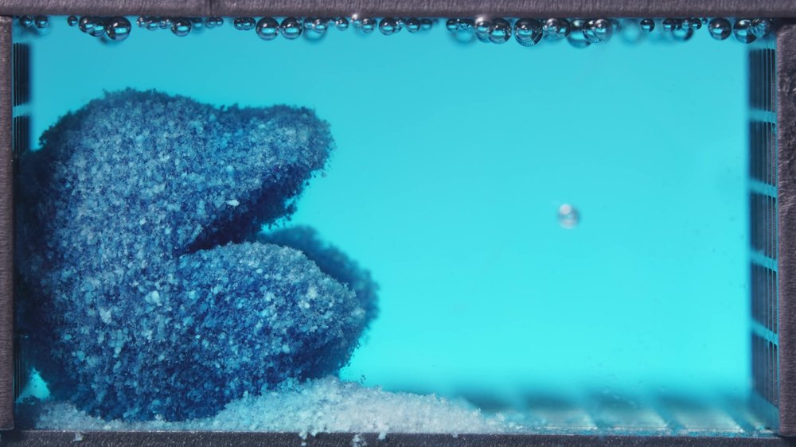  Low-viscosity formulation, 6.25-11.25 h image 1 | 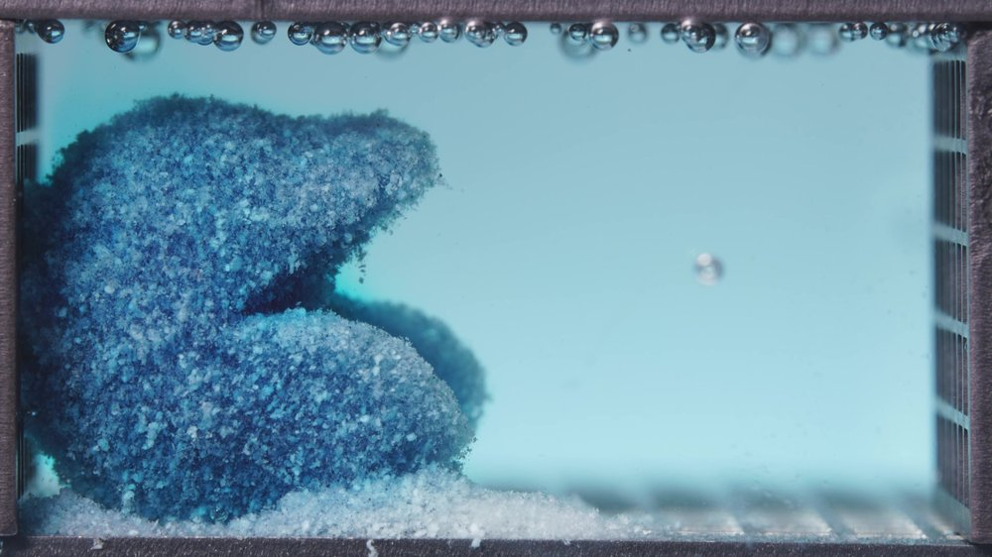  Low-viscosity formulation, 6.25-11.25 h image 2
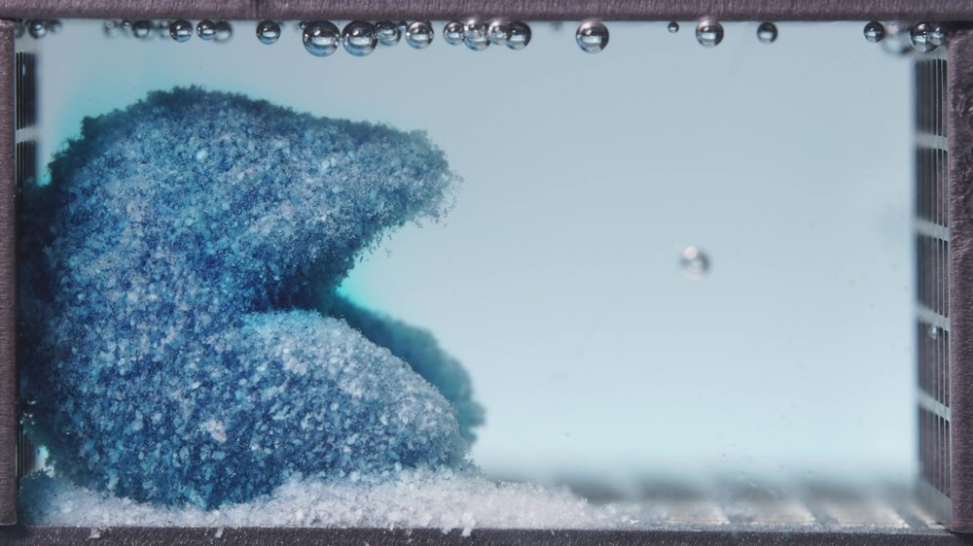
Low-viscosity formulation, 6.25-11.25 h image 3
Assistant
{
"group_id": "LOW-VISCOSITY",
"time_range_h": [6.25, 11.25],
"time_h": null,
"eight_dimension_description": {
"color_change": "Compared with the 0.104-5 h window, the tablet body appears less intensely dark blue and shows more extensive blue-white regions, indicating continued dye depletion from the matrix. The dissolution medium remains cyan-blue but is less visually saturated than the earlier strongly blue phase, suggesting that the most intense early dye diffusion has already occurred.",
"shape_change": "The original compact tablet outline is no longer preserved. The mass has collapsed laterally toward the left side of the cell, forming an irregular, layered mound with a protruding upper section and a lower eroded slope. Structural asymmetry and boundary loss are more advanced than in the previous window.",
"surface_texture_change": "The surface is highly rough, porous, granular, and friable. Fine particulate material covers most exposed surfaces, with extensive flaking and powder-like erosion. Compared with the previous window, the surface appears more depleted and mechanically loosened rather than merely swollen.",
"volume_change": "The visible occupied mass remains large, but its form has shifted from swollen block-like structure toward a collapsed and spread aggregate. The lower sediment bed is thicker and more continuous, indicating progressive redistribution of tablet material rather than uniform shrinkage.",
"dissolution_speed_time": "Relative to 0.104-5 h, the apparent disintegration rate has transitioned from rapid dye release and early matrix weakening to slower but continued structural erosion. The main change in this window is not abrupt new breakup, but sustained collapse, surface depletion, and accumulation of eroded particulate material.",
"physical_state_change": "The formulation now appears as a loose hydrated aggregate composed of weakened gel-like matrix, coarse granules, and fine sedimented particles. The coherent swollen mass seen earlier has progressed toward a partially collapsed, friable matrix with reduced structural integrity.",
"dissolution_medium": "The medium remains broadly blue-cyan, with mild haze and suspended fine material near the tablet and bottom region. Compared with the previous window, the medium no longer shows the same intense localized burst-like coloration; instead, it appears more evenly diluted while erosion products accumulate near the base.",
"fragment_distribution_density": "Detached material is densely concentrated along the bottom of the cell, forming a thick white-blue sediment layer extending from the original tablet region toward the right. Larger matrix fragments remain clustered near the left side, while smaller particles form a more diffuse boundary around the collapsed mass."
},
"notes_for_later_summary": "Most critical change versus the 0.104-5 h window: the low-viscosity formulation has moved from rapid early dye diffusion and swollen matrix weakening to an advanced collapsed aggregate with extensive surface depletion, a thicker sediment bed, and continued but less burst-like erosion during 6.25-11.25 h."
}

12.5-17.5 h
User
These are pictures of the low-viscosity formulation during 12.5-17.5 h.
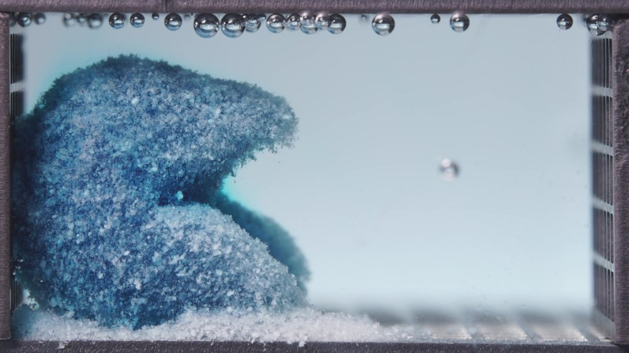  Low-viscosity formulation, 12.5-17.5 h image 1 | 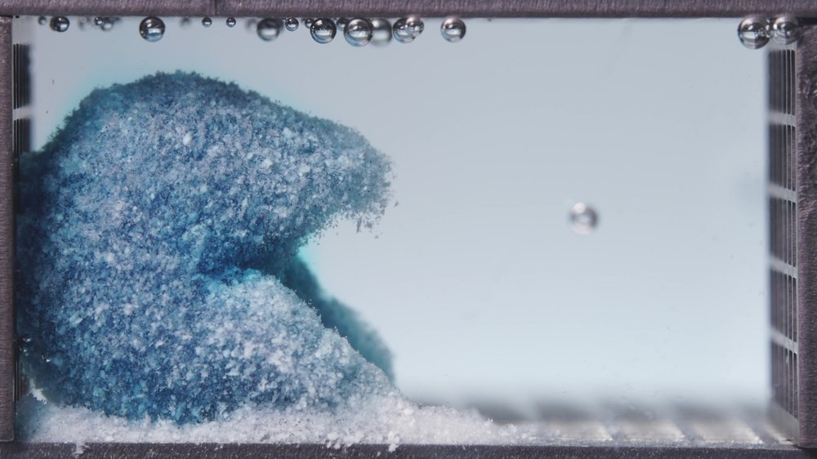  Low-viscosity formulation, 12.5-17.5 h image 2
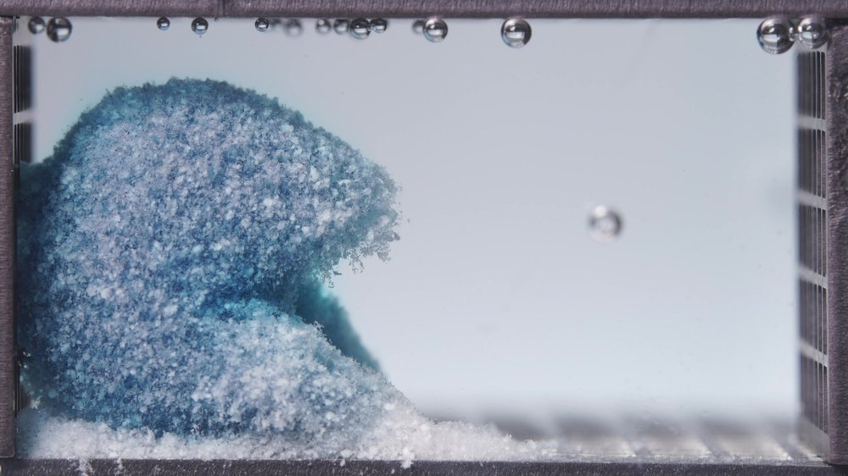
Low-viscosity formulation, 12.5-17.5 h image 3
Assistant
{
"group_id": "LOW-VISCOSITY",
"time_range_h": [12.5, 17.5],
"time_h": null,
"eight_dimension_description": {
"color_change": "Compared with the 6.25-11.25 h window, the residual tablet mass is further decolorized, with more extensive pale blue-white regions and fewer intensely dark blue zones. The surrounding medium appears much lighter and closer to pale cyan or nearly colorless, indicating that the earlier strong dye diffusion phase has largely diminished.",
"shape_change": "The original tablet geometry remains completely lost. The residual structure persists as a collapsed, irregular mound on the left side, with an upper rounded overhang and a lower sloped eroded region. Compared with the previous window, the mass appears more rounded, depleted, and consolidated into a residual aggregate rather than an actively expanding swollen body.",
"surface_texture_change": "The surface remains highly rough, porous, and granular, with dense fine particulate coverage. White or pale excipient-rich material is more dominant than in the previous window, and the surface has a friable, powdery appearance with fine edge shedding, especially around the upper-right boundary of the mound.",
"volume_change": "The visible occupied volume remains substantial, but there is no evidence of renewed swelling. The structure shows continued collapse and erosion, while the bottom sediment layer remains thick and extends rightward along the base. Overall volume reduction is gradual rather than abrupt during this window.",
"dissolution_speed_time": "Compared with 6.25-11.25 h, the apparent disintegration rate has slowed further. The dominant process is late-stage erosion and depletion of the residual matrix rather than rapid dye release or major new structural breakup.",
"physical_state_change": "The formulation appears as a weakened hydrated aggregate composed of residual gel-like matrix, coarse granules, and fine sedimented particles. The system has progressed beyond the swollen-matrix stage into a late eroded state, but a large cohesive residual mass still remains.",
"dissolution_medium": "The medium is much less intensely colored than in earlier windows, with only faint cyan-blue tint and mild haze near the residual mass and bottom sediment. The right side of the chamber appears relatively clear, suggesting reduced ongoing dye liberation compared with the early and mid-stage windows.",
"fragment_distribution_density": "Fragments remain highly concentrated near the original tablet location on the left and along the bottom surface. A dense pale sediment bed persists at the base, while small detached particles and diffuse eroded material are visible around the mound boundary. Broad dispersion into the full chamber is limited at this stage."
},
"notes_for_later_summary": "Most critical change versus the 6.25-11.25 h window: the low-viscosity formulation has entered a slower late-eroded phase, with markedly reduced medium coloration, increased pale matrix depletion, persistent bottom sediment, and a large but weakened residual aggregate still localized on the left side."
}

18.75-23.75 h
User
These are pictures of the low-viscosity formulation during 18.75-23.75 h.
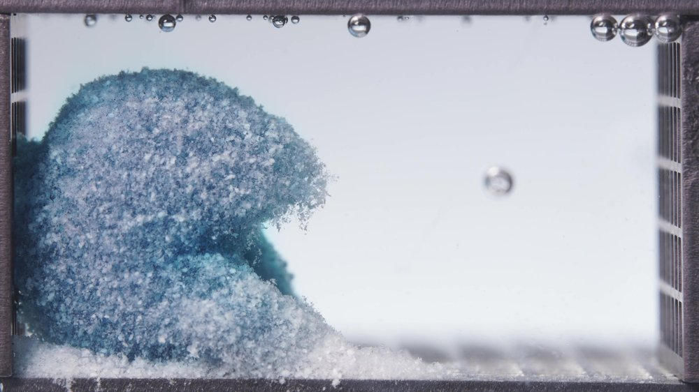  Low-viscosity formulation, 18.75-23.75 h image 1 | 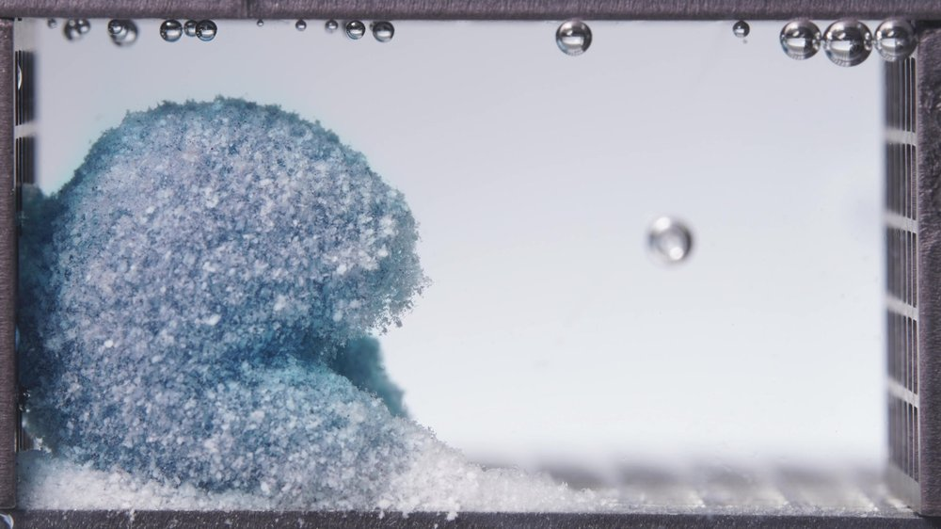  Low-viscosity formulation, 18.75-23.75 h image 2
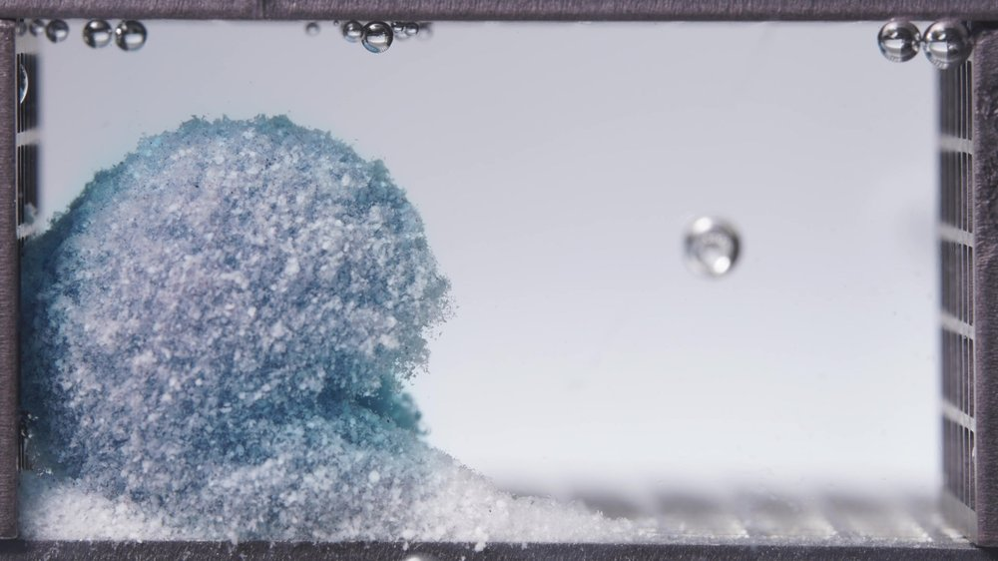
Low-viscosity formulation, 18.75-23.75 h image 3
Assistant
{
"group_id": "LOW-VISCOSITY",
"time_range_h": [18.75, 23.75],
"time_h": null,
"eight_dimension_description": {
"color_change": "Compared with the 12.5-17.5 h window, the residual tablet mass is further depleted in blue color, with pale blue, gray-blue, and white regions becoming dominant. Dark blue zones persist only in limited internal or lower-left areas. The surrounding dissolution medium is nearly colorless to very faintly bluish, indicating minimal visible ongoing dye diffusion at this late stage.",
"shape_change": "The original tablet shape remains completely absent. The residual mass persists as a large, collapsed mound localized on the left side, but the outline appears more rounded and eroded than in the previous window. The lower front slope and upper boundary show continued softening, with no recovery of a compact tablet-like geometry.",
"surface_texture_change": "The surface is extremely rough, porous, and powder-like, with dense pale particulate coverage across nearly the entire residual mass. Compared with the previous window, the surface appears more uniformly friable and decolorized, with fine edge shedding and a fuzzy, eroded boundary especially on the right-facing side.",
"volume_change": "The visible residual volume remains substantial, but the structure shows continued late-stage collapse and compaction rather than swelling. The mound height and occupied region appear slightly reduced or more rounded compared with the previous window, while the bottom sediment layer remains thick and continuous.",
"dissolution_speed_time": "Compared with 12.5-17.5 h, the apparent disintegration rate is slow. The dominant process is residual matrix erosion, surface depletion, and gradual particulate shedding, rather than rapid breakup or strong dye release.",
"physical_state_change": "The formulation is now in a late residual state composed of a weakened hydrated matrix, coarse pale granules, fine powder-like particles, and sedimented material. The coherent gel-like structure is largely depleted, but a sizable residual aggregate remains localized rather than fully dispersing.",
"dissolution_medium": "The medium is mostly clear or only faintly hazy, with very weak blue coloration. Suspended material is limited mainly to the region close to the mound and bottom sediment. The right side of the chamber appears comparatively clear, supporting reduced late-stage release intensity.",
"fragment_distribution_density": "Detached material remains densely concentrated along the bottom surface and around the left-side residual mass. The sediment bed is pale, thick, and continuous, extending rightward from the mound. Fine fragments are present at the eroded boundary, but broad chamber-wide dispersion is limited."
},
"notes_for_later_summary": "Most critical change versus the 12.5-17.5 h window: the low-viscosity formulation has reached a late depleted residual phase, with near-clear medium, dominant pale matrix material, slow ongoing erosion, persistent bottom sediment, and a large localized residual mound still present at 24 h."
}

Standard formulation: Image-Analysis Sequence

0.104-5 h
User
These are pictures of the standard formulation during 0.104-5 h.
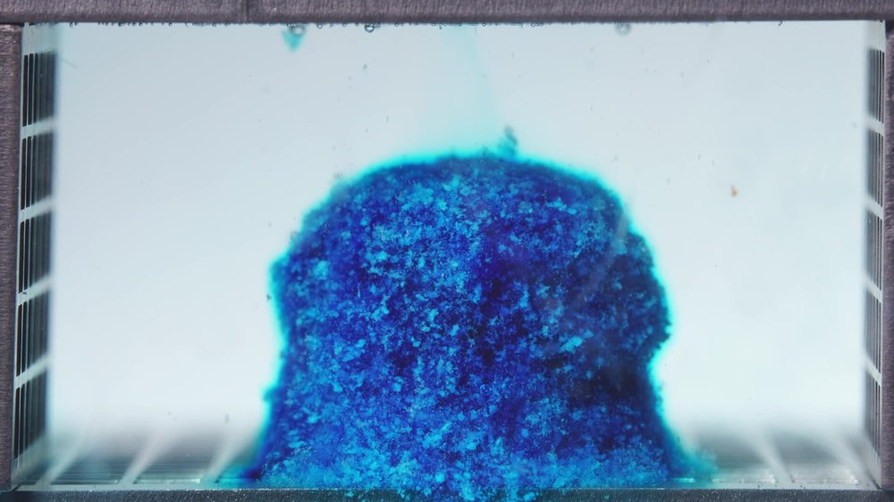  Standard formulation, 0.104-5 h image 1 | 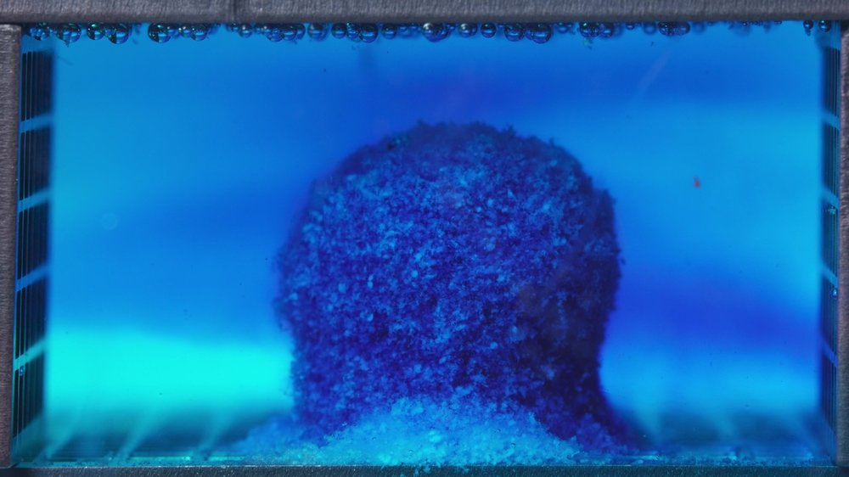  Standard formulation, 0.104-5 h image 2
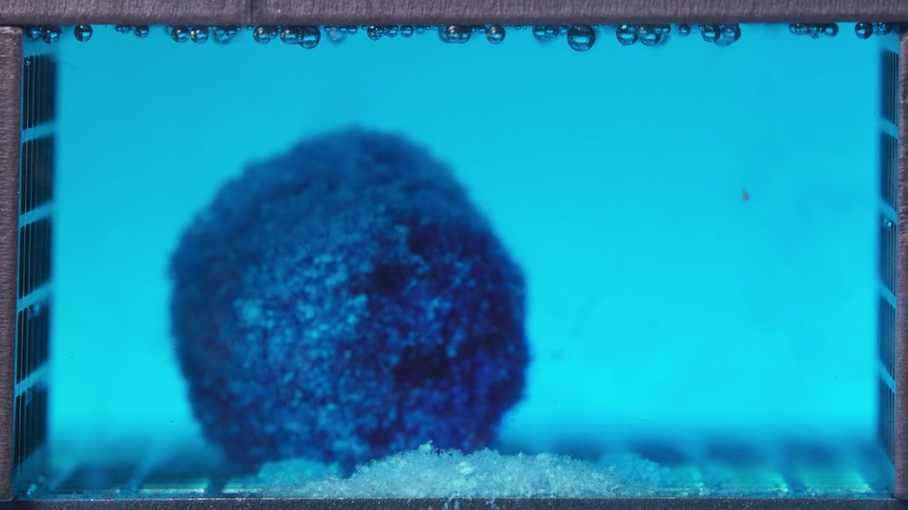
Standard formulation, 0.104-5 h image 3
Assistant
{
"group_id": "STANDARD",
"time_range_h": [0.104, 5],
"time_h": null,
"eight_dimension_description": {
"color_change": "During 0.104-5 h, the tablet remains predominantly dark blue to blue-cyan, while the surrounding medium changes from nearly clear with localized blue diffusion to broadly cyan-blue. The lower region near the tablet base becomes lighter blue-white, suggesting early leaching or exposure of less intensely stained matrix material.",
"shape_change": "The tablet initially retains a compact cylindrical or block-like outline with a softened boundary. By the later images in this window, the body remains largely coherent and upright, but the lower edge is visibly eroded and the outline becomes more rounded and less sharply defined.",
"surface_texture_change": "The surface is rough and granular from the beginning, with visible porous and particulate features. Over the window, the outer surface becomes more irregular and fuzzy, especially near the base and peripheral boundary, but large-scale cracking or complete breakup is not evident.",
"volume_change": "The visible tablet volume appears swollen and hydrated rather than rapidly reduced. The main body remains substantial through the window, while a pale particulate layer accumulates at the bottom, indicating material redistribution from the tablet surface or base rather than uniform shrinkage.",
"dissolution_speed_time": "Because no previous standard-formulation time window is available, direct comparison with an earlier standard-formulation stage is limited. Within this window, medium coloration develops rapidly, but structural disintegration remains moderate: dye release and surface erosion are evident while the main matrix remains coherent.",
"physical_state_change": "The tablet transitions from a compact hydrated solid toward a swollen, rough, gel-like matrix with early surface loosening. Detached fine material appears at the base, but the central mass remains mostly intact rather than collapsing into multiple large fragments.",
"dissolution_medium": "The medium shifts from almost clear to uniformly blue-cyan across the chamber. A stronger blue zone forms around the tablet during the middle of the window, followed by a more even cyan coloration. Mild turbidity is visible near the tablet base and bottom region.",
"fragment_distribution_density": "Detached material is mainly concentrated at the tablet base, forming a pale blue-white sediment layer along the bottom. Fine fragments remain localized near the original tablet position, with limited wide dispersion of visible solid particles into the full chamber."
},
"notes_for_later_summary": "No previous standard-formulation window is available for direct comparison. The critical observation in 0.104-5 h is rapid medium coloration with clear early surface and base erosion, while the main standard-formulation matrix remains upright, swollen, and largely coherent."
}

6.25-11.25 h
User
These are pictures of the standard formulation during 6.25-11.25 h.
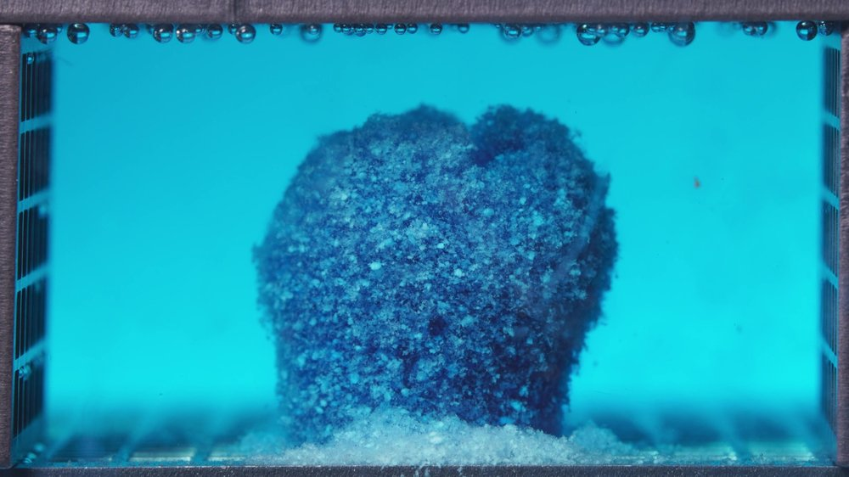  Standard formulation, 6.25-11.25 h image 1 | 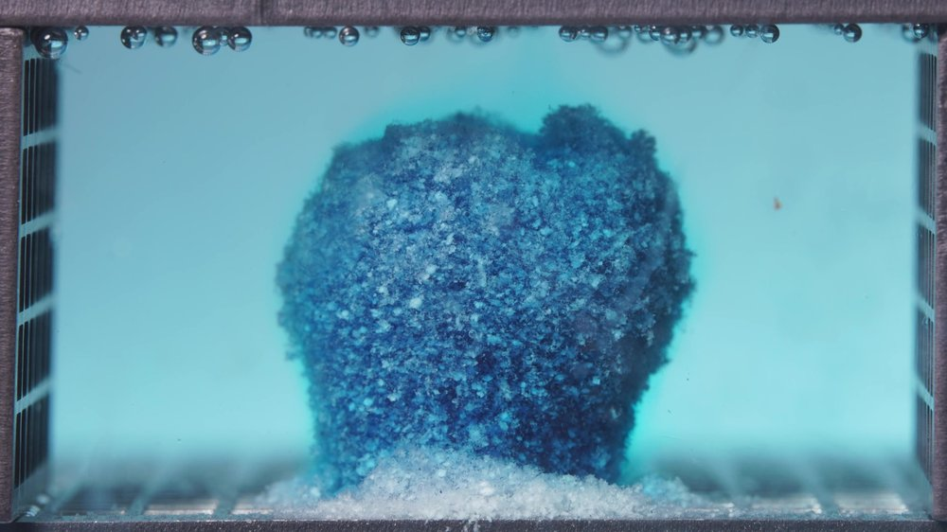  Standard formulation, 6.25-11.25 h image 2
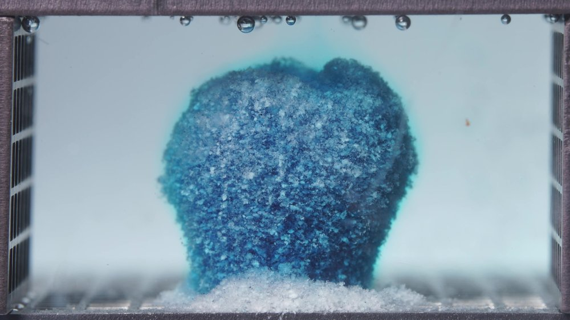
Standard formulation, 6.25-11.25 h image 3
Assistant
{
"group_id": "STANDARD",
"time_range_h": [6.25, 11.25],
"time_h": null,
"eight_dimension_description": {
"color_change": "Compared with the 0.104-5 h window, the tablet surface shows more pale blue-white regions, especially on the front and upper exposed surfaces, while dark blue areas remain within the matrix. The surrounding medium remains blue-cyan but appears less intensely saturated in the later images of this window, suggesting that the strongest visible dye diffusion occurred earlier.",
"shape_change": "The tablet remains largely upright and coherent, with the original compact body still recognizable. However, the top edge is more irregular, the lateral boundaries are softened, and the base shows clearer erosion. Compared with the previous window, there is no major collapse, but the outline is increasingly rounded and roughened.",
"surface_texture_change": "The surface is coarse, porous, and granular, with a fuzzy eroded boundary. Pale particulate material is more prominent than in the previous window, and the lower front surface shows stronger powder-like accumulation. The surface appears progressively loosened but not fully fragmented.",
"volume_change": "The visible main body remains substantial, indicating continued matrix integrity. The tablet appears swollen and rounded rather than sharply reduced in size. A thicker pale sediment layer is present at the base compared with the previous window, indicating gradual material loss from the matrix surface and lower region.",
"dissolution_speed_time": "Compared with 0.104-5 h, the disintegration appears to have shifted from rapid early medium coloration and initial base erosion to a slower, sustained erosion phase. The main matrix remains intact, so structural breakdown is moderate rather than rapid.",
"physical_state_change": "The formulation remains a hydrated, swollen, gel-like matrix with a coherent central mass. Detached fine particles and pale eroded material are increasingly visible at the base, but the tablet has not transitioned into a collapsed aggregate or multiple large fragments.",
"dissolution_medium": "The medium remains broadly cyan-blue with mild haze near the tablet and bottom sediment. The coloration is more evenly distributed than in the early window, while the area immediately around the tablet base shows localized turbidity and suspended fine material.",
"fragment_distribution_density": "Fragments remain mainly concentrated at the bottom directly in front of and around the tablet. A pale blue-white sediment bed is thicker and more continuous than in the previous window, but most visible solid material remains localized near the original tablet position rather than dispersing throughout the chamber."
},
"notes_for_later_summary": "Most critical change versus the 0.104-5 h window: the standard formulation remains upright and coherent, but surface decolorization, base erosion, and bottom sediment accumulation have increased. The behavior suggests sustained moderate erosion after the early dye-release phase, without the extensive collapse seen in the low-viscosity formulation over comparable time windows."
}

12.5-17.5 h
User
These are pictures of the standard formulation during 12.5-17.5 h.
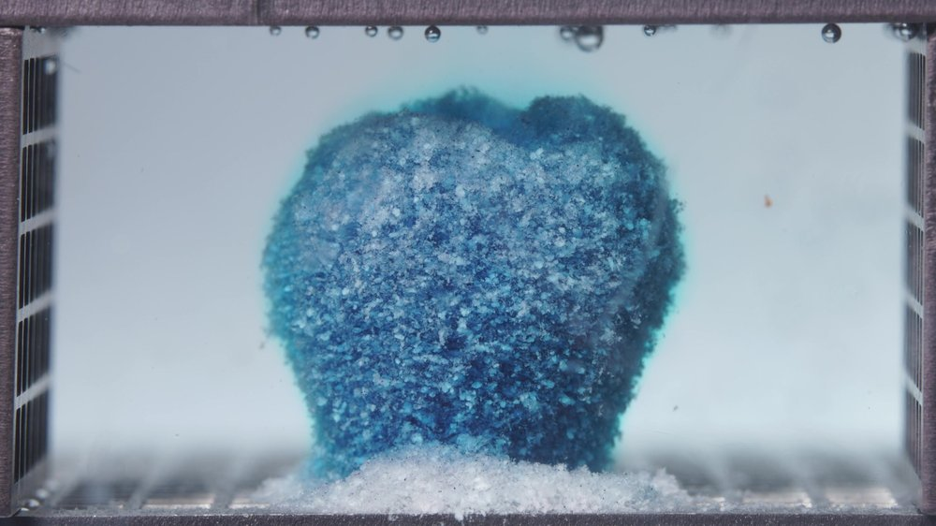  Standard formulation, 12.5-17.5 h image 1 | 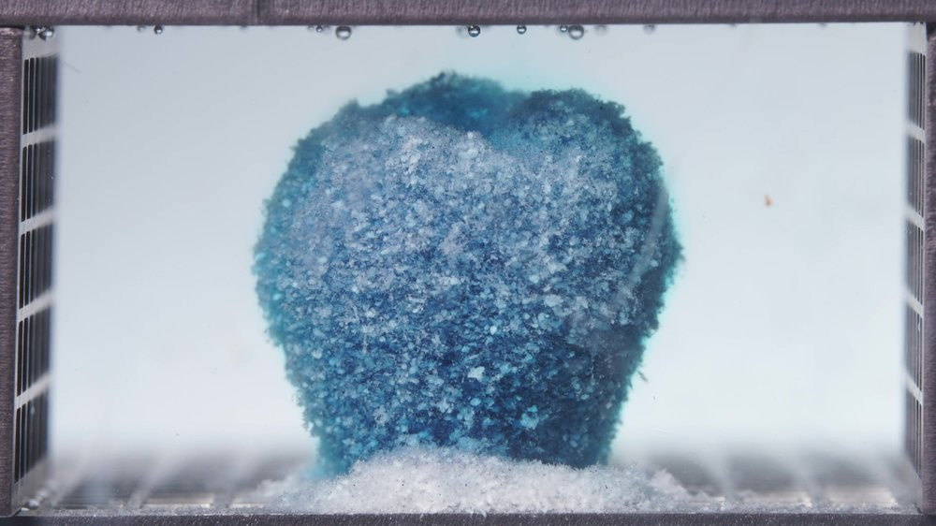  Standard formulation, 12.5-17.5 h image 2
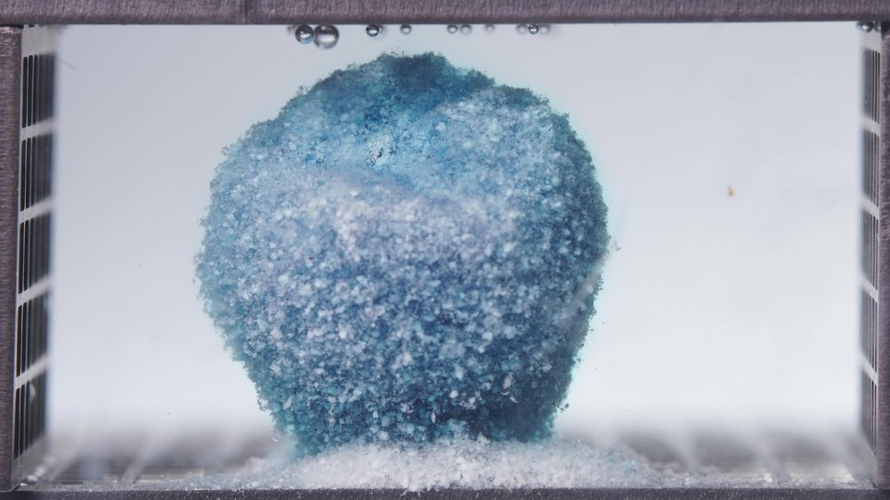
Standard formulation, 12.5-17.5 h image 3
Assistant
{
"group_id": "STANDARD",
"time_range_h": [12.5, 17.5],
"time_h": null,
"eight_dimension_description": {
"color_change": "Compared with the 6.25-11.25 h window, the standard formulation shows further color depletion on the surface, with larger pale blue-white areas over the front and upper regions. Darker blue zones remain mainly in deeper or lateral regions of the matrix. The surrounding medium is now much lighter, shifting from cyan-blue toward faint blue or nearly clear, indicating reduced visible dye release during this later window.",
"shape_change": "The tablet remains largely upright and coherent, and the original cylindrical or block-like body is still recognizable. The outline is more rounded and eroded than in the previous window, with a slightly uneven top boundary and softened lateral edges, but there is still no major lateral collapse or fragmentation into large separated pieces.",
"surface_texture_change": "The surface is highly rough, porous, granular, and powder-covered. Pale particulate material is more extensive than in the previous window, especially over the upper-front surface. The boundary appears fuzzy and eroded, consistent with sustained surface attrition rather than abrupt mechanical breakup.",
"volume_change": "The visible main body remains substantial, suggesting that the hydrated matrix still retains considerable structural integrity. Compared with 6.25-11.25 h, there is gradual rounding and surface depletion, but no marked volume collapse. The bottom sediment layer remains thick and prominent.",
"dissolution_speed_time": "Compared with 6.25-11.25 h, the apparent disintegration rate has slowed. The dominant change is progressive surface decolorization, matrix depletion, and sediment accumulation rather than rapid dye diffusion or large-scale structural failure.",
"physical_state_change": "The formulation remains a swollen, hydrated, gel-like matrix with a coherent central mass. The outer layer is increasingly friable and particulate, while the internal structure still appears sufficiently cohesive to maintain an upright residual body.",
"dissolution_medium": "The medium is much less intensely colored than in earlier standard-formulation windows, with only faint cyan tint and mild haze around the matrix and bottom sediment. The broader chamber appears relatively clear, supporting reduced ongoing dye liberation.",
"fragment_distribution_density": "Detached material remains concentrated near the tablet base, forming a thick pale blue-white sediment bed in front of the main matrix. Fine particles are present around the eroded boundary, but visible solid fragments remain localized rather than broadly dispersed throughout the chamber."
},
"notes_for_later_summary": "Most critical change versus the 6.25-11.25 h window: the standard formulation remains upright and structurally coherent, but has entered a slower depletion phase with increased pale surface coverage, reduced medium coloration, and persistent localized bottom sediment."
}

18.75-23.75 h
User
These are pictures of the standard formulation during 18.75-23.75 h.
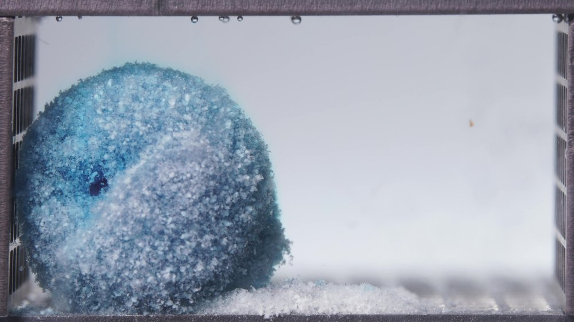  Standard formulation, 18.75-23.75 h image 1 | 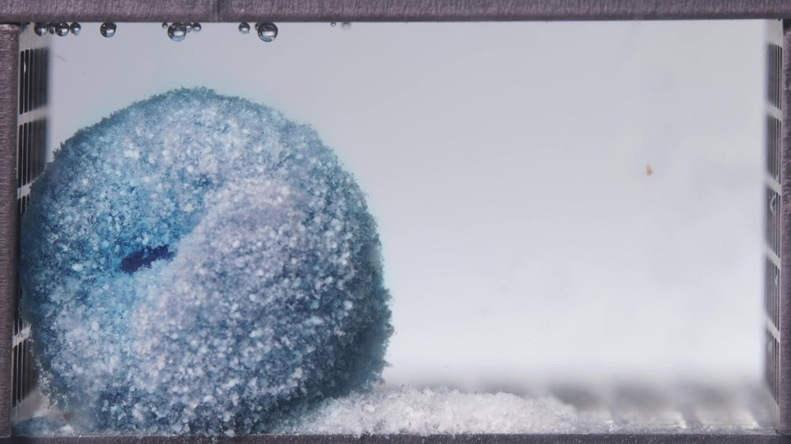  Standard formulation, 18.75-23.75 h image 2
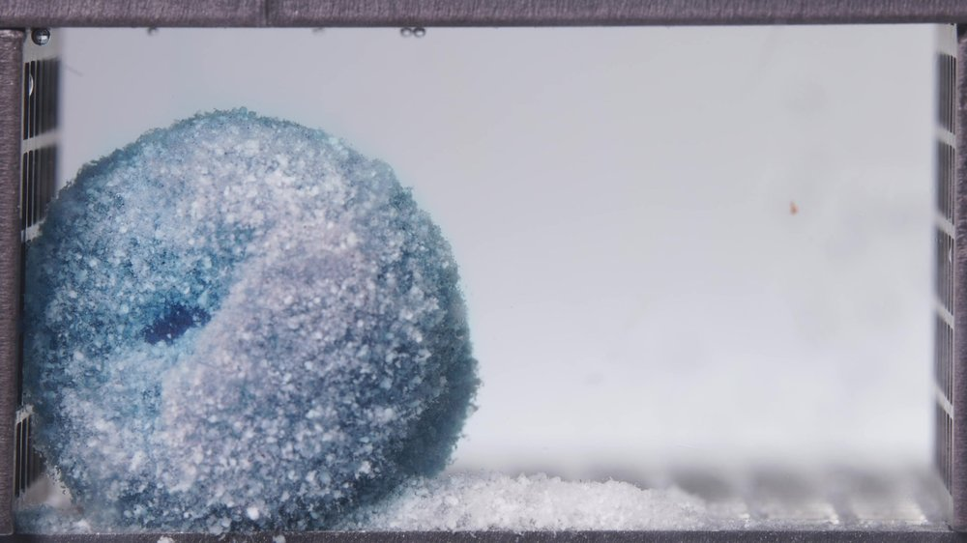
Standard formulation, 18.75-23.75 h image 3
Assistant
{
"group_id": "STANDARD",
"time_range_h": [18.75, 23.75],
"time_h": null,
"eight_dimension_description": {
"color_change": "Compared with the 12.5-17.5 h window, the residual standard-formulation matrix is further decolorized. Pale blue-white and gray-white regions dominate the exposed surface, while dark blue areas remain only as localized patches, especially in deeper or lower regions. The surrounding medium is nearly clear with only faint residual bluish tint, indicating very limited visible late-stage dye diffusion.",
"shape_change": "The original tablet outline is still absent, but the residual body remains as a large coherent rounded mound rather than a fully dispersed particle bed. Compared with the previous window, the mass appears more eroded, more rounded, and slightly more laterally settled toward the left side, with softened boundaries and no sharp cylindrical geometry.",
"surface_texture_change": "The surface is extremely rough, porous, and powder-covered. Pale particulate material is more dominant than in the previous window, giving the surface a friable, crust-like appearance. The outer boundary is fuzzy and irregular, with fine material shedding from the eroded surface.",
"volume_change": "The main residual volume remains substantial, but there is gradual late-stage compaction and rounding rather than active swelling. The bottom sediment layer remains thick and continuous, indicating continued redistribution of eroded matrix material from the body to the base.",
"dissolution_speed_time": "Compared with 12.5-17.5 h, the apparent disintegration rate is slow. The dominant visible process is residual matrix depletion, surface erosion, and sediment maintenance rather than rapid dye release, abrupt collapse, or large-scale fragmentation.",
"physical_state_change": "The formulation remains as a weakened hydrated matrix with a coherent residual core, surrounded by coarse granules and fine powder-like particles. The system is in a late eroded state: the outer layer is highly friable, but the inner matrix still maintains a large localized aggregate.",
"dissolution_medium": "The dissolution medium is mostly clear to faintly hazy, with minimal blue coloration. Visible turbidity is concentrated near the residual mound and bottom sediment rather than distributed throughout the chamber. The right side of the chamber is comparatively clear.",
"fragment_distribution_density": "Detached material remains concentrated at the base, forming a dense pale sediment bed in front of and around the residual mass. Fine fragments are present along the eroded surface and lower boundary, but there is limited broad dispersion of visible particles across the chamber."
},
"notes_for_later_summary": "Most critical change versus the 12.5-17.5 h window: the standard formulation has progressed into a late depleted residual phase, with near-clear medium, stronger pale surface coverage, persistent thick bottom sediment, and a large coherent rounded matrix still present at 24 h."
}

High-viscosity formulation: Image-Analysis Sequence

0.104-5 h
User
These are pictures of the high-viscosity formulation during 0.104-5 h.
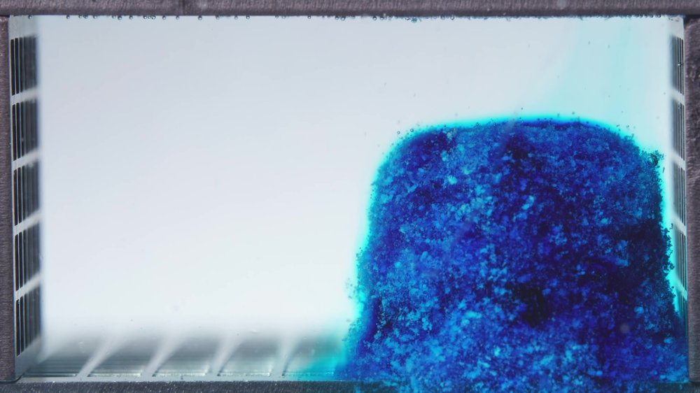  High-viscosity formulation, 0.104-5 h image 1 | 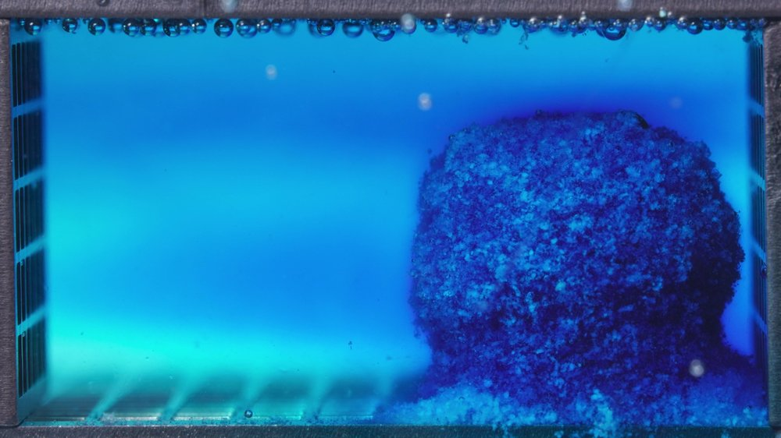  High-viscosity formulation, 0.104-5 h image 2
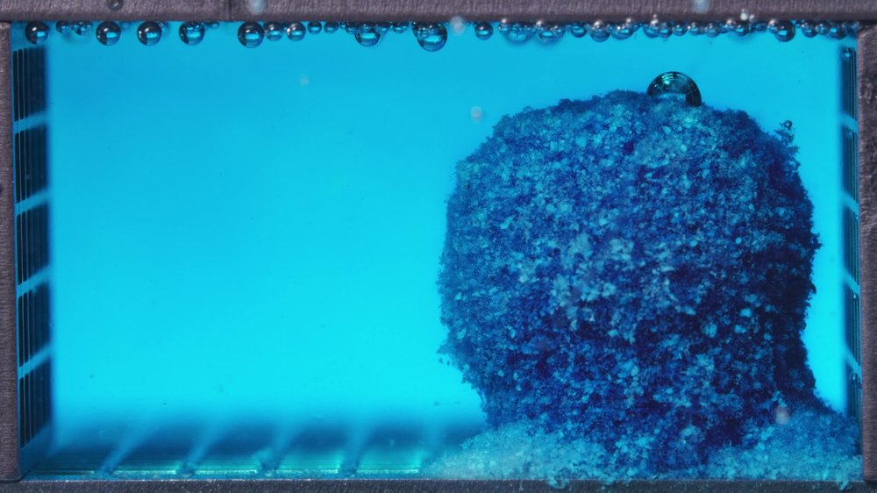
High-viscosity formulation, 0.104-5 h image 3
Assistant
{
"group_id": "HIGH-VISCOSITY",
"time_range_h": [0.104, 5],
"time_h": null,
"eight_dimension_description": {
"color_change": "During 0.104-5 h, the tablet remains predominantly dark blue to blue-cyan, with only limited pale blue-white exposure near the base and some surface regions. The dissolution medium changes from mostly clear with localized blue diffusion to broadly cyan-blue, indicating appreciable dye release, but the tablet body retains strong internal coloration through the window.",
"shape_change": "The tablet retains a largely coherent, upright, block-like or cylindrical outline throughout this window. The edges become softened and rounded, but there is no major lateral collapse or large-scale fragmentation. The body remains localized near its original position.",
"surface_texture_change": "The surface is rough, granular, and porous from the early image onward. Over the window, the external layer becomes fuzzier and more hydrated, with visible fine particulate shedding near the base and edges. Large cracks are not dominant; the main feature is progressive surface roughening and gel-layer formation.",
"volume_change": "The visible volume appears swollen and expanded rather than reduced. The main mass remains large and compact, while a pale blue-white sediment layer gradually accumulates at the bottom. There is no clear evidence of major shrinkage or collapse during this early window.",
"dissolution_speed_time": "Because no previous high-viscosity time window is available, direct rate comparison against an earlier stage is limited. Within this window, dye diffusion into the medium is evident, but structural disintegration appears restrained: the matrix remains cohesive and upright despite surface erosion.",
"physical_state_change": "The tablet transitions from a compact hydrated solid into a swollen, gel-like matrix with a roughened outer layer. Detached fine particles are visible near the base, but the central structure remains coherent and does not convert into a loose collapsed aggregate within this window.",
"dissolution_medium": "The medium progresses from nearly clear to broadly cyan-blue, with stronger coloration around the tablet and upper chamber by the later images. Mild turbidity and suspended fine material are present near the tablet surface and base, but visible solid dispersion remains relatively localized.",
"fragment_distribution_density": "Fragments and eroded material are mainly concentrated around the tablet base and lower edge, forming a pale sediment layer. Larger fragments are not widely separated from the main body. Fine particles remain close to the original tablet position, with limited broad chamber-wide solid dispersion."
},
"notes_for_later_summary": "No previous-window comparison is available for this first high-viscosity batch. The critical observation is that dye release into the medium occurs during 0.104-5 h, but the high-viscosity matrix remains upright, swollen, and structurally cohesive, with only localized surface erosion and basal sediment formation."
}

6.25-11.25 h
User
These are pictures of the high-viscosity formulation during 6.25-11.25 h.
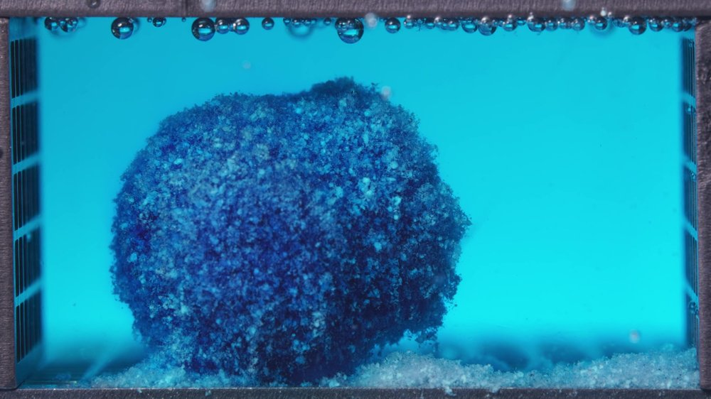  High-viscosity formulation, 6.25-11.25 h image 1 | 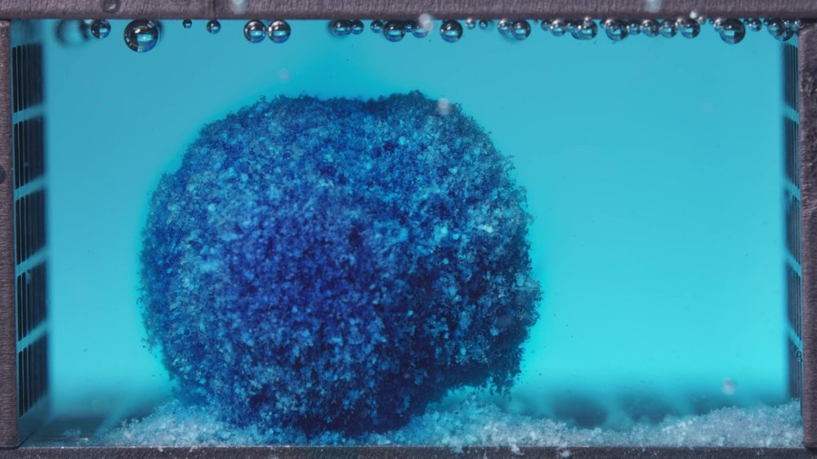  High-viscosity formulation, 6.25-11.25 h image 2
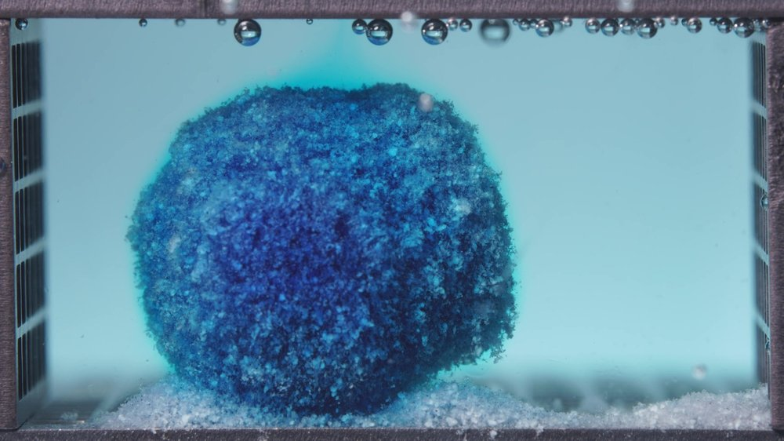
High-viscosity formulation, 6.25-11.25 h image 3
Assistant
{
"group_id": "HIGH-VISCOSITY",
"time_range_h": [6.25, 11.25],
"time_h": null,
"eight_dimension_description": {
"color_change": "Compared with the 0.104-5 h window, the high-viscosity tablet still retains strong dark blue coloration within the main matrix, although pale blue-white regions are more visible on the surface and lower eroded areas. The surrounding medium remains cyan-blue, but the coloration appears more even and less burst-like than the early window.",
"shape_change": "The tablet remains largely coherent and rounded, with the main body still localized near the original position. The original sharp cylindrical or block-like geometry is softened, but there is no major lateral collapse, splitting, or separation into large fragments. Compared with the previous window, the outline is more swollen and rounded rather than structurally failed.",
"surface_texture_change": "The surface remains rough, porous, granular, and fuzzy, with visible hydrated gel-like outer material. Pale particulate deposits are more apparent than in the previous window, especially near the lower front and base, but the outer layer remains attached to a cohesive central matrix.",
"volume_change": "The visible main body remains large and appears swollen, with no clear major volume loss. Compared with 0.104-5 h, the mass appears more rounded and expanded, while a thicker sediment layer has accumulated along the bottom. This suggests continued hydration and surface erosion without substantial collapse.",
"dissolution_speed_time": "Compared with 0.104-5 h, the apparent disintegration rate remains restrained. Early dye diffusion has already occurred, but the structural breakdown during 6.25-11.25 h is slower and mainly limited to surface erosion, outer-layer loosening, and basal sediment formation.",
"physical_state_change": "The formulation remains a swollen, hydrated, gel-like matrix with a coherent core. The outer surface is increasingly friable and particulate, but the system has not transitioned into a loose collapsed aggregate. Matrix integrity is stronger than would be expected for a rapidly eroding formulation.",
"dissolution_medium": "The medium remains broadly cyan-blue with mild haze, especially near the tablet and bottom region. Compared with the early window, the color field is more uniform and less dominated by localized intense release zones. Suspended fine material is present near the surface and base but is not widely dense across the chamber.",
"fragment_distribution_density": "Detached material is concentrated mainly along the bottom surface around and in front of the tablet, forming a pale blue-white sediment bed that is thicker than in the previous window. Larger fragments remain attached or close to the main matrix, while fine particles are mostly localized near the original tablet region."
},
"notes_for_later_summary": "Most critical change versus the 0.104-5 h window: the high-viscosity formulation shows increased surface depletion and bottom sediment accumulation, but the main matrix remains swollen, rounded, dark-blue, and structurally cohesive, indicating slower erosion and stronger gel-matrix integrity than the low-viscosity and standard formulations at comparable stages."
}

12.5-17.5 h
User
These are pictures of the high-viscosity formulation during 12.5-17.5 h.
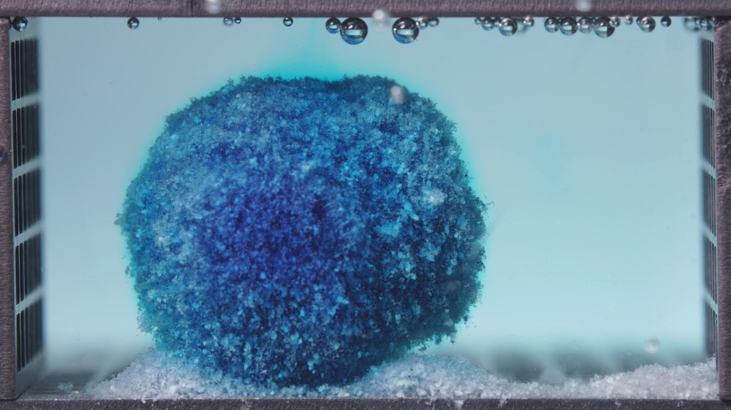  High-viscosity formulation, 12.5-17.5 h image 1 | 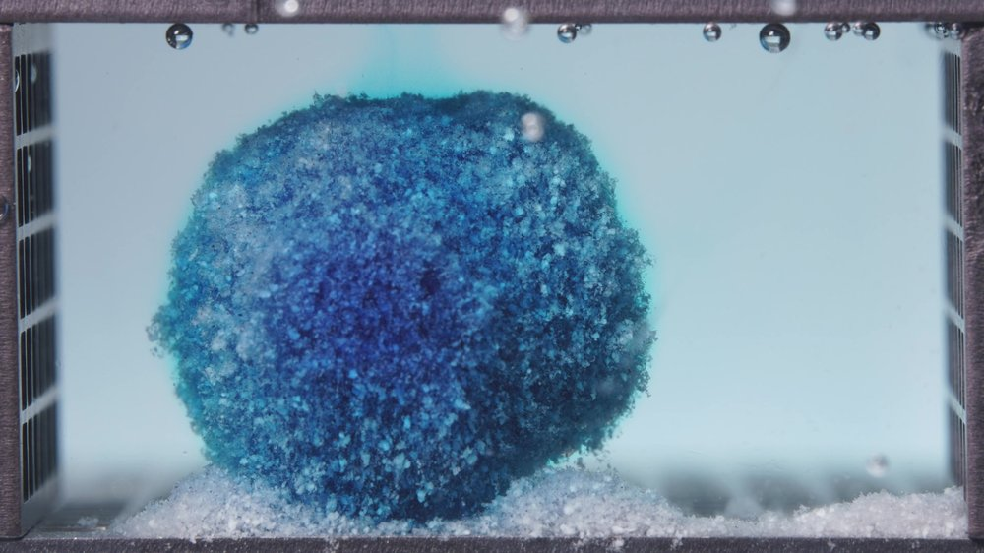  High-viscosity formulation, 12.5-17.5 h image 2
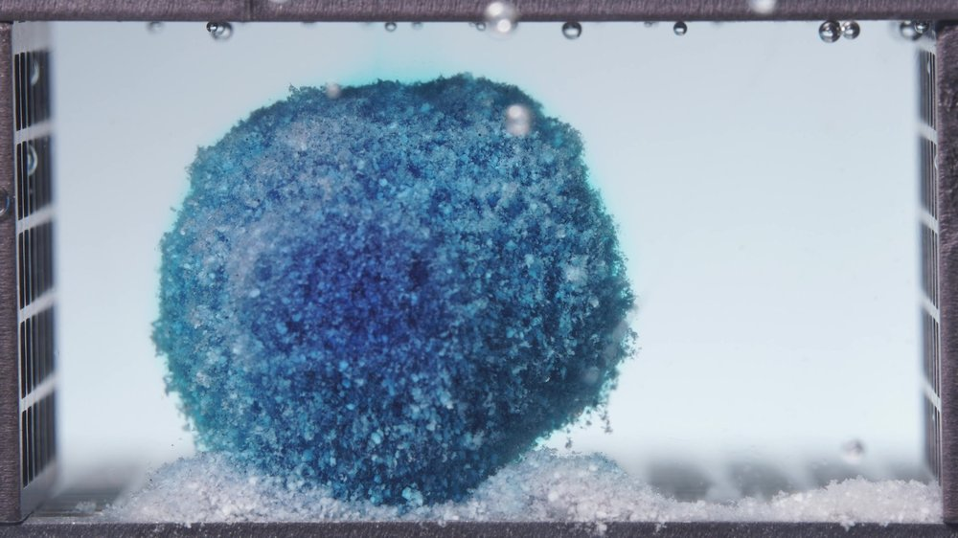
High-viscosity formulation, 12.5-17.5 h image 3
Assistant
{
"group_id": "HIGH-VISCOSITY",
"time_range_h": [12.5, 17.5],
"time_h": null,
"eight_dimension_description": {
"color_change": "The high-viscosity formulation still retains a strongly blue-stained main matrix, with a dark blue core and increasingly visible pale blue to blue-white regions across the outer surface. Compared with the 6.25-11.25 h window, the color contrast between the darker interior and the lighter outer layer is more apparent, suggesting continued outward depletion and slow release rather than rapid washout.",
"shape_change": "The tablet remains highly coherent and broadly rounded, with only modest contour softening. Its overall geometry is still close to a swollen spherical or dome-like mass, without obvious cracking, splitting, or gross collapse. Relative to the previous window, the outline appears slightly more regularized and compacted, but the gross structure is still well preserved.",
"surface_texture_change": "The surface remains rough, porous, fuzzy, and granular, consistent with a hydrated gel-matrix exterior undergoing slow erosion. Fine particulate texture is evident over the entire visible surface, and the outer layer appears somewhat more diffuse and softened than before, but still attached to the main body rather than peeling away as large fragments.",
"volume_change": "The visible main body remains large, indicating that the formulation has preserved substantial bulk. Any volume loss appears limited and gradual. Compared with 6.25-11.25 h, there may be slight surface attrition and minor reshaping, but no major shrinkage or collapse is evident.",
"dissolution_speed_time": "Dissolution/disintegration during 12.5-17.5 h still appears slow and controlled. The dominant process is continued surface erosion with sustained internal matrix integrity. Compared with the earlier windows, the release behavior remains restrained, consistent with prolonged gel-barrier control rather than fast structural disintegration.",
"physical_state_change": "The formulation remains in a swollen, hydrated, gel-supported solid state with a cohesive core. The exterior is increasingly friable at the microscopic level, but the bulk tablet has not transitioned into a loose aggregate or fragmented debris field. This indicates persistent matrix strength and sustained resistance to breakdown.",
"dissolution_medium": "The surrounding medium appears relatively pale and only lightly blue-tinted, with much less intense local color pluming than in early-stage release. This suggests that active release into the medium is ongoing but not explosive. The chamber remains visually clearer than would be expected for a rapidly eroding system.",
"fragment_distribution_density": "Detached material is concentrated mainly at the base, where a thicker pale blue-white particulate sediment layer is visible around the lower perimeter of the tablet. Compared with 6.25-11.25 h, the amount of basal deposited material appears increased, but most of the mass remains incorporated in the intact tablet rather than dispersed as free fragments."
},
"notes_for_later_summary": "Most critical change versus the 6.25-11.25 h window: the high-viscosity formulation shows further surface lightening and increased basal sediment accumulation, but the tablet still remains largely intact, rounded, and strongly cohesive. This reinforces that the high-viscosity system continues to exhibit the slowest erosion and strongest matrix integrity among the three formulations."
}

18.75-23.75 h
User
These are pictures of the high-viscosity formulation during 18.75-23.75 h.
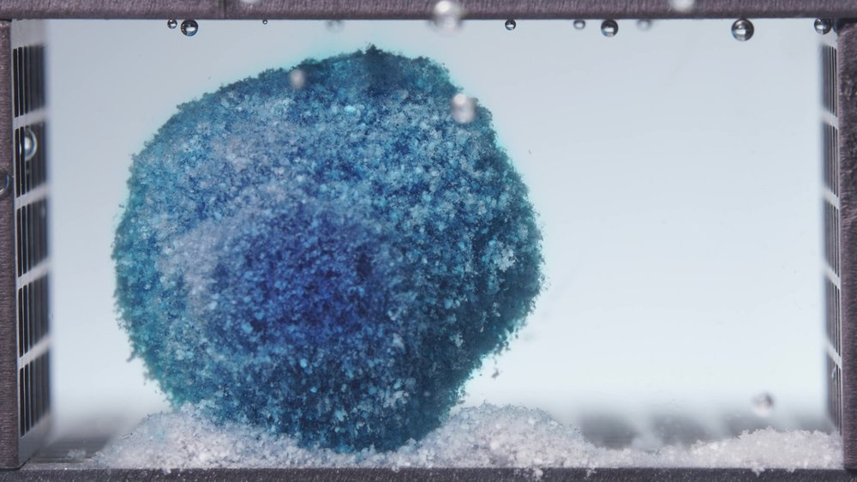  High-viscosity formulation, 18.75-23.75 h image 1 | 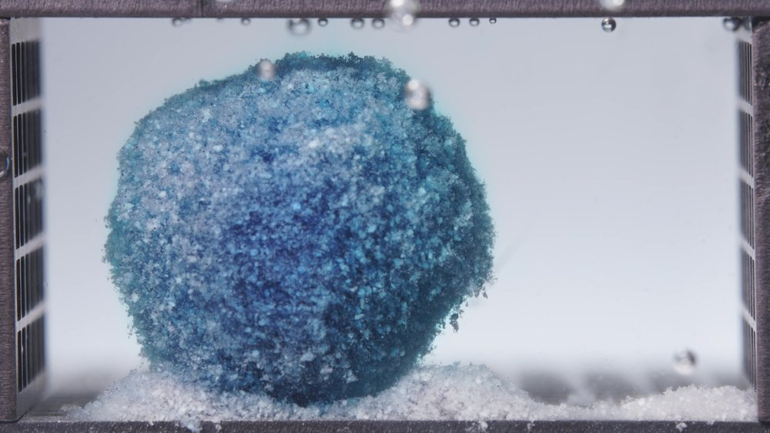  High-viscosity formulation, 18.75-23.75 h image 2
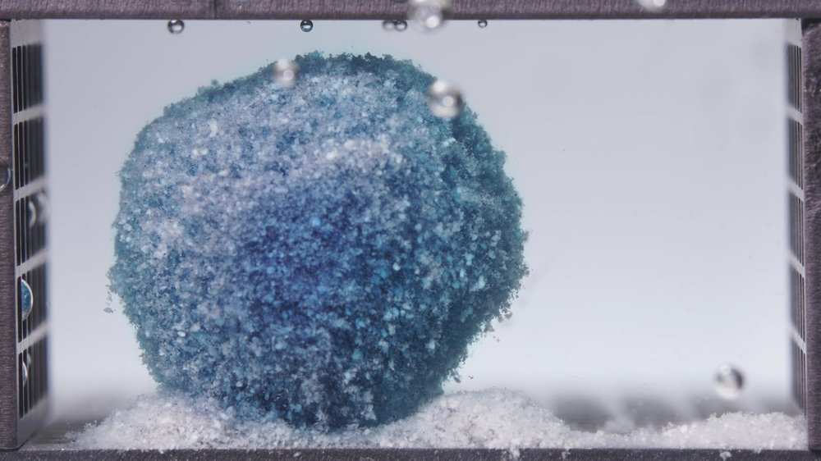
High-viscosity formulation, 18.75-23.75 h image 3
Assistant
{
"group_id": "HIGH-VISCOSITY",
"time_range_h": [18.75, 23.75],
"time_h": null,
"eight_dimension_description": {
"color_change": "The high-viscosity formulation still shows a pronounced dark-to-light blue gradient, with a darker blue central core and a broader pale blue to blue-white outer region. Compared with the 12.5-17.5 h window, the surface appears further lightened and more depleted, indicating continued slow outward release of methylene blue while substantial dye remains retained inside the matrix.",
"shape_change": "The tablet remains largely intact and coherent, preserving a bulky rounded to slightly polyhedral mass. Its outline is still well maintained, though the top appears somewhat flatter and the contour slightly more angular than in the previous window, suggesting gradual erosion and compaction rather than collapse.",
"surface_texture_change": "The surface remains coarse, porous, and granular, with a fuzzy hydrated outer layer. Fine particulate roughness is still visible over the full surface, and small edge irregularities suggest ongoing superficial erosion. However, there is no evidence of major shell rupture or large-sheet peeling.",
"volume_change": "The visible tablet body remains large, indicating that only limited net mass loss has occurred even by 18.75-23.75 h. There may be mild shrinkage or densification relative to the previous window, but no major reduction in bulk is apparent. Overall volume retention remains high.",
"dissolution_speed_time": "Dissolution/disintegration in this late-stage window remains slow and controlled. The formulation continues to erode gradually from the exterior while preserving a strong internal matrix. Even near 24 h, the process appears incomplete, consistent with the slowest release/disintegration tendency among the three formulations.",
"physical_state_change": "The tablet is still in a hydrated but structurally stable gel-supported solid state. Although the exterior is increasingly softened and particulate, the bulk matrix remains cohesive and self-supporting. It has not transitioned into a fragmented debris mass, demonstrating persistent structural integrity.",
"dissolution_medium": "The surrounding medium appears relatively clear and only faintly blue-tinted, without strong diffuse plumes around the tablet. This suggests that release into the medium is continuing at a restrained rate rather than through rapid washout. The visual appearance supports sustained, controlled release behavior.",
"fragment_distribution_density": "Detached material is concentrated mainly at the base, where a noticeable pale particulate sediment bed surrounds the lower portion of the tablet. Compared with 12.5-17.5 h, the amount of basal debris appears slightly increased, but free fragments remain limited relative to the large intact main body."
},
"notes_for_later_summary": "Most critical change versus the 12.5-17.5 h window: the high-viscosity formulation shows additional surface lightening, slight contour flattening/angulation, and somewhat increased basal sediment, but the tablet still remains strongly cohesive and largely intact through 18.75-23.75 h. This confirms persistent matrix strength and the slowest overall erosion/disintegration behavior among the three formulations."
}

Integrated Mechanistic Interpretation
User
Provide an integrated mechanistic interpretation of the observed disintegration behavior of the three methylene blue sustained-release tablet formulations.
The three formulations are the low-viscosity formulation, the standard formulation (medium-viscosity), and the high-viscosity formulation, and their main formulation difference lies in the ratio between HPMC K4M and HPMC 100lv.
Our optimization goal is to adjust the ratio between HPMC K4M and HPMC 100lv so that the cumulative release amount of the standard-viscosity methylene blue sustained-release tablet over the first 4 hours is increased to 110% of its original level.
In addition to the image-based disintegration observations, please also use the UV absorbance data from the flow-through-cell eluate as semi-quantitative release evidence.
All UV absorbance values are within the linear range.
The interval sequence is: 0-0.5 h, 0.5-1 h, 1-2 h, 2-4 h, 4-6 h, 6-8 h, 8-12 h, 12-16 h, 16-20 h, and 20-24 h.
The corresponding mean UV absorbance values are as follows:
Low-viscosity formulation: 0.0273, 0.0727, 0.1967, 0.5963, 0.3347, 0.0230, 0.0123, 0.0027, -0.0010, -0.0007.
Standard formulation: 0.0320, 0.0520, 0.1680, 0.5153, 0.5532, 0.0777, 0.0167, 0.0143, 0.0043, -0.0013.
High-viscosity formulation: 0.0243, 0.0403, 0.1213, 0.4743, 0.3490, 0.0890, 0.0217, 0.0077, 0.0047, 0.0010.
Please:
1) Summarize the key differences in disintegration behavior across the three formulations as evidence statements.
2) Using the literature and the current session data, focus on explaining how differences in the HPMC K4M / HPMC 100lv ratio may influence swelling, gel-layer formation, erosion, fragmentation, shell persistence, and other observed disintegration phenomena.
3) Relate the observed disintegration phenomena to the interval-based UV absorbance trends, and state whether the image-based evidence and the UV-based evidence are mutually supportive, partially aligned, or inconsistent.
4) Propose 2-5 mechanistic hypotheses, each clearly tied to the observed phenomena, the UV trends, and the HPMC ratio differences.
5) Explain what these mechanistic differences may imply for increasing the cumulative release amount of the standard-viscosity methylene blue sustained-release tablet over the first 4 hours to 110% of its original level, so that the result can support the next-step formulation optimization.
6) List alternative explanations and a minimal set of follow-up tests to discriminate between hypotheses.
Use only information from this session and the retrieved literature; do not invent missing details.
Do not provide a final optimized formulation recipe in this step.
Assistant
Phenomenon Review

Evidence statement 1 - low-viscosity formulation: The low-viscosity formulation showed the fastest visible structural destabilization. In the first 0.104-5 h window, the medium became broadly cyan-blue, the tablet surface became rough and porous, and basal erosion/sediment appeared early. By 6.25-11.25 h, the original compact geometry was largely lost, with lateral collapse, a thick sediment bed, and a loose hydrated aggregate. From 12.5 h onward, the medium became nearly clear while a pale, depleted residual mound persisted. This indicates fast early dye liberation followed by matrix exhaustion and residual excipient/gel debris.

Evidence statement 2 - standard formulation: The standard formulation showed an intermediate pattern. It released dye early and formed a visible basal sediment layer, but the main body stayed upright and coherent through 6.25-17.5 h. By 18.75-23.75 h, it was pale and rounded but still present as a large coherent residual matrix. Its behavior is therefore not as fragile as the low-viscosity formulation, but less structurally persistent than the high-viscosity formulation.

Evidence statement 3 - high-viscosity formulation: The high-viscosity formulation showed the strongest shell/matrix persistence. Across the full 24 h window, it retained a large, rounded, cohesive body with a darker blue internal region and progressive but limited surface lightening. Basal sediment increased gradually, but large-scale collapse, splitting, and broad fragment dispersion were not evident. This points to a stronger hydrated gel barrier and slower erosion.

Cross-formulation ranking from images: For visible early disintegration and matrix weakening, the order is approximately low-viscosity > standard > high-viscosity. For gel-shell persistence and retained coherent matrix, the order is approximately high-viscosity > standard > low-viscosity.

Concentration-Time Trend Review

Because all UV absorbance values are stated to be within the linear range, the interval mean absorbance can be treated as semi-quantitative evidence of eluate concentration. With the same 1 mL/min flow-through condition, interval mean absorbance x interval duration gives a proportional release exposure index, not an absolute mass release value because no calibration factor was provided.

Formulation | Peak interval by UV | Peak mean absorbance | 0-4 h proportional release index | Relative to standard 0-4 h
Low-viscosity | 2-4 h | 0.5963 | 1.4393 | 116.0%
Standard | 4-6 h | 0.5532 | 1.2406 | 100.0%
High-viscosity | 2-4 h | 0.4743 | 1.1022 | 88.8%

The UV data support the image-based ranking for early release: the low-viscosity formulation gives the highest 0-4 h release index, the standard formulation is intermediate, and the high-viscosity formulation is lowest. The standard formulation's highest interval occurs at 4-6 h rather than 2-4 h, consistent with a more sustained matrix that does not collapse as early as the low-viscosity formulation. The high-viscosity formulation has lower early absorbance despite strong blue color remaining in the tablet body, which is consistent with dye retention inside a stronger gel matrix.

Overall, the image-based and UV-based evidence are mutually supportive in the main early-release ranking and partially aligned in the 4-6 h transition region. The partial alignment is expected because visible matrix persistence does not necessarily mean no drug release; in HPMC matrices, drug can diffuse through a hydrated gel layer while polymer erosion and gross structural breakdown occur later.

Literature-Supported Typical Mechanistic Links

The formulation variable of interest is the HPMC K4M / HPMC 100lv balance. Literature describing Methocel/HPMC viscosity grades reports nominal viscosities of approximately 4000 cP for K4M and 100 cP for K100LV, measured at 2% concentration in water at 20 °C. Therefore, increasing the K4M fraction should generally increase the viscosity/gel-strength contribution, while increasing the 100LV fraction should generally shift the system toward a lower-viscosity, more readily hydrated/erodible matrix.

For hydrophilic HPMC matrix tablets, the usual sequence is water penetration, polymer hydration, gel-layer formation, drug diffusion through the gel, polymer chain relaxation, and matrix erosion. The relative contribution of diffusion versus erosion depends on polymer grade, polymer amount, gel strength, medium penetration, and mechanical stress.

Higher-viscosity HPMC grades are commonly associated with thicker and more persistent gel layers, slower HPMC leaching, slower erosion, and retarded drug release. One imaging/texture-analysis study reported that low-viscosity HPMC leached rapidly at the tablet surface, whereas high-viscosity HPMC formed a thicker gel layer that was maintained longer by slower erosion.

This literature pattern is consistent with the current images: the high-viscosity formulation retained a coherent rounded shell-like matrix through 24 h, whereas the low-viscosity formulation showed earlier collapse, more rapid matrix depletion, and faster disappearance of visible dye from the medium.

Tentative Integrated Mechanistic Interpretation Across the Three Formulations

Hypothesis 1 - gel-barrier strength controls early release intensity.
The low-viscosity formulation contains less HPMC K4M and more HPMC 100lv than the standard and high-viscosity formulations. Its early broad medium coloration, rapid surface roughening, and high 0-4 h UV index suggest that the hydrated barrier is weaker and/or less persistent, allowing faster methylene blue escape. The high-viscosity formulation, with more K4M and less 100lv, likely forms a stronger gel layer that slows diffusion and erosion; this matches its lower 0-4 h UV index and persistent dark core.

Hypothesis 2 - the low-viscosity formulation shifts earlier toward erosion-dominated release.
The low-viscosity tablet showed early basal erosion, lateral collapse, and dense sediment formation. Its UV absorbance peaked strongly in 2-4 h and then dropped rapidly after 4-6 h, with near-zero values after 8-12 h. This pattern suggests a faster early release/erosion phase followed by depletion of readily releasable methylene blue. The images and UV trend both support this.

Hypothesis 3 - the standard formulation has mixed diffusion-erosion behavior with delayed peak release.
The standard formulation released appreciable dye early but retained an upright coherent body through mid-time windows. Its UV absorbance was high at 2-4 h but peaked at 4-6 h. This suggests that the standard matrix initially restricts release more than the low-viscosity system, then continues releasing through a hydrated/eroding gel layer after the low-viscosity system has already begun to deplete. This is consistent with an intermediate HPMC K4M / 100lv balance.

Hypothesis 4 - the high-viscosity formulation retains dye because polymer erosion is slower than dye diffusion.
The high-viscosity formulation remained dark internally and structurally coherent through 24 h, while UV absorbance showed lower early release and a small but persistent tail. This can be explained by a strong gel layer that allows limited dye diffusion but restricts polymer erosion and gross matrix breakdown.

Hypothesis 5 - basal sediment is not equivalent to released methylene blue.
All three formulations produced pale basal sediment, but the UV trends differ. In the low-viscosity formulation, sediment persisted after the UV signal had nearly disappeared; in the high-viscosity formulation, a large blue-stained matrix persisted despite lower UV release. Therefore, visible sediment likely includes depleted excipient/polymer-rich material and hydrated matrix debris, not only drug-rich fragments. Residual matrix assay would be needed to confirm this.

Mechanistic Implications for the Next Optimization Step

The target is to increase the standard formulation's 0-4 h cumulative release to 110% of its original level. Based on the UV proportional release index, the standard 0-4 h index is 1.2406, so the target is approximately 1.3647 in the same proportional units. The low-viscosity formulation reaches 1.4393, which is above the target, while the high-viscosity formulation is 1.1022, below the standard.

Mechanistically, the low-viscosity direction appears closer to the desired early-release increase, but it overshoots the target and shows excessive early structural weakening, collapse, and matrix depletion. The high-viscosity direction is too slow for the stated 0-4 h goal because it preserves a strong gel shell and retains dye. The standard formulation is structurally acceptable but early release is insufficient relative to the target.

Therefore, the next optimization should be supported by a controlled, conservative shift of the standard formulation toward the low-viscosity tendency, meaning a modest reduction in gel-barrier strength and/or earlier surface erosion, while avoiding the low-viscosity formulation's pronounced early collapse. At this stage, the mechanistic target is not maximum erosion; it is slightly faster early dye diffusion through the hydrated matrix with sufficient shell persistence to prevent premature structural failure.

No final optimized formulation recipe is given here, as requested.

Suggestions for Further Validation

Alternative explanations that should not be excluded are differences in tablet hardness, compression density, porosity, local tablet position in the flow-through cell, bubble contact, flow heterogeneity, image exposure/white balance, particle-size distribution of excipients, lubricant distribution, and small drug-content variation. These could modify apparent erosion, sediment formation, or UV release independently of the HPMC K4M / 100lv ratio.

A minimal discriminating test set would be:
1. Replicate UV release and imaging for each formulation under identical flow-cell positioning to confirm the early-release ranking and the 4-6 h standard peak.
2. Quantify 0-4 h and 0-6 h release indices using calibrated methylene blue concentration rather than absorbance alone.
3. Measure swelling and erosion mass balance at 2 h, 4 h, 6 h, and 24 h to separate water uptake, polymer/excipient erosion, and true mass loss.
4. Assay residual methylene blue in the recovered matrix and basal sediment to determine whether sediment is drug-rich or mainly depleted excipient/polymer debris.
5. Perform texture or penetration testing of the hydrated gel layer at matched time points, because gel strength is directly linked in the literature to robustness against erosion and mechanical stress.

Next-Iteration Formulation Recommendation
User
Provide a formulation optimization recommendation for the next iteration based on the existing formulation information, optimization target, concentration-time summary, mechanistic analysis results, and prior disintegration-analysis conclusions in this session.
The three formulations are the low-viscosity formulation, the standard formulation (medium-viscosity), and the high-viscosity formulation. The standard formulation is the reference formulation.
Our optimization goal is to adjust the ratio between HPMC K4M and HPMC 100lv so that the cumulative release amount of the standard-viscosity methylene blue sustained-release tablet over the first 4 hours is increased to 110% of its original level.
Please integrate the prior evidence rather than repeating the earlier full image-analysis or mechanistic-analysis process. You MUST provide a next-step formulation proposal with explicit numeric values, especially for HPMC K4M and HPMC 100lv.
Please:
1) Briefly summarize which current formulation tendency appears closer to the optimization target and which tendencies appear too fast or too slow.
2) Propose one next-step optimized formulation anchored on the standard formulation and adjusted mainly through the balance between HPMC K4M and HPMC 100lv.
3) You MUST explicitly report the proposed HPMC K4M amount, the proposed HPMC 100lv amount, the proposed HPMC K4M:HPMC 100lv ratio, and the percentage change of each relative to the standard formulation.
4) Even if the evidence is not sufficient to justify a fully validated exact formula, you MUST still provide a best-estimate next-iteration formulation proposal with explicit numeric values and percentage changes, and clearly label it as tentative rather than omitting the numbers.
Use only information from this session and the retrieved literature if already available; do not invent missing details.
Do not output a same/different judgment.
Do not simply restate previous node outputs without synthesis.
Output the result in a clear structured format with the following sections:
Optimization Target Review
Evidence Summary from Existing Formulations
Recommended Next Formulation
Uncertainty and Validation Needs
Under "Recommended Next Formulation", directly report:
- Proposed HPMC K4M amount = X
- Proposed HPMC 100lv amount = Y
- Proposed HPMC K4M:HPMC 100lv ratio = X:Y
- Percentage change of HPMC K4M relative to the standard formulation = Z%
- Percentage change of HPMC 100lv relative to the standard formulation = W%
- A short rationale for why this ratio is recommended
Assistant
Optimization Target Review

The target is to increase the 0-4 h cumulative release of the standard formulation to 110% of its original level by adjusting mainly the HPMC K4M / HPMC 100lv balance.

Using the provided interval UV absorbance values as semi-quantitative release evidence:
- Standard 0-4 h proportional release index = 1.2406
- Target = 1.2406 x 110% = 1.3647
- Low-viscosity formulation 0-4 h index = 1.4393, about 116.0% of standard
- High-viscosity formulation 0-4 h index = 1.1022, about 88.8% of standard

Therefore, the low-viscosity tendency is numerically closer to the target, but it appears somewhat too fast because it produced early matrix weakening, rapid dye diffusion, lateral collapse, and strong early sediment formation. The high-viscosity tendency is too slow, with excessive matrix persistence and lower early UV release. The next formulation should move the standard formulation toward the low-viscosity direction, but not all the way to the low-viscosity composition.

Evidence Summary from Existing Formulations

The image evidence and UV evidence are directionally aligned. The low-viscosity formulation released faster in the first 4 h and showed early surface erosion/collapse. The standard formulation retained a more coherent matrix and peaked later, especially in the 4-6 h UV interval. The high-viscosity formulation retained the strongest rounded gel-matrix structure and showed the lowest 0-4 h release index.

Mechanistically, the prior interpretation supports the following: increasing the relative contribution of HPMC K4M strengthens gel-layer persistence and slows erosion/release, while increasing the relative contribution of HPMC 100lv weakens the gel barrier and promotes faster hydration, dye diffusion, and surface erosion. For the stated 110% early-release target, the standard formulation should be moderately shifted toward higher HPMC 100lv and lower HPMC K4M while keeping the total HPMC amount essentially constant.

Recommended Next Formulation

Tentative next-iteration formulation proposal, anchored on the standard formulation:
- Methylene blue = 0.1420
- Silicon dioxide = 0.0503
- Magnesium stearate = 0.1278
- Microcrystalline cellulose = 9.6893
- Lactose = 9.6830
- HPMC K4M = 1.5500
- HPMC 100lv = 3.7708

This keeps the total HPMC amount equal to the standard formulation:
- Standard total HPMC = 2.5037 + 2.8171 = 5.3208
- Proposed total HPMC = 1.5500 + 3.7708 = 5.3208

Direct required outputs:
- Proposed HPMC K4M amount = 1.5500
- Proposed HPMC 100lv amount = 3.7708
- Proposed HPMC K4M:HPMC 100lv ratio = 1.5500:3.7708
- Equivalent normalized ratio = 0.411:1
- Equivalent inverse expression = 1:2.433
- Percentage change of HPMC K4M relative to the standard formulation = -38.1%
- Percentage change of HPMC 100lv relative to the standard formulation = +33.9%

Short rationale: This ratio is selected as a tentative interpolation-based next step between the standard and low-viscosity formulations. It is expected to reduce gel-barrier strength enough to increase early methylene blue release toward the 110% target, while retaining more HPMC K4M than the low-viscosity formulation to avoid the excessive early collapse and depletion seen in the low-viscosity images.

Uncertainty and Validation Needs

This is a tentative next-iteration proposal, not a validated final optimized formulation. The strongest support is the consistent direction between image evidence and UV evidence: lower K4M / higher 100lv increased early release, while higher K4M / lower 100lv slowed release and preserved matrix integrity.

The main uncertainty is whether the release response is linear enough between the standard and low-viscosity formulations. The proposed formulation should be validated by measuring the 0-4 h cumulative release index directly, confirming whether it approaches 1.3647 on the same proportional UV basis, and checking that the tablet does not reproduce the excessive early collapse pattern observed in the low-viscosity formulation.

Export Request
User
Export all of our conversation content as a DOC file named after the conversation title.

