Methylene Blue Tablet Analysis

Conversation Export
Visible user messages, assistant responses, and image attachments from the conversation are compiled below.
Document title | Methylene Blue Tablet Analysis
Exported file | Methylene Blue Tablet Analysis.docx
Image batches included | 12 batches / 36 images
Primary subject | Methylene blue HPMC sustained-release tablet disintegration and formulation optimization

Turn 1
User
"We are analyzing the static disintegration images of three self-made methylene blue sustained-release tablet formulations with different HPMC ratios. "
"All images were captured under the same experimental conditions. "
"The dissolution medium is initially pH 1.2, and after 1 hour it is switched to pH 6.8. "
"The experiment was conducted at a controlled temperature of 38 °C to simulate a slightly elevated physiological condition. "
"The system is a flow-through cell with a flow rate of 1 mL/min. "
"The total observation period is 24 h. Images were captured continuously and later sampled into batches. "
"Each message you receive contains multiple images representing a time window (e.g., 0–6 h, 6–12 h, 12–18 h, 18–24 h). "
"Treat the images within the same window as observations from that time range rather than a single exact time point. "
"These three formulations are all methylene blue sustained-release tablets, and their main difference lies in the ratio between HPMC K4M and HPMC 100lv. "
"The first formulation is the low-viscosity formulation. In this formulation, methylene blue is 0.1436, silicon dioxide is 0.0501, magnesium stearate is 0.1274, microcrystalline cellulose is 9.6862, lactose is 9.686, HPMC K4M is 1.0624, and HPMC 100lv is 4.2484. "
"The second formulation is the standard formulation, which is also the medium-viscosity formulation. In this formulation, methylene blue is 0.142, silicon dioxide is 0.0503, magnesium stearate is 0.1278, microcrystalline cellulose is 9.6893, lactose is 9.683, HPMC K4M is 2.5037, and HPMC 100lv is 2.8171. "
"The third formulation is the high-viscosity formulation. In this formulation, methylene blue is 0.1446, silicon dioxide is 0.0502, magnesium stearate is 0.1276, microcrystalline cellulose is 9.6846, lactose is 9.6845, HPMC K4M is 4.246, and HPMC 100lv is 1.0653. "
"Our optimization goal is to adjust the ratio between HPMC K4M and HPMC 100lv so that the cumulative release amount of the standard-viscosity methylene blue sustained-release tablet over the first 4 hours is increased to 110% of its original level."
"Concentration-time information will be provided later after the image-analysis stage, so for now please focus on the image-based disintegration behavior under the current experimental and formulation background."
Assistant
{
"experiment_config": {
"medium_pH": "initially pH 1.2, switched to pH 6.8 after 1 hour",
"temperature_C": 38,
"total_duration_hours": 24,
"time_interval_hours": null,
"other_conditions": "Static disintegration images of three self-made methylene blue sustained-release tablet
formulations were captured under the same experimental conditions. The system is a flow-through cell with a flow rate
of 1 mL/min. Images were captured continuously and later sampled into batches. Each message contains multiple images
representing a time window, and images within the same window should be treated as observations from that time range
rather than a single exact time point."
},
"formulation_info": {
"formulation_1": {
"formulation_name": "low-viscosity formulation",
"sample_id": null,
"composition": {
"methylene_blue": 0.1436,
"silicon_dioxide": 0.0501,
"magnesium_stearate": 0.1274,
"microcrystalline_cellulose": 9.6862,
"lactose": 9.686,
"HPMC_K4M": 1.0624,
"HPMC_100lv": 4.2484
},
"excipients_or_polymer_info": "Main difference lies in the ratio between HPMC K4M and HPMC 100lv.",
"ratio_or_percentage": "HPMC K4M:HPMC 100lv = 1.0624:4.2484",
"key_formulation_comments": "First formulation; low-viscosity formulation.",
"process_notes": null
},
"formulation_2": {
"formulation_name": "standard formulation / medium-viscosity formulation",
"sample_id": null,
"composition": {
"methylene_blue": 0.142,
"silicon_dioxide": 0.0503,
"magnesium_stearate": 0.1278,
"microcrystalline_cellulose": 9.6893,
"lactose": 9.683,
"HPMC_K4M": 2.5037,
"HPMC_100lv": 2.8171
},
"excipients_or_polymer_info": "Main difference lies in the ratio between HPMC K4M and HPMC 100lv.",
"ratio_or_percentage": "HPMC K4M:HPMC 100lv = 2.5037:2.8171",
"key_formulation_comments": "Second formulation; standard formulation; medium-viscosity formulation.",
"process_notes": null
},
"formulation_3": {
"formulation_name": "high-viscosity formulation",
"sample_id": null,
"composition": {
"methylene_blue": 0.1446,
"silicon_dioxide": 0.0502,
"magnesium_stearate": 0.1276,
"microcrystalline_cellulose": 9.6846,
"lactose": 9.6845,
"HPMC_K4M": 4.246,
"HPMC_100lv": 1.0653
},
"excipients_or_polymer_info": "Main difference lies in the ratio between HPMC K4M and HPMC 100lv.",
"ratio_or_percentage": "HPMC K4M:HPMC 100lv = 4.246:1.0653",
"key_formulation_comments": "Third formulation; high-viscosity formulation.",
"process_notes": null
}
},
"optimization_context": {
"optimization_target": "Adjust the ratio between HPMC K4M and HPMC 100lv so that the cumulative release amount of
the standard-viscosity methylene blue sustained-release tablet over the first 4 hours is increased to 110% of its
original level.",
"optimization_strategy_notes": "Concentration-time information will be provided later after the image-analysis
stage, so the current stage should focus on image-based disintegration behavior under the stated experimental and
formulation background.",
"adjusted_formulation_variables": "Ratio between HPMC K4M and HPMC 100lv"
},
"analysis_plan": {
"dimensions": [
"Color Change",
"Shape Change",
"Surface Texture Change",
"Volume Change",
"Dissolution Speed and Time",
"Physical State Change",
"Dissolution Medium",
"Fragment Distribution with Density"
],
"single_formulation_strategy": "Analyze each formulation over time using the fixed eight dimensions and preserve
key transition points.",
"three_formulation_strategy": "Compare the three formulations across matched time windows using the same eight
dimensions to support optimization interpretation."
}
}

Turn 2
User
These are pictures of the low-viscosity formulation during 0.104-5h.@taki
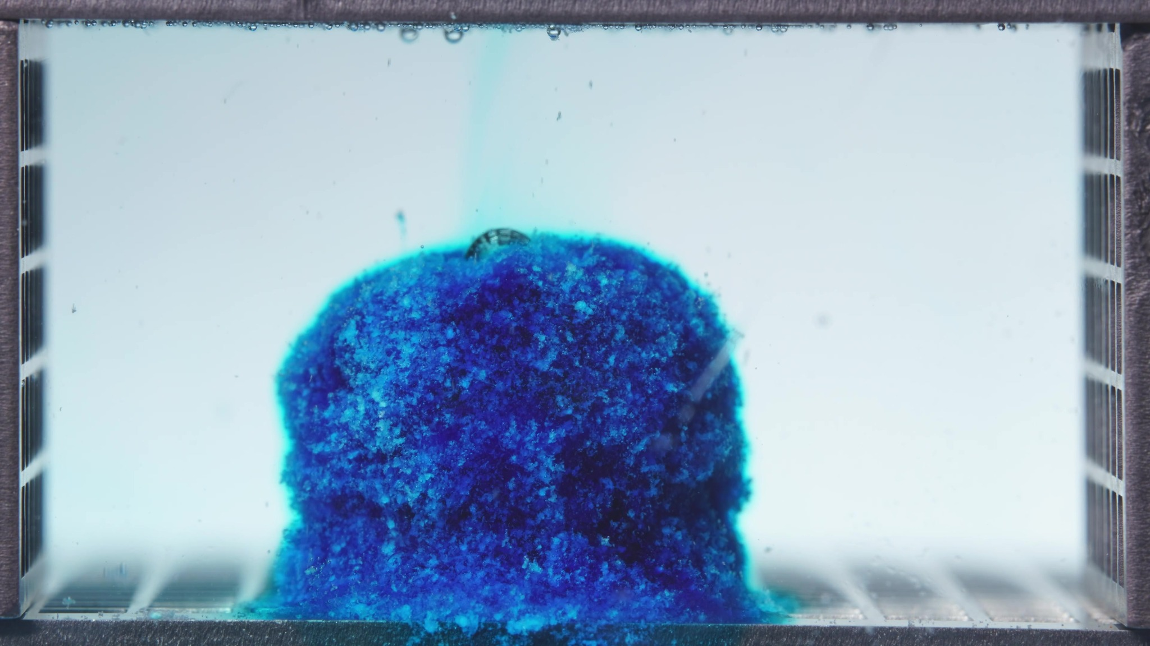
Image 1: 02-pH1.2-pH6.8T-亚甲蓝缓释片-低粘度-260417-24h-Side-750X-1_0000.500(6).jpg
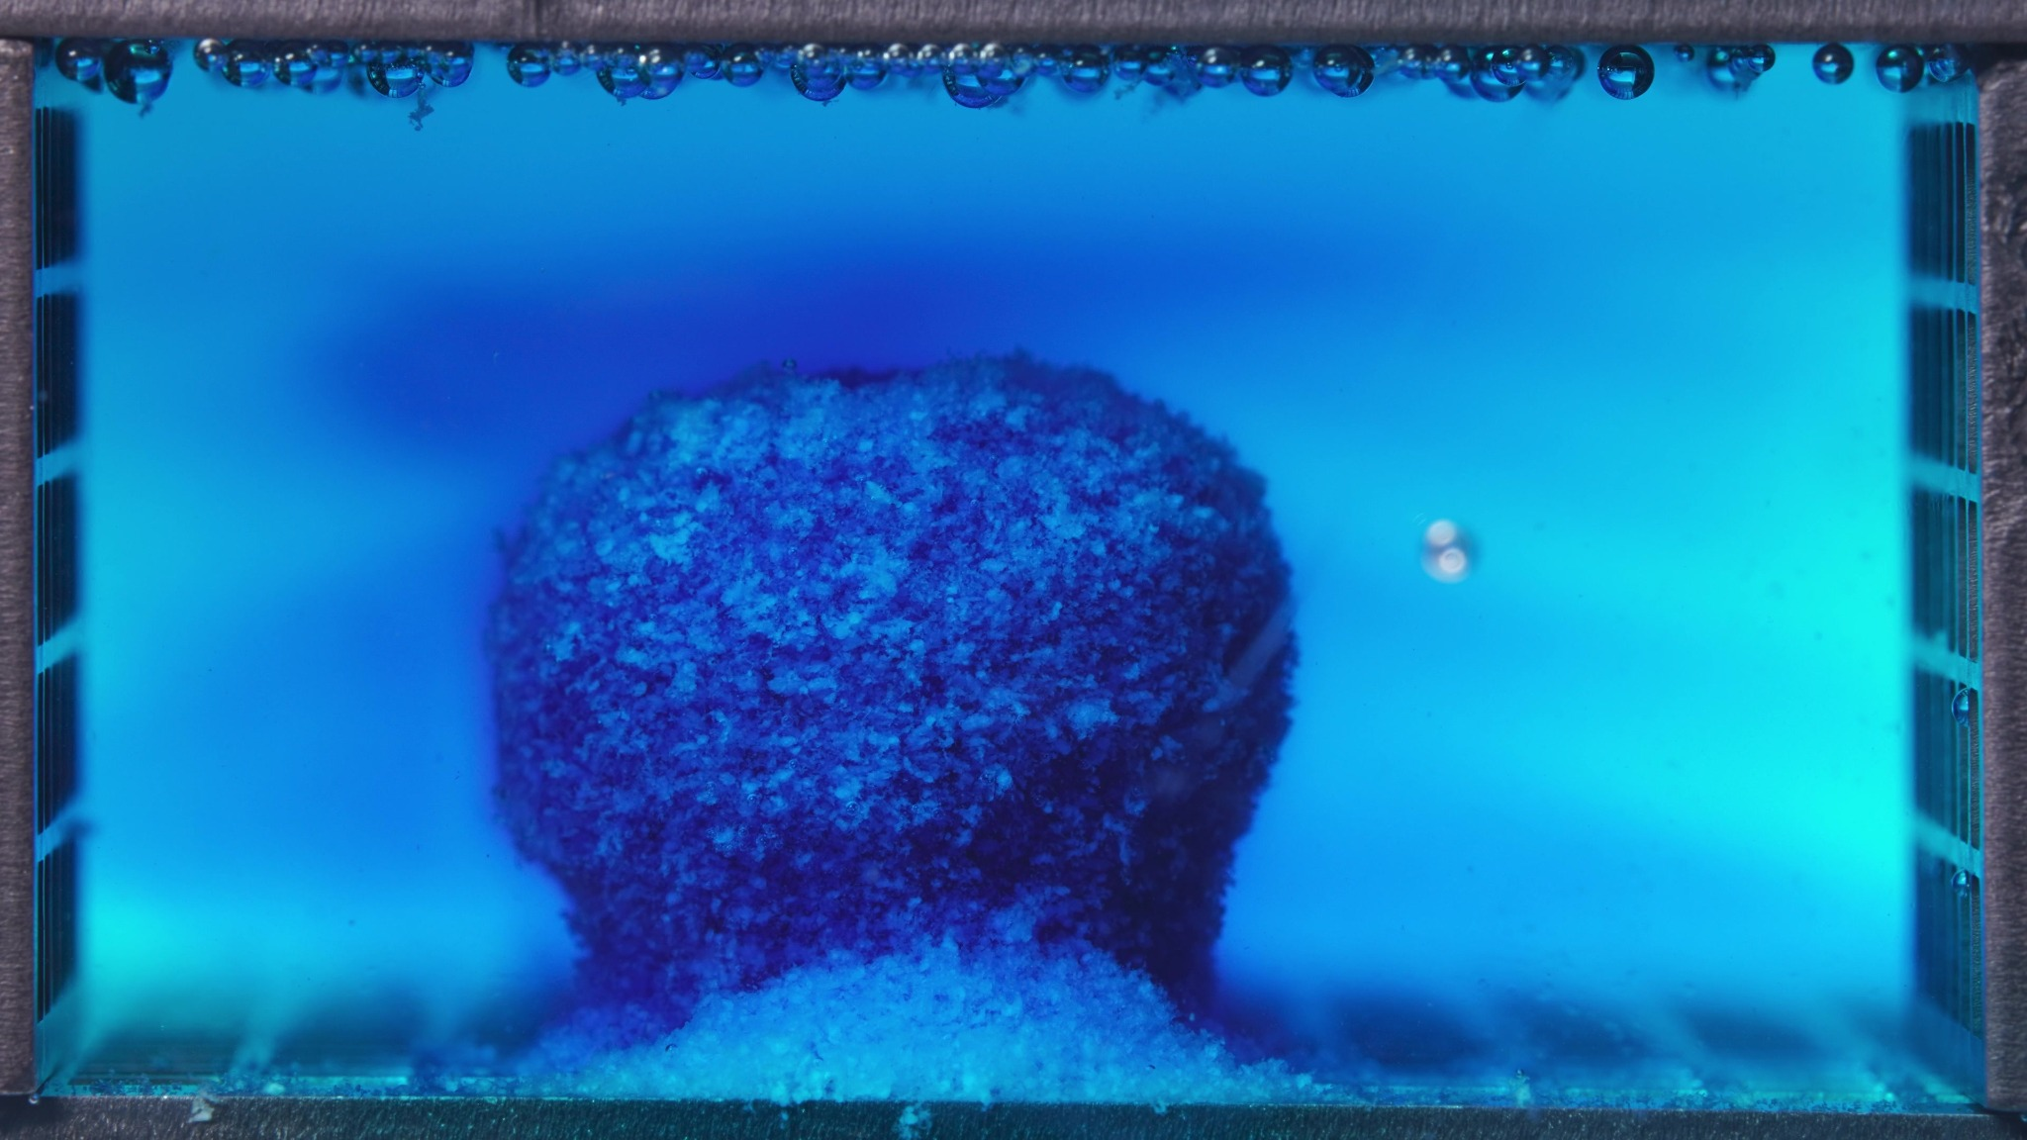
Image 2: 02-pH1.2-pH6.8T-亚甲蓝缓释片-低粘度-260417-24h-Side-750X-1_0012.000(6).jpg
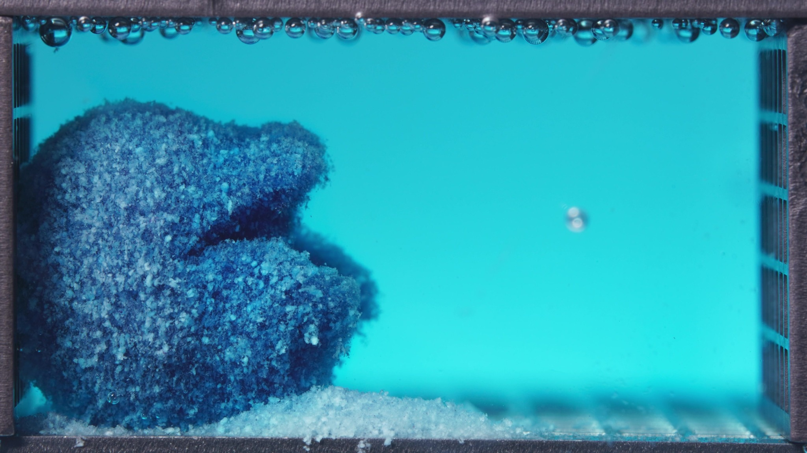
Image 3: 02-pH1.2-pH6.8T-亚甲蓝缓释片-低粘度-260417-24h-Side-750X-1_0024.000(7).jpg
Assistant
{
"group_id": "LOW-VISCOSITY",
"time_range_h": [0.104, 5.0],
"time_h": null,
"eight_dimension_description": {
"color_change": "The tablet mass shows intense methylene-blue staining from the beginning of this window, with a
dark blue core and lighter cyan-blue hydrated outer region. Across the batch, the surrounding medium changes from
relatively pale with localized blue diffusion to broadly blue/turquoise, indicating extensive dye migration into the
medium during 0.104-5 h.",
"shape_change": "The original compact tablet outline is not fully preserved. The mass remains as a large cohesive
body early in the window, but the outline becomes progressively irregular, swollen, and laterally expanded. By the
later image, the structure shows partial collapse, asymmetry, and a rough mound-like form rather than a defined tablet
geometry.",
"surface_texture_change": "The surface is highly rough and granular, with visible porous, crumb-like, and
flocculent features. The outer layer appears loosened rather than smooth, and the later image shows more pronounced
erosion, uneven surface relief, and exposed pale particulate material.",
"volume_change": "The visible occupied volume appears to increase initially because of hydration and swelling,
then transitions toward spreading and partial collapse. The mass becomes broader and less geometrically compact,
suggesting swell-then-erosion behavior rather than simple uniform shrinkage.",
"dissolution_speed_time": "Because no previous-window images are available, direct rate comparison against an
earlier stage is limited. Within this 0.104-5 h window, however, the formulation already shows rapid color release,
strong medium discoloration, early surface erosion, and visible particle shedding, consistent with relatively fast
early disintegration behavior.",
"physical_state_change": "The tablet appears to transition from a hydrated swollen solid into a loose, gel-like
and particulate mass. The structure remains partly cohesive, but the surface and lower regions show clear conversion
into soft, eroded, granular material.",
"dissolution_medium": "The medium changes from nearly clear or only lightly tinted around the tablet to broadly
blue/turquoise throughout the cell. Local cloudiness and dye-rich diffusion zones are visible around the tablet, while
later images show a more uniformly colored medium with suspended fine material and sediment near the bottom.",
"fragment_distribution_density": "Fragments and eroded particles remain densest around the original tablet
position and along the bottom surface. By the later part of the window, a noticeable sediment layer of pale and blue
particulate matter accumulates at the base, with limited but visible dispersion into the surrounding medium."
},
"notes_for_later_summary": "Previous-window comparison is unavailable for this first low-viscosity batch. The key
observation for later comparison is that the low-viscosity formulation already shows strong early dye release, rapid
medium discoloration, pronounced swelling, surface erosion, and basal sediment formation within 0.104-5 h, suggesting
comparatively fast early disintegration."
}

Turn 3
User
These are pictures of the low-viscosity formulation during 6.25-11.25h.
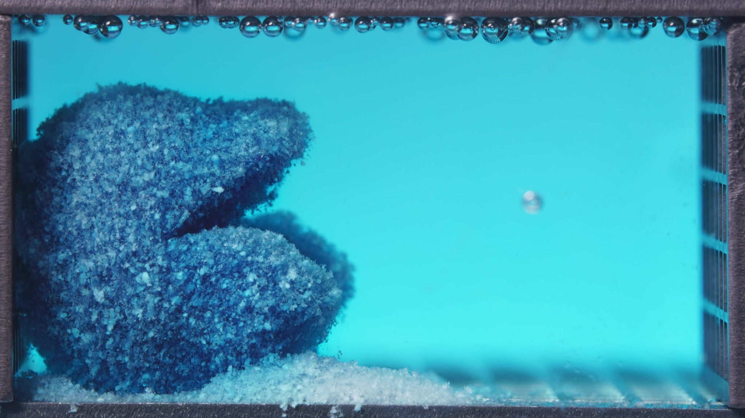
Image 1: 02-pH1.2-pH6.8T-亚甲蓝缓释片-低粘度-260417-24h-Side-750X-1_0030.000(5).jpg
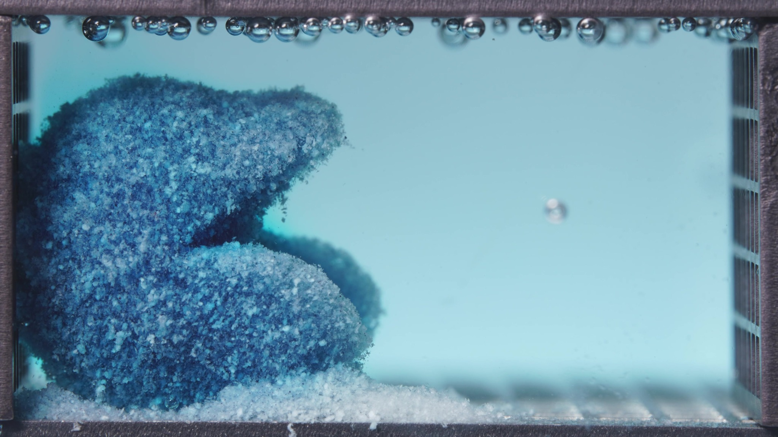
Image 2: 02-pH1.2-pH6.8T-亚甲蓝缓释片-低粘度-260417-24h-Side-750X-1_0042.000(5).jpg
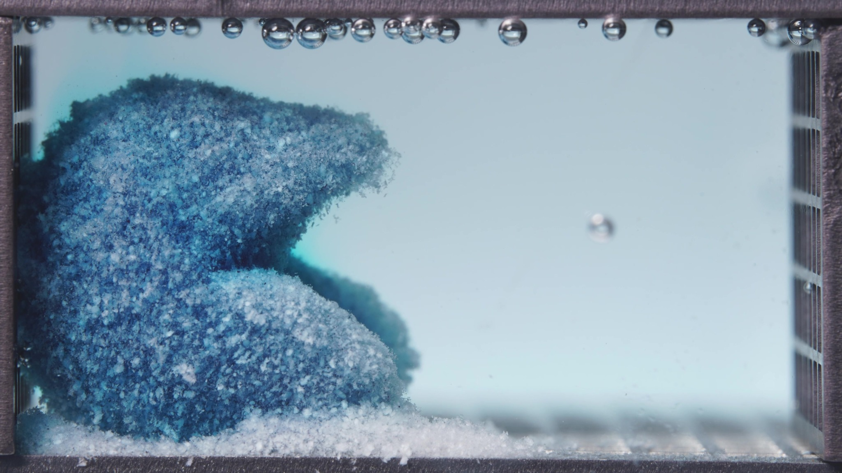
Image 3: 02-pH1.2-pH6.8T-亚甲蓝缓释片-低粘度-260417-24h-Side-750X-1_0054.000(5).jpg
Assistant
{
"group_id": "LOW-VISCOSITY",
"time_range_h": [6.25, 11.25],
"time_h": null,
"eight_dimension_description": {
"color_change": "The tablet mass remains blue but shows more pale cyan-white exposed particulate regions than in
the previous 0.104-5 h window. The surrounding medium is still blue/turquoise, but across the batch it appears less
intensely saturated and more pale, suggesting that the strongest visible dye release occurred earlier while residual
matrix erosion continues.",
"shape_change": "The original tablet geometry is no longer recognizable. The mass has become a large irregular
collapsed mound positioned mainly on the left side, with an overhanging upper region, a lower protruding lobe, and a
partially open gap or recessed zone between these regions. The structure remains partly cohesive but has lost compact
cylindrical integrity.",
"surface_texture_change": "The surface is very rough, porous, and granular. Compared with the previous window, the
surface contains more pale coarse particles and flocculent material, with a crumb-like eroded texture over most
exposed areas. No smooth intact coating-like surface is visible.",
"volume_change": "The occupied volume remains large, but the apparent structure is less compact and more spread
out than before. The mass shows continued swelling-collapse behavior: the upper portion remains bulky, while the lower
region has flattened and merged with a widening basal sediment layer.",
"dissolution_speed_time": "Compared with 0.104-5 h, the visible dye-diffusion phase appears less intense, while
matrix erosion, particle shedding, and sediment accumulation become more dominant. Disintegration appears to continue
by progressive erosion and collapse rather than by a sudden complete breakup during this window.",
"physical_state_change": "The formulation has progressed from a swollen, dye-rich, partially cohesive mass toward
a looser hydrated gel/particulate aggregate. The body is still not fully dispersed, but much of the visible structure
appears soft, friable, and granular, with increasing conversion into sedimented particulate material.",
"dissolution_medium": "The medium remains visibly colored but becomes paler and less uniformly deep blue across
the later images. Mild turbidity and haze persist around the eroding mass and near the base, while the right side of
the chamber is relatively clearer than the region adjacent to the tablet residue.",
"fragment_distribution_density": "Fragments are still concentrated near the original tablet position on the left
and along the bottom. The basal sediment layer is more extensive and denser than in the previous window, with abundant
pale and blue-white particles spreading from the left toward the center-bottom of the chamber. Broad dispersion into
the upper bulk medium remains limited."
},
"notes_for_later_summary": "Most critical change versus the previous 0.104-5 h window: the low-viscosity formulation
shifts from rapid early dye release with strong medium discoloration to a more advanced erosion/collapse stage
characterized by pale granular exposure, loss of tablet geometry, and marked basal sediment accumulation. This
supports continued fast early disintegration, but by 6.25-11.25 h the dominant visible process is matrix erosion and
residue sedimentation rather than fresh dye-front expansion."
}

Turn 4
User
These are pictures of the low-viscosity formulation during 12.5-17.5h.
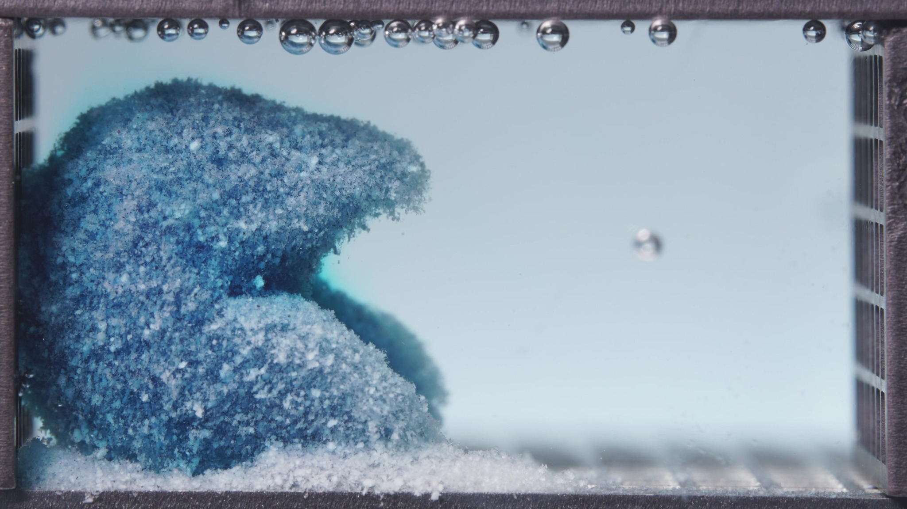
Image 1: 02-pH1.2-pH6.8T-亚甲蓝缓释片-低粘度-260417-24h-Side-750X-1_0060.000(5).jpg
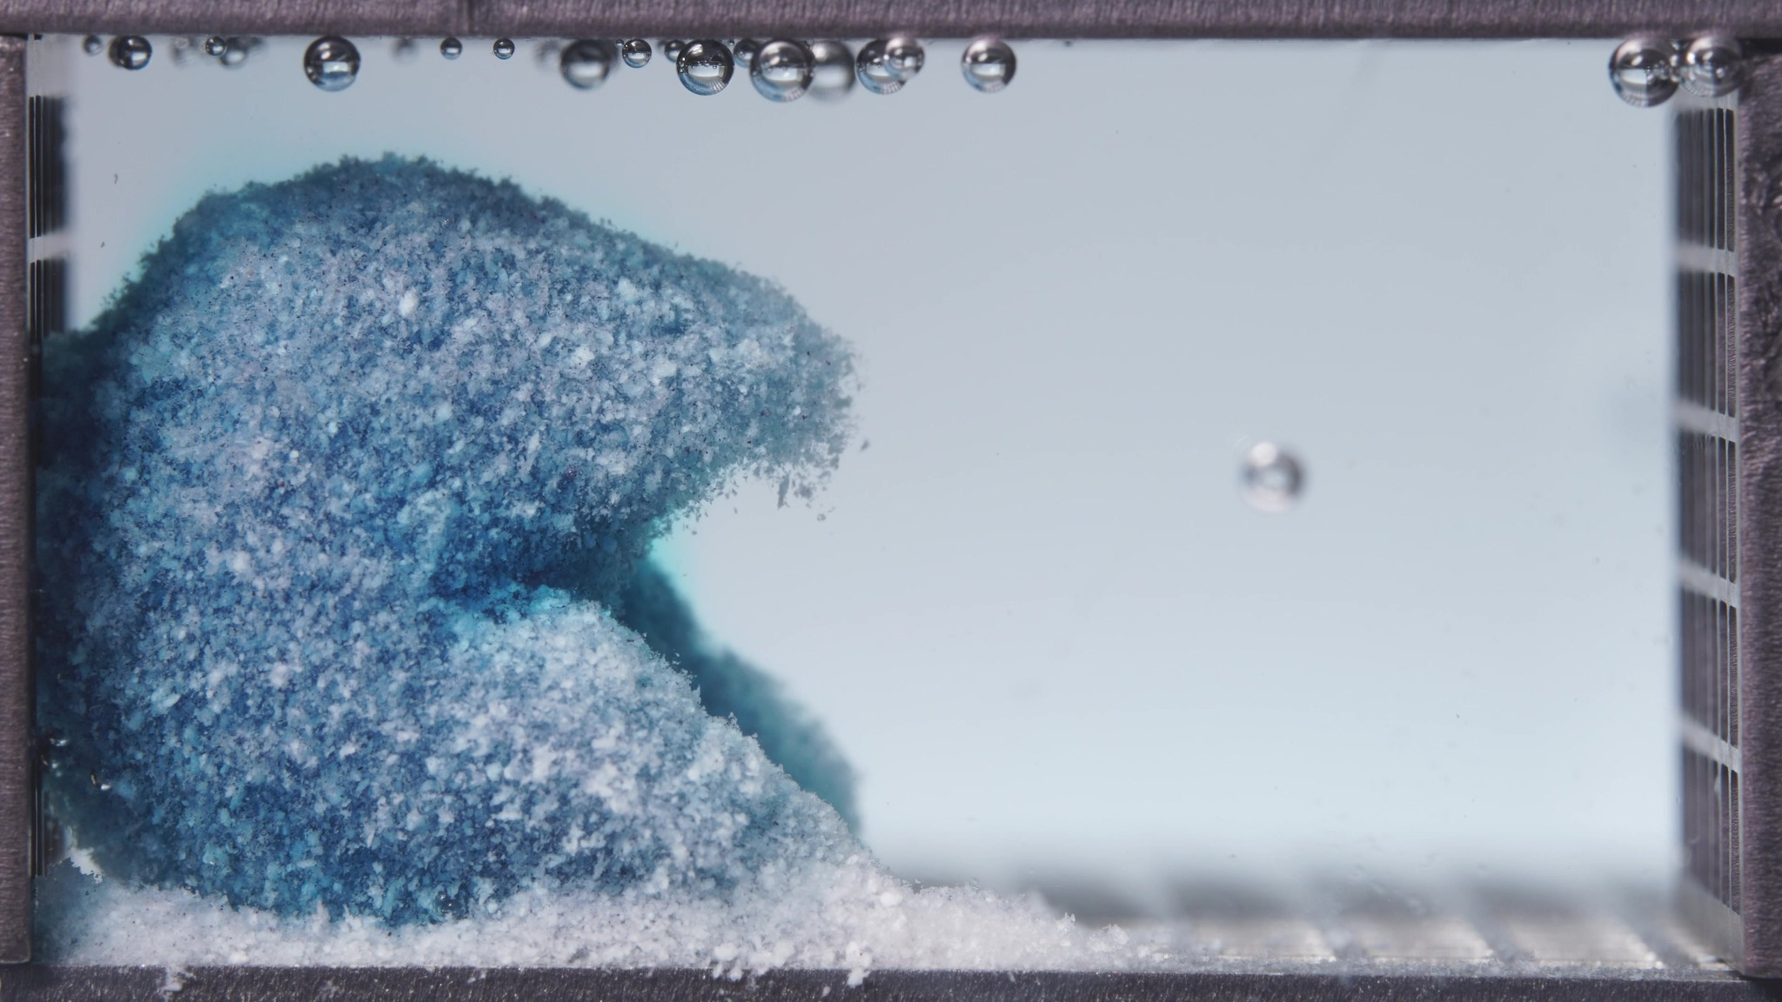
Image 2: 02-pH1.2-pH6.8T-亚甲蓝缓释片-低粘度-260417-24h-Side-750X-1_0072.000(5).jpg
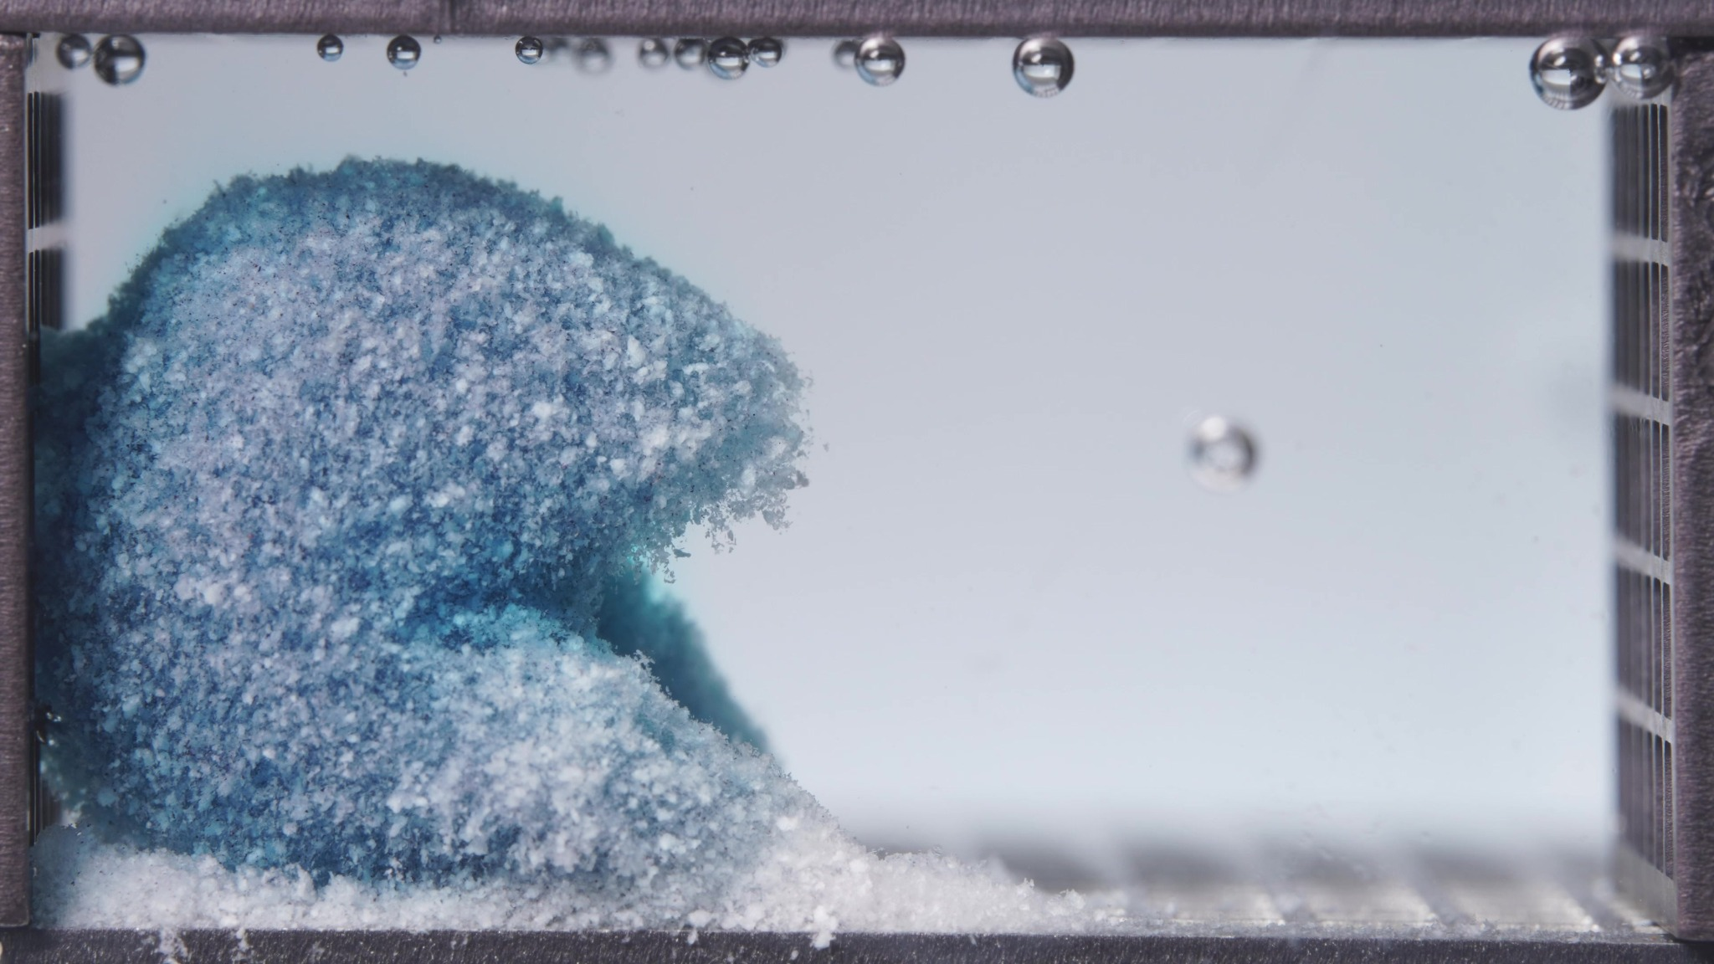
Image 3: 02-pH1.2-pH6.8T-亚甲蓝缓释片-低粘度-260417-24h-Side-750X-1_0084.000(5).jpg
Assistant
{
"group_id": "LOW-VISCOSITY",
"time_range_h": [12.5, 17.5],
"time_h": null,
"eight_dimension_description": {
"color_change": "The tablet residue shows further fading of blue intensity compared with the 6.25-11.25 h window.
Pale cyan-white and white particulate regions dominate the exposed surface, while darker blue zones remain mainly in
the inner-left and lower regions. The surrounding medium is now only faintly blue and appears much clearer than in
earlier windows, indicating that visible dye diffusion is no longer the dominant process.",
"shape_change": "The original tablet shape is completely lost. The remaining mass is an irregular, collapsed mound
located mainly on the left side, with a rounded upper body and a sloped lower extension merging into the sediment bed.
Compared with the previous window, the overhanging and bilobed structure appears less distinct, suggesting continued
structural collapse and consolidation into a residue mound.",
"surface_texture_change": "The surface remains highly rough, porous, and granular. The current window shows
stronger pale, crumb-like, flocculent, and powdery surface features than the previous window, with fine frayed edges
along the upper-right boundary of the residue. No intact smooth surface is visible.",
"volume_change": "The visible occupied volume remains substantial but appears more collapsed and less structurally
elevated than before. The mass no longer expands as an intact swollen body; instead, the residue appears to settle and
merge progressively with the basal sediment layer. The main apparent change is erosion and compaction rather than
further swelling.",
"dissolution_speed_time": "Compared with 6.25-11.25 h, visible disintegration appears to slow in terms of fresh
dye release, but erosion of the hydrated matrix continues. The dominant change is gradual loss of blue staining,
exposure of pale matrix material, and continuing sediment accumulation rather than rapid fragmentation or broad
dispersion.",
"physical_state_change": "The formulation is now mainly a hydrated, friable, particulate residue rather than a
coherent tablet body. The mass retains partial cohesion as a soft mound, but its surface and lower regions have
converted extensively into loose granular material and sedimented particles.",
"dissolution_medium": "The medium is substantially clearer and paler than in the previous window, with only weak
residual blue coloration. Local haze remains near the left-side residue and along the bottom, but the right side of
the chamber is comparatively clear. This suggests that the medium-phase color release has largely diminished while
residue erosion persists.",
"fragment_distribution_density": "Fragments remain concentrated near the original tablet location and along the
bottom. The basal sediment layer is thick and dense, extending from the left side toward the center-bottom of the
chamber. Particle distribution remains bottom-dominant rather than widely suspended in the bulk medium."
},
"notes_for_later_summary": "Most critical change versus the previous 6.25-11.25 h window: the low-viscosity
formulation progresses from an actively eroding blue collapsed mass to a paler, more residue-dominated mound with
clearer medium and denser basal sediment. This indicates that the early rapid release phase has largely passed by
12.5-17.5 h, while slow matrix erosion and sediment consolidation continue."
}

Turn 5
User
These are pictures of the low-viscosity formulation during 18.75-23.75h.
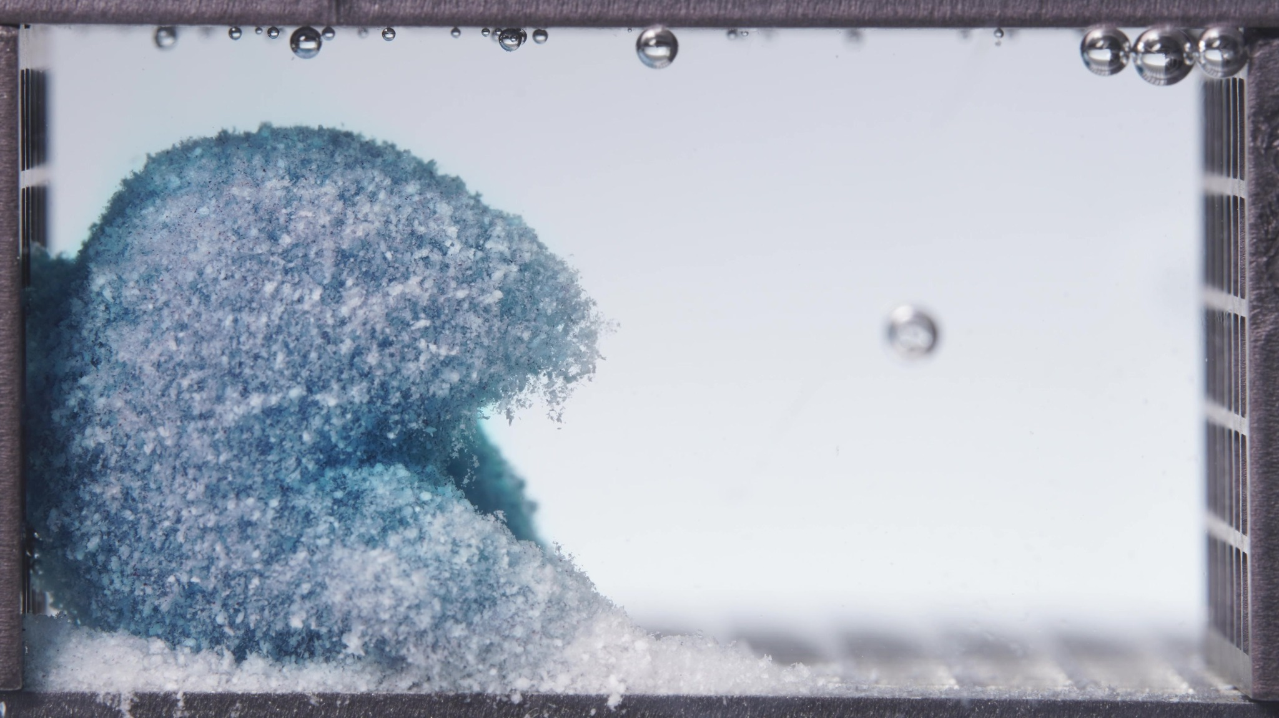
Image 1: 02-pH1.2-pH6.8T-亚甲蓝缓释片-低粘度-260417-24h-Side-750X-1_0090.000(5).jpg
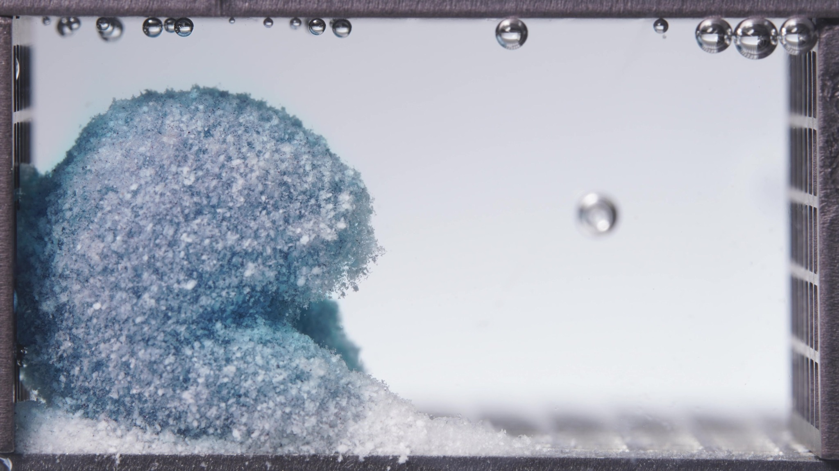
Image 2: 02-pH1.2-pH6.8T-亚甲蓝缓释片-低粘度-260417-24h-Side-750X-1_0102.000(5).jpg
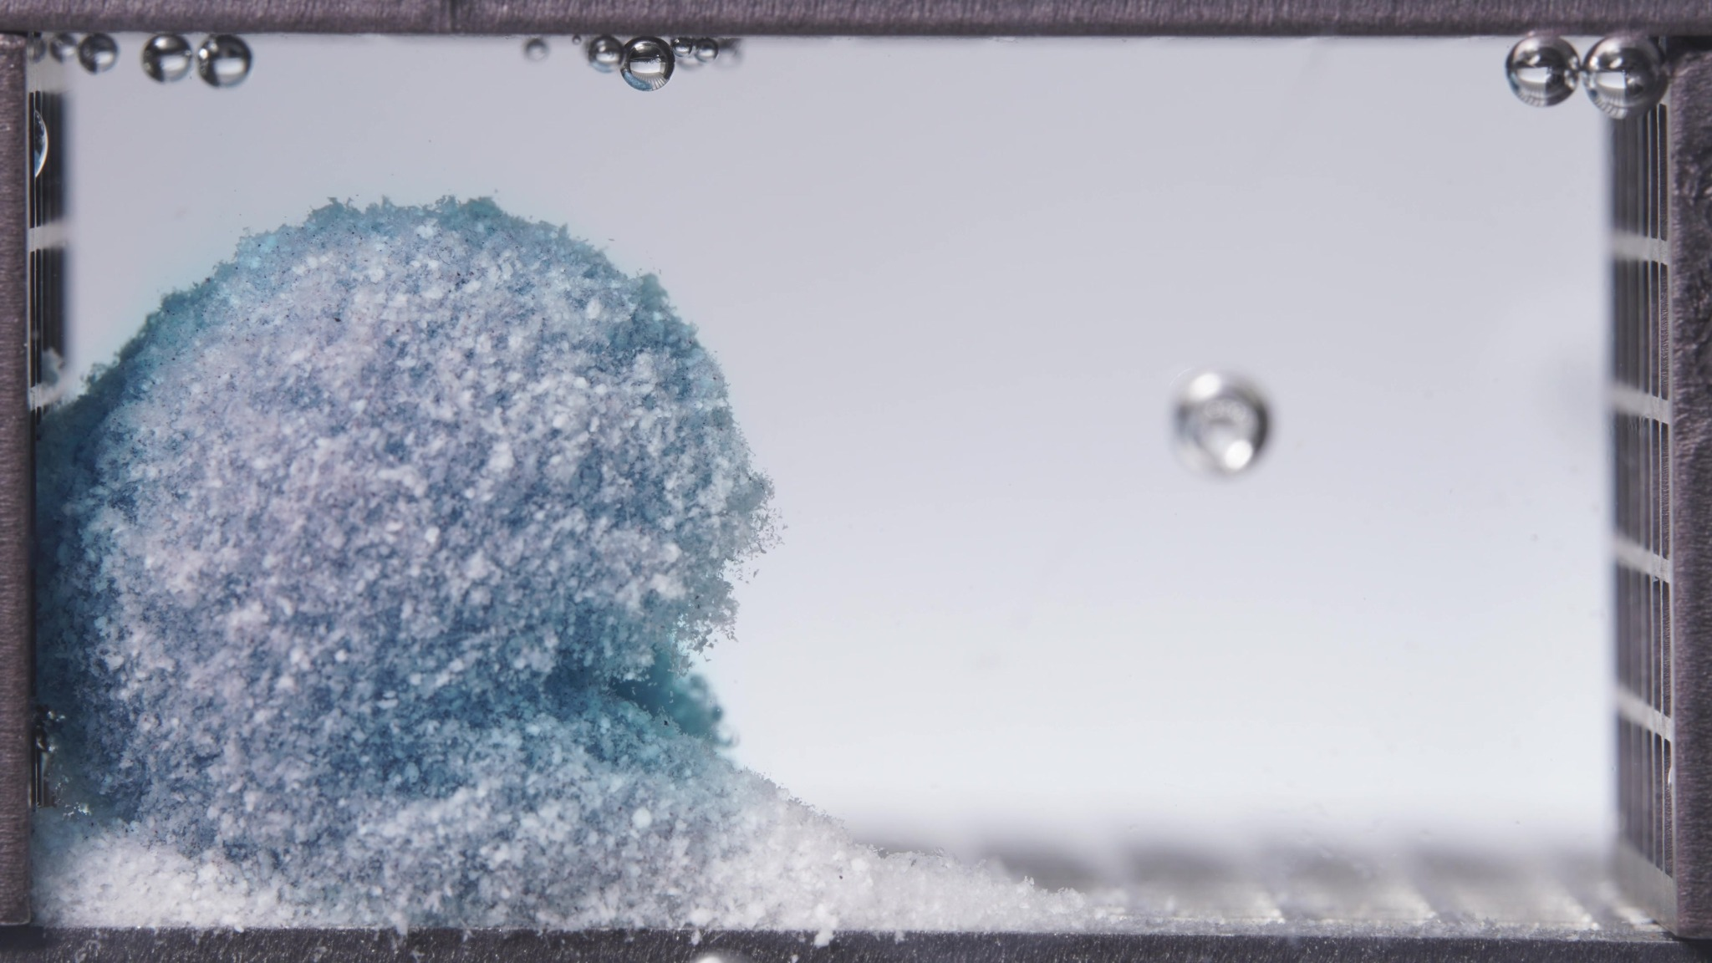
Image 3: 02-pH1.2-pH6.8T-亚甲蓝缓释片-低粘度-260417-24h-Side-750X-1_0114.000(5).jpg
Assistant
{
"group_id": "LOW-VISCOSITY",
"time_range_h": [18.75, 23.75],
"time_h": null,
"eight_dimension_description": {
"color_change": "The remaining tablet residue is predominantly pale cyan-white to white, with only weak residual
blue staining in deeper or lower-left regions. Compared with the 12.5-17.5 h window, blue intensity is further reduced
and the surrounding medium appears nearly clear, indicating minimal visible ongoing dye diffusion during this late
stage.",
"shape_change": "The original tablet geometry remains completely absent. The residue persists as a large,
irregular collapsed mound on the left side, with a rounded upper body and a sloped lower extension merging into the
basal sediment. Across the batch, the outline becomes slightly more rounded and consolidated, with less apparent
separation between upper mass and lower sediment than in the previous window.",
"surface_texture_change": "The surface remains very rough, porous, and granular, with extensive powdery and
flocculent pale material. The upper-right edge shows frayed, diffuse particulate boundaries. Compared with the
previous window, the surface appears more uniformly pale and residue-like, with fewer dark blue patches and no smooth
intact surface.",
"volume_change": "The visible occupied volume remains substantial but appears to be in a late collapsed-residue
state rather than an actively swelling state. Compared with 12.5-17.5 h, the mound is more compacted and integrated
with the sediment bed, while the basal particulate layer remains thick along the bottom.",
"dissolution_speed_time": "Compared with 12.5-17.5 h, visible disintegration has slowed further. Fresh dye release
is minimal, and the dominant process appears to be slow residual erosion, surface softening, and sediment
consolidation rather than rapid breakup or expansion.",
"physical_state_change": "The formulation is mainly a hydrated, friable, particulate residue. It retains partial
cohesion as a soft mound, but most visible material appears converted into loose granules, powder-like hydrated
matrix, and sedimented particles. The system is near a terminal residue stage rather than an intact or actively
disintegrating tablet stage.",
"dissolution_medium": "The medium is nearly clear to very faintly bluish, with much lower turbidity and color
intensity than earlier windows. Local haze remains close to the residue and along the bottom, but the right side of
the chamber is largely clear. No strong dye plume or broad cloud-like diffusion front is visible.",
"fragment_distribution_density": "Fragments remain strongly localized near the original tablet position and along
the bottom surface. The basal sediment layer is dense, pale, and continuous from the left side toward the center-
bottom. Fine particles are mainly sedimented rather than suspended broadly in the bulk medium, indicating bottom-
dominant residue accumulation."
},
"notes_for_later_summary": "Most critical change versus the previous 12.5-17.5 h window: the low-viscosity
formulation shifts further into a late-stage pale residue condition, with near-clear medium, minimal fresh dye
diffusion, and consolidated basal sediment. By 18.75-23.75 h, the visually dominant process is slow residue
persistence and sediment compaction rather than active release or rapid disintegration."
}

Turn 6
User
These are pictures of the standard formulation during 0.104-5h.
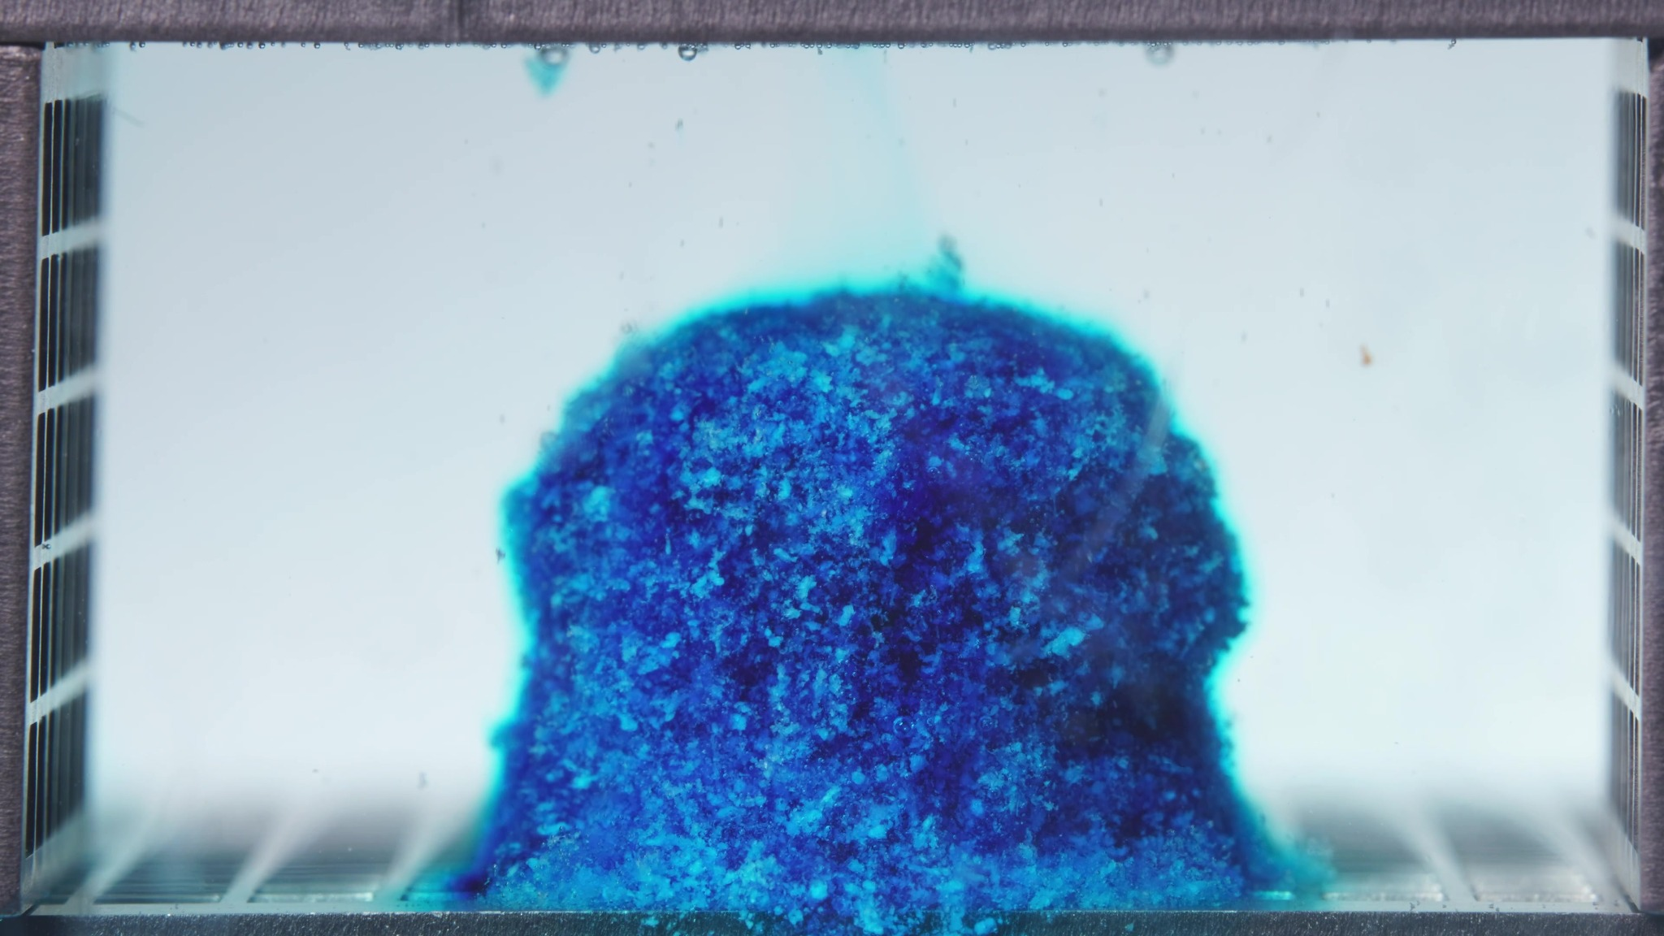
Image 1: 01-pH1.2-pH6.8T-亚甲蓝缓释片-标准粘度-260417-24h-Side-750X-2_0000.500(4).jpg
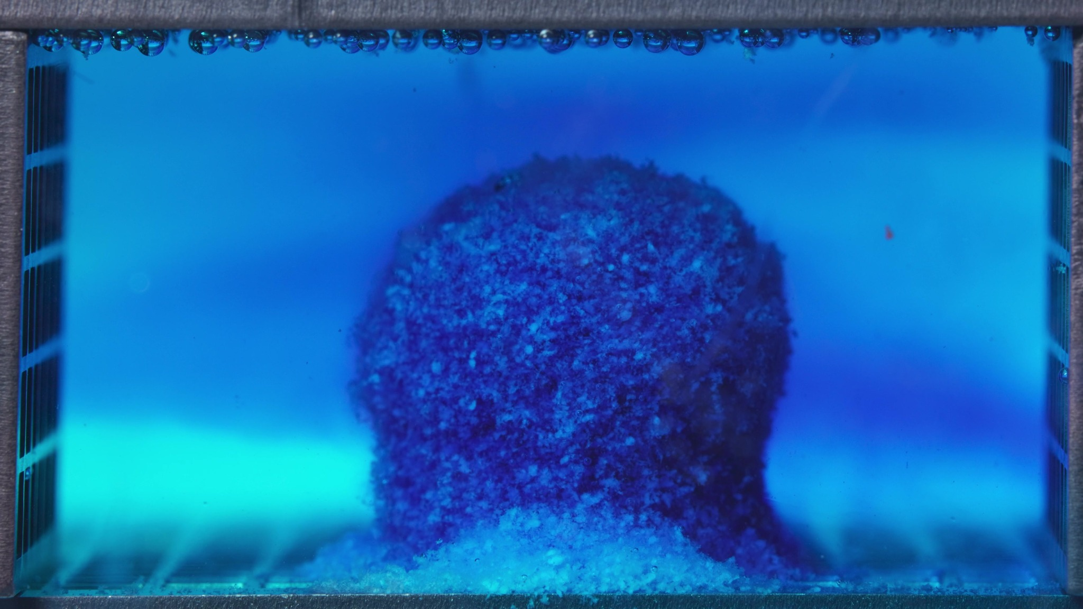
Image 2: 01-pH1.2-pH6.8T-亚甲蓝缓释片-标准粘度-260417-24h-Side-750X-2_0012.000(4).jpg
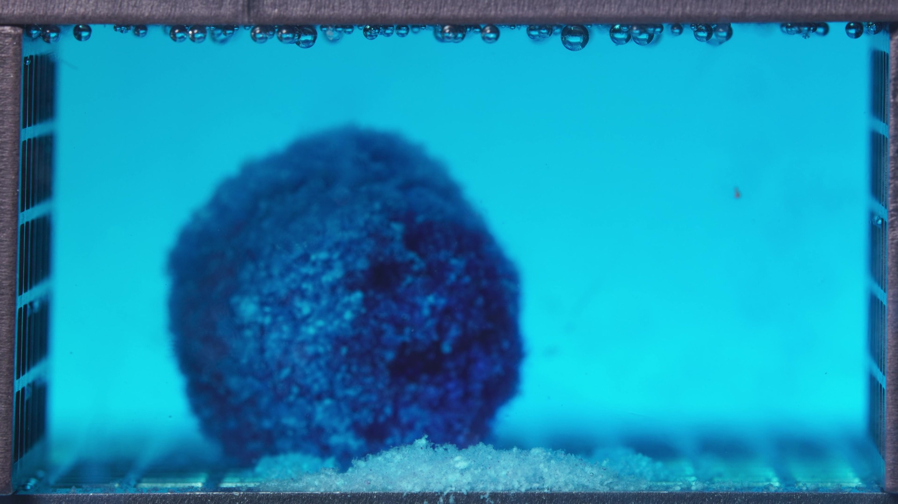
Image 3: 01-pH1.2-pH6.8T-亚甲蓝缓释片-标准粘度-260417-24h-Side-750X-2_0024.000(4).jpg
Assistant
{
"group_id": "STANDARD",
"time_range_h": [0.104, 5.0],
"time_h": null,
"eight_dimension_description": {
"color_change": "The tablet shows intense methylene-blue staining throughout this early window, with a dark blue
internal region and brighter cyan-blue hydrated margins. The surrounding medium changes from almost clear with
localized blue diffusion to broadly blue/turquoise, indicating substantial dye migration into the dissolution medium
during 0.104-5 h.",
"shape_change": "The tablet retains a relatively coherent bulk structure during this window. The initial
cylindrical or block-like outline is still partly recognizable early, but later images show rounding, edge softening,
and partial loss of the sharp tablet boundary. The body remains largely as one main mass rather than breaking into
many separated fragments.",
"surface_texture_change": "The surface is visibly rough, granular, and porous rather than smooth. Hydrated outer
material appears loosened, with small crumb-like particles on the surface and at the base. The later images show
stronger surface irregularity and a more diffuse boundary, especially around the lower and lateral edges.",
"volume_change": "The visible occupied volume appears to increase initially because of hydration and swelling. By
the later part of the window, the mass remains bulky and rounded, with a basal accumulation of loosened pale material.
The dominant visible pattern is swelling with early surface erosion rather than complete collapse.",
"dissolution_speed_time": "Previous-window comparison is unavailable for this first standard-formulation batch.
Within 0.104-5 h, the images show active early dye release, progressive medium coloration, and surface erosion, but
the central tablet body remains more cohesive than a fully dispersed particulate mass.",
"physical_state_change": "The tablet transitions from a compact solid into a hydrated swollen mass with a
roughened, softened outer layer. Some material at the base has converted into loose particulate or gel-like residue,
but the main body remains partially intact and cohesive during this window.",
"dissolution_medium": "The medium progresses from lightly tinted near the tablet to strongly blue/turquoise across
much of the chamber. Blue diffusion appears broad rather than only local by the later images. Mild haze and suspended
fine material are visible near the tablet and along the bottom, while the medium remains optically continuous rather
than filled with large fragments.",
"fragment_distribution_density": "Fragments and eroded particles are concentrated mainly around the tablet base
and original tablet position. A pale to cyan sediment layer develops along the bottom near the central region. Fine
particles are present, but broad dispersion of large fragments throughout the chamber is not evident."
},
"notes_for_later_summary": "Previous-window comparison is unavailable for the first standard-formulation batch. The
key observation for later comparison is that the standard formulation shows strong early dye release and swelling
within 0.104-5 h, but the tablet remains largely as one cohesive hydrated mass with localized basal sediment rather
than undergoing extensive early collapse."
}

Turn 7
User
These are pictures of the standard formulation during 6.25-11.25h.
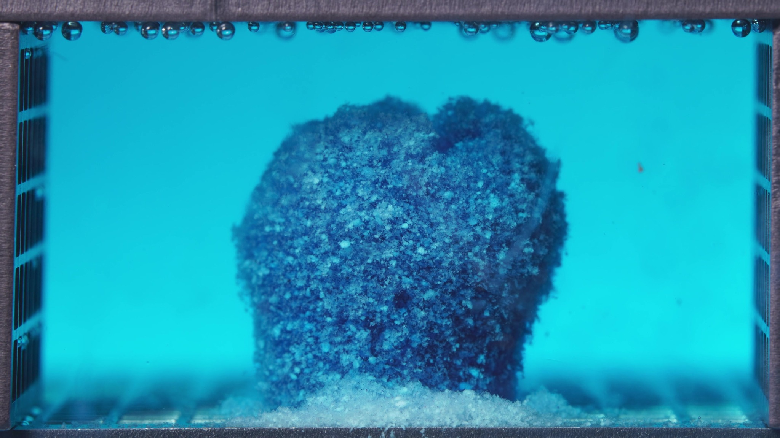
Image 1: 01-pH1.2-pH6.8T-亚甲蓝缓释片-标准粘度-260417-24h-Side-750X-2_0030.000(3).jpg
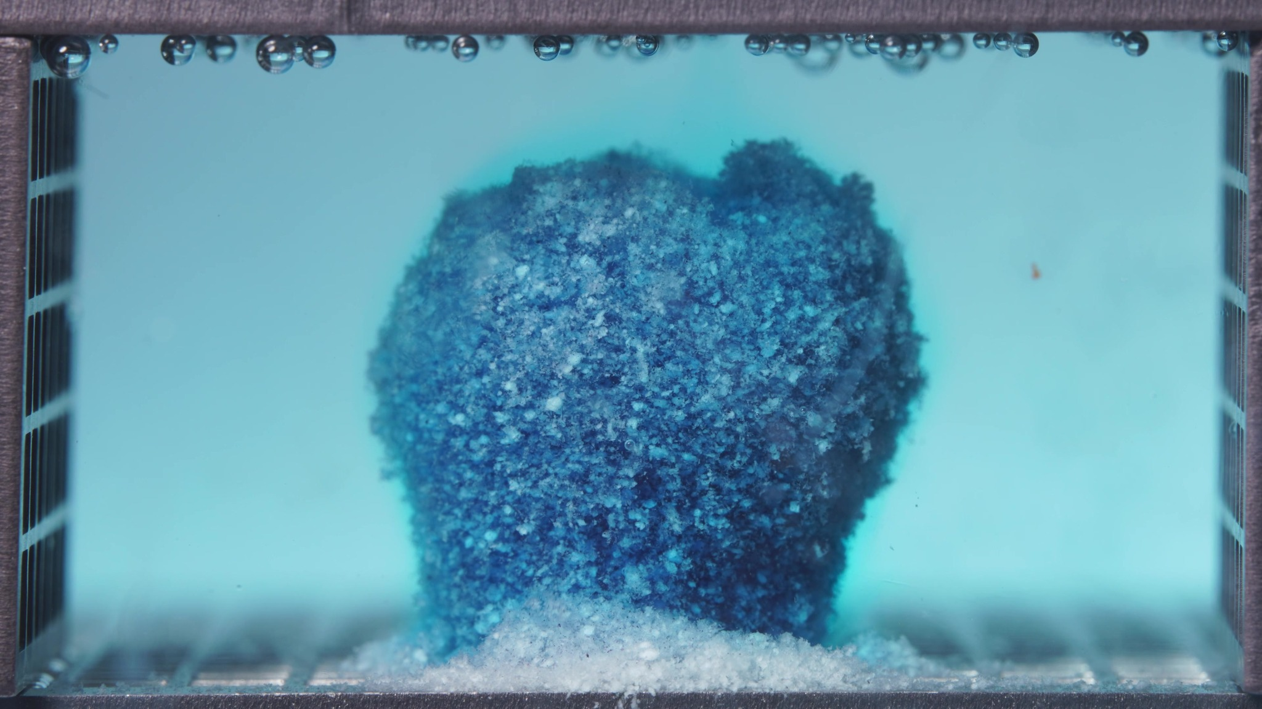
Image 2: 01-pH1.2-pH6.8T-亚甲蓝缓释片-标准粘度-260417-24h-Side-750X-2_0042.000(4).jpg
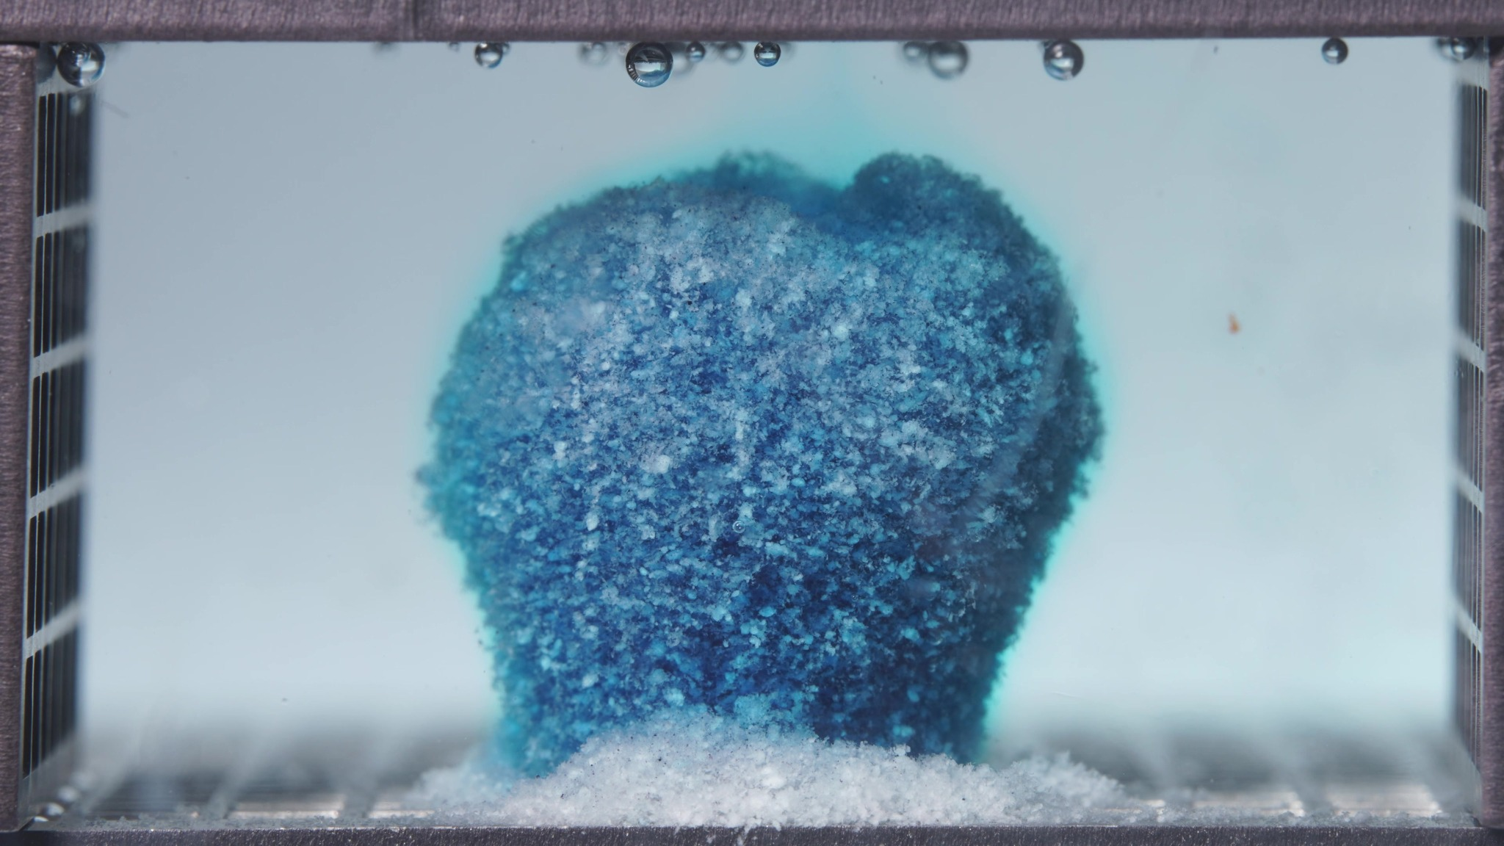
Image 3: 01-pH1.2-pH6.8T-亚甲蓝缓释片-标准粘度-260417-24h-Side-750X-2_0054.000(3).jpg
Assistant
{
"group_id": "STANDARD",
"time_range_h": [6.25, 11.25],
"time_h": null,
"eight_dimension_description": {
"color_change": "The tablet mass remains blue but shows increased pale cyan-white exposed regions on the surface
compared with the 0.104-5 h window. The surrounding medium remains blue/turquoise, but the color appears less
intensely saturated across the later images, suggesting that the strongest visible dye-diffusion phase occurred
earlier while residual release and erosion continue.",
"shape_change": "The tablet remains largely as one coherent swollen body. The original sharp tablet geometry is no
longer preserved, but the central mass keeps a compact rounded-to-cylindrical outline with only moderate edge
irregularity. Compared with the previous window, there is no major collapse into a broad mound and no separation into
multiple large fragments.",
"surface_texture_change": "The surface is rough, porous, and granular, with more pale crumb-like material visible
than in the previous window. The upper and lateral boundaries appear fuzzy and hydrated, while the main body still
retains a continuous surface rather than becoming fully dispersed.",
"volume_change": "The visible occupied volume remains substantial and relatively centralized. Compared with
0.104-5 h, the formulation appears to have passed the initial swelling stage and now maintains a bulky hydrated mass
with gradual surface erosion. The basal sediment layer is thicker, but the main body does not show marked shrinkage or
total collapse.",
"dissolution_speed_time": "Compared with the previous 0.104-5 h window, visible disintegration appears slower and
more controlled. Fresh dye-front expansion is less dominant, while progressive matrix erosion, surface whitening, and
sediment accumulation become more evident. The standard formulation continues to erode but maintains stronger
structural integrity during 6.25-11.25 h.",
"physical_state_change": "The tablet has progressed from a compact swollen solid toward a hydrated gel-like mass
with a friable outer layer. Some material has converted into loose particulate sediment at the base, but the central
body remains cohesive and only partially eroded.",
"dissolution_medium": "The medium remains blue/turquoise with mild haze, especially near the tablet and bottom
sediment. Compared with the previous window, the medium appears paler in the later images and lacks a strong newly
expanding dye plume. The right and upper regions are relatively clearer than the area immediately surrounding the
tablet.",
"fragment_distribution_density": "Fragments and eroded particles are concentrated around the tablet base and along
the bottom center. A dense pale sediment bed is more obvious than in the previous window, with small cyan-white
particles spreading laterally near the base. Large fragments remain limited, and broad suspension throughout the bulk
medium is not prominent."
},
"notes_for_later_summary": "Most critical change versus the previous 0.104-5 h window: the standard formulation
shifts from strong early dye release and swelling to a more controlled erosion stage, with increased pale surface
exposure and thicker basal sediment while the main tablet body remains cohesive. This indicates sustained matrix
integrity during 6.25-11.25 h rather than rapid collapse."
}

Turn 8
User
These are pictures of the standard formulation during 12.5-17.5h.
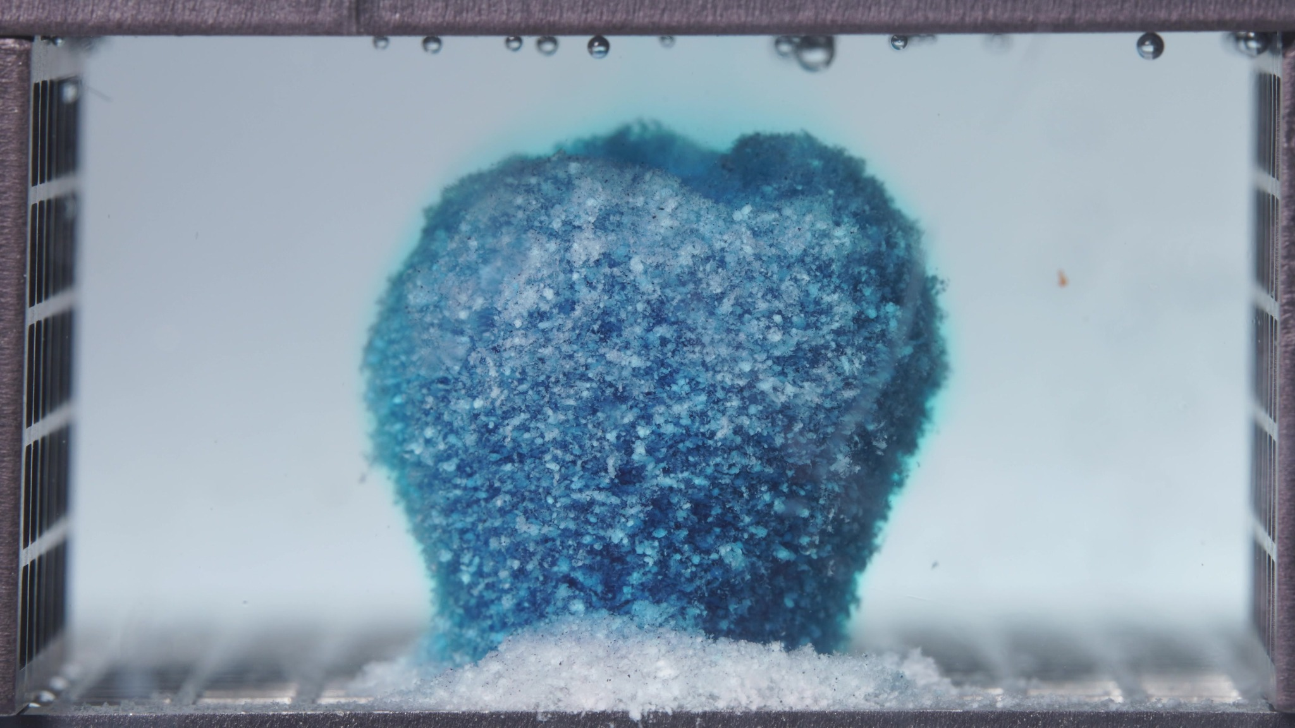
Image 1: 01-pH1.2-pH6.8T-亚甲蓝缓释片-标准粘度-260417-24h-Side-750X-2_0060.000(4).jpg
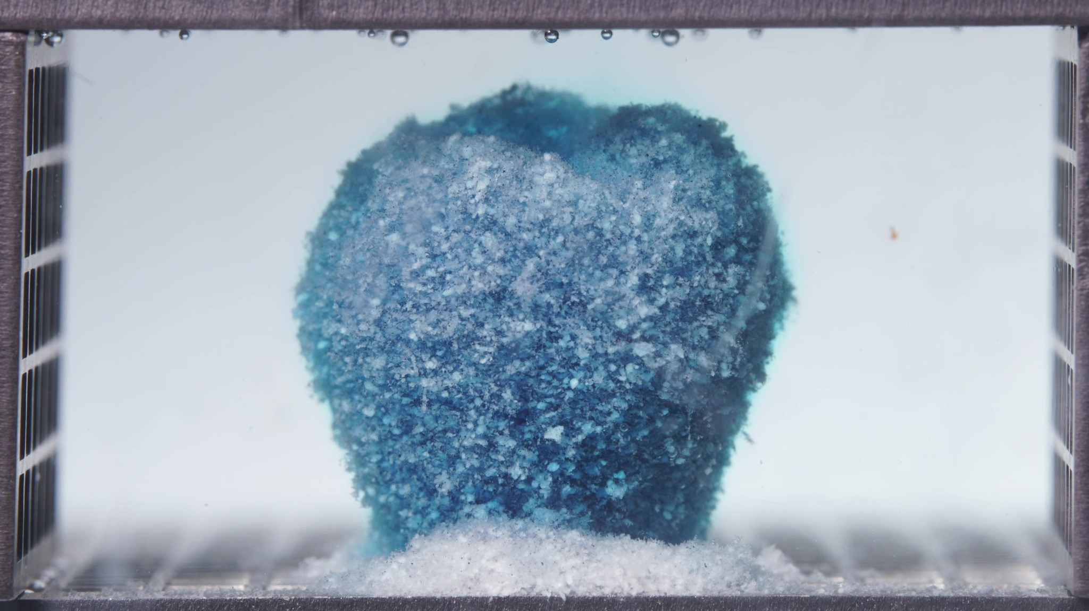
Image 2: 01-pH1.2-pH6.8T-亚甲蓝缓释片-标准粘度-260417-24h-Side-750X-2_0072.000(4).jpg
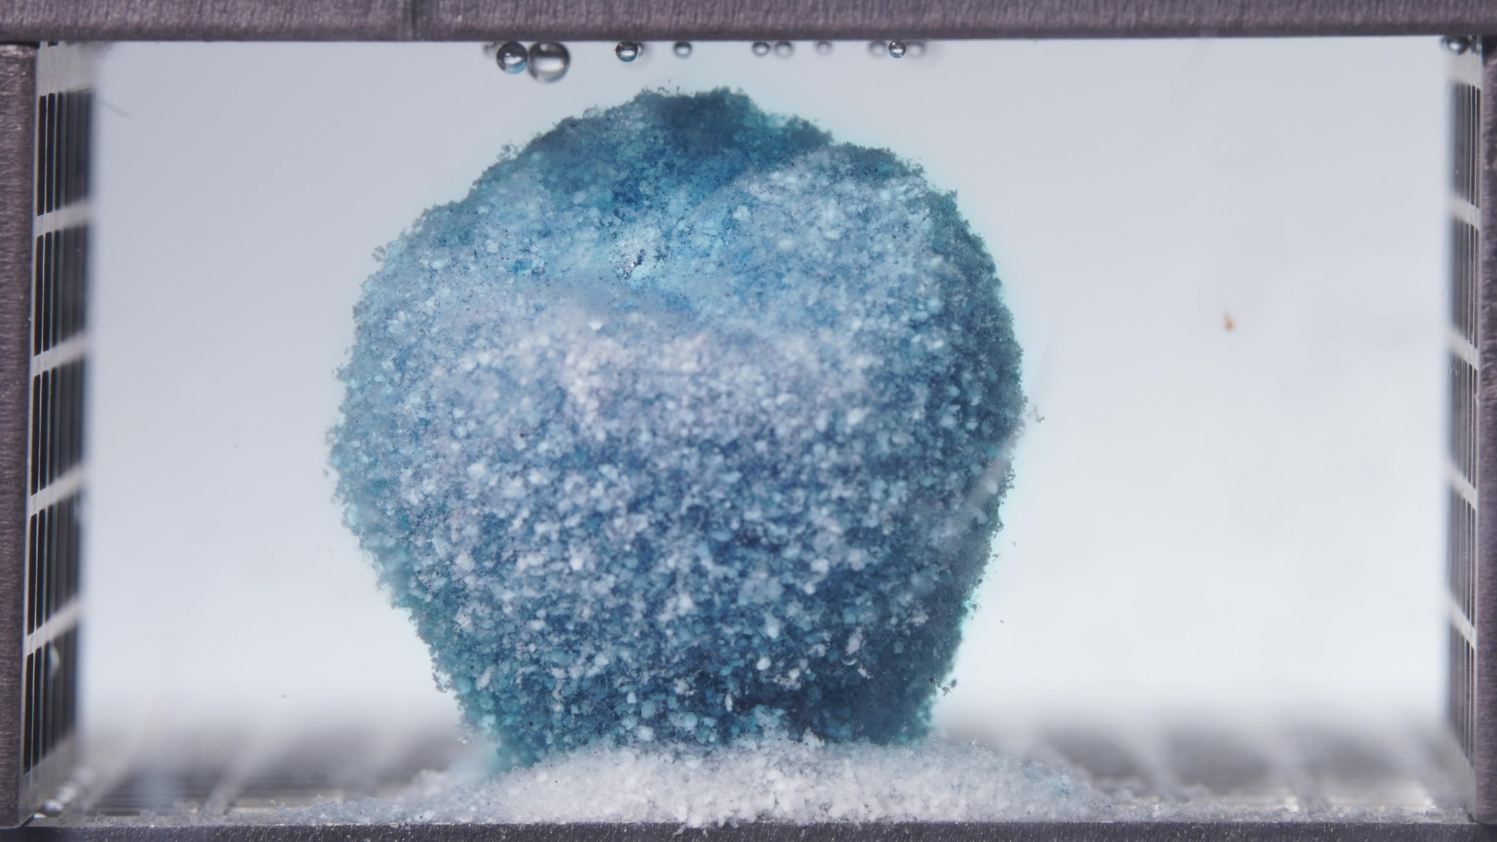
Image 3: 01-pH1.2-pH6.8T-亚甲蓝缓释片-标准粘度-260417-24h-Side-750X-2_0084.000(4).jpg
Assistant
{
"group_id": "STANDARD",
"time_range_h": [12.5, 17.5],
"time_h": null,
"eight_dimension_description": {
"color_change": "The tablet mass remains blue-cyan but shows a clear increase in pale cyan-white and white exposed
surface material compared with the 6.25-11.25 h window. Darker blue regions persist mainly in deeper internal zones
and along the lower/right side of the mass. The surrounding medium appears much paler and closer to clear than in
earlier standard-formulation windows, indicating reduced visible dye diffusion during this period.",
"shape_change": "The main tablet body remains largely cohesive and centralized. The original sharp cylindrical
geometry is no longer present, but the residue still keeps a rounded, bulky, single-mass outline rather than
collapsing into a broad low mound or separating into multiple large fragments. Compared with the previous window, the
upper boundary appears slightly more irregular and softened, but overall structural continuity is maintained.",
"surface_texture_change": "The surface remains rough, porous, and granular, with abundant pale crumb-like
particles distributed over the exposed face. Compared with 6.25-11.25 h, the surface appears more whitened and more
eroded, especially on the upper and central regions. The edge remains fuzzy and hydrated, but no smooth intact surface
is visible.",
"volume_change": "The visible occupied volume remains substantial and upright. There is no strong evidence of
major shrinkage or total collapse. Compared with the previous window, the mass appears slightly more rounded and
eroded at the surface, while the basal sediment bed becomes thicker and more prominent. The pattern is consistent with
continued surface erosion of a still-bulky hydrated matrix.",
"dissolution_speed_time": "Compared with 6.25-11.25 h, visible disintegration appears slower in terms of fresh dye
release but continues through gradual surface whitening, matrix erosion, and sediment growth. The formulation does not
show abrupt fragmentation; instead, it maintains a controlled erosion pattern with persistent cohesion of the central
tablet mass.",
"physical_state_change": "The tablet has progressed further toward a hydrated gel-like and friable particulate
state at the surface, while the inner body remains cohesive. The outer layer appears soft and erodible, with pale
granular material accumulating at the base. The structure is therefore intermediate between an intact swollen mass and
a late-stage residue, not yet fully dispersed.",
"dissolution_medium": "The medium is much less intensely blue than in the early window and appears pale cyan to
nearly clear across much of the chamber. Local haze persists close to the tablet and near the sediment layer, but
there is no strong expanding dye plume. The right side and upper bulk medium are relatively clear.",
"fragment_distribution_density": "Fragments remain concentrated at the tablet base and along the bottom center.
The basal sediment layer is denser and more extensive than in the previous window, consisting mainly of pale and cyan-
white fine particles. Large detached fragments are not prominent, and broad suspension throughout the chamber remains
limited."
},
"notes_for_later_summary": "Most critical change versus the previous 6.25-11.25 h window: the standard formulation
shows increased surface whitening, reduced medium blue intensity, and thicker basal sediment while retaining a
cohesive upright main body. This indicates transition from active dye release toward slower controlled matrix erosion,
with structural integrity still stronger than a fully collapsed residue state."
}

Turn 9
User
These are pictures of the standard formulation during 18.75-23.75h.
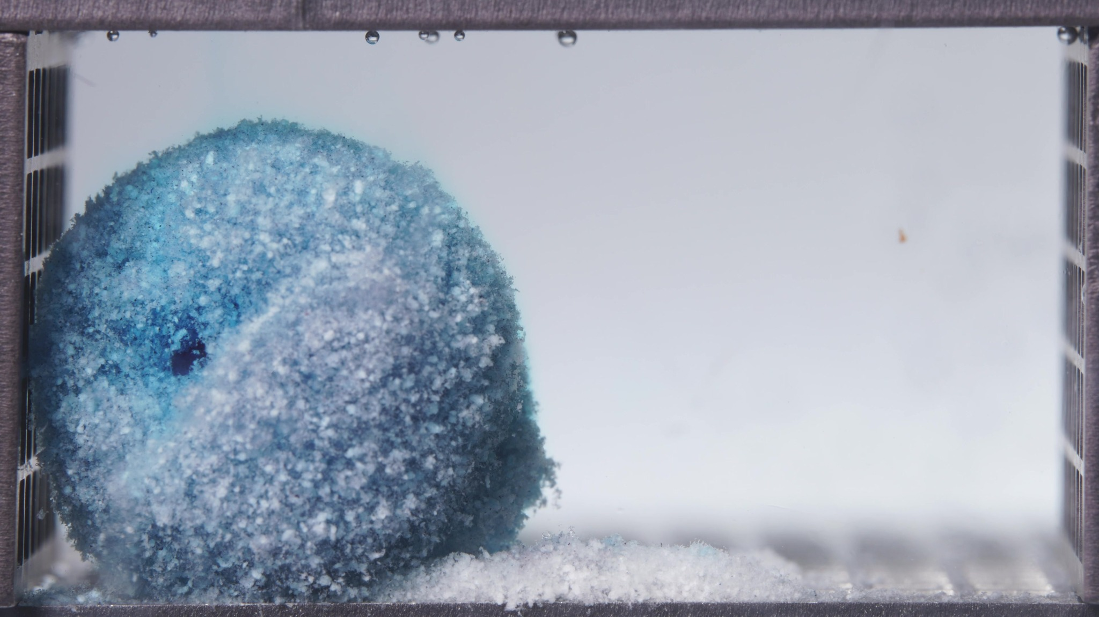
Image 1: 01-pH1.2-pH6.8T-亚甲蓝缓释片-标准粘度-260417-24h-Side-750X-2_0090.000(4).jpg
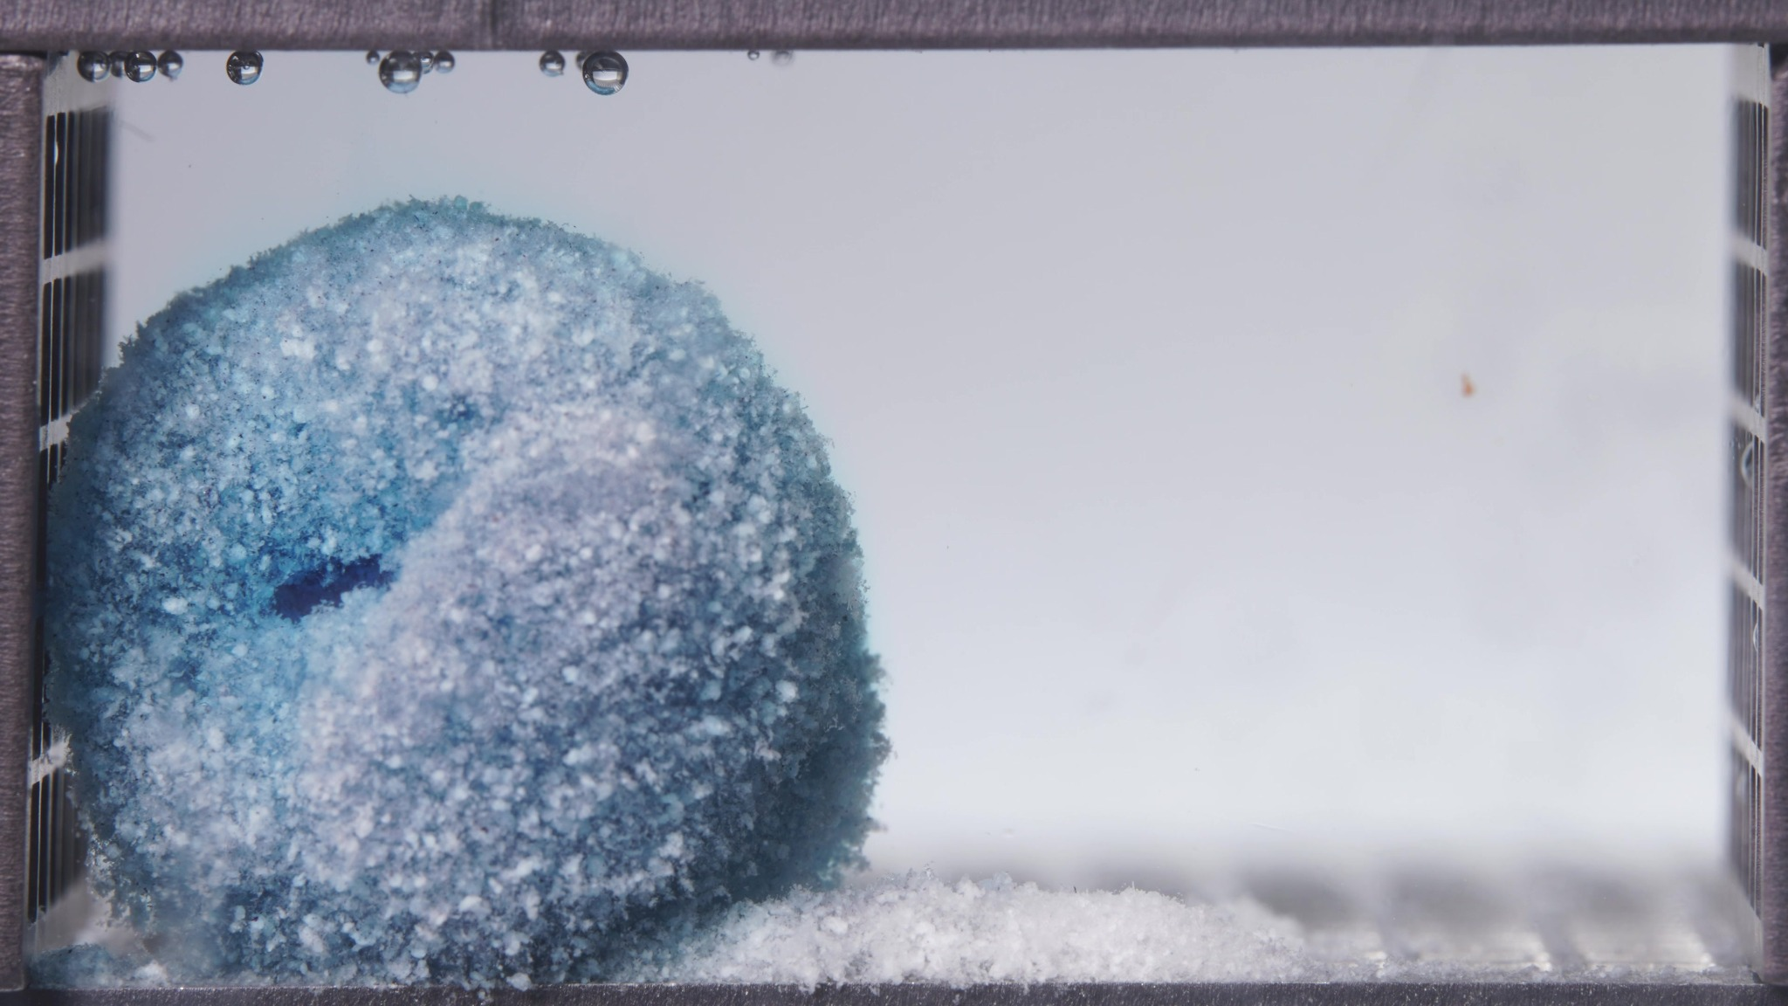
Image 2: 01-pH1.2-pH6.8T-亚甲蓝缓释片-标准粘度-260417-24h-Side-750X-2_0102.000(4).jpg
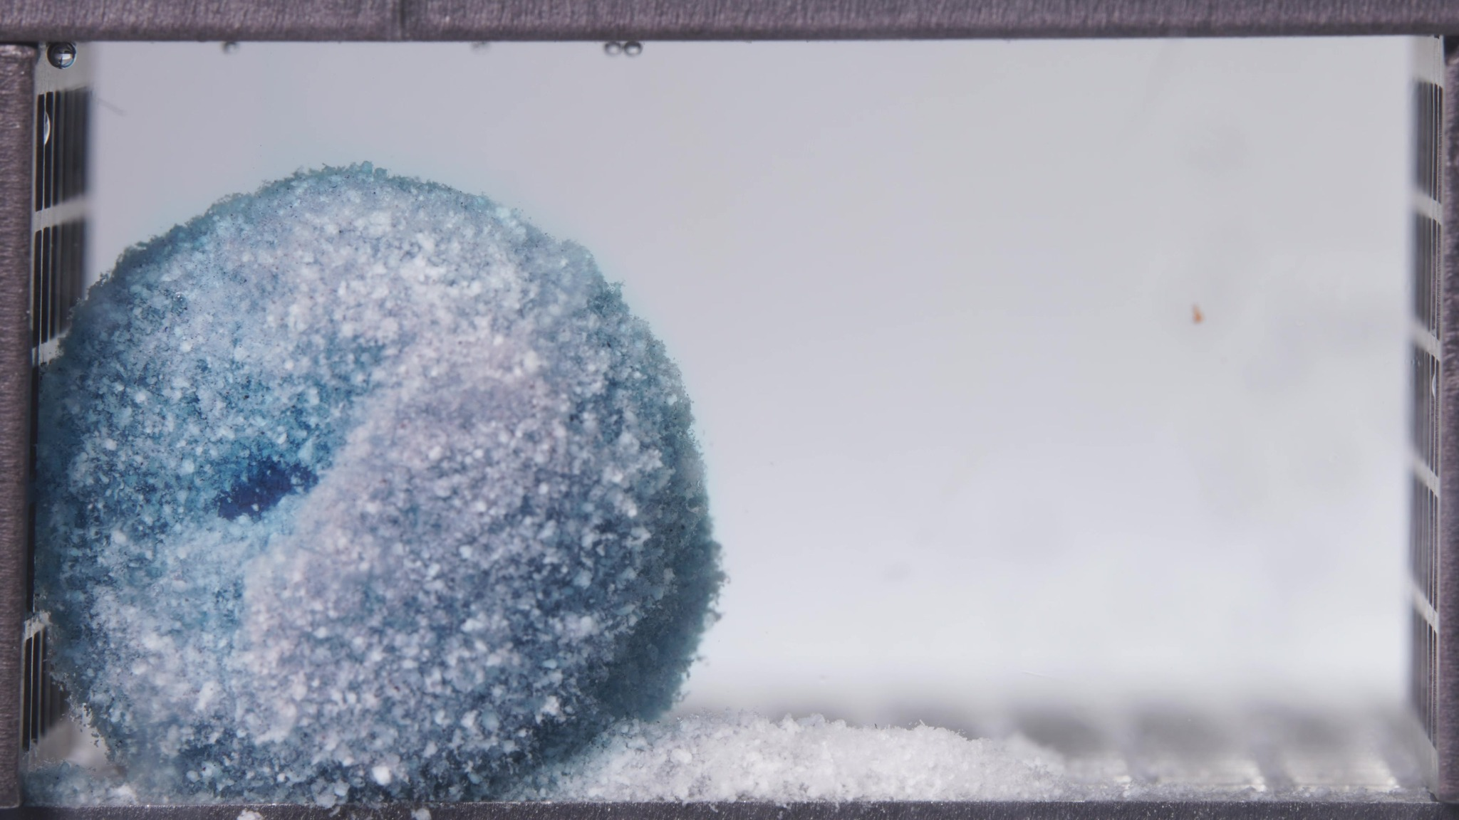
Image 3: 01-pH1.2-pH6.8T-亚甲蓝缓释片-标准粘度-260417-24h-Side-750X-2_0114.000(4).jpg
Assistant
{
"group_id": "STANDARD",
"time_range_h": [18.75, 23.75],
"time_h": null,
"eight_dimension_description": {
"color_change": "The remaining tablet mass is predominantly pale cyan-white with residual blue concentrated in
deeper internal zones and along the lower-left or rear portions of the residue. Compared with the 12.5-17.5 h window,
the exposed surface is further whitened and less intensely blue overall. The surrounding medium appears nearly clear
with only very faint bluish tint, indicating minimal visible ongoing dye diffusion during this late stage.",
"shape_change": "The original tablet geometry remains absent, but the formulation still persists as a large
cohesive residue rather than a fully collapsed flat mound. In this window the mass appears as a rounded, partly
bilobed or overlapping two-lobe structure located mainly on the left side, with a front rounded lobe and a larger rear
body. Compared with the previous window, the residue appears more laterally collapsed or reoriented and less like a
single upright central body, while still remaining continuous.",
"surface_texture_change": "The surface remains rough, porous, and granular, with abundant pale crumb-like
particles and a diffuse hydrated boundary. Compared with 12.5-17.5 h, the visible surface appears more uniformly pale
and residue-like, with fewer strongly blue exposed patches. The outer margins are soft and fuzzy, consistent with
continued surface erosion and hydrated particulate loosening.",
"volume_change": "The visible occupied volume remains substantial, showing that a large residue body persists even
at this late stage. However, compared with the previous window, the mass appears somewhat more rounded, consolidated,
and laterally settled rather than upright and centrally supported. The dominant pattern is late-stage residue
persistence with gradual compaction and continued basal sediment accumulation rather than fresh swelling.",
"dissolution_speed_time": "Compared with 12.5-17.5 h, visible disintegration appears slower still. Fresh dye
release is minimal, and the dominant changes are further surface whitening, gradual reshaping of the residue, and
continued sediment persistence. The standard formulation therefore remains in a controlled late erosion stage rather
than entering rapid breakup or broad dispersion.",
"physical_state_change": "The formulation is mainly a hydrated, friable, particulate residue with persistent
internal cohesion. The outer surface has largely converted into soft granular material, while the main mass still
holds together as a bulky late-stage residue. This indicates progression toward a terminal residue state, but not
complete disintegration into fine dispersed particles.",
"dissolution_medium": "The medium is nearly clear to very faintly bluish and shows much less visible color than in
earlier windows. Local haze is limited and mainly confined to the vicinity of the residue and bottom sediment. No
broad cloud-like dye plume or strong turbidity is evident, suggesting that medium-phase release activity is now low.",
"fragment_distribution_density": "Fragments remain concentrated near the original tablet position and along the
bottom surface. A dense pale sediment layer is clearly present along the base, extending from the left toward the
center-right. Fine particles are predominantly sedimented rather than widely suspended, and large detached fragments
are not prominent."
},
"notes_for_later_summary": "Most critical change versus the previous 12.5-17.5 h window: the standard formulation
progresses further into a pale late-stage residue condition, with near-clear medium, stronger surface whitening, and a
more rounded/laterally settled cohesive mass while the basal sediment remains dense. This indicates continued slow
controlled erosion with substantial residual structural integrity rather than rapid final collapse."
}

Turn 10
User
These are pictures of the high-viscosity formulation during 0.104-5h.
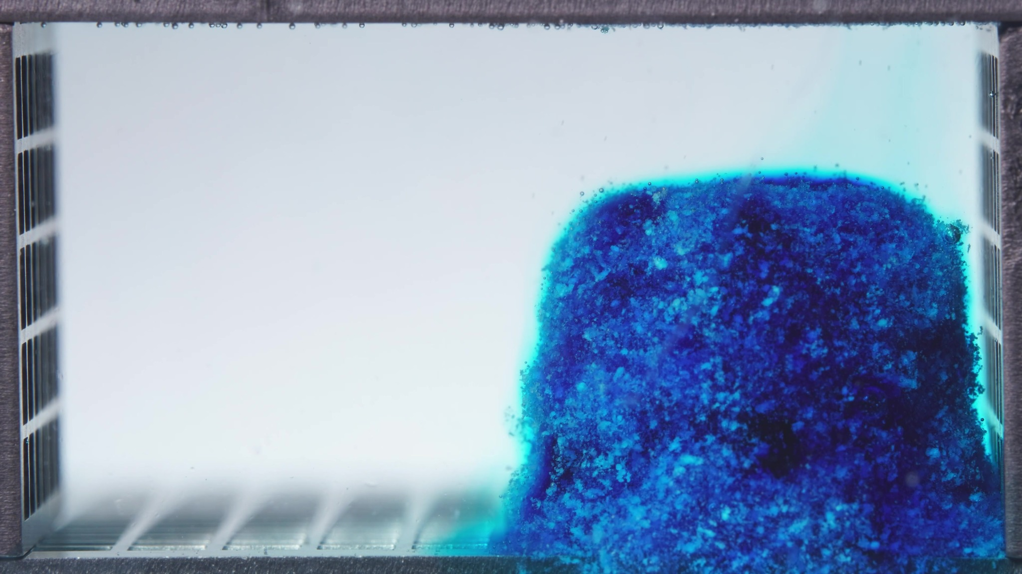
Image 1: 03-pH1.2-pH6.8T-亚甲蓝缓释片-高粘度-260417-24h-Side-750X-1_0000.500(5).jpg
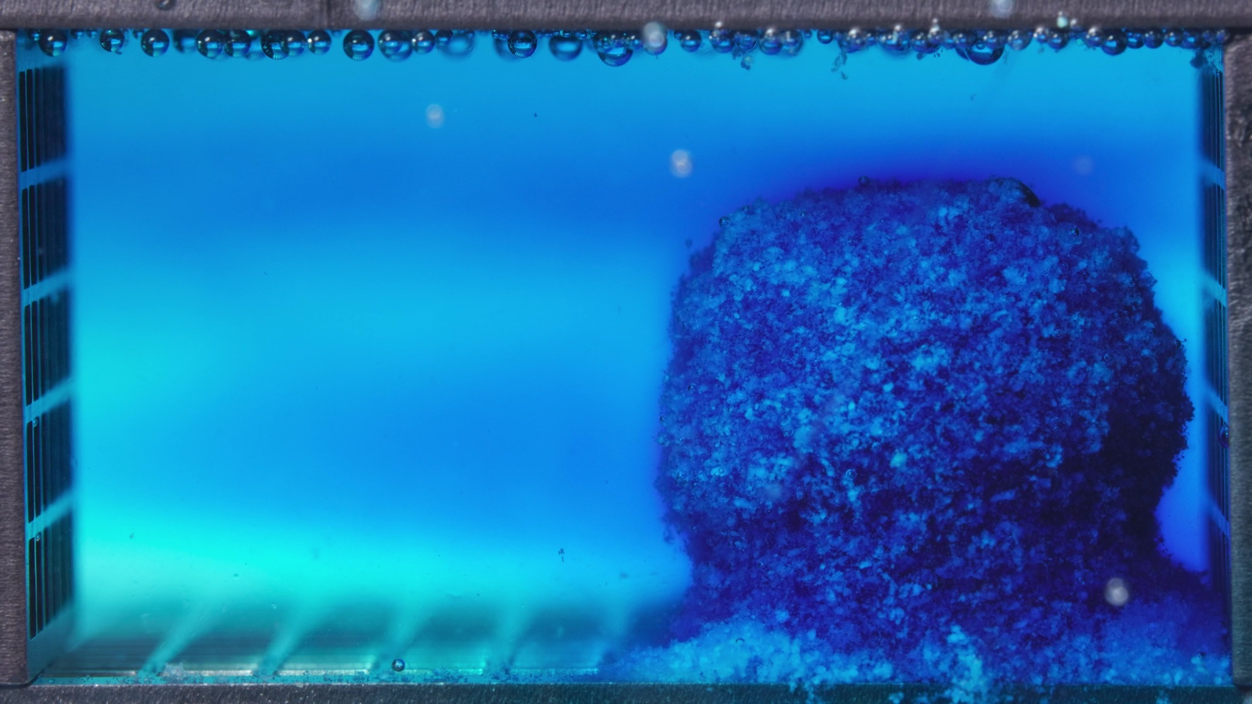
Image 2: 03-pH1.2-pH6.8T-亚甲蓝缓释片-高粘度-260417-24h-Side-750X-1_0012.000(5).jpg
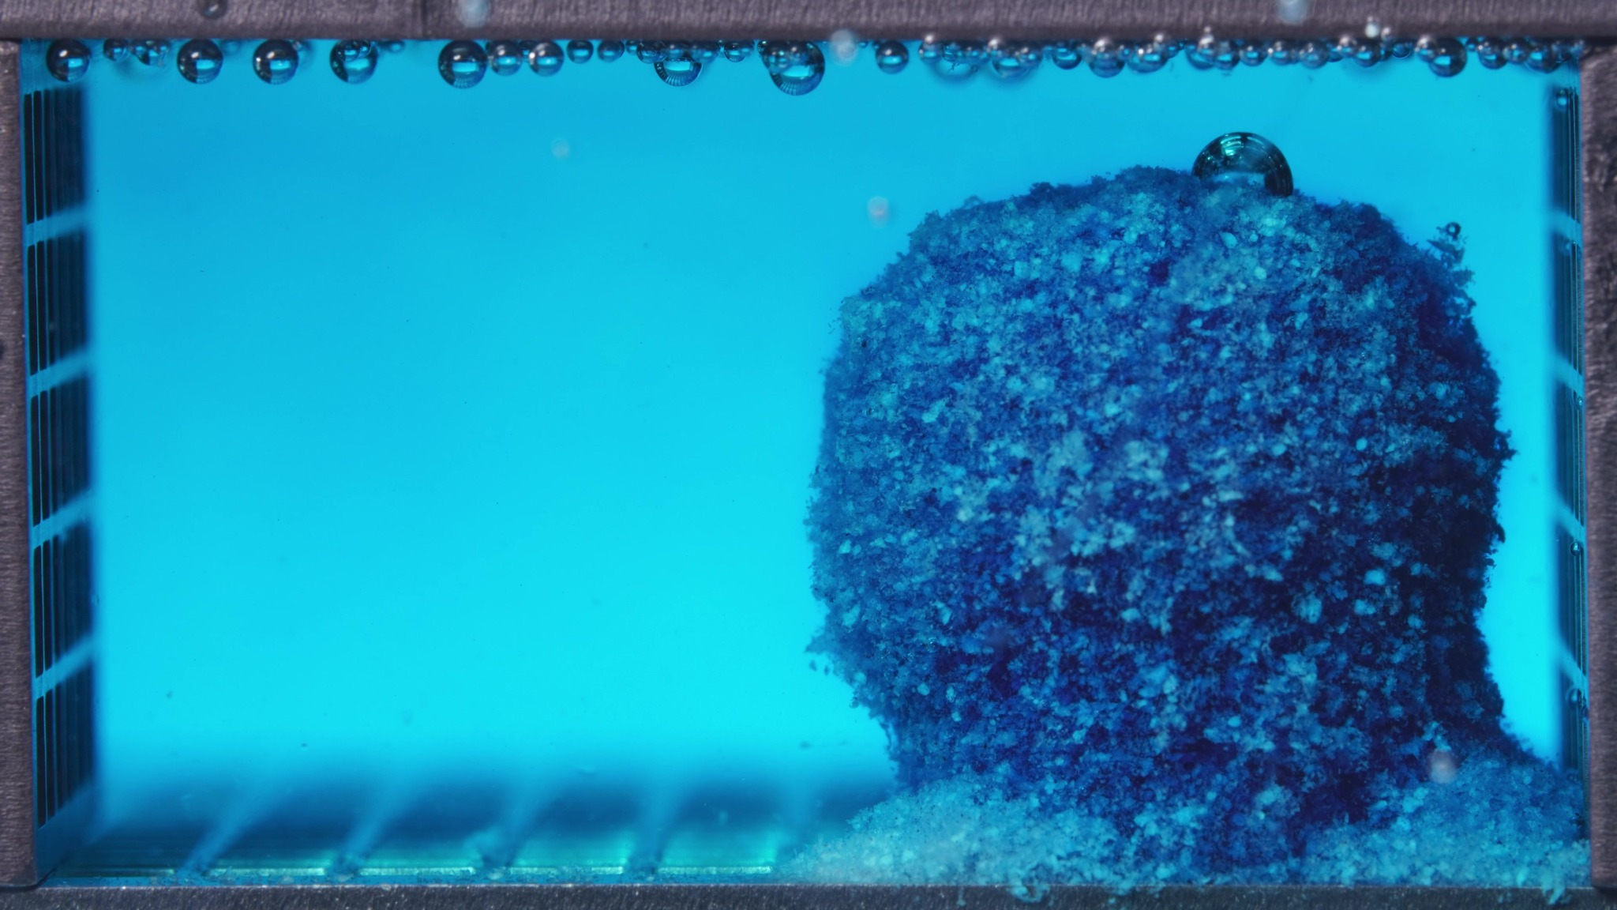
Image 3: 03-pH1.2-pH6.8T-亚甲蓝缓释片-高粘度-260417-24h-Side-750X-1_0024.000(5).jpg
Assistant
{
"group_id": "HIGH-VISCOSITY",
"time_range_h": [0.104, 5.0],
"time_h": null,
"eight_dimension_description": {
"color_change": "The tablet shows intense methylene-blue staining throughout the window, with a dark blue internal
region and brighter cyan-blue hydrated margins. The surrounding medium changes from nearly clear with localized blue
diffusion near the tablet to broadly blue/turquoise by the later images, indicating substantial dye migration into the
medium during 0.104-5 h.",
"shape_change": "The tablet remains largely as one coherent swollen body. The original compact geometry is
softened and rounded, with edge blurring and surface irregularity, but the main mass remains intact rather than
separating into multiple large fragments. The body is positioned mainly on the right side of the chamber and retains a
bulky block-like profile across the window.",
"surface_texture_change": "The surface is rough, granular, and porous, with visible hydrated particulate texture
over the exposed face. The outer boundary becomes fuzzy and softened, especially along the lateral and lower margins.
Fine crumb-like material is visible near the tablet base, but no smooth intact surface remains.",
"volume_change": "The visible occupied volume appears to increase initially due to hydration and swelling. Across
the window, the tablet remains bulky and elevated, with only limited visible collapse. A basal accumulation of
loosened material develops, but the main body retains substantial height and volume.",
"dissolution_speed_time": "Previous-window comparison is unavailable for this first high-viscosity batch. Within
0.104-5 h, the formulation shows active early dye release and medium coloration, but the main tablet body remains
highly cohesive, suggesting early swelling and surface erosion without extensive structural breakup during this
window.",
"physical_state_change": "The tablet transitions from a compact solid into a hydrated swollen mass with a
softened, roughened outer layer. Some material near the base converts into loose particulate or gel-like residue, but
the central mass remains continuous and mechanically coherent.",
"dissolution_medium": "The medium progresses from mostly clear or weakly tinted to broadly blue/turquoise. Blue
diffusion is visible around the tablet and later extends through much of the chamber. Mild haze and fine suspended
material are present near the tablet and bottom region, while no dense field of large detached fragments is visible in
the bulk medium.",
"fragment_distribution_density": "Fragments and eroded particles remain concentrated near the tablet base and
original tablet position on the right side. A pale to cyan sediment layer develops along the bottom adjacent to the
tablet. Fragment dispersion into the wider chamber is limited, with most visible particulate material remaining
localized near the mass and basal surface."
},
"notes_for_later_summary": "Previous-window comparison is unavailable for the first high-viscosity batch. The key
observation for later comparison is that the high-viscosity formulation shows strong early dye release and swelling
within 0.104-5 h, while retaining a bulky cohesive main body with localized basal sediment rather than undergoing
early gross collapse or broad fragment dispersion."
}

Turn 11
User
These are pictures of the high-viscosity formulation during 6.25-11.25h.
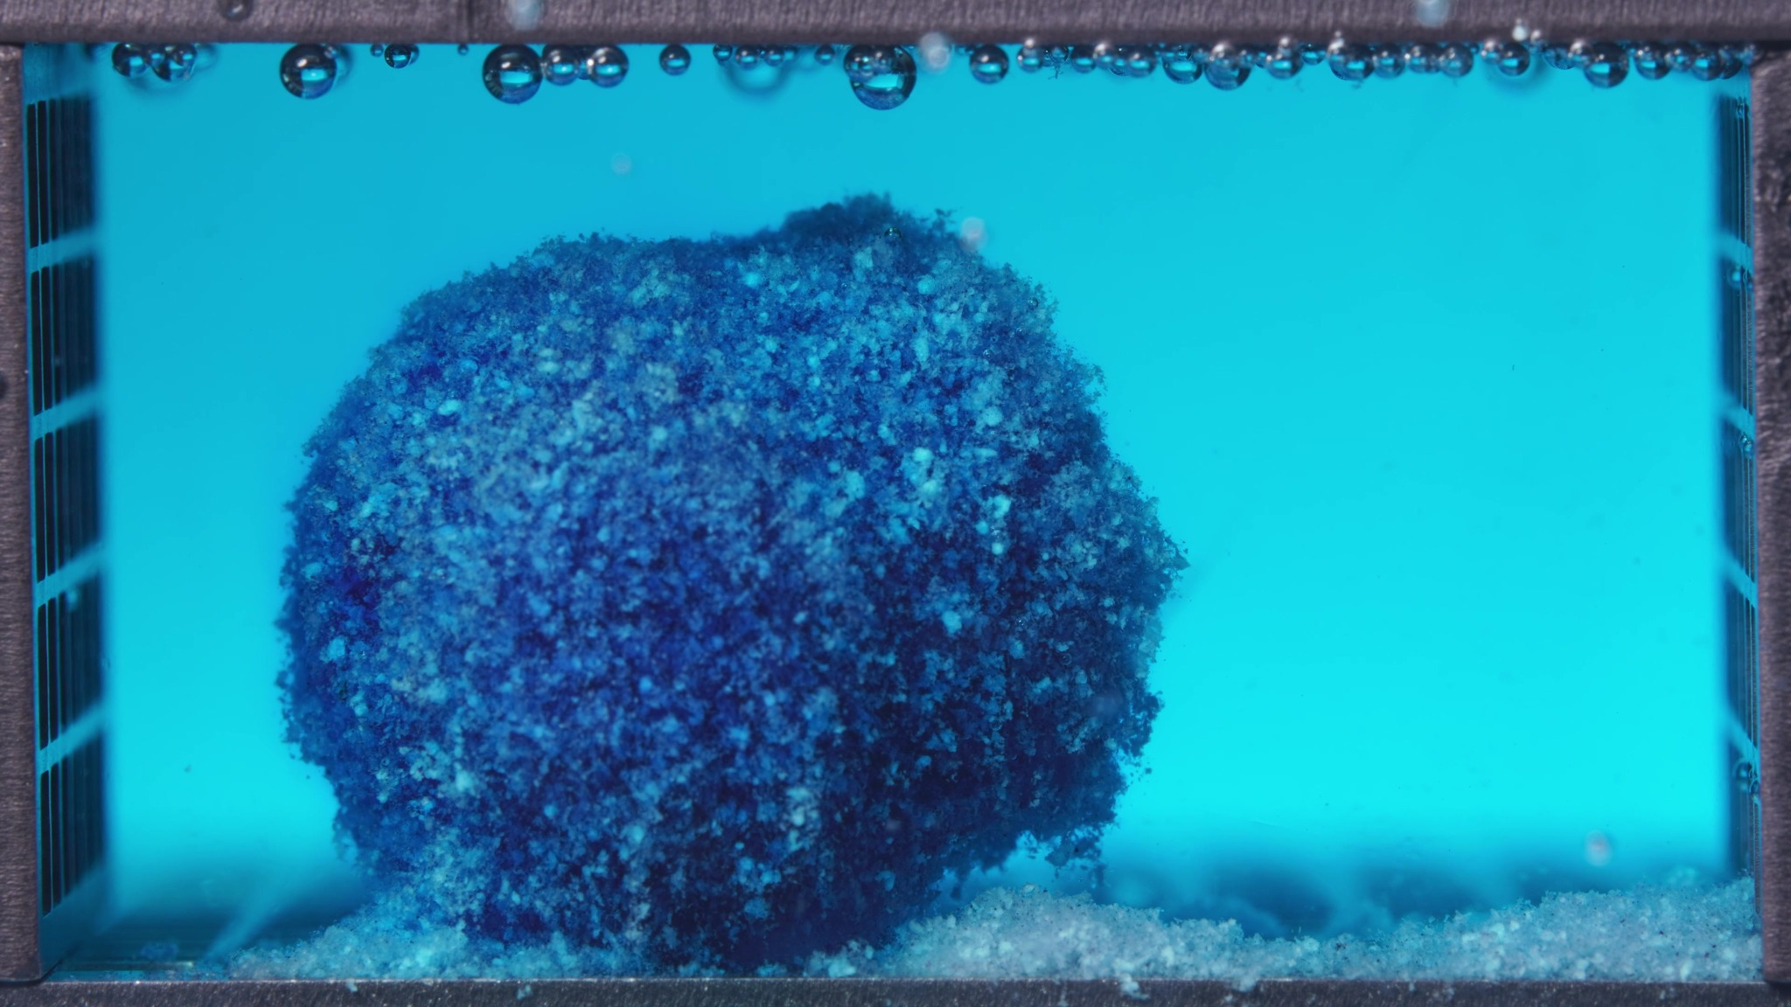
Image 1: 03-pH1.2-pH6.8T-亚甲蓝缓释片-高粘度-260417-24h-Side-750X-1_0030.000(5).jpg
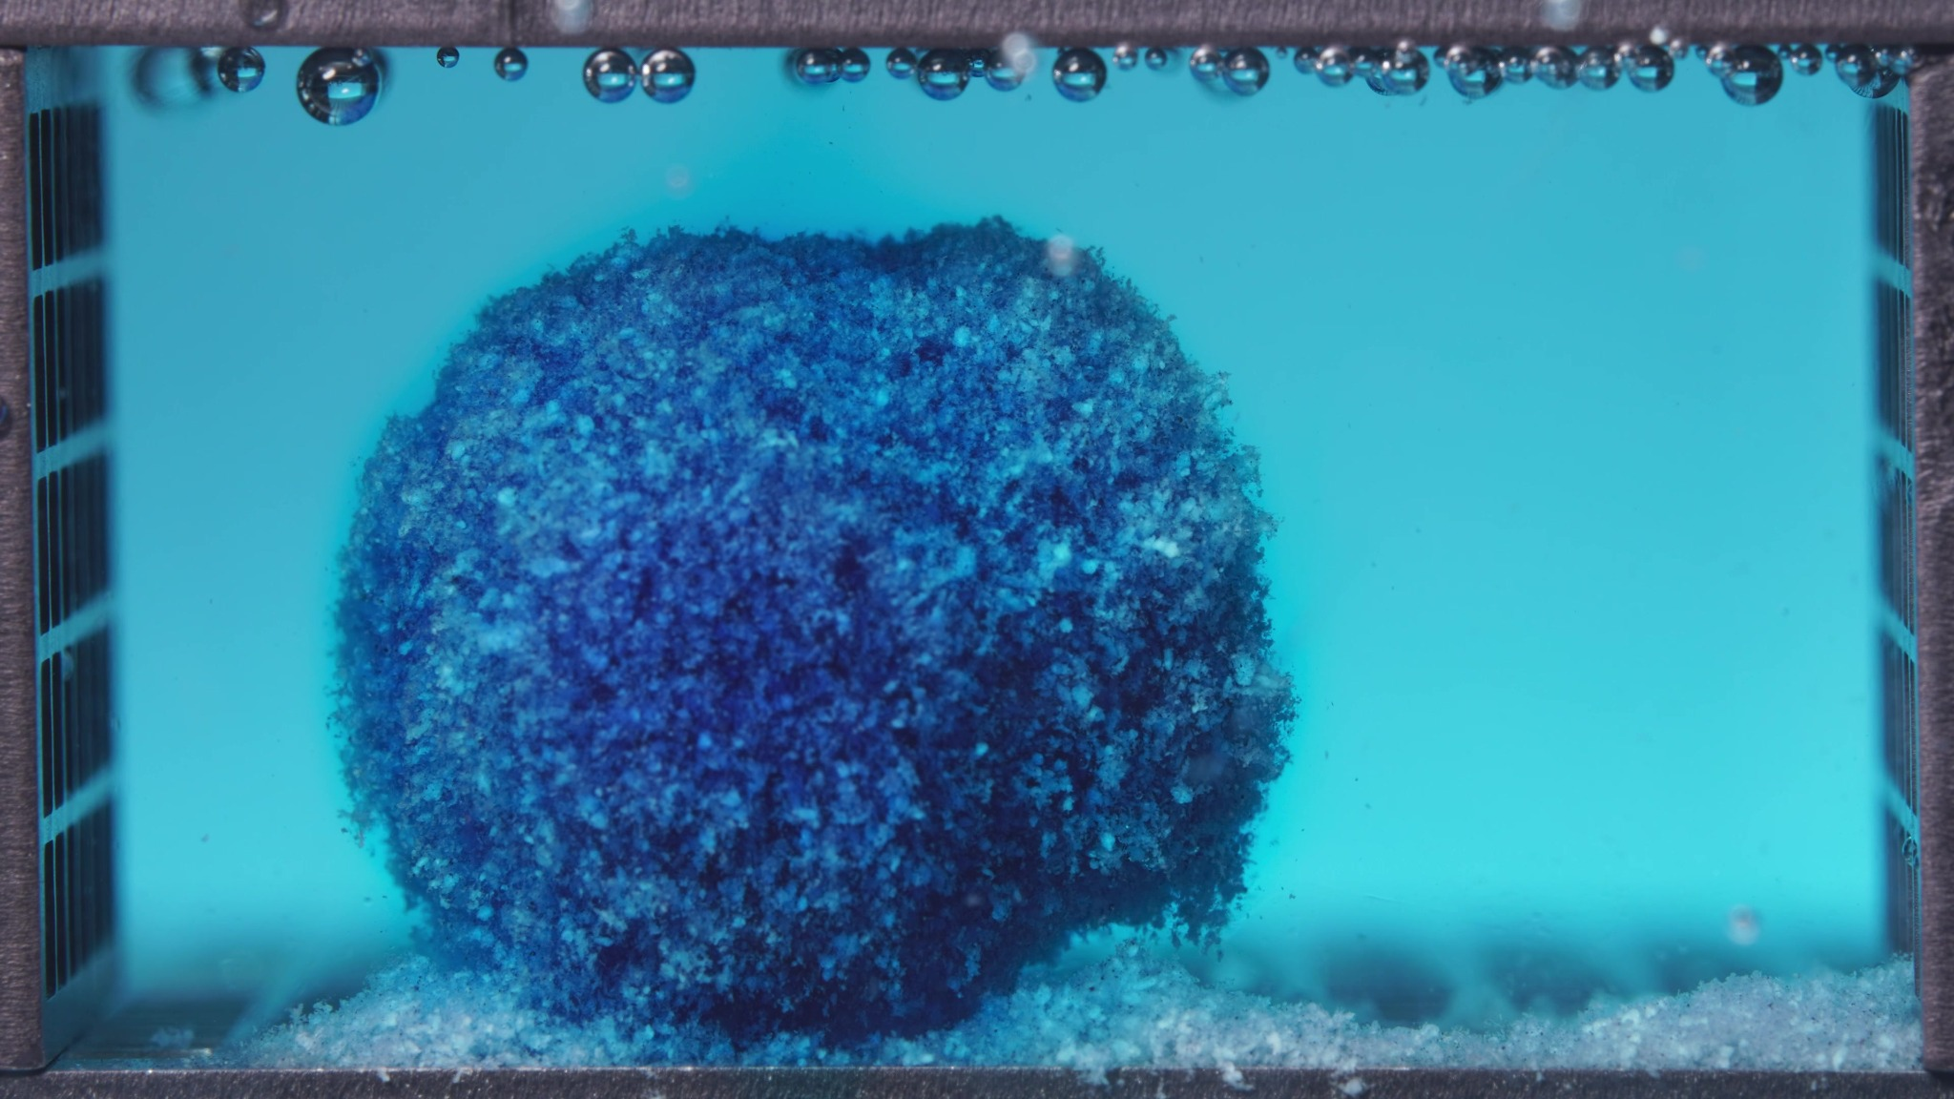
Image 2: 03-pH1.2-pH6.8T-亚甲蓝缓释片-高粘度-260417-24h-Side-750X-1_0042.000(5).jpg
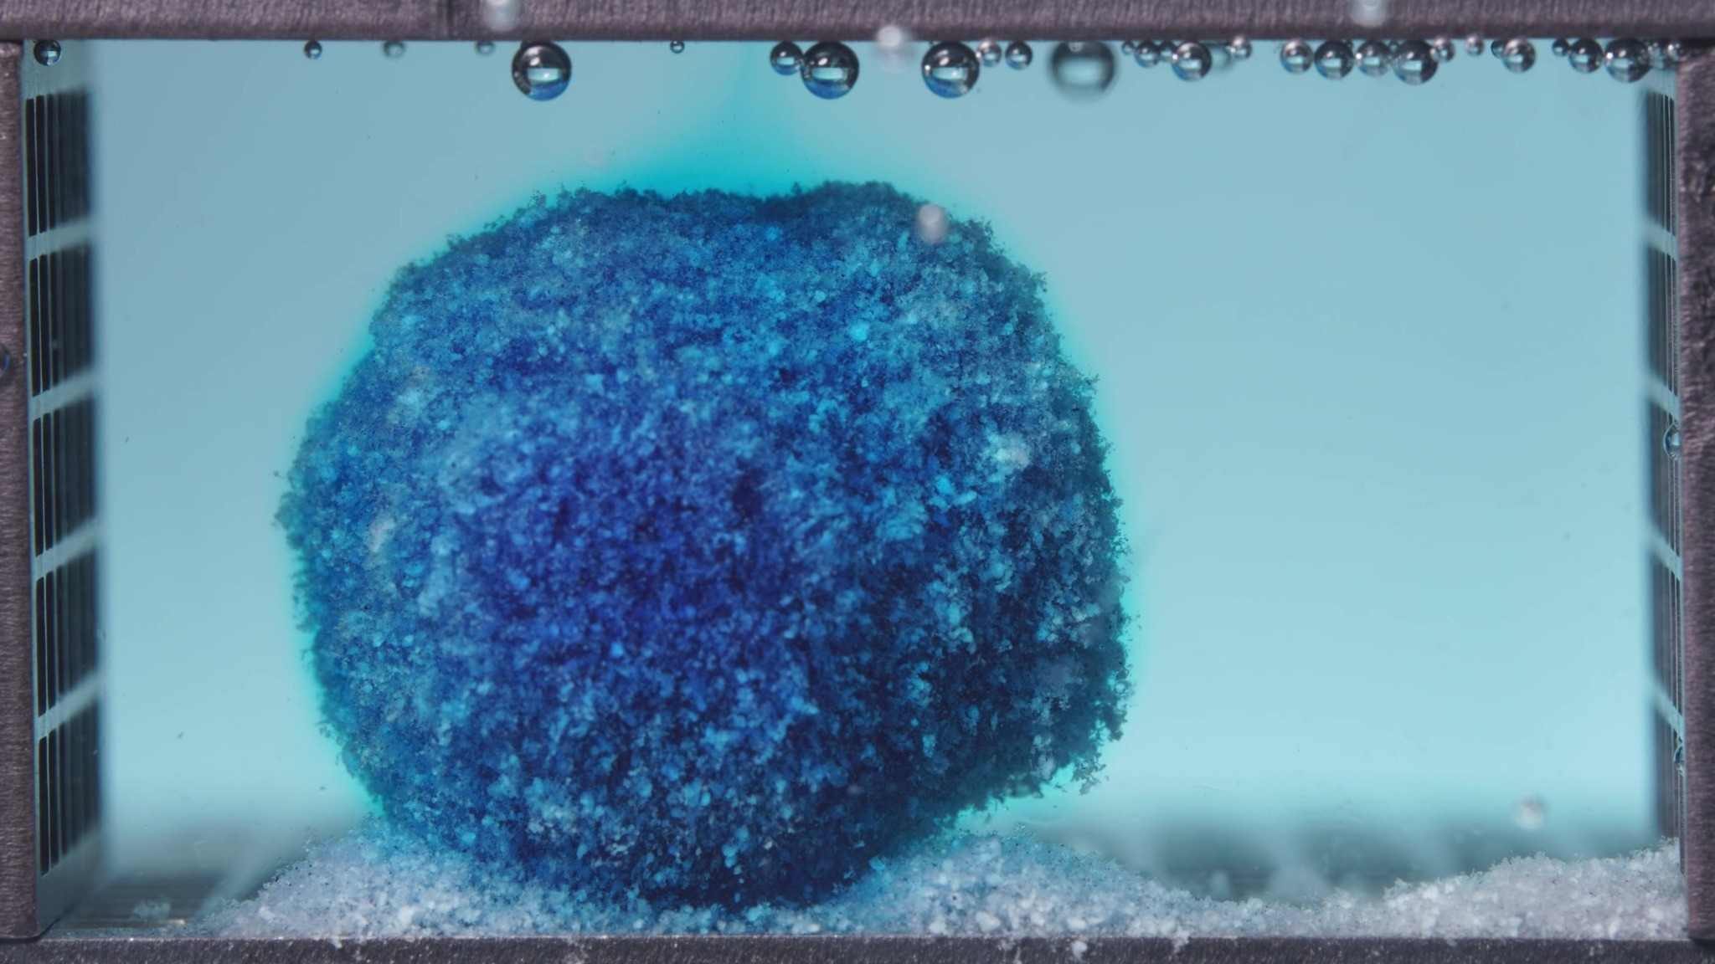
Image 3: 03-pH1.2-pH6.8T-亚甲蓝缓释片-高粘度-260417-24h-Side-750X-1_0054.000(5).jpg
Assistant
{
"group_id": "HIGH-VISCOSITY",
"time_range_h": [6.25, 11.25],
"time_h": null,
"eight_dimension_description": {
"color_change": "The tablet remains deeply methylene-blue stained, with a dark blue core and lighter blue hydrated
outer regions. The surrounding medium is now broadly turquoise-blue across the chamber rather than showing only
localized diffusion, indicating that dye has become more uniformly distributed compared with the previous window.",
"shape_change": "The main body remains as a single coherent mass with no major breakup into separate large
fragments. Compared with the previous window, the outline appears more rounded and dome-like, with softened edges and
a more regular swollen profile, while overall structural integrity is still preserved.",
"surface_texture_change": "The surface continues to appear rough, granular, and porous. Compared with the previous
window, the texture looks more uniformly hydrated and slightly more softened at the margins, but there is still no
smooth intact coating-like surface. Small crumb-like protrusions and loose material are visible around the lower
edge.",
"volume_change": "The tablet still occupies a large visible volume and appears to maintain, or show only slight
additional swelling from, the previous window. There is no clear evidence of marked shrinkage or collapse; the swollen
body remains bulky and elevated above the bottom sediment layer.",
"dissolution_speed_time": "Compared with the previous window, disintegration appears to progress more slowly in
structural terms: the medium is already strongly colored, but the tablet body remains highly cohesive with only
limited external erosion. This suggests continued hydration and slow surface loss rather than accelerated bulk
breakup.",
"physical_state_change": "The formulation remains in a swollen, hydrated mass state with a softened outer layer.
Relative to the previous window, it appears somewhat more gel-like and rounded, but it has not transitioned into a
collapsed paste or dispersed particle field. The internal body still looks compact enough to retain a stable single-
mass structure.",
"dissolution_medium": "The medium is visibly blue/turquoise throughout the chamber and appears more uniformly
colored than in the previous window. Local haze around the tablet persists, but the dominant visual feature is now a
broadly dyed medium rather than a strongly localized diffusion front. No major cloud of large suspended fragments is
visible.",
"fragment_distribution_density": "Fine eroded material and sediment remain concentrated near the tablet base and
adjacent bottom surface. Compared with the previous window, basal residue is still present but remains localized, with
no clear transition to wide fragment dispersion across the chamber. Detached material appears fine and sparse rather
than coarse or abundant."
},
"notes_for_later_summary": "Most critical change versus the previous window: the high-viscosity tablet has become
more rounded and uniformly hydrated while still remaining as one cohesive swollen mass; meanwhile, the medium has
become more uniformly blue, indicating continued release without major structural disintegration or broad fragment
dispersion."
}

Turn 12
User
These are pictures of the high-viscosity formulation during 12.5-17.5h.
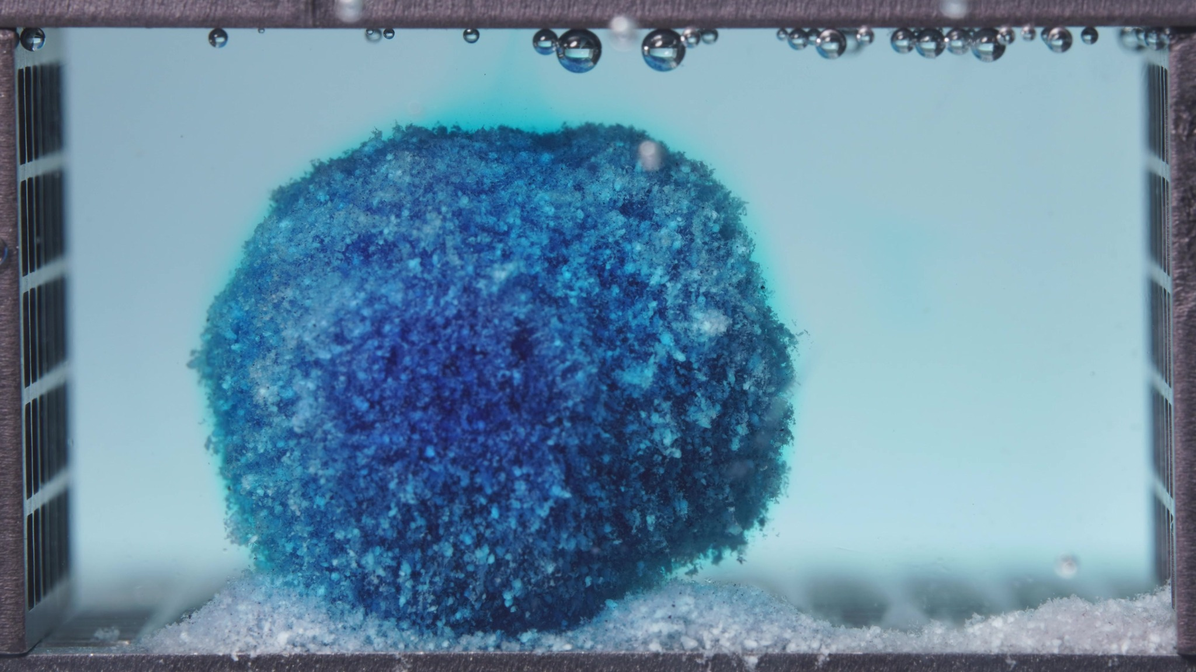
Image 1: 03-pH1.2-pH6.8T-亚甲蓝缓释片-高粘度-260417-24h-Side-750X-1_0060.000(4).jpg
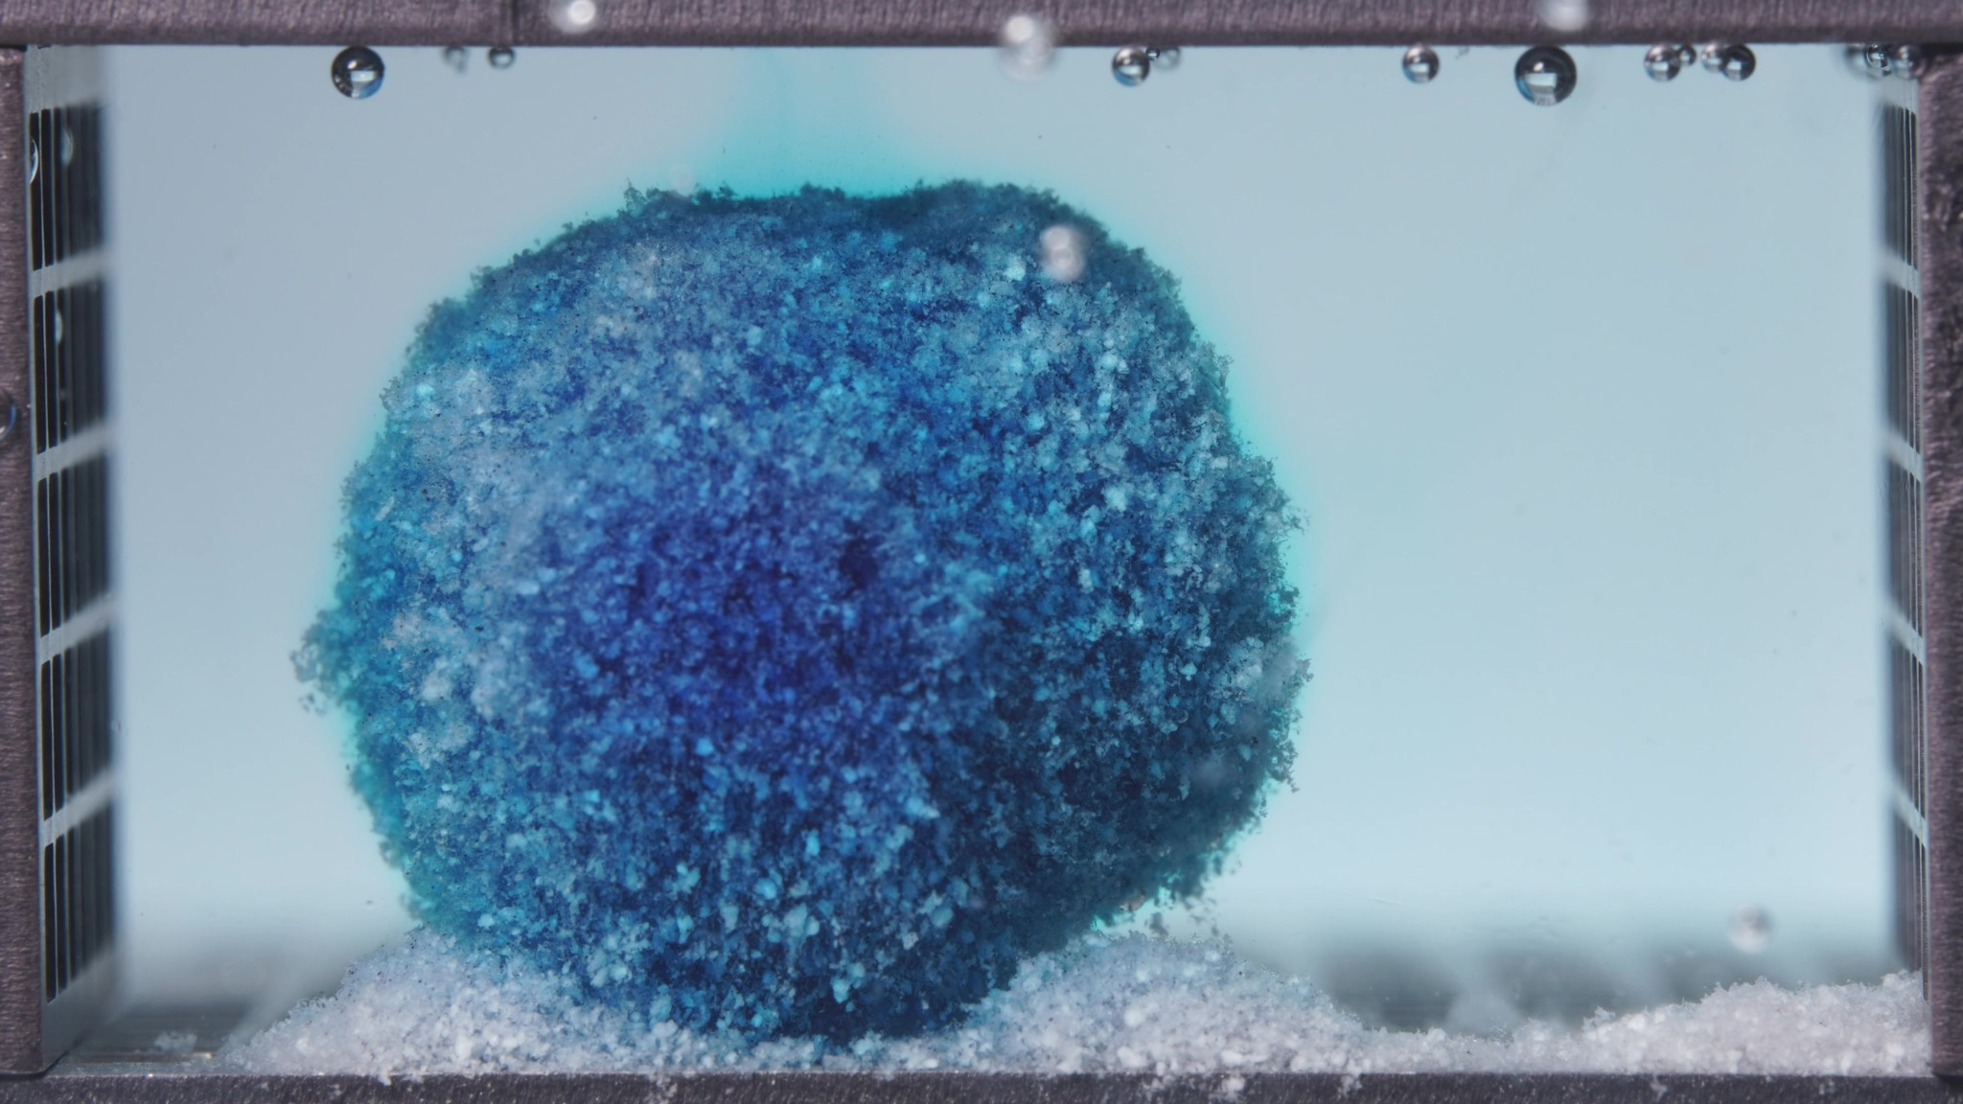
Image 2: 03-pH1.2-pH6.8T-亚甲蓝缓释片-高粘度-260417-24h-Side-750X-1_0072.000(4).jpg
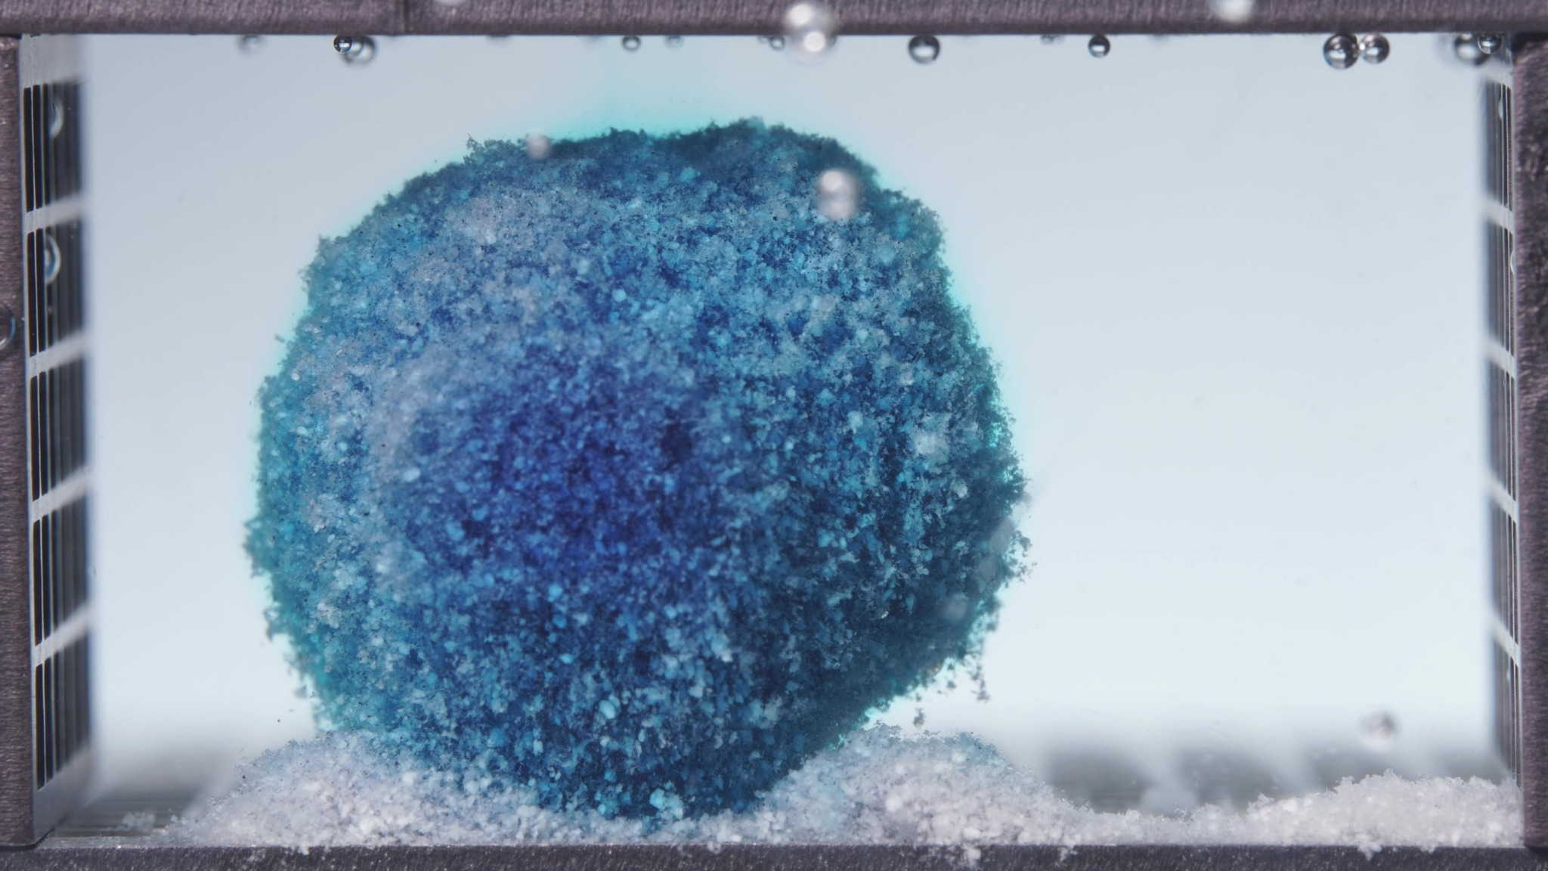
Image 3: 03-pH1.2-pH6.8T-亚甲蓝缓释片-高粘度-260417-24h-Side-750X-1_0084.000(4).jpg
Assistant
{
"group_id": "HIGH-VISCOSITY",
"time_range_h": [12.5, 17.5],
"time_h": null,
"eight_dimension_description": {
"color_change": "The tablet remains strongly methylene-blue stained, with a dark blue central body and slightly
lighter blue hydrated outer regions. Compared with the previous window, the coloration pattern is still dominated by
an intact dark core, while the surrounding medium appears pale turquoise to light blue and relatively uniform,
indicating continued dye release without abrupt structural breakdown.",
"shape_change": "The main body remains a single coherent mass and now appears even more rounded and near-spherical
overall. Compared with the previous window, the silhouette is more regular and compact, with only minor local
protrusions or flattening at the top and lower edge. There is still no major fragmentation into separate large
pieces.",
"surface_texture_change": "The surface continues to look rough, granular, and porous. Relative to the previous
window, the outer texture appears slightly more uniformly hydrated and somewhat softened, but it still retains obvious
particulate roughness rather than forming a smooth gel shell. Small loose crumb-like material remains visible near the
perimeter and base.",
"volume_change": "The tablet still occupies a large visible volume and remains markedly swollen. Compared with the
previous window, the overall volume appears broadly stable, with at most a slight increase in bulk or redistribution
into a more spherical swollen form. There is no clear evidence of major collapse or pronounced shrinkage.",
"dissolution_speed_time": "Dissolution/disintegration continues at a slow rate in structural terms. Compared with
the previous window, the tablet shows only modest external erosion and continued hydration rather than rapid breakup.
This suggests a sustained, controlled release process dominated by slow surface loss and persistent matrix
integrity.",
"physical_state_change": "The formulation remains in a swollen, hydrated, gel-like coherent mass state. Relative
to the previous window, it looks slightly more stabilized into a rounded swollen body, with continued maintenance of
internal cohesion. It has not transitioned into a dispersed particulate cloud or a collapsed paste-like residue.",
"dissolution_medium": "The dissolution medium appears lightly to moderately blue/turquoise and relatively uniform
across the chamber. Compared with the previous window, the medium still shows distributed dye presence, but the
dominant visual impression remains a stable hydrated tablet body rather than an expanding cloud of released fragments.
No dense plume of suspended debris is evident.",
"fragment_distribution_density": "Fine eroded material and pale sediment remain concentrated near the bottom and
around the tablet base. Compared with the previous window, fragment distribution is still localized and limited, with
no broad dispersion of coarse fragments into the chamber. Detached material appears sparse and fine, consistent with
slow surface erosion."
},
"notes_for_later_summary": "Most critical change versus the previous window: the high-viscosity tablet continues to
preserve a single large, near-spherical swollen mass with only minor additional erosion, indicating that even by
12.5-17.5 h the system remains highly cohesive and release is still governed mainly by slow hydration-controlled
surface dissolution rather than bulk disintegration."
}

Turn 13
User
These are pictures of the high-viscosity formulation during 18.75-23.75h.
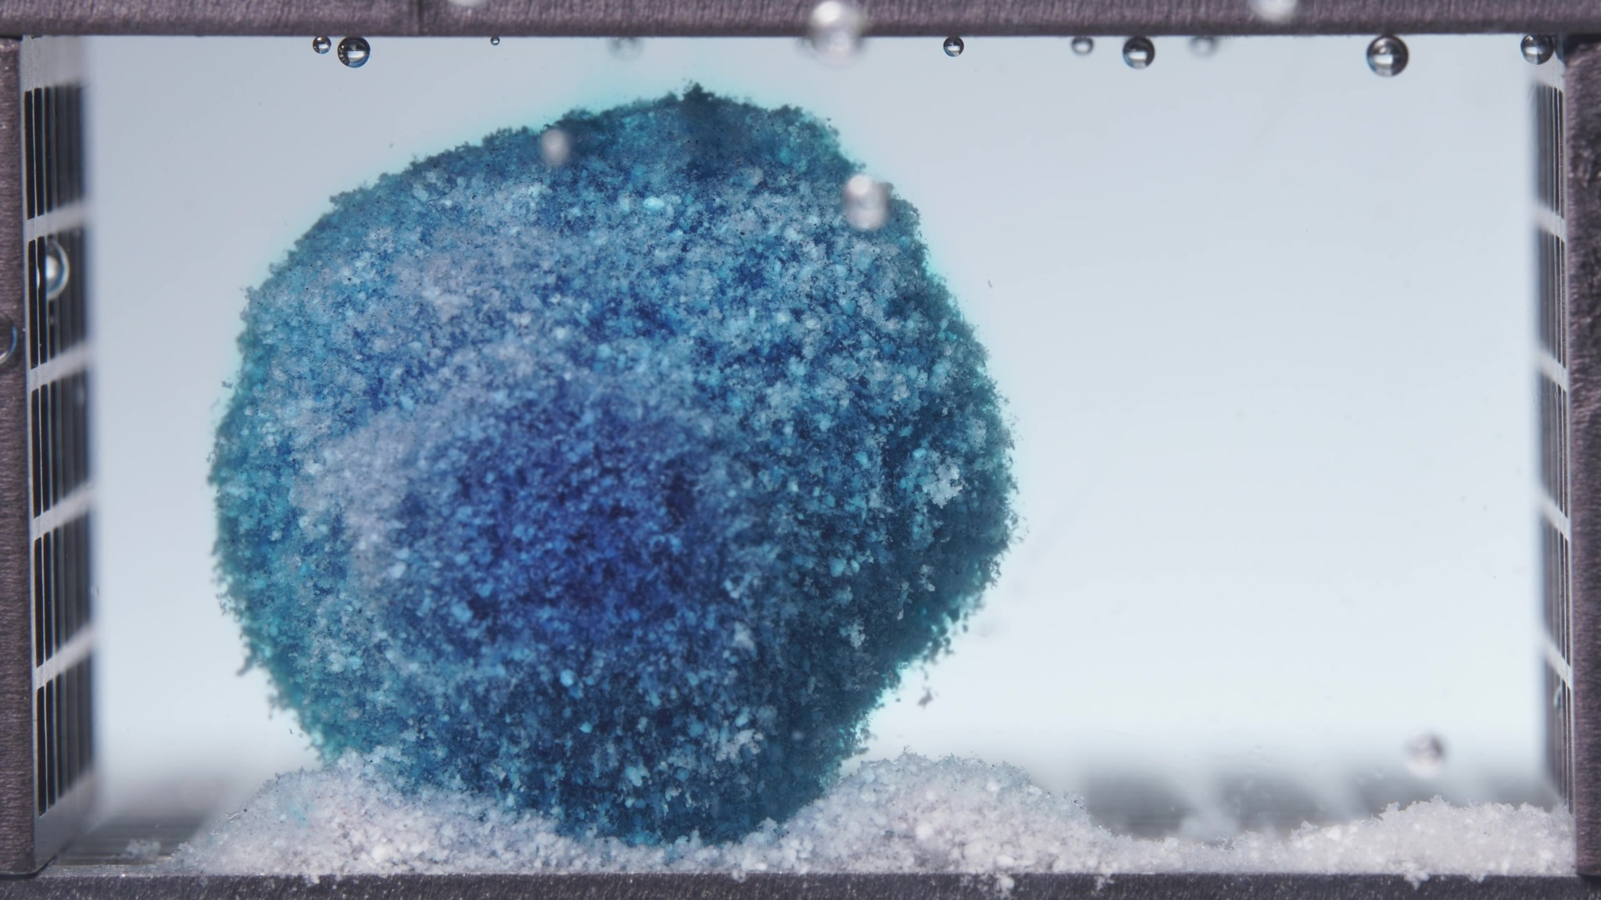
Image 1: 03-pH1.2-pH6.8T-亚甲蓝缓释片-高粘度-260417-24h-Side-750X-1_0090.000(4).jpg
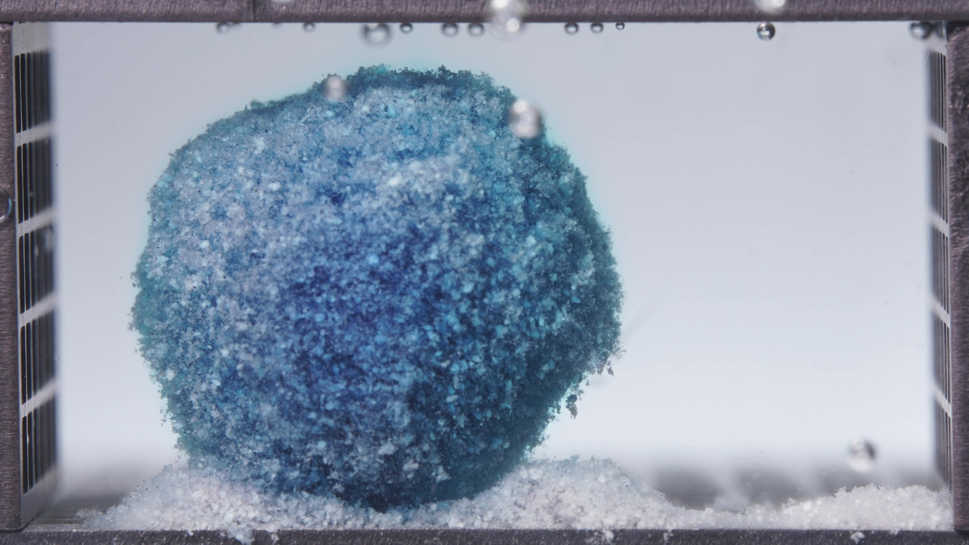
Image 2: 03-pH1.2-pH6.8T-亚甲蓝缓释片-高粘度-260417-24h-Side-750X-1_0102.000(4).jpg
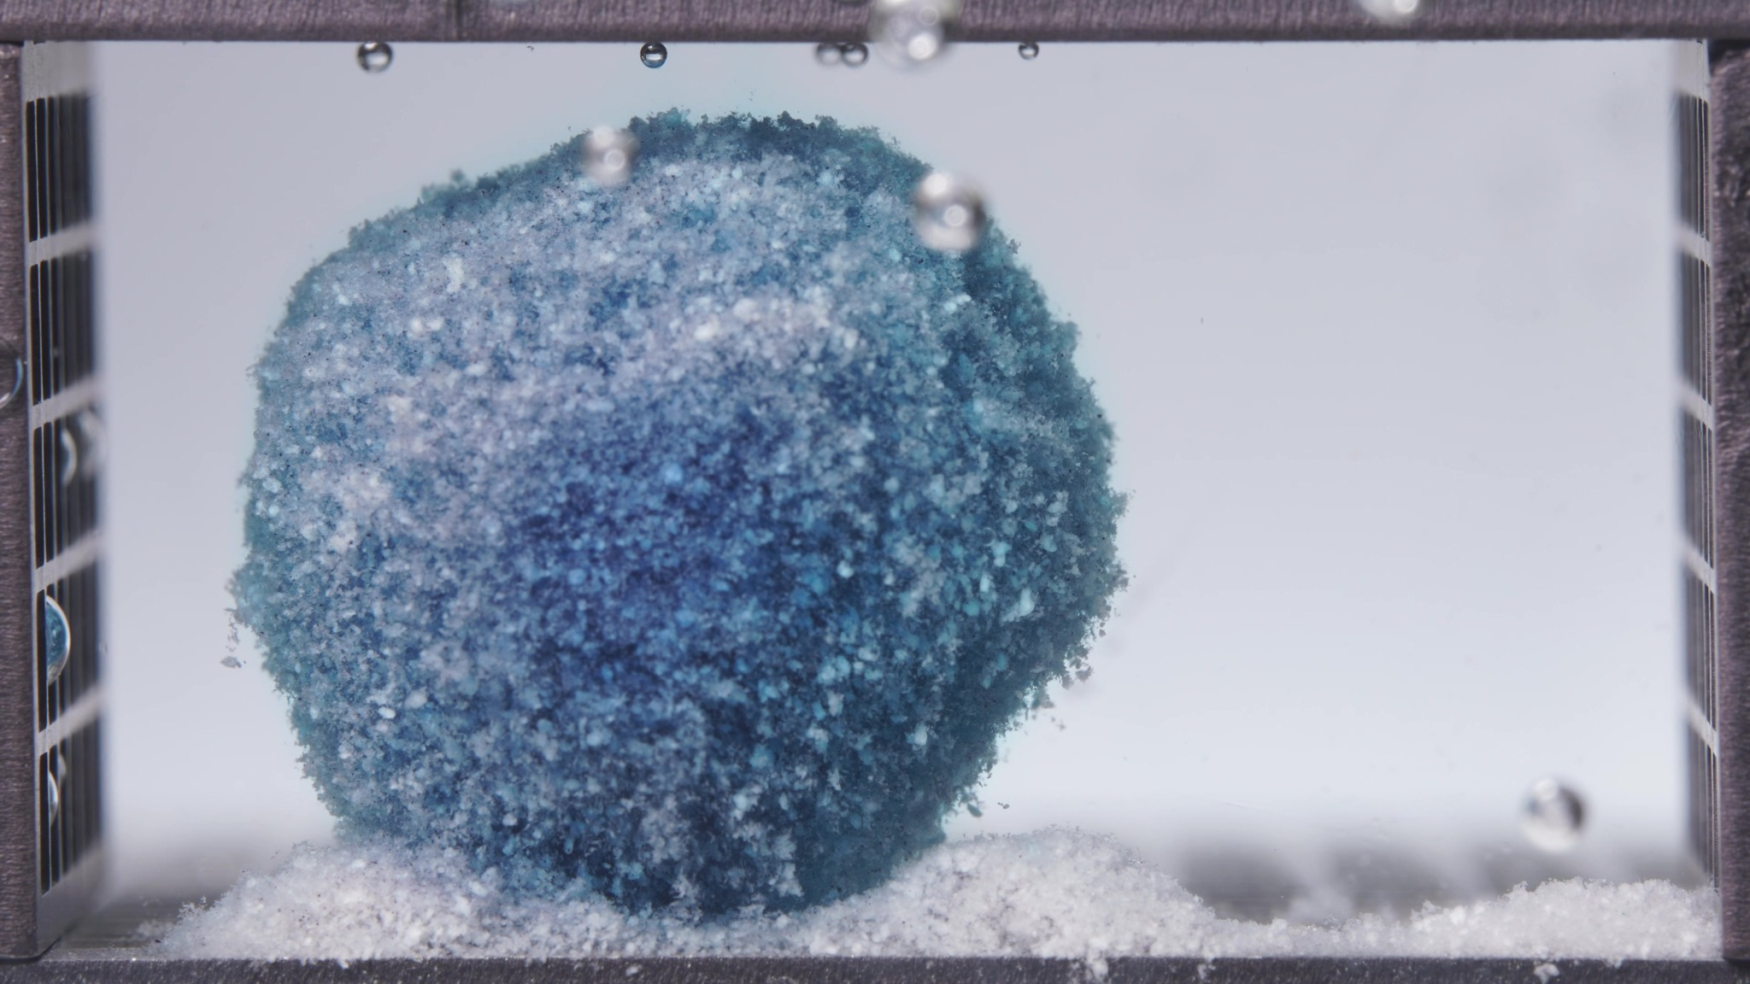
Image 3: 03-pH1.2-pH6.8T-亚甲蓝缓释片-高粘度-260417-24h-Side-750X-1_0114.000(4).jpg
Assistant
{
"group_id": "HIGH-VISCOSITY",
"time_range_h": [18.75, 23.75],
"time_h": null,
"eight_dimension_description": {
"color_change": "The tablet remains visibly blue, but the surface shows increased pale cyan-white and white
regions compared with the 12.5-17.5 h window. Darker blue staining persists mainly in the central and lower internal
regions, while the surrounding medium is now very pale to nearly clear. Visible dye diffusion into the bulk medium is
therefore much weaker than in the earlier windows.",
"shape_change": "The main body remains a single large coherent mass. The outline is still rounded and near-
spherical, with only slight flattening at the bottom where it contacts the sediment bed. Compared with the previous
window, the silhouette is broadly preserved and there is no major collapse, splitting, or conversion into multiple
large fragments.",
"surface_texture_change": "The surface remains highly rough, porous, and granular, with a diffuse hydrated
boundary and fine flocculent material along the margins. Compared with 12.5-17.5 h, the surface appears more pale and
more residue-like, especially on the upper-left and central exposed regions, but it still retains a continuous
swollen-matrix surface rather than becoming fully dispersed.",
"volume_change": "The visible occupied volume remains large and stable. The mass shows late-stage persistence of a
swollen matrix rather than marked shrinkage or collapse. Relative to the previous window, the tablet appears only
slightly more compacted at the base, while the basal sediment layer remains thick and continuous.",
"dissolution_speed_time": "Compared with 12.5-17.5 h, visible disintegration remains slow. Fresh dye release is
minimal, and the dominant changes are gradual surface whitening, limited peripheral erosion, and persistence of the
large coherent body. The high-viscosity formulation still shows strong matrix integrity even at 18.75-23.75 h.",
"physical_state_change": "The formulation remains a hydrated, gel-like, coherent swollen mass with a friable
particulate surface. Some external material has converted into loose sediment, but the central mass remains
mechanically continuous. It has not transitioned into a collapsed paste-like residue or a broadly dispersed particle
field.",
"dissolution_medium": "The dissolution medium appears nearly clear to faintly bluish, with limited local haze
around the tablet and basal sediment. Compared with the previous window, medium coloration is reduced, and no strong
expanding dye plume or dense suspended debris cloud is visible.",
"fragment_distribution_density": "Fragments and eroded particles remain concentrated at the tablet base and along
the bottom surface. The basal sediment layer is dense and pale, extending across the bottom near the tablet and toward
the right side. Detached particles appear mainly sedimented rather than broadly suspended, and large separated
fragments are not prominent."
},
"notes_for_later_summary": "Most critical change versus the previous 12.5-17.5 h window: the high-viscosity
formulation shows further surface whitening and reduced medium coloration, but the main mass remains large, rounded,
and cohesive. By 18.75-23.75 h, the dominant observation is persistent swollen-matrix integrity with slow peripheral
erosion and basal sedimentation rather than late collapse or broad disintegration."
}

Turn 14
User
"Provide an integrated mechanistic interpretation of the observed disintegration behavior of the three methylene blue sustained-release tablet formulations."
"The three formulations are the low-viscosity formulation, the standard formulation (medium-viscosity), and the high-viscosity formulation, and their main formulation difference lies in the ratio between HPMC K4M and HPMC 100lv."
"Our optimization goal is to adjust the ratio between HPMC K4M and HPMC 100lv so that the cumulative release amount of the standard-viscosity methylene blue sustained-release tablet over the first 4 hours is increased to 90% of its original level."
"In addition to the image-based disintegration observations, please also use the UV absorbance data from the flow-through-cell eluate as semi-quantitative release evidence."
"All UV absorbance values are within the linear range."
"The interval sequence is: 0–0.5 h, 0.5–1 h, 1–2 h, 2–4 h, 4–6 h, 6–8 h, 8–12 h, 12–16 h, 16–20 h, and 20–24 h."
"The corresponding mean UV absorbance values are as follows:"
"Low-viscosity formulation: 0.0273, 0.0727, 0.1967, 0.5963, 0.3347, 0.0230, 0.0123, 0.0027, -0.0010, -0.0007."
"Standard formulation: 0.0320, 0.0520, 0.1680, 0.5153, 0.5532, 0.0777, 0.0167, 0.0143, 0.0043, -0.0013."
"High-viscosity formulation: 0.0243, 0.0403, 0.1213, 0.4743, 0.3490, 0.0890, 0.0217, 0.0077, 0.0047, 0.0010."
"Please:"
"1) Summarize the key differences in disintegration behavior across the three formulations as evidence statements."
"2) Using the literature and the current session data, focus on explaining how differences in the HPMC K4M / HPMC 100lv ratio may influence swelling, gel-layer formation, erosion, fragmentation, shell persistence, and other observed disintegration phenomena."
"3) Relate the observed disintegration phenomena to the interval-based UV absorbance trends, and state whether the image-based evidence and the UV-based evidence are mutually supportive, partially aligned, or inconsistent."
"4) Propose 2–5 mechanistic hypotheses, each clearly tied to the observed phenomena, the UV trends, and the HPMC ratio differences."
"5) Explain what these mechanistic differences may imply for increasing the cumulative release amount of the standard-viscosity methylene blue sustained-release tablet over the first 4 hours to 90% of its original level, so that the result can support the next-step formulation optimization."
"6) List alternative explanations and a minimal set of follow-up tests to discriminate between hypotheses."
"Use only information from this session and the retrieved literature; do not invent missing details."
"Do not provide a final optimized formulation recipe in this step."
Assistant
## 1. Evidence-level differences across the three formulations

The three tablets had similar total HPMC amounts, but the K4M fraction increased markedly across the series: low-viscosity ≈20.0% K4M of total HPMC, standard ≈47.1%, and high-viscosity ≈79.9%. Because HPMC K100LV and K4M differ strongly in nominal viscosity grade, this series is mainly a gel-viscosity / gel-strength gradient rather than a total-polymer-content gradient. K100LV is a low-viscosity grade and K4M is about 4,000 mPa·s/cP at 2% aqueous solution, while K100LV is about 100 mPa·s/cP. ([pmc.ncbi.nlm.nih.gov](https://pmc.ncbi.nlm.nih.gov/articles/PMC2663671/?utm_source=chatgpt.com))

**Low-viscosity formulation:** the images show rapid early blue diffusion, early loss of tablet geometry, extensive rough granular erosion, collapse into an irregular mound, and thick basal sediment. By 12.5–23.75 h, the medium is nearly clear and the residual mass is pale, sediment-rich, and structurally depleted. This is consistent with a weak or rapidly eroding gel barrier.

**Standard formulation:** the images show strong early swelling and dye release, but the main body remains cohesive longer than the low-viscosity tablet. It develops surface whitening and basal sediment progressively, while maintaining an upright rounded residue through 12.5–17.5 h and a still-cohesive late residue at 18.75–23.75 h. This behavior is intermediate: more controlled than the low-viscosity tablet, but less persistent than the high-viscosity tablet.

**High-viscosity formulation:** the images show persistent swelling into a large rounded or near-spherical cohesive mass, slow surface erosion, limited gross fragmentation, and strong shell/matrix persistence even at 18.75–23.75 h. Basal sediment is present, but the central body remains intact much longer. This is consistent with a stronger, slower-eroding hydrated HPMC gel layer.

## 2. Mechanistic interpretation of the HPMC K4M / HPMC 100LV effect

The literature-supported framework is that HPMC matrix tablets hydrate at the surface, form a gel layer, and then release drug through a combination of diffusion through the hydrated gel and gradual polymer erosion at the gel–medium interface. Release rate is influenced by the hydrated network’s porosity, tortuosity, swelling, and erosion behavior. ([pmc.ncbi.nlm.nih.gov](https://pmc.ncbi.nlm.nih.gov/articles/PMC12196896/))

Within that framework, increasing the K4M / 100LV ratio should increase the viscosity and mechanical persistence of the hydrated gel phase. Published HPMC matrix studies report that low-viscosity HPMC can leach out more rapidly, whereas high-viscosity HPMC forms a thicker gel layer, maintains it longer, and retards drug release through slower erosion. ([eurekaselect.com](https://www.eurekaselect.com/article/53884)) High-viscosity HPMC matrices have also been associated with slower HPMC polymer release than drug release, meaning drug can diffuse out while the polymer shell persists. ([pubmed.ncbi.nlm.nih.gov](https://pubmed.ncbi.nlm.nih.gov/34420504/))

That mechanism maps well onto the images. The low-viscosity formulation, rich in HPMC 100LV, appears to hydrate and erode quickly, giving early dye release, fast loss of geometry, and rapid conversion into sediment. The high-viscosity formulation, rich in HPMC K4M, appears to form a more persistent swollen gel body, retaining a rounded shell-like mass and limiting fragmentation. The standard formulation sits between these states: it releases strongly but maintains enough matrix integrity to shift part of release into the 4–6 h interval rather than exhausting release early.

## 3. Relationship between image behavior and UV absorbance trends

Using interval mean absorbance × interval duration as a semi-quantitative release proxy, the 0–4 h cumulative release proxy is:

| Formulation | 0–4 h UV-area proxy | Relative to standard |
|---|---:|---:|
| Low-viscosity | 1.4393 UV·h | 116.0% |
| Standard | 1.2406 UV·h | 100.0% |
| High-viscosity | 1.1022 UV·h | 88.8% |

The 90% target for the current standard formulation corresponds to 1.1165 UV·h over 0–4 h. The high-viscosity formulation is slightly below that target, at 88.8% of the current standard, while the low-viscosity formulation is clearly above the standard at 116.0%.

The UV data and image evidence are **largely mutually supportive**:

The **low-viscosity formulation** has the highest early 0–4 h release proxy and the most visually aggressive early disintegration. Its UV peak is concentrated at 2–4 h, followed by rapid decline after 4–6 h, matching the visual pattern of early collapse, sediment formation, and later depletion.

The **standard formulation** shows a broader release phase. Its 2–4 h absorbance is high, but its 4–6 h absorbance is even slightly higher than its 2–4 h value. This matches the images: the tablet does not collapse immediately but remains a hydrated, eroding body that continues releasing after the earliest phase.

The **high-viscosity formulation** has the lowest 0–4 h cumulative proxy and strong visual matrix persistence. Its 2–4 h interval mean is lower than the standard, and its 4–6 h interval is also much lower than the standard, consistent with stronger gel-layer resistance and slower erosion.

The main partial mismatch is interpretive rather than contradictory: late images of the high-viscosity tablet still show a visibly blue mass, while eluate UV is low. This likely reflects retained methylene blue inside a persistent hydrated matrix, not high instantaneous release into the outflow.

## 4. Mechanistic hypotheses

**Hypothesis 1 — K4M-rich gel-layer strengthening retards early release.**
As K4M fraction increases, the hydrated layer becomes more viscous and mechanically persistent. This reduces early erosion and fragmentation, producing the high-viscosity tablet’s spherical swollen body and lower 0–4 h UV release. This is supported by the literature on thicker high-viscosity HPMC gel layers and slower polymer erosion. ([eurekaselect.com](https://www.eurekaselect.com/article/53884))

**Hypothesis 2 — 100LV-rich matrices undergo faster polymer leaching and erosion.**
The low-viscosity formulation likely forms a weaker hydrated barrier because the higher 100LV fraction hydrates and leaches more readily. This produces faster pore/channel formation, rapid dye escape, early collapse, and heavy basal sediment. The UV profile supports this: highest 0–4 h release, then rapid exhaustion after 4–6 h.

**Hypothesis 3 — the standard formulation gives a mixed diffusion–erosion regime.**
The standard tablet has enough 100LV to permit early hydration and dye release, but enough K4M to maintain a coherent hydrated body. This explains why release remains strong through 4–6 h rather than being exhausted by 4 h. Mechanistically, it appears to balance diffusion through gel with progressive surface erosion.

**Hypothesis 4 — late shell persistence decouples tablet color from eluate release.**
The high-viscosity tablet remains visibly blue at late time points because dye is retained inside a persistent swollen matrix. UV release is low because the gel shell and tortuous hydrated network limit outward transport. Thus, visible blue residue should not be interpreted as high release unless supported by eluate data.

**Hypothesis 5 — basal sediment acts as an erosion endpoint, not necessarily an active release front.**
Low- and standard-viscosity tablets generate more visible basal sediment than the high-viscosity tablet. This sediment likely reflects matrix erosion and insoluble or poorly mobile hydrated excipient residue. Its presence correlates with prior release activity, but late sediment persistence does not necessarily imply high late UV release.

## 5. Implication for the 0–4 h target of 90% of the current standard

Interpreting the target literally as **reducing the standard formulation’s 0–4 h cumulative release to 90% of its current value**, the formulation direction implied by the mechanism is toward a **slightly higher K4M / lower 100LV balance** than the current standard. The current high-viscosity formulation already gives 88.8% of the standard’s 0–4 h release proxy, which is slightly below the 90% target. Therefore, the mechanistic target is not to fully reproduce the high-viscosity behavior, but to move the standard modestly toward greater gel persistence while avoiding excessive shell persistence and under-release.

The key formulation risk is overshooting into the high-viscosity regime: that would likely further suppress 0–4 h release, preserve a large blue swollen core, and increase late retained residue. The opposite direction, toward more 100LV, would likely increase early release and erosion, moving away from the 90% target.

## 6. Alternative explanations and minimal follow-up tests

Alternative explanations that remain possible from the current data:

Compression force, porosity, tablet hardness, particle-size distribution, HPMC blend homogeneity, local flow-field differences, tablet position in the cell, camera exposure/color saturation, and pH-switch effects may also influence apparent erosion and release. The small differences in methylene blue loading should also be normalized in any final quantitative comparison.

Minimal follow-up tests:

1. **Normalize UV release by actual drug content** using assay or full extraction of intact/residual material.
2. **Measure swelling and erosion gravimetrically** at matched time points: wet weight, dry residual mass, and erosion fraction.
3. **Measure gel strength or texture** of hydrated tablets, especially at 2, 4, 6, and 12 h.
4. **Image tablet cross-sections** by optical imaging, NIR, Raman, or micro-CT to distinguish hydrated gel thickness, dry core persistence, and dye retention.
5. **Collect and assay basal sediment separately** to determine whether sediment contains unreleased methylene blue or mainly depleted excipient residue.
6. **Repeat dissolution with replicates and fixed orientation** to separate formulation effects from flow-cell placement effects.

Overall interpretation: the image and UV datasets support the same ranking of early-release tendency: **low-viscosity > standard > high-viscosity**. The underlying mechanism is best explained by increasing K4M fraction strengthening and prolonging the HPMC gel layer, thereby reducing early erosion and shifting release toward slower diffusion/erosion-controlled behavior.

Turn 15
User
"Provide a formulation optimization recommendation for the next iteration based on the existing formulation information, optimization target, concentration-time summary, mechanistic analysis results, and prior disintegration-analysis conclusions in this session."
"The three formulations are the low-viscosity formulation, the standard formulation (medium-viscosity), and the high-viscosity formulation. The standard formulation is the reference formulation."
"Our optimization goal is to adjust the ratio between HPMC K4M and HPMC 100lv so that the cumulative release amount of the standard-viscosity methylene blue sustained-release tablet over the first 4 hours is increased to 90% of its original level."
"Please integrate the prior evidence rather than repeating the earlier full image-analysis or mechanistic-analysis process. You MUST provide a next-step formulation proposal with explicit numeric values, especially for HPMC K4M and HPMC 100lv."
"Please:"
"1) Briefly summarize which current formulation tendency appears closer to the optimization target and which tendencies appear too fast or too slow."
"2) Propose one next-step optimized formulation anchored on the standard formulation and adjusted mainly through the balance between HPMC K4M and HPMC 100lv."
"3) You MUST explicitly report the proposed HPMC K4M amount, the proposed HPMC 100lv amount, the proposed HPMC K4M:HPMC 100lv ratio, and the percentage change of each relative to the standard formulation."
"4) Even if the evidence is not sufficient to justify a fully validated exact formula, you MUST still provide a best-estimate next-iteration formulation proposal with explicit numeric values and percentage changes, and clearly label it as tentative rather than omitting the numbers."
"Use only information from this session and the retrieved literature if already available; do not invent missing details."
"Do not output a same/different judgment."
"Do not simply restate previous node outputs without synthesis."
"Output the result in a clear structured format with the following sections:"
"Optimization Target Review"
"Evidence Summary from Existing Formulations"
"Recommended Next Formulation"
"Uncertainty and Validation Needs"
"Under “Recommended Next Formulation”, directly report:"
"- Proposed HPMC K4M amount = X"
"- Proposed HPMC 100lv amount = Y"
"- Proposed HPMC K4M:HPMC 100lv ratio = X:Y"
"- Percentage change of HPMC K4M relative to the standard formulation = Z%"
"- Percentage change of HPMC 100lv relative to the standard formulation = W%"
"- A short rationale for why this ratio is recommended"
Assistant
## Optimization Target Review

For this recommendation, the target is treated numerically as:

**Target 0–4 h cumulative release = 90% of the current standard formulation 0–4 h cumulative release.**

Using the interval UV absorbance values as semi-quantitative release evidence:

| Formulation | 0–4 h UV-area proxy | Relative to standard |
|---|---:|---:|
| Low-viscosity | 1.4393 | 116.0% |
| Standard | 1.2406 | 100.0% |
| High-viscosity | 1.1022 | 88.8% |
| Target | 1.1165 | 90.0% |

Therefore, the target lies **very close to the high-viscosity formulation**, but slightly above it. The next formulation should move the standard formulation strongly toward the high-viscosity direction, but not fully to the current high-viscosity ratio.

## Evidence Summary from Existing Formulations

The **low-viscosity formulation** is too fast for this target. It showed rapid early dye release, early structural collapse, strong erosion, and heavy basal sedimentation. Its 0–4 h release proxy was 116.0% of the standard.

The **standard formulation** is the reference, but its 0–4 h release is higher than the 90% target. Its images showed intermediate behavior: strong swelling and dye release, but still with appreciable matrix integrity.

The **high-viscosity formulation** is closest to the target but slightly too slow. It gave 88.8% of the standard 0–4 h release proxy and showed persistent swollen-matrix integrity, slower erosion, and less gross collapse. This indicates that increasing the HPMC K4M fraction is the correct adjustment direction, but a slightly less extreme K4M-rich ratio than the high-viscosity formulation should be used.

## Recommended Next Formulation

**Tentative next-iteration formulation proposal, anchored on the standard formulation and keeping total HPMC approximately constant at the standard level:**

- **Proposed HPMC K4M amount = 4.07**
- **Proposed HPMC 100lv amount = 1.25**
- **Proposed HPMC K4M:HPMC 100lv ratio = 4.07:1.25**, approximately **3.26:1**
- **Percentage change of HPMC K4M relative to the standard formulation = +62.6%**
- **Percentage change of HPMC 100lv relative to the standard formulation = −55.7%**

For the other components, the most controlled next step is to keep the standard formulation amounts unchanged:

| Component | Recommended amount |
|---|---:|
| Methylene blue | 0.142 |
| Silicon dioxide | 0.0503 |
| Magnesium stearate | 0.1278 |
| Microcrystalline cellulose | 9.6893 |
| Lactose | 9.683 |
| HPMC K4M | **4.07** |
| HPMC 100lv | **1.25** |

**Short rationale:**
This ratio moves the standard formulation substantially toward the high-viscosity behavior because the target release, 90% of standard, is numerically close to the high-viscosity formulation’s observed 88.8%. However, the proposed ratio is slightly less K4M-rich than the existing high-viscosity formulation, so it is intended to avoid excessive gel-shell persistence and under-release. Mechanistically, the increased K4M fraction should strengthen and prolong the hydrated HPMC gel layer, reduce early matrix erosion, and suppress the 0–4 h release from the current standard level toward the 90% target.

## Uncertainty and Validation Needs

This proposal is a **best-estimate next-iteration formulation**, not a validated final formula. It assumes an approximately monotonic relationship between K4M fraction and 0–4 h release over the tested formulation range.

Minimum validation tests should include:

1. Repeat flow-through UV release for the proposed formulation and calculate the 0–4 h cumulative UV-area proxy.
2. Compare disintegration images at 0.104–5 h and 6.25–11.25 h against the standard and high-viscosity formulations.
3. Check whether the proposed tablet avoids excessive late blue-core retention, which would indicate over-strengthened gel-shell persistence.
4. Normalize release by actual methylene blue content if assay data are available.

Turn 16
User
Export all of our conversation content as a DOC file named after the conversation title.

