Distributions
dayofmonth
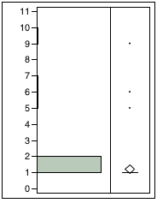

Quantiles
100.0% | maximum | 9
99.5% |  | 9
97.5% |  | 6.3
90.0% |  | 1
75.0% | quartile | 1
50.0% | median | 1
25.0% | quartile | 1
10.0% |  | 1
2.5% |  | 1
0.5% |  | 1
0.0% | minimum | 1

Moments
Mean | 1.2266667
Std Dev | 1.1691223
Std Err Mean | 0.1349986
Upper 95% Mean | 1.4956573
Lower 95% Mean | 0.9576761
N | 75
month
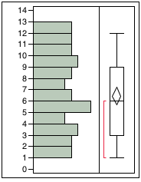

Quantiles
100.0% | maximum | 12
99.5% |  | 12
97.5% |  | 12
90.0% |  | 11
75.0% | quartile | 9
50.0% | median | 6
25.0% | quartile | 3
10.0% |  | 2
2.5% |  | 1
0.5% |  | 1
0.0% | minimum | 1

Moments
Mean | 6.4533333
Std Dev | 3.4417678
Std Err Mean | 0.3974211
Upper 95% Mean | 7.2452122
Lower 95% Mean | 5.6614545
N | 75
month_name
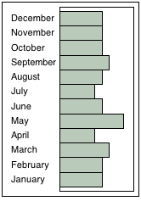

Frequencies
Level | Count | Prob
January | 6 | 0.08000
February | 6 | 0.08000
March | 7 | 0.09333
April | 5 | 0.06667
May | 9 | 0.12000
June | 6 | 0.08000
July | 5 | 0.06667
August | 6 | 0.08000
September | 7 | 0.09333
October | 6 | 0.08000
November | 6 | 0.08000
December | 6 | 0.08000
Total | 75 | 1.00000

N Missing
0
12 Levels
quarter
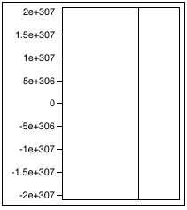

Quantiles
100.0% | maximum | 0
99.5% |  | 0
97.5% |  | 0
90.0% |  | 0
75.0% | quartile | 0
50.0% | median | 0
25.0% | quartile | 0
10.0% |  | 0
2.5% |  | 0
0.5% |  | 0
0.0% | minimum | 0

Moments
Mean | .
Std Dev | .
Std Err Mean | .
Upper 95% Mean | .
Lower 95% Mean | .
N | 0
quarter_name
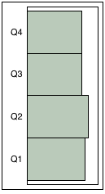

Frequencies
Level | Count | Prob
Q1 | 19 | 0.25333
Q2 | 20 | 0.26667
Q3 | 18 | 0.24000
Q4 | 18 | 0.24000
Total | 75 | 1.00000

N Missing
0
4 Levels
year
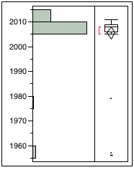

Quantiles
100.0% | maximum | 2011
99.5% |  | 2011
97.5% |  | 2011
90.0% |  | 2010
75.0% | quartile | 2009
50.0% | median | 2008
25.0% | quartile | 2006
10.0% |  | 2005
2.5% |  | 1956
0.5% |  | 1956
0.0% | minimum | 1956

Moments
Mean | 2005.5867
Std Dev | 10.800517
Std Err Mean | 1.2471363
Upper 95% Mean | 2008.0716
Lower 95% Mean | 2003.1017
N | 75

