|  |  |
| --- | --- |
|  | **2017** |
|  | UN ID: 17429445  Dikshen Tamang |

|  |
| --- |
| **[ web development ]** |
| *Report on web page designing* |

**Table of contents:**

* Introduction
* Wireframe
* Screen mockup
* Testing
* Conclusion
* References

1. **Introduction:**

We students of 1st year (term 1) were given an assignment in Web Development module where we were told to design our own website. The main aim of this assignment was to make us design WebPages representing our portfolio. The basic requirements for our web pages were provided to us. Some of them were like, we were asked to create four web pages representing CV, Bio, Index and Contact. In the making of the web pages formation of index.html is a must providing a link on the top of our log. In my assignment I have tried my best to accomplish all of the requirements. I have used appropriate HTML5 tags, CSS file containing five rules and validate them both using the website links mentioned. In addition I have also prohibited using frames in my websites as per the requirements.

Well, when I started my project I had many kinds of confusions and yet I was not that confident too. Actually, developing a web page in itself was a big question to me by me. But then all of the knowledge I could gain during my classes, visiting and learning from some websites, a little assistance from my friends and obviously a lot of help from my teacher during the making of WebPages actually helped me a lot and changed my question of “Can I? ” to “why not?”. Then I started the making of this project by taking references from different websites. Actually, I have especially taken the references of the templates and color codes available.

1. **Wireframe:**

In this report I have included the wireframes of my WebPages before I had actually implemented the HTML codes and CSS tags in Atom while making the WebPages. After taking the references from different WebPages and reading the requirements of assignment, I thought of creating WebPages looking really simple and which can actually fulfill the requirements. As per the different web pages I have created different wireframes respectively. They are the home page, about me page, CV page and the contact page. If a visitor visits my website then he/she will get to see my home page at first that means index.html is going to be my default 1st page. The overall wireframe of my WebPages are given below:

s

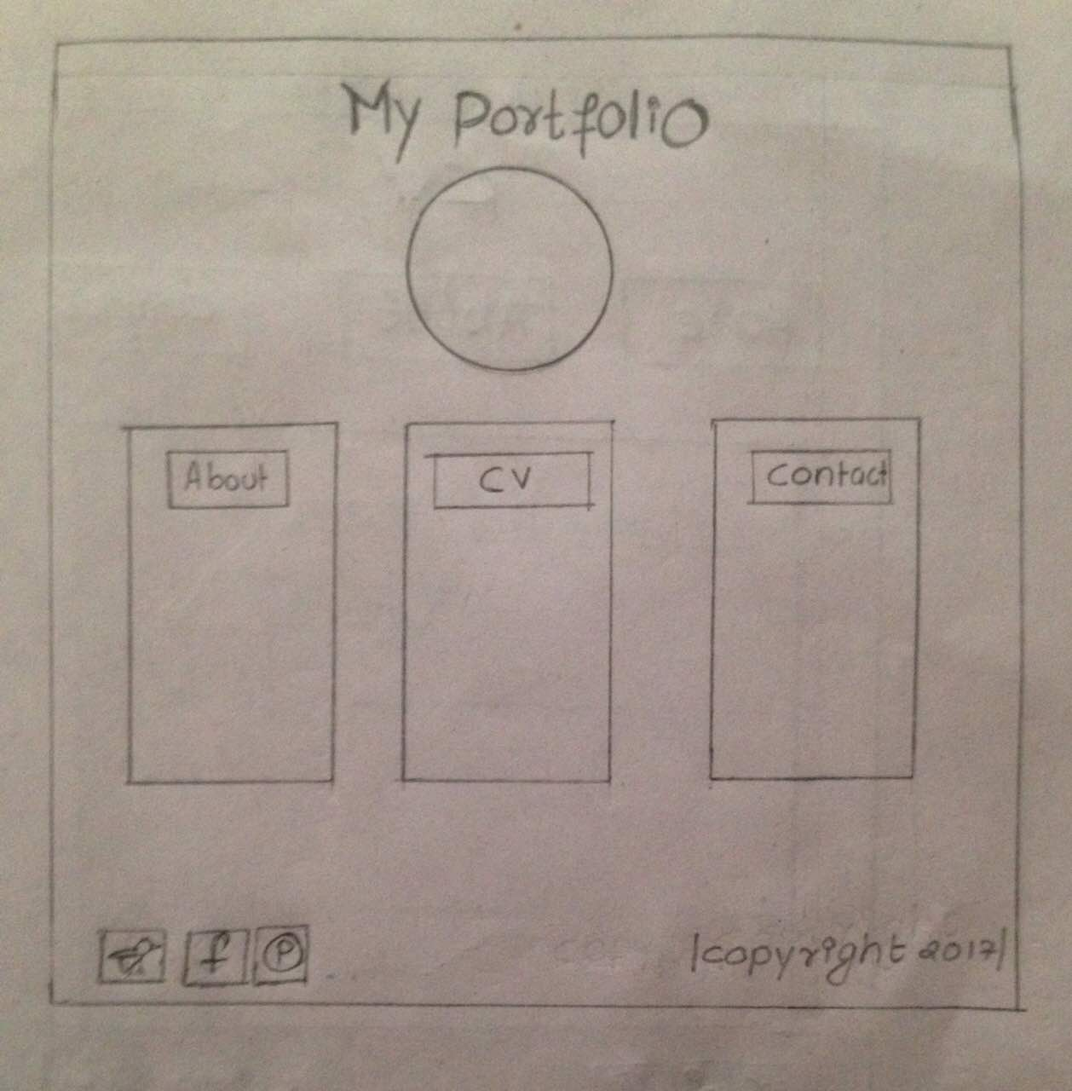

Figure 1(wireframe of home page)

This is the very 1st wireframe for my website which represents my homepage. The visitors will be able to see this page as soon as they open my website. In this page I have given a header of the webpage “My portfolio” so that it would be easier for the visitors to know where they are. Below that I have made a circle which is for an image of mine. Below that image there are three different blocks which consists of buttons on each of them. The first one is for the link of about me page, second one is for the CV page and the third one is for the Contact me page. Just below that I have included two parts there one on the left and another on the right. Left one consists of three images of social media through which visitors can actually visit all those social Medias and now on the right side you can see a text “copyright” including the year.

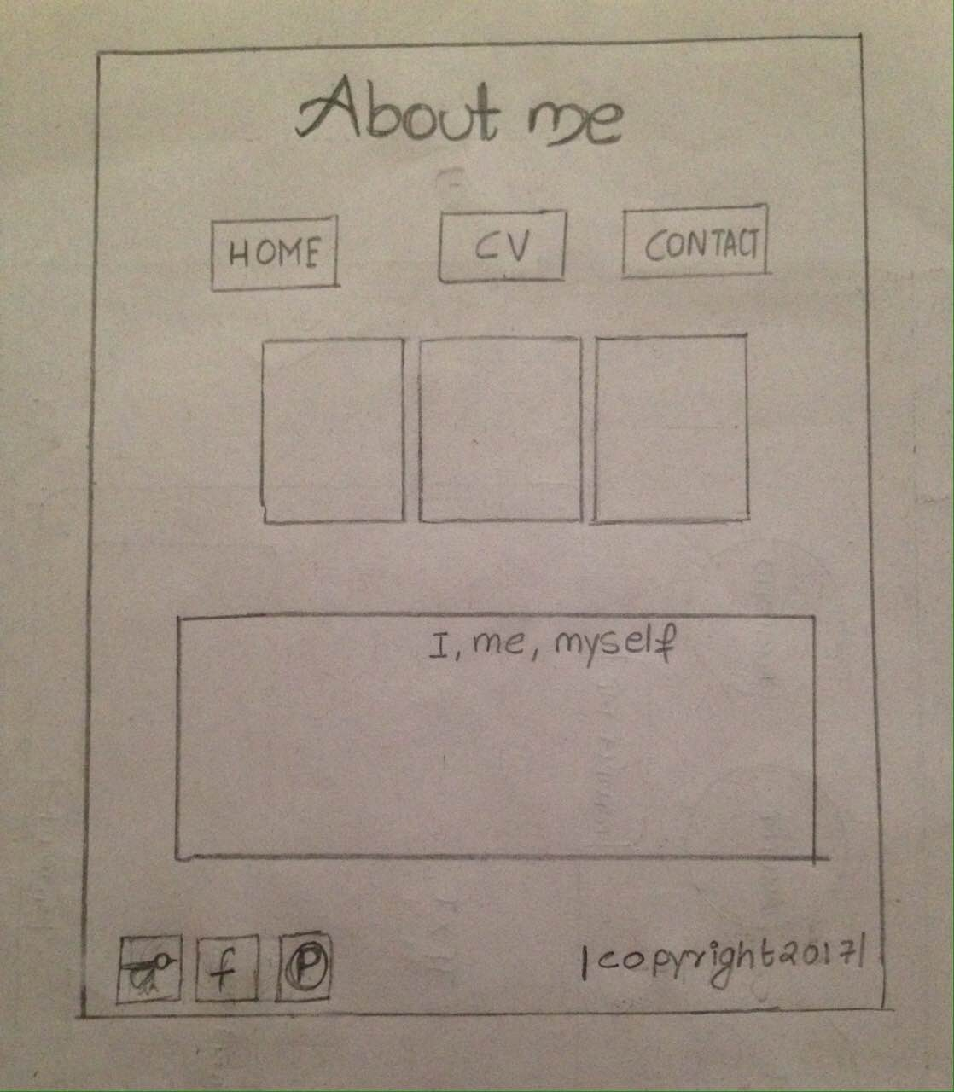

Figure 2(wireframe of about me page)

This wireframe represents “About me” page. In this wireframe I have placed header of the webpage at the top, then three buttons below the header which links the visitors to another pages. Then below those three buttons the three square boxes in the row are for three images. Now the rectangular box just below the three images in a row some information about me is to be placed. At the bottom of this page I have included two parts there one on the left and another on the right as that of the home page. Left one consists of three images of social media through which visitors can actually visit all those social Medias and now on the right side you can see a text “copyright” including the year.

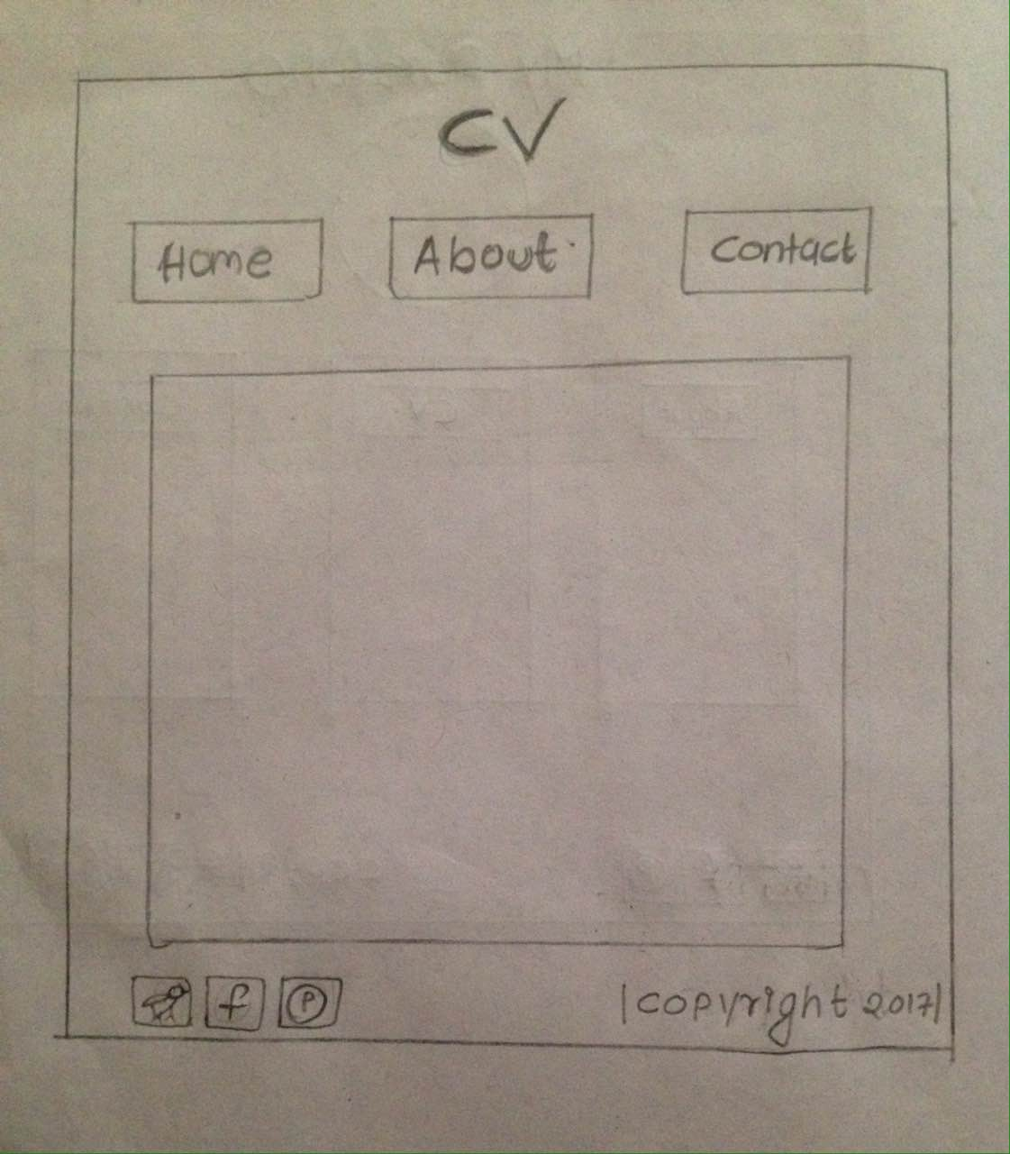

Figure 3(wireframe of CV)

This wireframe is for the curriculum vita which has “CV” as its header. Here in this wireframe too I have placed three buttons to link every single webpage with one another. Below that there is only a single block. In that block all of the important information that a CV should have is to be placed. At the bottom of this page too I have included two parts one on the left and another on the right as that of the home page and about me page. Left one consists of three images of social media through which visitors can actually visit all those social Medias and now on the right side you can see a text “copyright” including the year.

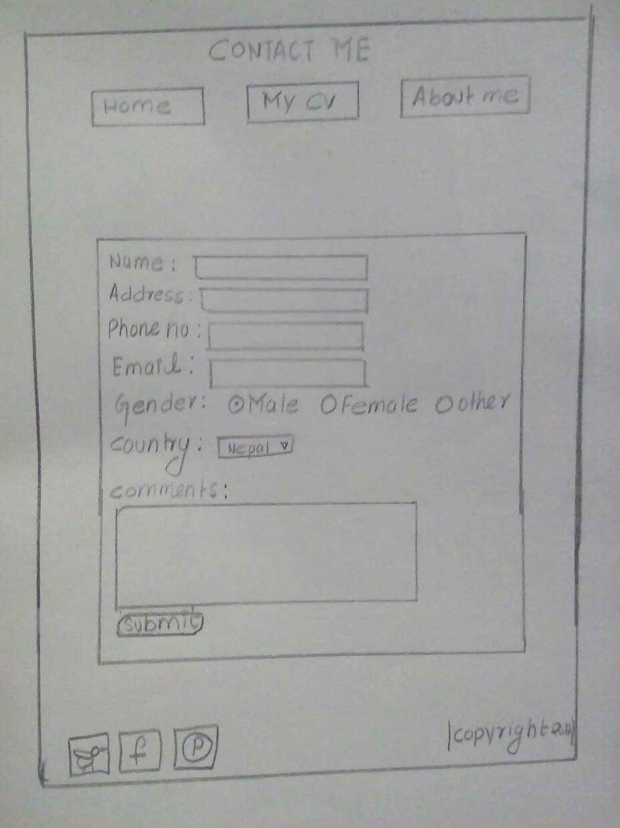

Figure 4(wireframe of Contact me page)

This is the last wireframe for my website and this represents the “Contact me” page as written in the header. Just like about me page and the CV page, this page also consists of three different buttons each linking to all of the web pages. Here, a single block is drawn where the visitors will be able to add some of their details and contact me as per their wish. The bottom part includes the similar part as that of other pages that is the left and the right .Left one consists of three images of social media through which visitors can actually visit all those social Medias and now on the right side you can see a text “copyright” including the year.

**Screen Mockup:**

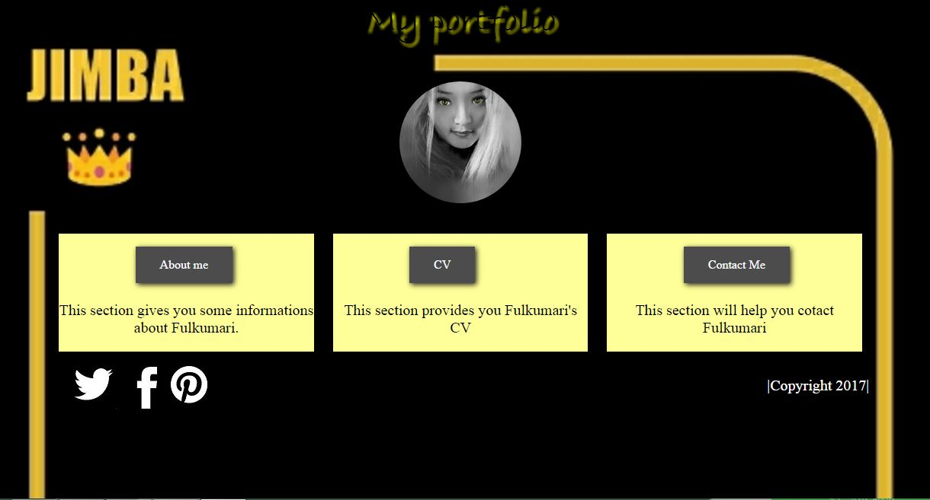

Figure 5(screen mockup of the home page)

This is the screen mockup of the very first webpage of my website. I have placed a background image in it with cover size; the header contains “My portfolio” text and has a shadow. In this webpage, the image used is made round by using border radius: 50%. If you move your cursor in that image it will be rotating in 360 degree that is round like a C.D player. Below that in those three blocks there also consists three buttons on each. If you point your cursor in any one of those buttons, those buttons will hover and change its color too greenish. Each button will allow the visitors to link into other different WebPages like about me, CV and contact me respectively. The images placed at the bottom left of this web page are about the social Medias and if you click on any of those three images it will take you to the respective website of social. The footer part consists of copyright of this webpage.

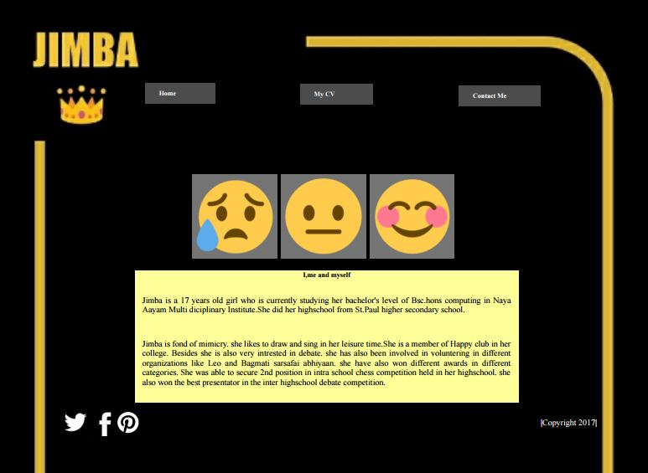

Figure 6(screen mockup of the about me page)

Now this is the screen mockup of the about me page. Hear you can see three buttons in the upper most part, if you point your cursor in any one of those buttons, those buttons will hover and change its color to greenish. Each button will allow the visitors to link into other different WebPages like Home, CV and contact me respectively. Below the buttons, you can see there are three different images. I have added these three images in a single division so the transition provided is applicable to all of them but the transition occurs when you move your cursor over it. The images placed at the bottom left of this web page are about the social Medias and if you click on any of those three images it will take you to the respective website of social. The footer part consists of copyright of this webpage.

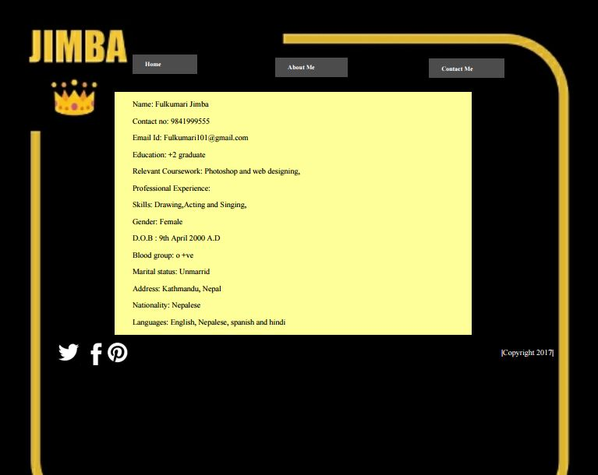

Figure 7(screen mockup of CV)

This is the screen mockup of the CV page. Hear also you can see three buttons in the upper most part, if you point your cursor in any one of those buttons, those buttons will hover and change its color to greenish. Each button will allow the visitors to link into other different WebPages like Home, about me and contact me respectively. Below the buttons, you can see there is only one block. In that one block I have place all of the details that a CV should have. The images placed at the bottom left of this web page are about the social Medias and if you click on any of those three images it will take you to the respective website of social media. The footer part consists of copyright of this webpage.

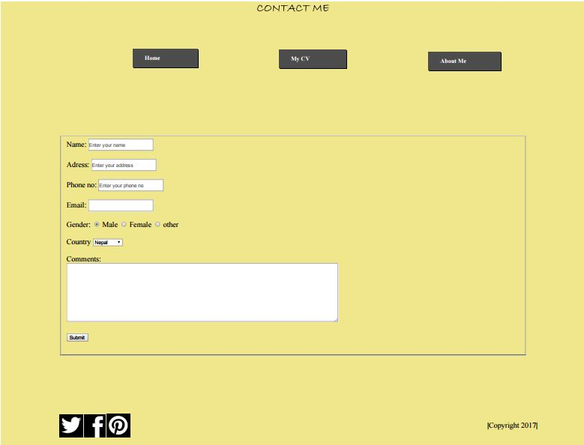

Figure 8(screen mockup of Contact me)

This is the screen mockup of the contact me page. Similar to other WebPages, here too you can see three buttons in the upper most part, if you point your cursor in any one of those buttons; those buttons will hover and change its color to greenish. Each button will allow the visitors to link into other different WebPages like Home, about me and contact me respectively. Below the buttons, you can see there is only one block. In that one block I have placed all of the details that might be needed to contact. In gender there will always be male as a selected gender and there will be various countries to select in the country box. The images placed at the bottom left of this web page are about the social Medias and if you click on any of those three images it will take you to the respective website of social media. The footer part consists of copyright of this webpage.

**Mobile Responsive diagram:**

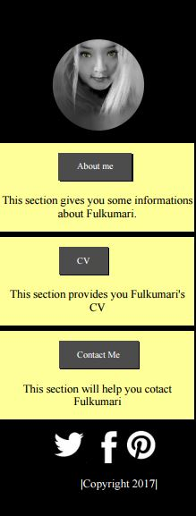

Figure 9(mobile responsive image of home page)

For this kind of mobile responsive display of a web pages must of the elements are to be re coded and placed in a better place so the visitors can see each and every information present there.

**Testing:**

**Use of validator:**

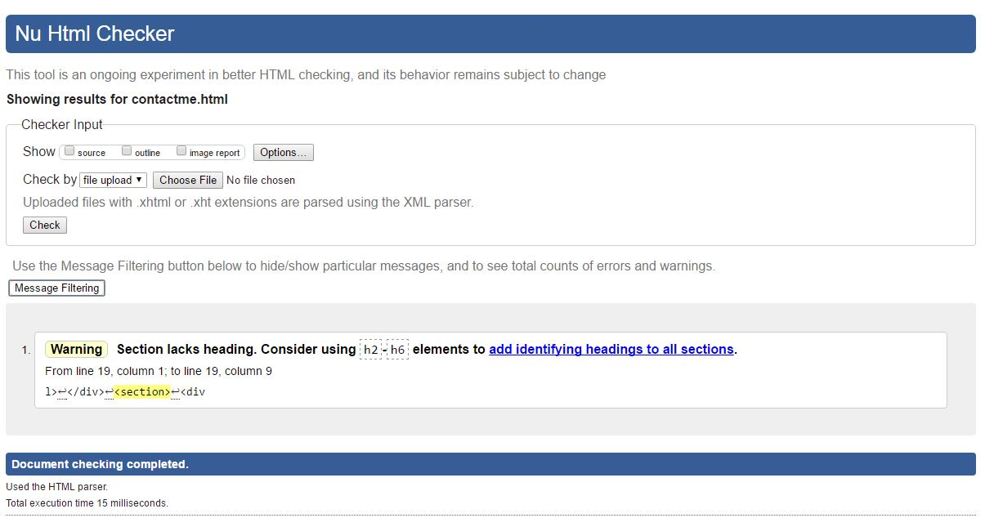

Figure 10(screenshot of validator checking HTML)

**This image explains the use of** <https://validator.w3.org/> in order to check all of the faults that took place in html while creating the website.

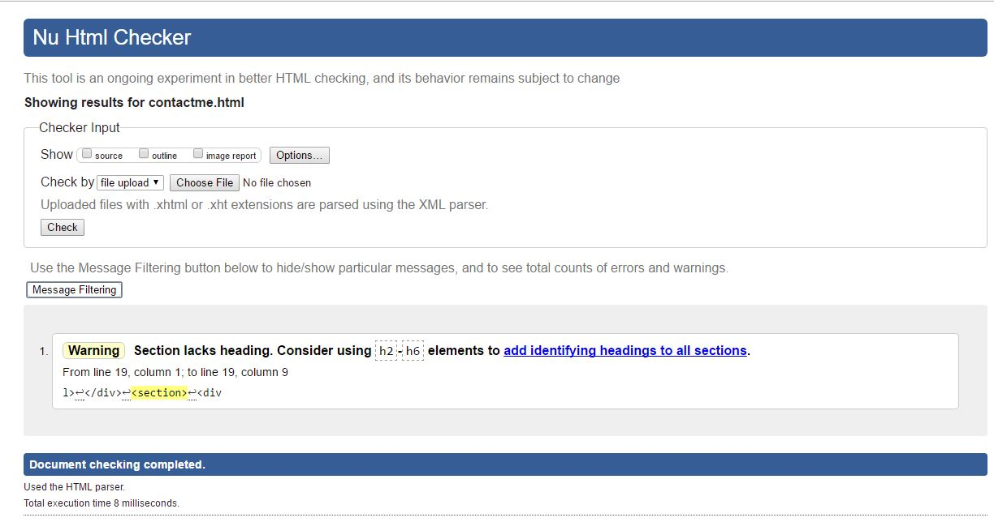

Figure 11(screenshot of validator checking CSS)

This image explains the use of <https://jigsaw.w3.org/css-validator/> in order to check all of the faults that took place while writing proper CSS for html.

**Conclusion:** To sum up, the assignment was accomplished consisting all of the requirements I could consider. During the overall process of the making of this project, there occurred some problems as well. One of the problems I faced was I could not capture a perfect screenshot for the screen mockup diagram as the header of some WebPages got invisible. Another thing is because of the Limited time frame I couldn’t add any more codes and do some animations by doing research on it. It took me 62 hours to complete the overall project. But still I have tried my best to create a simple and responsive website on my own.

**References:**

* Validator.w3.org, (2017).The W3C Markup Validation Service. [online]Available at: https://validator.w3.org/ [08 April. 2017].
* Jigsaw.w3.org, (2017).The W3C CSS Validation Service. [online] Available at: https://jigsaw.w3.org/css-validator/[08 April. 2017].
* Color-hex.com,(2017).color Hex Color Codes.[online]Available at: [http://www.color-hex.com/ [08](http://www.color-hex.com/%20%5b08) April.2017].