Working through User Assignment Flask SQL started 04/08/19

7:08 p.m. seem to have finished delete..checking

1:55 p.m.

Have completed two pages and the routes to get them there:

/users/<id>

Readone.html

/users

Readall.html

Now I want to do **create.html** and the routes that will get me there

* /**users**/new-
  + This /users/new seems to do very little other than take me to create.html
  + Does create.html need anything?
    - It does not appear that it does

====

These have the values to send to readone.html the returned id was just sent to the rendering route, so it is just passed back. The other values need to come from the database by doing a query including a where. I will use 3 as the sample

select *

from user_table

where id = 3

;

But wait…I don’t need to return all those that way…I can use the technique as on the other page: {{the_users['id']}

* retuned_fname
* returned_lname
* retuned_email
* retuned_last_date
* returned_id

Note my struggle to get just one value from one record:

Question, please

This works, but there is only one record/dictionary, in the list, so I don't think I really need the for loop...

I should be able to say: get the value for the key of id for the only item/dictionary in the list...right?

{% for the_users in returning_one %} User # {{the_users['id']}} {% endfor %} {% for the_users in returning_one %} User # {{the_users['id']}} {% endfor %}

**kent_h**

[1:05 PM](https://dojo.news/coding-dojo/pl/uw39nyk6h3fctxdnwkukxgox8h)

This outputs the entire dictionary as below, but I only want the value for the key of id: {{returning_one[0]}}

produces {'id': 2, 'fname': 'Andrew', 'lname': 'Lee', 'email': '[alee@gmail.com](mailto:alee@gmail.com)', 'created_at': datetime.datetime(2019, 4, 9, 0, 3, 58), 'updated_at': datetime.datetime(2019, 4, 9, 0, 3, 58)}

Answer: This worked: {{returning_one[0]['id']}}

I hope that helps somebody else

Full Name: {{retuned_fname}} &nbsp; {{returned_lname}}

</p>

<p>

Email: {{retuned_email}}

</p>

<p>

Created On: {{retuned_created_at}}

</p>

<p>

Last Updated On: : {{retuned_last_date}}

</p>

<p class="edt_delete_andchors">

<a class="ActionsAnchor" href="/users/ {{ returned_id }} /edit ">Edit | </a>

<a class="ActionsAnchor" href=" (/users/{{ returned_id }}

9:40

Having trouble running the next route…

But this worked on checkerboard…just put in 5000/4 or whatever number of columns wanted

@app.route("/<rows_cols>") #the "@" decorator associateds this route with the function immediately follow

def checkerboard(rows_cols):

#Instead of returning a string,

#we'll return the result of a the render_template method, passing in the name of our HTML file

Problem was I was not using the passed in parameter/argument…in the above case it was row_cols

9:30 a.m. finished first route and readall.html

===notes from 4/9/19 circa 7:45 a.m.

Consider organizing the .py file into the same order of build

Start from:

* **/users** - GET - method should return a template that displays all the users in the table
  + This template is readAll.html
* About the hyperlinks on that page such as show, edit, delete
  + They will look something like: <a href="/users/{{user.id}}">Show</a>
    - The delete link deletes the user fromt he database(/users/<id>/destroy) and redirects to this page at /users
    - that means, when the user clicks delete, it goes to /users/<id>/destroy but we already know that that route ends up going to /users which ends up at the bottom going right back to readall.html
  + He says: The delete link deletes the user from t he database(/users/<id>/destroy) and redirects to this page at /users
  + I think that means, when the user clicks delete, ot does to /users/<id>/destroy but we already know that that route ends up going to /users which ends up at the bottom going right back to readall.html
  + The ID column also has blue underlines like it is <a tags...but it does not say what that means
  + On the same page..."Add a New User" must go to the route that renders create.html (the one that has "Add a new user" that route is...♣ /users/new

Reference:

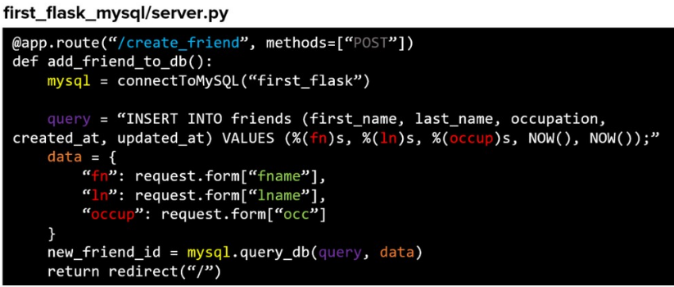

Inserts are used for creating new records (users) and when that happens, we need to save the id to a variable and to a session variable as below:

mysql = connectToMySQL("first_flask")

query = "INSERT INTO friends (first_name, last_name, occupation, created_at, updated_at) VALUES (%(fn)s, %(ln)s, %(occup)s, NOW(), NOW());"

data = { "fn": request.form["fname"],

"ln": request.form["lname"],

"occup": request.form["occ"]

}

mysql = connectToMySQL("first_flask")

new_friend_id = mysql.query_db(query, data)

print("should be new friend id: " , new_friend_id)

session['friend_id'] = new_friend_id

return redirect("/")

===Notes below from 4/8/19 p.m.

My Database:

Database name: user_assignment

Table name: user_table

Field names:

id | fname | lname | email | created_at | updated_at

Starting data:  
  
+----+---------+-------+------------------+---------------------+---------------------+

| id | fname | lname | email | created_at | updated_at |

+----+---------+-------+------------------+---------------------+---------------------+

| 1 | Jimmy | Jun | jjun@gmail.com | 2019-04-09 00:03:58 | 2019-04-09 00:03:58 |

| 2 | Andrew | Lee | alee@gmail.com | 2019-04-09 00:03:58 | 2019-04-09 00:03:58 |

| 3 | Jay | Patel | jpatel@gmail.com | 2019-04-09 00:03:58 | 2019-04-09 00:03:58 |

| 4 | Eduardo | Baik | ebaik@gmail.com | 2019-04-09 00:03:58 | 2019-04-09 00:03:58 |

+----+---------+-------+------------------+---------------------+---------------------+

