Domoticz

Open Source Home Automation System

Manual date: January 2013

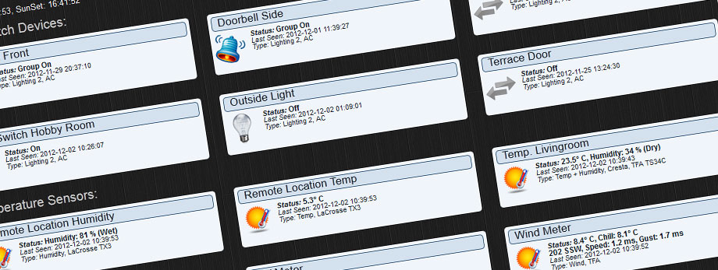

Author: Robbert E. Peters

Email: Info@Domoticz.com

Table of Contents

Introduction 4

System Requirements 4

Installation 4

Unix/Linux/Raspberry Pi/…. 4

Windows Users 4

Usage 5

Navigation 5

Command Line parameters 5

Unix Starup Script 5

Setup 6

Location Setup 6

Hardware Setup 7

Setting up a USB device 7

Setting up a LAN device 7

Sharing Devices 8

Domoticz Remote Server 8

Devices 9

Temperature 10

Log 11

Edit 12

Notifications 12

Weather 13

Log 14

Utility 15

Labels 15

Lights/Switches 16

Adding a Light/Switch by Auto Learning 17

Adding a Light/Switch Manually 18

Sub/Slave Devices 19

What is a Sub/Slave Device 19

Example 1 (Outdoor Light) Setup 19

Example 2 (Floor Lights) Setup 21

Notifications 23

What are Notifications? 23

Setting up the Notification System 23

Browser Cache 24

Chome 24

Firefox 24

Internet Explorer 10+ 24

Receiver improvements 24

IPhone / IPad 25

Sharing USB Devices over LAN 25

Participation 25

Thanks 25

# Introduction

Domoticz is a Home Automation system design to control various devices and receive input from various sensors. **The Main hardware component is a RF Receiver/Transmitter from RFXCOM**.

Additional hardware support for: P1 Smart Meter (serial):

http://www.smartmeterdashboard.nl/webshop

For example this system can be used with:

* Light switches
* Door sensors
* Doorbells
* Security devices
* Weather sensors like: UV/Rain/Wind Meters
* Temperature Sensors
* …

# System Requirements

This system is designed to run on most common hardware, this includes:

* Raspberry Pi (Model B/2 advised)
* Unix
* Windows

256MB memory recommended, 200MB free hard disk space, Firefox/Chrome/Safari browser.

A screen resolution SXGA = 1200x1024 or higher is recommended.

***If you want to use Internet Explorer, you need version 10+.***

Consult the RFXCOM website for supported devices. (http://www.rfxcom.com)

# Installation

## Unix/Linux/Raspberry Pi/….

See the Install.txt file for installation/compile instructions.

## Windows Users

An installer is provided for easy installation.

**When updating the software, do not uninstall, just reinstall, or the central database is deleted!**

When the application is started under Windows, a system tray popup message will display the port used to connect to:

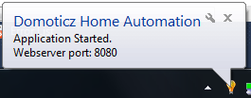

## Usage

The core application runs at the background, and has a web-based user interface.

The default port of the web interface is 8080. For a local setup you can connect to <http://127.0.0.1:8080>

To access the system from a remote location, consult your router manual to forwarding/NAT a port to your system.

## Navigation



Navigation is done by pressing the tabs at the top of the webpage.

Most tabs are automatically refreshed every 10 seconds. (Except Devices/Hardware/Setup)

## Command Line parameters

The following command line parameters are available:

-www port (for example -www 8080)

-dbase file_path (for example D:\domoticz.db or /opt/domoticz/domoticz.db)

-verbose x (where x=0 is none, x=1 is debug)

-startupdelay seconds (default=0)

-nowwwpwd (in case you forgot the webserver username/password)

## Unix Starup Script

To start Domoticz automatically when the system starts perform the following steps:

sudo cp domoticz.sh /etc/init.d

sudo chmod +x /etc/init.d/domoticz.sh

Edit the startup script and point the DEAMON location to point to the installation folder:

sudo vi /etc/init.d/domoticz.sh

DAEMON=/home/pi/domoticz/domoticz

If you want to use another web interface port change:

OPTIONS="-www 8080"

You can now start domoticz with:

/etc/init.d/domoticz.sh start

To stop:

/etc/init.d/domoticz.sh stop

To check if domoticz is running:

/etc/init.d/domoticz.sh status

# Setup

There are various application settings. For control of Light/Switches based on Sun Set /Sunrise timings, it is important to setup your location.

## Location Setup

To setup your location click on the ‘Setup’ tab, and enter the Latitude/Longitude parameters.

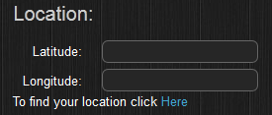

If you do not know these parameters, press the ‘Here’ link and enter your address:

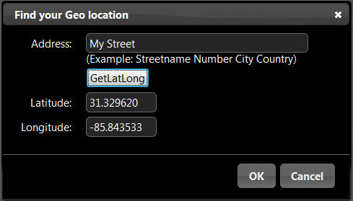

When pressing OK the parameters are accepted by the application.

Press the SAVE button to store the settings.

# Hardware Setup

Before you can use the application to control devices you must setup the communication hardware device(s).

The following devices are supported:

* RFXCOM - RFXtrx315 USB 310Mhz or 315Mhz Transceiver
* RFXCOM - RFXtrx433 USB 433.92Mhz Transceiver
* RFXCOM – RFXtrx connected to a LAN-USB interface
* Domoticz - Remote Server
* P1 Smart Meter USB cable
* P1 Smart Meter connected to a LAn-USB interface

## Setting up a USB device

First make sure the device is recognized in the system.

Domoticz automatically detects the USB port.

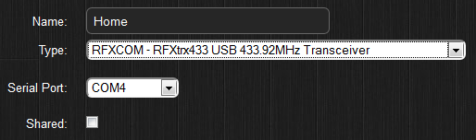

## Setting up a LAN device

First make sure you know the IP address and port of the device.

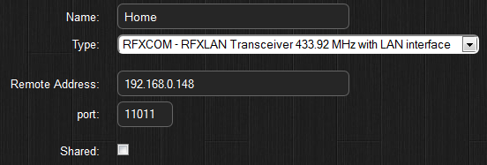

## Sharing Devices

It is possible to share your sensors with friends. For instance you can share your Rain Meter.

To do so, check the checkbox next to ‘Shared’ and enter TCP Port, and (optional) a username/password:

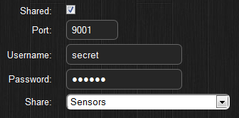

The TCP port has to be a free port, not being used by the system.

To enable this share from outside your home, you will have to add a rule to the firewall/router.

Consult the documentation of the router on how to setup a Firewall/NAT/Forward rule.

## Domoticz Remote Server

This device can connect to a Shared Hardware device.

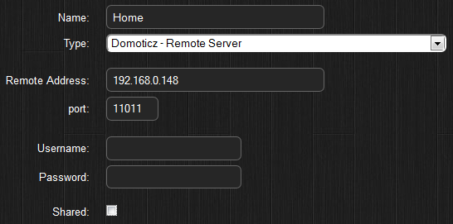

By pressing the ADD button, the hardware is added to the system and will automatically start.

You can see a debug console (windows) by pressing the right mouse button on the Domoticz icon in the system tray.

If you have sensors like Rain/Temperature meters, wait a few minutes and the system has recognized them. This can be seen in the ‘Devices’ tab.

# Devices

Once the application is running it will collect all devices found/received and begin logging the messages.

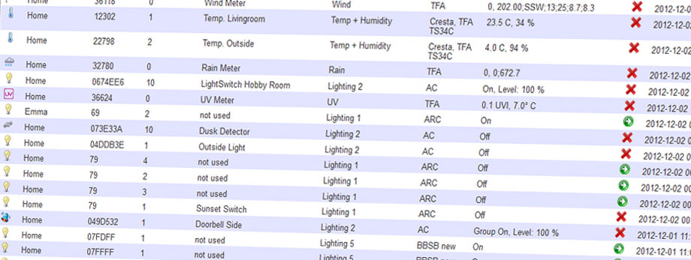

Devices can be Added/Removed from this tab. Light devices can also be added to the system from the ‘Lights/Switches’ tab.

To Add temperature/weather sensors press the add button, and enter a name. You will now find them in their respective tabs.

# Temperature

The temperature tab includes all sensors that have a temperature sensor.

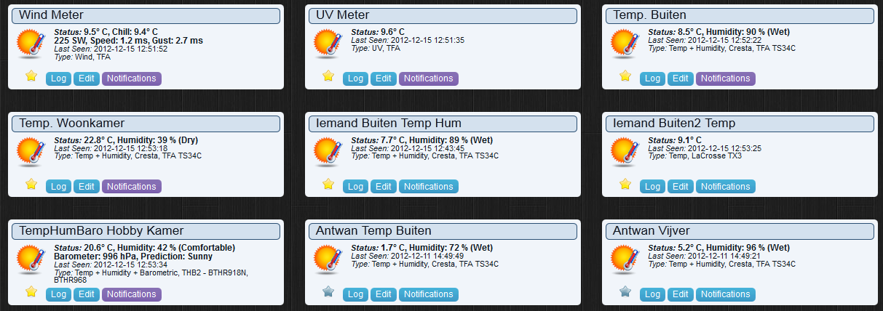

A temperature sensor can also include a Humidity sensor.

Each item has the following options:

* Favorite push icon (to display this device on the Dashboard tab)
* Log (Displays the log)
* Edit (Edit device parameters)
* Notifications (see Notification chapter)

By Dragging/Dropping the sensor items, you can change the position of the devices in the window.

## Log

By pressing the log button you can see the log of the sensor. It is possible to zoom in/out.

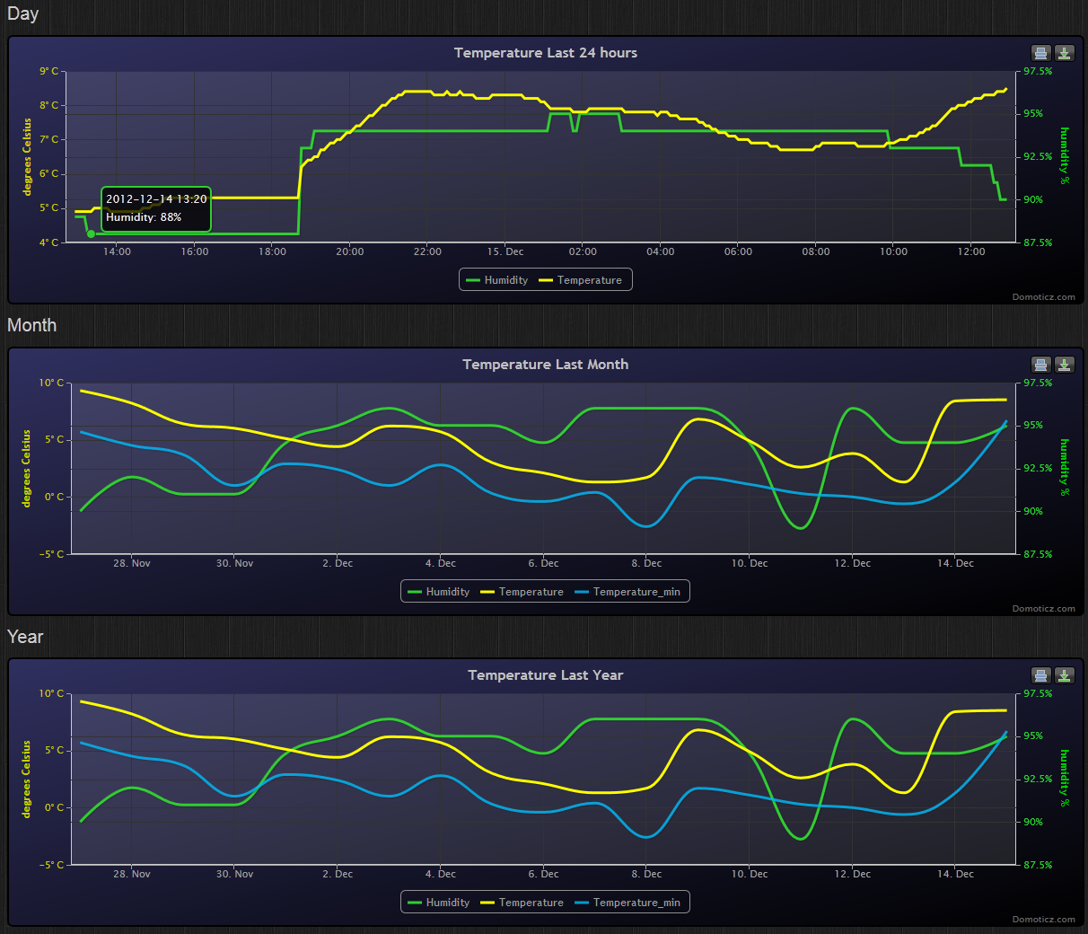

By pressing the BACK button you return to the overview.

## Edit

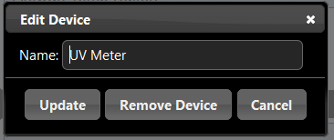

In this dialog you can rename the device, or remove it

## Notifications

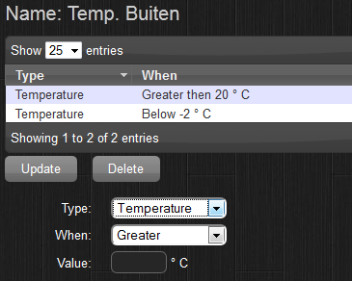

Each device has different notifications (depending on the hardware options).

For example, in the above screenshot, you want to be notified if the temperature drops below -2 degrees.

See the Notification chapter for more details.

# Weather

The weather tab includes all sensors that are related to weather...

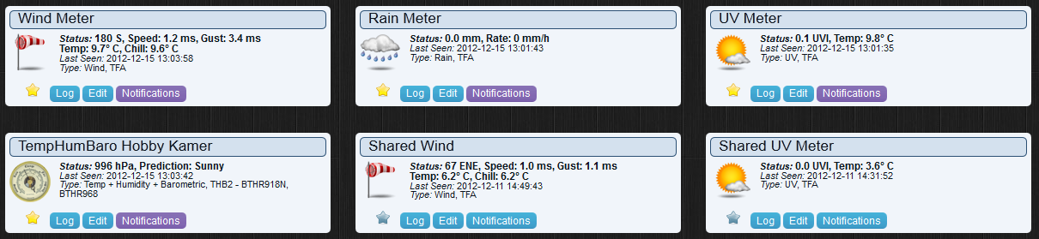

A weather sensor can be:

* Rain Meter
* Wind Meter
* UV Meter
* Barometer

Each item has the following options:

* Favorite push icon (to display this device on the Dashboard tab)
* Log (Displays the log)
* Edit (Edit device parameters)
* Notifications (see Notification chapter)

By Dragging/Dropping the sensor items, you can change the position of the devices in the window.

## Log

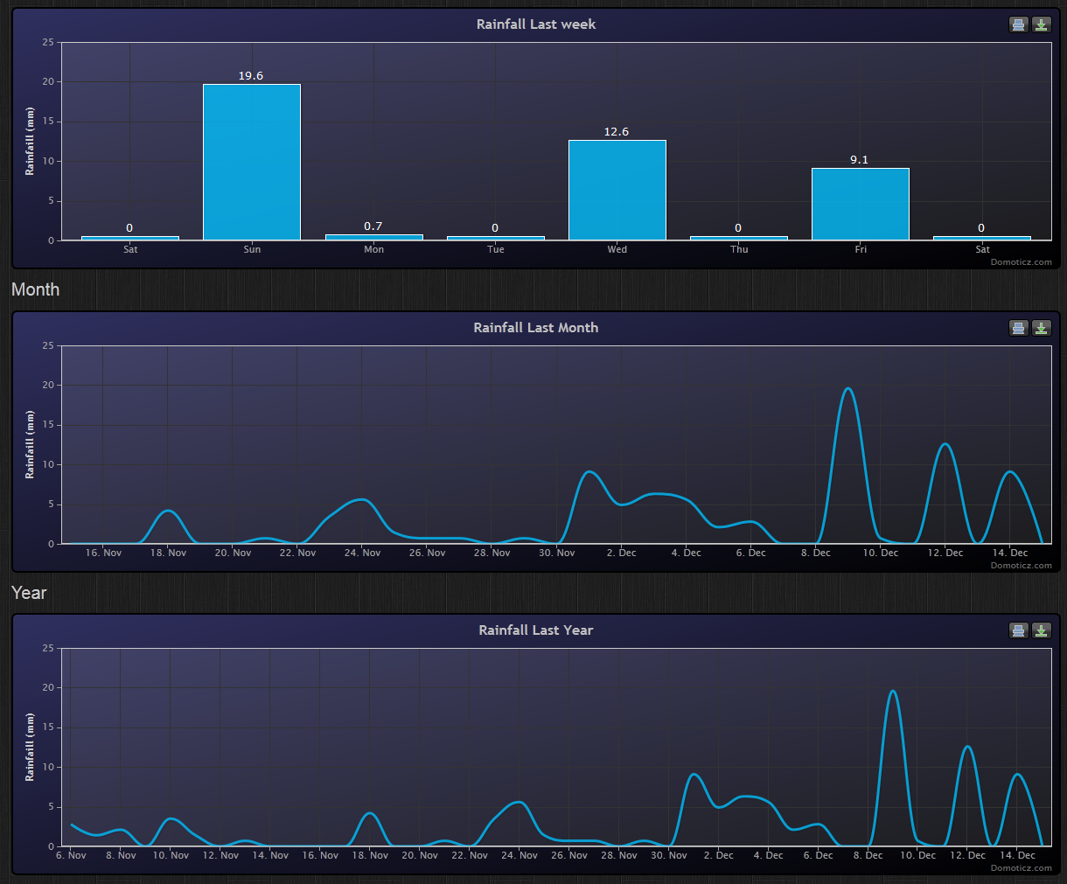

# Utility

The utility tab includes Meter Sensors (Energy / Gas / P1)

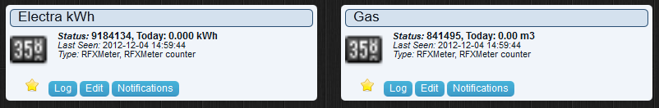

Each item has the following options:

* Favorite push icon (to display this device on the Dashboard tab)
* Log (Displays the log)
* Edit (Edit device parameters)
* Notifications (see Notification chapter)

By Dragging/Dropping the sensor items, you can change the position of the devices in the window.

## Labels

When using the dashboard in compact or mobile mode, there is limited room for the current status.

Therefor the following labels apply:

R = Return

T = Today

U = Usage

A = Actual

*to-do: this chapter needs to be updated

# Lights/Switches

The lights/switches tab includes devices like:

* Light Switches
* Door sensors
* Blinds
* Doorbells
* Security
* Sirens
* …



This chapter can be the most difficult part to setup. (Depending on your needs)

Each item has the following options:

* Status icon that can be push to toggle on/off status (depending on the hardware)
* Favorite push icon (to display this device on the Dashboard tab)
* Log (Displays the log)
* Edit (Edit device parameters, and Sub/Slave Devices)
* Notifications (see Notification chapter)

By Dragging/Dropping the sensor items, you can change the position of the devices in the window.

Lights and Switches can be added by:

* Auto Learning
* Manual Setup
* From the devices tab

## Adding a Light/Switch by Auto Learning



By pressing the ‘Learn Light/Switch’ button you have 5 seconds to press the remote/switch/sensor.

If this time is too short you should position yourself nearer the remote/switch/sensor by using a portable computer such as Tablet or Smartphone

Once you press the button the following screen is presented:

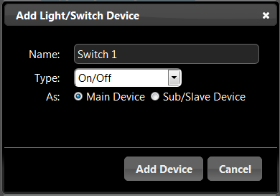

For the switch type there are various options to choose from:

* On/Off (a normal switch/remote button)
* Doorbell
* Contact (like a door sensor)
* Blinds
* X10 Siren device

Normally you setup a new light as a ‘Main’ device, but it can also be a Sub/Slave device.

More about Sub/Slave devices later.

## Adding a Light/Switch Manually

If you know the switch brand/type/address it is also possible to enter the parameters by hand.

It is also possible to create a new ‘virtual’ device that can control a light without having to buy a remote/switch.

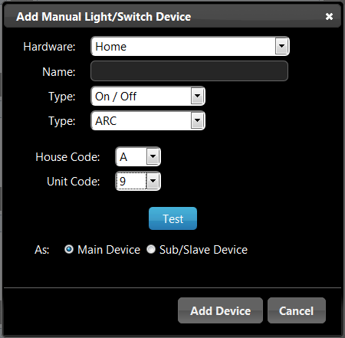

## Sub/Slave Devices

(One of the most difficult chapters)

### What is a Sub/Slave Device

Most Lights can be controlled from up to 6 remotes.

See the following two examples:

***Example 1 (Outdoor Light)***

Imagine you have an outdoor light that is controlled by a switch **(*a)** from inside the house.

It is possible to buy small remote controllers **(*b)** for on a keychain.

When you also want to control the outside light from this small remote, the small remote **(*b)** is a Sub/Slave device from the main switch **(*a)**.

***Example 2 (Floor Lights)***

Imagine you have a house with two floors, each floor has its own switch **(*a, first floor)** and **(*b, second floor)**.

Downstairs next to your exit door you have a switch **(*c)** to turn ON / OFF ALL the lights.

In this case the switch **(*c)** is a Sub/Slave device for switch **(*a, first floor)** and **(*b, second floor)**

**Consult your hardware manual on how to setup two/multiple switches for one light.**

### Example 1 (Outdoor Light) Setup

First you add the normal in-house switch **(*a)** like adding a normal Main light/switch as shown above:

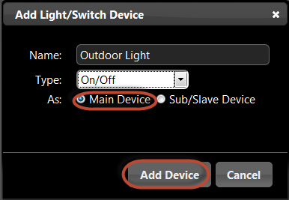

Next we are going to add the keychain remote **(*b)**, but instead of choosing to set it up as Main device, we are selecting ‘Sub/Slave’ device:

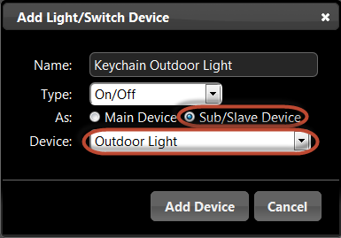

When selecting ‘Sub/Slave’ Device, a new option will become visible, and here we select the ‘Main’ device, in this case the ‘Outdoor Light’.

### Example 2 (Floor Lights) Setup

First you add the two floor lights **(*a)** and **(*b)** like adding a normal Main light/switch as shown above:

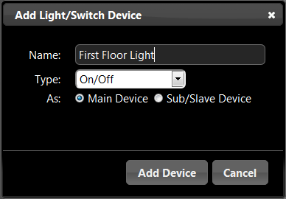 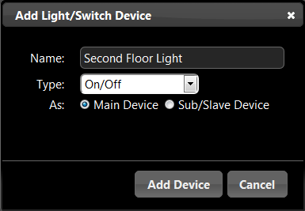

Next we are going to add the downstairs switch **(*c)** that can turn ON / OFF both floor lights.

Remember to select Sub/Slave Device:

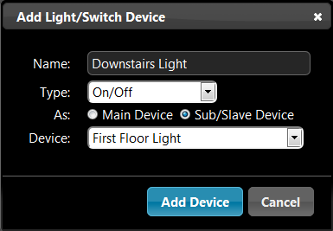

Select the First Floor Light **(*a)** as the Main device.

Now that we have added the ‘Downstairs Light’ we can also make this a Sub/Slave device for another Main Device.

To at the ‘Downstairs Light’ as a Sub/Slave device for the ‘Second Floor Light’ **(*b)** press the ‘Edit’ button:

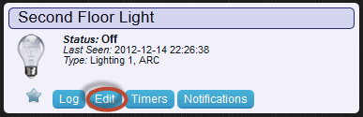

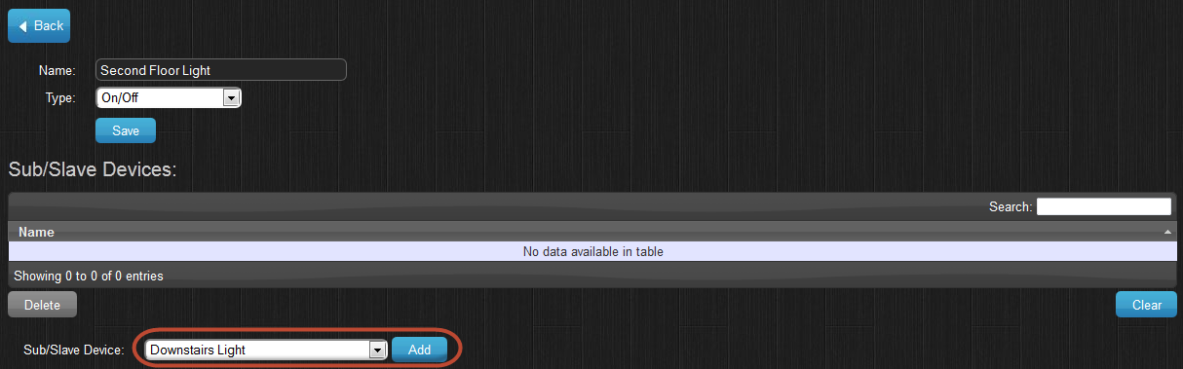

From the Sub/Slave devices select the Downstairs Light **(*c)** and press ADD.

Now this Sub/Slave device is also assigned to this device.

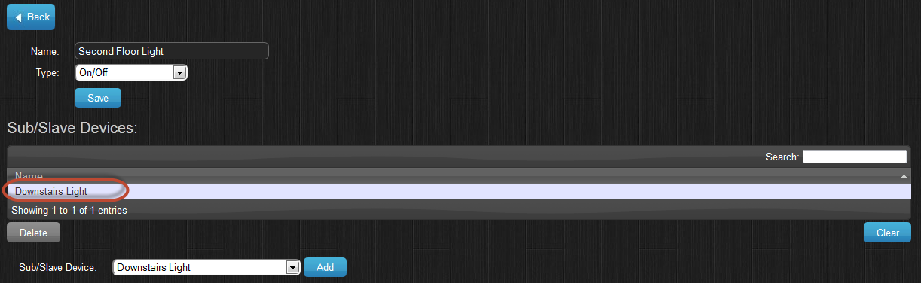

*\*Note:* When adding a Sub/Slave device, this will not be visible in the ‘Lights’ tab by default. You see this device in the ‘Edit’ screen from the device you added it too.

If you also want to control or see the Sub/Slave device, you will have to add this device again, and set it up as Main device.

# Notifications

## What are Notifications?

Notifications can be used when you want to know if a switch is pressed (for example a doorbell), or when a temperature is below/above a certain degree, or when you power usage is above xxx Watt, etc.

Each device has different parameters for notifications, a switch might have an On/Off state, a temperature device might have a temperature/humidity and a wind meter might have wind force/speed/chill…

## Setting up the Notification System

Notifications are sent via the Prowl (iPhone) or NMA (Android) system.

You need to create a (free) account for one/all of the above systems. Then the API key has to be specified in the Settings tab:

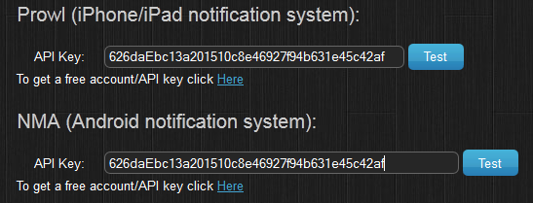

If you use one of the above systems, you need to download the client on your mobile/tablet device.

The price of the client is around 3 dollars. (On most devices, buy one time, use on all your devices)

# Browser Cache

The web frontend is set to be cached. This will speed up the application launch time, and is perfect if you create a shortcut on the home screen of an iPhone/iPad/….

If for some reason, the page does not load correctly in Firefox / Chrome, clear this cache.

## Chome

From inside the Chrome browser browse to the following URL:

chrome://appcache-internals/

You will now see all web applications that are cached.

Find the Domoticz cache and press ‘Remove’.

## Firefox

From the options page, go to the ‘Advanced’ page.

At the bottom you will see all web applications that are cached.

Select the Domoticz application, and press ‘Remove’.

## Internet Explorer 10+

From the options page, go to ‘General’, Under ‘Browser History’ select settings, then select the ‘Caches and databases’ tab.

Select the Domoticz application, and press ‘Delete’.

# Receiver improvements

Another antenna is officially not allowed because the RFXtrx is certified with the supplied antenna.

But to increase the receiving range you can connect (for example) a 190073 Conrad 433MHz ground plane, however this will also increase the radiated transmit power which is illegal! (If you are not licensed to it.)

The following adapter can be used for SMA- to BNC:

<http://www.ebay.com/itm/BNC-female-SMA-male-plug-coax-connector-adapter-/180454327185?pt=LH_DefaultDomain_0&hash=item2a03ea8391>

The location of the sensor and the RFXCOM is also important if the RF signal has to pass through walls. See chapter 2.4 in the RFXtrx User Guide

<http://www.rfxcom.com/documents/RFXtrx%20User%20Guide.pdf>

It is expected that RF interference is happening if sensor signals disappear for several hours. RF interference will also occur if sensors of the same type are configured to the same channel.

If sensors disappear for a longer period the source of the problem can be another transmitter that is transmitting continuously or with short intervals.

If X10 MS13 sensors are in use check the battery in this sensor because when the battery becomes almost empty the MS13 starts transmitting a weak continuous RF signal but just enough to disturb the sensitive RFXCOM receiving.

# IPhone / IPad

If you browse on your iPhone/iPad to the Domoticz site (for example <http://192.168.0.3:8080>), and add a shortcut to the home screen, the application will launch 90% faster, and works as a stand-alone application. It is best to add a shortcut for ‘internal’ and ‘external’ use. (Internal = from inside your house, External = from outside your house). For external usage, you need to add a firewall rule in your router.

# Sharing USB Devices over LAN

If you would like to share USB devices via TCP/IP you can use the applications ‘Ser2Net’ or Socat.

# Participation

We always welcome talented C++/HTML5/JQuery developers.

If you think you want to help, please contact us at [Info@Domoticz.com](mailto:Info@Domoticz.com)

# Thanks

Thanks go out to all people that have helped during development and testing.