**2013 all fatalities by weekday**

Trying to get data for other years so we can have have multiple year drop downs

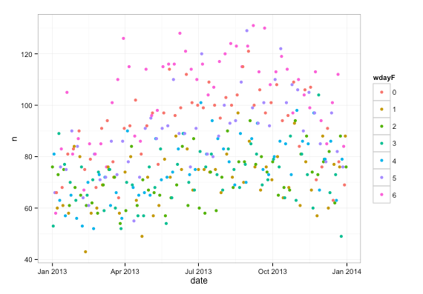

What day of week is the worst in each state ?

2013 Fatalities by state and day of week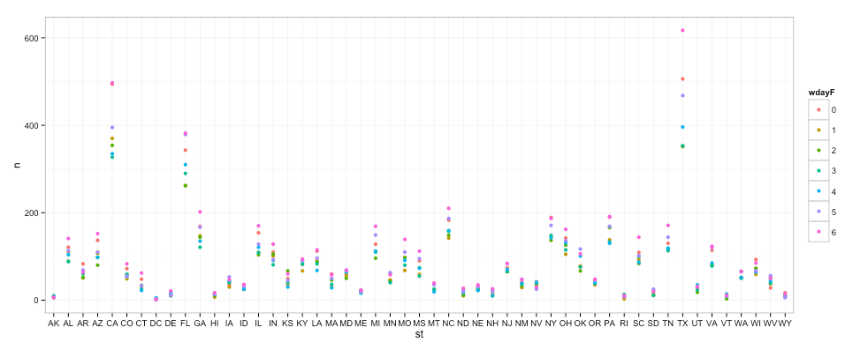

**Fatalities by state and weekday**

(normalized by annual miles driven)

http://www.fhwa.dot.gov/policyinformation/statistics/2013/vm2.cfm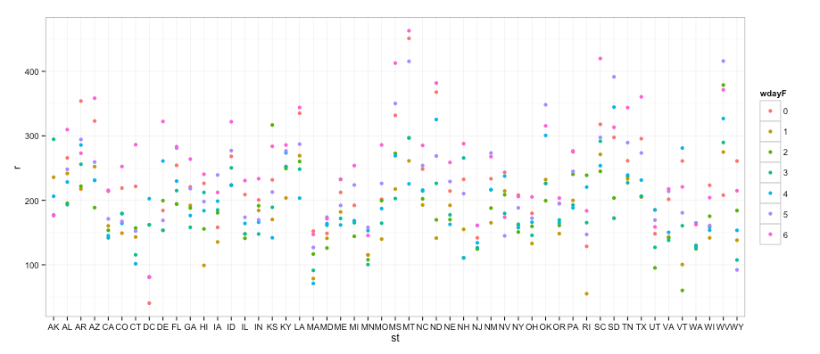

State fatality rate normalized by annual vehicle miles in millions

ggplot(v2, aes(x=reorder(st, r), y=r)) + geom_bar(stat='identity') + theme_bw() + coord_flip()

Rural population dominates fatalities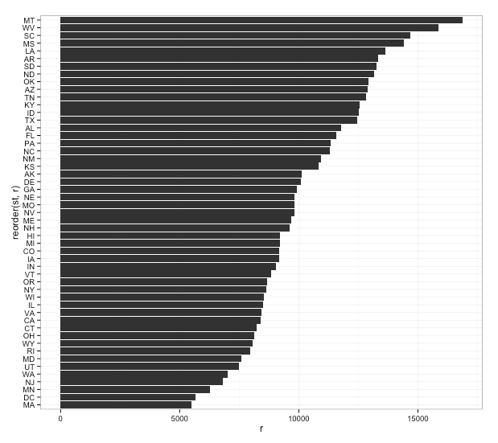

**Fatality rate vs Urban population**

Each dot is a state.

- X axis is number of fatalities per million mile driven. I got the miles driven per state from here (Federal Highway Authority)

- Y axis is how rural the state is. I got that from here which comes from 2010 census data

You can see a relationship/correlation in the lines. The more urban a state is (high Y) the fewer fatalities per mile driven. Surprising, isn't it. Yes, the worst fatalities rates when normalized by miles driven are in the rural states like Montana (which also doesn't have speed limits on some roads).There are two outliers near the bottom lower part of the graph. Medium fatality rates but very rural They are Vermont and Maine (i.e. North-east rural states)