Appendix I – Linux Basics

The name of your computer

A. Use terminal to enter/exit folders and find files:
“cd” command: open a directory(folder).

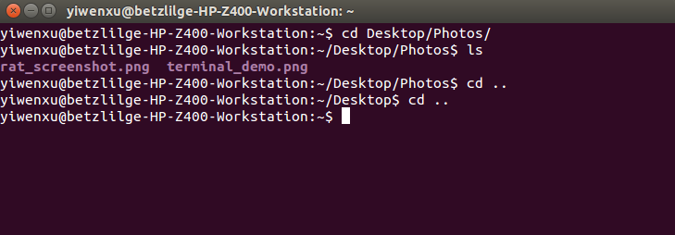
Showing the current directory(folder). In this case, it means you are in the “Photos” folder on your desktop.
“~” is the short form of your home directory, which is equivalent to “/home/username”
“cd ..” command: go back to the parent directory(folder).
“ls” command: list all files, folders, programs,etc. in the current directory(folder).

B. Use terminal to execute programs:

Example: open a software named “matlab”

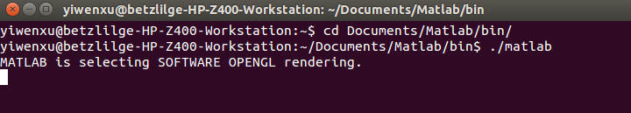
step1: use “cd” command to enter the folder containing matlab.

step2: use “./”+“software name” to execute the program. In this case type “./matlab” in the terminal and hit
Enter

Appendix II – Building From Source

A. Why build from source?

Binary packages: - packages that are already built from source by someone else
- easy to install
- may not have all options from upstream package

Source packages: - take more time to install
- heavy customization option

B. How to build software/library from source?

(The following is a an outline for building using Cmake. Please see below the installation of MeshTool as a detailed example.)

step 1: Download source code or clone the source code from Github.

step 2: Go to the directory where you downloaded the source code file in terminal

step 3: Use command “tar zxvf” + “<file name.tar.gz>” to extract the file into a folder. The command may be different for different types of archive files.
eg:

step 4: Enter the folder in terminal and create a build-release folder inside it (for the purpose of out-of-source build).

step 5: Enter the build-release folder and run Cmake using command “ccmake ..”

step 6: Configure using Cmake and generate the software/library.

step 7: Make install the sofware/library.

C. What is Cmake?

CMake is an open-source, cross-platform family of tools designed to build, test and package software. CMake is used to control the software compilation process using simple platform and compiler independent configuration files, and generate native makefiles and workspaces that can be used in the compiler environment of your choice. The suite of CMake tools were created by Kitware in response to the need for a powerful, cross-platform build environment for open-source projects such as ITK and VTK.

We use Cmake to build software/library from source.

FullMonte Software Installation Instruction

Step 1: Install Itk-snap and Paraview

Step 2: Install MeshTool

Step 3: Install FullMonteSW

Step 1: Install Itk-snap and Paraview


Itk-snap:

Itk-snap is a software application used to segment structures in 3D medical images.

Download link: http://www.itksnap.org/pmwiki/pmwiki.php?n=Downloads.SNAP3

Version: 3.6.0 or later

Tutorial: http://www.itksnap.org/pmwiki/pmwiki.php?n=Train.Sep2014

Paraview:

ParaView is an open-source, multi-platform data analysis and visualization application. ParaView users can quickly build visualizations to analyze their data using qualitative and quantitative techniques. The data exploration can be done interactively in 3D or programmatically using ParaView’s batch processing capabilities.

Download link: https://www.paraview.org/download/

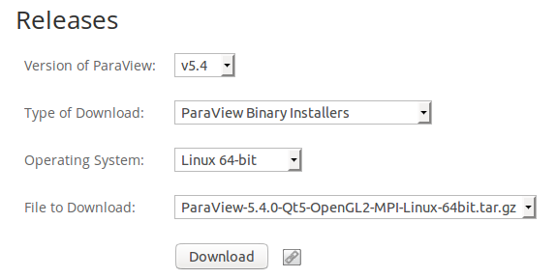
Version:
(5.4 or later)

Tutorial: https://www.paraview.org/tutorials/

Step 2: Install MeshTool

I. Download/build All Pre-Requisites

Download Cmake from: https://cmake.org/download/. Version 3.1 or later

Download Qt 5.3.2 from : https://download.qt.io/archive/qt/5.3/5.3.2/. Choose the one with name “qt- opensource-linux-x64-5.3.2.run”

Download VTK from: http://www.vtk.org/download/. Version 6.3.0 or later.

Download Boost from: http://www.boost.org/. Recent Version.

Download CGAL from: https://github.com/CGAL/cgal/releases/tag/releases/CGAL-4.8.1. Choose “Source Code (tar.gz)”, and build from source. See a detailed building instruction here:http://doc.cgal.org/latest/Manual/installation.html.

Download Eigen Library from: http://eigen.tuxfamily.org/index.php?title=Main_Page. Choose latest version and build from source using Cmake.

II. Clone source code of MeshTool and FullMonteSW from Github:

~$ git clone http://github.com/zachzzc/MeshTool
~$ cd MeshTool/
~/MeshTool$ mkdir build-release
~/MeshTool$ cd ..
~$ git clone http://github.com/jeffreycassidy/FullMonteSW
~$ cd MeshTool
~/MeshTool$ cd build-release/
~/MeshTool/build-release$ ln -s ~/FullMonteSW/ FullMonte
~/MeshTool/build-release$ ccmake ..

Interpretation:

line 1: Clone the MeshTool software package from Github (need internet connection)
line 2: Enter the directory of the package that is cloned onto your computer
line 3: Create a new directory “build-release” inside MeshTool. This directory is where the software will be finally built.
line 4: Go back to home directory
line 5: Clone the FullMonte software package from Github (need internet connection)
line 6: Enter MeshTool directory
line 7: Enter build-release directory (you can combine these two steps into one by using “cd MeshTool/build-release/”
line 8: Make connection between MeshTool and FullMonteSW. To allow MeshTool run properly, FullMonteSW is needed.
line 9: Open CMake Gui
III. Configure and build MeshTool:
After typing the last command “ccmake ..” in your terminal, you should be able to see a new window that looks like this:
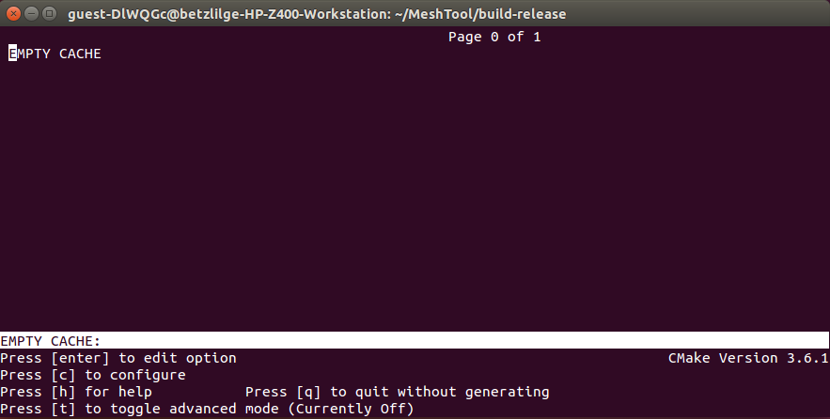

c
Press to configure and you will see some error messages that look like this. Most of the time, these errors need to be fixed before generating the software.

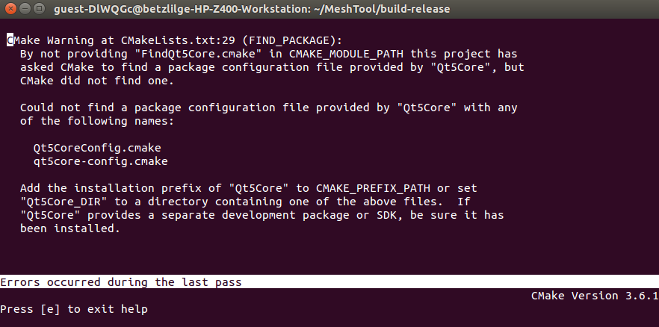
Press to go back to the previous window and you will see some entries:
e

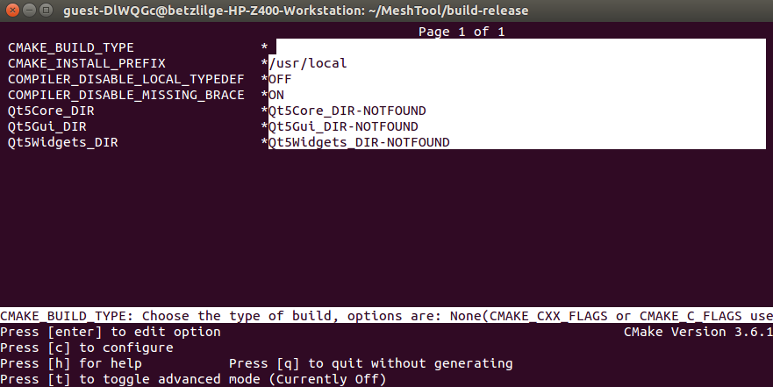

To fix the error messages in this example, we need to setup all Qt paths that Cmake failed to find manually. Use the arrow keys to choose the directory that you want to change (in this case they are “Qt5Core_DIR, Qt5Gui_DIR, Qt5Widgets_DIR”). Press to allow edition. And set the path according to the following(Press again once finish editing):
Enter
Enter

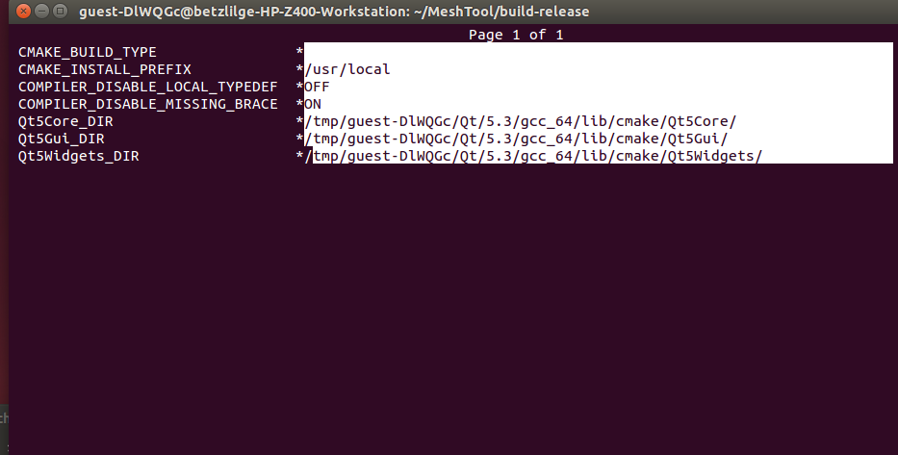
the CMake Package_DIR options give the location of PackageConfig.cmake (ie. if exists a file /a/b/c/Qt5Config.cmake then Qt5_DIR=/a/b/c)
The paths in this example. The path is often but not always of the form /a/b/c/lib/cmake

Then press to toggle advanced mode. You will see more options as shown below:
t

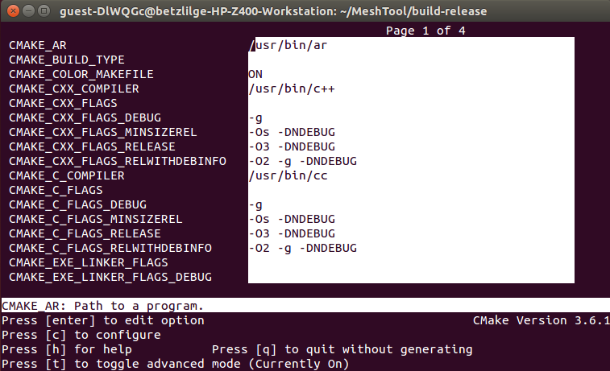

Once in the advanced mode, set “CMAKE_CXX_FLAGS” to
“-DBOOST_PARAMETER_MAX_ARITY=12”. And then press to configure again.
c
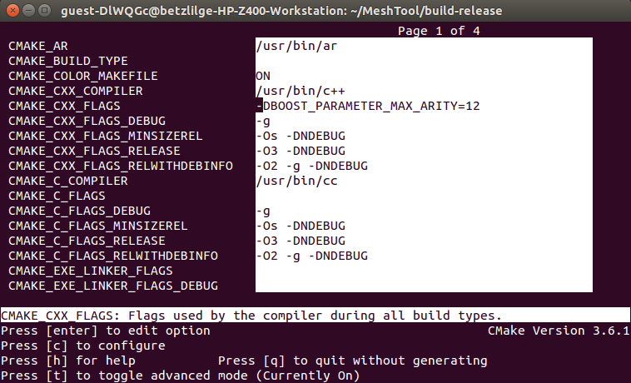

If you then see this message or nothing, press and you are almost there. If there is any other error message, please fix it before you proceed to the next step.
e
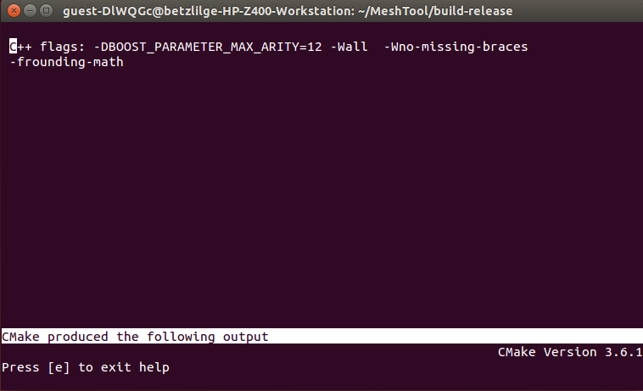
g
You should be able to see a new option [g] by now(If you don't, try to configure one more time). Press
to generate the software.
g
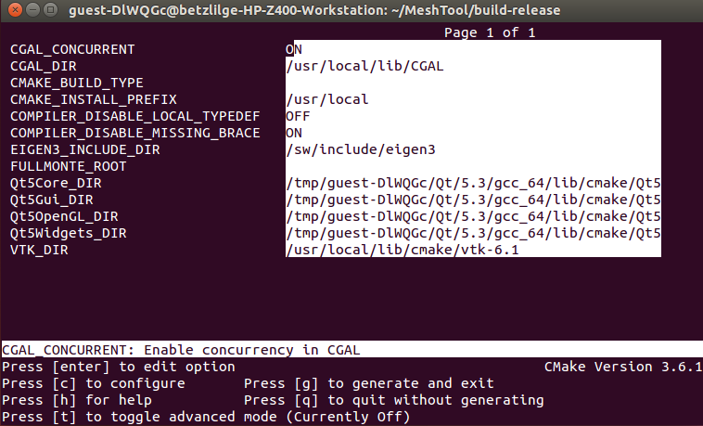
Now the window should have disappeared and you are back to the terminal.
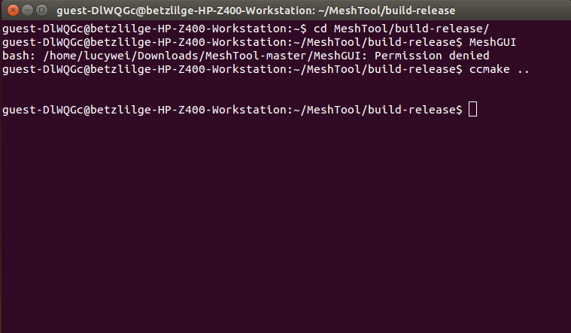

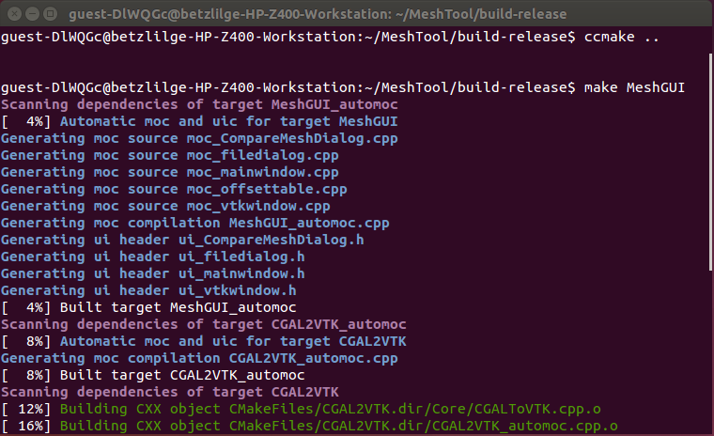
Type “make MeshGUI” in the terminal and the software will then be generated automatically. Once you see [100%], the software is built successfully.
Step 3: Install FullMonteSW

I. Pre-Requisites(In addition to the onces required for MeshTool)

- Modern compiler with C++11 support: G++ version 4.9 or higher, or Clang
Instruction for installing G++ 4.9: https://askubuntu.com/questions/428198/getting-installing-gcc-g-4-9-on-ubuntu.

- Tcl 8.5 or 8.6 (for Tcl wrapping)

- SWIG 3.0 (for Tcl wrapping)

II. Configure and build FullMonte:

Make sure you read the notes below and the file README.md in the FullMonteSW package first before configuring or building the software.

The configuring and building process of FullMonte is similiar to that of MeshTool, with some additional notes below:

Notes:
- You may find it necessary to specify paths to packages such as Boost (`ccmake -DBOOST_DIR=/path/to/boost`). CMake documentation will help with standard packages (VTK, Tcl/Tk, Swig) and compiler settings.

- To output VTK files or perform visualization, the `WRAP_VTK` option must be enabled during build.

- Ensure that build type is set to release for full performance. Architecture should be set appropriately to "AVX" or "AVX2" (Use 'cpuid' command to help choosing AVX vs AVX2)
The processor must support at least AVX.

- Important variables:
Variable Description | Values
WRAP_VTK | on/off | Generate VTK interface code and scripting support
WRAP_TCL | on/off | Generate TCL interface code
CMAKE_BUILD_TYPE | Release | Build type (use Release for best performance)
VTK_DIR | path | Folder containing VTKConfig.cmake (eg /usr/local/lib/VTK-7.1.1/lib/cmake)
BOOST_ROOT | path | Location of Boost library and header files

- Please see README.md for Using G++ on Mac OS

