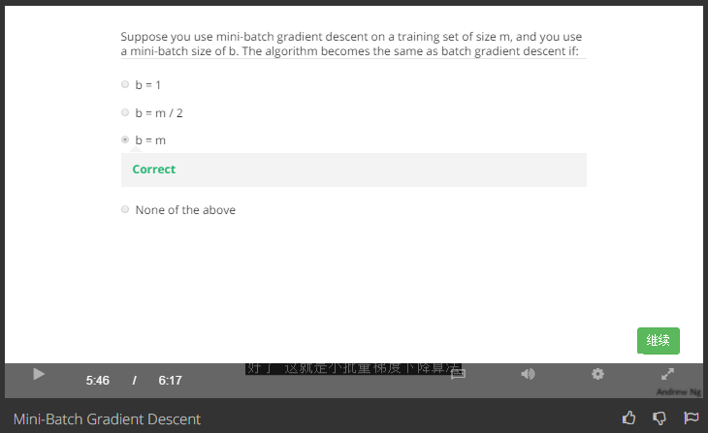

Answer:

Batch gradient descent: use all m examples in each iteration

Stochastic gradient descent: use 1 example in each iteration

Mini-Batch gradient descent: use b examples in each iteration