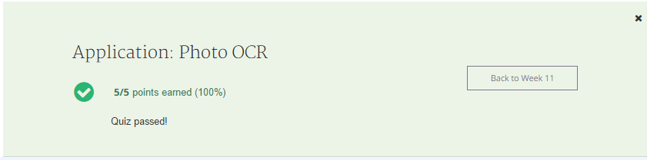

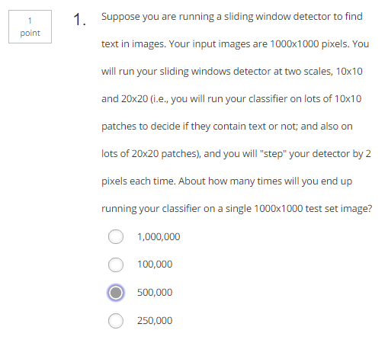

Answer:

1000x1000/2x2 = 250000

2x250000 = 50000

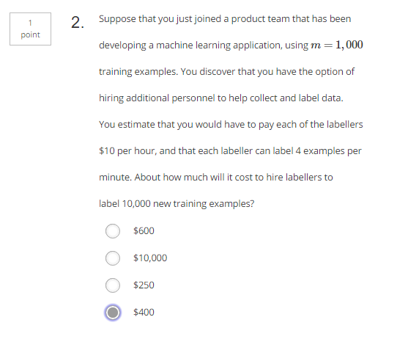

Answer:

10$ for 240 samples.

(10000/240)x10=416$

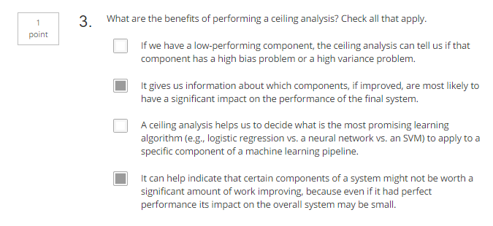

Answer:

A: learning curve can tell that, not ceiling analysis

C: Test can help decide the best algorithm

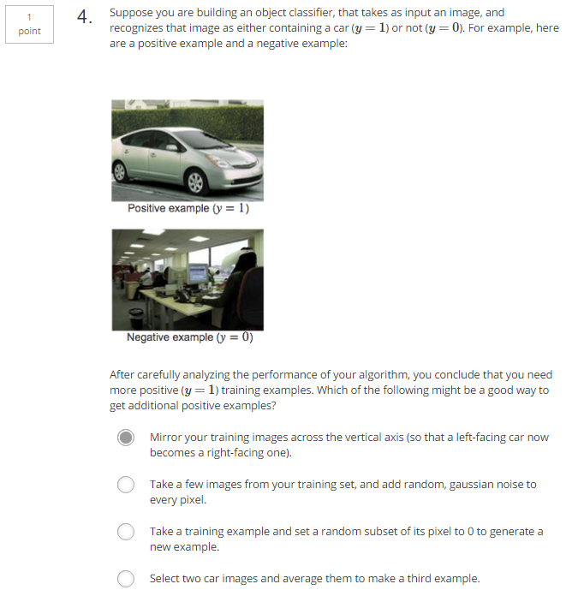

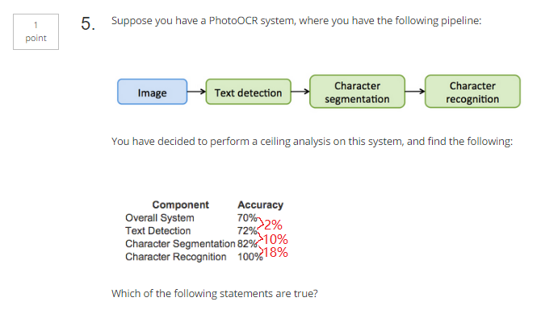

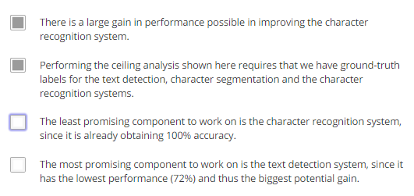

Answer:

Accuracy is whole system accuracy,

70%, current accuracy

72%, when Text Detection is 100% (which means if the Text Detection is 100%, we can only gain 2% to our system)

82%, when Text Detection & Character Segmentation are 100%(which means if the Character Segmentation is 100%, we can only gain 10% to our system)

100%, when Text Detection & Character Segmentation & Character Recognition are 100%(which means if the Character Recognition is 100%, we can gain 18% to our system)