1

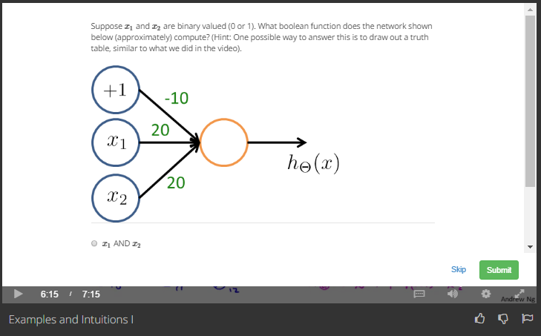



Answer

h(x)=g(-10+20x1+20x2)

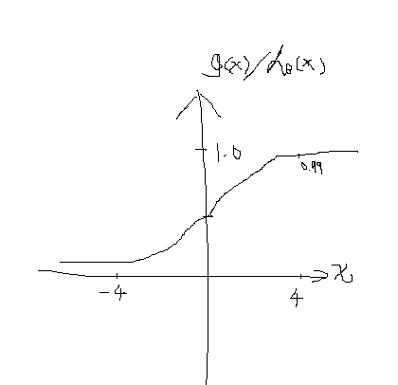

|  |  |  |
| --- | --- | --- |
| X1 | X2 | Result |
| 0 | 0 | g(-10)=0 |
| 0 | 1 | g(10)=1 |
| 1 | 0 | g(10)=1 |
| 1 | 1 | g(30)=1 |

2

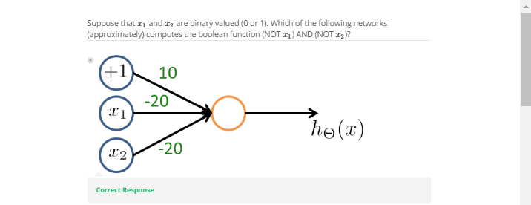

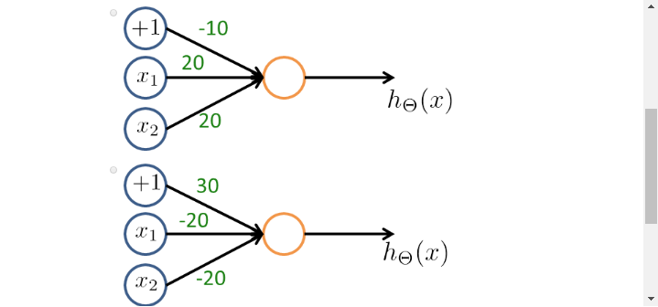

Answer:

Check the logic below

|  |  |  |
| --- | --- | --- |
| X1 | X2 | Result |
| 0 | 0 | 1 |
| 0 | 1 | 0 |
| 1 | 0 | 0 |
| 1 | 1 | 0 |