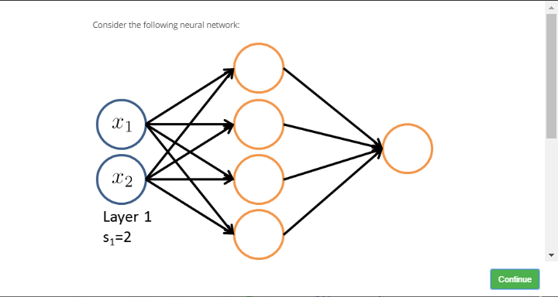

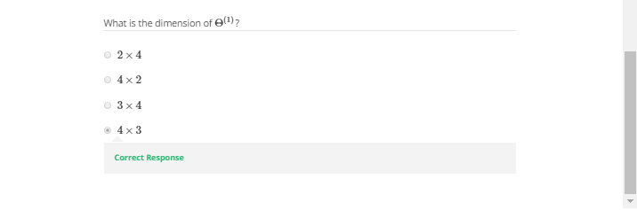

Answer:

As the figure below shows:

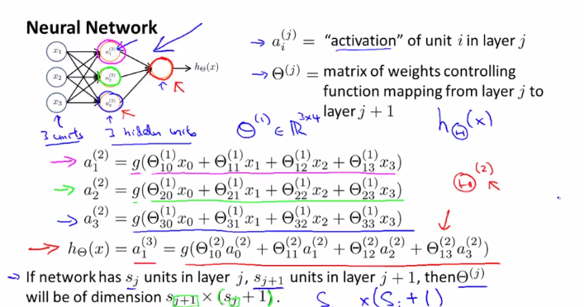

We have 4 layer units, and 2 input units (which will be enlarged to 3 by adding x1), so 4x3