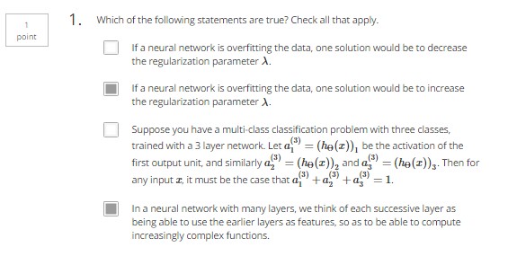

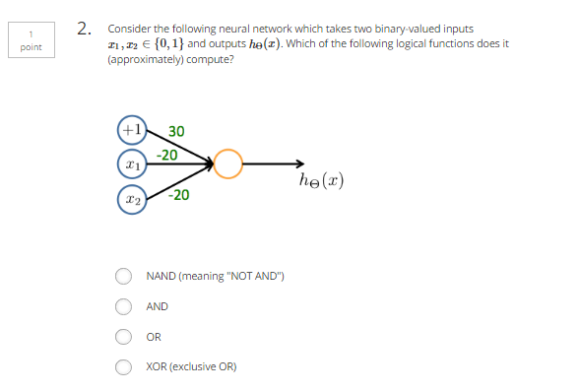

|  |  |  |
| --- | --- | --- |
| X1 | X2 | Result |
| 0 | 0 | g(30)=1 |
| 0 | 1 | g(10)=1 |
| 1 | 0 | g(10)=1 |
| 1 | 1 | g(-10)=0 |

So NAND

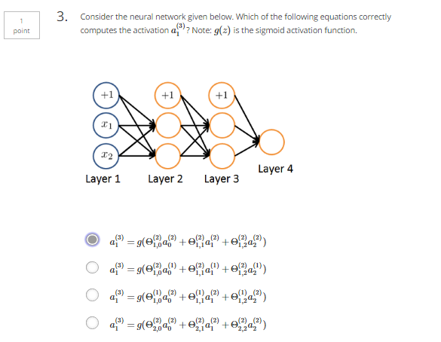

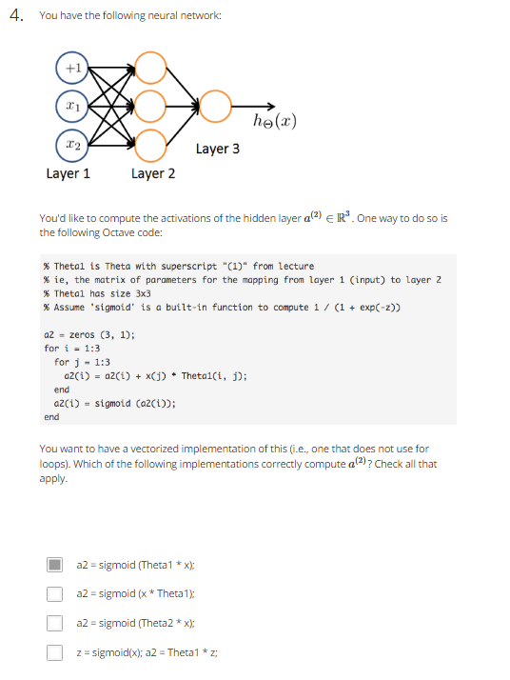

a 3x3

x 1x3

theta 3x3

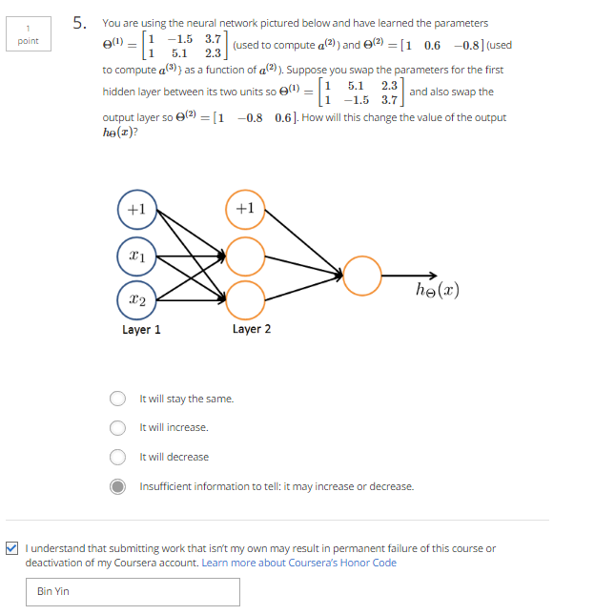.

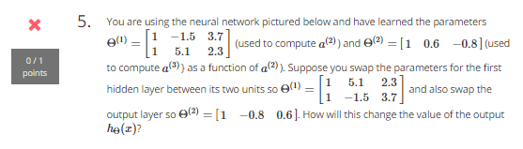

Correct: Stay the same

Since this just swap the hidden layer values