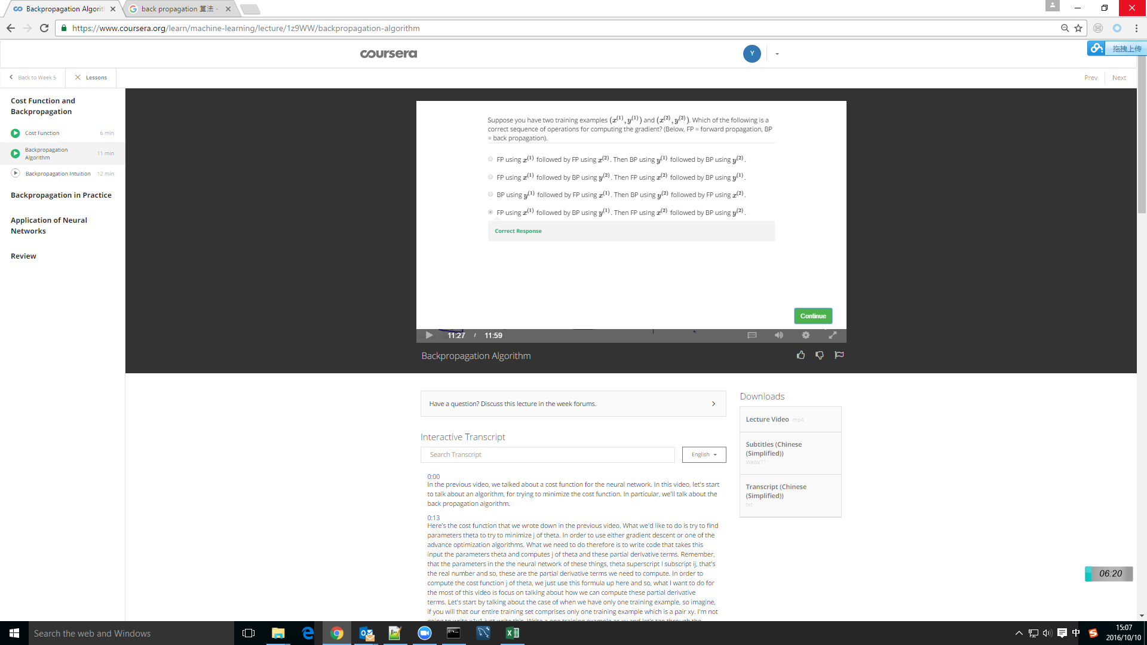

First FP, and get predict,

Then BP, to get error=predict-y