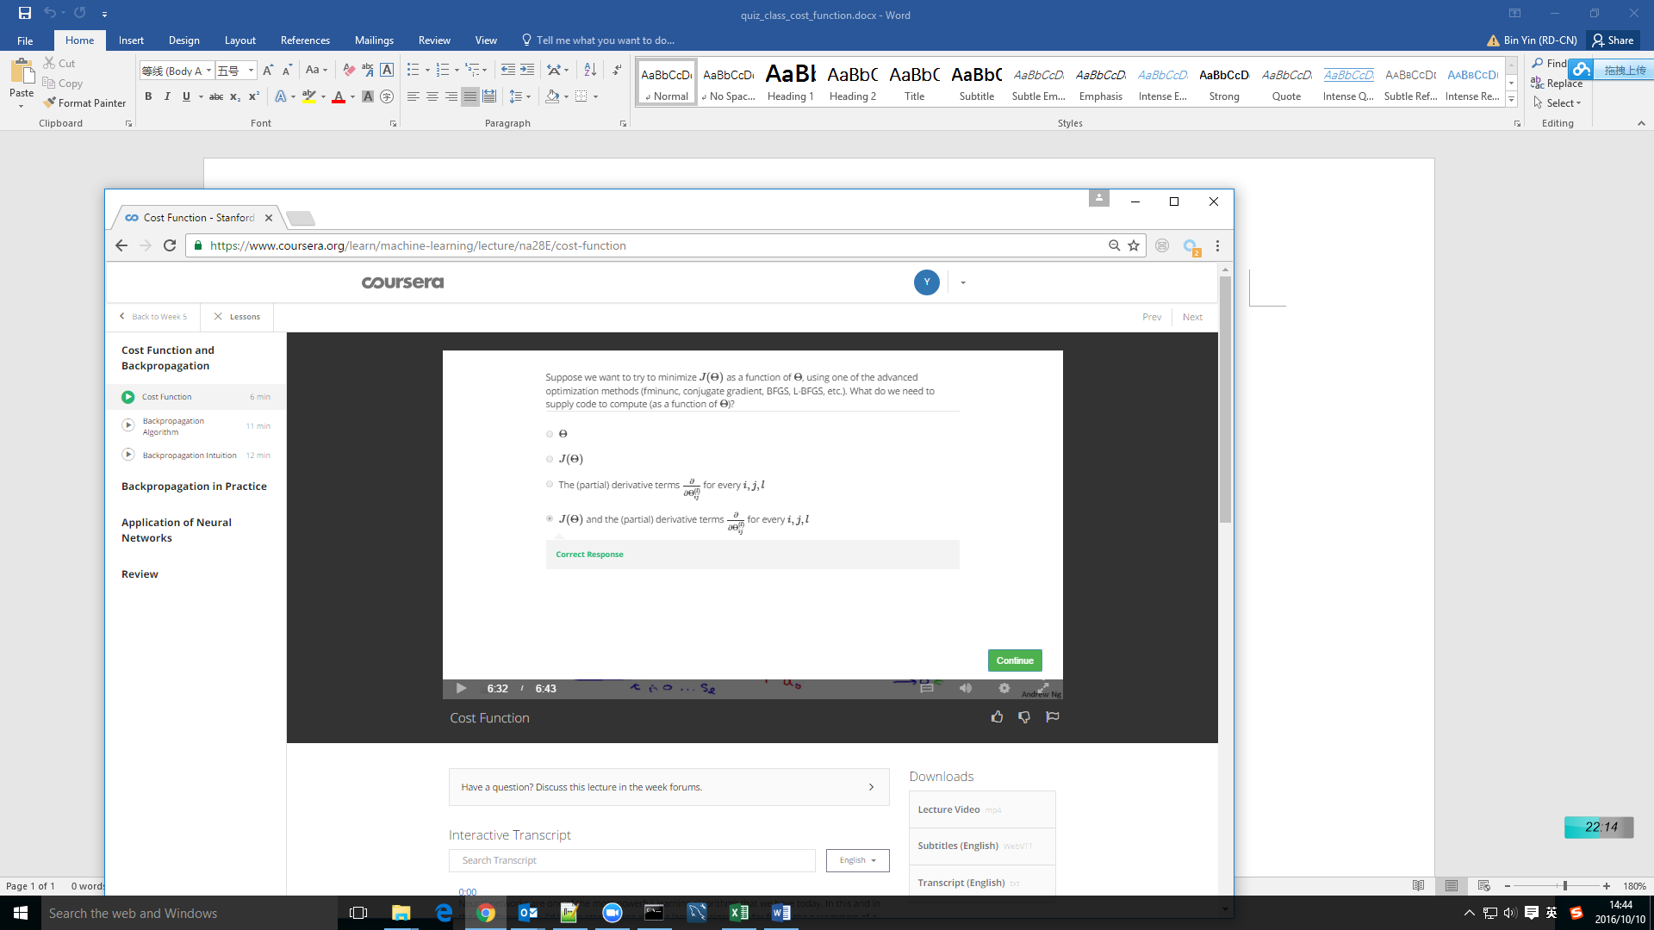

We need to calculate gradient and J(theta) to get min J.