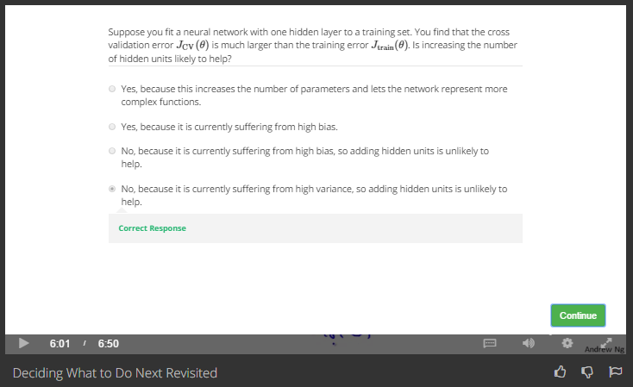

Jcv>>Jtrain, that is overfitting, so we should reduce the complexity of NN