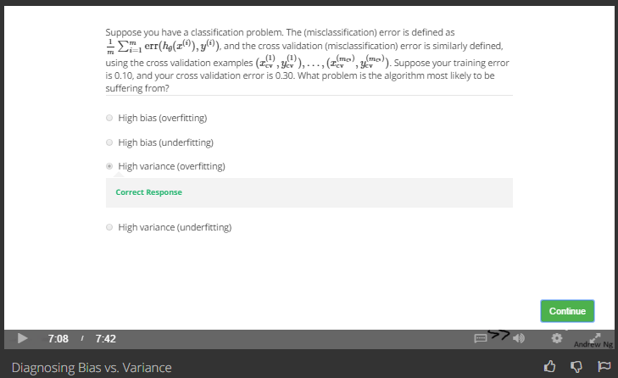

Training error is low, but CV error is high, that is overfitting