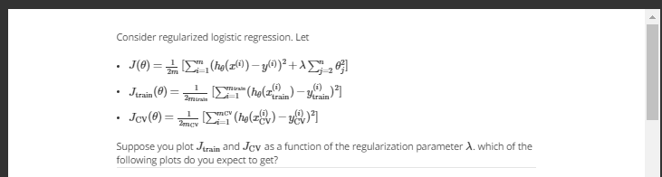

Lambda small, like high polynomial model, training error low, test error high

Lambda big, like low polynomial model, training error high, test error high

So choose below graph

