

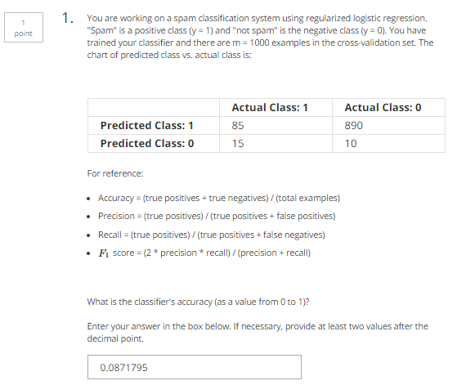

Answer

|  |  |
| --- | --- |
| TP=85 | FP=890 |
| FN=15 | TN=10 |

Accuracy = (TP+TN)/(85+890+15+10)=95/1000=0.095

Precision = TP/predict as positive = TP/(TP+FP) = 85/975 = 0.0871795

Recall = TP/actual positive = TP/(TP+FN) = 85/100=0.85

F1 = 2*P*R/(P+R)=0.1482/0.9371795=0.158134



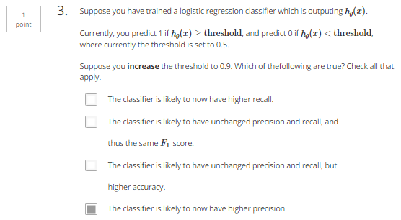

High precision, low recall

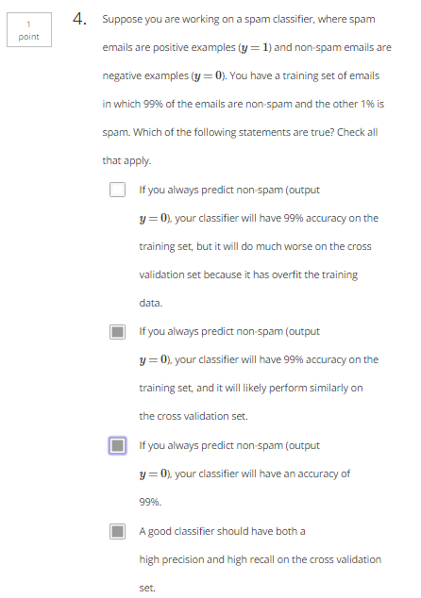

**If always y=0:**

100 samples, predict_1 = 0, predict_0=100

|  |  |  |
| --- | --- | --- |
|  | Actual=1 | Actual=0 |
| Predict=1 | TP = 0 | FP = 0 |
| Predict=0 | FN = 1 | TN = 99 |

Accuracy = (TP+TN)/TotalSample = 99%

Precision = TP/Predict_1 = 0

Recall = TP/Actual_1 = 0

**If always y=1:**

100 samples, predict_1 = 100, predict_0=0

|  |  |  |
| --- | --- | --- |
|  | Actual=1 | Actual=0 |
| Predict=1 | TP = 1 | FP = 99 |
| Predict=0 | FN = 0 | TN = 0 |

Accuracy = (TP+TN)/TotalSample = 1%

Precision = TP/Predict_1 = 1%

Recall = TP/Actual_1 = 100%

