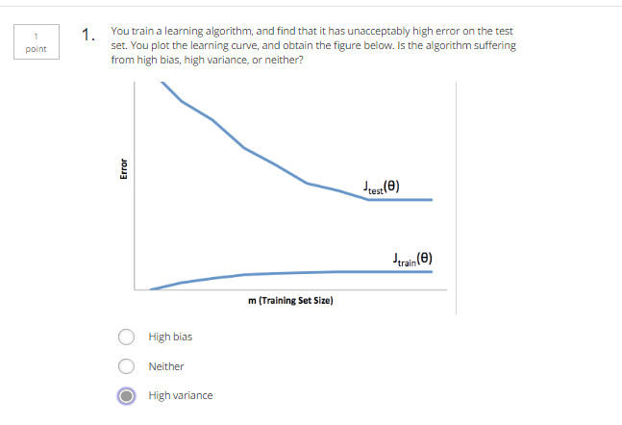

Jtest>>Jtrain, and Jtrain not big.

That is High variance

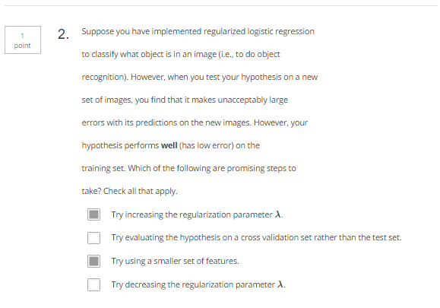

Work well on training dataset. But bad on test dataset.

That is overfitting.

We should: (1) increase regularization lambda. (2) reduce feature. (3) increase training dataset

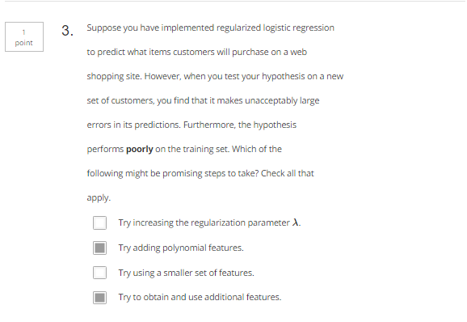

Jtrain and Jtest are large, that is high bias

We should:

1. Decrease lambda. (2) increase feature. (3) increase polynomial items(x^2)

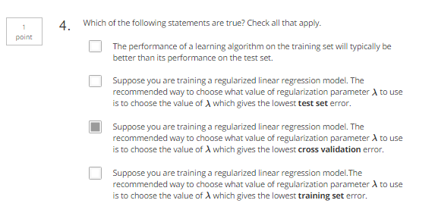

Training dataset error low: which might be overfitting

Test dataset low: which might be trained only for test dataset

CV is the middle validation rule

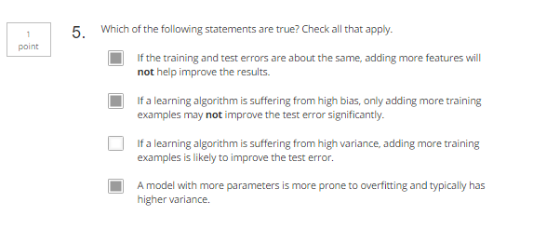

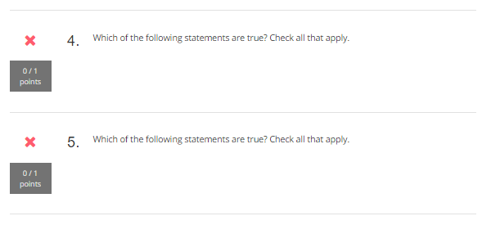

# Attend Quiz Again

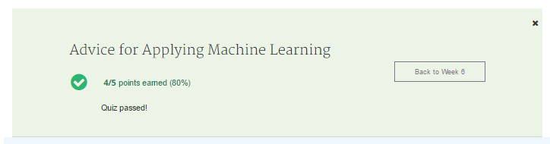



Jtest>>Jtrain, and Jtrain not big.

That is High variance

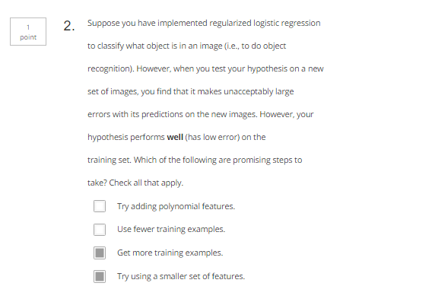

Work well on training dataset. But bad on test dataset.

That is overfitting.

We should: (1) increase regularization lambda. (2) reduce feature. (3) increase training dataset

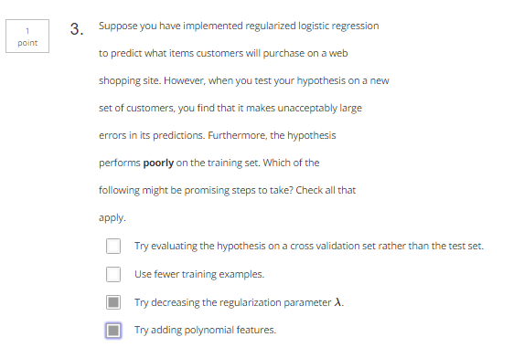Jtrain and Jtest are large, that is high bias

We should:

1. Decrease lambda. (2) increase feature. (3) increase polynomial items(x^2)

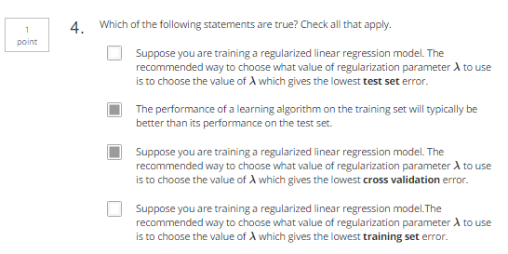

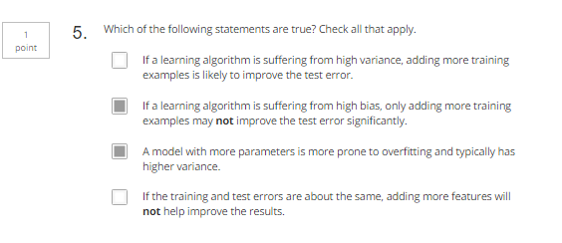

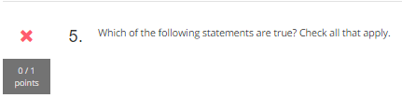

CORRECT: still not know