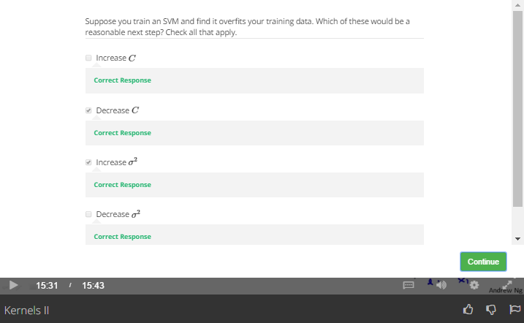

Overfitting, means High Variance

We should increase lambda (ie decrease C), and increase deta2