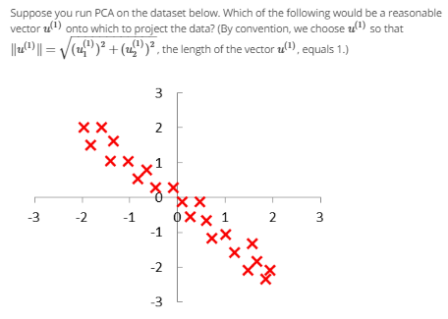

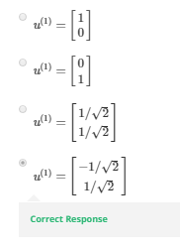

Answer:

The best direction of u is blue, and u1^2+u2^2=1, so u1 =-1/sqrt(2), u2 =1/sqrt(2)

